Given a BST with **n (n>=2)** nodes, find the **kth** common ancestor of nodes **x** and **y** in the given tree. Return **-1** if kth ancestor does not exist.

Nodes x and y will always be **present** in the input of a BST, and **x != y**.

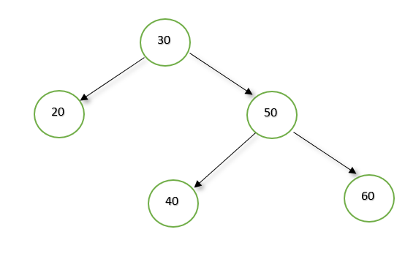

k = 2, x = 40, y = 60   
**Output:**  
30  
**Explanation:**  
Their 2nd common ancestor is 30.

Example 2:

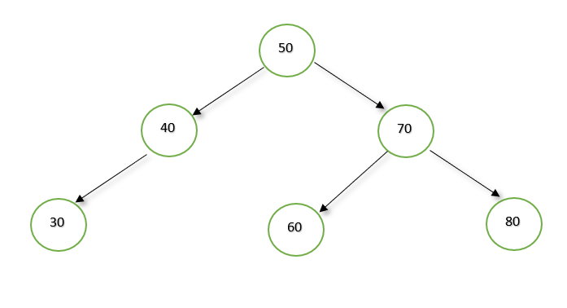k = 2, x = 40, y = 60  
**Output:**  
-1  
**Explanation:**  
LCA of 40 and 60 is 50, which is root itself. There does not exists 2nd common ancestor in this case.