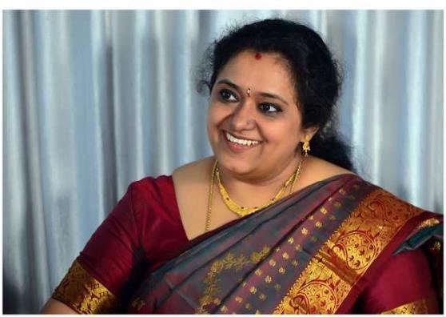

1. Name: Aparna R
2. Current Role :-

Assistant Professor, 14 years of teaching experience

Department of Computer Science and Engineering

Ramaiah Institute of Technology

1. Technology Areas of Interest/Expertise :-

6 years of industry experience

Cloud security, High performance Computing

1. Contribution to the project :-

Team mentor

1. Contact Details :-

Phone Number : 9901688004

Email Id : [aparna@msrit.edu](mailto:aparna@msrit.edu)



1. Name: Aravind Shreyas Ramesh
2. Current Role :-

Computer Science Engineering

5th Semester, 3rd Year

Ramaiah Institute Of Technology

1. Technology Areas of Interest/Expertise :-

Data analytics and Data Science

1. Contribution to the project :-

Team lead, Documentation, Implementation of Reminders feature

1. Contact Details :-

Phone Number : 7829561632

Email Id : [aravindshreyasramesh@gmail.com](mailto:aravindshreyasramesh@gmail.com)

1. LinkedIn Profile : <https://www.linkedin.com/in/aravind-shreyas-ramesh-6b6a631b2/>

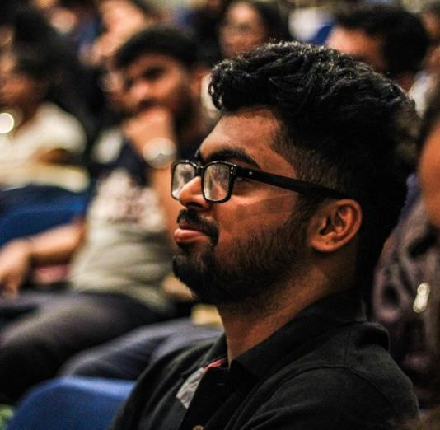

1. Name: Dheeraj Bhat
2. Current Role :-

Computer Science Engineering

5th Semester, 3rd Year

Ramaiah Institute Of Technology

1. Technology Areas of Interest/Expertise :-

Data science, Machine Learning, and Deep Learning

1. Contribution to the project :-

Implementation of features such as MOM, automated email and outlook calendar integration

1. Contact Details :-

Phone Number : +91 7411452100

Email Id : bhatdheeraj19@gmail.com

1. LinkedIn Profile : https://www.linkedin.com/in/dheeraj-bhat-37b3531b7/

1. Name: Gaurav V
2. Current Role :-

Computer Science Engineering

5th Semester, 3rd Year

Ramaiah Institute Of Technology

1. Technology Areas of Interest/Expertise :-

Web and mobile development, UI/UX design, software engineering and graphic design

1. Contribution to the project :-

Frontend design, project structure and implementation of TTS and voice features.

1. Contact Details :-

Phone Number : +91 7022851931

Email Id : [gv71.msrit@gmail.com](mailto:gv71.msrit@gmail.com)

1. LinkedIn Profile : [www.linkedin.com/in/gaurav-v-8071](http://www.linkedin.com/in/gaurav-v-8071)

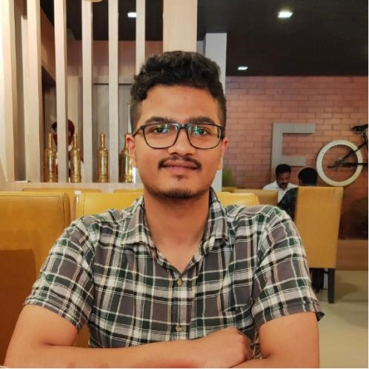

1. Name: Chinmay Bhatkal
2. Current Role :-

Computer Science Engineering

5th Semester, 3rd Year

Ramaiah Institute Of Technology

1. Technology Areas of Interest/Expertise :-

Full stack web development and software engineering

1. Contribution to the project :-

Frontend design, code organization, implementation of search features such as Wikipedia and browser interaction.

1. Contact Details :-

Phone Number : +91 9620796530

Email Id : chinmay.bhatkal@gmail.com