MASTERING AGENTIC AI | WEEK 1

NCR RidePulse
Solution Design Document
Ride Demand, Reliability & Trip Intelligence
Approach 3 / Path C: Build your own app with vibe-coding.
Document Control
Property | Details
Document version | 1.1 - structured formatting revision
Issue date | 10 October 2026
Project context | Maven Project | Mastering Agentic AI, Week 1
Audience | Project reviewers, developer and AI coding assistant
Development environment | Visual Studio Code, Claude Code extension and Python uv
Application stack | Python, Streamlit, pandas, Plotly and Pydeck
Design status | Agreed product and wireframe baseline; implementation requires acceptance testing
Revision scope | Reorganized sections, numbered headings, contents, tables, figures and page layout. Agreed solution scope retained.

An independent educational analysis of the uploaded 2024 Delhi-NCR ride-booking dataset associated with the Kaggle “Uber Data India” page. Not an official Uber analytics product or verified real-time operational system.
This document records the approved design direction. It is not a certification that the application has been implemented or independently tested.
Source baseline: NCR RidePulse - Solution Design Document, version 1.0, and the project artifacts referenced in Section 10.2.
Contents
1. Project Overview 3
1.1 Executive Summary 3
1.2 Purpose and Design Status 3
1.3 Problem Statement and Target Users 3
1.4 Success Criteria 3
2. Solution Approach and Development Workflow 4
2.1 Selected Approach 4
2.2 Agreed Solution Decisions 4
2.3 Vibe-Coding Workflow 4
3. System Architecture 5
3.1 Logical Architecture 5
3.2 Component Responsibilities 5
3.3 MVP Architecture Boundaries 5
4. Data Design and Preparation 6
4.1 Dataset Profile 6
4.2 Booking Outcomes and Baseline 6
4.3 Preprocessing Responsibilities 7
4.4 Geographic Lookup Structure 7
4.5 Reported Coordinate Pilot 7
5. Metrics and Calculation Rules 8
6. User Experience and Agreed Wireframes 9
6.1 Layout and Global Interaction Model 9
6.2 Executive Overview 10
6.3 Rider & Demand 11
6.4 Trip Explorer 12
7. Geographic Mapping Design 13
8. Testing and Risk Management 14
8.1 Automated Verification 14
8.2 Manual Browser Acceptance 14
8.3 Risks and Mitigations 14
9. Implementation and Delivery Plan 15
9.1 Implementation Stages and Acceptance Gates 15
9.2 Implementation Status 15
9.3 Five-Minute Demo Narrative 16
9.4 Assignment Submission Traceability 16
10. Open Decisions and References 17
10.1 Open Decisions and Limitations 17
10.2 References and Project Artifacts 17

Project Overview

Executive Summary
NCR RidePulse is a proposed operations-intelligence dashboard for exploring recorded ride bookings in and around Delhi NCR. It connects booking demand, fulfillment outcomes and geographic flows in a single, consistent experience. The differentiator is an interactive map that explains which origins connect to which destinations and what happened to the associated bookings.

Purpose and Design Status
Status distinction. Source analytics and planned behavior are specified here. User-reported completed stages and a Claude Code pilot message are not equivalent to verified production implementation. No local project repository or running application was supplied for independent testing in this document.

Problem Statement and Target Users
The source table contains individual booking records but does not directly reveal when recorded requests concentrate, why rides fail to complete, which vehicle categories users request, or how requested origins and destinations interact across the region. Static charts alone make these questions difficult to investigate contextually.
Table 1. Target users and analytical questions
User / Persona | Key Questions
City operations manager | How many bookings completed? What proportion were cancelled or could not find a driver?
Demand analyst | Which hours and weekdays show greater recorded booking activity? Which vehicle categories are most requested?
Geographic planner / investigator | Which areas connect, which origins have high non-completion, and what is the sample size behind those rates?
Assignment reviewer | Can the solution be demonstrated end to end, and is the AI-assisted development process documented?

Success Criteria
- A browser-accessible, functioning Streamlit app with the three agreed tabs and shared filters.
- Unfiltered KPI totals reproduce the approved data baseline and remain consistent under filters.
- A real, reviewed-coordinate pilot map renders with source/attribution, supports a selection or dropdown drill-down, and reports partial coverage.
- User can complete a clear explore-filter-map-insight-reset walkthrough within five minutes.
- The codebase, development log, screenshots, and demo evidence satisfy the Week 1 handout deliverables.

Solution Approach and Development Workflow

Selected Approach
The handout permits any application, stack or AI coding assistant under Path C. We selected a locally developed Streamlit application rather than a BI-only dashboard or custom JavaScript frontend: it offers fast end-to-end Python development, reuse of the existing CSV preparation and metrics logic, and integration of Plotly and Pydeck without an additional service layer.
Table 2. Alternatives considered and selection
Alternative | Assessment | Decision
Streamlit + Plotly + Pydeck | Rapid Python-first build, sufficient controls and mapped layers; fewer moving parts. | SELECTED
Dash + Plotly | Strong callback composition, but more callback UI plumbing for this deadline. | Deferred
React + deck.gl / MapLibre | Maximum UI control; additional frontend and deployment effort. | Not needed for MVP

Agreed Solution Decisions
Navigation comprises exactly three tabs: Executive Overview, Rider & Demand, and Trip Explorer. All views share persistent sidebar filters, active-filter context and a Reset Filters action.
The map-first approach uses OpenStreetMap for the pilot and supports the wider Delhi-NCR study area. A working three-tab MVP takes priority over completing all 176 location reviews; coordinate review and transparent map coverage remain required.

Vibe-Coding Workflow
- Discover: read handout, inspect schema, profile dataset and identify exceptions.
- Design: establish target personas, MVP features, KPI rules, map decision and sidebar-first wireframe.
- Plan: store persistent project guidance in CLAUDE.md and the solution brief; request an implementation plan in Claude Code.
- Build incrementally: preprocessing/metrics → coordinate pilot/map → unified app.py → polish.
- Test and improve: pytest + Ruff + real browser acceptance and regression checks; record prompts and corrections.
- Deliver: version-controlled repository, screenshots, documentation, and a sub-five-minute demonstration.
Acceleration decision. After the proposed 10-location pilot, the user selected OSM as the pilot basemap and asked Claude to proceed with map integration and the three-tab app in one cycle. That does not waive coordinate review or browser-validation gates.

System Architecture

Logical Architecture
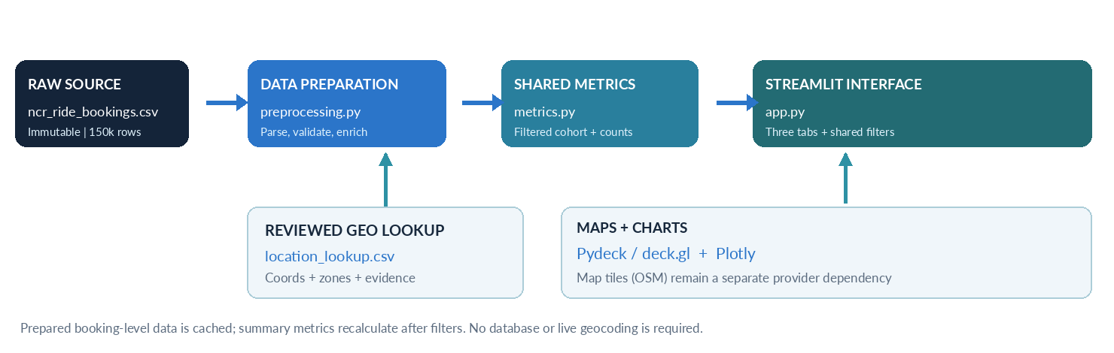
Figure 1. Logical architecture and intended data flow. This is a design diagram, not evidence of a deployed system.

Component Responsibilities
Table 3. Architecture layers and responsibilities
Layer | Responsibility
Raw source | Unmodified ncr_ride_bookings.csv stored in the local project; original record structure preserved.
Preparation | preprocessing.py: schema checks, normalization, derived date/outcome fields, quality reports, safe geographic joins.
Reference | data/reference/location_lookup.csv: reviewed representative coordinates, city/zone, evidence and review status.
Analytical layer | metrics.py: common filters, KPI definitions, denominator-safe aggregations; maps.py: geography validation and bounded flow aggregation.
Presentation | app.py: Streamlit pages/tabs, sidebar state, Plotly charts, Pydeck map and details panel.
Verification | pytest regression/unit tests, Ruff, uv lockfile, manual browser map/interaction checks.

MVP Architecture Boundaries
No database, prediction model, separate API, live geocoding, or paid LLM integration is required for the MVP. The prepared booking-level dataset remains available so that summaries can be recalculated when any shared filter changes.

Data Design and Preparation

Dataset Profile
Dataset: user-uploaded ncr_ride_bookings.csv, associated with https://www.kaggle.com/datasets/anilrohan/uber-data-india. The source contains booking date/time, identifiers, booking status, vehicle category, pickup/drop location, cancellation and incomplete flags/reasons, fare field, ride distance, timing fields, ratings and payment method.
Table 4. Dataset profile and design implications
Profile | Value | Implication
Records / columns | 150,000 / 21 | Base counting grain: source booking record, not deduplicated Booking ID.
Distinct Booking IDs | 148,767 | Repeated IDs exist; do not delete them automatically.
Distinct Customer IDs | 148,788 | Identifier-based distinct count; not verified individual people.
Date coverage | 01 Jan - 30 Dec 2024 | Derive hours/weekdays; apply actual coverage and exposure denominators.
Location labels | 176 | Coordinates absent; a separate reviewed geographic lookup is mandatory.
Directional locality pairs | 30,564 | Too sparse and numerous to draw all at once; aggregate and limit arcs.

Source: ncr_ride_data_audit.md; baseline carried forward from version 1.0.

Booking Outcomes and Baseline
Table 5. Full-dataset booking outcomes
Booking Status | Count | Share
Completed | 93,000 | 62%
Cancelled by Customer | 10,500 | 7%
Cancelled by Driver | 27,000 | 18%
No Driver Found | 10,500 | 7%
Incomplete | 9,000 | 6%

Metric caution. Cancellation rate = customer cancellations + driver cancellations divided by all booking records = 25%. Non-completion rate = 38%; do not combine it with cancellations. A displayed “vehicle count” would be incorrect: this source counts bookings by vehicle category, not fleet inventory.

Preprocessing Responsibilities
- Parse source dates/times; derive month, weekday/order, booking hour and weekend indicator; report parse errors.
- Normalize identifiers without losing quoted strings; preserve duplicates and add a stable source-row key.
- Normalize missing-value notation and verified category spellings; preserve unrecorded numeric values as missing.
- Produce a status flag for each of the five outcomes and validate exception flags against source statuses.
- Join geographic lookup to pickup and drop separately with validated many-to-one joins; assert row count unchanged.
- Write a prepared booking-level CSV and JSON/Markdown data-quality report; cache prepared data by input version.
- Preserve reviewed geographic rows during reruns; newly discovered labels begin unresolved.

Geographic Lookup Structure
Table 6. Location lookup fields and review controls
Field | Role
original_location / normalized_location | Stable label and documented join key; avoid merging similar names without evidence.
latitude / longitude | Representative locality point, not GPS ride trace; blank unless sourced.
city_or_zone | Analyst-created classification, subject to review.
coordinate_source / review_notes | Source URL and explanation of interpretation and positional precision.
review_status | Unresolved → proposed → reviewed; only reviewed entries participate in map layers.

Reported Coordinate Pilot
Pilot reported by Claude Code. 10 location coordinates were proposed, 166 remained untouched, and approximately 443 bookings had both endpoints in the pilot subset; the figures were developer-reported, not independently revalidated here. MG Road and Khandsa were flagged ambiguous. A reported HTTP 429 during external lookup prompted safer caching and refusal handling.
For expanded geographic coverage, review the names Panipat, Meerut, Sonipat, Bhiwadi and others against authoritative NCR geography. Do not automatically call long-distance records “Uber Outstation”: the CSV does not include an Uber service-product identifier.

Metrics and Calculation Rules
All shared calculations use the same filtered booking cohort. The rules below define the counting grain, eligible populations and handling of missing or undefined values.
Table 7. Shared metric definitions and denominator rules
Metric / View | Calculation / Assumption
Base cohort B | All source records meeting date, hour, weekday, vehicle and optional pickup/drop filters.
Total bookings | Number of source records in B (not distinct Booking IDs).
Unique customers | Distinct normalized nonmissing Customer IDs in B.
Completion rate | Count status = Completed / count B.
Cancellation rate | (Count Cancelled by Customer + Count Cancelled by Driver) / count B.
No-driver rate | Count No Driver Found / count B.
Non-completion rate | 1 − completion rate; this differs from cancellation rate.
Payment mix | Count payment categories among completed B records with nonmissing method.
Weekday / hour averages | Count in relevant weekday/hour ÷ eligible occurrences of weekday within selected calendar range.
Location reliability | Outcome count ÷ all base cohort records belonging to selected location/zone; local flow mode must not redefine numerator.
No eligible rows | Display N/A for undefined ratios, and zero only for true zero counts.
Booking value (optional) | Sum among completed records with recorded values; do not call net Uber revenue.

For true denominator and rate integrity, aggregate raw counts before computing percentages. Do not average subgroup percentages without weighting. Keep payment and revenue cohorts visible and avoid converting missing fare/distance/rating values to zero.

User Experience and Agreed Wireframes

Layout and Global Interaction Model
The agreed wireframe uses a persistent dark sidebar and a light analytics canvas, with a clear header and three top-level tabs. Filtering is a first-class dimension of the product: all three tabs derive from one shared base cohort. The figures below are conceptual wireframes, not screenshots of the implemented app.
Table 8. Global filters, controls and expected behavior
Sidebar Filter | Control / Default | Behavior
Booking date range | Date-range selector / full observed period | Inclusive date filtering; valid empty state.
Vehicle type | Searchable multiselect / all seven | Keeps Bike and eBike distinct.
Day of week | Monday-Sunday multiselect / all | Preserves chronological weekday order.
Booking hour | Range slider 0-23 / all hours | Uses booking timestamp, not actual GPS journey times.
Pickup location | Searchable multiselect / all | Origin scope; meaningful under map drill-down.
Drop location | Searchable multiselect / all | Destination scope; separate from pickup selection.
Reset Filters | Single action | Restores all defaults and clears stale drill-down selection.

Shared interface conventions: visible active-filter summary; state persists between tabs; local status/map controls do not silently rewrite executive KPI denominators; hover tooltips show count definitions; loading, no-results and partial-map states are explicit. An optional city/zone filter becomes available after geographic review.
The following three figures preserve the agreed wireframes from version 1.0. They illustrate layout and interaction intent, not screenshots of a verified running application.

Executive Overview
Primary question: How is recorded booking demand and fulfillment performing in the selected region and period?
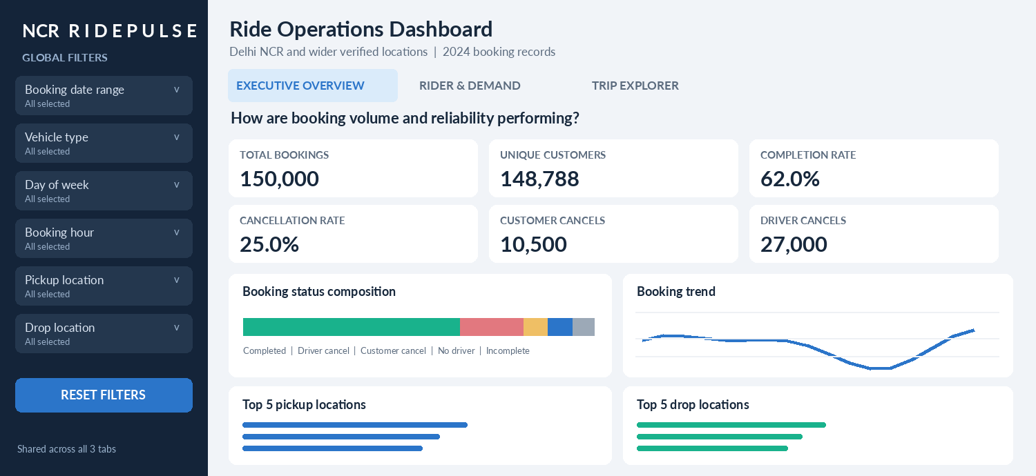
Figure 2. Executive Overview wireframe: shared sidebar, six KPI cards, booking outcomes, trend and location rankings. Values and chart shapes are illustrative design content.
Table 9. Executive Overview component specification
Component | Design Contract
Six KPI cards | Total booking records; distinct customer IDs; completion rate; cancellation rate; customer cancellations; driver cancellations.
Outcomes composition | 100% stacked status bar covering all five source statuses, with a legend and counts.
Volume trend | Daily/weekly booking count; completion-rate trend separately labeled where included.
Origin / destination rankings | Top five pickups and top five drops by recorded booking count.
Computed insight | One neutral, deterministic observation from the filtered counts; no speculative causes or invented deltas.

Rider & Demand
Primary question: When are ride bookings requested, and what types of service or payment are observed?
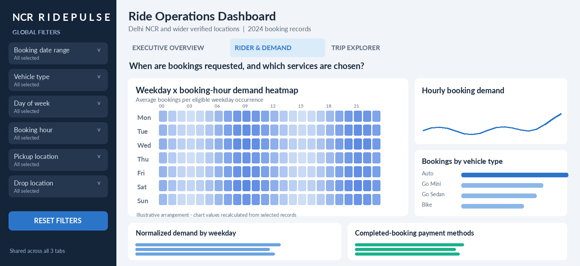
Figure 3. Rider & Demand wireframe: weekday-hour heatmap and supporting demand, vehicle-category and payment-method views.
Table 10. Rider & Demand component specification
Component | Design Contract
Weekday-hour heatmap | Rows Monday-Sunday, columns 00:00-23:00; average bookings per eligible calendar occurrence of each weekday, not raw totals.
Weekday comparison | Average per eligible weekday in selected date range; include exposure counts and show zero-booking eligible days.
Hourly demand | All-outcome booking-request counts by hour; preserve chronological ordering.
Vehicle categories | Bookings by requested category (Auto, Go Mini, Go Sedan, Bike, Premier Sedan, eBike, Uber XL).
Payment method mix | Completed records with a recorded payment method only; show eligible denominator.

Analytical integrity. The audit found little normalized difference across weekdays but a stronger hour-of-day pattern (18:00-18:59 was highest in the full dataset). Present descriptive demand honestly; do not overclaim a behavioral cause.

Trip Explorer
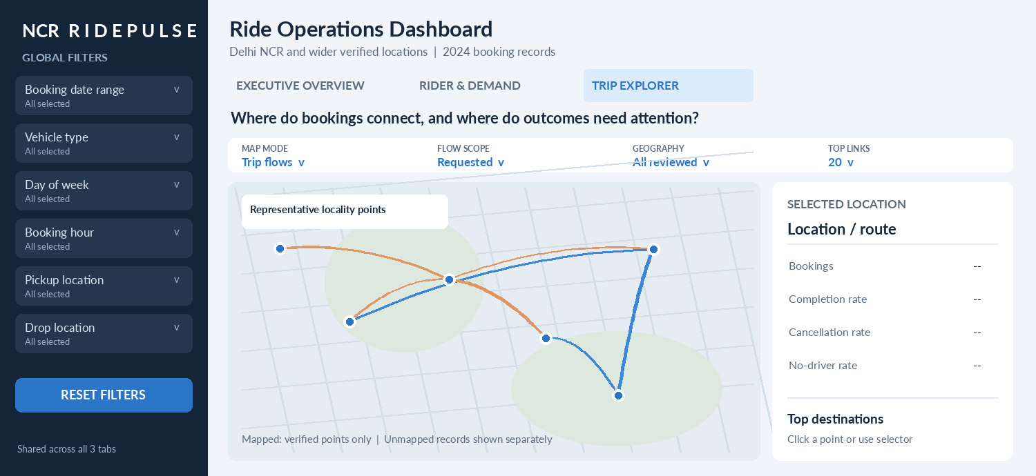
Figure 4. Trip Explorer wireframe: approximately 70% map area and 30% detail panel. Points and arcs are schematic, not verified routes.
Table 11. Trip Explorer map modes and analytical purposes
Mode | Visual / Analytical Purpose
Trip flows | Directional arc thickness = count. Toggle requested flows (all outcomes) vs completed flows. Default bounded top-N (~20); reviewed zones first, then selected-locality drill-down.
Demand hotspots | Pickup or drop locality-level concentration using weighted points/density, not exact street-level GPS heatmap.
Service reliability | Location marker size = booking volume; color = selected non-completion/cancellation/no-driver rate. Initially flag groups with fewer than 50 records.

The selected location or connection panel presents booking count, completion and cancellation/no-driver rates, leading destinations and reasons where eligible, sample size and the active geographic scope. A dropdown provides equivalent navigation if point/arc clicks are unavailable.
Map footer and legend distinguish: mapped vs unmapped records, lines hidden by top-N limits, source vs destination direction, rate denominators and representative-position precision.

Geographic Mapping Design
Geographic views use reviewed representative points and bounded origin-destination aggregations. Partial mapping must remain visible without changing the overall booking cohort.
Table 12. Map integrity and geographic behavior rules
Design Issue | Agreed Handling
No GPS coordinates in source | Use only vetted coordinates from an offline lookup; no guessed or random coordinates.
Map extent | Support core Delhi view and expanded study-area view to include other verified NCR/intercity locations.
OSM tiles | Selected pilot basemap, subject to compliant use and attribution “© OpenStreetMap contributors”; verify actual Pydeck tile integration.
Ambiguous place labels | MG Road, Khandsa and other ambiguous matches stay proposed/unresolved until positively reviewed.
Flow geometry | Arcs are conceptual links between representative points, never actual road paths or verified completed journeys.
Coverage by layer | Flow needs both endpoints; pickup views need pickup only; drop views need drop only. Show distinct denominators.
Very sparse individual routes | Aggregate at reviewed zone level for overview; allow selected-origin drill-down; do not draw 30,564 pairs.
Direction and self-links | Keep A→B distinct from B→A; report same-location loops rather than zero-length invisible arcs.
Reliability sample size | With fewer than 50 eligible records, show “limited sample” not a confident operational comparison.
Status distinction | Requested flows can include cancelled bookings; “completed trips” is completed-status subset only.

Required on-map note: “Representative locality coordinates. Connections show origin–destination relationships, not actual roads traveled.”

Testing and Risk Management

Automated Verification
- Schema/record invariants: all expected source fields; record count preserved after preparation and geographic joins; no silent deduplication.
- Status and KPI denominators: completed/cancelled/no-driver/incomplete counts, filtered recomputation and empty denominators.
- Identifier/missingness handling: quoted identifiers, repeated IDs and missing numeric measures.
- Time normalization: weekday ordering, selected-date exposure, zero-booking eligible days, 7 × 24 heatmap layout.
- Geography: duplicate-lookup rejection, valid coordinate bounds/status, independent pickup/drop eligibility, directional grouping and top-N limits.
- Reproducibility: repeated preparation retains reviewed lookup rows; source fingerprint checks; pytest and Ruff pass.

Manual Browser Acceptance
- All three tabs load; every global filter changes all relevant charts/KPIs; Reset restores baseline.
- Pydeck basemap tiles render and show attribution; selectable points/arcs or dropdown update the correct detail cohort.
- Mapped-record coverage, excluded/unresolved counts and top-N truncation are visible and consistent.
- Empty states, small-screen layout, hover/legend readability, and keyboard-accessible alternative selector are checked.
- No generated placeholder coordinates, fabricated route geometry, or unsupported operational claims appear.

Risks and Mitigations
Table 13. Project risks and mitigations
Risk | Mitigation
Ambiguous coordinate or geographic classification | Source citation, explicit review_status, authoritative boundary check and excluded-until-reviewed behavior.
OSM rate limits / tile policy / network outage | Use compliant basemap, attribution and fallback table; test actual connectivity and provider requirements.
Large number of OD pairs | Aggregate by reviewed zones, select a locality and cap arc count before sending to browser.
Metric drift after filters | Centralize computation in metrics.py and reuse one filtered cohort.
Source licensing / confidentiality | Verify redistribution rights before publishing raw CSV; do not send customer IDs or Booking IDs to geocoders.
Overstated data provenance | Label as independent study; no official Uber endorsement or verified real-world provenance claimed.

Implementation and Delivery Plan

Implementation Stages and Acceptance Gates
Table 14. Implementation stages, deliverables and exit criteria
Stage | Deliverable | Exit Criterion
0. Planning | Brief, CLAUDE.md, prompt milestones | Approved architecture, filter contract, definitions and scope.
1. Data foundation | preprocessing.py, metrics.py, prepared data, quality reports | Reproduced baseline, invariants and tests; preservation of raw CSV.
2A. Map coordinate pilot | 10 proposed labels with provenance and reviewed subset | Ambiguities documented, accurate review statuses, no fabricated points.
2B. Map integration | Pydeck view, real basemap, arcs, selection/dropdown, coverage | Browser-visible map and verified interaction; partial coverage labeled.
3. Integrated MVP | app.py with three tabs and persistent sidebar | Working filtered UI, baseline counts and no broken tab interactions.
4. Geographic and UI polish | Broader reviewed lookup, improved modes and layout | Coverage increased with recorded review evidence; performance and UX checks.
5. Delivery | README, DEVLOG, GitHub, screenshots, ≤5-min video | Complete documented walkthrough and submission artifacts.

Implementation Status
Implementation status at document date. The user reports early stages working. The supplied Claude Code screenshot depicts 10 proposed geographic matches and a pending review for the pilot; subsequent instructions authorized faster development of the map and app. A completed running app, full coordinate lookup, screenshots, and deployed URL have not been independently observed in this environment.

Five-Minute Demo Narrative
Table 15. Suggested demonstration sequence
Time | Show / Say
0:00-0:35 | The problem, dataset scope, chosen Approach 3 and why the map is central.
0:35-1:20 | Executive Overview: five outcomes, completion vs cancellation and the six KPI cards.
1:20-2:10 | Filter October, Auto + Go Mini, and 17:00-22:00; show recalculation of cards and heatmap.
2:10-3:35 | Trip Explorer: reviewed points, origin-destination links, location detail and coverage disclaimer.
3:35-4:15 | Reset filters; explain the key data-quality discoveries and geographic uncertainty.
4:15-5:00 | Explain Claude Code/uv build stages, tests, prompt iterations and GitHub/code documentation.

Assignment Submission Traceability
Table 16. Assignment requirements and submission evidence
Handout Expectation | Project Evidence To Submit
Choose Path C and build functional application | The working Streamlit app, three-tab screenshots and a live demo.
Document the problem and build steps | Project design document, preprocessing audit, prompt timeline, recorded errors and improvements.
Video demonstration (≤5 min) | One continuous screen capture with demonstrated shared filters and map.
Codebase on GitHub | app.py, preprocessing.py, metrics.py, maps.py, tests, README, uv files; subject to data redistribution permission.

The assignment handout lists a “Builder of the Week” deadline of Sunday 11 October 2026, 11:59 p.m. PT; later submissions are permitted but do not qualify for that recognition. The more detailed analytics and map controls in this document are project design decisions rather than compulsory handout requirements.

Open Decisions and References

Open Decisions and Limitations
- Coordinate acceptance and source precision for the proposed pilot, especially MG Road and Khandsa.
- Whether the actual project files currently implement Pydeck selection, a zone-level flow view, all three map modes and full shared filtering; inspect the local repository and browser to confirm.
- Specific authoritative NCR membership and zone definitions for named places; “outstation” product status must not be inferred from geographic distance.
- Current OSM tile endpoint, attribution, caching policy and network compatibility with the deployed Pydeck runtime.
- Exact currency/time-zone and operational definitions of Avg VTAT / Avg CTAT; do not make uncertain business claims.
- Dataset redistribution/license and final deployment target; decide before publishing the source data.

References and Project Artifacts
The following source groups are retained from version 1.0. This formatting revision does not independently revalidate external service terms, geographic boundaries or application behavior.
- Project sources: Week 1 Project Handout (uploaded); Kaggle Uber Data India (kaggle.com/datasets/anilrohan/uber-data-india); D3 connection-map gallery.
- Implementation sources: Streamlit Pydeck API; OpenStreetMap tile policy; uv project guides; Claude Code VS Code documentation.
- Working materials: ncr_ride_bookings.csv; ncr_ride_data_audit.md; PROJECT_BRIEF.md; CLAUDE.md; BUILD_PROMPTS.md; wireframe design notes; Claude Code pilot screenshot.

