OrgGraph RAG
GraphRAG for Organizational Knowledge — Technical Project Documentation
Week 2 · Project 3 · Build Your RAG Application (The Gen Academy)
Item | Details
Author | Gaurav Chavan
Date | October 2026
Repository | https://github.com/Gaurav-Chavan/GenAI_Learnings/tree/main/Maven-MasteringAgenticAI/Week2_Project
Live app | https://<your-app>.streamlit.app (Streamlit Community Cloud; optional password)
Stack | Python 3.12 · uv · Neo4j Aura · LangChain · LangGraph · OpenAI · Chroma · Streamlit
Status | Complete · 14-question evaluation · 51 offline tests passing · deployed

At a glance
Metric (14 questions, human-reviewed) | GraphRAG | Vector RAG
Average correctness | 0.96 | 0.75
Fully correct answers | 13/14 | 8/14
Entity recall | 1.00 | 0.76
Faithfulness (claims supported by retrieved context) | 1.00 | 1.00
Median / p95 latency | 5.45 s / 5.91 s | 2.19 s / 3.85 s
Tokens per question | 2,548 | 588
Head-to-head | 5 wins · 9 ties | 0 wins

Contents
1. Executive summary
2. Problem statement and requirements
3. System architecture
4. Data model and knowledge graph
5. Ingestion pipeline
6. Retrieval and generation
7. Design decisions
8. Evaluation
9. Streamlit user interface
10. Deployment and operations
11. Testing and quality
12. Iterations and lessons learned
13. Limitations and future work
Appendix A — Repository layout and commands
Appendix B — Key prompts and queries

1. Executive summary
Questions about an organization — who worked on what, who approved which decision, who reports to whom — are about relationships between records, not about a single passage of text. Standard vector RAG retrieves the few chunks most similar to the question, which works for lookups but fails when the answer must be assembled from many records (aggregation) or reached through a chain of relationships (multi-hop).
OrgGraph RAG models the organization as a Neo4j knowledge graph and answers questions with a LangGraph GraphRAG pipeline: an LLM writes a read-only Cypher query, a grader checks the result, and an entity-anchored fallback retrieves nearby context when the query is insufficient. A deliberately fair vector-RAG baseline (one Chroma card per entity, listing all its relationships) answers the same questions with the same answer prompt, so the evaluation compares retrieval patterns rather than data access.
On a 14-question evaluation, GraphRAG reached 0.96 average correctness (13/14 fully correct) versus 0.75 (8/14) for vector RAG. GraphRAG wins aggregation, multi-hop and filter questions; on single-entity lookups the two tie, and vector RAG is about 2.5× faster and uses 4.3× fewer tokens. Both systems are fully grounded (faithfulness 1.00). The bonus Streamlit UI shows both answers side by side with the generated Cypher, the cited sources and the subgraph behind each answer.
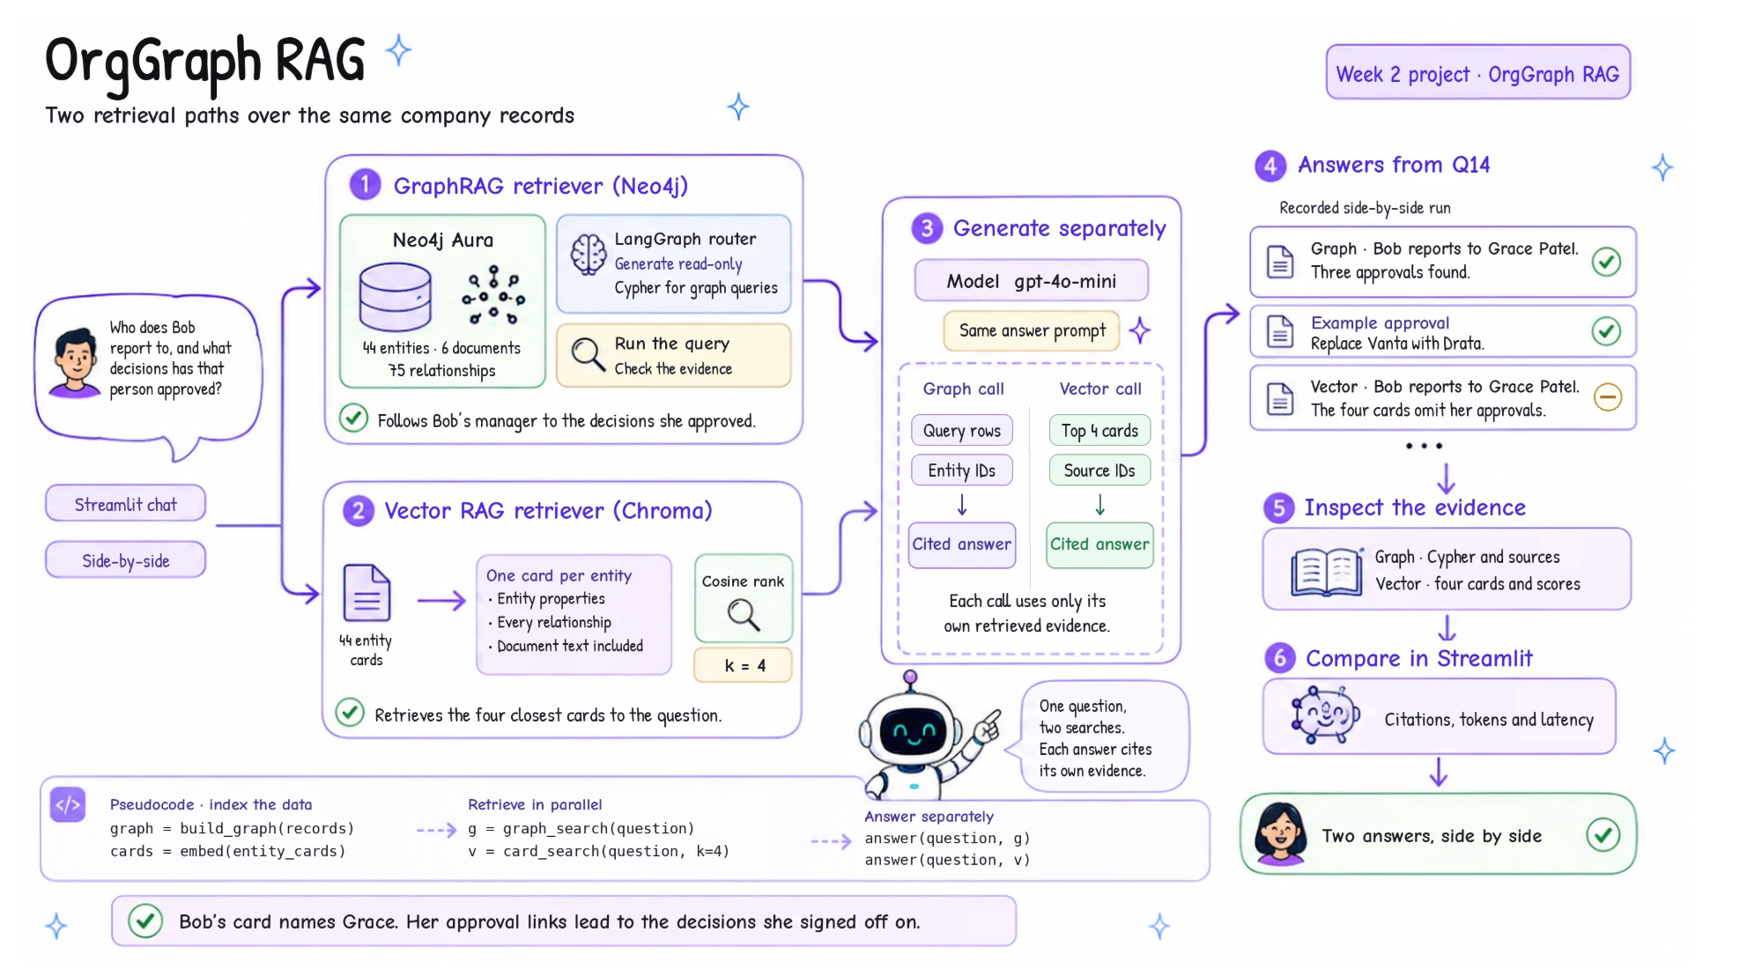
Figure 1 — Overview: two retrieval paths over the same company records, illustrated with Q14 ("Who does Bob report to, and what decisions has that person approved?").

2. Problem statement and requirements

2.1 Problem
- Aggregation. "Who has worked on more than one project?" needs every Person→Project relationship. Top-k similarity returns k records; no k fits "all entities that satisfy X".
- Multi-hop. "Who does Bob report to, and what has that person approved?" — the second hop's facts live on the manager's record, which the question never names.
- Temporal reasoning. "The last compliance audit" requires ordering projects by date, not by similarity.
- Grounding. When the data has no answer ("Who approved the migration to GCP?") the system must refuse rather than invent one.

2.2 Project brief (handout, Project 3)
Table 1 — Handout requirements and where they are met
Requirement | How it is met
Knowledge graph with 20+ nodes | 44 entities and 75 relationships in Neo4j Aura (50 / 81 including document chunks)
GraphRAG vs vector RAG on 10 queries | 14 queries across 11 question types, judged by gpt-4o and reviewed by hand
Analysis of when each approach wins | Section 8 and docs/comparison_analysis.md
Bonus: chatbot UI | Streamlit app with side-by-side comparison, explainability panels and an evaluation dashboard

2.3 RAG framework (handout Part 1)
One-liner: My RAG app helps PMs, tech leads and executives answer who/what/why questions about people, projects, tools and decisions from an org knowledge graph in a Streamlit chat, with ≥ 90% correctness on multi-hop questions and < 6 s p95 latency.
Table 2 — The handout's RAG framework, filled in for this project
Field | Decision
Use case | Who/what/why questions about people, teams, projects, skills, tools, documents and decisions, asked in a Streamlit chat.
Corpus | Course mock organization (mock_data.py), extended: 8 people, 7 teams, 5 projects, 6 skills, 7 tools, 6 documents, 5 decisions; 75 relationships; English; synthetic.
Ingestion + cleaning | Structured Python records → idempotent MERGE into Neo4j; ISO dates converted to Neo4j Date; a text description generated per node; documents chunked with a title prefix.
Ingestion + freshness | Batch: re-run ingest.py (idempotent, seconds). The vector index rebuilds with --build or automatically on app start when missing. Static dataset, so no freshness SLA.
Chunking + embedding | One chunk per entity card (37–555 chars) and per document (RecursiveCharacterTextSplitter 800/100); text-embedding-3-small (1536-d) suits short chunks.
Retrieve | GraphRAG: Text2Cypher over Neo4j + entity-anchored fallback (full-text 3 + vector 4 seeds, 1-hop, 2 chunks). Baseline: Chroma dense cosine top-4.

3. System architecture
The system has three layers: a Streamlit presentation layer, two retrieval pipelines that share one generation step, and external services (Neo4j Aura, OpenAI) plus a local Chroma store. Ingestion and evaluation are offline command-line jobs.
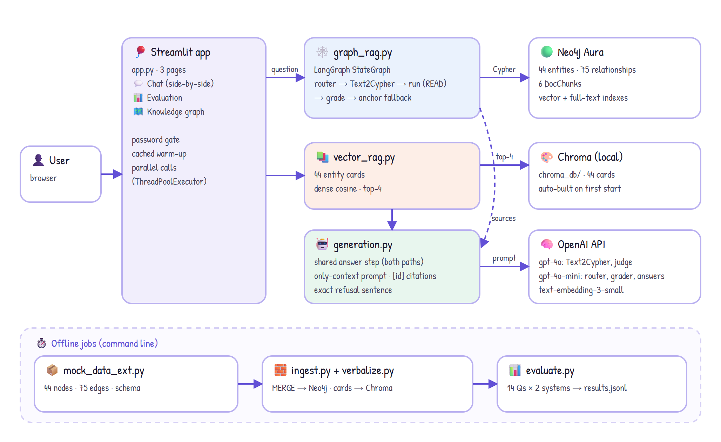
Figure 2 — Component architecture. Both pipelines end in the same generation step, so only retrieval differs between them.
Table 3 — Modules and responsibilities
Module | Responsibility
app.py | Streamlit UI: Chat (GraphRAG / Vector / side-by-side), Evaluation dashboard, Knowledge graph explorer; password gate; cached warm-up.
config.py | Settings from .env or host secrets (Neo4j, models, APP_PASSWORD); Neo4j driver and OpenAI client factories.
data/mock_data_ext.py | Extended dataset and the graph SCHEMA (allowed source–relationship–target triples).
ingest.py | Constraints, node/edge MERGE, embeddings, document chunks, vector and full-text indexes, verification report.
verbalize.py | node_text() for entity embeddings; entity_cards() for the vector baseline.
graph_rag.py | LangGraph pipeline: router, Text2Cypher, read-only execution, grader, anchor fallback, answer, subgraph.
prompts.py | Router, Text2Cypher (schema, catalog, rules, 7 few-shots) and grader prompts.
vector_rag.py | Chroma index build (and ensure_index on start) and top-4 retrieval.
generation.py | Shared answer prompt, refusal sentence, citation parsing, RAGResult type.
evaluate.py | Runs both systems, LLM-judge correctness and faithfulness, string metrics, CSV/JSONL/Markdown reports.
ui_graph.py | vis-network rendering of subgraphs and the full graph (validated colour palette).

3.1 Request lifecycle (Q14 walkthrough)
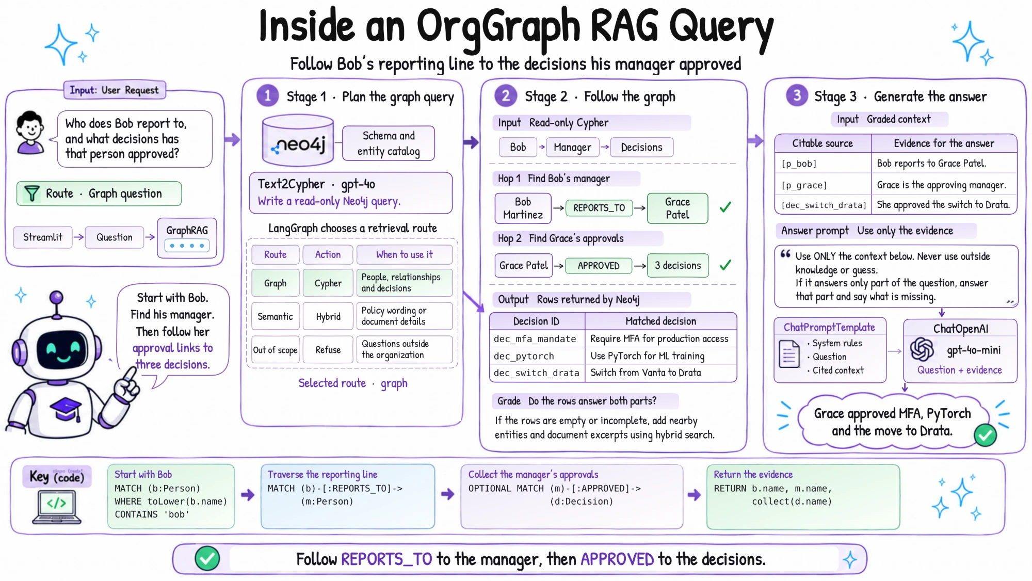
Figure 3 — Inside one GraphRAG query: route → read-only Cypher → two hops → graded, cited answer. (Decision titles in the "Matched decision" table are abbreviated; the graph stores e.g. "Mandate MFA for all production system access".)
- 1 · Route. gpt-4o-mini classifies the question as graph, semantic or out_of_scope (structured output).
- 2 · Plan. gpt-4o writes one Cypher query from the schema, the live entity-name catalog and real role/level values.
- 3 · Execute. A regex rejects write clauses; the query then runs in a READ transaction (≤ 50 rows). Errors get one retry with the error message.
- 4 · Grade. gpt-4o-mini checks the rows answer every part of the question; if not — or if no rows came back — the anchor step adds 1-hop neighbourhoods and document chunks.
- 5 · Answer. The shared prompt answers only from context, cites entity ids and refuses with one exact sentence when the answer is missing.

4. Data model and knowledge graph
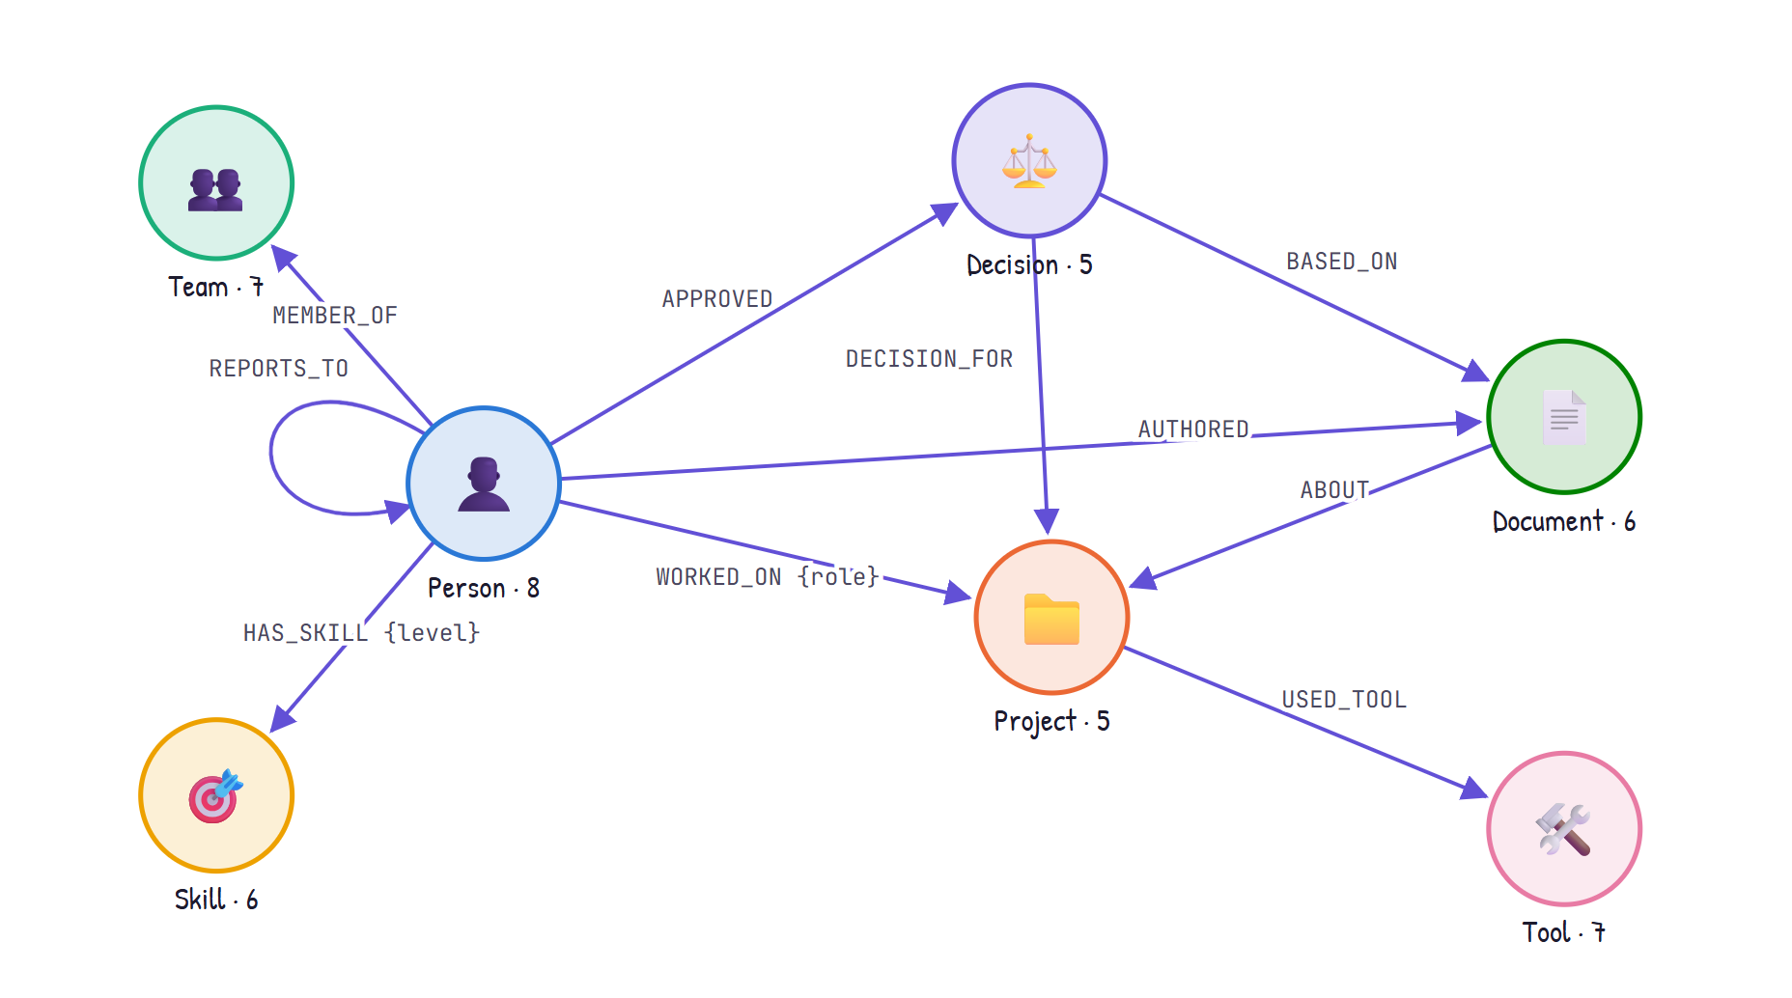
Figure 4 — Graph schema: 7 node types (with counts) and 10 relationship types.
Table 4 — Relationship types
Relationship | From → To | Properties | Answers questions like
WORKED_ON | Person → Project | role | Who worked on the last audit? Who leads it?
HAS_SKILL | Person → Skill | level | Who has SOC2 expertise?
USED_TOOL | Project → Tool | — | Which tools are shared across projects?
AUTHORED | Person → Document | — | Who wrote the churn analysis?
ABOUT | Document → Project | — | Which documents describe this project?
DECISION_FOR | Decision → Project | — | Which decisions were made for the pricing project?
APPROVED | Person → Decision | — | Who approved the pricing change?
MEMBER_OF | Person → Team | — | Who is on the Security team?
REPORTS_TO | Person → Person | — | Who does Bob report to?
BASED_ON | Decision → Document | — | Why was the decision made?

4.1 Dataset extension
The course dataset (32 nodes, 48 edges) is kept untouched in mock_data.py; mock_data_ext.py adds exactly the structure that separates graph retrieval from similarity search:
- Older 2024 SOC2 audit. Makes "the last audit" a date question.
- Distractors. Henry Okafor and the Vanta tool belong only to the 2024 audit — they must not appear in answers about the latest audit.
- Teams + MEMBER_OF. Derived from each person's team field (7 Team nodes).
- REPORTS_TO. Reporting lines enable two-hop questions.
- BASED_ON. Decision → evidence document, for "why" questions; plus a Vanta → Drata decision linking the two audits.
Every node also carries a shared :Entity label with id, name, description (generated text) and a 1536-d embedding, so one constraint and one vector index cover all kinds. Gold answers for graph-dependent questions are pinned by offline tests, so a data edit that changes an expected answer fails a test first.

5. Ingestion pipeline
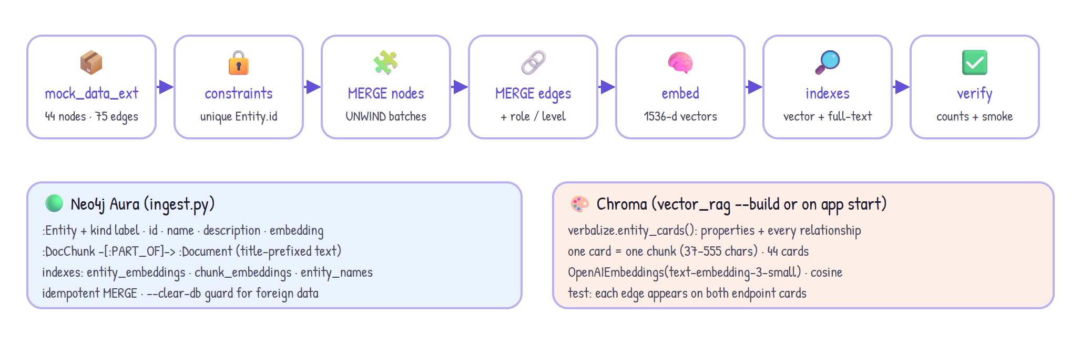
Figure 5 — Ingestion: one dataset feeds both the Neo4j graph and the Chroma entity cards.
- Idempotent. UNWIND-batched MERGE on Entity.id; re-running never duplicates nodes or edges.
- Indexes. entity_embeddings and chunk_embeddings (vector, cosine, 1536-d); entity_names (full-text) for exact-name lookup.
- Safety. Stops if the database holds another project's data (the tutorial's :Skill nodes collided); --clear-db wipes it explicitly.
- Verification. Every run prints node/relationship counts per type against the dataset, index states and smoke queries (last audit, full-text, vector).
- Isolation. Document chunks use a :DocChunk label so they never mix with the tutorial's :Chunk nodes or index.
UNWIND $rows AS row
MERGE (n:Entity {id: row.id})
SET n:Person, n += row.props, n.embedding = row.embedding

CREATE VECTOR INDEX entity_embeddings IF NOT EXISTS FOR (n:Entity) ON (n.embedding)
OPTIONS {indexConfig: {`vector.dimensions`: 1536, `vector.similarity_function`: 'cosine'}}

6. Retrieval and generation

6.1 GraphRAG pipeline (LangGraph)
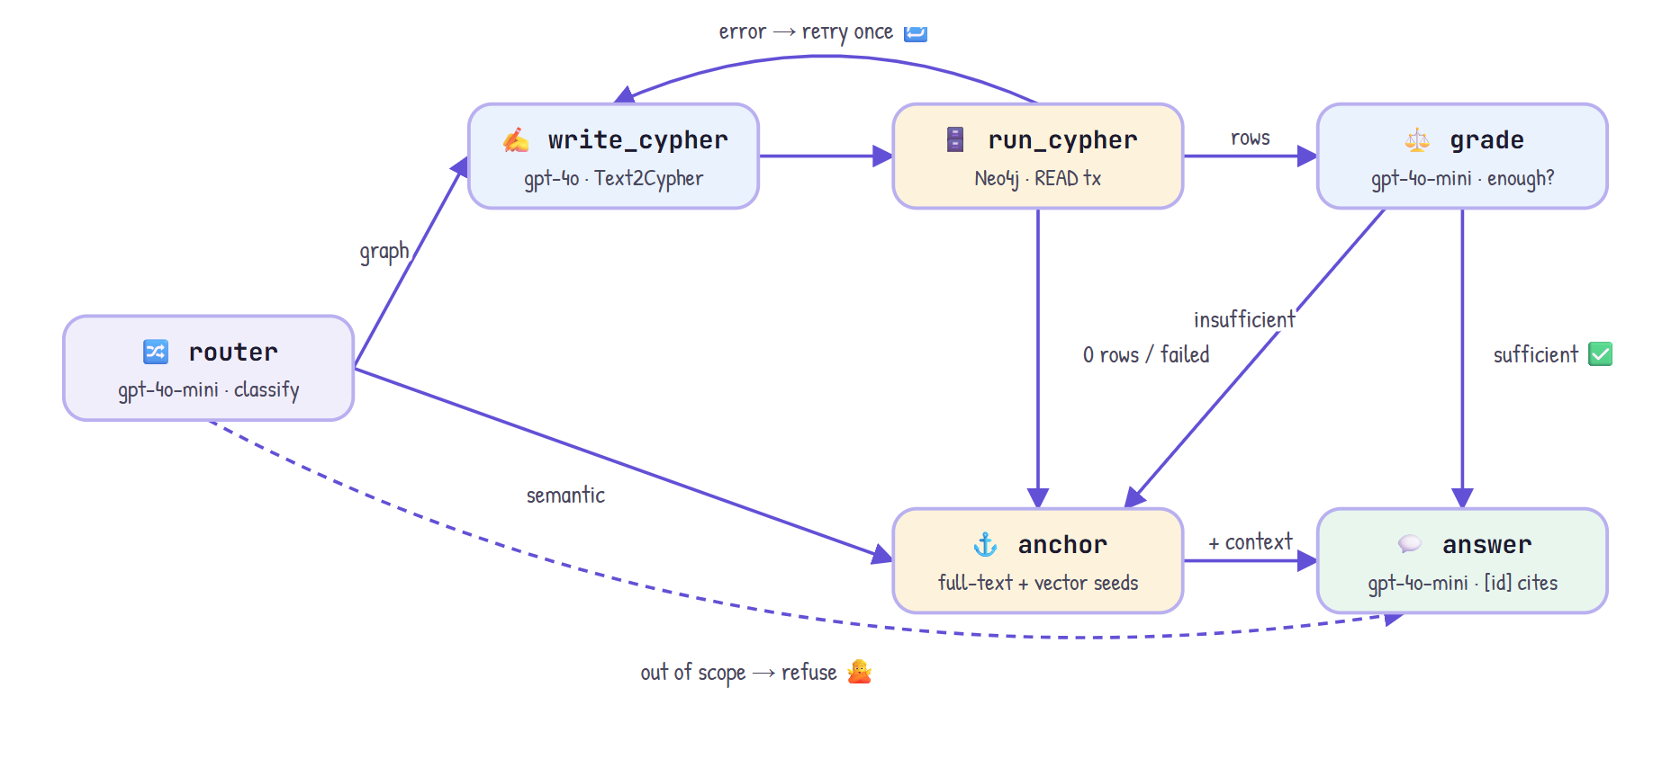
Figure 6 — GraphRAG state machine with conditional edges. The anchor fallback replaces guessing when Cypher fails, returns nothing or is graded insufficient.
Table 5 — Pipeline nodes
Node | Model / store | What it does | Next
router | gpt-4o-mini | Classify: graph · semantic · out_of_scope | write_cypher · anchor · answer
write_cypher | gpt-4o | Text2Cypher from schema, catalog, values, few-shots | run_cypher
run_cypher | Neo4j (READ tx) | Reject writes; execute; rows → table + entity descriptions | grade · anchor · retry
grade | gpt-4o-mini | Do the rows answer every part? | answer · anchor
anchor | Neo4j indexes | Full-text 3 + vector 4 seeds → 1-hop [id] triples + 2 chunks | answer
answer | gpt-4o-mini | Shared prompt; citations; subgraph for the UI | END

Text2Cypher prompt ingredients: the schema (labels, properties, relationship directions), a live catalog of every entity name, the real WORKED_ON roles and HAS_SKILL levels, seven few-shot patterns (deliberately not the evaluation questions) and rules — case-insensitive CONTAINS for names and roles, date ordering for "last", collect(DISTINCT …), always return ids, LIMIT 50.

6.2 Vector RAG baseline
Each of the 44 entities becomes one card: its properties plus every relationship it takes part in, in both directions (a test checks every edge appears on both endpoint cards). Cards are embedded with text-embedding-3-small into Chroma (cosine) and the top 4 are retrieved. Documents' full text is inside their cards.
Person: Bob Martinez, Senior Engineer on the Platform team.
Worked on: Q3 2025 SOC2 Compliance Audit (role: Evidence Engineer); ML Recommendation Engine ...
Skills: Python (level: Expert); AWS (level: Expert).
Member of team: Platform.
Reports to: Grace Patel.

6.3 Shared generation
- Use ONLY the context; never outside knowledge or guesses.
- Cite entity ids after each fact, e.g. [proj_audit_q3]; for result tables, cite the ids inside the rows.
- If the context lacks the answer, reply exactly: "I couldn't find this in the org knowledge base."
- If only part is answered, answer that part and say what is missing.
- Citations are parsed (including grouped [a, b]) and validated against the ids actually provided.

7. Design decisions
Each row records the choice, the alternatives considered and the trade-off accepted.
Table 6 — Design decisions
# | Decision | Alternatives | Rationale | Trade-off
D1 | Neo4j Aura Free as the graph store | Local Docker; Neo4j Desktop | No install; native vector + full-text indexes; reachable from any host | Pauses when idle; one free instance shared with the tutorial
D2 | Extend the dataset in a separate file | Use as-is; large synthetic org | Adds traps (older audit, distractors, hops) while keeping the original untouched | Gold answers depend on our additions → pinned by tests
D3 | Shared :Entity label on every node | Per-label indexes | One constraint, one vector index, one full-text index for all kinds | Every query must filter by kind label
D4 | Text2Cypher as the primary retriever | Vector-anchored expansion only; fixed query templates | Exact counting, filtering, ordering and hops | LLM-written queries can be wrong → grader + fallback
D5 | Router before retrieval | Always run Cypher | Saves a gpt-4o call on text questions; early refusal for out-of-scope | One extra small call on every question
D6 | Grader + anchor fallback | Trust the query result | Recovers wrong or empty queries (Q5) instead of refusing | ~1 s extra latency on graph questions
D7 | gpt-4o for Cypher, gpt-4o-mini elsewhere | One model everywhere | Query writing is the hardest step; small model is enough for routing, grading, answers | Higher cost on the Cypher call
D8 | Two read-only guards | Trust the prompt | Regex rejects writes; READ transaction enforced by Aura | Rare false rejections (e.g. the word SET in text)
D9 | Fair baseline: entity cards with relationships | Embed the 6 raw documents | Same facts in both systems → the eval measures retrieval, not data access | Strong baseline; GraphRAG wins fewer questions
D10 | Same answer prompt and model for both | Tune each system separately | Isolates retrieval as the only variable | Neither system is individually optimised
D11 | LLM judge + human review | Exact-match scoring only | Handles free-text answers; one judge error was caught and corrected | Manual review step
D12 | Streamlit + custom vis-network component | streamlit-agraph; React | Python-only UI; vis-network embeds cleanly; agraph has no key and breaks on repeated graphs | Own small component to maintain
D13 | Parallel side-by-side calls | Sequential | Wait time = slower system, not the sum | Two concurrent API calls
D14 | Auto-build Chroma on start; optional APP_PASSWORD | Commit chroma_db; open app | Fresh hosts just work; protects API credits on a public URL | First start is slower
D15 | Deploy on Streamlit Community Cloud | Replit; Render | Built for Streamlit; secrets UI; deploys from the repo subfolder (src/ added to sys.path) | Runtime files (feedback, index) are not permanent

8. Evaluation

8.1 Method
- 14 questions, 11 types: multi-hop, temporal, aggregation, provenance, path, filter + hop, skill + hop, semantic, detail-in-text, unanswerable, why.
- Correctness: gpt-4o judge against a reference answer (1 / 0.5 / 0).
- Faithfulness: gpt-4o judge — are the answer's claims supported by the retrieved context?
- Entity recall and distractors: string checks for expected names and for 2024-audit distractors.
- Refusal, latency, tokens: refuse only when unanswerable; warm-start latency and tokens across every LLM call.
- Human review: every non-perfect score was checked; one judge error (vector Q10, a correct date marked wrong) was overridden.

8.2 Results
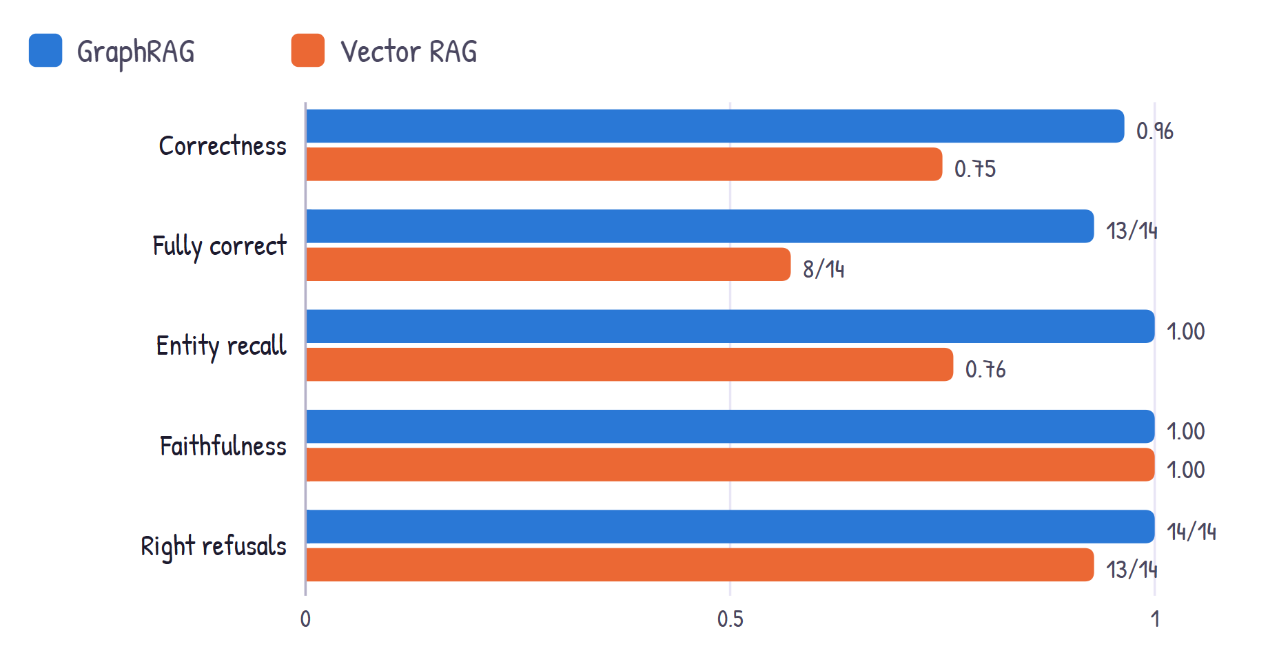
Figure 7 — Quality metrics, GraphRAG vs vector RAG (human-reviewed).
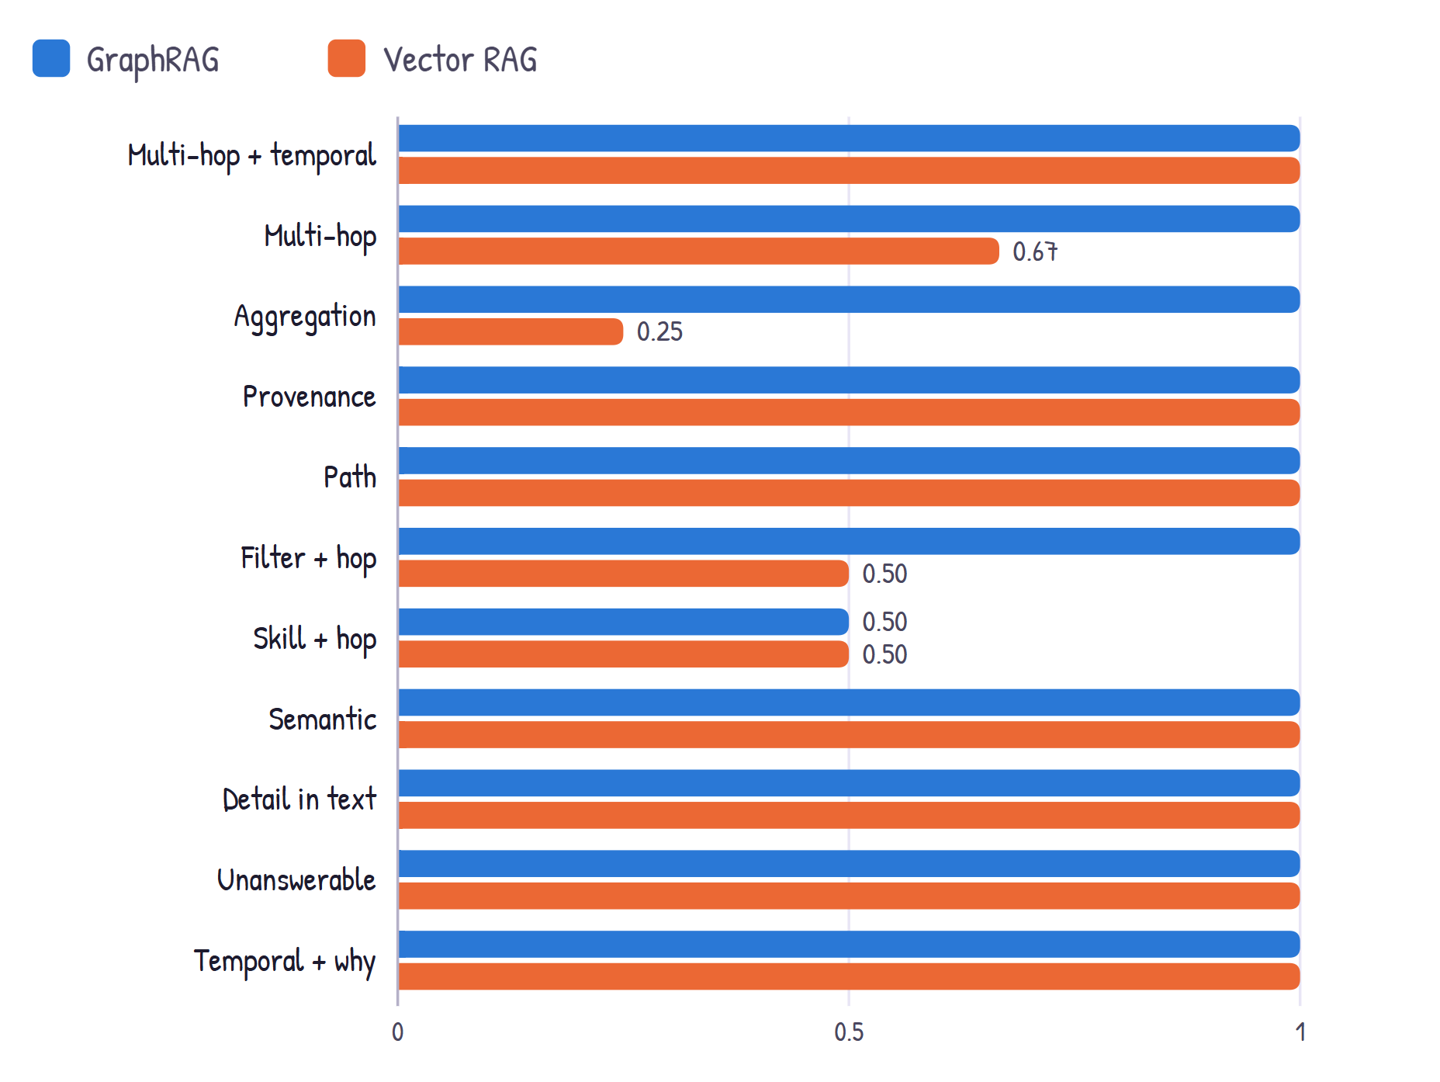
Figure 8 — Average correctness by question type (labels shown only where below 1.0).
Table 7 — Cost of structure
System | Median latency | p95 latency | Tokens / question | LLM calls / question
GraphRAG | 5.45 s | 5.91 s | 2,548 | 3–4 (router, Cypher, grader, answer)
Vector RAG | 2.19 s | 3.85 s | 588 | 1 (answer)

8.3 When each approach wins
- GraphRAG — aggregation (Q3, Q4): one collect() sees every person; vector RAG found 2 of 4 people and wrongly refused the tools question.
- GraphRAG — two hops (Q6, Q14): Bob's card names Grace, but her approvals live on her card, which vector RAG never retrieved.
- GraphRAG — filter + hop (Q8): Cypher matched the Tech Lead role; vector RAG named the Executive Sponsor as the lead.
- Tie — single-entity lookups (Q1, Q2, Q5, Q7, Q13): a rich card holds the whole answer.
- Tie — facts inside text (Q10, Q11): GraphRAG routes these to its semantic path anyway.
- Vector RAG — always cheaper: ~2.5× less latency and ~4.3× fewer tokens.
Table 8 — Answers that were not fully correct
Question | System | Score | Root cause
Q9 SOC2 expertise | GraphRAG | 0.5 | Generation: a retrieved project was omitted by the answer model
Q3 >1 project | Vector | 0.5 | Top-k ceiling on aggregation
Q4 shared tools | Vector | 0 | Top-k ceiling; wrongly refused
Q6 Grace's decisions | Vector | 0.5 | Second hop not retrieved
Q8 project leads | Vector | 0.5 | Lead's card not retrieved; plausible wrong inference
Q14 manager's approvals | Vector | 0.5 | Second hop not retrieved

9. Streamlit user interface
Three pages from one file via st.navigation: Chat, Evaluation and Knowledge graph. Every interaction re-runs app.py; conversation state lives in st.session_state, and expensive set-up is cached with st.cache_resource.
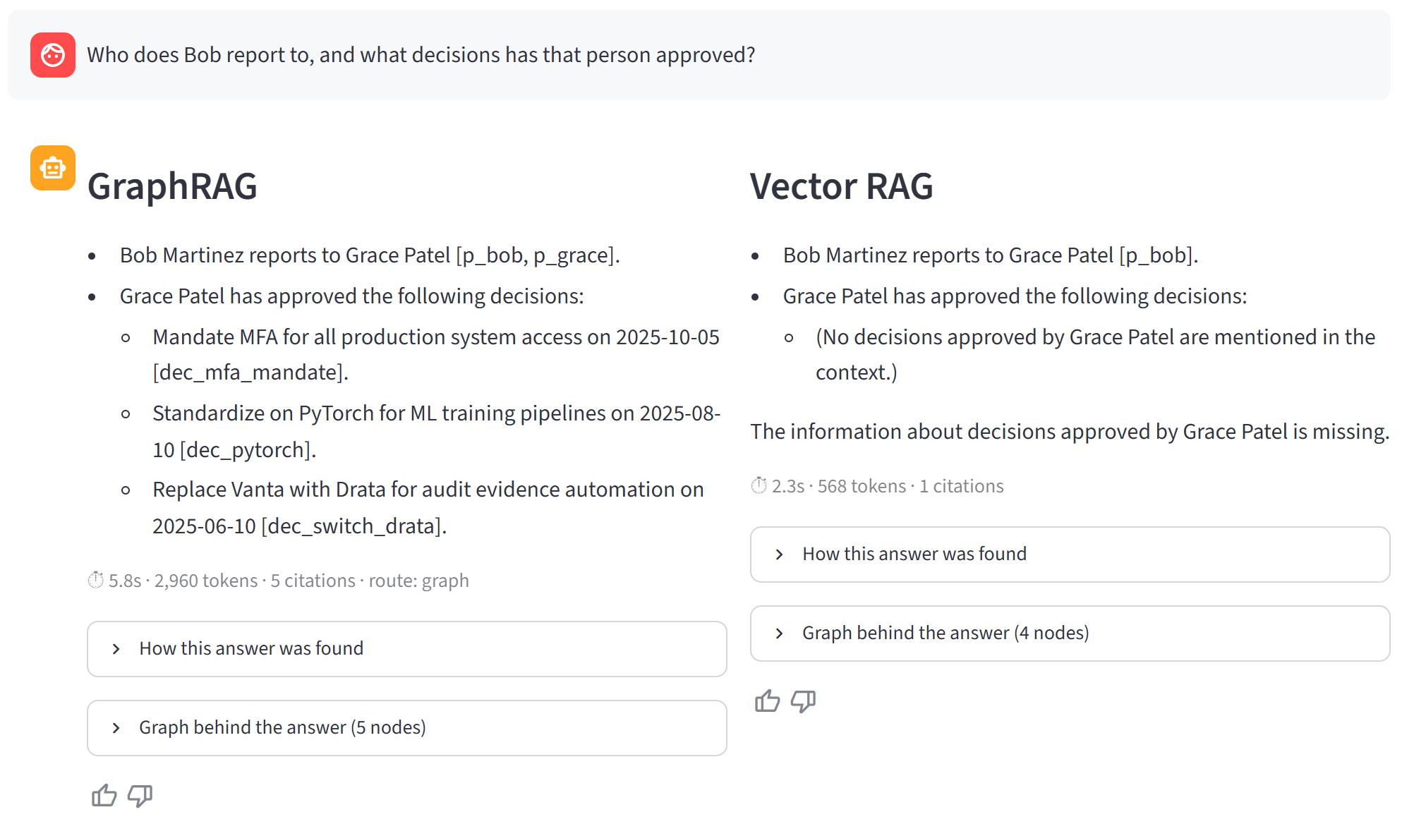
Figure 9 — Chat page in side-by-side mode on Q14: GraphRAG answers fully; vector RAG reports the approvals as missing.
- Startup once: startup() warms the Neo4j connection, entity catalog and embeddings, and builds Chroma if missing.
- Input: st.chat_input or a sidebar example button (stored in session_state.pending).
- Parallel run: a ThreadPoolExecutor calls both systems; each returns a RAGResult (answer, sources, citations, latency, tokens, route, Cypher, subgraph).
- Explainability: "How this answer was found" shows the pipeline path, the Cypher and every source with a cited flag; "Graph behind the answer" draws the subgraph.
- Feedback: st.feedback thumbs append to feedback.jsonl.
- Evaluation page: reads eval/results.jsonl through the same system_summary() as the CLI report.

10. Deployment and operations
Table 9 — Deployment configuration
Setting | Value
Host | Streamlit Community Cloud — repo Gaurav-Chavan/GenAI_Learnings, branch main
Main file | Maven-MasteringAgenticAI/Week2_Project/app.py (src/ is added to sys.path by app.py)
Python | 3.12; dependencies from requirements.txt (exported from uv.lock without dev tools)
Secrets | OPENAI_API_KEY, NEO4J_URI, NEO4J_USERNAME, NEO4J_PASSWORD, NEO4J_DATABASE, APP_PASSWORD (optional)
First start | Builds the Chroma index (~44 embedding calls), then caches the warm-up
Alternative | .replit and scripts/make_zip.py for Replit (import attempted; the workspace did not start)

- Aura Free pauses when idle — resume it before demos; the app shows a clear message if it cannot connect.
- Files written at runtime (feedback.jsonl, chroma_db/) are not permanent on the host.
- Secrets never enter git: .env is ignored, and the zip builder refuses to package any file containing a .env value.

11. Testing and quality
Table 10 — Offline test suite (51 tests, no network needed)
Test file | What it guards
tests/test_mock_data_ext.py | Unique ids; every edge matches the schema; gold answers for Q1–Q4, Q6, Q9, Q13, Q14
tests/test_verbalize.py | One card per node; each edge on both endpoint cards; refusal flag
tests/test_graph_rag_helpers.py | Write queries rejected, few-shots allowed; fences; Lucene escaping; citation parsing; prompt variables
tests/test_evaluate.py | Eval set shape; reference answers contain their expected entities; metric helpers

End-to-end checks beyond unit tests: the ingestion verification report, a full evaluation run, browser tests of the UI (answers, expanders, feedback), and a simulated Streamlit Cloud install from requirements.txt in a fresh environment.

12. Iterations and lessons learned
Table 11 — Iteration log
Iteration | Observation | Change
1 | Anchor query crashed (ORDER BY after aggregation) | Return a seed rank and order by it
1 | Answers cited the results table, or nothing | Prompt: every fact needs a citation; cite entity ids inside tables
2 | Q8 wrong: Cypher tested role = 'Lead'; leads are 'Tech Lead' | Give the model real role/level values; match roles with CONTAINS
2 | Citations grouped as [a, b] were not counted | Parser accepts comma-separated ids
3 | Q9 regressed: 'expertise' became level = 'Expert' | Filter on level only when the question names one
3 | Duplicated rows; 10 s first answer | collect(DISTINCT …); warm_up() at start
Eval | Judge marked a correct date wrong | Human review of every non-perfect score

- Every hint given to Text2Cypher can over-constrain another question — re-run the whole set after each change.
- A fair baseline changes the conclusion: with good entity cards, vector RAG is strong on lookups.
- Design the refusal path first; the grader + fallback turned a wrong query (Q5) into a right answer.
- Show the evidence: the route, the Cypher, the sources and the subgraph make answers trustworthy.

13. Limitations and future work
- Small graph (44 entities). Benefits of structure grow with size, but so does Text2Cypher difficulty — add schema-aware query validation.
- Single evaluation run. LLM variance; repeat runs and report spread.
- Questions written by the author. Biased toward graph-shaped questions; add real user questions from feedback.jsonl.
- Simple baseline. Add hybrid BM25, reranking or query decomposition to vector RAG.
- Latency. Skip the grader when rows are clearly complete; run the router and embedding in parallel; cache Cypher for repeated shapes.
- Persistence. Store feedback in a database instead of a local file on the host.

Appendix A — Repository layout and commands
src/orggraph_rag/ config · ingest · verbalize · graph_rag · prompts · vector_rag · generation · evaluate · ui_graph
src/orggraph_rag/data/ mock_data.py (original) · mock_data_ext.py (extension + schema)
app.py Streamlit UI tests/ 51 offline tests
eval/ queries.yaml · results.csv · results.jsonl · summary.md
docs/ PLAN.md · comparison_analysis.md · infographic · demo narrative · this document

uv sync
uv run python -m orggraph_rag.ingest # build / verify the graph
uv run python -m orggraph_rag.vector_rag --build
uv run python -m orggraph_rag.evaluate # ~4 min, writes eval/
uv run streamlit run app.py
uv run pytest

Appendix B — Key prompts and queries
Generated Cypher for Q14 (two hops):
MATCH (b:Person)-[:REPORTS_TO]->(m:Person)
WHERE toLower(b.name) CONTAINS 'bob'
OPTIONAL MATCH (m)-[:APPROVED]->(d:Decision)
RETURN b.id AS person_id, b.name AS person, m.id AS manager_id, m.name AS manager,
collect({decision_id: d.id, decision: d.name, date: d.date}) AS approved_decisions

Aggregation pattern (Q3):
MATCH (p:Person)-[:WORKED_ON]->(proj:Project)
WITH p, collect({project_id: proj.id, project: proj.name}) AS projects
WHERE size(projects) > 1
RETURN p.id AS person_id, p.name AS person, size(projects) AS project_count, projects

Answer prompt (system message, abbreviated):
Use ONLY the context below. Never use outside knowledge or guess.
Cite ids right after each fact, e.g. "Alice Chen led the audit [proj_audit_q3]".
If the context does not contain the answer, reply exactly:
"I couldn't find this in the org knowledge base."
If it answers only part of the question, answer that part and say what is missing.

