NCR RidePulse
  - Ride Demand, Reliability & Trip Intelligence — project documentation
Week 1 project · Maven: Mastering Agentic AI · built by vibe coding with Claude Code (VS Code extension)
Author: Gaurav Chavan · Date: 10 October 2026
At a glance
What it is: a three-tab Streamlit dashboard that turns 150,000 Delhi-NCR ride-booking records into booking KPIs, demand patterns and an interactive origin–destination map.
Stack: Python 3.14 · uv · pandas · Streamlit · Plotly · Pydeck · pytest · Ruff.
Quality: 111 automated tests pass; Ruff lint and format clean; every headline number reproduces an independent audit of the source file exactly.
Map coverage: 8 of 176 locations have reviewed coordinates (pilot); nothing is placed at invented points.
Demo video: add link GitHub repository: add link

Disclaimer. NCR RidePulse is an independent, educational analysis of a public Kaggle dataset. It is not an official Uber product and does not describe verified Uber operations. Booking times are treated as local time; currency, provenance and some field meanings are unverified.

1. Overview
NCR RidePulse helps a city operations analyst see where and when bookings happen, which outcomes stop a booking from completing, and which areas or connections deserve a closer look. It reads a prepared, quality-checked copy of the booking data and presents it in three tabs that share one set of filters, so every number on every tab describes the same selection of bookings.
The project was built in phases with Claude Code acting as the developer and the author approving each phase. Two project files governed the work: CLAUDE.md (standing rules such as never modifying the raw data and never inventing coordinates) and PROJECT_BRIEF.md (the product, metric and testing requirements).

2. Problem statement
Raw booking exports are hard to reason about: identifiers repeat, missing values are written as text, outcomes are split across several columns, and locations are only names. An analyst needs trustworthy answers to questions such as:
- How many bookings complete, and what share are cancelled by customers or drivers?
- When are bookings requested — which weekdays and hours are busiest, fairly compared?
- Which vehicle types and payment methods do riders choose?
- Where do trips connect, and are some locations less reliable than others?
Out of scope for this MVP: live data, prediction models, customer profiling or loyalty analysis, an LLM chatbot, a database, authentication, and road routing (map arcs show origin–destination relationships, not roads).

3. Dataset
Source: ncr_ride_bookings.csv, associated with the Kaggle dataset anilrohan/uber-data-india (kaggle.com/datasets/anilrohan/uber-data-india). The file is kept unchanged in the project folder, excluded from git, and identified by its SHA-256 fingerprint.
Property | Value
Size | 25,537,048 bytes · 150,000 rows · 21 columns
Fingerprint (SHA-256) | 545118f78c629cf8…c6db72e7 (full value in Appendix C)
Date range | 1 January – 30 December 2024 (365 dates, no gaps)
Booking IDs | 148,767 distinct; 1,224 IDs repeat (1,233 extra rows). All repeated groups have different customer IDs, so they are kept as separate records.
Customer IDs | 148,788 distinct (identifiers, not verified people)
Locations | 176 location labels used for both pickup and drop; 30,564 directed pickup→drop pairs, the busiest with only 17 bookings
Raw-format quirks | Every ID is wrapped in literal quote characters; missing values are the text null; there are no coordinate columns

Fields
Group | Source columns
Time & identity | Date, Time, Booking ID, Customer ID
Outcome | Booking Status, Cancelled Rides by Customer, Reason for cancelling by Customer, Cancelled Rides by Driver, Driver Cancellation Reason, Incomplete Rides, Incomplete Rides Reason
Trip | Vehicle Type, Pickup Location, Drop Location, Avg VTAT, Avg CTAT, Ride Distance
Value & rating | Booking Value, Payment Method, Driver Ratings, Customer Rating

Key facts (reproduced exactly from an independent prior audit)
Booking outcome | Records | Share
Completed | 93,000 | 62.0%
Cancelled by Driver | 27,000 | 18.0%
Cancelled by Customer | 10,500 | 7.0%
No Driver Found | 10,500 | 7.0%
Incomplete | 9,000 | 6.0%

- Vehicle types: Auto 37,419 · Go Mini 29,806 · Go Sedan 27,141 · Bike 22,517 · Premier Sedan 18,111 · eBike 10,557 · Uber XL 4,449 (booking records, not fleet size).
- Payment on completed bookings: UPI 44.98% · Cash 24.85% · Uber Wallet 12.05% · Credit Card 10.02% · Debit Card 8.09%.
- Busiest hour: 18:00–18:59 (12,397 bookings). Weekday averages differ by only about 1.5% (Thursday 407.98/day to Saturday 414.27/day).
- Completed booking value: 47,260,574 source currency units (INR is a proposed, unverified label).

Caveats
The round outcome totals, near-uniform location volumes (790–949 pickups per label) and tiny weekday differences suggest the data may be synthetic. The dashboard therefore reports differences descriptively and never makes causal claims. Provenance, licence, time zone, currency and the meaning of Avg VTAT/Avg CTAT are unverified, so those names are kept exactly as in the source.

4. Solution: the three tabs
A persistent sidebar holds the global filters — booking date range, vehicle type, day of week, booking hour range, pickup location and drop location (searchable) — plus Reset all filters. A line under the title shows the active filters and how many of the 150,000 records match. Booking status is deliberately not a global filter, because filtering by status would distort completion and cancellation rates.
Tab | Question it answers | What it shows
Executive Overview | How is the selected region performing? | Six KPI cards (total bookings, unique customer IDs, completion rate, cancellation rate, customer and driver cancellations) · all five booking outcomes · one computed insight · weekly or daily volume trend with a separate completion-rate chart · top 5 pickup and drop locations
Rider & Demand | When are bookings requested and what do riders choose? | Weekday × hour heatmap of average bookings per eligible calendar day · normalized day-of-week and hourly demand · bookings by vehicle type · payment mix on completed bookings
Trip Explorer | Where do trips connect, and where should we look closer? | Interactive map (about 70% of the width) with three modes — trip flows, demand hotspots, service reliability — plus a details panel (about 30%) for a selected location or connection, and tables covering every location

Example computed insight (unfiltered): “Cancelled by Driver is the largest non-completion outcome in this selection: 27,000 records (18.0% of all bookings, 47.4% of the 57,000 bookings that did not complete). Completion rate: 62.0%.”

5. Architecture
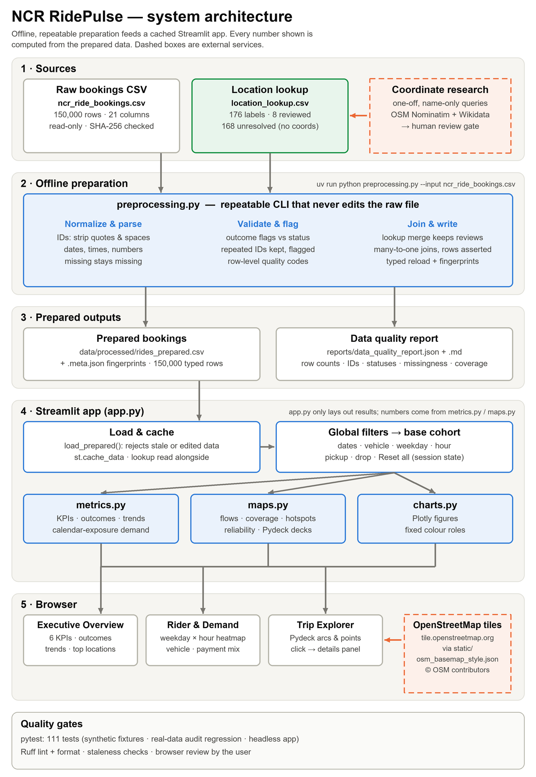
Figure 1. System architecture: sources → offline preparation → prepared outputs → Streamlit app → browser. Dashed boxes are external services.
The system has two halves. An offline preparation step turns the raw CSV into a typed, validated, fingerprinted dataset and quality reports. A Streamlit app loads only that prepared data, applies the shared filters once, and hands the resulting cohort to calculation and chart modules.

Module responsibilities
Module | Responsibility
preprocessing.py | Command-line preparation: reads the raw CSV as text, normalizes and types every field, validates outcomes and ranges, maintains the location lookup without overwriting reviews, joins coordinates, writes the prepared CSV with fingerprints, re-reads it to prove it round-trips, and writes the quality reports.
metrics.py | Pure calculation functions: the base-cohort filter, KPIs, outcome mix, payment mix, calendar-exposure demand normalization, trends, origin–destination flows, location reliability and reason breakdowns. No UI code, no hard-coded values.
maps.py | Geography: reviewed coordinates, map coverage, mapped flows with honest omission counts, hotspots, reliability, a view that fits every point, click parsing and the Pydeck map builders.
charts.py | Plotly figure builders and number formatting with fixed colour roles.
app.py | Layout only: cached loading, sidebar filters in session state, the three tabs and the details panel.
static/osm_basemap_style.json | Map style pointing at OpenStreetMap's standard tiles, served by Streamlit's static file serving.
tests/ | 111 pytest tests: synthetic fixtures, real-data audit regression and headless app tests.

Key design decisions
- Prepared data only at runtime. The app never reads the raw CSV for analysis. Fingerprints of the source, the lookup and the prepared file are checked at load time, so outdated or edited data is rejected with instructions to regenerate it.
- Fast, cached loading. st.cache_data holds 26 needed columns. Measured: about 2.5 s for a cold load, about 0.05 s per rerun, and about 0.07 s to filter and compute every metric.
- One cohort, many views. All tabs use the same filtered cohort, so totals agree everywhere (verified by a test: filtering to Auto gives 37,419 in the KPI card, the heatmap data and the Trip Explorer).
- Honest geography. Only reviewed coordinates are drawn; unmapped records still count in every KPI and chart, and each map states how many records it could not draw and why.
- Licence-aware basemap. Streamlit's default map style silently uses CARTO, whose terms now require the user's own key. The app instead loads OpenStreetMap tiles through its own style file.

Technology
Component | Version | Role
Python (via uv) | 3.14.8 (pinned 3.14) | Language and runtime; uv 0.12.23 manages the lockfile
pandas | 3.0.6 | Data preparation and aggregation
Streamlit | 1.65.0 | Web app, widgets, caching, static serving
Plotly | 7.1.0 | Charts
Pydeck | 0.9.3 | Interactive map layers
pytest · Ruff | 9.1.1 · 0.16.10 | Tests · lint and formatting

6. Data pipeline and quality rules
Run uv run python preprocessing.py --input ncr_ride_bookings.csv (about 17 seconds). The row count is checked after every step: 150,000 → 150,000 → 150,000 → 150,000.
Rule | Why it matters | How it is enforced
The raw file is never modified | The source must stay auditable | Read-only access; SHA-256 checked before and after each run; outputs that would overwrite it are refused
No rows dropped or merged | Repeated Booking IDs are real, distinct records | Each row gets a source_record_key; repeats and exact duplicates are flagged, never removed
Missing stays missing | Zero-filling would distort averages and totals | Nullable types; a test deliberately zero-fills and must fail
Outcomes validated | Exception flags must agree with status | Flag-versus-status checks (0 mismatches in this file); missing flags are not treated as 0
Parse failures reported | Bad dates or numbers must be visible | Counts and example rows in the quality report; row-level issue codes
Safe geographic joins | A bad lookup must not multiply rows | Many-to-one validated joins with an asserted row count; duplicate lookup keys are rejected
Reviews preserved | Human coordinate review must never be lost | Re-runs only append new labels as unresolved; reviewed rows stay byte-for-byte unchanged
Stale data blocked | The app must not show outdated numbers | Fingerprint file beside the prepared CSV; the app refuses mismatches

Outputs: data/processed/rides_prepared.csv (+ .meta.json), data/reference/location_lookup.csv, and reports/data_quality_report.json / .md.

7. Metric definitions
Every metric is calculated on the base cohort B — the bookings matching the global filters. Rates with an empty denominator show N/A, never 0; aggregate rates are always recomputed from counts, never averaged across groups.
Metric | Definition
Total bookings | Rows in B (one source row = one booking record)
Unique customer IDs | Distinct non-missing customer IDs in B
Completion rate | Completed ÷ all rows in B
Cancellation rate | (Cancelled by Customer + Cancelled by Driver) ÷ all rows in B. No Driver Found and Incomplete are separate outcomes, not cancellations.
Payment mix | Completed rows with a recorded payment method, by method (eligible count shown)
Completed booking value | Sum of recorded values on completed rows (not revenue or profit)
Reason shares | Reason count ÷ rows of that outcome that have a recorded reason
Location reliability | Outcome rates per location over all outcomes; locations with fewer than 50 records are labelled low-sample (a product guardrail, not a statistical test)

Fair weekday and hour comparisons
Demand averages divide by eligible calendar days, not by days that happen to have bookings. 2024 in this file contains 53 Mondays and 52 of every other weekday, so raw totals would favour Monday. A day with zero bookings after a vehicle or location filter still counts, and hours or weekdays outside the selection are left blank rather than shown as zero demand. The weekly trend plots average bookings per day, so the final one-day week of the year does not appear as a false collapse.

8. Geography and the map
The source contains location names only. Coordinates therefore had to be researched and reviewed, under three rules from CLAUDE.md: never invent coordinates, never geocode without approval, and never send booking or customer data to an external service.

Coordinate sourcing and review
- Pilot of 10 varied labels, approved by the author, looked up by name only in OpenStreetMap (Nominatim) with Wikidata as an independent cross-check, respecting the services' usage policies (one request at a time, identifying User-Agent, cached responses).
- Every candidate was written to the lookup as proposed, with its source link, the distance to the cross-check and interpretation notes. Raw responses are kept as evidence.
- Review decision: the author instructed “use only confidently verified pilot coordinates” and to keep ambiguous names unresolved. Eight were accepted; MG Road (a road over 10 km long, plus a metro station of the same name) and Khandsa (coarse point, ambiguous meaning) were withdrawn.
Location | Decision | Primary source | Cross-check
Barakhamba Road | Reviewed | OSM road segment | 0.19 km (Wikidata)
Saket | Reviewed | Wikidata settlement | 1.07 km (OSM point of interest)
Pragati Maidan | Reviewed | Wikidata venue (Bharat Mandapam) | 0.32 km (OSM bus stop)
Cyber Hub | Reviewed | OSM retail area | Single source, exact name
Noida Sector 62 | Reviewed | OSM suburb node | Single source, exact name
Ghaziabad | Reviewed | OSM city node | 0.67 km (Wikidata)
IGI Airport | Reviewed | OSM aerodrome | 0.26 km (Wikidata)
Panipat | Reviewed | OSM city node | 0.81 km (Wikidata)
MG Road | Withdrawn | — | Ambiguous
Khandsa | Withdrawn | — | Coarse and ambiguous

Coverage
With 8 of 176 labels reviewed: 7,068 pickups (4.7%) and 6,758 drops (4.5%) can be mapped, and 285 bookings (0.19%) have both ends mapped, across 55 directed connections. The busiest connection has 12 bookings and the longest arc runs about 94 km to Panipat. The app labels this clearly as partial, pilot coverage.

Basemap decision
CARTO's basemap terms changed on 29 September 2026 to require each user's own API key, and Streamlit's default map style uses CARTO. The author approved OpenStreetMap standard tiles instead: no key is needed, usage is light, and “© OpenStreetMap contributors” is shown on every map. The tiles are desaturated so the coloured arcs stand out.

Map design and interaction
- Trip flows: directional arcs fade from blue (pickup) to orange (drop); width shows bookings. A top-N slider (default 20) and a requested-versus-completed toggle affect only the flows.
- Demand hotspots: circle size shows pickup or drop volume at each reviewed location.
- Service reliability: circle colour shows the chosen failure rate on a fixed scale; locations under 50 records are grey.
- Interaction: hover tooltips on every point and arc; clicking loads that location or connection into the details panel, and selecting a location redraws only the connections leaving it.
- Transparency: every map states how many records were drawn, left out by the top-N limit, unmapped, or same-location, with a legend and the disclaimer “Connections show origin–destination relationships, not actual roads traveled.”

9. Development process (vibe coding)
The author directed the work in plain-language prompts; Claude Code inspected, planned, coded, tested and reported, and stopped at each approval gate. A running development log (docs/DEVLOG.md) records every prompt, decision, command and result.
Phase | Author's prompt (key words) | What was built or found | Gate
0 · Inspect & plan | “For now, inspect and plan only. Do not modify project files…” | Checked the environment; profiled the CSV read-only; its fingerprint matched the prior audit; found quoted IDs and literal null; proposed a plan | “Proceed with your recommendation”
1 · Data foundation | “The plan is approved for Phase 1 only.” | preprocessing.py, metrics.py, quality reports, 176-row lookup template, 63 tests; every audit value reproduced | Author review
Stage 3 · Dashboard | “I am approving Stage 3: Streamlit Dashboard Development.” | Found the claimed Stage 2 map work did not exist; built the three tabs with an honest “map not available” state; 92 tests | Browser screenshot
2A · Coordinates | “Why I am not getting map for 3rd tab?” → “Approved” | Explained the cause; researched 10 pilot locations by name; checked basemap terms | Author choice of basemap
2B / 3 · Map | “Let's accelerate… I approve OpenStreetMap as the initial basemap.” | 8 reviewed locations; Pydeck arcs, hotspots and reliability on OSM tiles; click-to-select; 110 tests | Browser screenshots
Fixes & sign-off | “Map is not shown properly” → “Project is Perfect” | Fixed the stale-server error and the map rendering bug; 111 tests | Author sign-off

Safeguards that shaped the build
- Implement only the approved phase; inspect existing files before changing anything.
- Never modify the raw CSV; never invent coordinates; never send booking data to services.
- Keep prior-audit numbers in tests only, never as dashboard values.
- Report honestly what was and was not verified — especially browser behaviour.

10. Iterations and bugs fixed
Issue | How it was found | Resolution
Claimed Stage 2 map work was missing | Checked the files, git history and lookup before building | Built a working table-based Trip Explorer with an explicit “map not available” banner (Figure 2) until coordinates were sourced
Wikidata rate limit (HTTP 429) | Error on the 16th request during sourcing | Stopped all further Wikidata calls; cached each response immediately; reported one duplicate query honestly
Default basemap needed a CARTO key | Read the installed Streamlit and Pydeck source and CARTO's current terms | Served an OpenStreetMap style file from the app's static folder
AttributeError in Trip Explorer | Author's screenshot (Figure 3) | A long-running server had kept an old copy of maps.py; restarting it fixed the error
Arcs drawn as giant fans; dots invisible | Author's screenshot (Figure 4) | Pydeck turns plain strings into JavaScript expressions, so “pixels” became undefined. Wrapped literal settings correctly and added a regression test

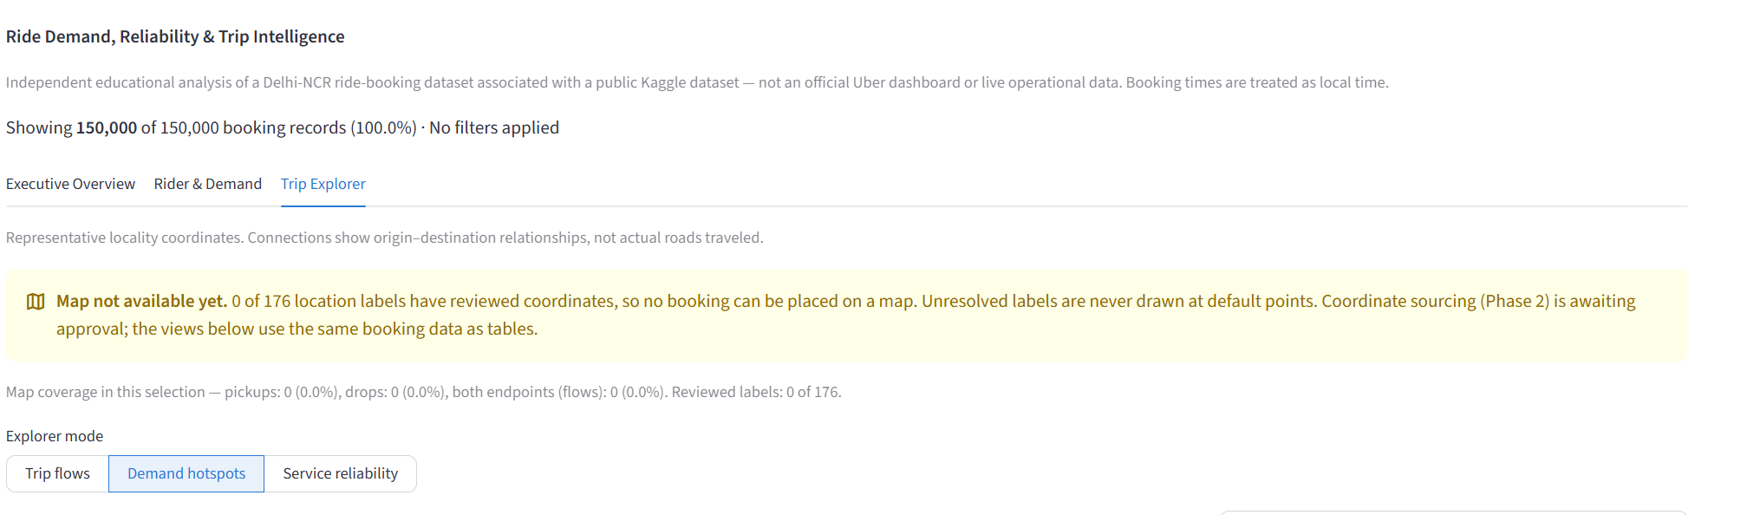
Figure 2. Stage 3: the Trip Explorer before any coordinates were reviewed — the app states plainly that no map can be drawn.
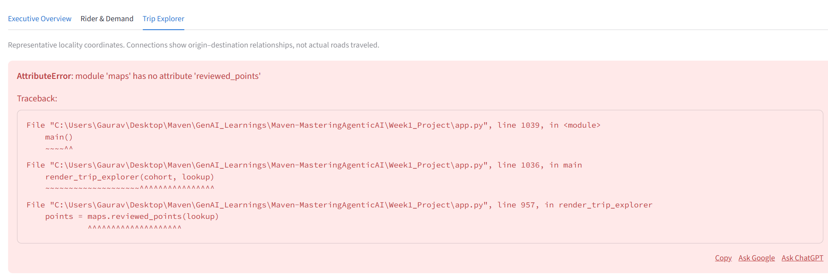
Figure 3. A server started before the map code changed kept an outdated module; restarting resolved it.
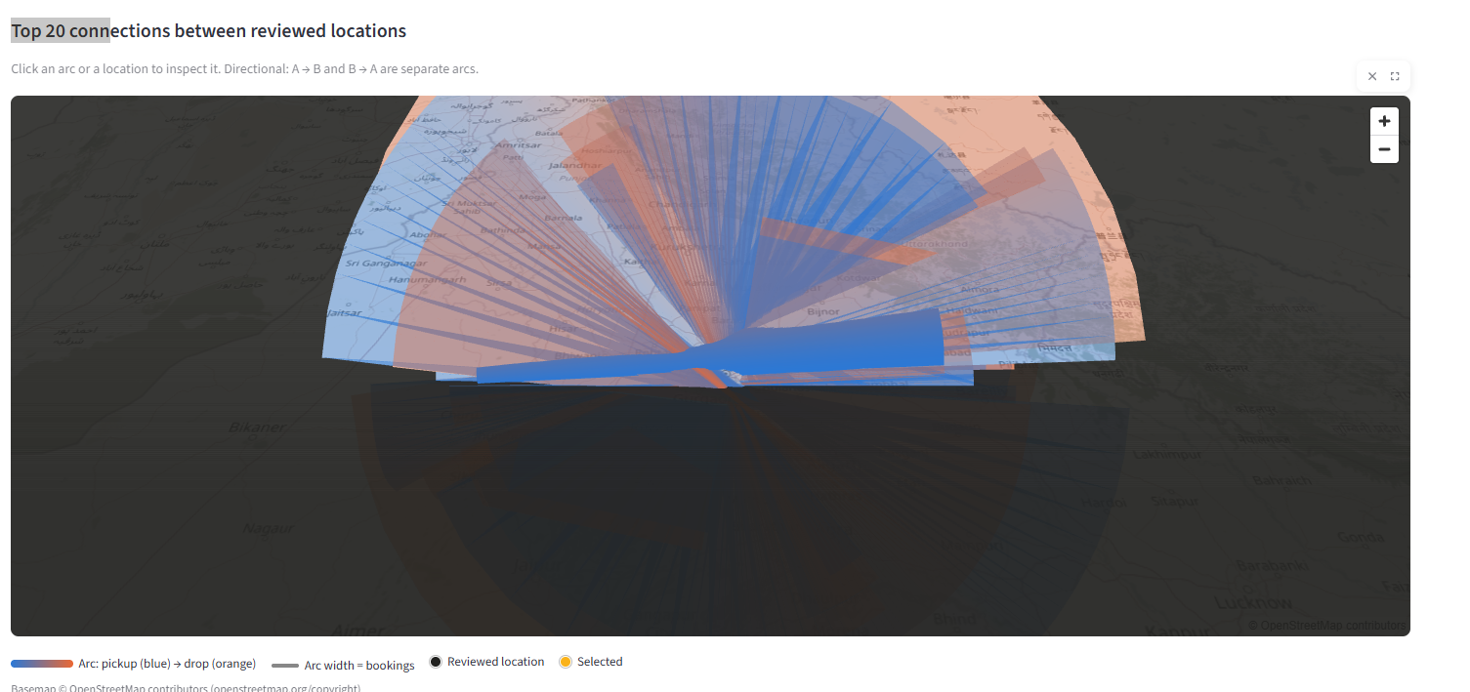
Figure 4. The rendering bug: basemap correct, but arc widths and point sizes were sent as broken expressions. Fixed and covered by a test.

11. Testing and verification
Test file | Tests | What it covers
test_preprocessing.py | 17 | ID normalization, repeated IDs kept, missing values, parse failures, status rules, reload consistency, stale-data and raw-file protection
test_lookup.py | 18 | Lookup template, preserved reviews, duplicate-key rejection, coordinate validation, safe joins, per-layer coverage
test_metrics.py | 23 | Denominators, N/A rules, payment mix, calendar normalization, Monday–Sunday order, trends, directional flows, reliability
test_maps.py | 22 | Top-N and unmapped accounting, drill-down, view fitting, click parsing, OSM-only basemap, map-setting regression
test_charts.py | 11 | Formatting, fixed colours, masked heatmap cells, empty inputs
test_real_data.py | 5 | Raw file unchanged, every record kept, audit regression on the fingerprinted file
test_app.py | 15 | Headless run of the real app: KPIs match the audit, filters update all tabs, reset, empty results, map content and drill-down
Total | 111 | All passing; Ruff lint and format clean

- Tests that test the tests: three rules were broken on purpose in a scratch copy (counting “No Driver Found” as a cancellation, zero-filling missing numbers, using the wrong weekday denominator). The suite caught all three (1, 19 and 3 failing tests).
- Audit regression: every figure in the prior audit — outcome counts, weekday averages, vehicle and payment counts, top locations, booking value — matched the local file exactly.
- Browser checks: done by the author. Screenshots exposed two real problems that headless tests could not (Figures 3 and 4); after the fixes the author confirmed the finished app works.

12. How to run
Requirements: uv and internet access (for package installation and map tiles). From the project folder:
uv sync
uv run python preprocessing.py --input ncr_ride_bookings.csv
uv run python -m pytest -q
uv run ruff check .
uv run streamlit run app.py

- Place ncr_ride_bookings.csv in the project folder first; it is excluded from git until redistribution rights are confirmed.
- Re-run the preparation step whenever the CSV or the location lookup changes — the app refuses outdated data and shows the command to run.
- Restart Streamlit (Ctrl+C, then run it again) after changing .streamlit/config.toml or the Python modules.
- For a local-only demo add --server.address localhost; by default Streamlit listens on all network interfaces.

13. Limitations and future work

Limitations
- Map coverage is a pilot: 8 of 176 locations (4.7% of pickups; 0.19% of trips with both ends).
- The eight accepted coordinates were approved by instruction rather than inspected one by one.
- The data looks synthetic; provenance, licence, currency, time zone and some field meanings are unverified.
- Location pairs are sparse (17 bookings at most), so route-level rates are not reliable evidence.
- The basemap depends on internet access and OpenStreetMap's light-use tile policy.
- The app runs locally; it has not been deployed.

Future work
- Source and review coordinates for more locations, then add a zone-level overview map.
- Confirm the dataset's licence before publishing data or deploying publicly.
- Add a deterministic “Explain this view” summary for each tab.
- Record the demo video and capture final screenshots for each tab.

14. Learnings
- Fingerprint the data first. Matching the file's SHA-256 to the prior audit turned “the numbers look right” into a regression test scoped to that exact file.
- Check premises against the files. The prompt said Stage 2 was finished; a quick check showed it was not, which avoided building on missing work.
- Read the installed library, not memory. The CARTO default, the string-only map style and Pydeck's string-to-expression rule were all found by inspecting installed code.
- Headless tests are not a browser. Two of the most visible bugs were caught only by the author's screenshots, so the human check remained essential.
- Honest empty states beat fake data. A clear “map not available” banner kept the app truthful until real coordinates existed.
- Small approval gates keep AI work on track. Phase-by-phase approval and a running log made every change reviewable.

Appendix A. Screenshots of the final app
Insert screenshot: Executive Overview tab — KPI cards, outcomes and trends
Insert screenshot: Rider & Demand tab — weekday × hour heatmap
Insert screenshot: Trip Explorer — connection map with a selected location
Insert screenshot: sidebar filters applied, showing the active-filter line
Demo video (five minutes or less): add link
GitHub repository: add link

Appendix B. Project files
Path | Purpose
app.py · preprocessing.py · metrics.py · maps.py · charts.py | Application and data code
static/osm_basemap_style.json · .streamlit/config.toml | Basemap style and Streamlit settings
tests/ (7 files) · tests/baselines/ | Automated tests and the audit baseline
data/reference/location_lookup.csv · coordinate_evidence/ | Location lookup and raw lookup evidence
data/processed/ (git-ignored) | Prepared bookings and fingerprints
reports/data_quality_report.json · .md | Data quality reports
docs/DEVLOG.md · DATA_DICTIONARY.md · COORDINATE_REVIEW.md · PRIOR_DATA_AUDIT.md | Development log, field and metric definitions, coordinate review record, prior audit
CLAUDE.md · PROJECT_BRIEF.md · BUILD_PROMPTS.md · Readme.md | Project rules, brief, staged prompts, setup guide
pyproject.toml · uv.lock · .python-version | Dependencies and Python version

Appendix C. Source fingerprint
ncr_ride_bookings.csv SHA-256:
545118f78c629cf8495770a2c16f839a5a3fbcbd0af7982c98309d5dc6db72e7

