UI Description
  - A guided tour of the Competitor Analysis Agent, screen by screen
Week 3 Project 3A, Maven Mastering Agentic AI | Sample company: Cursor | Screenshots are from a live run

🎯 The UI in one minute
The app is one web page, built with Streamlit. You type a company name. An agent team finds its three top competitors, researches each one, and writes a briefing with sources.
The page stops twice and waits for you. The first stop is before any research starts: you confirm the list of competitors. The second stop is before anything is saved: you read the briefing and approve it, ask for changes, or throw it away. Everything between those two stops runs on its own, and you can watch it.
💡 Why have a UI at all?
An agent that researches the web can be wrong. The UI is where a person stays in charge. The two stops are not pop-ups added afterwards. They are real pauses in the agent's workflow, so the agent cannot carry on without your answer.

At a glance
Item | Detail
Start it | uv run streamlit run app.py, then open http://localhost:8501
Two modes | 🎭 Stub mode: fake data, no keys, no cost. 🌐 Live mode: real Tavily searches, Claude and Nebius. The sidebar shows which one is on.
Typical live run | For Cursor: 17 search calls, one retry round, about one minute of research (53 to 85 seconds across the runs we timed), plus a few seconds for the competitor list and the writing.
Where the file goes | A Markdown file in the briefings/ folder, only after you approve.
Refresh the page? | Safe. The run id is in the web address and the progress is saved, so you land on the same screen.

🗺️ The layout
The page has two parts. A sidebar on the left is always there. The main area on the right changes depending on where the run is. The screenshot below is Checkpoint 2, with every control numbered.
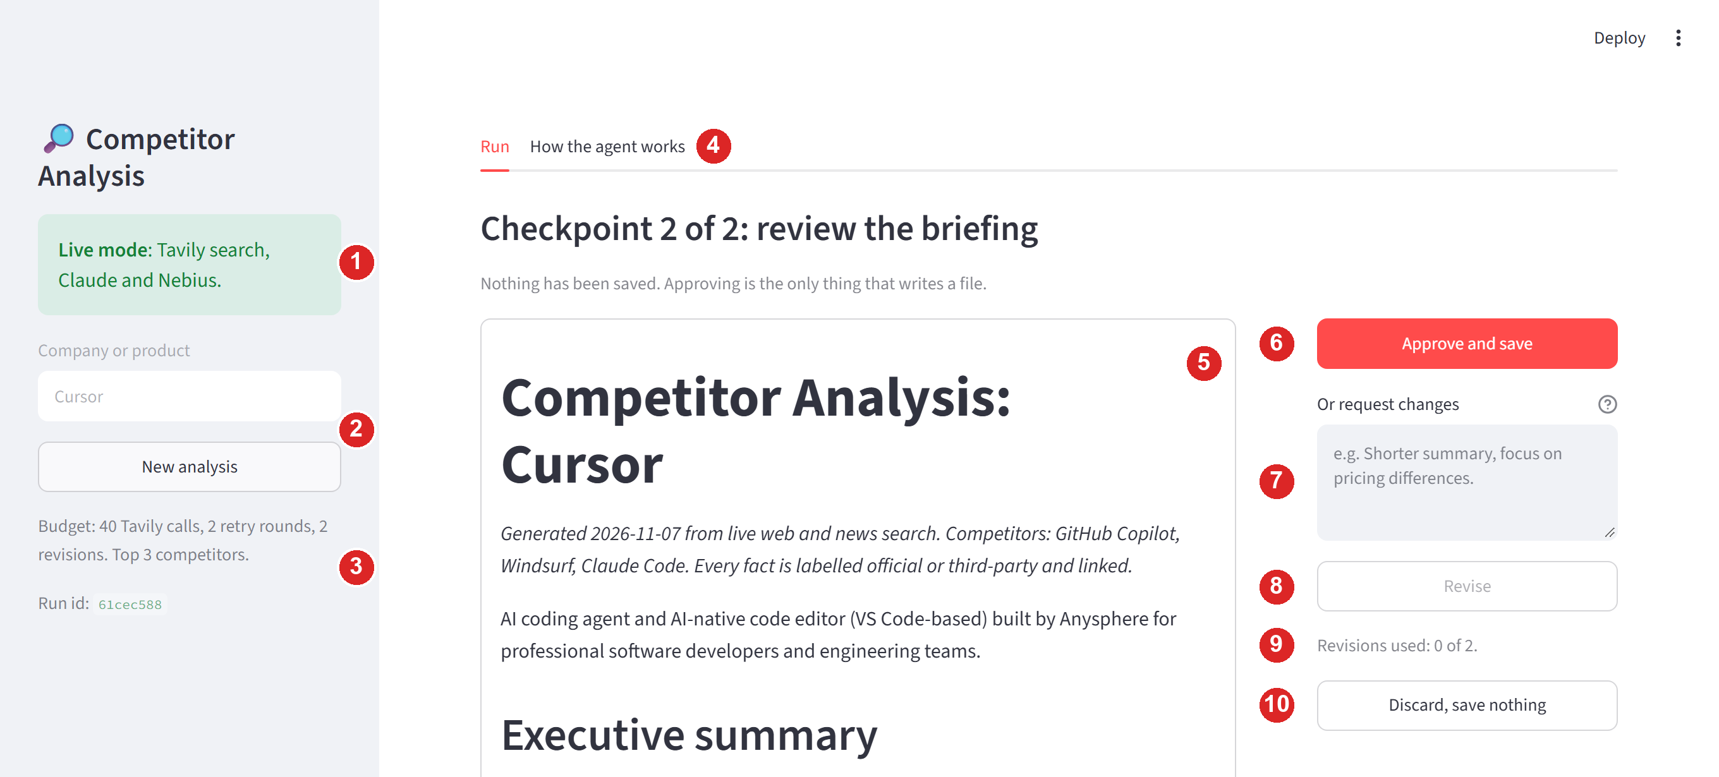
Figure 1. The whole page at Checkpoint 2, with numbered controls (live run, company: Cursor).
# | What it is | What it does
1 | Mode box | Green says Live mode (real searches). Yellow says Stub mode (fake data). To switch, change USE_STUBS in the .env file and restart.
2 | Company box and New analysis | Where you type the company before a run. It is locked while a run is in progress. New analysis starts a fresh run with a new run id.
3 | Budget and run id | The limits for each run: 40 search calls, 2 retry rounds, 2 revisions, top 3 competitors. The run id identifies this run in the web address.
4 | Tabs | Run is the working screen. How the agent works explains the agent in the course's nine-field format.
5 | Briefing panel | The full briefing, as it will be saved. Read-only: you change it by asking for a revision.
6 | Approve and save | The only button that writes a file.
7 | Request changes box | Type what you want different, for example “Shorter summary, focus on pricing differences”.
8 | Revise | Sends your request to the writer. Greyed out until you type something, and after 2 revisions.
9 | Revision counter | How many of the 2 allowed revisions you have used.
10 | Discard, save nothing | Ends the run without saving a file.

🔄 The journey: who does what
You make two decisions. The agent team does the rest. The dashed arrow is the agent checking its own work and searching again for anything that is missing.
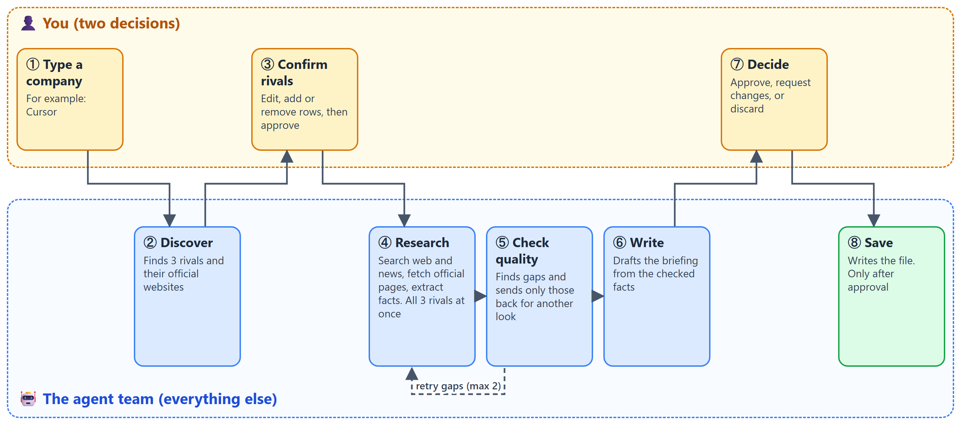
Figure 2. Eight steps. The top lane is you, the bottom lane is the agent team.
The page itself is a small set of screens. Each button moves you from one screen to the next, as shown below.
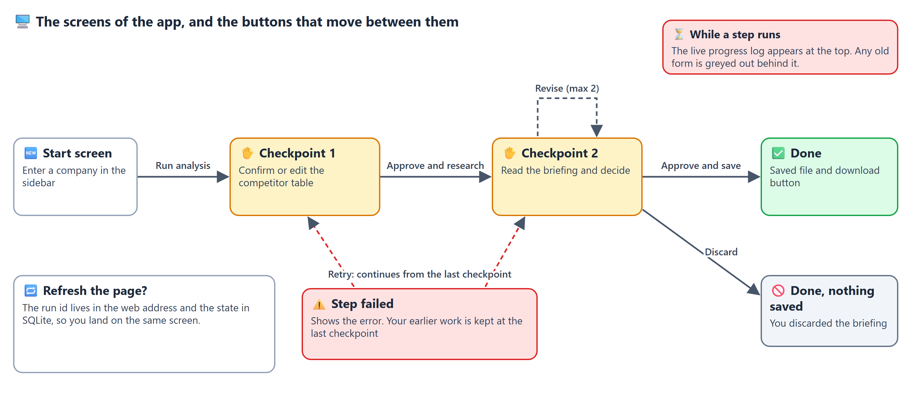
Figure 3. The screens of the app and the buttons that move between them.

🖥️ Screen by screen

1. Start screen 🆕
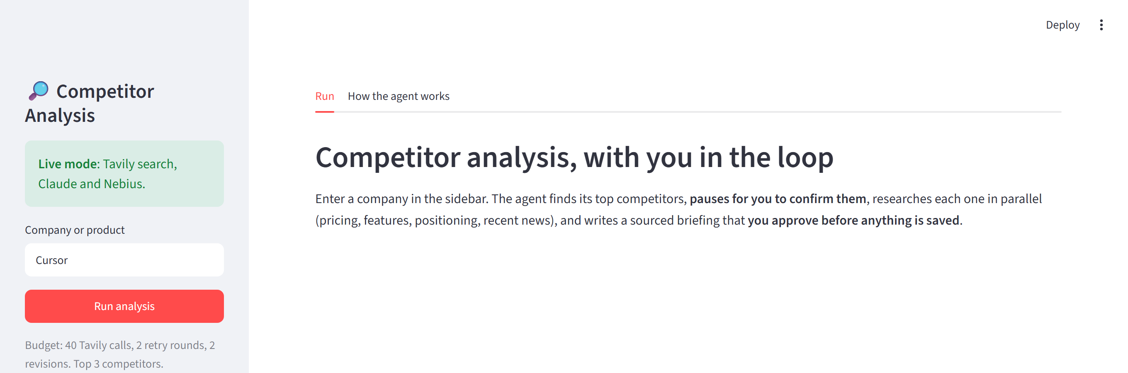
Figure 4. The start screen. Type a company in the sidebar and press Run analysis.
- What you see: a short explanation and, in the sidebar, the company box with Run analysis.
- What you do: type a company or product name (up to 80 characters) and press Run analysis. The button stays disabled while the box is empty.
- What happens next: the agent searches the web twice and asks Claude to name the three best competitors. This takes about ten seconds.

2. The progress view ⏳
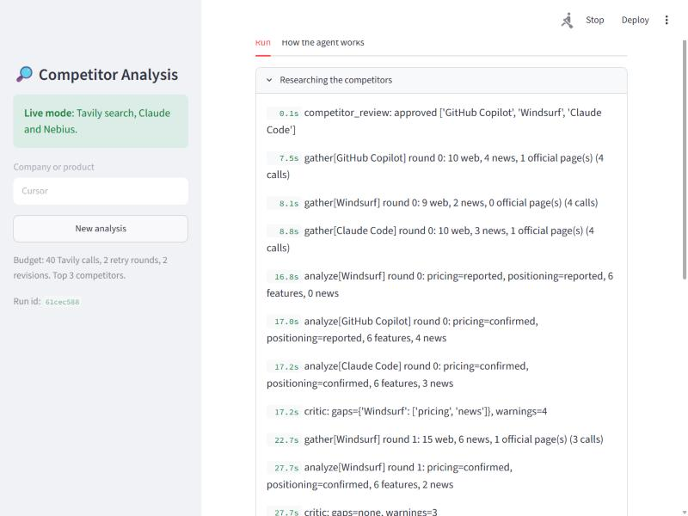
Figure 5. While a step runs, each finished step appears with a timestamp (live run).
While the agent works, a box at the top lists every finished step with the time it finished. These are plain sentences, not code. Here is how to read the lines in Figure 5:
Line | What it means
competitor_review: approved [...] | Your Checkpoint 1 answer was received.
gather[Windsurf] round 0: 9 web, 2 news, 0 official page(s) (4 calls) | The Gather worker for Windsurf found 9 web results and 2 news items and made 4 search calls. It did not find an official page yet.
analyze[Claude Code] round 0: pricing=confirmed, positioning=confirmed, 6 features, 3 news | The Analyze worker pulled out the facts. “Confirmed” means the price came from the company's own website.
critic: gaps={'Windsurf': ['pricing', 'news']} | The quality check found that Windsurf's price is not confirmed and it has no recent news.
gather[Windsurf] round 1: ... | Only Windsurf is searched again, with a wider news search. This is the retry.
critic: gaps=none | Nothing is missing any more, so the writing can start.

ℹ️ About the greyed-out form
While a step runs, the previous screen can still be seen faintly behind the progress box. It is Streamlit's way of showing that the old content is out of date. You cannot use it, and it disappears when the step finishes.

3. Checkpoint 1: confirm the competitors ✋
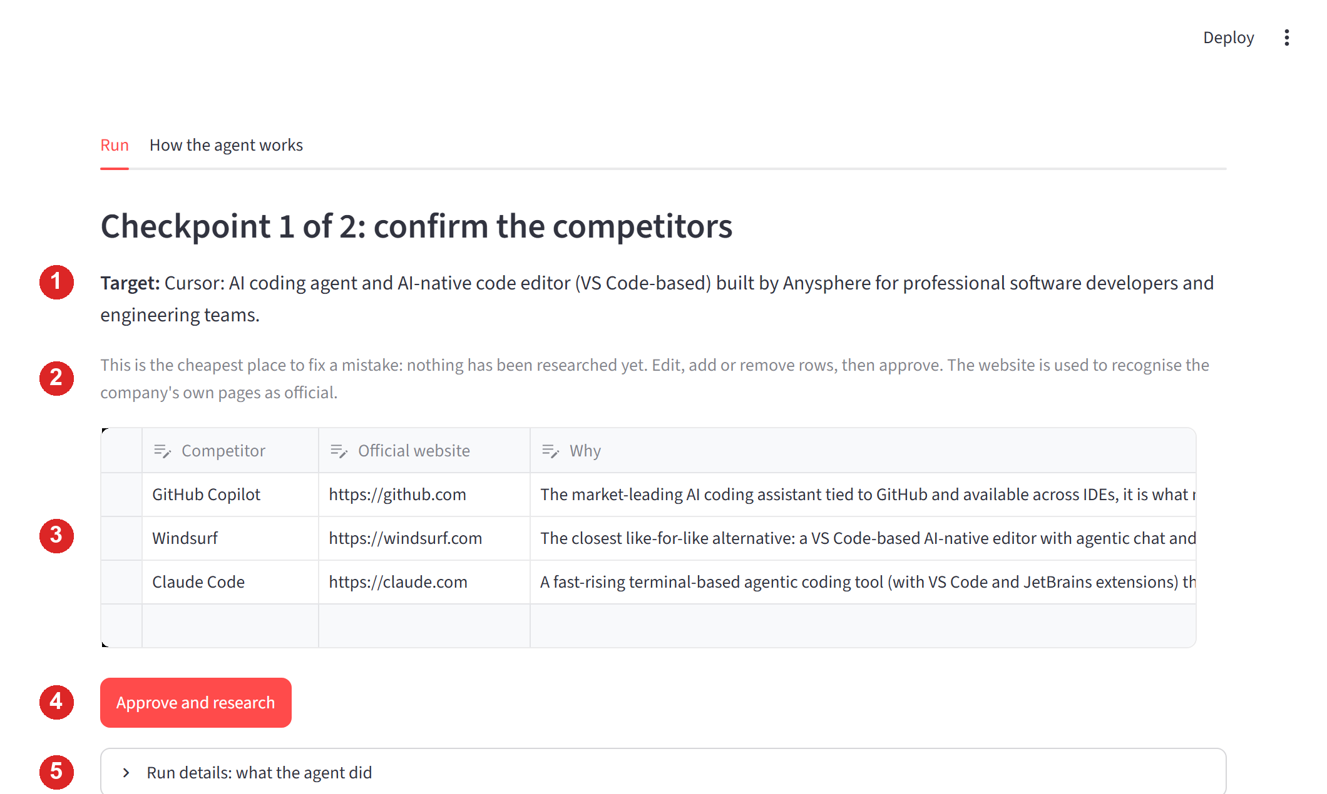
Figure 6. Checkpoint 1 with the three competitors Discovery proposed for Cursor.
# | What it is | Why it matters
1 | Target line | How the agent understood your input. For “Cursor” it says: an AI coding agent and code editor from Anysphere. If a name could mean several companies, a yellow note appears here.
2 | Explanation | This is the cheapest place to fix a mistake, because nothing has been researched yet.
3 | Competitor table | Three columns: Competitor, Official website, Why. Click any cell to edit it. Use the empty last row to add a competitor, and select a row to delete it.
4 | Approve and research | Sends your final table to the agent team. Disabled while the table has a problem.
5 | Run details | A closed box with the run's log and counters. Useful after the run.

What the table checks before it lets you continue
If you... | You will see
leave the table empty | Add at least one competitor.
add more than five | At most 5 competitors (each one costs search calls).
use the same name twice | Competitor names must be unique.
type a website without http:// or https:// | Websites must start with http:// or https://.

🔗 Why the website column matters
The agent labels a fact official only when it comes from the competitor's own website. The website you see here is how it recognises that site. Claude Code, for example, is made by Anthropic, so a rule based only on the product name would miss its official pages. The agent also verifies the website itself before it trusts it.

4. Checkpoint 2: review the briefing ✋
This screen is the one in Figure 1. The left side shows the briefing exactly as it will be saved. The right side holds your three choices.
Your choice | What happens
Approve and save | The save tool runs, the file is written to briefings/, and the screen changes to the Done screen.
Revise | The writer rewrites the briefing using only facts already collected. You return to this screen with the new version. Limit: 2 revisions.
Discard, save nothing | The run ends and no file is written.

A yellow warning appears above the briefing if some facts could not be confirmed after the retry rounds, for example “Unresolved gaps after retries: Windsurf: pricing”. It tells you where to look before you approve.

What is inside the briefing
- Title and date, and the list of competitors.
- Executive summary: a few bullets with the main findings.
- Comparison at a glance: a table with pricing, positioning and best-for for each competitor.
- What this means for the target company: short takeaways.
- Competitor profiles: for each competitor the positioning, pricing, core features, recent news and any source conflicts. Every fact shows a label (official source or third-party source) and a link.
- Data quality notes: anything the agent could not confirm.
- Sources: every link used, numbered in the order it first appears.
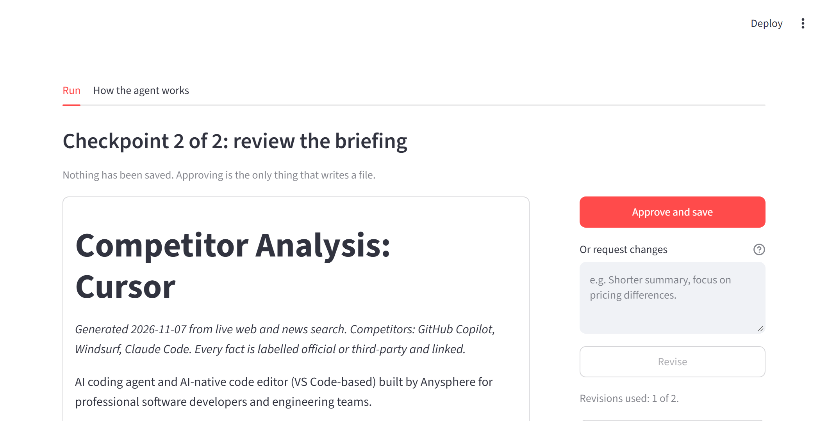
Figure 7. After one revision (“Make the executive summary shorter: three bullets, focused on pricing differences”) the summary has three bullets and no new figures.
🛡️ The revision guard
A rewrite is accepted only if it adds no new dollar figure and no new web link. If it does, the old text is kept, a note is added under it, and you are told why. In the live test above, the rewrite passed.

5. Done screen ✅
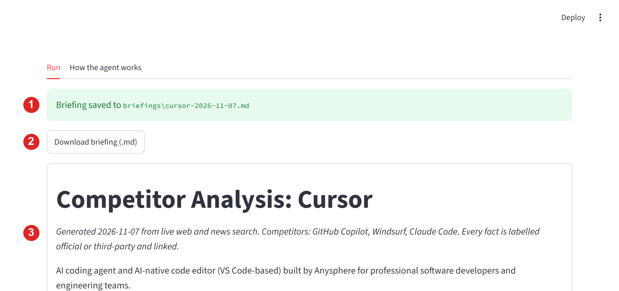
Figure 8. The Done screen after approving. The file is saved and can be downloaded.
# | What it is
1 | Green banner with the saved file path, for example briefings\cursor-2026-11-07.md.
2 | Download briefing (.md) gives you a copy through the browser.
3 | A copy of the final briefing, so you can read it once more.

If you chose Discard, the banner is replaced by a blue note: “You discarded the briefing, so nothing was saved.”
⚠️ Same company, same day
The file name is the company and the date, so saving the same company twice on one day overwrites the first file. Copy any briefing you want to keep as a sample.

6. Failed screen ⚠️
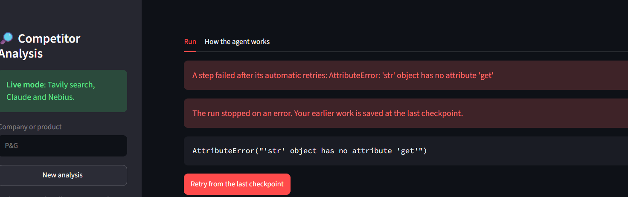
Figure 9. A failed step, captured during a P&G test before the bug behind it was fixed. It is shown here as an example of the failed screen.
- What you see: a red message with the error, and the button Retry from the last checkpoint.
- What it means: a step still failed after its automatic retries. Everything the agent had finished is saved.
- What the button does: continues from the last saved point. It does not start over and does not repeat finished work.

7. The “How the agent works” tab 📘
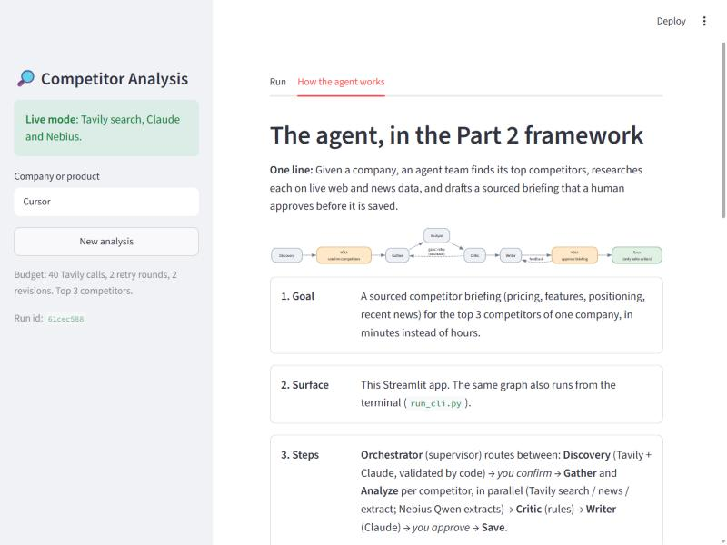
Figure 10. The second tab shows the flow and the nine fields of the agent framework.
This tab is for readers and reviewers. It shows the flow diagram and, one box per field, the agent's goal, surface, steps, tools (read versus write), memory, never-do list, human checkpoints, failure handling and success measure. The numbers in it (call budget, retry rounds, revisions) are read from the app's settings, so they always match.

🛡️ What the UI protects you from
Risk | How the UI handles it
Spending searches on a wrong competitor list | Checkpoint 1 comes first, before any research.
Saving a briefing you did not approve | Only Approve and save writes a file.
Never-ending revisions | A limit of 2, shown on the screen.
Bad input | The table refuses an empty list, duplicates, more than 5 rows and websites without http(s).
Prices that look like maths | Streamlit treats text between two dollar signs as a formula. The page escapes dollar signs when it shows the briefing, so “$10/mo to $200/mo” stays readable. The saved file is not changed.
Losing a run | Progress is saved after every step. Refresh the page or use the Retry button and you continue where you were.
A step that fails | The error is shown in plain words with a Retry button, and finished work is kept.

🚧 Known limits of the UI
- Switching modes needs a restart. The mode is read from .env when the app starts.
- The briefing is read-only. You change it by asking for a revision, not by typing in it.
- A revision takes about 45 seconds in live mode, because the writer rewrites the whole briefing.
- No run history list. A past run can be reopened only through its web address.
- No button to simulate a failure. The Failed screen appears only when a real step fails.
- The first page load is slow (10 to 15 seconds) because the libraries load once.
- Fallback table cells end with “…”. When the writer's own table cell is rejected by the dollar-figure check, the cell shows the real price text, shortened at a plan boundary.
- Software-style pricing is assumed. A consumer-goods company such as P&G has no pricing page, so its pricing shows as “not found”.

📖 Appendix: every button and message
Label or message | Where | Meaning
Run analysis | Sidebar | Starts a run for the company in the box.
New analysis | Sidebar | Opens a fresh run with a new run id.
Approve and research | Checkpoint 1 | Confirms the competitor table and starts the research.
Approve and save | Checkpoint 2 | Writes the briefing to a file.
Revise | Checkpoint 2 | Rewrites the briefing using your feedback (max 2).
Discard, save nothing | Checkpoint 2 | Ends the run without a file.
Download briefing (.md) | Done | Downloads the saved briefing.
Retry from the last checkpoint | Failed | Continues the run from its last saved point.
Stub mode / Live mode | Sidebar | Fake data or real searches.
Unresolved gaps after retries | Checkpoint 2 | Some facts could not be confirmed. Details are in the Data quality notes.
Revision not applied | In the briefing | The rewrite added a new figure or link, so the old text was kept.
No official website proposed for ... | Checkpoint 1 note | Discovery gave no website for that competitor, so official-page detection uses the name only.
Name ambiguity: ... | Checkpoint 1 note | The company name could mean more than one company. Check the target line.

