Project Explanation
  - What the Competitor Analysis Agent does, how it is built, and what we learned
Week 3 Project 3A, Maven Mastering Agentic AI | Code track: LangChain + LangGraph | Sample company: Cursor

🎯 The project in one page
The problem. Someone asks, “How do our three closest competitors price their product, and what happened to them this week?” Answering takes hours of searching, and the sources often disagree.
The idea in one sentence. Give the agent a company name. A team of agents finds its top three competitors, researches each one on live web and news data, and writes a sourced briefing. A person approves the competitor list before the research and the briefing before it is saved.
What you get. A short briefing with an executive summary, a comparison table, a profile of each competitor and a numbered list of sources. Every fact is labelled official source or third-party source and links to where it came from. Anything the agent could not confirm is listed instead of guessed.
Item | Choice
Assignment and framework | Project 3A (competitor analysis), code track: LangChain and LangGraph. Streamlit for the user interface.
Search | Tavily: web search, news search and page extraction
Models | Claude Sonnet 5.5 (finds competitors, writes the briefing). Qwen3-235B on Nebius Token Factory (extracts the facts).
Memory | LangGraph state, saved to SQLite after every step
Sample company | Cursor (the AI code editor). Competitors found: GitHub Copilot, Windsurf, Claude Code.
Safety nets | Two human checkpoints, trust labels set by code, bounded retries, a single write tool
Tests | 101 offline tests (no network or API keys needed)

🤔 Why this is harder than it looks
Searching is easy. Deciding what to believe is the hard part. Here are two real examples from our test runs.
- Cursor's price. On 5 November 2026 the official pricing page showed Free $0, Plus $8, Premium $30 and Super $100 per month. Many blog posts still listed $20, $60 and $200 for older plan names. A summary built from the blogs would have been confidently wrong.
- Windsurf's price. Some third-party sites said the Pro plan costs $15 a month. The official page said $20. The agent has to notice the disagreement, trust the official page and say so.
So the design follows one rule: use the official page first, put a source and a date on every fact, label how far each fact can be trusted, and let plain code, not the AI, decide those labels.

📋 The agent in the course's nine-field framework
The course asks for an agent to be described in nine fields. This is ours, in plain words.
Field | Our answer
1. Goal | A sourced briefing on the top three competitors of one company (pricing, features, positioning, recent news), in minutes instead of hours.
2. Surface | A Streamlit web app. The same graph also runs from the terminal (run_cli.py).
3. Steps | Discover the competitors, you confirm them, gather evidence and extract facts for each competitor in parallel, check quality (search again for gaps), write the briefing, you approve it, save.
4. Tools: read versus write | Read: tavily_search (web), tavily_search (news), tavily_extract (full text of a page). Write: save_briefing, the only one, and it is reachable only after you approve.
5. Memory | Within one run: the LangGraph state, saved to SQLite after every step. This is what lets a failed run continue and a page refresh return to the same screen. There is no memory between runs.
6. Never do | Invent a price or a link. Call a third-party claim official. Save without approval. Go over the search budget.
7. Human in the loop | Two real pauses: before any research (confirm the competitors) and before the write (approve, revise or discard).
8. Failure handling | Retry flaky searches, skip a call that keeps failing, search again only for missing facts (max 2 rounds), keep earlier good data when a re-analysis fails, return a facts-only briefing if the writer fails, and let you retry from the last checkpoint.
9. Success measure | Targets: official pricing confirmed for most competitors, every fact has a link and a date, no dollar figure in the text that is not in the evidence, a run in a few minutes within 40 search calls. These are tracked per run. A multi-company evaluation is not built yet.

🏗️ Architecture
The agent is a LangGraph graph. In the middle sits an orchestrator (a supervisor). It looks at the step that just finished and decides what happens next, and every worker reports back to it. Each worker is tagged with what it uses: a search tool, a model, or plain code.
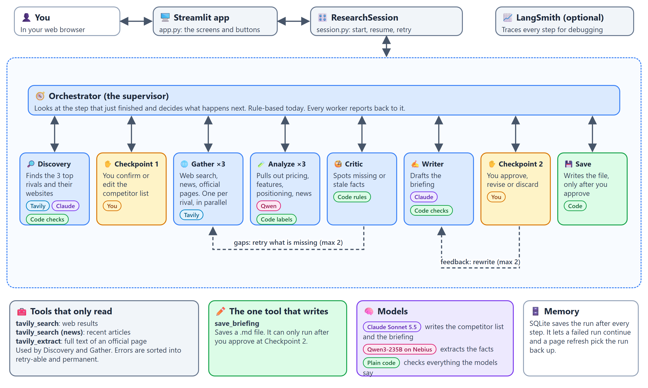
Figure 1. Architecture: the app, the session controller, the LangGraph agent team, its tools, models and memory.

Who does what
Worker | Job | Uses AI? | How it is checked
🎛️ Orchestrator | Decides the next step. Allows a retry only within the budget. | No, rules | Bounded: 2 retry rounds, 40 search calls
🔎 Discovery | Finds the 3 top competitors and their official websites. | Claude | Each name must appear in the search results, not be the company itself, not repeat, and be exactly 3. One repair attempt.
🌐 Gather ×3 | Searches web and news and fetches the official pricing page, one worker per competitor, in parallel. | No | Verifies the official website. Drops video, social and Q&A pages.
🔬 Analyze ×3 | Turns the evidence into pricing, features, positioning and news. | Qwen on Nebius | Code labels each fact official or third-party. A source that was never retrieved is removed.
🧐 Critic | Finds missing or stale facts. | No, rules | Pricing not official, fewer than 3 features, no news or news older than 60 days.
✍️ Writer | Drafts the briefing text. A revision rewrites it from your feedback. | Claude | Code writes every fact and source. Every dollar figure in the AI's text must exist in the facts.
💾 Save | Writes the file. | No | Runs only after you approve.

❓ Why a supervisor instead of a fixed chain?
A fixed chain cannot go back. Here the Critic can send only the competitors with gaps back to Gather, and your feedback can send the Writer back for a rewrite. One orchestrator that looks at the last step and picks the next one keeps those loops in a single, readable place. Today it follows rules. The spots where an AI could decide instead (retry or accept, revise or stop) are marked in the code.

❓ Why two different models?
Claude does the jobs that need judgement and good writing: choosing competitors and drafting the briefing. A Qwen model on Nebius does the high-volume extraction. The course requires at least one Nebius call, and splitting the work keeps the cost and the risk where they belong.

🚶 One run, step by step (Cursor)
You make two decisions, and the agent team does the rest.
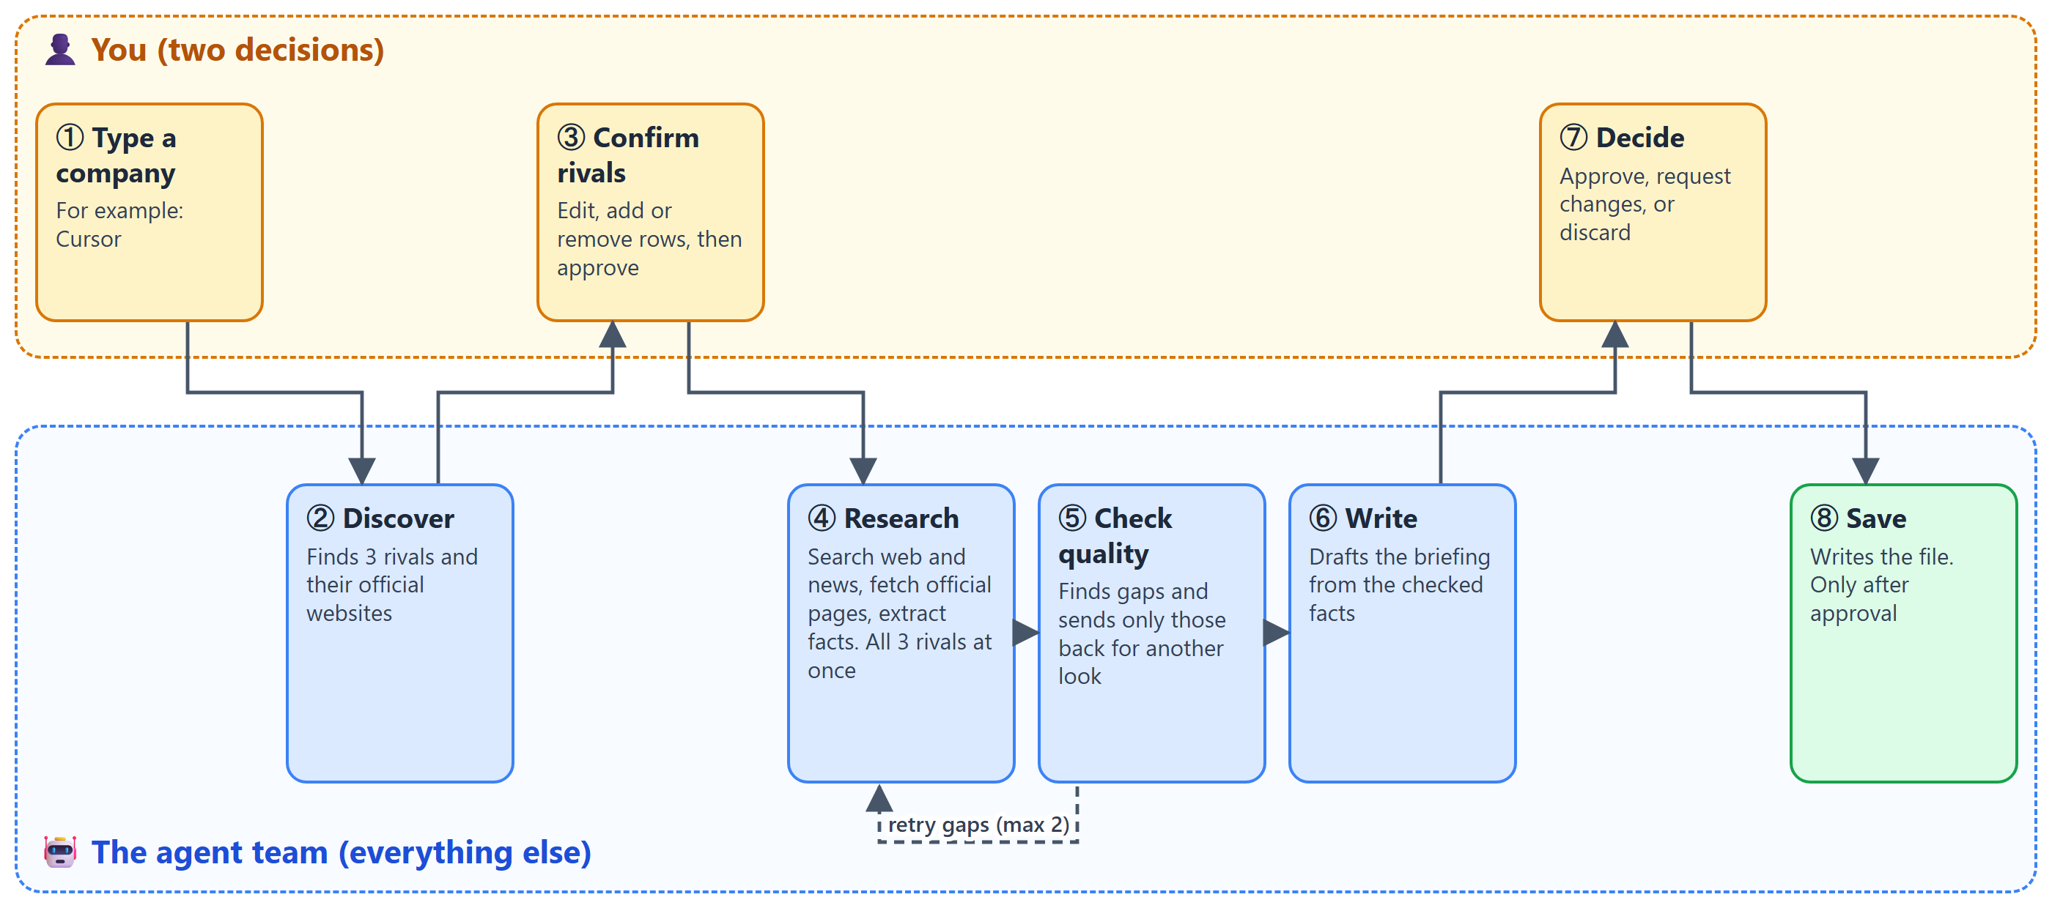
Figure 2. The eight steps. The dashed arrow is the quality check sending only the gaps back for another search.
This is what happened in a real run on Cursor (7 November 2026).
Step | What happened
1. Discover | Cursor was understood as an AI coding agent and editor from Anysphere. Three competitors were found from 10 search results: GitHub Copilot (github.com), Windsurf (windsurf.com) and Claude Code (claude.com).
2. Checkpoint 1 | The list was approved as proposed.
3. Gather, round 0 | Four search calls per competitor. GitHub Copilot: 10 web results, 4 news items, 1 official page. Windsurf: 9 web, 2 news, no official page yet. Claude Code: 10 web, 3 news, 1 official page.
4. Analyze, round 0 | GitHub Copilot and Claude Code pricing came from their own sites, so they were labelled official. Windsurf's pricing came from a third party.
5. Critic | Found two gaps, both for Windsurf: pricing not confirmed and no recent news.
6. Retry, round 1 | Only Windsurf was searched again, with a wider news search. It found windsurf.com/pricing. Pricing became official and two news items were added.
7. Critic again | No gaps left. In total the run used 17 search calls and one retry round.
8. Write | The writer drafted the briefing: summary, comparison table, takeaways, profiles, data quality notes, sources.
9. Checkpoint 2 | Feedback was “Make the executive summary shorter: three bullets, focused on pricing differences.” The rewrite was accepted. Five bullets became three.
10. Save | The approved briefing was saved as briefings/cursor-2026-11-07.md.

A piece of the finished briefing
Executive summary (after the revision)
Entry paid pricing is close: GitHub Copilot Pro is $10/mo, while Windsurf Pro is $20/mo and Claude Code Pro is $20/mo monthly or $17/mo annual (all official).
Top individual tiers diverge: Copilot Max is $100/mo, Claude Code Max starts from $100/mo, and Windsurf Max is $200/mo (all official).

One competitor profile line, as the briefing prints it
Pricing (official source, as of 2026-11-07, source link): Copilot Free $0; Copilot Student $0; Copilot Pro $10/mo; Copilot Pro+ $39/mo; Copilot Max $100/mo; Copilot Business $19/mo per seat; Copilot Enterprise $39/mo per seat

Notice the label, the date and the link on every fact. That is the product.

🏷️ How the agent decides what to trust
Every fact gets one of four labels. Plain code sets the label, by looking at the web address. The AI is never asked how sure it is.
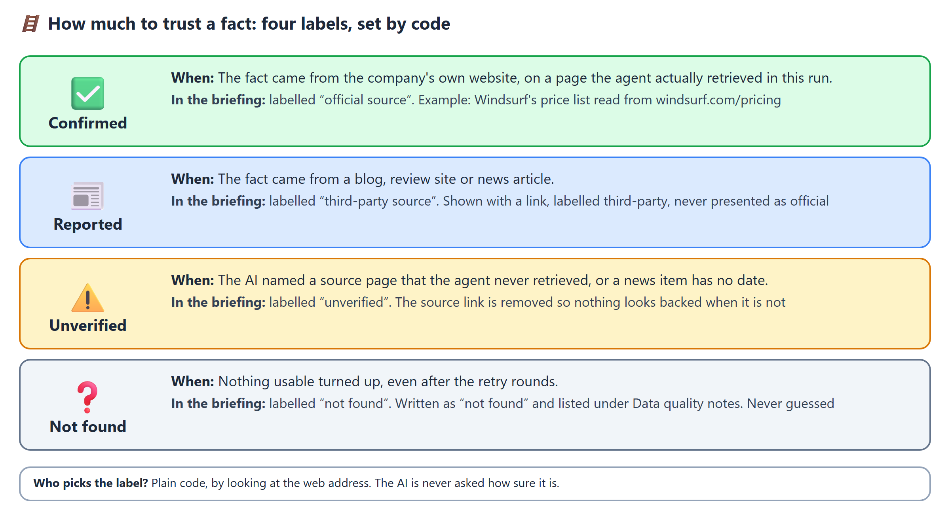
Figure 3. The four trust labels.

How it knows which website is “official”
A rule that only matches the product name fails for products made by a bigger company. Claude Code is made by Anthropic, so “claude” does not appear in every official address. The agent therefore treats the website as a claim that must be checked:
- Discovery asks the model for each competitor's official website.
- Gather accepts it only if one of the two checks passes: the competitor's own search results include a page on that domain, or fetching <website>/pricing returns a page on that domain that mentions the product.
- Only then does a page on that domain count as official. A claim that fails is not trusted and is not retried.
🔍 What we learned the hard way
Our first check required the website to appear in Discovery's evidence. It rejected all three correct answers, because that evidence is articles about Cursor and rarely mentions the competitors' own domains. A check has to be tested on the real case it is meant to fix.

🛠️ The AI proposes, plain code checks
Language models are good at reading and writing and bad at being reliable. So every AI output goes through a check written in ordinary code.
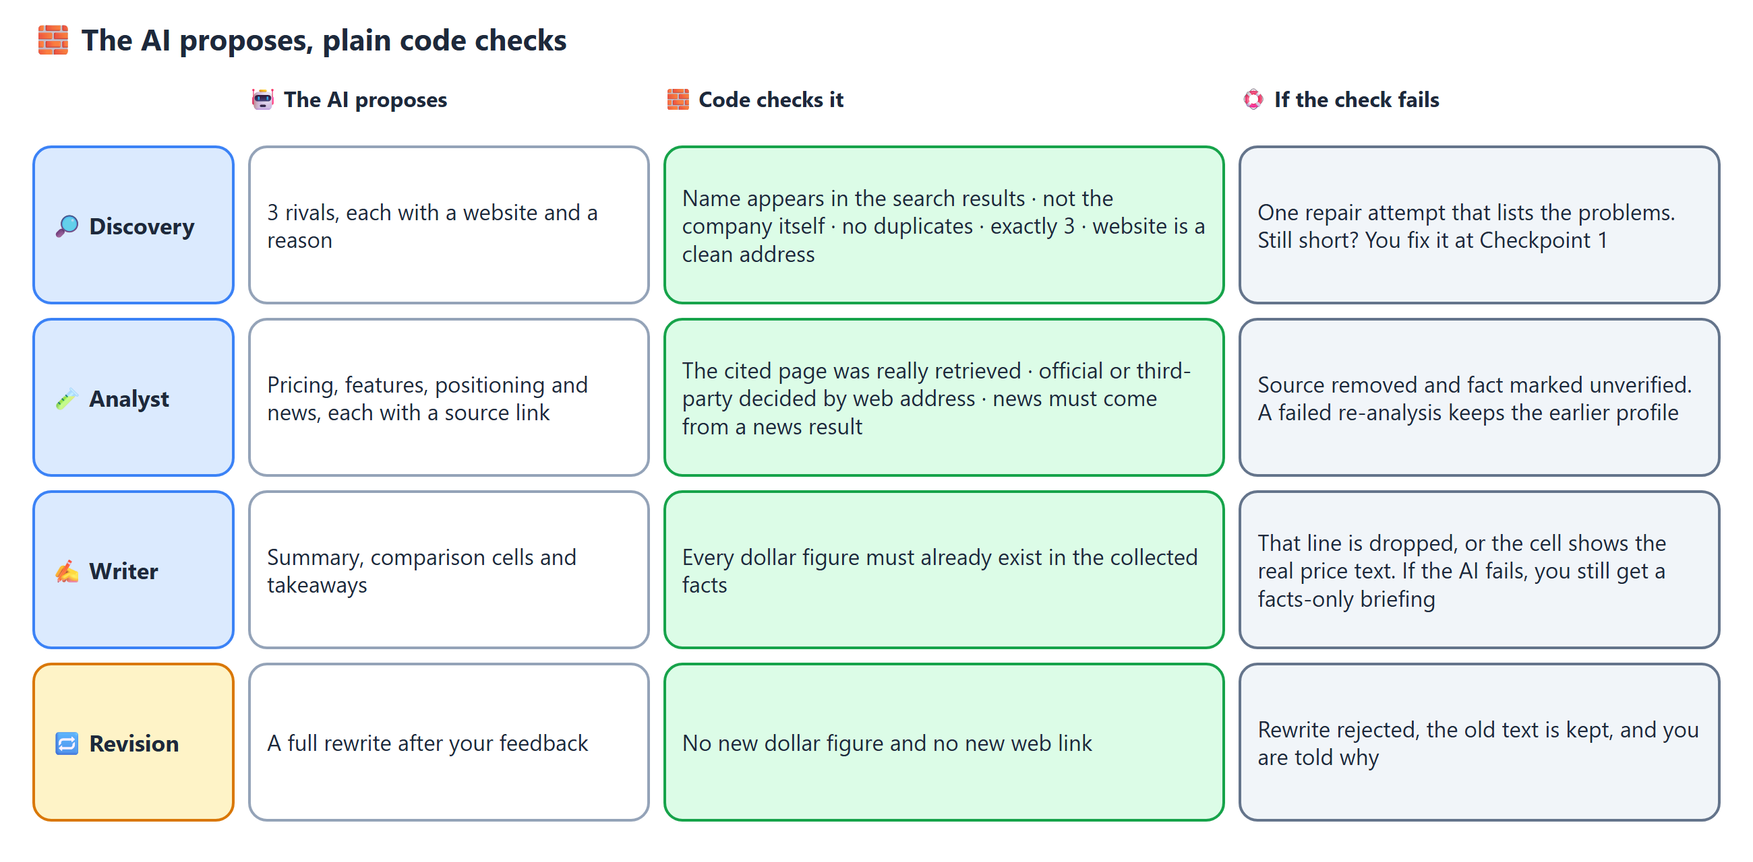
Figure 4. For each AI step: what it proposes, what the code checks, and what happens if the check fails.
The dollar-figure check deserves a special mention. A briefing about prices is only worth reading if the prices are real, so any dollar amount in the AI's summary must already exist in the collected facts. If it does not, that line is dropped.

🆘 When things go wrong
Real tools fail. The agent is built to degrade gracefully instead of crashing or guessing.
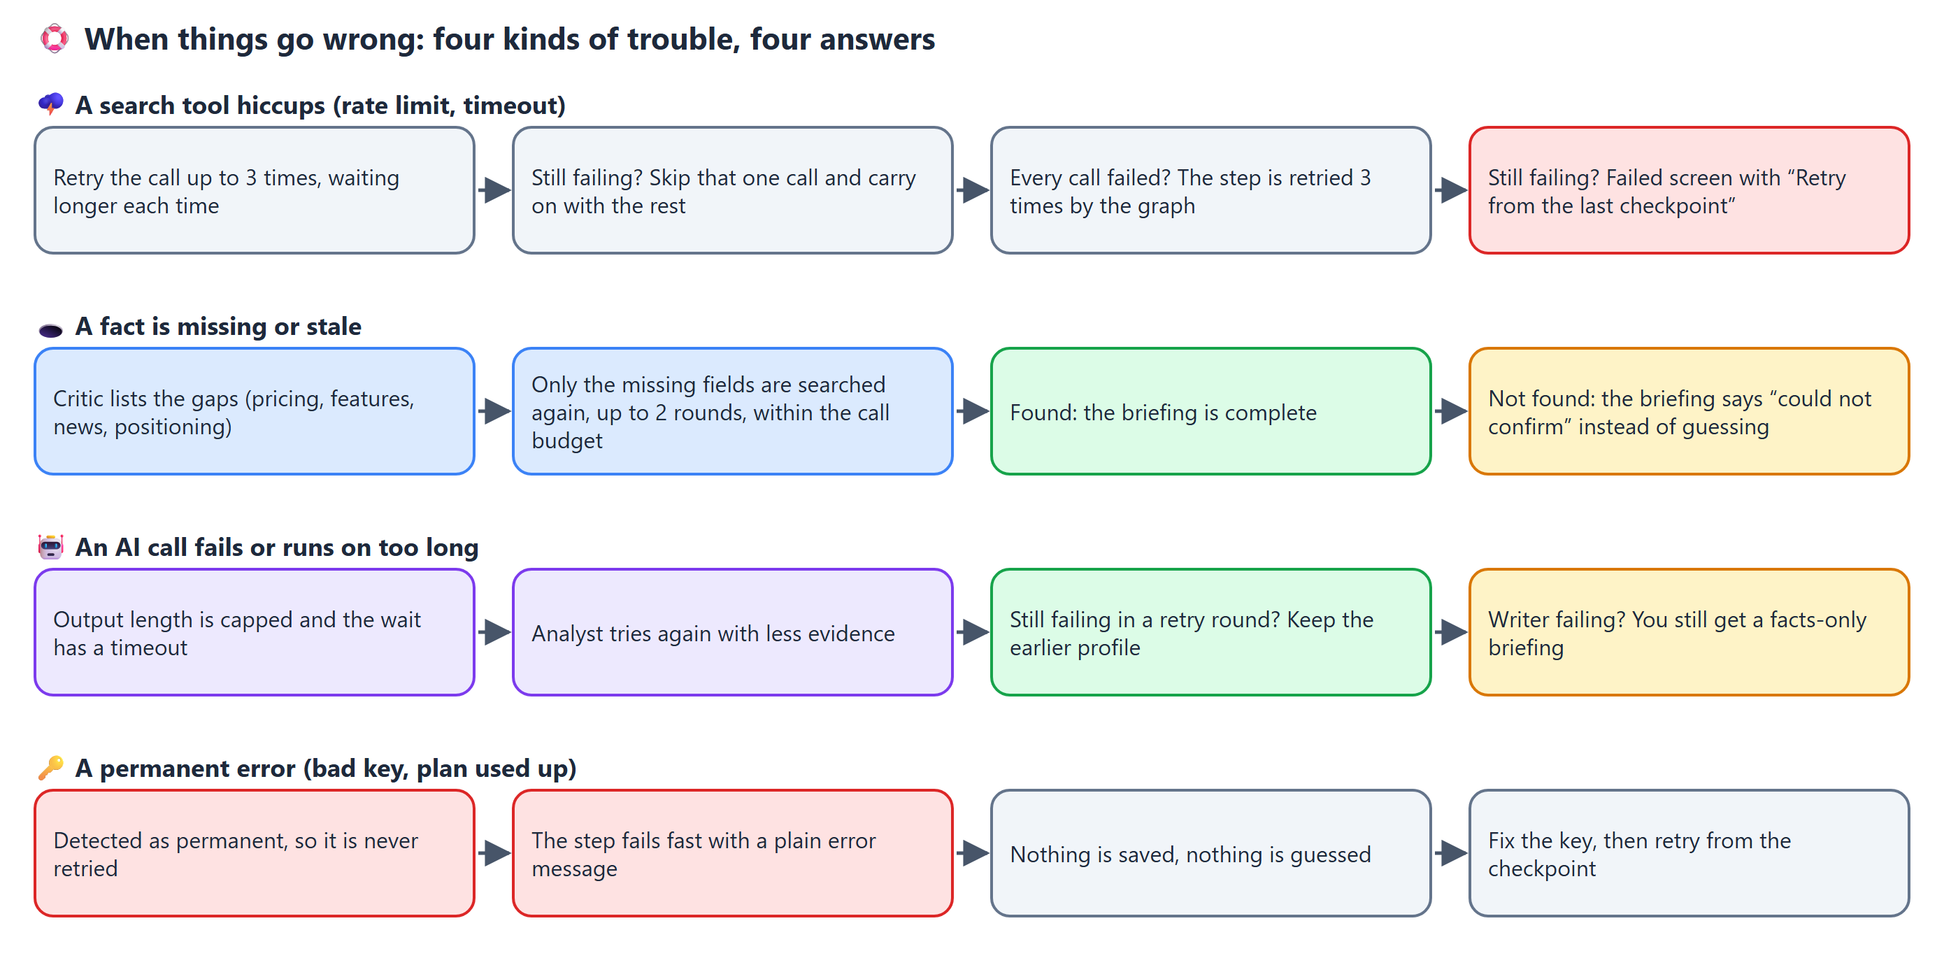
Figure 5. Four kinds of trouble and how the agent answers each.
Limit | Value | Why it exists
Retry rounds after the quality check | 2 | Stops an endless search for a fact that does not exist.
Search calls per run | 40 | Hard budget. No more retry rounds once it is reached.
Revisions after your feedback | 2 | Keeps the review step finite.
Model output length | 3,500 tokens, 120 s timeout | One uncapped call once ran for minutes (see the build story).
Evidence sent to the Analyst | Best 8 web and 6 news results | Keeps the prompt small and the answer on topic.
Attempts for one search call | 3, with waiting between them | Rate limits and timeouts usually pass on a second try.

🖥️ The user interface
The Streamlit app is a thin view over a small controller (session.py). It knows five states: new, waiting at Checkpoint 1, waiting at Checkpoint 2, failed and done. The two checkpoints are real LangGraph pauses, so the agent cannot continue without your answer. Progress lines stream while a step runs, and the run id in the web address means a refresh returns to the same screen. The separate UI Description document walks through every screen.
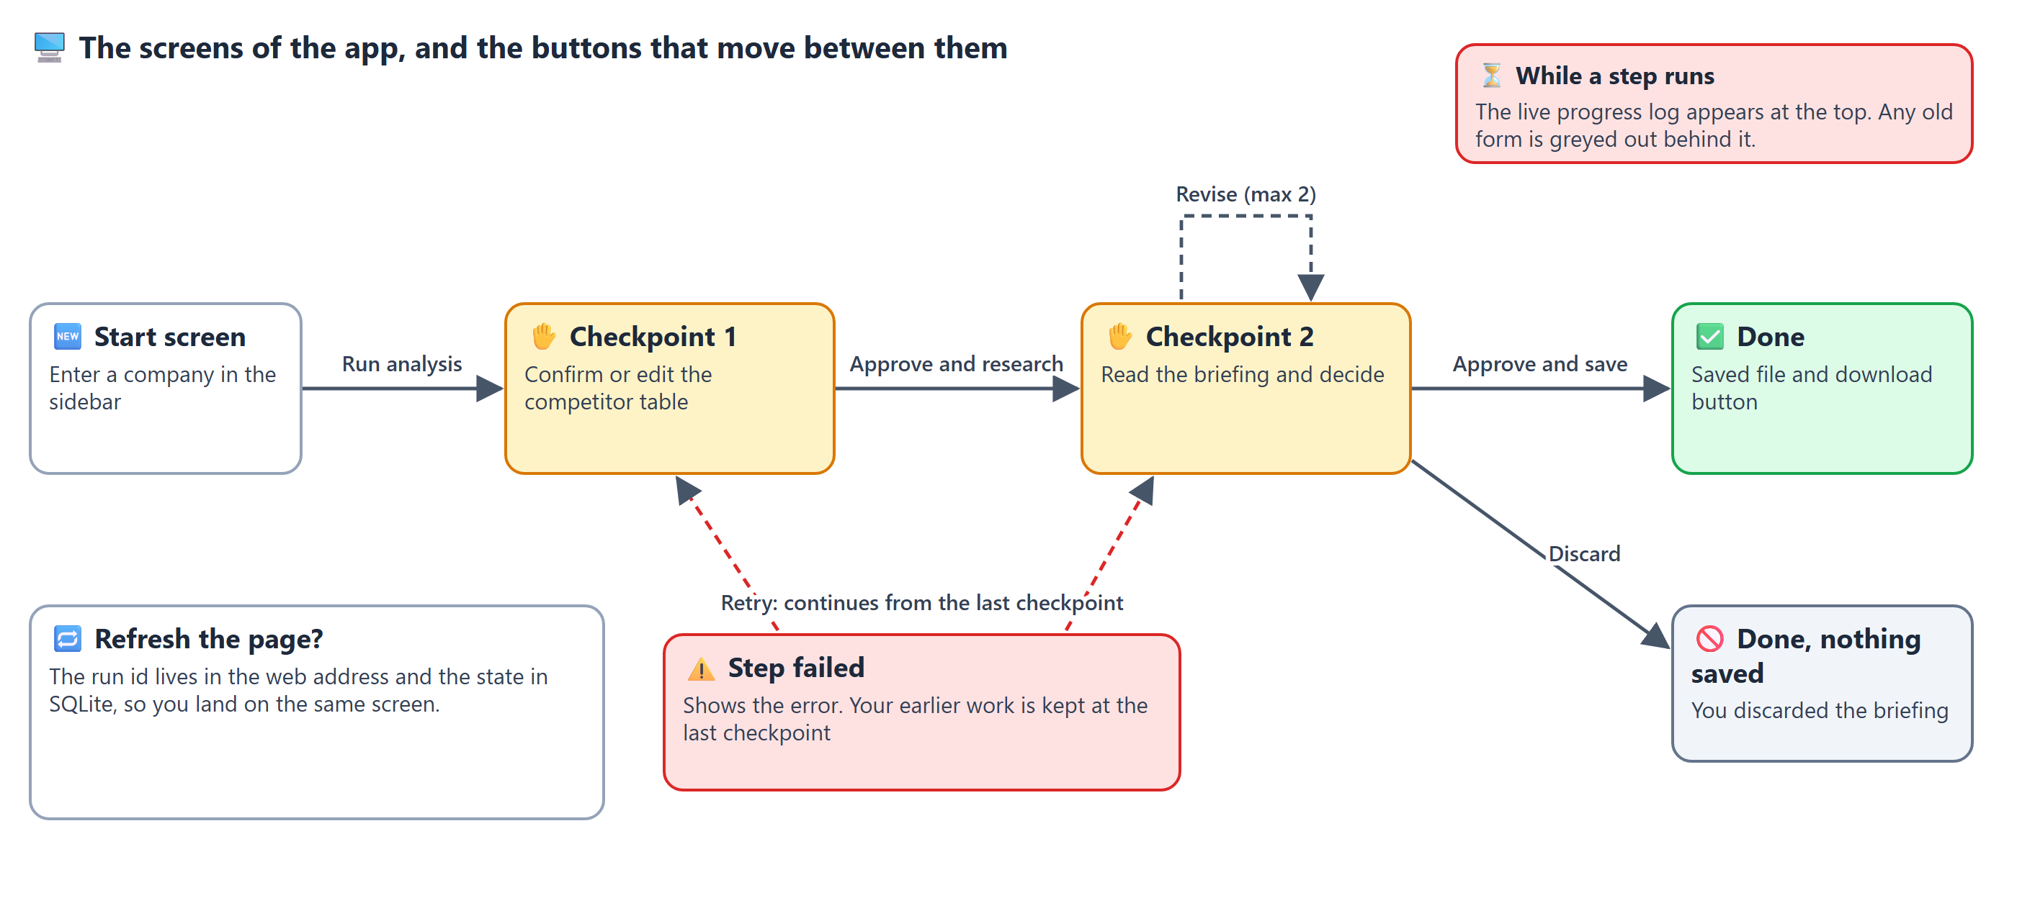
Figure 6. The screens and the buttons between them.

🔬 The build story: what went wrong and what we changed
The project was built step by step with an AI coding assistant. Each step was run against live data, and the problems that showed up are more instructive than the parts that worked first time. The full log, with the prompts, is in PROMPTS_AND_ITERATIONS.md.
# | What went wrong | What we changed
1 | The first human checkpoint never advanced. LangGraph ignores an empty answer {}. | Every answer now carries a value, such as {"approved": true}.
2 | A retry round was logged as round 0. | The round number is taken from the next retry, not the previous state.
3 | Packages were installed with plain pip out of habit. | Moved to uv with a lock file, which also fixed certificate errors.
4 | The first choice of Nebius model was not in the account's model list. | Listed the real model ids from the account and chose Qwen3-235B.
5 | Live searches failed with certificate errors (antivirus re-signs web traffic). | Python now trusts the operating system's certificate store. Tool errors are split into retry-able and permanent.
6 | Claude Sonnet 5.5 does not support forced tool calling, so structured output could silently not fire. | Switched to the native structured-output mode. A test guards it.
7 | A new test failed because we had miscounted the calls in the scenario. | The code was right and the test was wrong. We fixed the test.
8 | First full run took 602 seconds, and one competitor's finished profile was overwritten by an empty one after a failure. | Output caps and a timeout, a smaller evidence set, junk-source filtering, and a rule that failed re-analysis keeps the earlier profile.
9 | Table cells that failed the figure check had no sensible fallback. | They now fall back to the real price text, and the log names the rejected figure.
10 | Claude Code's official pricing was missed, causing two wasted retry rounds. | Discovery returns each website and Gather verifies it (see the trust section).
11 | The UI showed price ranges as garbled maths, and an old form stayed on screen during a run. | Dollar signs are escaped for display only. Steps now run before any form is drawn.
12 | P&G crashed the Gather step. The figure check also read “$0,” as a figure and dropped good lines. A fallback cell was cut mid-word. | A text result from the extract tool now means “nothing found”. The check ignores trailing punctuation. Cells are cut at a plan boundary.

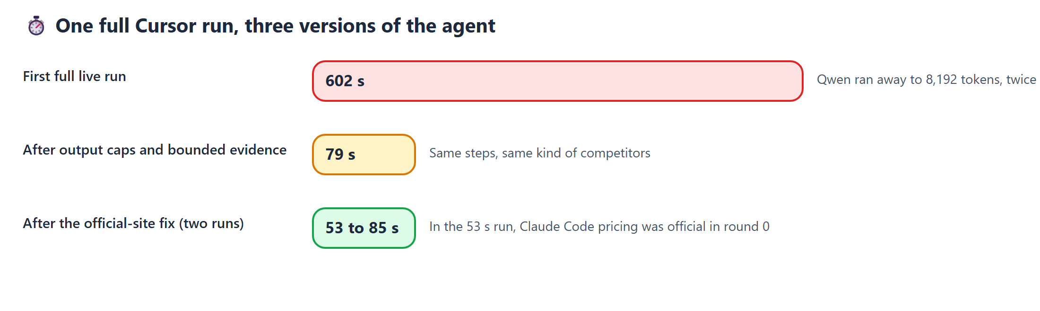
Figure 7. The same Cursor analysis across three versions of the agent.

Lessons, in plain words
- Test with real data. The garbled prices and the P&G crash never appeared with fake data.
- Cap everything a model can run on about. One unlimited call cost eight of the ten minutes.
- Never let a fallback overwrite good data. Keep the last good result.
- A check that rejects good output is also a bug. Log what it rejects and test it.
- Treat a model's claim as a candidate. The model named the right websites, but we still verify them before labelling anything official.
- SDKs return failures as values, not only as errors. Check the type of what comes back.
- Read the log lines you wrote for yourself. The odd $0, in a log line was the clue to a wrong check that had been there for days.
- Not every company has a price list. The agent assumes software-style pricing, which is a limit to state, not hide.

🚧 What is not built yet, and known limits
Limit | Detail
The orchestrator follows rules | Choosing between “retry” and “accept”, and between “revise” and “stop”, is rule-based. Those two spots are marked for AI decisions later.
No multi-company evaluation | The success measures are tracked per run. A scored test over about ten companies is not built.
The competitor list varies | Different runs on Cursor have returned Claude Code or Cline as the third competitor. Checkpoint 1 is where a person fixes that.
Name confusion in news | “Windsurf” also matches windsurfing sport news. The news query needs the product category added.
Rebranded products | Windsurf is described in some sources as now branded Devin Desktop, and its official page can land on a different domain. In one run the first check of windsurf.com/pricing did not verify and the page was found a round later.
Not a fit for every company | A consumer-goods company such as P&G has no pricing page, so pricing shows as “not found”. In a live P&G run the agent spent 23 search calls and both retry rounds looking for prices that do not exist, then said so in the briefing.
The target's own prices | The briefing does not research the target company itself, so “What this means for Cursor” cannot size a price gap.
No failure-injection switch | The failed screen appears only when a real step fails, which makes it hard to demonstrate on demand.

▶️ How to run it
You need Python 3.11 and the uv package manager. In the project folder:
- Install: uv sync (add --system-certs if an antivirus breaks certificate checks).
- Copy .env.example to .env and fill in the keys named below.
- For real research set USE_STUBS=false. Leave it true to try the app with fake data.
- Start the app: uv run streamlit run app.py, then open http://localhost:8501.
- Or run from the terminal: uv run python run_cli.py Cursor (it approves both checkpoints automatically).
- Run the tests: uv run pytest (101 offline tests).
Setting in .env | What it controls
USE_STUBS | true for fake data, false for live research
TAVILY_API_KEY | Search, news and page extraction
ANTHROPIC_API_KEY, ORCHESTRATOR_MODEL | Claude, used by Discovery and the Writer
NEBIUS_API_KEY, NEBIUS_BASE_URL, ANALYST_MODEL | The Qwen model that extracts facts
MAX_RETRIES, MAX_TAVILY_CALLS, MAX_REVISIONS, TOP_N_COMPETITORS | The limits (defaults 2, 40, 2, 3)
BRIEFINGS_DIR, CHECKPOINT_DB | Where briefings and the saved run state go
LANGSMITH_* | Optional tracing of every step

Keep API keys only in .env, which is excluded from version control.

Where things live
File | Role
app.py | The Streamlit screens and buttons
src/competitor_agent/session.py | Controller used by the UI: start, resume, retry, and the current phase
graph.py, nodes.py | The LangGraph graph, the orchestrator, the two human checkpoints
discovery.py, gather.py, analyst.py, critic.py, writer.py | One module per agent, with its checks
tools.py, llm.py, prompts.py, config.py, state.py | Tavily tools, model setup, all prompts, settings, data shapes
tests/ | 101 offline tests
PROMPTS_AND_ITERATIONS.md | The build log: prompts, iterations, learnings

📖 Glossary
Term | Meaning
Agent | A program that uses an AI model to decide and act, usually with tools.
Orchestrator (supervisor) | The part that looks at the last step and decides the next one.
LangGraph | A library for building agents as a graph of steps that share a saved state.
Checkpoint (human) | A point where the agent stops and waits for a person's answer. Technically a LangGraph “interrupt”.
Checkpointer | The saving of the run's state after every step, here in SQLite.
Tavily | A search service built for AI agents: web search, news search and page extraction.
Structured output | Asking the model to answer in a fixed shape (named fields), so code can check it.
Parallel fan-out | Running the same step for several items at once, here one worker per competitor.
Grounded | Supported by the evidence that was actually collected.
Official versus third-party | Whether a fact came from the company's own website or from someone else.
Stub mode | A mode with fake data and no API calls, used for testing.

