A Study of the Dark Side of AI: Adversarial Attacks on Deep Learning Systems and Defense Mechanisms

Gaurav Sharma , Dr.Sreevani Maddukuri
Gaurav Sharma (student), INT.Mtech CSE Spec. Cyber Security, VIT Bhopal Dr.Sreevani Maddukuri(supervisor), Dr. Hemraj .S.Lamkuche(reviewer 1),Puspinder Singh Patheja(reviewer 2), School of Computing Science Engineering and Artificial Intelligence, VIT Bhopal

ABSTRACT
Image classifiers built with convolutional neural networks often report strong accuracy on benchmark test sets, yet that score can collapse when inputs receive bounded pixel-level perturbations. In this project, a compact CNN was trained on CIFAR-10 and evaluated under the Fast Gradient Sign Method (FGSM) before and after adversarial training.
On clean test images, the baseline model reached 72.54% accuracy. FGSM at ε = 0.03 reduced attacked accuracy to 7.34%, even though the perturbed images remained visually close to the originals. A second model was then trained with FGSM-generated samples mixed into each batch. That robust variant achieved 65.15% clean accuracy and 28.38% accuracy under the same ε = 0.03 attack—substantially higher than the baseline under identical conditions.
Robustness curves across four epsilon settings, confusion matrix analysis, and side-by-side visual comparisons of clean versus perturbed inputs were used to interpret the numeric gap between the two models. The experiments show that robustness should be treated as a training-time design choice rather than assumed from high clean accuracy alone.

Introduction
Convolutional neural networks are now embedded in software used for medical imaging review, payment fraud screening, traffic monitoring, and intrusion detection. During implementation, these models rely on gradient-based optimization: each training step adjusts weights according to how sensitive the loss is to small input changes. That same gradient signal can be inverted at inference time. An attacker who can supply or query inputs may push an image along the loss gradient so the network outputs a different class while the picture still appears normal to a human observer.

Such manipulated inputs are called adversarial examples. They are not random noise artifacts; they are deliberately constructed failures. In a security-sensitive pipeline, a wrong label may pass unnoticed because the input still looks legitimate. That property makes adversarial risk relevant to cyber security work, where model outputs may gate access, trigger alerts, or influence automated decisions.
This paper documents a controlled experiment on CIFAR-10 image classification. A baseline CNN was trained and scored on clean test data. FGSM attacks were then executed at perturbation strengths ε ∈ {0.01, 0.03, 0.05, 0.10}. After measuring the drop in attacked accuracy, a second training run incorporated on-the-fly FGSM perturbations into each mini-batch. Both models were compared using accuracy tables, multi-epsilon robustness plots, confusion matrices, and stored image pairs showing prediction changes.

The primary contributions of this work are as follows:
- Development of a CNN-based image classification model using the CIFAR-10 dataset. Implementation and evaluation of FGSM adversarial attacks under multiple perturbation levels.
- Investigation of adversarial training as a defense mechanism against adversarial attacks.
- Comparative analysis of standard and robust models using quantitative and visual evaluation metrics.
- Discussion of the security implications of adversarial attacks and the importance of robust AI systems.

Literature Review
Early adversarial machine learning studies reported a puzzling inconsistency: networks that generalize well on held-out data can still assign high-confidence incorrect labels when inputs are modified within a small L∞ budget. The failure is tied to how decision boundaries are arranged in high-dimensional pixel space, not to a single coding error in one layer.
Goodfellow et al. proposed the Fast Gradient Sign Method (FGSM) as a practical one-step attack that follows the sign of the input gradient. Because FGSM requires only one forward and one backward pass per image, it is widely used in teaching labs and baseline robustness evaluations. Later work introduced stronger iterative and optimization-based attacks—such as projected gradient descent and Carlini–Wagner methods—that often break defenses tuned only for single-step perturbations. Even so, FGSM remains a standard first test of whether a model reacts sensibly to gradient-directed input shifts.

On the defense side, Madry et al. helped establish adversarial training as an empirical countermeasure: perturbed samples are generated during learning and optimized with their original labels. Reported results commonly show higher accuracy under attack alongside a modest reduction in clean-data performance. That accuracy–robustness trade-off appears repeatedly across datasets and architectures.
Parallel lines of AI security research examine poisoning of training data, model extraction through query access, membership inference on private records, and misuse of generative models. Together, these topics show that risk can appear during data collection, training, deployment, and inference. Against that background, hands-on reproduction remains useful. This study contributes an end-to-end implementation on a compact CIFAR-10 CNN, applying FGSM as the attack and adversarial training as the defense, with outcomes reported through measured accuracies, robustness curves, confusion matrices, and visual adversarial examples.

Methodology
This research investigates the vulnerability of deep learning models to adversarial attacks and evaluates the effectiveness of adversarial training as a defense mechanism. The overall methodology consists of dataset preparation, CNN model development, adversarial attack generation, adversarial training, and robustness evaluation.

Dataset
The CIFAR-10 dataset was used for all experiments. CIFAR-10 is a widely used benchmark dataset for image classification tasks and contains 60,000 color images of size 32×32 pixels distributed across 10 classes. The dataset is divided into 50,000 training images and 10,000 testing images.
The ten classes included in the dataset are:
* Airplane
* Automobile

* Bird
* Cat
* Deer
* Dog
* Frog
* Horse
* Ship
* Truck
The dataset was loaded using the PyTorch framework and transformed into tensor format before training and evaluation.

Convolutional Neural Network Architecture
A Convolutional Neural Network (CNN) was implemented as the baseline image classification model. The architecture consists of two convolutional layers followed by a max-pooling operation and two fully connected layers.
The model architecture is summarized below:
- Convolution Layer 1: 3 input channels, 32 output channels, kernel size 3×3.
- Convolution Layer 2: 32 input channels, 64 output channels, kernel size 3×3.
- Max Pooling Layer: Pool size 2×2.
- Fully Connected Layer 1: 4096 input features and 512 output features.
- Fully Connected Layer 2: 512 input features and 10 output classes.
The network was trained using the Adam optimizer with a learning rate of 0.001 and Cross Entropy Loss as the objective function.

Fast Gradient Sign Method (FGSM)
To evaluate model vulnerability, the Fast Gradient Sign Method (FGSM) was implemented. FGSM generates adversarial examples by adding perturbations in the direction of the gradient of the loss function with respect to the input image.
The perturbation is calculated as: FGSM(x) = x + ε · sign(∇x J(θ, x, y)) where:
* x represents the original image.
* ε represents the perturbation strength.

* J represents the loss function.
* θ represents model parameters.
* y represents the true label.
Multiple perturbation strengths were evaluated to analyze attack effectiveness under varying threat levels

Adversarial Training
To improve robustness against adversarial attacks, adversarial training was employed. During training, adversarial examples generated using FGSM were incorporated into the learning process.The adversarial trained model was exposed to both clean and adversarial samples, enabling the network to learn more robust feature representations and decision boundaries. Comparative experiments were performed to evaluate the effectiveness of adversarial training relative to the baseline CNN model.

Evaluation Metrics
The performance of the proposed system was evaluated using the following metrics:
- Classification Accuracy
- Adversarial Accuracy
- Multi-Epsilon Robustness Analysis
- Confusion Matrix Evaluation
- Visual Analysis of Adversarial Examples
These metrics provide both quantitative and qualitative insights into model performance, vulnerability, and robustness under adversarial conditions.

Experimental Setup
  - Development Environment
All experiments were conducted using Python and the PyTorch deep learning framework. The implementation was developed and executed in Visual Studio Code on a Windows-based system. Model training, adversarial attack generation, robustness evaluation, and result visualization were performed within a virtual Python environment.
The primary software components used in this research include:
* Python 3.x
* PyTorch
* Torchvision
* Matplotlib

* NumPy
* Scikit-learn

Dataset Configuration
The CIFAR-10 dataset was automatically downloaded using Torchvision. The dataset consists of 50,000 training images and 10,000 testing images distributed across ten object categories.
Images were converted into tensor format before being supplied to the neural network.

CNN Training Configuration
The baseline CNN model was trained using the following parameters:

Parameter | Value
Optimizer | Adam
Learning Rate | 0.001
Loss Function | Cross Entropy Loss
Batch Size | 32
Dataset | CIFAR-10
Training Images | 50,000
Testing Images | 10,000

The baseline model achieved a classification accuracy of 72.54% on the CIFAR-10 test dataset.

FGSM Attack Configuration
The Fast Gradient Sign Method (FGSM) was used to generate adversarial examples and evaluate model robustness.
The following perturbation strengths were evaluated: Epsilon Value
0.01, 0.03 ,0.05,0.10

These values were selected to observe the effect of increasing perturbation strength on classification accuracy.Adversarial Training Configuration
To improve model robustness, adversarial training was performed using FGSM-generated adversarial examples.
The final robust model was trained using:

Parameter | Value
Adversarial Attack | FGSM
Training Epsilon | 0.03
Epochs | 10
Optimizer | Adam
Learning Rate | 0.001
Loss Function | Combined Clean And Adversarial Loss

The adversarial trained model was evaluated using the same test dataset and attack configurations to enable fair comparison with the baseline CNN model.

Generated Artifacts
Several artifacts were generated during experimentation for analysis and visualization:
* Epoch Accuracy Graph
* FGSM Accuracy Comparison Graph
* Multi-Epsilon Robustness Graph
* Adversarial Example Visualization
* Robust Adversarial Example Visualization
* Confusion Matrix
These artifacts provide both numerical and visual evidence of model behavior under adversarial conditions.

Results and Discussion
  - Baseline CNN Performance
The CNN model was initially trained and evaluated on the CIFAR-10 dataset to establish a baseline performance benchmark.

The model achieved a test accuracy of:
72.54%
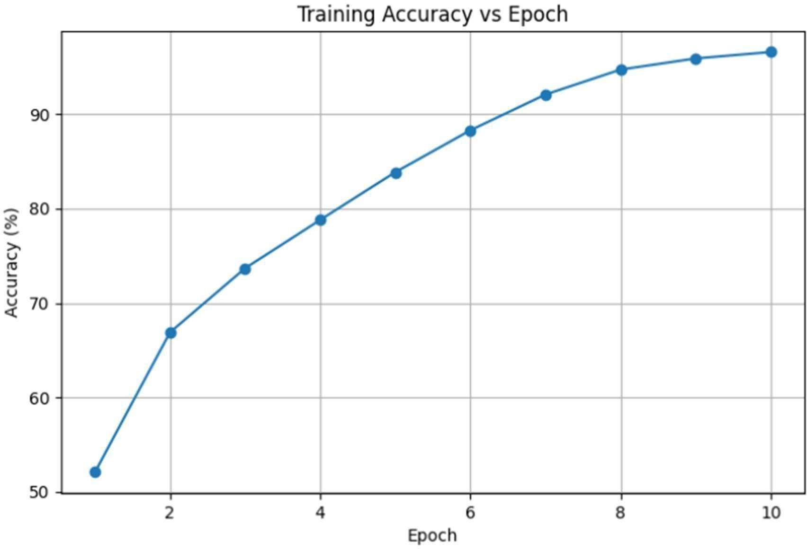
Figure 1. Training Accuracy of CNN Across Training Epochs
This result demonstrates that the CNN was capable of learning meaningful image representations from the dataset and provided a suitable baseline for adversarial attack analysis.

Impact of FGSM Adversarial Attacks
To evaluate model vulnerability, FGSM adversarial attacks were performed using multiple perturbation strengths.
The classification accuracy of the baseline CNN under adversarial conditions is shown below.

Epsilon | Accuracy(%)
0.01 | 23.13
0.03 | 7.34
0.05 | 3.35
0.10 | 1.04
The results indicate a significant degradation in classification performance as the perturbation strength increased. Even a relatively small perturbation value of 0.03 reduced model accuracy from 72.54% to 7.34%, demonstrating the vulnerability of deep learning models to adversarial

manipulation.

Adversarial Example Analysis
Visual inspection of adversarial examples revealed that the generated perturbations were difficult to distinguish from the original images. Despite minimal visual differences, the CNN frequently produced incorrect predictions.
In one experimental example:
* Original Prediction = 3
* Adversarial Prediction = 5
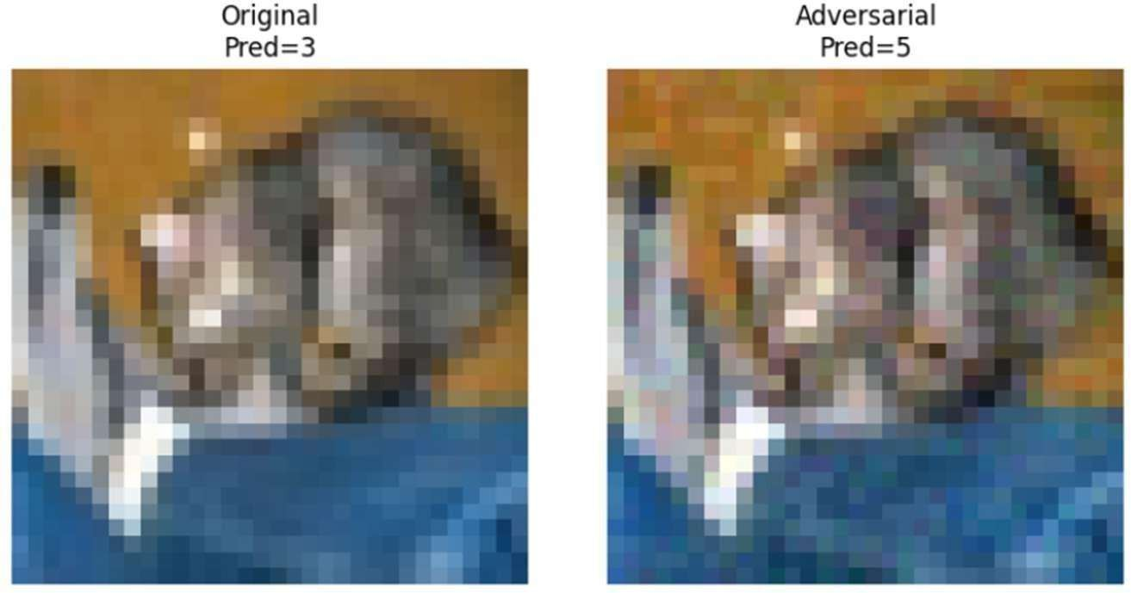
Figure 4. Successful FGSM Attack Causing Prediction Change
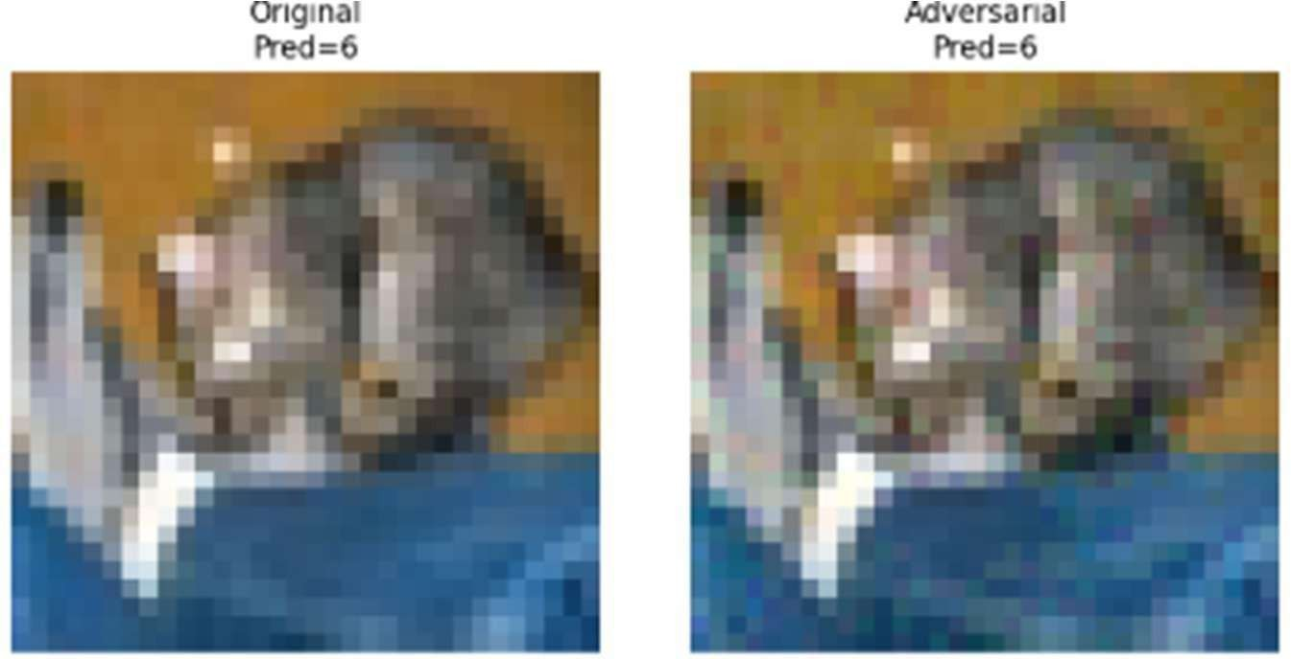
Figure 5. Robust CNN Preserving Prediction Under FGSM Attack
The results demonstrate that adversarial perturbations can successfully mislead a standard CNN model. In contrast, the adversarial trained model-maintained prediction consistency under similar perturbations, indicating improved robustness against FGSM attacks.
This observation confirms that adversarial perturbations can successfully mislead deep learning models without introducing obvious visual distortions.

Adversarial Training Performance

To improve robustness, adversarial training was implemented. The final adversarial trained model achieved:

65.15% Classification Accuracy
Although the accuracy was lower than the baseline CNN, the model demonstrated substantially improved resistance to adversarial attacks.
This result highlights the tradeoff between classification accuracy and robustness that is commonly observed in adversarial machine learning.

Robustness Evaluation of the Adversarial Trained Model
The robust model was evaluated using the same FGSM attack strengths. Table 2. Robust Model Accuracy Under FGSM Attack

Epsilon | Robust Accuracy (%)
0.01 | 49.87
0.03 | 28.38
0.05 | 16.09
0.10 | 4.63

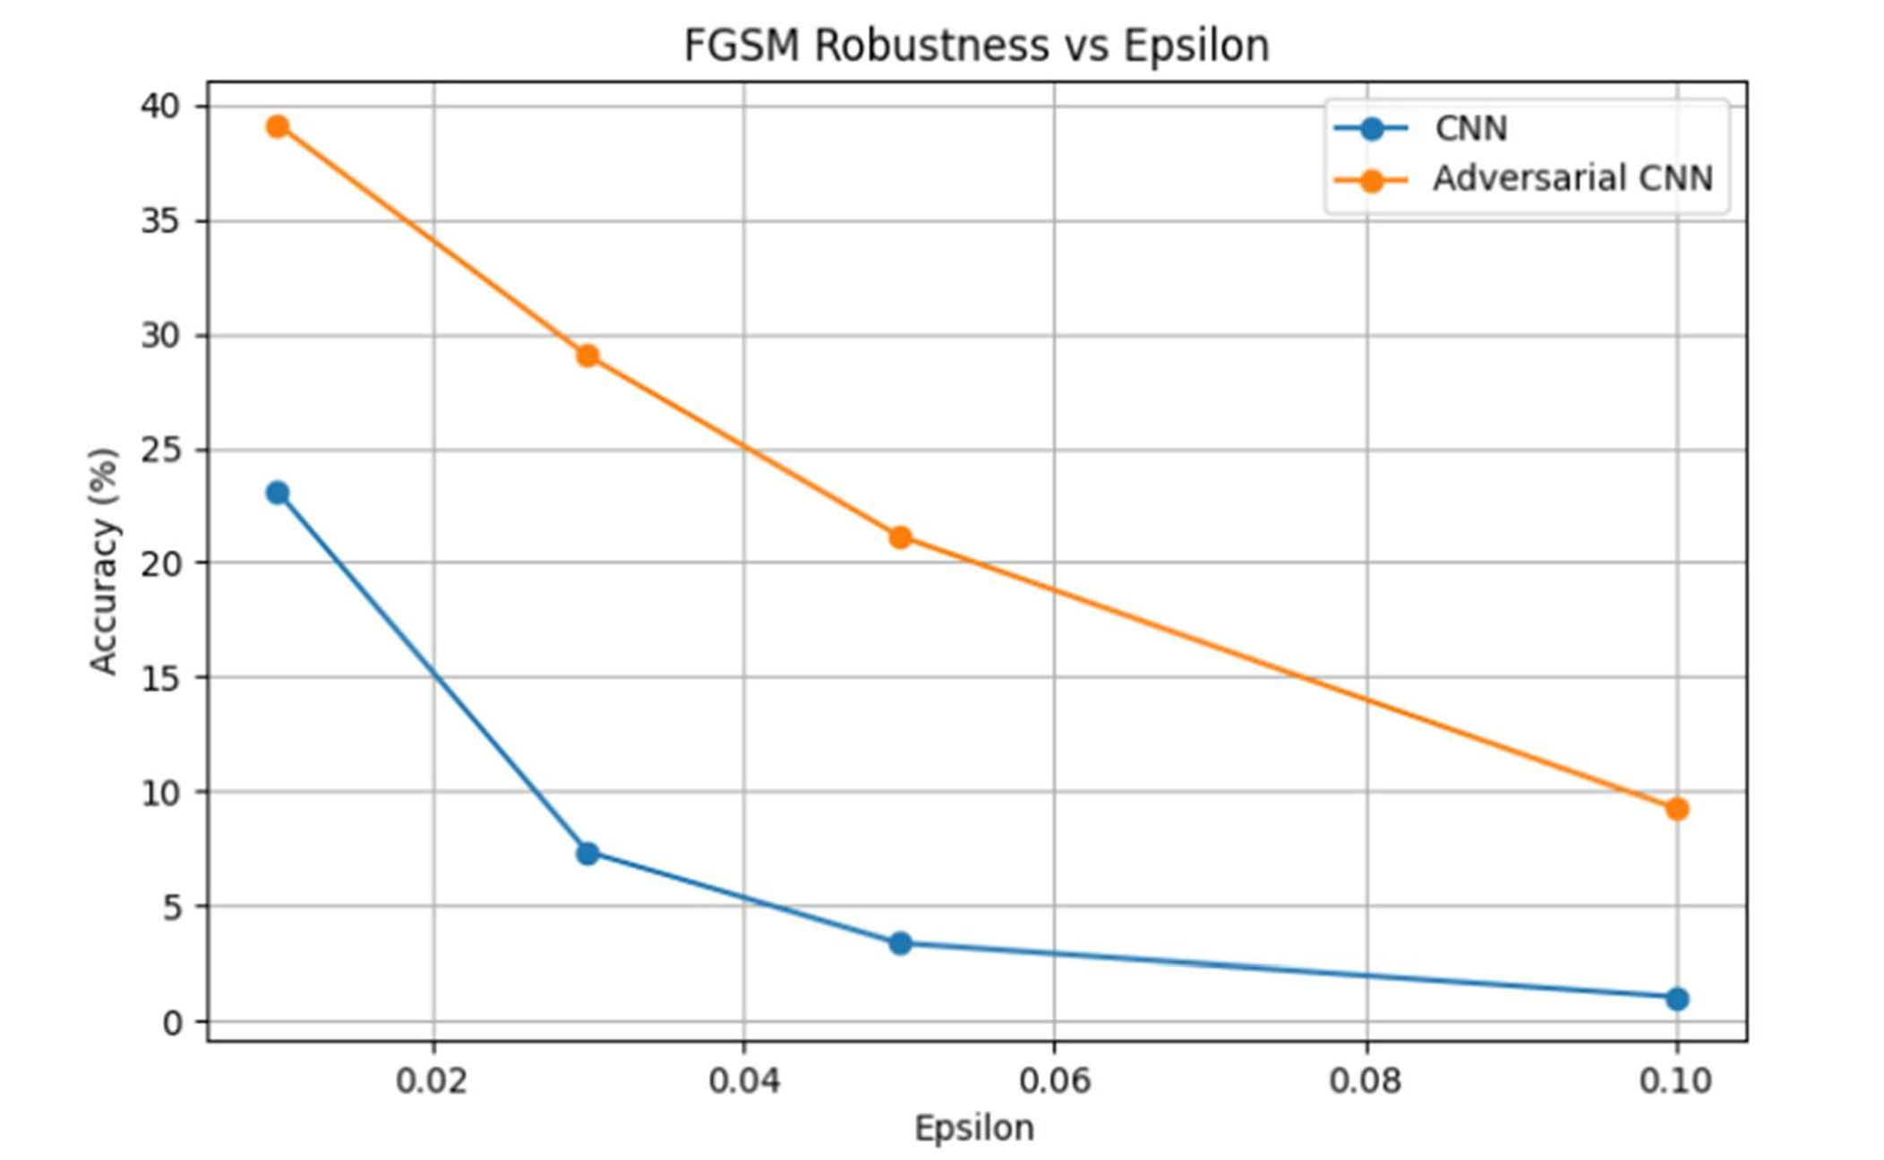
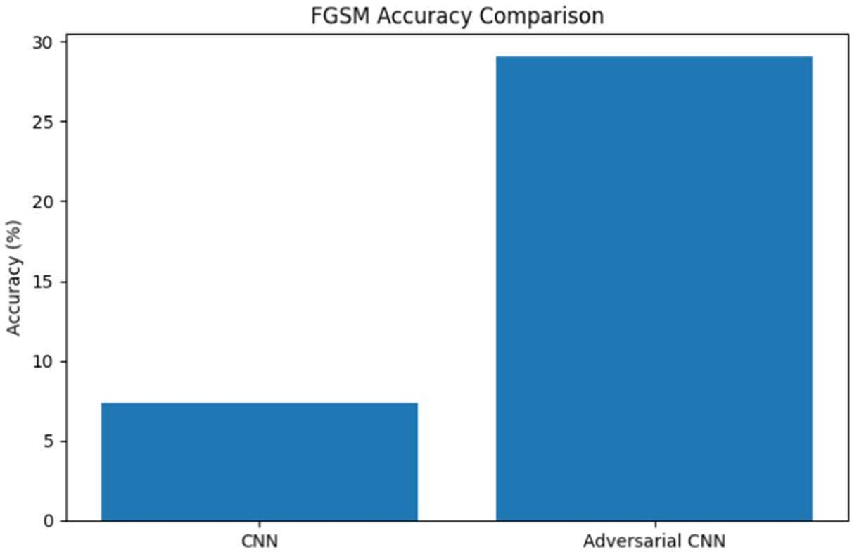
5.5 Robustness Evaluation of the Adversarially Trained Model The robust model was evaluated using the same FGSM attack strengths

Figure 6. FGSM Accuracy Comparison Between Standard CNN and Adversarial Trained CNN.
Compared with the baseline CNN, the adversarial trained model retained significantly higher accuracy under attack conditions.

For example: * Baseline CNN at ε = 0.03 → 7.34%
* Robust CNN at ε = 0.03 → 28.38%
This demonstrates the effectiveness of adversarial training in improving model resilience

Metric | Standard CNN | Robust CNN
Clean Accuracy | 72.54% | 65.15%
FGSM Accuracy (ε=0.03) | 7.32% | 28.38%

Comparison Between Standard and Robust Models
The robust model sacrificed a portion of clean accuracy in exchange for significantly improved adversarial robustness. This tradeoff is consistent with observations reported in existing adversarial machine learning literature.

Confusion Matrix Analysis

A confusion matrix was generated to analyze class-level prediction behavior.
The confusion matrix revealed that certain visually similar classes were more likely to be misclassified than others. Such observations provide insight into the strengths and limitations of the CNN architecture when applied to complex image classification tasks.
The confusion matrix further supports the quantitative evaluation results by highlighting specific categories that contribute to overall classification errors.
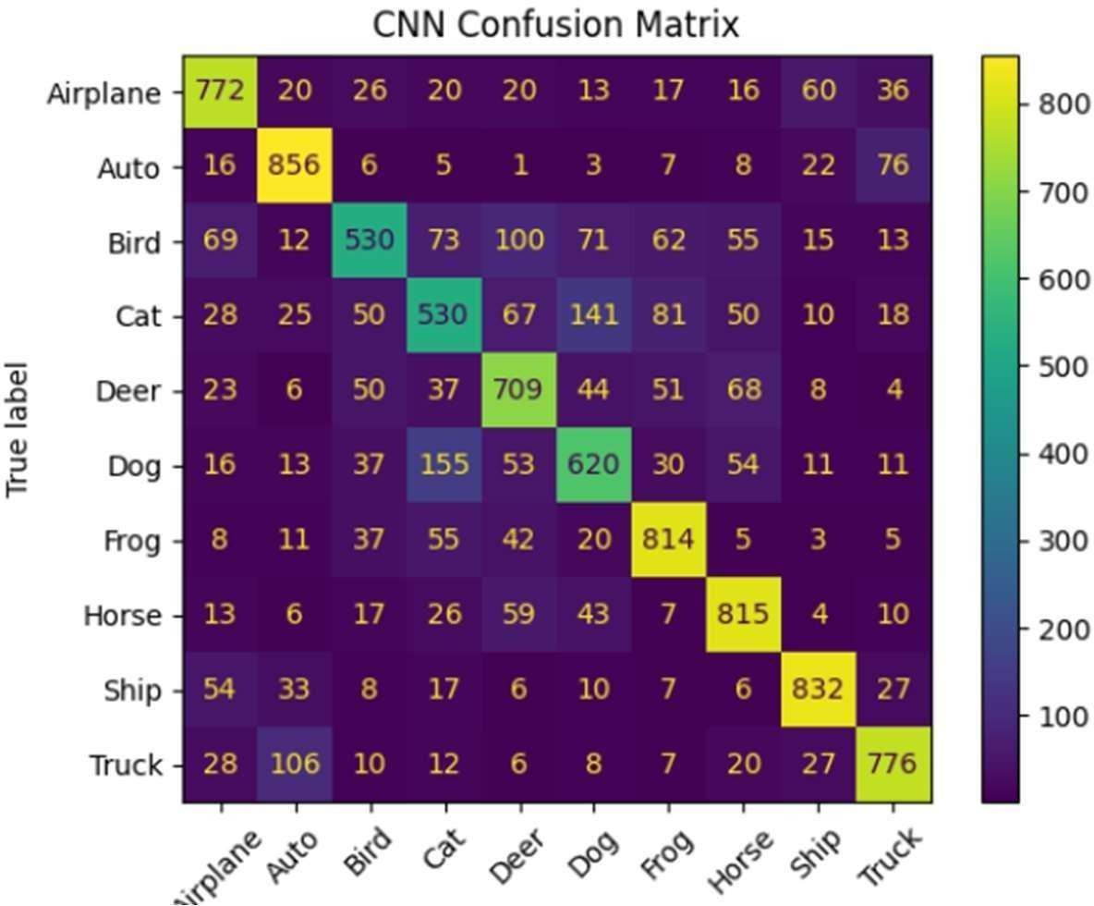
Figure 7. Confusion Matrix of CNN Classification Results

Discussion
The numbers from this implementation point to a clear split between clean-data competence and behavior under FGSM. The baseline CNN reached 72.54% on unperturbed CIFAR-10 test images, which is reasonable for a shallow architecture trained without augmentation. That same checkpoint was not reliable once FGSM was applied at test time. At ε = 0.03, accuracy fell to 7.34%—below the 10% expected from random guessing across ten classes—while the perturbed frames still looked nearly identical to the originals in side-by-side plots.
From an implementation standpoint, the attack loop was straightforward: compute the input gradient, apply the signed update, clamp pixel values, and re-run inference. The ease of that procedure is itself part of the security concern. Any deployment where outside parties can submit images inherits exposure to gradient-directed tampering unless training explicitly accounts for it.
Adversarial training changed the outcome without changing the network layout. The robust model dropped to 65.15% clean accuracy but recovered 28.38% attacked accuracy at ε = 0.03, compared with 7.34% for the baseline. Multi-epsilon curves showed the same pattern at 0.01, 0.05, and 0.10: lower clean scores, higher attacked scores. Confusion matrix output further showed that errors clustered among visually similar classes—cat versus dog, automobile versus truck—at 32×32 resolution, which matches what the qualitative image pairs suggested during manual review.
These observations do not imply full protection. FGSM was the only attack tested, the CNN is compact, and CIFAR-10 is a controlled benchmark. Even so, the measured gap between 72.54% clean and 7.34% attacked accuracy on the baseline, and the partial recovery after retraining, support treating robustness as a property to engineer during model development—especially for cyber security, autonomous perception, healthcare screening, and financial fraud pipelines where misclassification may carry operational cost.

Limitations of the Study
Although the proposed adversarial training approach improved robustness against FGSM attacks, several limitations remain. The experiments were conducted using a relatively simple CNN architecture and a single benchmark dataset (CIFAR-10). Additionally, the defense mechanism was evaluated primarily against FGSM attacks and may exhibit different performance against stronger adversarial attack methods such as PGD or Deep Fool. Future research should investigate more advanced architectures, larger datasets, and multiple attack strategies to provide a broader assessment of model robustness.

Conclusion
This project trained a CIFAR-10 CNN, stressed it with FGSM at four epsilon settings, and retrained a second model with adversarial examples included in each batch. The baseline reached 72.54% clean test accuracy but fell to 7.34% when attacked at ε = 0.03. After adversarial training, clean accuracy was 65.15%, while attacked accuracy at the same epsilon rose to 28.38%.
The robustness plots, confusion matrix, and stored clean-versus-perturbed image pairs all reflected the same pattern: high clean accuracy alone did not predict stable behavior under gradient-based perturbation, and mixing adversarial samples into training partially closed that gap. For systems that may receive manipulated inputs in production, defense methods such as adversarial training should be considered during initial model design rather than added only after deployment.

8.Future Work
Although the proposed defense mechanism improved robustness against FGSM attacks, several

opportunities remain for future research.
Future work may include Evaluation of additional adversarial attack techniques such as Projected Gradient Descent (PGD), DeepFool, and Carlini-Wagner attacks.
- Investigation of advanced defense mechanisms including robust optimization and certified defenses.
- Application of adversarial training to deeper neural network architectures.
- Evaluation of robustness on larger and more complex datasets.
- Exploration of adversarial threats in domains such as cybersecurity, autonomous systems, healthcare, and privacy-preserving AI.
These directions can further contribute to the development of secure, trustworthy, and resilient artificial intelligence systems.

9.References
- I. J. Goodfellow, J. Shlens, and C. Szegedy, “Explaining and Harnessing Adversarial Examples,” International Conference on Learning Representations (ICLR), 2015.
- A. Krizhevsky, “Learning Multiple Layers of Features from Tiny Images,” University of Toronto, Technical Report, 2009.
- Y. LeCun, Y. Bengio, and G. Hinton, “Deep Learning,” Nature, vol. 521, no. 7553, pp. 436–444, 2015.
- N. Papernot et al., “Practical Black-Box Attacks against Machine Learning,” ACM Asia Conference on Computer and Communications Security, 2017.
- A. Madry et al., “Towards Deep Learning Models Resistant to Adversarial Attacks,” International Conference on Learning Representations (ICLR), 2018

