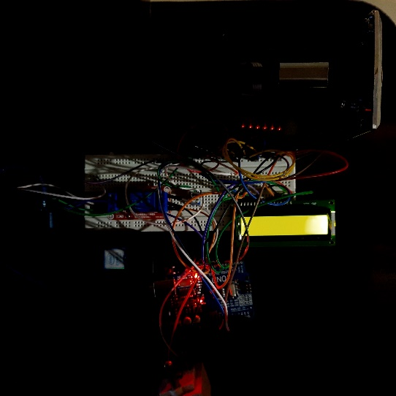

GAURAV H

SAMARTH B DEVARAMANI

SAMUEL R

SANDEEP IYAGAR

PRAVEEN KUMAR G S

V HARSHINI

**INNOVATIVE PROJECT – ARDUINO USING EMBEDDED C (CSE1002)**

Mobile-phones have become an essential gadget for communication as well as our day-to-day life. Hence, charging the mobile phones have become a greater task. In this project, we are trying to design a mobile battery charger on coin insertion. As usage of mobile phones have been increasing day by day, it thus becomes necessary for us to charge the device from time-to-time. This is where public charging comes into the play. Excessive usage of mobile phones in public places could drain the battery, and to keep using the device, they can be re-charged through these public mobile charger by inserting a coin. Once the coin has been inserted, the coin is recognized, and then the user can charge their device through one of the adapters that come along with the system. The mentioned system can be implemented in public places like railway stations, airports, bus stops, hospitals, malls, cafeterias, etc. to avail these services.

**IPC - 79**

**MOBILE CHARGING ON COIN INSERTION**

**SCHOOL OF ENGINEERING**