***Pocket Wise***

***Student Expenditure Tracker***

Synopsis

Gaurav Jain – 2241129

Yash P Mehta - 2241164

***Abstract***:

The *Student Expenditure Tracker* is a mobile application designed to assist students in managing their finances by tracking daily expenses and monitoring remaining pocket money. With an easy-to-use interface, the app allows users to log expenses across predefined categories such as food, books, transportation, entertainment, and more. By offering features like expenditure logging, pocket money tracking, and monthly financial overviews, the app aims to help students develop better budgeting habits. Additionally, it visualizes spending patterns through graphs and reports, making it easier for students to understand their financial behavior and make informed decisions. The app also includes secure user authentication for personalized tracking.

***Introduction*:**

Managing finances can be a challenge for students with limited budgets. The *Pocket Wise* aims to provide an intuitive platform where students can easily monitor their spending habits and stay within budget. This tool not only helps them track day-to-day expenses but also provides an overview of their monthly expenditure patterns, assisting in better decision-making.

***Objectives*:**

* To enable students to track and categorize their daily expenses.
* To provide an overview of their remaining pocket money after each expenditure.
* To help students understand their spending habits through visual reports.
* To foster better financial management and budgeting habits among students.

***Existing Systems:***

Existing expenditure tracking apps are often too complex or designed for a broader audience, making them unsuitable for students who need simplicity and efficiency. Furthermore, these apps typically lack features tailored specifically to student life, such as managing pocket money and categorizing educational expenses.

***Proposed* *System*:**

The proposed *Student Expenditure Tracker* will address the specific needs of students by providing a simple, category-based expenditure logging system. With tailored features like pocket money tracking and monthly expense breakdowns, this app will provide a personalized financial management experience. The use of graphs and charts will further enhance the user's ability to interpret their spending patterns.

***Design*:**

The design of the application will focus on a clean and user-friendly interface. The homepage will include categories such as food, books, transportation, and entertainment. Each expenditure will be logged under a specific category with options to provide reasons for the expense. Users will be able to view their remaining pocket money and spending breakdowns in a visually appealing format using charts and graphs.

***Methodology*:**

The app will be built using Kotlin for Android development with Firebase or Firestore as the backend database. It will use a login and registration system for user authentication. Expenses will be logged and stored in the database, where users can categorize and view their expenditures. The data will be processed to generate visual reports on spending habits, including monthly summaries.

***Conclusion*:**

The *Student Expenditure Tracker* aims to fill a gap in the market by providing students with a tool to effectively manage their limited finances. By simplifying the process of logging expenses and tracking pocket money, the app encourages better financial habits. The visual insights offered by the application will further empower students to make informed financial decisions and maintain control over their budgets.

***ER Diagram***

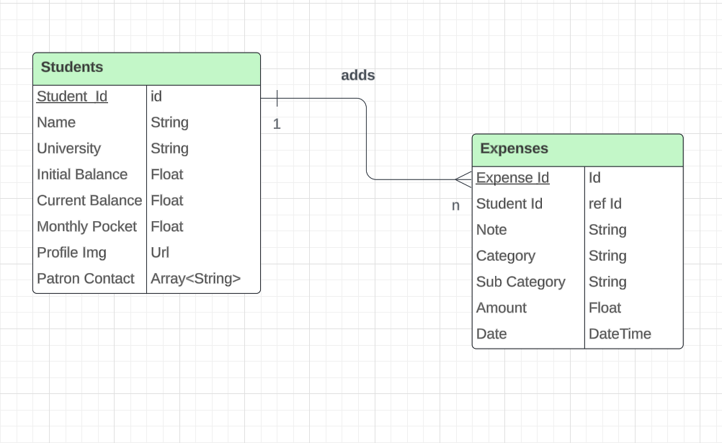

***Data Flow Diagram***

