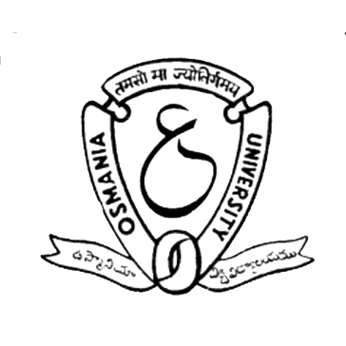

**Department of Electrical Engineering,**

**University College of Engineering (Autonomous),**

**Osmania University, Hyderabad – 500007, TS, India.**

**Contact info: +91 9704112831, +91 8500190719**

**Website: techsonance.org.in, Email ID: techsonance@uceou.edu**

Date: / / 2023,

Hyderabad.

**To,**

**Subject:** Invitation for TECHSONANCE 2023, 23rd National Level Technical Symposium as a Chief Guest.

Respected Sir,

Greetings from Department of Electrical Engineering, University College of Engineering(A), Osmania University.

I hope this letter finds you in good health and high spirits. I am writing to invite you as the chief guest for our upcoming event, Techsonance, which is an annual fest organized by our college to showcase the technological advancements and innovations of the current era.

We believe that your experience and expertise in the field of technology would be an immense asset to our event, and we are confident that your presence as our chief guest would inspire and motivate the students who attend Techsonance.

The event is scheduled to take place on the 15th of June, 2023, and will include a series of workshops, competitions, and keynote speeches by industry leaders. Your presence would greatly enhance the impact of our event, and we would be honoured to have you as our chief guest.

We look forward to hearing back from you soon and hope that you can honour our request to be the chief guest at Techsonance.

Thank you for your time and consideration.

Yours sincerely,

**CHIEF PATRON**

Prof. Sriram Venkatesh

Principal, UCE (A), OU.

**HEAD OF THE DEPT.**

Prof. G. Yesuratnam

UCE (A), OU.

**CO-ORDINATORS**

Prof. B. Mangu

UCE (A), OU.

Mr. P. Lokender Reddy

Assistant Professor

UCE (A), OU.

**CONVENER**

Mr. M. Vivek

**SECRETARY**

Ms. T. Akshaya

**TREASURER**

Mr. S. Naresh

**JOINT TREASURER**

Mr. G. Rakesh

**CO-CONVENERS**

Ms. D. Manisha

Ms. Md. Kulsum

Mr. K. Sanjay Kumar

Mr. T. Santosh Kiran

Mr. N. Radha Krishna (M.E)

Mr. G. Chandra Kanth (M.E)

**TECHNICAL HEAD**

Mr. P. Sai Charan Teja

**SPONSORSHIP HEAD**

Mr. G. Gaurav Krishna

**Mr. P. Lokender Reddy**

Faculty Co-ordinator,

Techsonance 2023.

**Prof. B. Mangu**

Faculty Co-ordinator,

Techsonance 2023.