SQL Assignment – 7

Summarizing Data with Aggregate Functions.

1) Write a query that counts all orders for october 3.

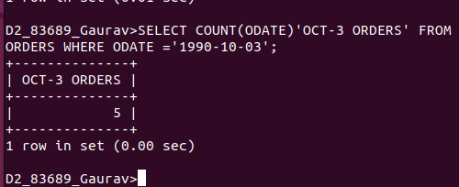

2) Write a query that counts the number of different non-NULL city values in the Customers
table.

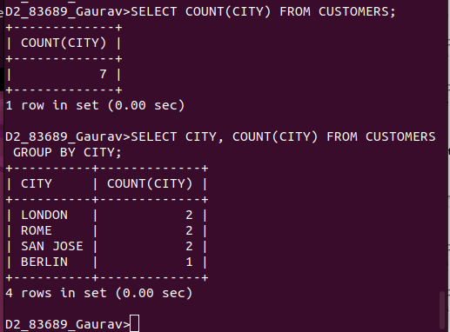

3) Write a query that selects each customer’s smallest order.

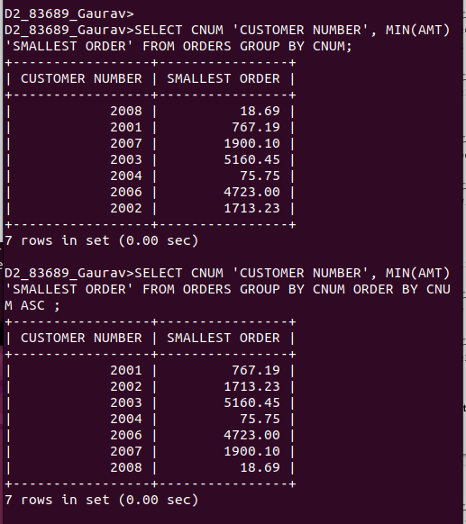

4) Write a query that selects the first customer in alphabetical order, whose name begins with G.

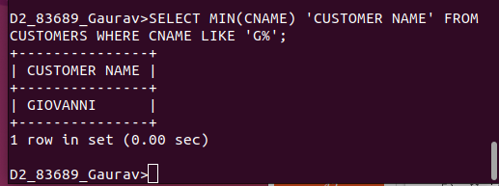

5) Write a query that selects the highest rating in each city.

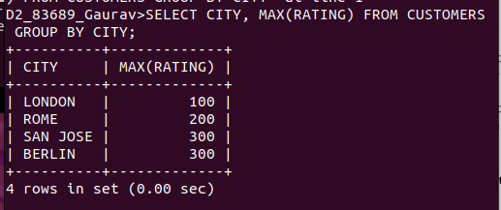

6) Write a query that counts the number of salespeople registering orders for each day. (If a
salesperson has more than one order on a givenday, he or she should be counted only once.).

