DBT ASSIGNMENT 1

1.TABLES CREATED FOR SALESPEOPLE, CUSTOMERS,ORERS
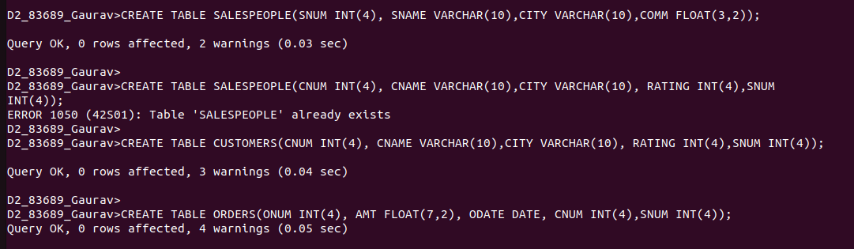

2.1 INSERTED THE VALUES IN TABLE OF SALESPEOPLE.

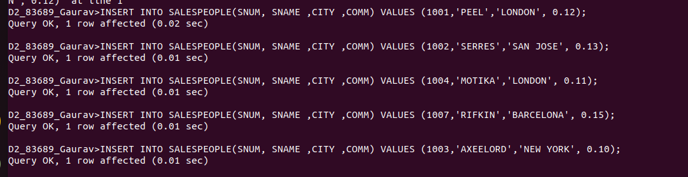

2.2 INSERTED THE VALUES IN TABLE OF CUSTOMERS.
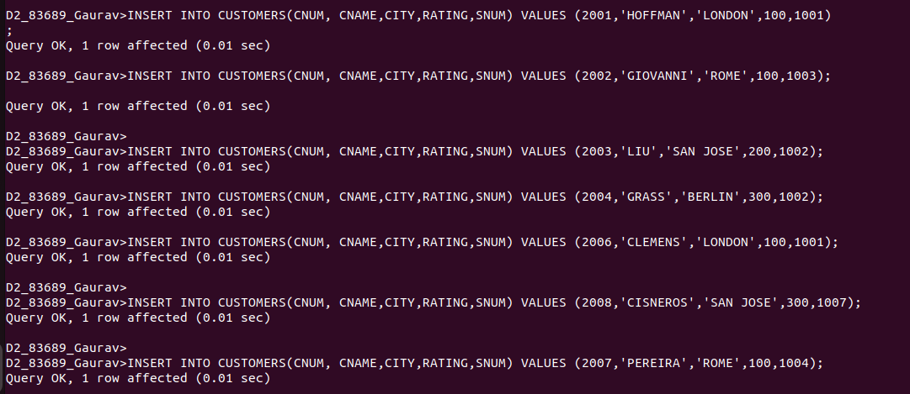

2.3 INSRTED VALUES FOR TABLE OFORERS.

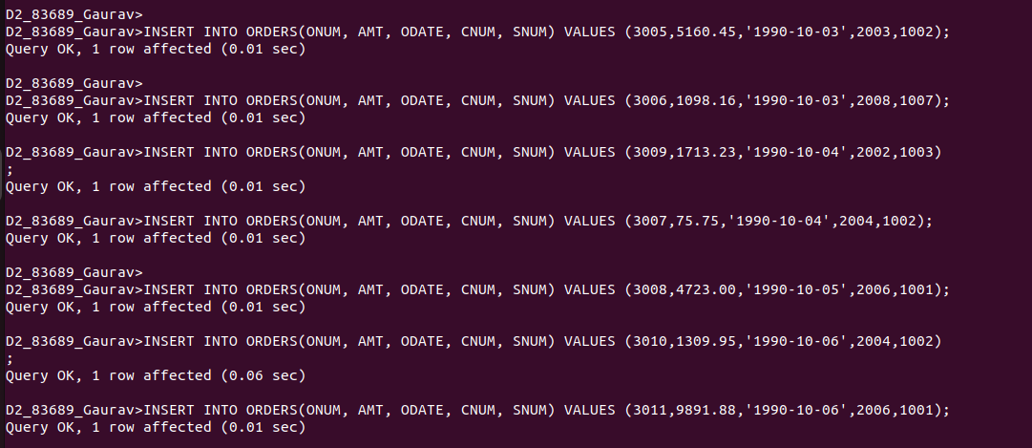

3.OUTPUT OF THE TABLES CREATED
