SQL Assignment-14

Q.1)Write a command that puts the following values, in their given order, into the salespeople table: city – San Jose, name – Blanco, comm – NULL, cnum – 1100.
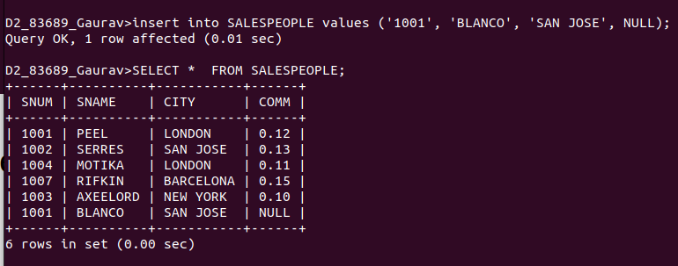

Q.2)Write a command that removes all orders from customer Clemens from the Orders table.
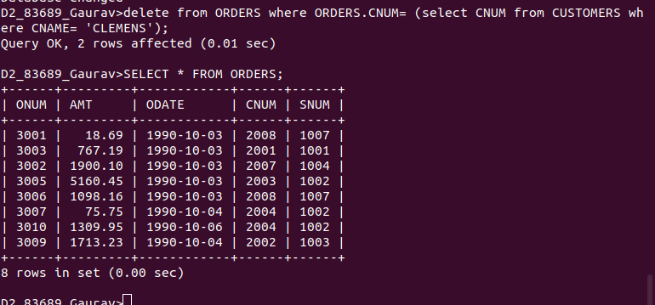

Q.3)Write a command that increases the rating of all customers in Rome by 100.
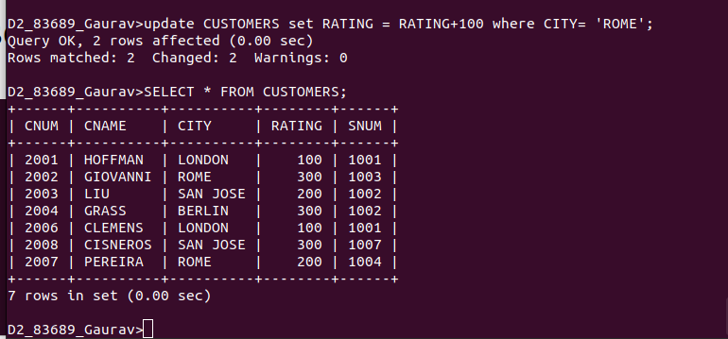

Q.4)Salesperson Serres has left the company.Assign her customers to Motika.


