**Project – Bank CRM**

**Objective Questions:**

1. **What is the distribution of account balances across different regions?**

**Answer:** After analyzing the data with the help of Power BI I have found that among the 3 regions France has highest account balance.

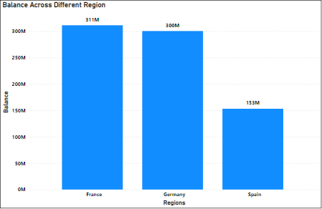

1. **Identify the top 5 customers with the highest Estimated Salary in the last quarter of the year. (SQL)**

**Answer:** **To retrieve the top 5 Customers with the highest estimated salary in the quarter of the year we can use this query:**

SELECT CustomerID, Surname, EstimatedSalary

FROM customerinfo

WHERE quarter(Bank_DOJ) = 4

ORDER BY EstimatedSalary DESC

LIMIT 5;

**Visual:**

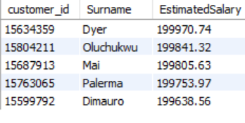

1. **Calculate the average number of products used by customers who have a credit card. (SQL)**

**Answer:**

**We calculate the average number of products used by customer using this query in MySQL:**

SELECT avg(NumOfProducts) as AverageProductUsedByCustomer

from Bank_Churn

where HasCrCard = 1;

**Visual:**



1. **Determine the churn rate by gender for the most recent year in the dataset.**

**Answer:** To determine churn rate by gender we have to use DAX function in Power BI.

DAX Formula **- Churn Rate by Gender =**

**DIVIDE(**

**Bank_Churn[Churned Customers],**

**[Total Customer],**

**0**

**)**

After calculating the churn rate by gender we will use visualization charts to find the churn rate for the most recent year.

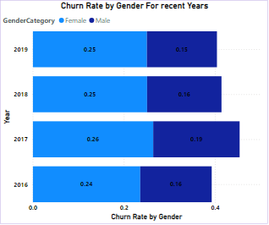

So, it can be seen that the churn rate for the most recent year i.e 2019 is 25% for females and 15% for males.

1. **Compare the average credit score of customers who have exited and those who remain. (SQL)**

**Answer:**

**We can get the average credit score of customers who have exited and those who remains using this query :-**

select

avg(case when Exited=1 then CreditScore else null end) as AvgOfExited,

avg(case when Exited=0 then CreditScore else null end) as AvgOfRetained

from bank_churn;

**Visual:**



1. **Which gender has a higher average estimated salary, and how does it relate to the number of active accounts? (SQL)**

**Answer:**

**To get higher average estimate salary of different genders and there relation with the number of active accounts we can use this query :-**

SELECT

c.GenderID,

ROUND(AVG(c.EstimatedSalary),3) AS AverageSalary,

COUNT(DISTINCT b.CustomerId) AS ActiveAccounts

FROM bank_churn b

JOIN customerinfo c ON b.CustomerId = c.CustomerId

WHERE b.IsActiveMember = 1

GROUP BY c.GenderID;

**Visual:**



1. **Segment the customers based on their credit score and identify the segment with the highest exit rate. (SQL)**

**Answer:**

**To identify the segment with highest exist rate based on the credit score of the customer we can use this query :-**

WITH CreditScoreSegments as (

select CustomerID,

CASE WHEN CreditScore < 580 then 'Poor'

WHEN CreditScore between 580 and 669 then 'Fair'

WHEN CreditScore between 670 and 739 then 'Good'

WHEN CreditScore between 740 and 799 then 'Very Good'

ELSE 'Exceptional' END AS Credit_Segments

from Bank_Churn b

)

select Credit_segments,

avg(Exited)*100 as Exit_Rate

from CreditScoreSegments cs

join Bank_Churn b on cs.CustomerID = b.CustomerID

group by Credit_Segments

order by Exit_Rate desc;

**Visual:**

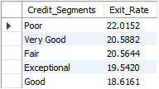

1. **Find out which geographic region has the highest number of active customers with a tenure greater than 5 years. (SQL)**

**Answer:**

**To find the highest number of active customers in different region with a tenure greater than 5 years, we can use this query:**

SELECT

c.GeographyID,

COUNT(c.CustomerID) as ActiveCustomers

FROM customerinfo c

JOIN bank_churn b on c.CustomerID = b.CustomerID

WHERE Tenure > 5 AND IsActiveMember = 1

GROUP BY c.GeographyID;

**Visual:**

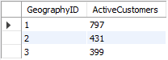

1. **What is the impact of having a credit card on customer churn, based on the available data?**

**Answer:** To check the impact we can simply use charts and DAX functions to find churned customers.

DAX FORMULA - Churned Customers = CALCULATE(COUNTROWS(Bank_Churn),Bank_Churn[Exited] = 1)

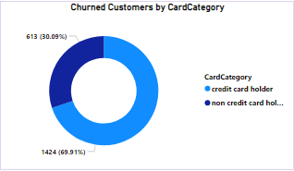

The churn rate for card holders is almost 70% and the churn rate for the non-credit card holder is 30%.

1. **For customers who have exited, what is the most common number of products they have used?**

**Answer:** Product 1 is the most used product by the churned customers followed by Product 2.

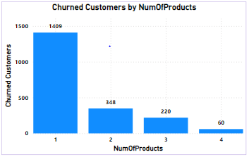

1. **Examine the trend of customers joining over time and identify any seasonal patterns (yearly or monthly). Prepare the data through SQL and then visualize it.**

**Answer: To determine the trend of customers to join over time and identify any seasonal patterns, we can use this query in MYSQL:**

select

extract(year FROM Bank_DOJ) AS JoinYear,

extract(month from Bank_DOJ) AS JoinMonth,

count(CustomerID) AS TotalCustomers

from customerinfo

group by JoinYear,JoinMonth

order by JoinYear,JoinMonth;

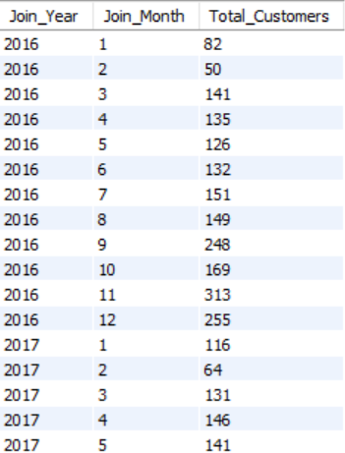**Visual:**

1. **Analyze the relationship between the number of products and the account balance for customers who have exited.**

**Answer:** To analyze the relationship between number of products and the account balance of customer who have existed, first we have to calculate the balance of churned customer using DAX formula the we can find the relation between them using charts.

DAX Formula - Balance for Churned customers = CALCULATE(SUM(Bank_Churn[Balance]),Bank_Churn[Exited] = 1)

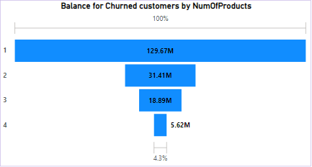

The balance of churned customer who used product 1 is about 130 M.

1. **Identify any potential outliers in terms of balance among customers who have remained with the bank.**

**Answer:** The balance of the retained customer is more than the churned customers. The balance of retained customers is 580M while the balance of churned customers is 185M.

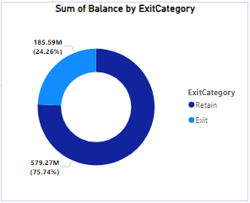

1. **How many different tables are given in the dataset, out of these tables which table only consists of categorical variables?**

**Answer**: The dataset comprises two tables.

* One table contains the following columns:
* customer_id, Surname, Age, GenderID, EstimatedSalary, GeographyID, and Bank_DOJ.
* The other table includes the columns:
  + CustomerId, CreditScore, Tenure, Balance, NumOfProducts, HasCrCard, IsActiveMember, and Exited.

Among these tables, the first table exclusively consists of categorical variables, which are customer_id, Surname, GenderID, Geography, and Bank_DOJ.

1. **Using SQL, write a query to find out the gender-wise average income of males and females in each geography id. Also, rank the gender according to the average value. (SQL)**

**Answer:**

**To find the average income of males and females in each geography id we can use this query:**

with GenderAvgIncome as (

select GeographyID,

GenderCategory,

ROUND(avg(EstimatedSalary),2) AS AvgIncome

from customerinfo

group by GeographyID,GenderCategory

)

select * ,

RANK() over(partition by GeographyID order by AvgIncome desc) as GenderRank

from GenderAvgIncome

order by GeographyID, GenderRank;

**Visual:**

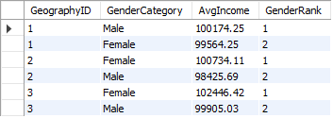

1. **Using SQL, write a query to find out the average tenure of the people who have exited in each age bracket (18-30, 30-50, 50+).**

**Answer:**

**To find the average tenure of people who have exited in different age brackets we can use this query :**

select

case

when c.Age between 18 and 30 then '18-30'

when c.Age between 30 and 50 then '30-50'

else '51+'

end as AgeBracket,

avg(b.Tenure) as AvgTenure

from customerinfo c

join bank_churn b on c.customer_id = b.CustomerID

where Exited = 1

group by AgeBracket

order by AgeBracket;

**Visual:** 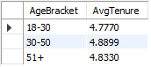

1. **Is there any direct correlation between salary and the balance of the customers? And is it different for people who have exited or not?**

**Answer:** Based on the provided datasets, the following observations are made:

* There is no direct correlation between salary and customer balance.
* Salary accounts do not necessitate a minimum balance, and zero balance accounts are also feasible.
* The relationship between salary and balance might differ for exited versus active customers. However, this is not conclusively determined from the available sources, as there is a lack of data regarding exit reasons.

1. **Is there any correlation between the salary and the Credit score of customers?**

**Answer**: Based on the provided datasets, the following observations are noted:

* There is no direct correlation between salary and credit scores of customers.
* Credit scores are influenced by factors such as payment history, debt-to-credit ratio, credit history length, new credit, and credit amount, rather than salary.
* While income may influence credit limits, it does not directly affect credit scores.

1. **Rank each bucket of credit score as per the number of customers who have churned the bank.**

**Answer:** To rank the customers who have churned the bank on the basis of their credit score we can simply use funnel chart in Power BI, it will automatically rank the bucket of credit score segments.

I found that Fair category has ranked 1 as 685 churned people fall in this category.

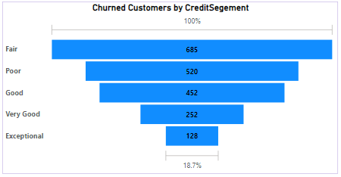

1. **According to the age buckets find the number of customers who have a credit card.**

**Answer:** I use Matrix visual to illustrate the numbers of customers who have credit card and non-credit card holders among different age group.

So, we can see that there are total 7055 credit card holders among them middle aged people hold 4143 credit card which outnumbered the other category.

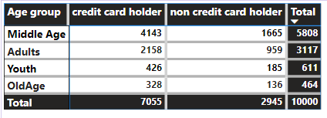

1. **Also retrieve those buckets that have lesser than average number of credit cards per bucket.**

**Answer**: The average number of credit card holder is 1764. So, with the above visual we can clearly see that the Youth and Old Age category have lesser number of credit card holders than the average credit cards holders.

1. **Rank the Locations as per the number of people who have churned the bank and average balance of the customers.**

**Answer: In order to rank the regions on the basis of average balance and numbers of customers who have churned I used DAX formula.**

**DAX formula - Rank by Balance =**

**RANKX(**

**ALL('CustomerInfo'[GeographyID]),**

**[Avg Balance per Location],**

**,**

**DESC**

**)**

**It will rank on the basis of Balance of customers.**

**DAX formula - Rank by Churned =**

**RANKX(**

**ALL('CustomerInfo'[GeographyID]),**

**[Churned Customers per Location],**

**,**

**DESC**

**)**

**It will rank on the basis of churned customers.**

**DAX Formula - Combined Rank =**

**AVERAGEX(**

**VALUES('CustomerInfo'[GeographyID]),**

**[Rank by Churned] + [Rank by Balance]**

**) / 2**

**It will combined the rank.**

**DAX Formula - Avg Balance per Location =**

**CALCULATE(**

**AVERAGE('Bank_Churn'[Balance]),**

**ALLEXCEPT('CustomerInfo', 'CustomerInfo'[GeographyID])**

**)**

**It will calculate the average balance per locations of the customers.**

**DAX Formula - Churned Customers per Location =**

**CALCULATE(**

**COUNT('Bank_Churn'[CustomerId]),**

**'Bank_Churn'[Exited] = 1,**

**ALLEXCEPT('CustomerInfo', 'CustomerInfo'[GeographyID])**

**)**

**It will count the churned customers of different locations.**

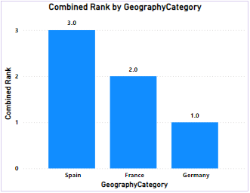

**So, Germany ranked as 1 according to our criteria and France placed as 2.**

1. **As we can see that the “CustomerInfo” table has the CustomerID and Surname, now if we have to join it with a table where the primary key is also a combination of CustomerID and Surname, come up with a column where the format is “CustomerID_Surname”.**

**Answer**: It can easily have done using add column feature by using the formula given below:

Formula - **Column = CustomerInfo[CustomerId]&"_"&CustomerInfo[Surname]**

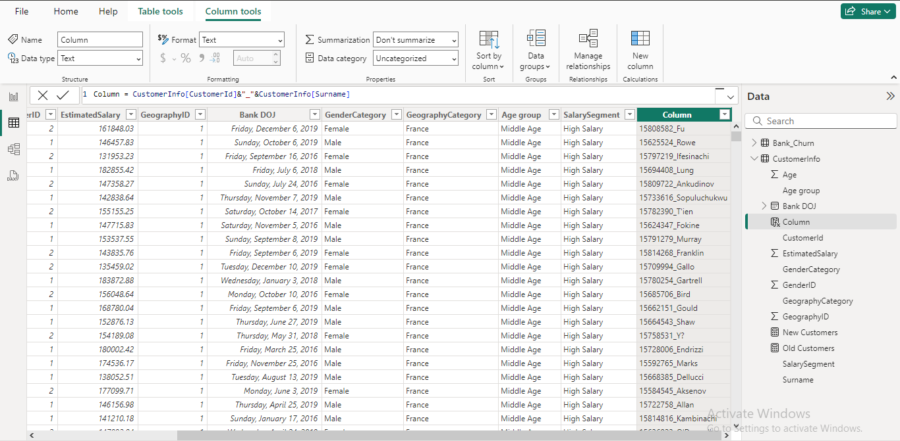

1. **Without using “Join”, can we get the “ExitCategory” from ExitCustomers table to Bank_Churn table? If yes do this using SQL.**

**Answer:** I have already changed the column that the question asked for using excel but we can achieve this by MYSQL without using join function. So simply we can achieve the required output using this query in MYSQL:

SELECT * ,

CASE WHEN Exited = 0 THEN "Retain" ELSE "Exit" END as Exit_Category

FROM Bank_Churn;

**Visual:**

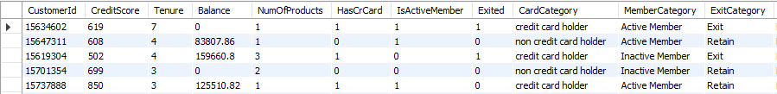

1. **Were there any missing values in the data, using which tool did you replace them and what are the ways to handle them?**

**Answer**: This section addresses missing values, which can occur when data points are not recorded or are unavailable. In our analysis, we were fortunate to have a dataset free of missing values. This eliminates the need for imputation techniques that might introduce assumptions or biases.

General Approaches to Handling Missing Values (for future reference):

While our dataset is free of missing values, it's valuable to be aware of common approaches for handling them in future analyses:

* **Deletion:** This involves removing rows or columns with missing values. This approach can be appropriate if the missing data is minimal and doesn't significantly impact the analysis. However, it can also lead to a loss of information.
* **Imputation:** This replaces missing values with estimated values. Techniques include mean/median/mode imputation, k-Nearest Neighbors (KNN), or more sophisticated methods. The chosen method should be based on the data type and distribution.
* **Modeling Techniques:** Some statistical models can handle missing values directly. However, understanding the reasons for missingness is still important.

1. **Write the query to get the customer IDs, their last name, and whether they are active or not for the customers whose surname ends with “on”.**

**Answer: To get the Customer ID and their last name , and whether they are active or not for the customers who name ends with “on” we can use this query in MYSQL:**

SELECT b.CustomerID, c.Surname,

case when b.IsActiveMember = 1 then 'Active'

else 'InActive' end as ActiveStatus

from customerinfo c

join bank_churn b on c.CustomerId = b.CustomerID

where c.Surname regexp 'on$'

order by c.Surname;

**Visual:**

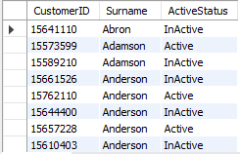

1. **Can you observe any data disrupency in the Customer’s data? As a hint it’s present in the IsActiveMember and Exited columns. One more point to consider is that the data in the Exited Column is absolutely correct and accurate.**

**Answer:** Yes, there is data discrepancy in the customer data as 735 customers who exited the bank but they are showing as active customer which is logically not possible. Customer who left the bank logically marked as inactive members.

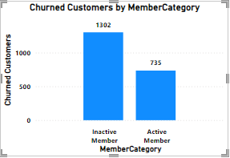

**Subjective Question:**

1. **Customer Behavior Analysis: What patterns can be observed in the spending habits of long-term customers compared to new customers, and what might these patterns suggest about customer loyalty?**

**Answer:** The analysis of customer spending patterns reveals significant insights from three charts focusing on average balance, salary, and the number of products held by new and long-term customers:

* **Average Balance:(Chart - Average of Balance, Old Customers and New Customers by Month)**
  + New customers consistently have lower average balances compared to long-term customers.
  + New customers exhibit fluctuating balances, while long-term customers show an increasing trend.
  + This may suggest that long-term customers benefit from familiarity with the bank's services, experience income growth, or receive better incentives.
* **Average Salary:(Chart - Average of Estimated Salary, New Customers and Old Customers by Month)**
  + Long-term customers have higher average salaries compared to new customers.
  + New customers display a slight upward trend in salary over time.
  + There is a noticeable correlation between customer tenure and salary.
* **Number of Products Held:(Chart - Average of NumOfProducts, New Customers and Old Customers by Month)**
  + Long-term customers hold more products on average than new customers.
  + New customers gradually increase products held over time.
  + New customers start with fewer products, likely exploring offerings.

**These insights highlight the connection between customer loyalty and increased spending, salary, and product holdings, informing the bank's marketing and retention strategies.**

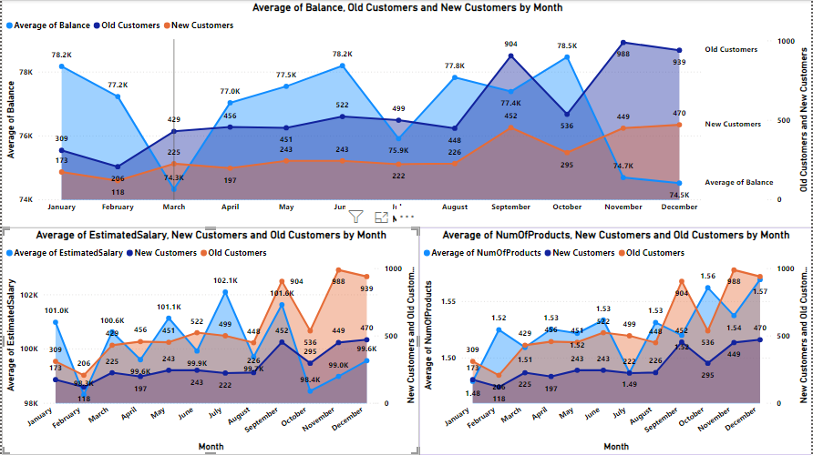

1. **Product Affinity Study: Which bank products or services are most commonly used together, and how might this influence cross-selling strategies?**

**Answer:** Customers frequently use specific bank products together, and understanding these pairings can help develop targeted cross-selling strategies to boost customer satisfaction and revenue.

* **Commonly Used Products (Examples):**
  + Checking Accounts: Essential for daily transactions.
  + Debit Cards: Linked to checking accounts, providing convenient access to funds.
  + Savings Accounts: Facilitate savings growth and often earn interest.
  + Credit Cards: Offer credit lines for purchases with interest repayment.
  + Loans: Tailored financial solutions like mortgages or auto loans.
* **Cross-Selling Strategies:**
  + **Recommend Complementary Products:** For instance, suggest debit cards and online banking to checking account users for easy management. Savings account holders could benefit from automatic transfers or higher-interest options like CDs.
  + **Personalize Based on Usage:** Offer travel rewards cards to credit card users with travel habits. Provide bundled insurance options to loan seekers.
  + **Leverage Digital Platforms:** Promote paperless statements, bill auto pay, investment options, and financial tools through online/mobile banking.

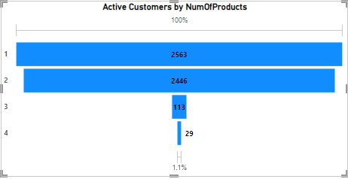

1. **Geographic Market Trends: How do economic indicators in different geographic regions correlate with the number of active accounts and customer churn rates?**

**Answer: To know the Market trends, We will analyze three key economic indicators: average balance, average salary, and credit score.**

* **Average Balance by Geographic Location:**
  + The chart shows the average balance across different regions, with Germany having the highest balance.
  + Although there is no direct link to churn, areas with lower balances might experience higher churn rates if customers are more sensitive to costs.

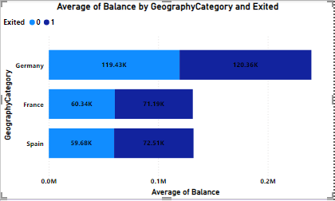

* **Average Credit Score by Geographic Location:**
* The chart illustrates variations in credit scores across locations, with Germany exhibiting the highest average.
* This data, combined with churn rate information, may reveal a potential correlation between higher credit scores and lower churn rates, indicating that more creditworthy customers are less likely to switch banks.

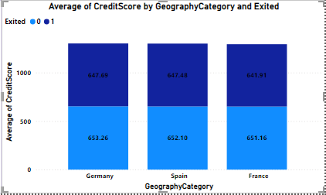

* **Average Salary by Geographic Location:**
  + The chart presents variations in average salaries across regions, with Germany having the highest average.
  + When considered alongside churn information, this data may offer insights into the relationship between higher salaries and customer churn rates**.**

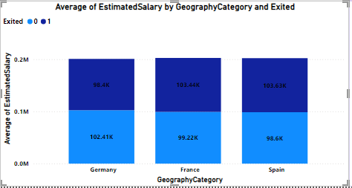

1. **Risk Management Assessment: Based on customer profiles, which demographic segments appear to pose the highest financial risk to the bank, and why?**

**Answer: Based on the chart, we can identify the following findings for various demographic segments:**

* **To define the customer segment, I divided the segment in 3 categories.**
* Rich – High Salary (Above 1,30,000)
* Middle Class – Medium Salary (Between 65000 to 1,30,000)
* Poor – Low Salary (Below 65,000)
* **High Risk Assessment:**
* **Poor Category -** Poor category has lower number of customers as compared to Fair category. So the poor category itself indicates higher financial risk. In this category there are total 2362 customers out of which 733 has low salaries. So it is also a risky group.
* **Fair Category -** This category has the highest number, particularly those with low salary. Individual with low salary and fair credit scores present higher financial risk due to their low income and average creditworthiness. There are total 3331 customers who fall under faircategory out of which 1102 have low salary. So we can say that it is a significant risk group.

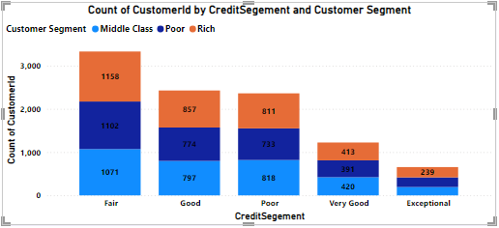

1. **Customer Tenure Value Forecast: How would you use the available data to model and predict the lifetime (tenure) value in the bank of different customer segments?**

**Answer:** Here are the key insights and predictions based on the chart showing average tenure by balance segments, salary segments, and customer segments:

* Customers with higher average balance segments tend to have longer tenure with the bank.
* This could be due to being more invested in the bank's products and services.
* Or because the bank offers better benefits to retain them

**Balance Segments**:

* Weak trend between salary segments and tenure
* On average, higher salary segments have slightly longer tenures.
* Differences are not substantial across most segments.

**Predicted average tenure for salary segments:**

* + High Salary: 4.8 – 5.15 years
  + Low Salary: 4.83 – 4.87 years
  + Average Salary: 4.8 - 5.0 years

Balance segments are a more important factor in predicting tenure than salary segments.

* Target retention efforts towards higher balance segments
* Develop strategies to improve customer satisfaction and product adoption across all segments.

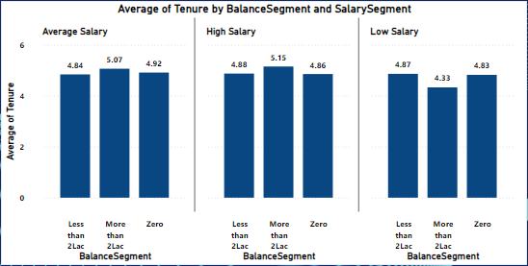

1. **Marketing Campaign Effectiveness: How could you assess the impact of marketing campaigns on customer retention and acquisition within the dataset? What extra information would you need to solve this?**

**Answer**: To assess the impact of marketing campaigns on customer retention and acquisition within a dataset, one would typically use a combination of data analysis and statistical techniques. Here's a general approach we could take:

* Define key metrics for customer retention and acquisition.
  + - * For retention: customer churn rate, retention rate
      * For acquisition: new customer acquisition rate, customer acquisition cost (CAC)
* Segment data based on different marketing campaigns to analyze the impact of each campaign separately.
* Calculate the defined metrics for each segment and time period (e.g., monthly, quarterly, annually) to understand how each campaign affects customer retention and acquisition over time.
* Compare metrics across different campaigns to identify the most effective ones at retaining and acquiring customers.
* Use statistical tests (e.g., t-tests, ANOVA) to determine if differences in metrics between campaigns are statistically significant.
* Gather additional information for a comprehensive analysis:
* Customer demographics to understand if certain demographics respond better to certain campaigns.
* Campaign details (e.g., duration, channels used, messaging)
* Competitor data to understand the competitive landscape and its impact.
* External factors (e.g., economic conditions, seasonality, industry trends) that might affect customer behaviour.

By following this approach and gathering necessary information, you can assess the impact of marketing campaigns on customer retention and acquisition within this dataset.

1. **Customer Exit Reasons Exploration: Can you identify common characteristics or trends among customers who have exited that could explain their reasons for leaving?**

**Answer:** The query tasks us with pinpointing common traits or patterns among bank customers who have exited (churned) to comprehend the reasons behind their departure. Two potential characteristics have been identified:

1. **Credit card ownership:** Suggesting that customers with credit cards are more prone to churning compared to those without.
2. **Number of products purchased:** Indicating that customers who purchase fewer products are more inclined to churn than those who buy more.  
   The bar chart labeled "**Churned Customers by HasCrCard and NumOfProducts**" appears to partially validate the assumption regarding credit card ownership.

* **Analysis of Credit Card Ownership:**

The chart titled "**Churned Customers by HasCrCard and NumOfProducts**" displays the number of customers who exited the bank categorized by the number of products they purchased.

It indicates the relationship between the number of products bought by customers and their likelihood of churning.

By analyzing this chart, we can assess whether customers who purchased fewer products are more prone to churning compared to those who bought more products.

* **Analysis of Number of Products Purchased:**

The chart supports the idea that customers who buy fewer products are more likely to churn.

* 1. The highest number of customers who exited the bank purchased zero products.
  2. The number of exited customers steadily declines as the number of products purchased increases.
  3. Very few exited customers (around 41) bought four or more products.
* **Possible reasons for this trend:**

Customers using more products are likely to be more satisfied with the bank overall and find more value in the relationship.

The bank may offer benefits or discounts to customers who use more products, incentivizing them to stay

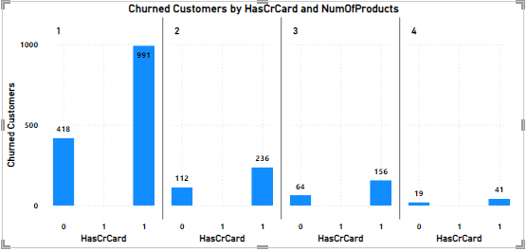

1. **Are 'Tenure', 'NumOfProducts', 'IsActiveMember', and 'EstimatedSalary' important for predicting if a customer will leave the bank?**

**Answer:** Based on the Power BI chart provided, here are the key points regarding the importance of Tenure, NumOfProduct, IsActiveMember, and EstimatedSalary for predicting customer churn:

**Tenure**

* The chart shows significant variation in the number of active customers across different tenure periods.
* Customers with shorter tenures (0-5 years) have a higher number of churned customers compared to those with longer tenures.
* This suggests that tenure is a key factor in predicting customer churn, as customers who have been with the bank for a shorter period are more likely to leave.

**Number of Products (NumOfProducts)**

* The chart indicates that the number of products a customer holds is an important factor in predicting churn.
* Customers with fewer products (0-2) have a higher number of churned customers compared to those with more products.
* This implies that customers who use a wider range of the bank's products are less likely to churn.

**Active Member Status (IsActiveMember)**

* Since the chart focuses on active customers, the active member status is inherently considered in the analysis.
* However, the chart does not provide a direct comparison between active and inactive members.
* To fully assess the importance of active member status, a separate analysis comparing churn rates between active and inactive members would be necessary.

**Estimated Salary (EstimatedSalary)**

* The chart does not show a clear trend correlating estimated salary with the number of active customers.
* The importance of estimated salary in predicting churn is uncertain based on the information provided in the chart alone.
* Further analysis would be needed to determine if there is a relationship between salary and churn.

**In summary, the Power BI chart suggests that:**

* Tenure and the number of products held by a customer are important factors in predicting customer churn for a bank.
* The importance of active member status and estimated salary requires additional analysis to draw definitive conclusions.
* By understanding these factors, banks can develop targeted strategies to retain customers and reduce churn.

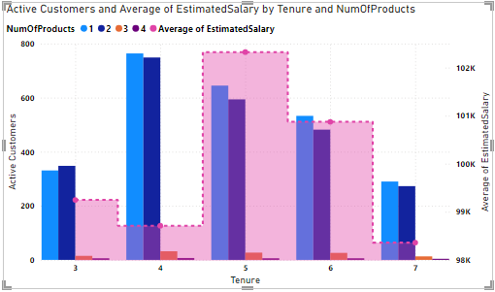

1. **Utilize SQL queries to segment customers based on demographics and account details**

**Answer:**

**As question asked that we have to divide the customer on the basis of their account details and their demographics.**

**So, first I divided the salary segments on the basis of maximum and minimum salary. I categorized them as :- salary < 65000 as low, salary < 130000 as average and else high.**

**So, now to divide the customer on the basis of their salary category we can use MYSQL by using this query:**

select GeographyLocation,

case when EstimatedSalary <= 65000 then 'Low'

when EstimatedSalary <= 130000 then 'Average'

else 'Good' end as SalaryCategory,

GenderCategory,

Age,

count(CustomerId) as NumOfCustomers

from customerinfo

group by SalaryCategory,GenderCategory,Age,GeographyLocation

order by GeographyLocation,Age,NumOfCustomers;

**By using this query we can easily divide the customer on the basis of their demographic and account details.**

**Visual:**

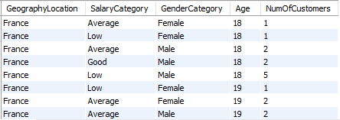

1. **How can we create a conditional formatting setup to visually highlight customers at risk of churn and to evaluate the impact of credit card rewards on customer retention?**

**Answer:** Here's how we can create a conditional formatting setup in Power BI to visually highlight customers at risk of churn and evaluate the impact of credit card rewards on customer retention:

Conditional Formatting for Churn Risk

1. **Create a new column** in your data model called "Churn Risk" that assigns a risk level based on the customer's characteristics. For example:
   * If Tenure < 3 AND NumOfProducts < 2, Churn Risk = "High"
   * If Tenure >= 3 AND NumOfProducts < 2, Churn Risk = "Medium"
   * If NumOfProducts >= 2, Churn Risk = "Low"
2. **In the report**, we need to create a table visual with the following columns: CustomerID, Tenure, NumOfProducts, HasCrCard, Exited, Churn Risk.
3. **Apply conditional formatting** to the Churn Risk column:

Format the background color based on the risk level (e.g., red for High, yellow for Medium, green for Low)

1. **Analyze the table** to identify customers with High churn risk who have active credit cards but have exited. These are prime candidates for credit card rewards to incentivize retention.
   * Fortunately, there are no “High risk” customers, but we have around **5084** potential churn customers (“Medium risk”) which we should take care of.

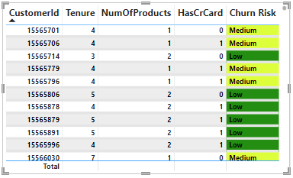

* **Evaluating Credit Card Rewards Impact**
* **Create "Retained Customers" Measure:**
  + This measure calculates the customers who have not existed:
* **DAX - Retained Customers = COUNTROWS(FILTER(Bank_Churn,Bank_Churn[Exited] = 0))**
* **Create "Retained Credit Card Customers" Measure:**
  + This measure help to count the customers who are retained and have credit card:
* **DAX - Retained Credit Card Customers = CALCULATE([Retained Customers], Bank_Churn[HasCrCard] = 1)**
* **Create a KPI Visual:**
  + Track the percentage of retained credit card customers out of total customers:
* **DAX - Retained Credit Card Customers % = DIVIDE([Retained Credit Card Customers], [Retained Customers])*100**

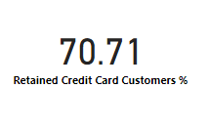

* **Monitor the KPI Over Time:**
  + Evaluate the impact of credit card rewards on customer retention. An increase in the percentage indicates that credit card rewards are effectively reducing churn among credit card holders.

By combining conditional formatting to identify high-risk customers and measures to track retained credit card customers, you can gain valuable insights into churn patterns and the effectiveness of credit card rewards in improving customer retention.

1. **What is the current churn rate per year and overall as well in the bank? Can you suggest some insights to the bank about which kind of customers are more likely to churn and what different strategies can be used to decrease the churn rate?**

**Answer**: This analysis provides the current churn rates, identifies customer segments most susceptible to churn, and proposes strategies to decrease churn and improve customer retention.

**Churn Rate:**

* The overall churn rate for the bank is **20.37%**
* Year-on-year churn rates show some fluctuations:
  + 2016: 19.27% (lowest)
  + 2017: 22.35% (highest)
  + 2018: 20.21%
  + 2019: 19.86%

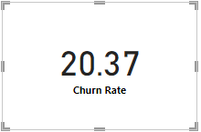

The churn rate can be obtained by the following formula:

* **Churn Rate = DIVIDE(Bank_Churn[Churned Customers],[Total Customer])*100**

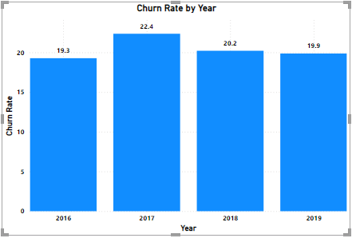

* **Customer Segments Prone to Churn:**
  + Purchases 1 product: Customers using only one product by a bank may perceive less value compared to competitors with broader offerings.
  + Has credit card:
    - Limited credit limits not meeting their needs.
    - Lack of rewarding programs incentivizing card retention.
    - High credit card fees.
  + Tenure of 4-5 years: Customers in this tenure phase may be approaching the end of introductory offers, making them susceptible to competitor offers with better terms.
  + High salary: High-income earners might be more inclined to switch for slightly better rates or benefits elsewhere.
* **Recommendations to Reduce Churn:**
  + Targeted Product Bundles: Create tailored bundles for specific customer segments, emphasizing added benefits and potential cost savings for customers using only one product.
  + Enhanced Credit Card Rewards:
    - Increase credit limits based on customer history and creditworthiness.
    - Offer rewards aligned with spending habits (e.g., travel rewards, cash back).
    - Reduce or waive annual fees, especially for high-value customers.
  + Retention Offers for Existing Customers: Proactively offer personalized retention deals to customers nearing the end of introductory offers.
  + Customer Satisfaction Surveys: Regularly conduct surveys to understand reasons for churn and improve retention strategies.
  + Relationship Management for High-Value Customers: Assign dedicated managers to high-value customers for personalized service and exclusive benefits.

1. **Create a dashboard incorporating all the KPIs and visualization-related metrics. Use a slicer in order to assist in selection in the dashboard.**

**Answer:**

* **Main Dashboard**

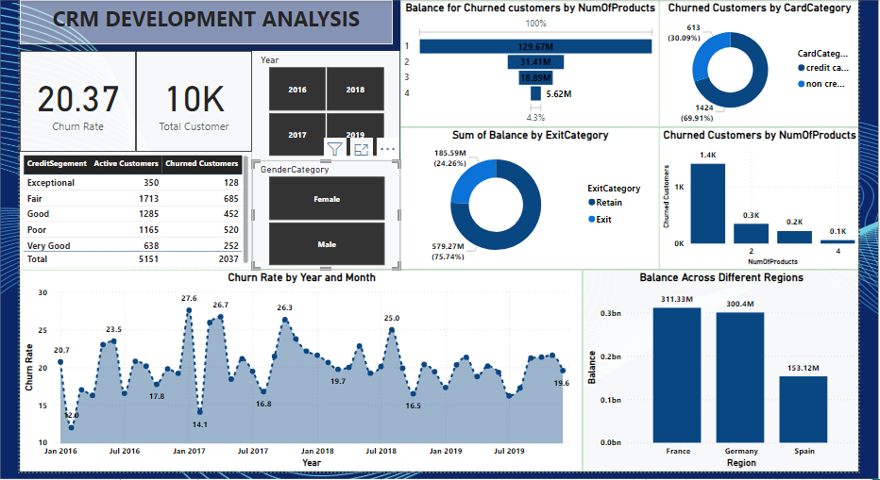

* **Subjective Analysis**

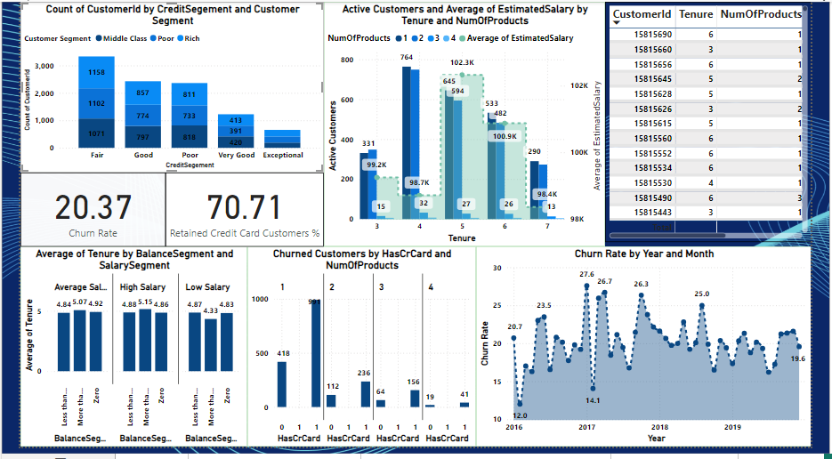

* **Product Affinity Study & Geography market trends**

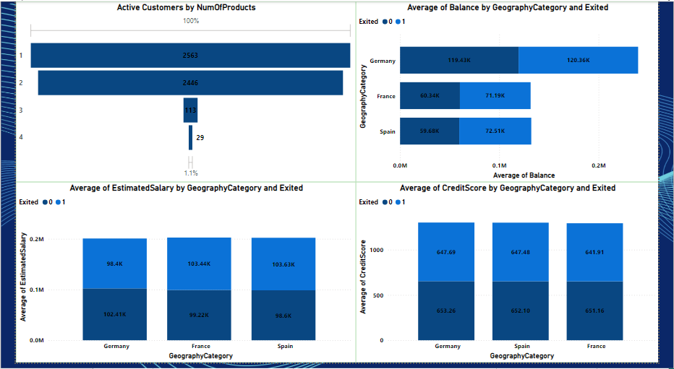

* **Customer Behavior Analysis**

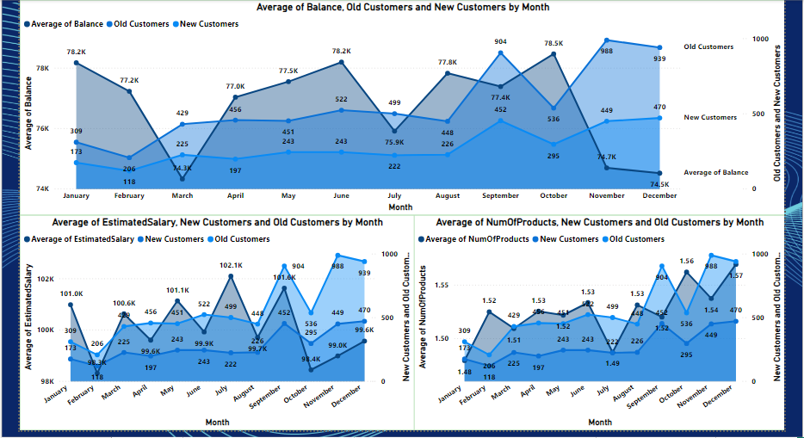

1. **How would you approach this problem, if the objective and subjective questions weren't given?**

**Answer:** If the subjective and objective question are not there I will approach the problem in the following steps –

* **Hypothesis Generation:**
  + Make assumptions about the data or problem based on domain knowledge, industry best practices, or initial observations.
* **Question Formulation:**
  + Formulate questions that can be answered using the available data to validate or refine hypotheses.
  + Examples for Customer Churn Analysis:
    1. Are there demographic patterns (age, income) associated with customer churn?
    2. Does account balance or number of products hold influence churn rates?
    3. How does customer activity (transactions, logins) correlate with churn?
  + Examples for Marketing Campaign Analysis:
    1. Which marketing channels (email, social media) are most effective at reaching target audiences?
    2. Is there a correlation between ad spend and campaign performance?
    3. How does campaign messaging impact customer engagement and conversion rates?
* **Data Exploration and Analysis:**
  + Use data visualization and statistical analysis techniques to answer the formulated questions.
* **Insights and Recommendations:**
  + Draw insights from the analysis findings to inform decision-making in areas such as customer behavior, marketing strategies, product development, etc.

By following this process of hypothesis generation, question formulation, data exploration, and insight derivation, you can effectively approach a problem and gain valuable insights, even without explicit objective and subjective questions.

1. **In the “Bank_Churn” table how can you modify the name of the “HasCrCard” column to “Has_creditcard”?**

**Answer:** This task can easily achieve by using alter table function in MySQL.

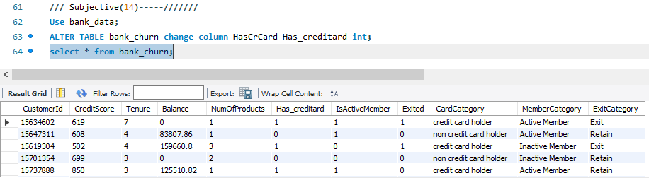

By using this query we can easily change the name of any column in any table**.**

**Query – ALTER TABLE TABLE_NAME CHANGE COLUMN OLD_COLUMN_NAME NEW_COLUMN_NAME DATATYPE;**