# **ZOMATO ANALYSIS**

**Problem Statement**

* **Suggestions of the Countries where Zomato can open newer Restaurants.**
* **Suggestions of the cities in suggested countries.**
* **Analyze the quality regarding ratings for restaurants that are already present in the countries.**
* **Analyze the expenditure on food.**
* **Analyze the competitors.**
* **Analyze the cuisines that need to be focused.**
* **Analyze the trends of the Online deliveries and table bookings.**
* **Analyze the rates of the cuisines.**

**Objective Questions**:

1. **What is the total no. of tables present in the data?**

**Answer: There are 2 Tables present in the given dataset.**

* Raw data
* Country Description

1. **What is the total no. of attributes present in the data**?

**Answer:** **There are total 22 attributes in the given dataset.**

* Raw data – 20 Attributes
* Country description – 2 Attributes

1. **How many categorical columns are there in the data? [Search about categorical and continuous data, and try to answer this question]**

**Answer: There are** **16 Categorical columns in the given dataset**

* Raw data – 14 Categorical Column
* Country description – 2 Categorical Column

1. **The data consists of some inconsistent and missing values so ensure that the data used for further analysis is cleaned**.

**Answer:** **Handling of Missing and inconsistent values.**

1. Date key column – In date key _ is replaced with the / for proper formatting of date.
2. Average cost for two column – There are some value which is zero so using aggregate function the value is replaced with the average value.
3. Cuisines column – In cuisines column there are some missing value, so they are replaced with No Information.
4. **Using the Lookup functions, fill up the countries in the original data using the country code.**

**Answer:** **In Filter data table, column D**

* **Formula** **used**: **=VLOOKUP($C2,'country description'!$A$2:$B$16,2,0)**

1. **Create a table to represent the number of restaurants opened in each country**.

**Answer:** **In order to find the number of restaurants open in each country I made a pivot table. In which country is available in rows and restaurant id is in column.**

**Reference – Sheet name – 2. Opening of Restaurants**

1. **Also, the management wants to look at the number of restaurants opened each year, so provide them with something here.**

**Answer: In order to find the number of restaurants open in each year I made a pivot table. In which Year is available in rows and restaurant id is in column.**

**Reference – Sheet name – 2. Opening of Restaurants.**

1. **What is the total number of restaurants in India in the price range of 4?**

**Answer: In order to find the total number of restaurants in India which has price range of 4, I used aggregate function i.e. “Countifs”.**

* **Formula used - COUNTIFS ('Filter data '!$D:$D,"India",'Filter data '!$Q:$Q,4)**

**Reference – Sheet name: 2. Opening of Restaurants**

1. **What is the average number of voters for the restaurants in each country according to the data?**

**Answer: In order to find the average number of voter in each country , I made a pivot table in which Country is placed in rows while Votes are placed in value field.**

**Reference: Sheet name – 5. Votes**

|  |  |
| --- | --- |
| **Country** | **Average of Votes** |
| Australia | 111.4166667 |
| Brazil | 19.61666667 |
| Canada | 103 |
| India | 137.212552 |
| Indonesia | 772.0952381 |
| New Zealand | 243.025 |
| Philippines | 407.4090909 |
| Qatar | 163.8 |
| Singapore | 31.9 |
| South Africa | 315.1666667 |
| Sri Lanka | 146.45 |
| Turkey | 431.4705882 |
| United Arab Emirates | 493.5166667 |
| United Kingdom | 205.4875 |
| United States of America | 428.2211982 |
| **Grand Total** | **156.9097477** |

1. **Calculate the average rating for all the restaurants that have price_range < 4 and provide online delivery. Use only the “IF” function, Logical Operators, and Aggregation functions to solve this problem. [Note: Don’t use Conditional aggregation in this question.]**

**Answer:** **To find the average rating for all the restaurants that have price range < 4 and provide online delivery is I used array formula using if and average.**

* **Formula used: ={AVERAGE(IF(('Filter data '!$Q:$Q<4)*('Filter data '!$N:$N="Yes"),'Filter data '!$W:$W))}**
* **The average rating is 3.27381151**

**Reference: Sheet name – 3. Ratings**

1. **Using Conditional formatting highlight, the rows of restaurants that are located in the countries or cities that you’ve suggested to the management for opening new restaurants.**

**Answer: For conditional formatting –**

* + - * + Select Data:

Highlight the data you wish to format.

* + - * + Conditional Formatting:
* Go to the “Conditional Formatting” option.
* New Rule:
* Create a new custom formatting rule.
* Formula:
* Use the following formula: = OR ($D1=”Australia”, $D1=”Canada”, $D1=”Singapore”, $D1=”Sri Lanka”).
* Format Color: Specify the formatting style that should apply when the condition is met.

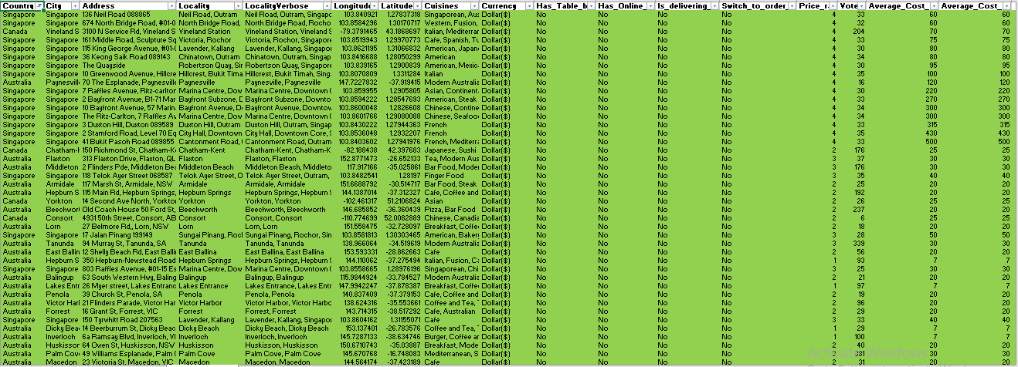

1. **Create a new customized price column that consists of the abbreviation/symbol of the currency along with the Average_cost_for_two value. [Use string operations to do this task]**

**Answer: To create the new customized price column that consist of the abbreviation/symbol of the currency along with the average cost of two value, I insert a column U and used string formula.**

* **Formula used: =CONCATENATE(VLOOKUP($C3,'country description'!$A$1:$E$16,4,0),'Filter data '!$T3)**

**Reference: Sheet name – Filter data**

1. **How can you create an array formula in Excel or Google Sheets to count the number of restaurants listed that do not offer online delivery, are in the lowest** **price range, and have an average cost for two people less than or equal to 250 Indian Rupees?**

**Answer**: **To count the number of restaurants that do not offer delivery, and are in the lowest price range, and have average cost for two peoples less than or equal to 250 Indian rupees, I used aggregation function Countifs.**

* **Formula used: =COUNTIFS('Filter data '!$N:$N,"No",'Filter data '!$Q:$Q,1,'Filter data '!$S:$S,"<=250",'Filter data '!$L:$L,"Indian Rupees(Rs.)")**

**Reference: Sheet name – 2. Opening of Restaurants**

**Subjective Question:**

**1. Suggest a few countries where the team can open newer restaurants with lesser competition. Which visualization/technique will you use here to justify the suggestions?**

**Answer: To find the countries where the team can open new restaurants with lesser competition I analyses the average ratings and number of restaurants in each country.**

* **To analyze the data, I made the pivot table which include Country in rows and in the field section I put ratings and restaurant id to find the total no. of restaurants and average ratings in each country.**
* **After analyzing the pivot, I found that the Countries like India, Australia, Singapore, Brazil, Sri Lanka & Canada have most least ratings among other countries.**
* **Also, the number of restaurants in countries like Australia, Canada, Singapore & Sri Lanka is less as compare to other countries.**
* **So, Countries like Australia, Singapore, Canada & Sri Lanka are better place with lesser competition to open a new restaurant.**
* **Reason behind the approach: The country with less number of restaurants and less number of restaurants have less competition because the customers are not satisfied with the current services and foods there. So, we have chance to satisfy the customer by providing best services and food to attract them towards us also this will help us to grow well as the number of restaurants are less there.**

|  |  |  |
| --- | --- | --- |
| **Country** | **Count of RestaurantID** | **Average of Rating** |
| Australia | 24 | 3.658333333 |
| Brazil | 60 | 3.846666667 |
| Canada | 4 | 3.575 |
| India | 8652 | 2.770550162 |
| Indonesia | 21 | 4.295238095 |
| New Zealand | 40 | 4.2625 |
| Philippines | 22 | 4.468181818 |
| Qatar | 20 | 4.06 |
| Singapore | 20 | 3.575 |
| South Africa | 60 | 4.21 |
| Sri Lanka | 20 | 3.87 |
| Turkey | 34 | 4.3 |
| United Arab Emirates | 60 | 4.233333333 |
| United Kingdom | 80 | 4.1 |
| United States of America | 434 | 4.011290323 |

* **For visualization, we can use pivot charts such as line charts and clustered bar charts to compare the competition between different countries.**

**Reference: Sheet Name – 1.Suggestion**

**2. Come up with the names of States and cities in the suggested countries suitable for opening restaurants.**

**Answer: To find the cities in the suggested countries I applied the same criteria of comparing average ratings among other cities and number of restaurants in each city.**

* **To analyze the data, I created a pivot table in which I put city in rows, average ratings and count of restaurants IDs in values and country and ratings in the filter field.**
* **I applied the filter on the suggested countries and ratings below 3.5 to find the cities with lesser competition.**
* **Here is the list of the cities with low competition which falls under the criteria which I used to find the countries and cities with lesser competition to open new restaurants.**
* **So, according to the given data we can open new restaurant in Colombo, Consort, Mayfield, Montville, Paynesville, Yorkton, etc. as they are the best choice for opening of restaurant.**
* **Reference: Sheet name – 2. Opening of Restaurants**

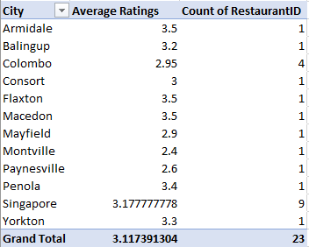

**3. According to the countries you suggested, what is the current quality regarding ratings for restaurants that are open there?**

**Answer: To find the current quality regarding ratings for restaurants in the suggested countries, I made a table as mentioned below and find out the overall average ratings of the restaurants that are opened there.**

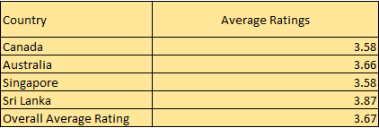

* **According to the data the overall average rating of the suggested countries is almost 3.7 i.e. the customer is not fully satisfied with the current service and taste of the cuisines there.**
* **Reference: Sheet Name – 1.Suggestion**

**5. Also, what is the current expenditure on food in the suggested countries, so we can keep our financial expenditure in control?**

**Answer:** **Method used:** Here we used Aggregated function Sumif to get current expenditure of selected countries and then converted them into dollars.

**Formula:** SUMIF ('Filter data '!$D:$D,"COUNTRY",'Filter data '!$T:$T)

After this I multiply the result with current conversion rate of dollar to convert them in dollar.

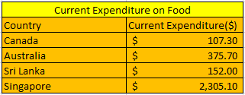

Reference: 2. Opening of Restaurants

**6. Come up with the names of restaurants from the recommended states that are our biggest competitors and also those that are rated in the lower brackets, i.e. 1-2 or 2-3.**

**Answer:** **Method used:** I used pivot table to find competitors. In which I put restaurants name in rows, countries in filter & ratings in value. (Sheet name: Ratings).

After Analyzing here are some suggested restaurants:

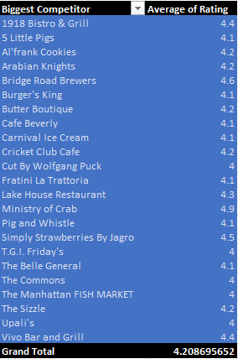

* These restaurants have higher ratings in the suggested countries. So we can say that they are the biggest competitor for us in the market.
* **LOWER BRACKETS**
* Here is the list of some restaurants who fall under the criteria of lower brackets.

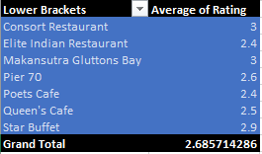

**Reference**: 8. Competitor’s Analysis

**7. Which cuisines should we focus on in the newer restaurants to get better feedback? Does the choice of cuisines affect the restaurant ratings?**

**Answer: Method used: Pivot Table and Filtering (Sheet name: Cuisines)**

* 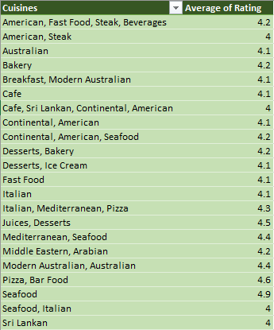
* **Above is the list of cuisines which are available in the menu of restaurants which have average ratings greater than 4.**
* **So, according to the country where we plan to open restaurants we can focus on these cuisines.**

**8. According to our current data, should we go for online delivery and table booking? Does that affect the customer’s ratings?**

**Answer: Method used : pivot table (Sheet name : Online booking and table book)**

|  |  |  |  |  |
| --- | --- | --- | --- | --- |
| **Countries** | **Online Delivery** | | **Table Booking** | |
| **YES** | **NO** | **YES** | **NO** |
| Canada |  | 4 |  | 4 |
| Australia |  | 24 |  | 24 |
| Singapore |  | 20 |  | 20 |
| Sri Lanka |  | 20 |  | 20 |

* **Decision -** We should go for table booking and online delivery. As none of the restaurants are providing this facility. This can be an edge over our competitors. But for doing this we can go for a survey to know that people in that country are willing to go for online delivery and table booking or not.

* **Cost vs. Services**: Explore if there is a relationship between the cost for two and the availability of table booking or delivery services. Analyze whether customers are willing to pay more for the convenience of these services.
* **Geographical Trends**: Consider exploring if the prevalence of table booking and delivery services varies by country or region.

**9. Should the team keep the rate of cuisines higher? Will that affect the feedback? According to our data are the rates of cuisines and ratings, correlated?**

**Answer:**

**Method used** : I have used CORREL Function to find the correlation between rate of cuisines and ratings**.**

* **Magnitude (Absolute Value)**: The absolute value (ignoring the negative sign) is very close to zero (0.058957), indicating an extremely weak correlation. In practical terms, the correlation is so minimal that it's unlikely to be practically significant or meaningful
* **Decision**: We can keep the rate of cuisines higher or we can keep it moderate so it will be affordable to everyone , as the correlation is very negligible between rating and rate of cuisines

**CORREL function : (Sheet name – Ratings)**

**10.What is the distribution of the number of restaurants of different price ranges in all the countries?**

Answer: Reference: Sheet Name – Price Range

|  |  |  |  |  |
| --- | --- | --- | --- | --- |
| **Country** | **Number of restaurants** | | | |
|
| **Price Range 1** | **Price Range 2** | **Price Range 3** | **Price Range 4** |
| Australia | 4 | 14 | 5 | 1 |
| Brazil | 2 | 7 | 16 | 35 |
| Canada |  | 3 |  | 1 |
| India | 4295 | 2858 | 1111 | 388 |
| Indonesia |  | 1 | 20 |  |
| New Zealand | 3 | 4 | 17 | 16 |
| Philippines |  | 1 | 12 | 9 |
| Qatar |  | 1 | 5 | 14 |
| Singapore |  | 1 | 5 | 14 |
| South Africa |  | 4 | 17 | 39 |
| Sri Lanka |  | 6 | 11 | 3 |
| Turkey |  | 11 | 18 | 5 |
| United Arab Emirates |  | 9 | 29 | 22 |
| United Kingdom | 4 | 28 | 32 | 16 |
| United States of America | 136 | 165 | 110 | 23 |

**11. Explain your approach in brief for suggesting countries/cities in order to open new restaurants, if the objective and subjective questions would have been given to assist you. [you have to give bullet pointers in order to answer this question]**

**Answer: In order to find countries with lesser competition for new restaurants, I will consider analyzing data based on the following criteria if the objective and subjective question are not given to assist:**

1. **Aggregate Data by Country:** Group the data by country to see the distribution of restaurants across different countries.
2. **Analyze Cuisine Trends:** Identify the most popular cuisines in each country based on the dataset. This will help me understand the local food preferences.
3. **Evaluate Average Cost and Price Range:** Compare the average cost for two and price range across countries. Consider the affordability of dining out in each country and how it aligns with our team target market.
4. **Assess Ratings and Votes:** Examine the ratings and number of votes for each restaurant. This can give insights into customer satisfaction levels and the competitiveness of the restaurant scene in each country.
5. **Consider Market Saturation:** Look at the number of restaurants in each country to assess market saturation. A high number of restaurants may indicate a competitive market, while a lower number may present opportunities for new restaurants.
6. **Review Opening Dates:** Take into account the dates of opening for each restaurant. This can help identify emerging markets where there's potential for growth.
7. **Factor in City-Level Data:** If available, analyze the dataset at the city level to pinpoint specific locations within countries that have a high demand for restaurants or are underserved.
8. **Rank and Prioritize:** Based on my analysis, rank the countries according to their suitability for opening a new restaurant. Consider factors such as market size, growth potential, competition, and alignment with team business objectives.

By following this approach, I will suggest the country name and cities to the team to open new restaurant in the market with lesser competition.