- About Data set –
BANK FINANCIAL LOAN ANALYSIS AND CONCLUSIONS
The financial loan dataset contains over 38,000 loan applications, capturing borrower demographics, employment details, income levels, loan amounts, interest rates, and repayment status. It is designed to analyse borrower profiles, loan performance, and customer behaviour. Key variables such as loan application grade, debt-to-income ratio, and loan status enable risk assessment and predictive modelling for financial institutions.

- _{Conclusions –}
I have used PostgreSQL to analyse this dataset. During the analysis, I added some useful columns such as year and month (using date and time functions), and total interest amount (using aggregate functions). In addition, I derived valuable information from multiple columns, including total funded amount, total payment, total interest amount, and the average interest rate for specific loan applications.

- TOTAL LOAN APPLICATION – 38069
- TOTAL FUNDED AMOUNT - 430033125
- TOTAL PAYMENT - 466809643
- TOTAL INTEREST AMOUNT – 36776518
- MONTHLY LOAN APPLICATION –

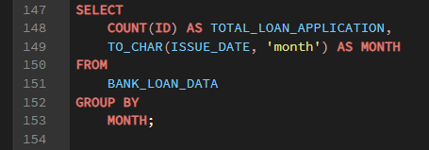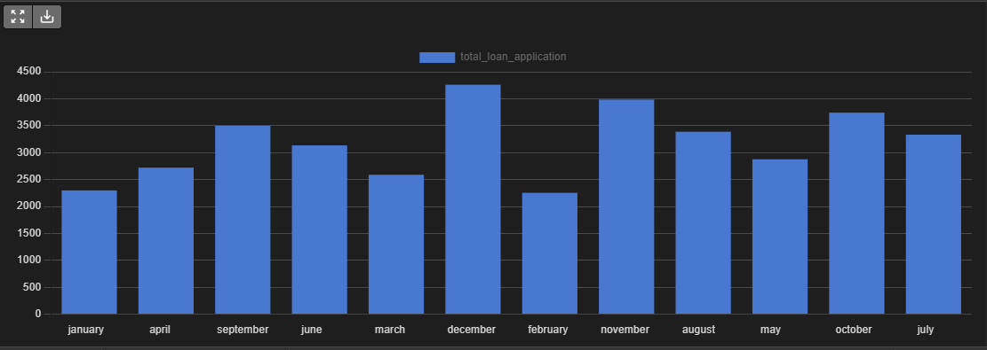
- MONTHLY FUNDED AMOUN
T – 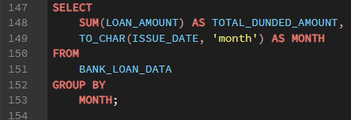
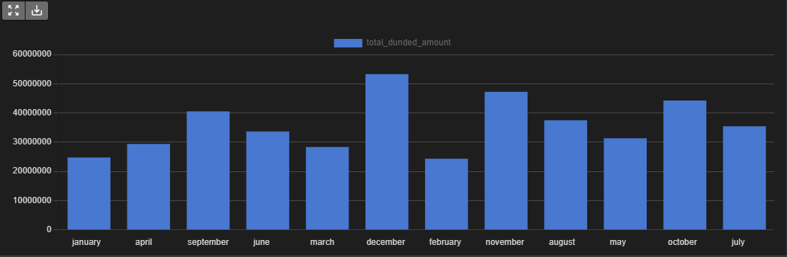

- TOTAL LOAN APPLICATION BASED ON GRADE – 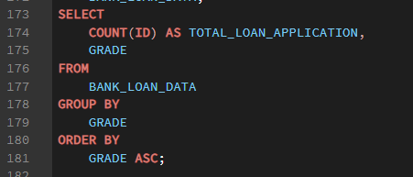 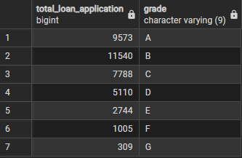
- 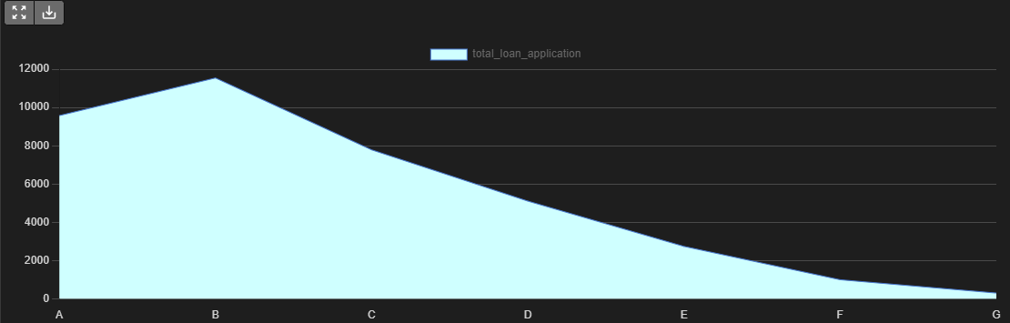
- Grade B received highest number of loan application.

- Top 5 loan application and their loan amount. 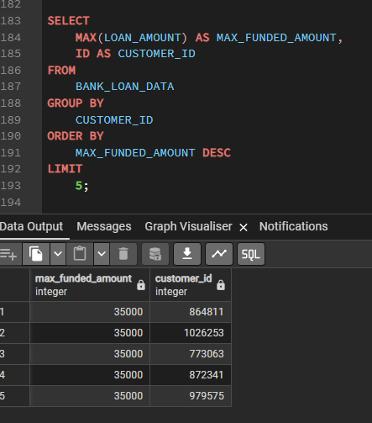

- Final conclusion –

With these steps, our Exploratory Data Analysis (EDA) is complete. We now have a comprehensive and in-depth understanding of the data structure, loan application performance, and customer behaviour — providing a solid foundation for advanced business analytics, reporting.

------------------------------------------------------------------------------------------------------------------------------------------------------------------------------------------------------------------------------------------------------------------------------------------

