BANK
FINANCIAL LOAN
ANALYSIS SUMMERY

YEARLY details.
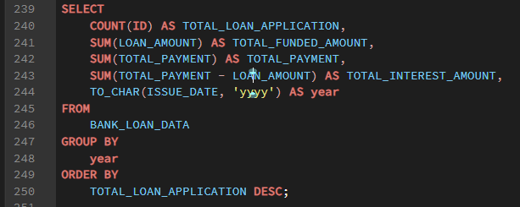
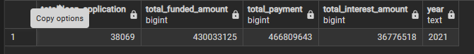

- Year 2021 ->
- TOTAL LOAN APPLICTION – 38,069
- TOTAL LOAN AMOUNT – ₹ 43,00,33,125
- TOTAL PAYMENT RECEIVED BY BANK -₹46,68,09,643
- TOTAL INTEREST – ₹ 3,67,76,518

MONTHLY details.

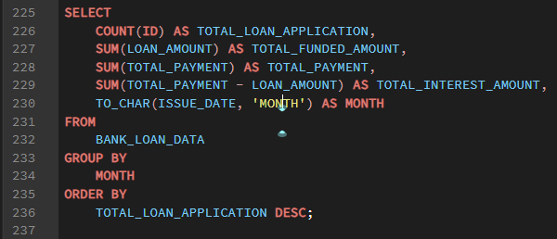
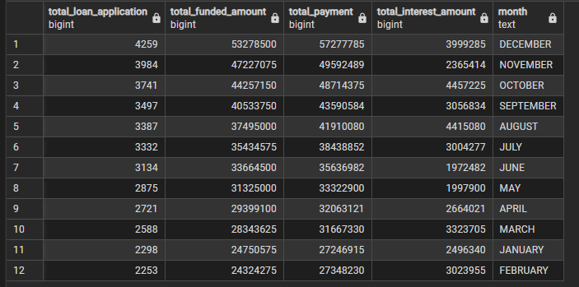
-The bank has received the highest number of loan applications In December month with
- total payment – ₹52277785
Total interest amount - ₹3999285

Quarterly details.

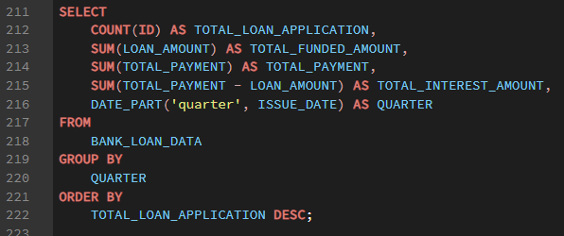
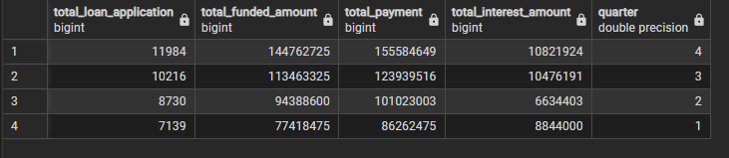
- In quarter 4 bank has received highest loan application with:
- total loan amount – ₹144762725
-total payment – ₹155584649
- total interest amount - ₹10821924

Total loan application.
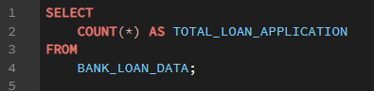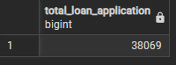
- Total 30069 loan Application received by bank.

Top 5 state where bank has received highest loan application.
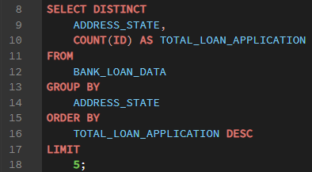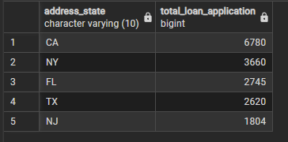
- CA on first position from where bank has got highest loan application.
top 5 emp title where bank have got highest loan application.
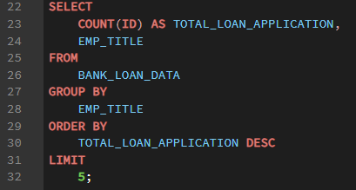
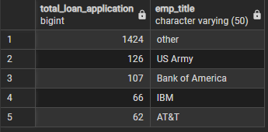
- Where emp title is not describe bank has got highest loan application.

Highest loan application according to the grade.
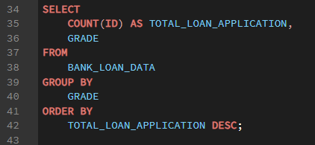
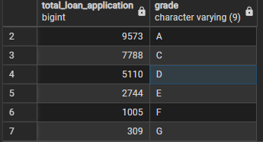
- Highest loan application in A grade and Grade G has got minimum loan application.

Sum of loan application and their home ownership status.
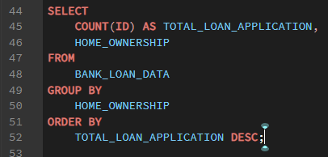
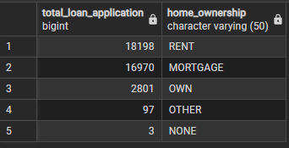
- Where home ownership status is rented bank has got highest loan application.

Monthly total loan application.
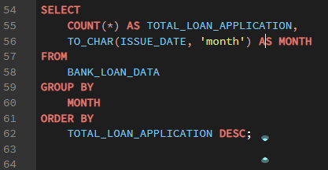
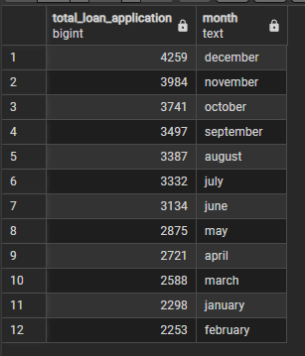
- In December bank has got highest loan application and in February month bank has got lowest loan application.

Total loan application according to the loan status.
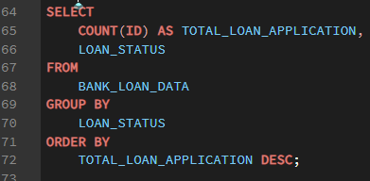
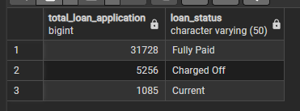
- In this data we have three types of loan status, fully paid loan application is 31728 and current loan application status is 1085.

Total loan application on loan purpose.
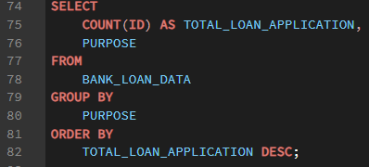
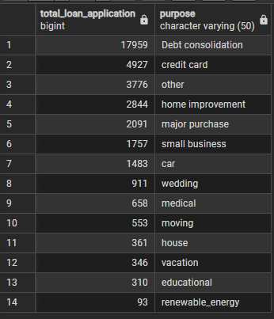
- Where purpose of loan is debt consolidation got 17959 highest loan application.
- And renewable energy has got minimum loan application.

Total loan application on duration().
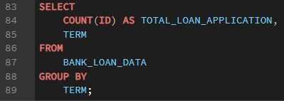
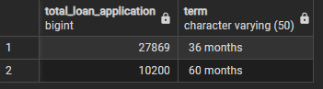
Total loan application and their verification status.
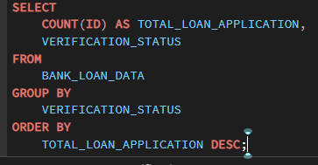
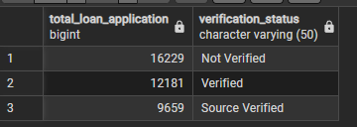
- Not verified – highest loan application.

Total funded amount.
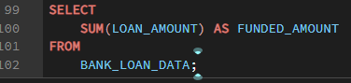
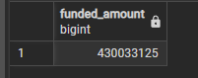
- Funded amount – which amount bank has funded toward the customers.

rank of address state according to the funded amount.
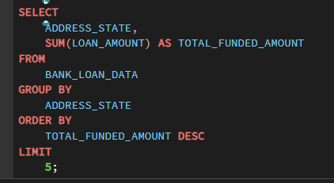
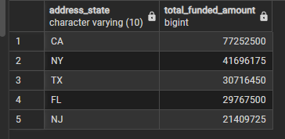
-California on first position according to the funded amount.

Monthly Funded amount.
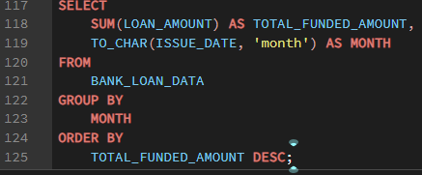
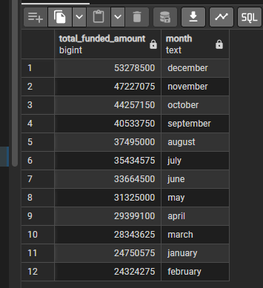
-total funded amount highest in December (INR-53278500) and lowest in February (INR-24324275).

Total loan application and their funded amount followed by grade.
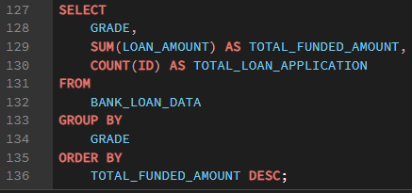
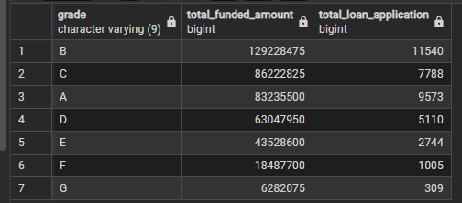
- Highest loan amount and loan application in B grade.
- Grade – G lowest in this case.

OTHER Details: -
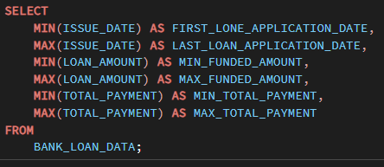

- Oldest loan application date 2021-01-01
- Last loan application on 2021-12-12
- Minimum bank’s loan amount INR-500.
- Maximum loan amount INR- 35000.
- Lowest returns INR – ₹ 35.
- Maximum returns INR – ₹58564.

Top highest returns and their loan application ID’s.
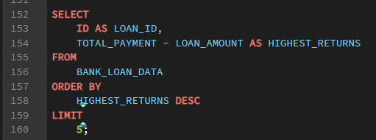
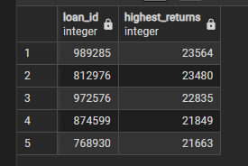

Top 5 loan application and their loan recovery days.
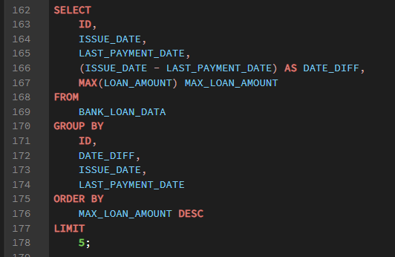
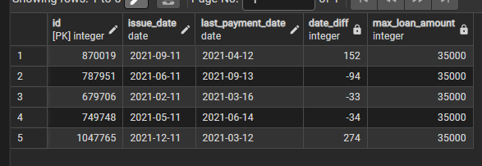
-loan application id ‘870019’ has highest loan recovery period which is 152 days.

Top 5 customer and their total interest amount.
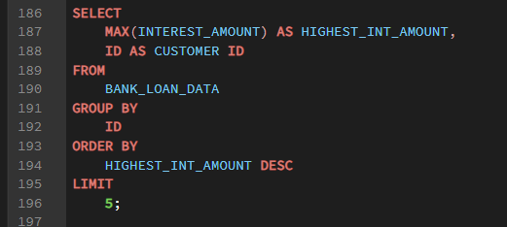
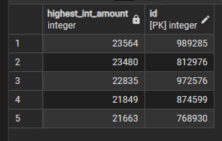
- Customer id ‘989285’ has highest interest amount which is INR- 23564 / -

Highest payment and their recovery periods.
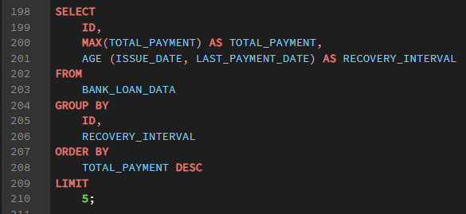
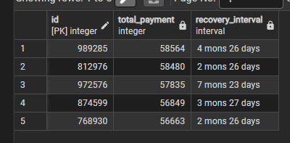
- On total amount ‘₹ 58564’ and Id ‘989285’ have highest recovery period.

----------------------------------------------------------------------------------------------------------------------------------------------------------------------------------------------------

