BIG BAZAAR SALES ANALYSIS AND EDA (EXPLORATORY DATA ANALYSIS) REPORT

- Introduction / About Dataset
The dataset represents Big Bazaar’s transactional sales records, capturing product purchases, customer demographics, and payment details. It enables analysis of sales performance, consumer behaviour, and regional demand. Key findings include city-level rankings, product popularity, and spending extremes, which can guide marketing and inventory decisions. In this dataset we 4 following tables…
1. In the Customers table, I have data for 520 customers with the following columns:
# customer_id (unique ID for each customer)
# customer_name(name of the customer)
# city (location of the customer)
# signup_date(date of the customer’s signup or order)

2. In the Orders items table, we have data for 2,050 orders with the following columns:
# order_item_id - unique ID of each order item
# order_id - unique ID of each order
# product_id - unique ID of each product
# quantity - quantity of the product
# unit_price - price of each product

3. In the orders table, we have data for 1,240 orders with the following columns:
# order_id - unique ID of each order
# customer_id - unique ID of each customer
# order_date - date of the order
# payment_method - payment method used for the order

4. the product table, we have data for 90 products with the following columns:
# product_id - unique ID of each product
# product_name - name of the product
# category - category to which the product belongs
# base_price - cost of the product without extra charges

- PROBLEM STATEMENTS
- Incorrect datatypes
- Total revenue 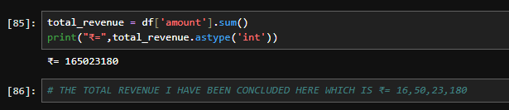
- Handling null values in various column
- Handling duplicate values
- Inconsistent values in various column
- Data transformation by
Amount, year, month. 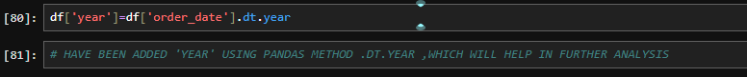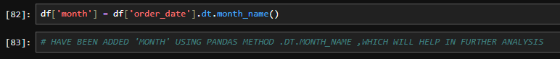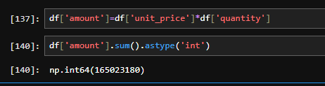

- EDA PROCESS
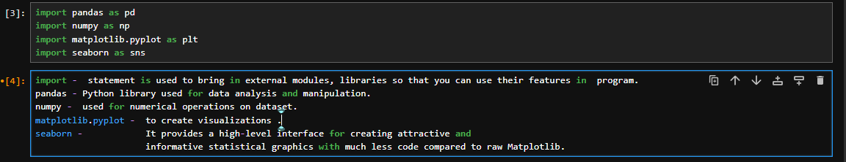
- Python Libraries’: -
1.Pandas
2.numpy
3.matplotlib
4.seaborn
* File importation…
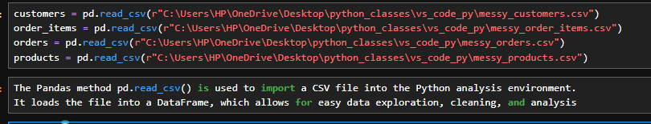
--------------------------------------------------------------------------------------------------------------------------------------------------------------------------------
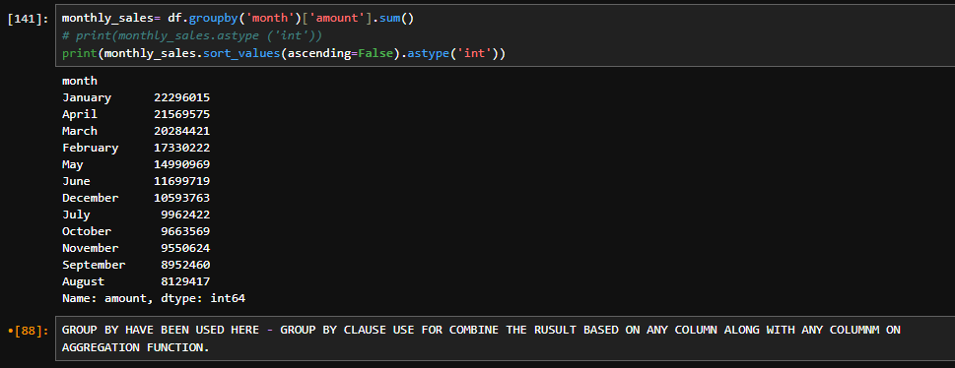
- Total sales highest in January and after that it decrease.
- Lowest sales in august month.
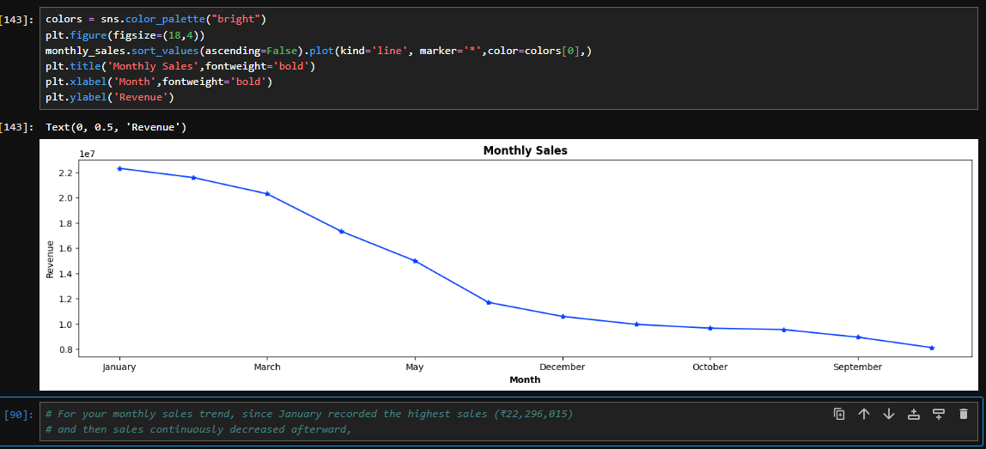
- The data shows a clear downward trajectory, beginning with higher sales in January and gradually declining through March, May, September, October, and finally December. This consistent fall in revenue highlights a negative sales trend over time, suggesting reduced customer activity or market demand in later months.

- top 5 products by revenue: -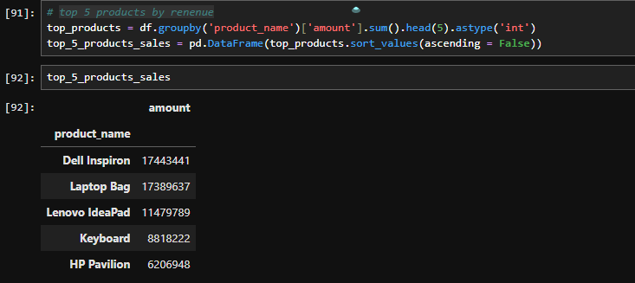

  - the revenue contribution of five products. Among them, Dell Inspiron generates the highest revenue, followed by Laptop Bag, Lenovo IdeaPad, and Keyboard, while HP Pavilion ranks lowest. This distribution shows that Dell Inspiron is the most profitable product, whereas HP Pavilion contributes the least to overall revenue.
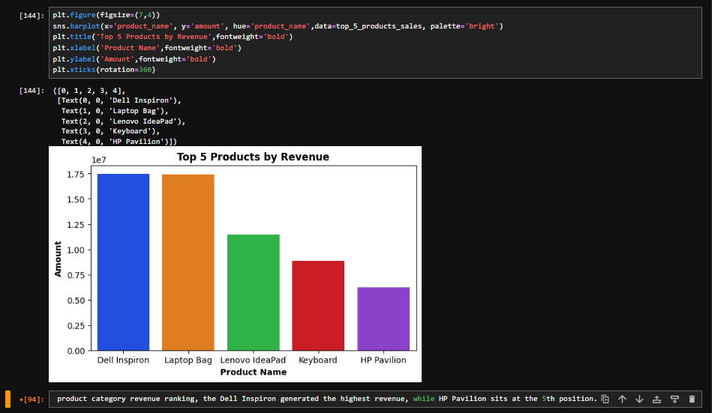

- top 5 products by product popularity.
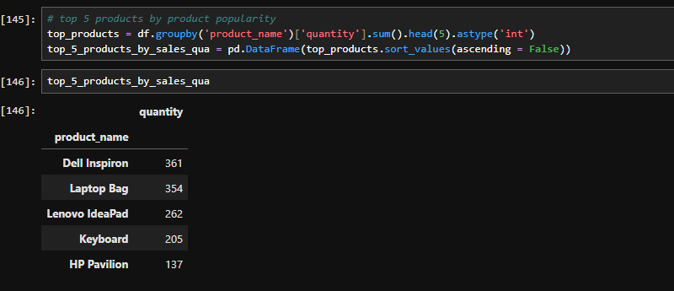

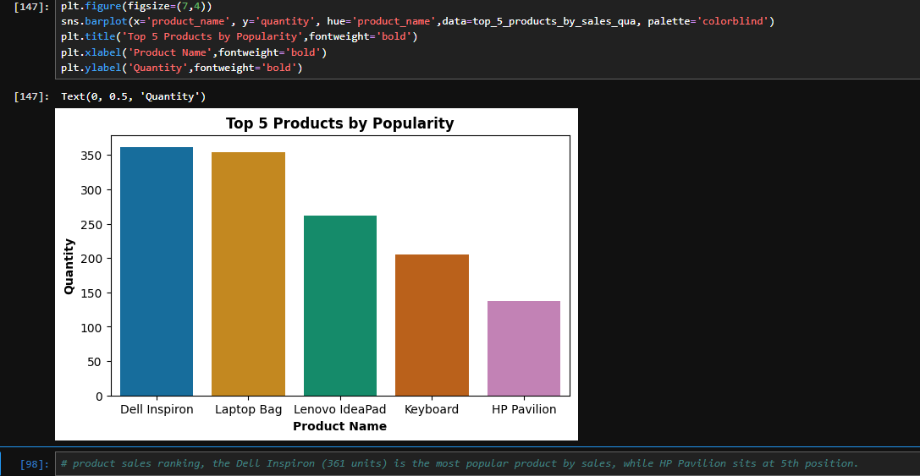

presents product demand based on sales quantity. Dell Inspiron is the most popular product, selling the highest number of units (361), followed by Laptop Bag, Lenovo IdeaPad, and Keyboard, while HP Pavilion ranks lowest in popularity. This ranking highlights Dell Inspiron as the leading product in terms of customer preference, whereas HP Pavilion contributes the least to overall sales volume.

- total payment using payment method.

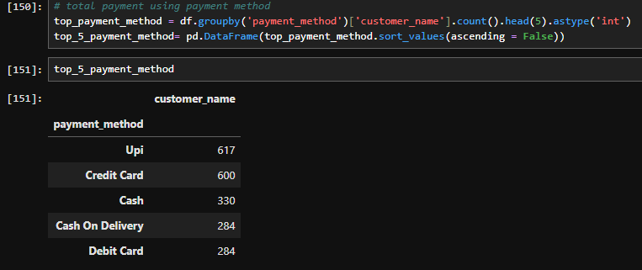
The bar chart titled Top 5 payment method shows the distribution of customers across five payment methods. UPI emerges as the most preferred option, followed closely by Credit Card, while Cash and Cash on Delivery occupy middle positions, and Debit Card is the least chosen. This highlights a strong customer inclination toward digital transactions, with UPI and Credit Card dominating over traditional methods.

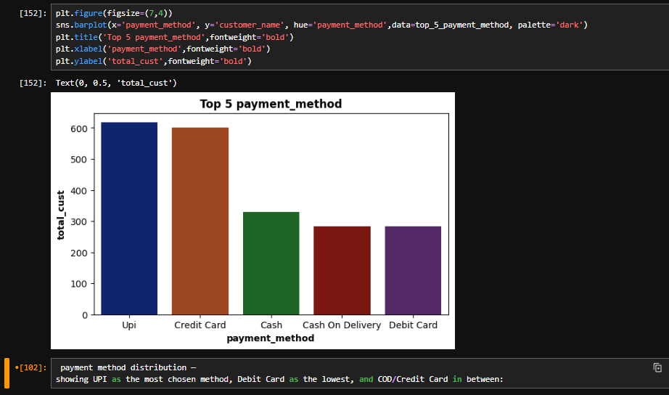

- category wise revenue: -
.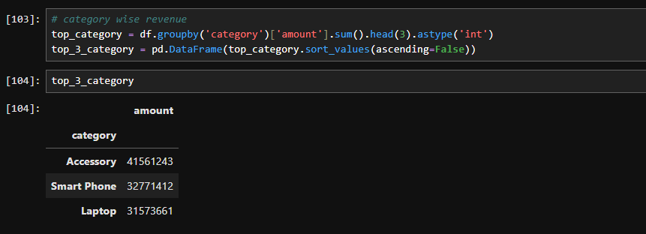 revenue across three product categories. The Accessory category generates the highest revenue (₹41,561,243), followed by Smart Phone, while Laptop records the lowest revenue (₹32,000,000 approx). This ranking clearly shows that accessories outperform core products in revenue contribution, with smartphones in the middle and laptops trailing behind.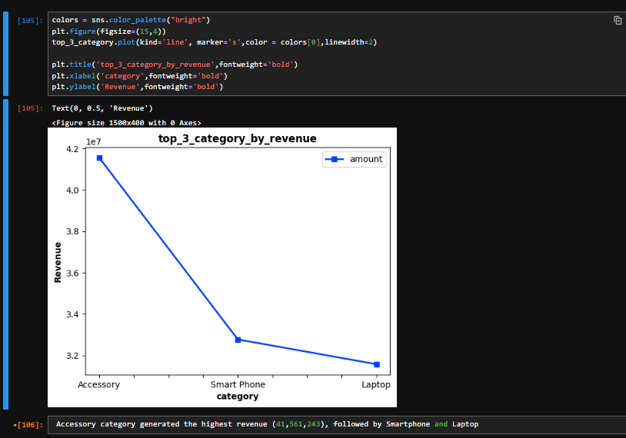

- highest Sold Quantity by Category.
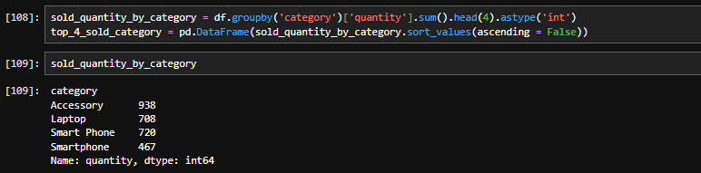
accessory has got first position in total sales products which is total 938 products followed by laptop and smart phone. 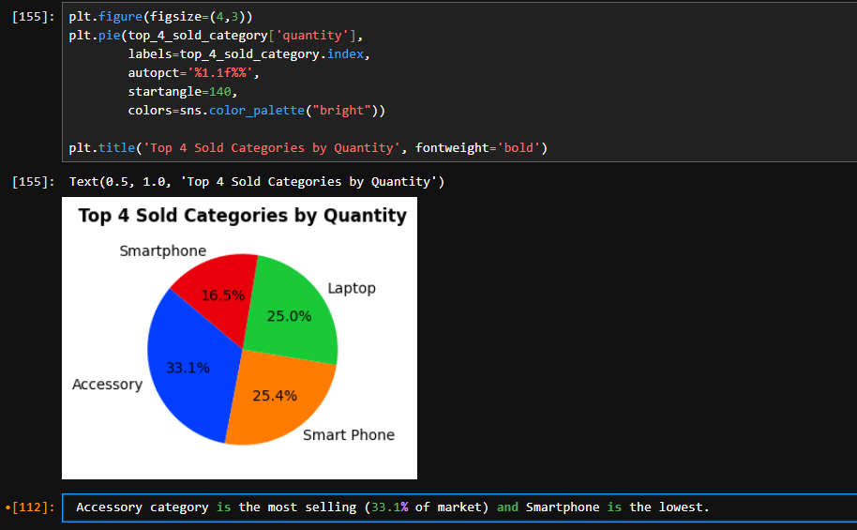 distribution of sales across four categories. Accessory holds the largest share at 33.1%, making it the most sold category. Smart Phone (25.4%) and Laptop (25.0%) follow closely, while Smartphone contributes the smallest share at 16.5%. This ranking highlights accessories as the dominant category in terms of sales volume, while smartphones trail behind.

- the Top Order IDs with Highest purchase Amount —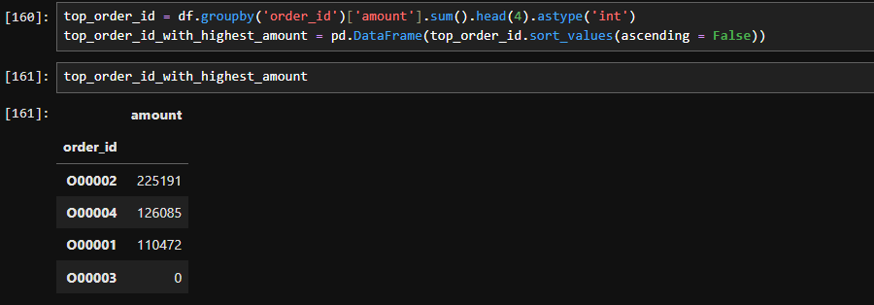
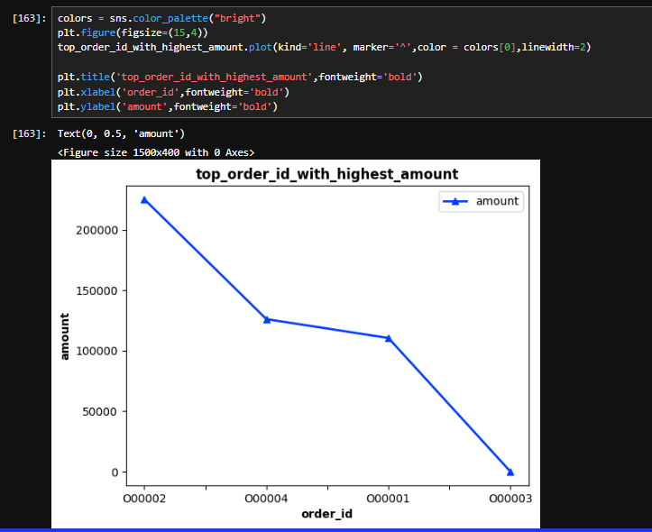 compares transaction amounts across selected order IDs. The data shows that order ID 000002 recorded the highest amount, followed by 000004, while 000001 and 000003 reflect lower values. The overall trend is downward, indicating that the transaction amounts decrease progressively across these order IDs.

- Top City by Spending Amount on products. 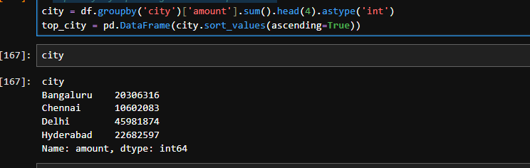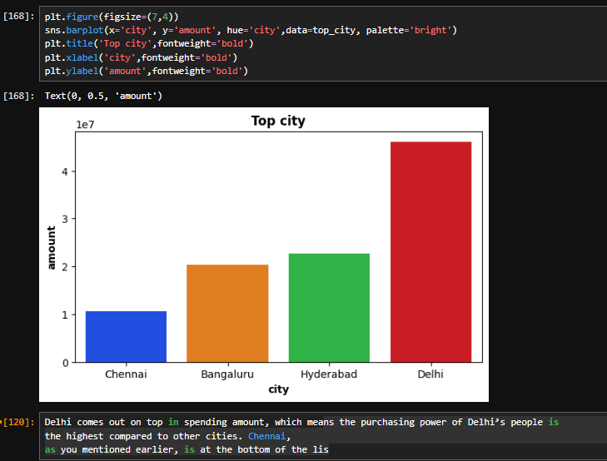 spending amounts across four major cities. Delhi records the highest spending (₹45,981,874), indicating the strongest purchasing power. Hyderabad follows with ₹22,682,597, while Bangaluru contributes ₹20,366,316. Chennai ranks lowest with ₹10,602,803. This distribution highlights Delhi as the leading city in terms of consumer spending, with Chennai showing comparatively weaker purchasing power.
customer distribution by city looks like this -
# Delhi - Most customers (Rank 1)
# Mumbai - Second position (Rank 2)
# Chennai - Lowest (Rank last)

- yearly total sales trend (based on amount)

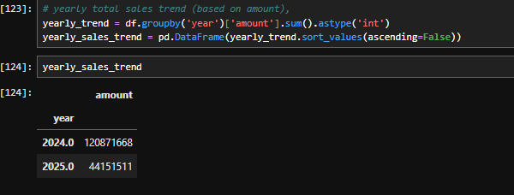 shows a sharp decline in sales between 2024 and 2025. In 2024, sales peaked at approximately ₹120,000,000, marking the highest point in the dataset. By contrast, 2025 recorded the lowest sales, dropping to around ₹40,000,000. This steep fall indicates a significant downturn in business performance after 2024.
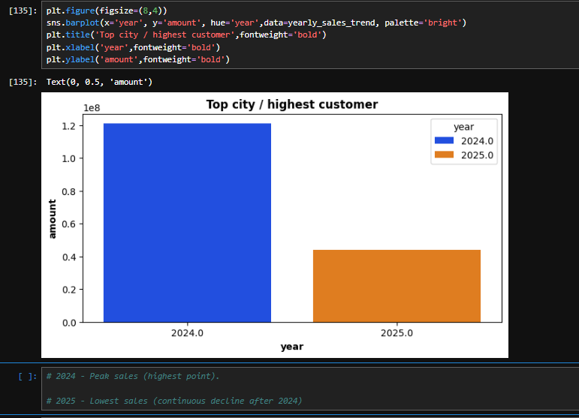

- yearly sales trend based on sold quantity 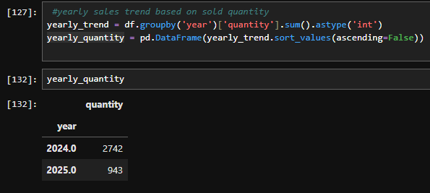
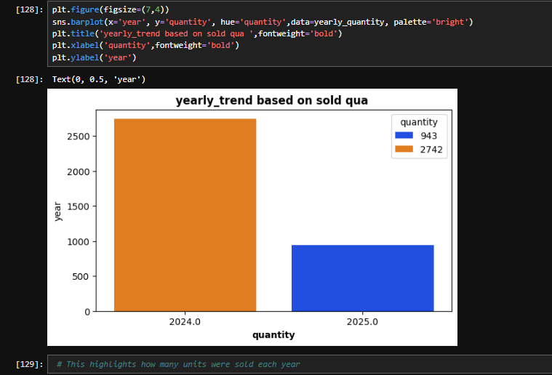
total units sold across two years. In 2024, sales quantity peaked at 2,742 units, marking the strongest performance. In contrast, 2025 recorded only 943 units, showing a sharp decline. This highlights a significant drop in product demand or sales activity between the two years.
- Final Conclusions –
• Sales performance shows a significant decline from 2024 to 2025, both in revenue and quantity.

• 2024 was the peak year, while 2025 experienced a sharp downturn, indicating possible business or market issues.
• Delhi is the top-performing city in terms of total spending and customer count.

• Hyderabad and Bangalore follow as moderate contributors.

• Chennai shows the lowest spending and weaker market presence
• Accessories dominate sales, contributing the highest share.

• Smartphones and Laptops perform moderately well.

• Some categories (like smartphones in your breakdown) contribute relatively less, suggesting potential underperformance or competition

------------------------------------------------------------------------------------------------------------------------------------------------------------------------------------------------------------------------------------------------------------

