- Total Respondent.
HealthCare Analysis|Sammary
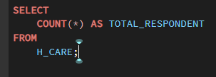
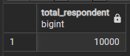

- Average age of Respondent.
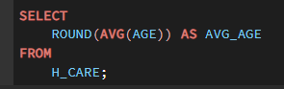
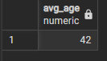

- Other Important Information.
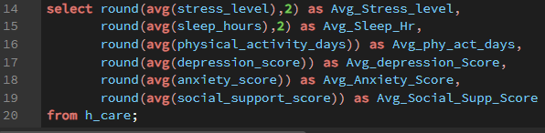

- Information based on Mental Health Risk.
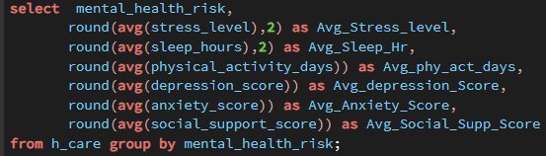
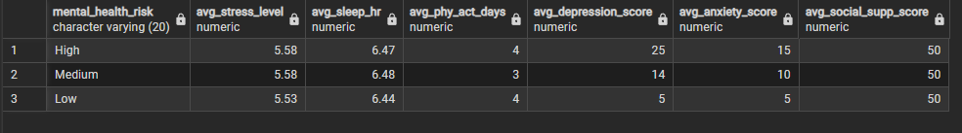

- Total Respondent according to gender.

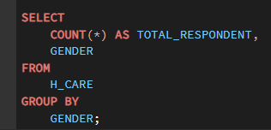
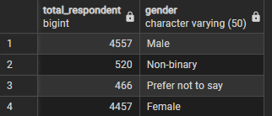

- Total Respondent according to employment status.

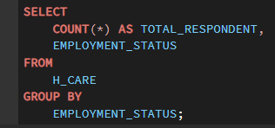
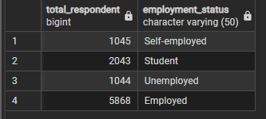

- Total Respondent According to Work environment.





