SOFTWARE REQUIREMENTS
SPECIFICATION
Order Management and Payment Reconciliation System
for Madhav Bharat Gas Agency (MBGA)
PHASE 1
Implementation-Ready Requirements Baseline
Version 1.0 | 04 September 2026

Document Control
Document | Software Requirements Specification — Order Management and Payment Reconciliation System
Client | Madhav Bharat Gas Agency (MBGA)
Release | Phase 1
Version | 1.0
Date | 04 September 2026
Status | Draft for Review / Pending Client Validation
Primary Sources | Statement of Work (modified 20-Aug-2026) and MBGA Site Visit Notes
Scope Baseline | Phase 1 requirements only; later-phase capabilities are explicitly marked as Out of Scope or Flagged

Approval & Sign-Off
Role | Name | Status | Date
MBGA Business Owner | ________________ | Pending | ____________
MBGA Project Representative | ________________ | Pending | ____________
Implementation Team | ________________ | Pending | ____________

Document Control Note
This document is the Phase 1 implementation baseline. Requirements are not repeated in later sections unless they are referenced for traceability. Any site-visit requirement that conflicts with the agreed SoW phasing is isolated in the scope-reconciliation/open-items sections.

Table of Contents
Section | Title
1 | Introduction
2 | Overall Description
3 | Functional Requirements
4 | External Interface Requirements
5 | System Workflows
6 | Non-Functional Requirements
7 | Data Requirements
8 | Role and Permission Matrix
9 | Consolidated Open Items Requiring MBGA Confirmation
Appendix A | Cylinder Type Reference

Reading Order
Sections 1–2 establish the purpose, scope, users and operating context. Section 3 is the authoritative functional-requirement baseline. Sections 4–8 define interfaces, workflows, quality attributes, data and access control. Section 9 contains only unresolved/flagged decisions requiring client confirmation.

1. Introduction

1.1 Purpose
This Software Requirements Specification (SRS) defines the functional and non-functional requirements for Phase 1 of the Order Management and Payment Reconciliation System being built for Madhav Bharat Gas Agency (MBGA). It translates the Phase 1 scope agreed in the Statement of Work (SoW, modified 20-Aug-2026) together with the clarifications captured during the MBGA site visit into a single, implementation-ready requirements baseline.
Where the site visit notes introduced requirements that the SoW had scheduled for a later phase, or introduced entirely new capabilities, this document flags them explicitly rather than silently expanding or shrinking Phase 1 scope. Section 2.7 consolidates every such item for MBGA to confirm before development begins.

1.2 Scope
Phase 1 delivers a centralized, cloud-based platform (web back-office + mobile apps) that replaces MBGA's manual, phone-call-based order process with a digital workflow covering:
Customer onboarding with document-based pre-verification (retailer and industrial)
Customer-wise monthly pricing with priority-tier overrides on a BPCL base
Digital order placement and booking-cutoff based scheduling
Delivery execution, cylinder exchange, and pending-pickup tracking
Split payment collection (cash / UPI / NEFT) and basic reconciliation (over/under payment flagging, invalid-transaction handling)
Godown inventory tracking across all cylinder types, filled / empty / defective
Role-based access for Manager, Salesperson, Godown Stock Manager, Accountant, Driver, Helper, and Customer
In-app and email notifications for order lifecycle events and operational exceptions
Basic expense tracking and a light task-assignment/escalation mechanism
Explicitly out of scope for Phase 1 (per the SoW's own phasing) unless otherwise flagged in Section 2.7: route optimization and trip sequencing, full OEM telematics integration, competitor intelligence tracking, the full management dashboard/report suite, and comprehensive audit logging — these remain targeted at Phases 2 through 4.

1.3 Definitions, Acronyms and Abbreviations
Term | Definition
MBGA | Madhav Bharat Gas Agency — the client and distributor
BPCL | Bharat Petroleum Corporation Limited — upstream LPG supplier and base-price reference
SoW | Statement of Work document for this engagement
SRS | Software Requirements Specification (this document)
RBAC | Role-Based Access Control
OTP | One-Time Password, used for delivery confirmation
FSSAI | Food Safety and Standards Authority of India — license required for industrial customer verification
GST | Goods and Services Tax registration
PAN | Permanent Account Number — Indian tax identity document
Aadhaar | Indian resident biometric identity number, used for retailer verification
L-type / V-type | Liquid-offtake / Vapour-offtake sub-types of the 47.5 kg industrial cylinder
Hippo cylinder | 422 kg bulk industrial LPG cylinder
SLA | Service Level Agreement / target resolution time for an exception
OEM telematics | Vehicle-tracking systems supplied by the vehicle manufacturer (e.g., Eye-Alert, Tata Motors Telematics Feed, iMAXX)
FIFO | First-In-First-Out stock rotation logic
FR | Functional Requirement
NFR | Non-Functional Requirement

1.4 References
Statement of Work — "Order Management and Payment Recon System for MBGA", modified 20-Aug-2026
MBGA Site Visit Notes (17 numbered points covering inventory, roles, verification, tracking, notifications and escalation), received September 2026

1.5 Document Conventions
Each functional requirement is tagged with an ID in the form FR-<Module>-<Number> and a priority:
Must-Have — required for Phase 1 go-live, drawn directly from SoW-tagged Phase 1 items
Should-Have — valuable Phase 1 addition raised in the site visit; recommended for inclusion but not release-blocking
Flagged — introduced by the site visit but conflicts with, or depends on, a capability the SoW scheduled for a later phase; requires explicit MBGA confirmation before being committed to the Phase 1 build (see Section 2.7)
Source references such as “(Site Visit #14)” or “(SoW §2d)” point back to the originating note or SoW clause for traceability.

2. Overall Description

2.1 Product Perspective
The system is a new, standalone cloud platform; it is not an extension of an existing MBGA system. It replaces a manual register- and phone-call-based process with a digital platform accessed through a responsive web back-office (for Manager, Salesperson, Godown Stock Manager, Accountant) and mobile apps (for Customer, Driver, and Helper). All roles share a single central database so that pricing, orders, delivery, payment and stock stay consistent across every touchpoint.

2.2 Product Functions (Phase 1 Summary)
Verify and onboard retailer and industrial customers before they can place orders
Maintain customer-wise monthly pricing on top of a BPCL base rate, adjustable by priority tier
Let customers place, repeat, and track orders digitally, respecting per-customer/zone cutoff times
Plan and execute delivery, track cylinder exchange, and auto-maintain a pending-pickup list
Record split payments, flag over/under payments, and route invalid transactions to an authorised reviewer
Track godown stock (filled, empty, defective) across all cylinder types in real time
Send in-app and email notifications for order milestones and operational exceptions
Enforce role-based access so each user sees only the functions and data relevant to their role
Track basic operational expenses and assign/escalate exception-driven tasks

2.3 User Classes and Characteristics
Role | Description | Technical Proficiency
Manager | Business owner / overall administrator. Full system access, approves pricing changes, views all reports. | Moderate — daily web portal user
Salesperson | New Phase 1 role (Site Visit #6). Onboards customers, assists with order entry and pricing input in the field. | Moderate — mobile-first
Godown Stock Manager | New Phase 1 role (Site Visit #6). Owns filled/empty/defective stock, allocates cylinders to trips. | Basic to moderate
Accountant | Reconciles payments, reviews and corrects flagged/invalid transactions, exports period-wise reports. | Moderate — spreadsheet-literate
Driver | Executes delivery, confirms via OTP/signature, records empty collection. | Basic — simple mobile UI required
Helper | Assists the driver with loading, unloading and empty collection; may have limited literacy. | Basic — icon-led mobile UI required
Customer (Retail) | Retail shop owner ordering 19 kg (primarily) and other cylinder types. | Basic to moderate
Customer (Industrial) | Industrial account, potentially multi-site, ordering 47.5 kg / 422 kg cylinders. | Moderate

2.4 Operating Environment
Cloud-hosted backend and central database, accessible over the internet
Web back-office (desktop/tablet browser) for Manager, Salesperson, Godown Stock Manager, Accountant
Native or cross-platform mobile app (Android priority, per typical field-staff device base) for Customer, Driver, Helper
Standard mobile connectivity (3G/4G) in delivery areas; app should tolerate intermittent connectivity for Driver/Helper screens

2.5 Design and Implementation Constraints
BPCL base pricing is treated as a reference value entered/updated in the system (manual or file-based) in Phase 1; no confirmed real-time BPCL pricing API exists at this stage
Aadhaar data handling must follow Aadhaar Act / UIDAI guidelines — Phase 1 stores masked/hashed identifiers only, never raw Aadhaar numbers in plain text
Three distinct OEM telematics formats (Eye-Alert, Tata Motors Telematics Feed, iMAXX) exist in the fleet; Phase 1 does not commit to full multi-OEM integration (see Section 2.7)
Booking cutoff and next-day auto-scheduling logic must be configurable per customer and per zone, not hard-coded

2.6 Assumptions and Dependencies
MBGA will supply or approve a document verification method for Aadhaar/PAN and GST/FSSAI — either manual back-office review in Phase 1 or a third-party verification API if budget/timeline allow
An email-sending service (e.g., SMTP relay or transactional email provider) will be available for notifications
Cylinder type master data (5 kg, 10 kg, 19 kg, 47.5 kg-L, 47.5 kg-V, 422 kg) is fixed for Phase 1 and any new type requires a scope change
Baseline load for capacity planning: 100–125 units of 19 kg delivered daily, 45–50 active retailer/industrial accounts, with demand rising ≈30% during peak periods (Site Visit #2, #3)

2.7 Scope Reconciliation — Site Visit Notes vs. SoW Phasing
The SoW tags many features with an explicit phase. The site visit raised several of these earlier than scheduled, and introduced a few capabilities the SoW does not mention at all. The table below is the single source of truth for how each site-visit item is being treated in this Phase 1 SRS. Items marked “Flagged” are included in this document only to the extent noted, and need explicit MBGA sign-off before development.
Site Visit Item | SoW Phase Tag | Phase 1 Treatment | Action Needed
Full cylinder type matrix incl. 47.5 kg L/V split, 422 kg hippo (#1) | Not itemised (SoW says “retail 19kg / industrial >19kg”) | Included — data model and inventory carry the full matrix from day one | None — low-cost to include now
Daily volume (100–125 units) & 45–50 active accounts (#2) | Not stated | Used as capacity-planning input (Section 6.1), not a feature | None
+30% peak demand (#3) | Not stated | Used as scalability input (Section 6.1/6.2) | None
BPCL base + priority-tier override pricing (#4) | Phase 1 (“category-based pricing logic”) | Included — formalised as explicit priority tiers | Confirm tier definitions with MBGA
Multi-site industrial accounts (#5) | Implied, not explicit | Included in Customer Management | None
Salesperson & Godown Stock Manager roles (#6) | Not listed (SoW lists Admin, Delivery Coordinator, Accounts, Driver/Helper, Customer) | Included — role set expanded for Phase 1 per site visit | Confirm final role naming/mapping to SoW's “Admin” / “Delivery Coordinator”
Aadhaar/PAN and FSSAI/GST pre-verification (#7) | Not detailed in SoW | Included — manual back-office verification workflow in Phase 1; API-based auto-verification is a future enhancement | Confirm verification method/vendor if automated
Booking cutoff windows & next-day auto-reschedule (#8) | “Will be covered in Phase 2” | FLAGGED — included as a basic configurable cutoff in Phase 1 because it is foundational to order automation; SMS/WhatsApp reminder part remains Phase 2 | MBGA to confirm bringing cutoff logic into Phase 1
In-app + email notifications (#9) | SoW Phase 1 order collection mentions app/notification/WhatsApp/web | Included for in-app + email; WhatsApp chatbot ordering channel remains a later-phase item per SoW | Confirm WhatsApp is out of Phase 1
Multi-address with mandatory verification (#10) | Not detailed | Included in Customer Management | None
Expense management — salaries & daily costs (#11) | Not in SoW module list | Included as a lightweight Phase 1 module | Confirm required expense categories
Multi-OEM fleet telematics (Eye-Alert, Tata, iMAXX) (#12) | Not mentioned; relates to Phase 3 route optimization | FLAGGED — Phase 1 provides a basic manual trip/vehicle log only; live multi-OEM feed integration deferred | MBGA to confirm whether any OEM integration is needed before Phase 3
Live customer-facing route tracking (#13) | “Live stage tracking — Phase 3” | FLAGGED — not built in Phase 1; Phase 1 gives status-based tracking only (Confirmed/Dispatched/Delivered), not live map tracking | MBGA to confirm this stays in Phase 3
Proximity alert + instant add-on booking within 5 km (#14) | Not in SoW; depends on live GPS which is Phase 3 | FLAGGED — depends on live location data; Phase 1 can only offer a light version using periodic (non-live) location pings if GPS capture is added early | MBGA to decide: defer fully to post-Phase 3, or approve a light periodic-ping version now
Automated order lifecycle alerts (#15) | Aligns with Phase 1 delivery/notification scope | Included | None
Automated exception alerts — pickups, dues, re-order breaks (#16a) | Aligns with Phase 1 payment/pickup tracking | Included | None
AI Voice Calling Agent (#16b) | Not in SoW | FLAGGED — not included in Phase 1; requires telephony/voice-AI vendor selection | MBGA to confirm target phase (recommend Phase 2/3)
Task assignment & escalation matrix (#17) | Not in SoW as a named module | Included as a basic rule-based version tied to exceptions | Confirm escalation hierarchy/SLA windows

3. Functional Requirements
Requirements are grouped by module. Each carries an ID, description, and priority as defined in Section 1.5.

3.1 Customer Management and Onboarding

3.1.1 Registration and Verification
ID | Requirement | Priority
FR-CM-01 | System shall allow creation of a customer profile as either Retail or Industrial type. | Must-Have
FR-CM-02 | For Retail customers, system shall capture and store Aadhaar and PAN details for verification prior to order placement (Site Visit #7). | Must-Have
FR-CM-03 | For Industrial customers, system shall capture and store FSSAI license and GST details for verification prior to order placement (Site Visit #7). | Must-Have
FR-CM-04 | Raw Aadhaar numbers shall never be stored in plain text; system shall store a masked/hashed reference only. | Must-Have
FR-CM-05 | An authorised role (Manager/Salesperson) shall review submitted documents and approve or reject the customer with a reason. | Must-Have
FR-CM-06 | A customer shall not be able to place an order until verification status is Approved. | Must-Have

3.1.2 Profile, Address and Multi-Site Management
ID | Requirement | Priority
FR-CM-07 | System shall store customer profile fields: name, type, GST (if applicable), volume history, and payment terms. | Must-Have
FR-CM-08 | System shall maintain a credit history / basic ledger view per customer. | Must-Have
FR-CM-09 | Industrial customers shall be able to register multiple delivery sites under a single corporate account (Site Visit #5). | Must-Have
FR-CM-10 | Customers shall be able to save and manage multiple delivery addresses within their profile (Site Visit #10). | Should-Have
FR-CM-11 | Every newly added address shall go through a mandatory verification step (field confirmation or geo-tag check) before it becomes usable for delivery (Site Visit #10). | Should-Have
FR-CM-12 | A customer shall be assigned a priority tier that drives pricing and, where configured, service prioritisation. | Must-Have
FR-CM-13 | Customers shall be able to access only their own bookings, payment details, and profile data (no visibility into other customers' data). | Must-Have

3.2 Pricing Management
ID | Requirement | Priority
FR-PR-01 | System shall allow entry of a monthly customer-wise price, referencing a BPCL base rate. | Must-Have
FR-PR-02 | System shall allow MBGA to apply a customized price adjustment (override) on top of the BPCL base rate, based on the customer's priority tier (Site Visit #4). | Must-Have
FR-PR-03 | All price entries and overrides shall be logged with user, date/time, and previous value (edit log). | Must-Have
FR-PR-04 | System shall send an auto-reminder to the responsible role on the 1st of each month to set/confirm pricing. | Should-Have
FR-PR-05 | Pricing shall be maintained per cylinder type (5 kg, 10 kg, 19 kg, 47.5 kg-L, 47.5 kg-V, 422 kg). | Must-Have

3.3 Order Collection and Booking
ID | Requirement | Priority
FR-OC-01 | Verified customers shall be able to place an order via mobile app or web login, selecting cylinder type and quantity. | Must-Have
FR-OC-02 | System shall offer a “Repeat Last Order” option that pre-fills the previous order's quantities. | Should-Have
FR-OC-03 | System shall support a configurable booking cutoff time per customer or per delivery zone (Site Visit #8; brought forward from SoW Phase 2 — flagged in Section 2.7). | Flagged
FR-OC-04 | Orders placed after the applicable cutoff shall be automatically scheduled for next-day delivery, or flagged for manual rescheduling if next-day capacity is unavailable (Site Visit #8). | Flagged
FR-OC-05 | System shall display the applicable price (BPCL base + tier override) to the customer before order confirmation. | Must-Have
FR-OC-06 | Each order shall carry a status field (Confirmed as a minimum in Phase 1) visible to both customer and MBGA staff. | Must-Have

3.4 Delivery and Cylinder Exchange Tracking
ID | Requirement | Priority
FR-DL-01 | System shall allow the Godown Stock Manager to allocate cylinders to a confirmed order by type. | Must-Have
FR-DL-02 | System shall generate a digital delivery slip for each dispatched order. | Must-Have
FR-DL-03 | System shall record cylinders ordered vs. cylinders actually delivered. | Must-Have
FR-DL-04 | System shall record empty-cylinder returns against each delivery. | Must-Have
FR-DL-05 | Where an empty is not collected, system shall automatically add it to a Pending Cylinder Pickup list. | Must-Have
FR-DL-06 | System shall capture delivery confirmation via OTP or digital signature. | Must-Have
FR-DL-07 | System shall update order status to Delivered once confirmation is captured, and update godown stock accordingly. | Must-Have
FR-DL-08 | System shall assign a Driver and Helper to each dispatched trip. | Must-Have

3.5 Payment Collection and Reconciliation
ID | Requirement | Priority
FR-PY-01 | System shall record split payments across cash, UPI, and NEFT for a single invoice/booking. | Must-Have
FR-PY-02 | Every payment entry shall be tagged against the corresponding invoice or booking. | Must-Have
FR-PY-03 | System shall maintain a running credit/advance ledger per customer. | Must-Have
FR-PY-04 | System shall automatically flag payments where the amount collected is less than (underpayment/due) or more than (overpayment/advance) the invoice value. | Must-Have
FR-PY-05 | System shall allow a payment entry to be marked Invalid (e.g., wrong mode recorded) by an authorised user only (Accountant/Manager). | Must-Have
FR-PY-06 | System shall generate a daily Payment Collection Report for the Accountant/Manager. | Must-Have

3.6 Inventory / Godown Stock Management
ID | Requirement | Priority
FR-IN-01 | System shall track filled, empty, and defective stock separately for every cylinder type (5 kg, 10 kg, 19 kg, 47.5 kg-L, 47.5 kg-V, 422 kg). | Must-Have
FR-IN-02 | System shall reduce filled stock automatically when an order is dispatched, and increase empty stock when an exchange is recorded. | Must-Have
FR-IN-03 | System shall provide a real-time view of available stock by type. | Must-Have
FR-IN-04 | System shall trigger a refill/reorder alert to the Manager when stock of any type falls below a configurable threshold. | Must-Have
FR-IN-05 | BPCL refill tracking, FIFO stock logic, and vehicle-wise dispatch/return entries remain out of scope for Phase 1 per SoW phasing (targeted Phase 3). | Out of Scope (Phase 3)

3.7 Notifications
ID | Requirement | Priority
FR-NT-01 | System shall send in-app and email notifications for order lifecycle milestones: Order Placed, Dispatched, Out for Delivery, Delivered (Site Visit #15). | Must-Have
FR-NT-02 | System shall send in-app and email notifications for operational exceptions: uncollected empty cylinders, payment dues, and breaks in re-order consistency (Site Visit #16a). | Must-Have
FR-NT-03 | AI Voice Calling for automated customer contact is FLAGGED — not built in Phase 1 (Site Visit #16b; see Section 2.7). | Flagged — Out of Scope
FR-NT-04 | SMS/WhatsApp channels and per-customer notification-channel preferences remain Phase 2 per SoW. | Out of Scope (Phase 2)

3.8 Task Assignment and Escalation (Basic)
ID | Requirement | Priority
FR-TA-01 | System shall allow an exception (pending pickup, payment due, re-order break) to be assigned to a responsible role/user (Site Visit #17). | Should-Have
FR-TA-02 | System shall track a target resolution window (SLA) per exception type. | Should-Have
FR-TA-03 | If an exception is not resolved within its SLA window, system shall auto-escalate it to the next role in a configurable escalation matrix. | Should-Have
FR-TA-04 | Full workflow-builder style task assignment across all modules is out of scope for Phase 1; only exception-driven tasks are covered. | Out of Scope (later phase)

3.9 Expense Management (Basic)
ID | Requirement | Priority
FR-EX-01 | System shall allow recording of operational expenses, including employee salaries (Site Visit #11). | Should-Have
FR-EX-02 | System shall allow recording of daily management/operational costs (Site Visit #11). | Should-Have
FR-EX-03 | System shall provide a simple period-wise (daily/weekly/monthly) expense listing. | Should-Have

3.10 Role-Based Access Control
ID | Requirement | Priority
FR-RB-01 | System shall support distinct roles: Manager, Salesperson, Godown Stock Manager, Accountant, Driver, Helper, and Customer (Site Visit #6). | Must-Have
FR-RB-02 | Each role shall see only the modules and data permitted for that role (see Section 8, Role & Permission Matrix). | Must-Have
FR-RB-03 | Only the Manager role shall be able to add, remove, or modify other users' role assignments in Phase 1. | Must-Have
FR-RB-04 | Comprehensive audit logging of every field-level edit (SoW §4) is targeted for Phase 4; Phase 1 logs pricing changes and invalid-transaction actions only (see FR-PR-03, FR-PY-05). | Out of Scope (Phase 4, partial in Phase 1)

3.11 Proximity Alerts and Instant Add-on Booking (Flagged)
This feature was raised in the site visit (#14) but functionally depends on live vehicle location, which the SoW schedules under Phase 3 (Live Route Tracking / route optimization). It is documented here so the workflow is ready to build once the dependency is resolved, but it is not committed to the Phase 1 build until MBGA confirms an approach.
ID | Requirement | Priority
FR-PX-01 | (Conditional) System shall calculate distance between an active delivery vehicle and nearby retailer accounts using periodic location pings. | Flagged
FR-PX-02 | (Conditional) When a vehicle is within 5 km of a retailer, system shall send a proximity alert with an option to place an instant add-on order. | Flagged
FR-PX-03 | (Conditional) An accepted add-on order shall be linked to the active trip and notified to the assigned Driver/Helper. | Flagged

3.12 Fleet Location Reference (Basic, Flagged)
Multi-OEM telematics integration (Eye-Alert, Tata Motors Telematics Feed, iMAXX) was raised in the site visit (#12) but is not part of the SoW's Phase 1 scope; it aligns with Phase 3 route optimization. Phase 1, if approved, would provide only a manual trip log (vehicle, driver, helper, dispatch/return time) with no live OEM feed.
ID | Requirement | Priority
FR-FL-01 | (Conditional) System shall allow manual logging of a vehicle's trip: vehicle ID, driver, helper, dispatch time, return time. | Flagged
FR-FL-02 | Live ingestion of Eye-Alert, Tata Motors Telematics Feed, and iMAXX data streams is out of scope for Phase 1. | Out of Scope (Phase 3)

3.13 Reports (Phase 1 Subset)
The SoW's full Dashboard & Reports module is targeted at Phase 4, but three reports are explicitly pulled forward to Phase 1 per the SoW's own annotations.
ID | Requirement | Priority
FR-RP-01 | System shall generate a Daily Delivery Report. | Must-Have
FR-RP-02 | System shall generate a Payment Collection Report. | Must-Have
FR-RP-03 | System shall generate a Pending Cylinder Pickup Report. | Must-Have
FR-RP-04 | Tally/invalid-transaction reports, outstanding credit ledger reports, profitability, inventory-movement, churn alerts, and full data export remain out of scope for Phase 1 (targeted Phase 2/4). | Out of Scope

4. External Interface Requirements

4.1 User Interfaces
Web Back-Office: Manager, Salesperson, Godown Stock Manager, Accountant dashboards, each scoped to their role's modules
Customer Mobile/Web App: onboarding & document upload, browse pricing, place/repeat orders, view order and payment status, manage addresses
Driver/Helper Mobile App: assigned trip list, delivery slip view, OTP/signature capture, empty-collection entry — designed for low-literacy, icon-led use

4.2 Hardware Interfaces
Customer, Driver and Helper apps run on standard Android/iOS smartphones with camera (document upload, OTP/signature capture) and GPS (if/when proximity or fleet features are approved per Section 2.7)
No direct hardware interface to OEM telematics devices is built in Phase 1 (see FR-FL-02)

4.3 Software Interfaces
Interface | Purpose | Phase 1 Approach
Aadhaar/PAN verification | Retailer identity pre-verification (FR-CM-02) | Manual back-office review of uploaded documents; automated API is a future enhancement
GST/FSSAI verification | Industrial customer pre-verification (FR-CM-03) | Manual back-office review of uploaded documents
BPCL pricing reference | Base price input for Pricing Management | Manual/periodic entry by Manager; no confirmed live BPCL feed
Email gateway (SMTP / transactional email provider) | Order lifecycle and exception notifications | Required dependency — provider to be confirmed with MBGA
Push notification service | In-app notifications on mobile | Standard FCM/APNs-style push service
OEM telematics APIs (Eye-Alert, Tata, iMAXX) | Live fleet tracking | Not integrated in Phase 1 (flagged, Section 2.7)

4.4 Communication Interfaces
All client-server communication over HTTPS/TLS
REST-based APIs between mobile/web clients and the backend
Push notifications over standard mobile push infrastructure; email over SMTP/API-based transactional email

5. System Workflows
The diagrams below translate the functional requirements in Section 3 into end-to-end flows, covering the customer, delivery, payment, inventory, and exception-handling journeys for Phase 1 (with flagged/conditional steps noted where they depend on later-phase capabilities).

5.1 Customer Onboarding and Verification Flow
Covers FR-CM-01 to FR-CM-06. Retailers verify via Aadhaar and PAN; industrial customers verify via FSSAI and GST. An account only becomes Active — able to place orders — after document review, address verification, and priority-tier/pricing assignment.

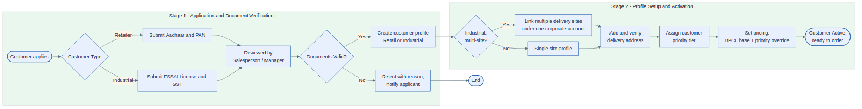
Figure 1 — Customer Onboarding and Verification Flow

5.2 Order Placement and Booking-Cutoff Flow
Covers FR-OC-01 to FR-OC-06. A verified customer places or repeats an order; the system checks the applicable cutoff time for that customer/zone before confirming same-day or next-day scheduling. (Cutoff logic is flagged in Section 2.7 — brought forward from SoW Phase 2.)

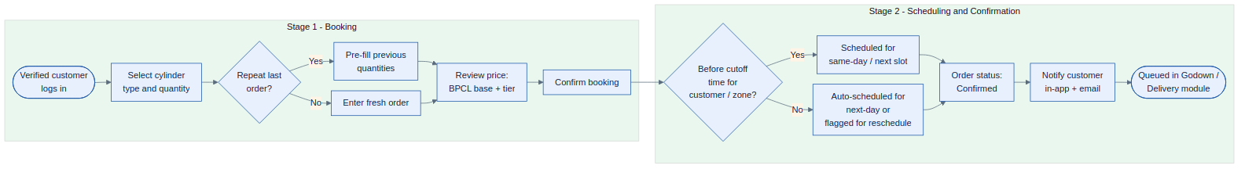
Figure 2 — Order Placement and Booking-Cutoff Flow

5.3 Delivery and Cylinder Exchange Flow
Covers FR-DL-01 to FR-DL-08. From godown allocation and dispatch, through on-site delivery and empty-cylinder exchange, to OTP/signature confirmation and stock update. Any uncollected empties automatically join the Pending Cylinder Pickup list.

Figure 3 — Delivery and Cylinder Exchange Flow

5.4 Payment Collection and Reconciliation Flow
Covers FR-PY-01 to FR-PY-06. Split payments are tagged to an invoice, compared against the invoice value to flag over/under payment, and any suspected-invalid entry is routed to an authorised Accountant or Manager before being confirmed and rolled into the daily report.

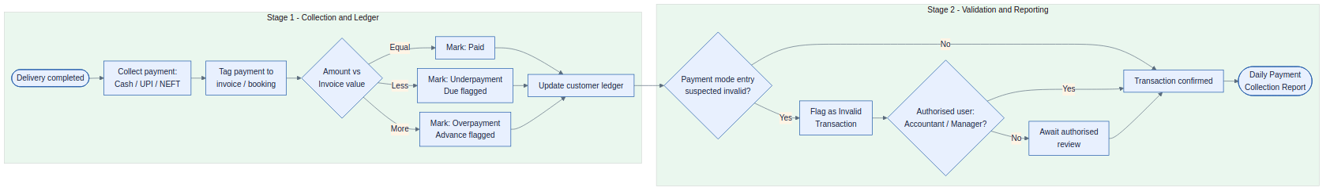
Figure 4 — Payment Collection and Reconciliation Flow

5.5 Proximity Alert and Instant Add-on Booking Flow (Flagged)
Covers FR-PX-01 to FR-PX-03. This flow depends on live or periodic vehicle location data. It is documented so the workflow is ready to build, but is not committed to Phase 1 until MBGA confirms an approach (see Section 2.7 and Section 3.11).

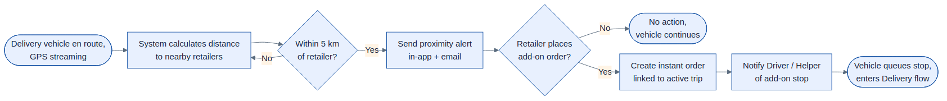
Figure 5 — Proximity Alert and Instant Add-on Booking Flow (Flagged / Conditional)

5.6 Godown Inventory Management Flow
Covers FR-IN-01 to FR-IN-04. Filled, empty, and defective stock are tracked per cylinder type, feeding a real-time dashboard that triggers a refill/reorder alert once any type falls below its configured threshold.

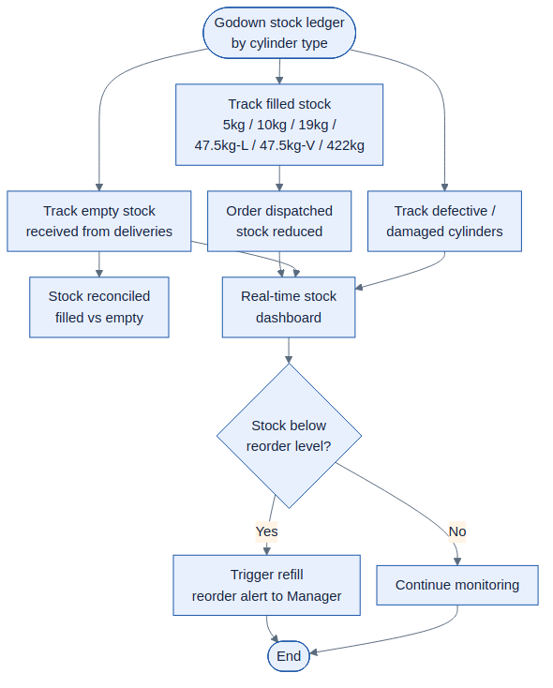
Figure 6 — Godown Inventory Management Flow

5.7 Exception Handling, Escalation and AI Voice Agent Flow
Covers FR-TA-01 to FR-TA-03 and the exception-notification requirements in Section 3.7. Detected exceptions (uncollected empties, payment dues, re-order breaks) are assigned and notified; if unresolved within the SLA window, the task auto-escalates. The AI Voice Calling Agent step is flagged as out of Phase 1 scope (FR-NT-03) but shown here for end-to-end context.

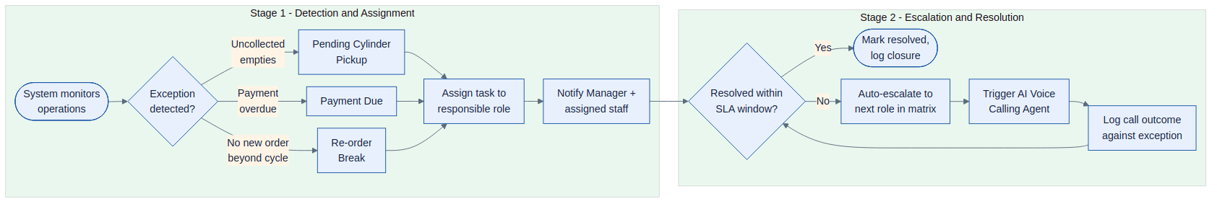
Figure 7 — Exception Handling, Escalation and AI Voice Agent Flow

5.8 Phase 1 System / App Architecture Overview
Shows how the client applications for each role connect to the Phase 1 core modules, and how those modules reach external interfaces such as document verification, the BPCL pricing reference, and the email gateway (see Section 4).

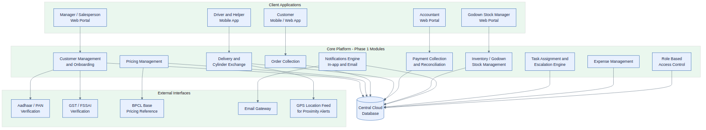
Figure 8 — Phase 1 System / App Architecture Overview

5.9 Role-Based Access Hierarchy
Summarises the reporting/access hierarchy behind the Role and Permission Matrix in Section 8 — the Manager has full access, while Salesperson, Godown Stock Manager, Accountant, Driver and Helper each operate within their own functional scope, and Customers interact only through the Salesperson-mediated onboarding path and their own account.

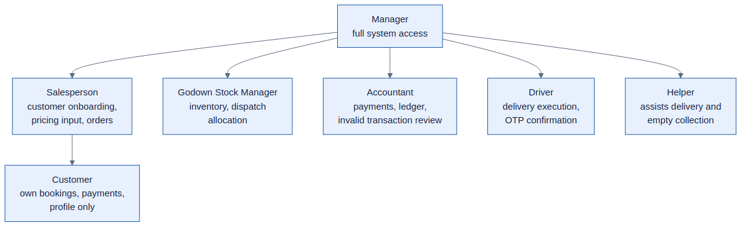
Figure 9 — Role-Based Access Hierarchy

6. Non-Functional Requirements

6.1 Performance and Capacity
System shall comfortably support the current baseline of 100–125 units of 19 kg cylinders delivered daily, plus other cylinder types, across 45–50 active accounts (Site Visit #2).
System shall absorb a demand/circulation increase of approximately 30% during peak periods without degradation of order-placement or delivery-confirmation response times (Site Visit #3).
Core transactional screens (order placement, delivery confirmation, payment entry) shall respond within 2–3 seconds under normal load.

6.2 Scalability
Architecture shall allow the active-account base and daily order volume to grow beyond current baseline without a redesign (e.g., as MBGA adds retailer/industrial accounts).
Data model shall accommodate additional cylinder types or pricing tiers with configuration changes, not code changes.

6.3 Availability and Reliability
Platform should target high availability during business hours (order-taking and delivery windows), with planned-maintenance windows communicated in advance.
Driver/Helper mobile screens should degrade gracefully (queue and sync) under intermittent connectivity typical of delivery routes.

6.4 Security
All customer, payment, and identity data encrypted in transit (TLS) and at rest.
Aadhaar numbers stored masked/hashed only, in line with Aadhaar Act / UIDAI guidance (see Section 2.5).
Role-based access strictly enforced at the API layer, not just in the UI (FR-RB-02).
Only the Manager role may create/modify/deactivate other user accounts (FR-RB-03).
Full audit logging of every field-level edit is a Phase 4 target; Phase 1 covers pricing-change and invalid-transaction logs only.

6.5 Usability
Driver and Helper interfaces shall use large touch targets and icon-led navigation, given the Helper role may have limited literacy.
Customer app shall clearly separate Retail vs Industrial flows given their different verification and ordering needs.
Language localisation (e.g., Hindi/regional language support) is not explicitly scoped — recommend confirming with MBGA as an open item.

6.6 Compliance
GST-compliant invoicing for industrial customers.
Retention and secure handling of FSSAI, GST, Aadhaar and PAN documents in line with applicable Indian data-protection norms.

6.7 Maintainability
Pricing tiers, cutoff-time rules, escalation matrices and reorder thresholds shall be configurable by the Manager without code changes.

7. Data Requirements (Key Entities)
Entity | Key Attributes | Notes
Customer | customer_id, type (Retail/Industrial), name, GST, priority_tier, verification_status | One customer can have many addresses and, if Industrial, many sites
Address / Site | address_id, customer_id, geo-tag, verification_status | Mandatory verification before use (FR-CM-11)
Verification Document | doc_id, customer_id, type (Aadhaar/PAN/GST/FSSAI), status | Aadhaar stored masked/hashed only
Cylinder Type | type_code (5kg,10kg,19kg,47.5L,47.5V,422kg), description | Fixed master list for Phase 1
Pricing | price_id, customer_id, cylinder_type, month, base_price, override_price, log | Edit-logged (FR-PR-03)
Order | order_id, customer_id, items[cylinder_type, qty], status, cutoff_flag | Status minimally: Confirmed in Phase 1
Delivery | delivery_id, order_id, driver_id, helper_id, filled_out, empty_in, confirmation_method | Drives Pending Pickup list
Payment | payment_id, order_id/invoice_id, mode, amount, flag (over/under/invalid) | Invalid flag settable by authorised users only
Ledger Entry | ledger_id, customer_id, type (credit/advance/due), amount | Rolls up from Payment
Inventory Stock | stock_id, cylinder_type, filled_qty, empty_qty, defective_qty | Real-time view (FR-IN-03)
User / Role | user_id, role (Manager/Salesperson/Godown Stock Manager/Accountant/Driver/Helper) | RBAC enforced at API layer
Exception / Task | task_id, type (pending pickup/payment due/re-order break), assignee, sla_due, status | Drives escalation matrix
Expense | expense_id, category (salary/daily cost), amount, date | Basic Phase 1 tracking only

8. Role and Permission Matrix
Legend: F = Full access, E = Edit within own scope, V = View only, – = No access.
Module | Manager | Salesperson | Godown Stock Mgr | Accountant | Driver | Helper | Customer
Customer Onboarding & Verification | F | E | – | V | – | – | E (own profile)
Pricing Management | F | V | – | V | – | – | V (own price)
Order Collection | F | E | V | V | V (own trips) | V (own trips) | E (own orders)
Delivery & Cylinder Exchange | F | V | E | V | E (own trips) | E (own trips) | V (own orders)
Payment & Reconciliation | F | – | – | F | V (own collections) | – | V (own payments)
Inventory / Godown Stock | F | V | F | V | – | – | –
Notifications | F | V | V | V | V | V | V (own)
Task Assignment & Escalation | F | V (own tasks) | V (own tasks) | V (own tasks) | V (own tasks) | V (own tasks) | –
Expense Management | F | – | – | E | – | – | –
User & Role Management | F | – | – | – | – | – | –

9. Consolidated Open Items Requiring MBGA Confirmation
Pulled together from Section 2.7 for easy sign-off:
Confirm whether booking cutoff & next-day auto-reschedule (FR-OC-03/04) is brought into Phase 1, or deferred to Phase 2 as originally scoped.
Confirm whether a light, non-live version of proximity alerts / instant add-on booking (Section 3.11) is wanted in Phase 1, or fully deferred until after Phase 3 live tracking.
Confirm whether any manual/basic vehicle trip logging (Section 3.12) is wanted in Phase 1, given full OEM telematics integration is a Phase 3 item.
Confirm target phase for the AI Voice Calling Agent (FR-NT-03) — recommend Phase 2 or 3 given telephony/voice-AI vendor selection is required.
Confirm final role naming and mapping between the site visit's role list (Manager, Salesperson, Godown Stock Manager, Accountant, Driver, Helper) and the SoW's original role list (Admin, Delivery Coordinator, Accounts, Driver/Helper, Customer).
Confirm document verification approach: manual back-office review (Phase 1 default assumption) vs. a paid third-party Aadhaar/PAN/GST/FSSAI verification API.
Confirm priority-tier definitions (how many tiers, what they unlock) for pricing overrides.
Confirm escalation matrix hierarchy and SLA windows for exception handling (Section 3.8).
Confirm whether Hindi/regional-language UI support is required for Driver/Helper/Customer apps.

Appendix A — Cylinder Type Reference
Cylinder Type | Segment | Notes
5 kg | Retail (domestic/small shop)
10 kg | Retail
19 kg | Retail / commercial — primary daily volume (100–125 units/day) | Core SKU for daily retailer supply
47.5 kg – Liquid (L-type) | Industrial | Liquid off-take sub-type
47.5 kg – Vapor (V-type) | Industrial | Vapor off-take sub-type
422 kg (“Hippo”) | Industrial / bulk | Largest bulk cylinder type

