Bandhan Life Insurance Limited
Pre Issuance Verification Report
Report Type | Final | Investigation Date | 21-07-2026
Application No | ALI000001078039 | RCD | NA
INV Received Date | 18-07-2026 | Report Sent Date | 23-07-2026
Name of Life Assured | Akarsh
Company Provided Address | Vill Bhikhapur Ayodhya Uttar Pradesh India 224001 City Ayodhya State Uttar Pradesh pin_code 224001
Contact No / Alternate No | 8400003587
LA Met in person | Yes | If died, DOD | No
Existence of Address | Confirmed | Existence of LA | Confirmed
Date of Birth | 01-07-2004 | Qualification | BSC
Occupation | Self-Employed | Nature of Work | Kirana Store
Name of Employer | NA | Income | Approx/-06 lacs per annum
Standard of Living | Middle Class | Health Condition | Good
Negative Habits | NA | Pre Existing illness | Not Disclosed
Call History | NA | Evidence collected | Not Disclosed
Audio/Video Confirmation | NA | Location Photo with Geo tagging | Attached
Existing policy details
Overall Findings | Vicinity Findings:  - During investigation, IO called on the given No. of LA IO introduce himself and said he is behalf of from Bandhan life and he want to came for a verification.  - LA fix appointment with IO for 21-07-2026 on (July) at noon.  - After which IO visited to given address, and inquires nearby people.  - Nearby people recognize LA, and given address.  - They said that LA is Unmarried having 07 members in his family  - They said that LA runs his own Kirana store.  - They said that LA has no medical issues, looking wise LA is fit & healthy.  - Neighbors confirmed the name and existence of LA at the given address but refused for any further details.  Overall Findings:  - IO visited the mentioned address for verification on behalf of Bandhan Life Insurance.  - IO introduced himself and showed the authority letter.  - After showing authority letter LA gave various information.  - The LA confirmed that the mentioned address is his own residence.  - The LA stated that he is Unmarried and there are 07 family members in the family.  - The LA confirmed that he has completed BSC.  - The LA informed that he runs his own Kirana Store.  - The LA stated that his annual income is approximately Rs 06 lakh.  - The LA confirmed that the policy nominee is his mother Mrs. Kiran.  - LA did not share the policy premium.  - The LA confirmed that he is not suffering from any illness and does not have any bad habits.  - The LA shared his Aadhaar Card and Pan Card as KYC documents which is attached with the report.  - Meeting with the LA is done at hi mention address.
Summary of Findings | Meeting with LA is Done.
Investigation Final Remark | positive
Verification agency & Owner name | Virtual007 Investigation  Dhiraj Kaushik
Field officer details | Anoop Kumar Pathak
Photograph with Geo tagging with Latitude and Longitude –
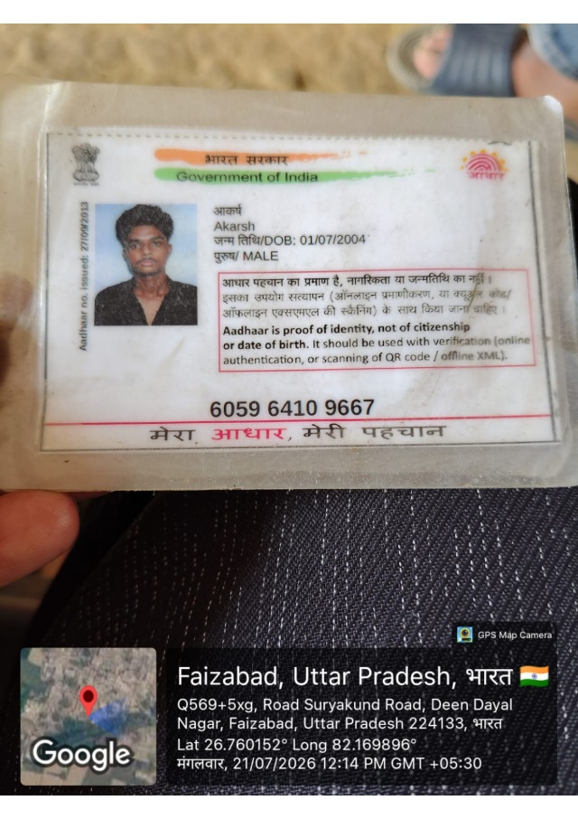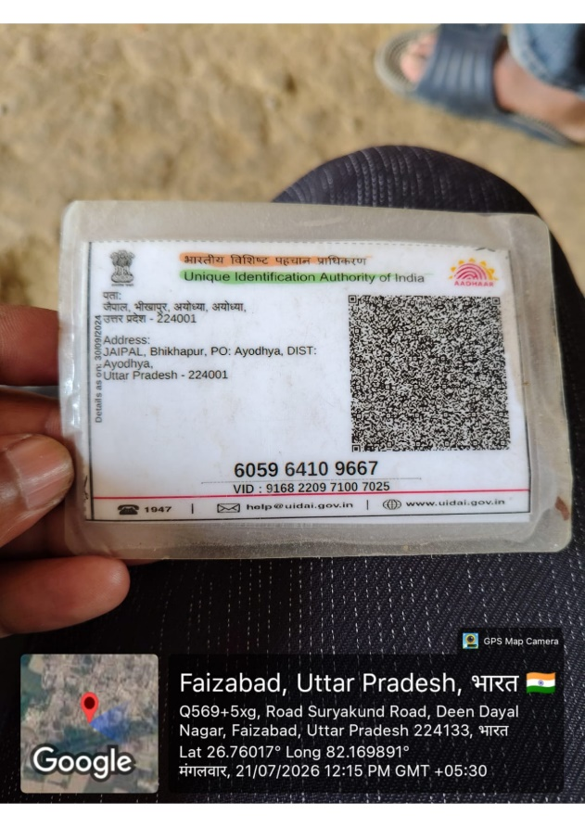
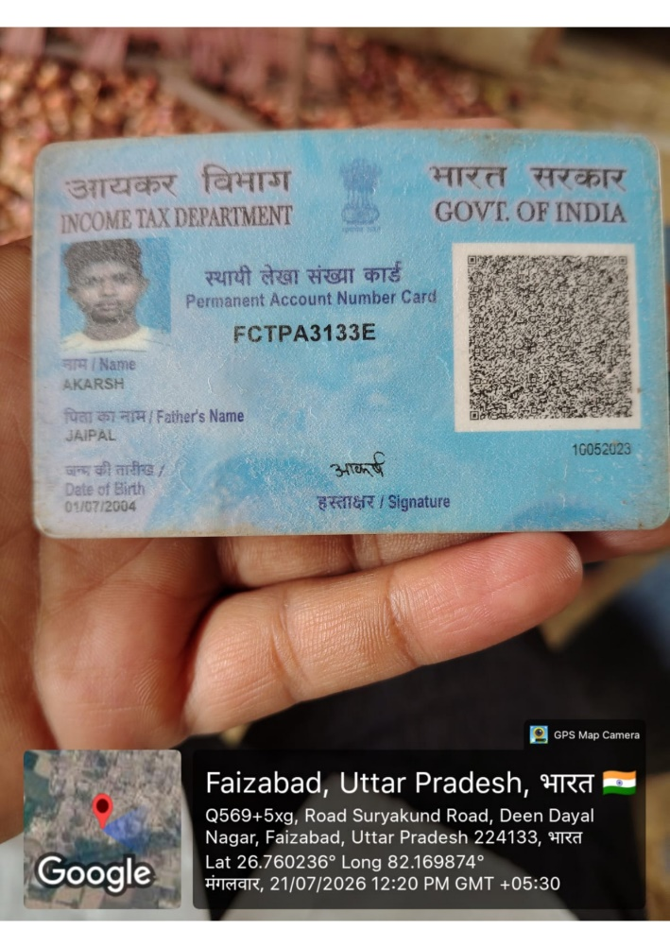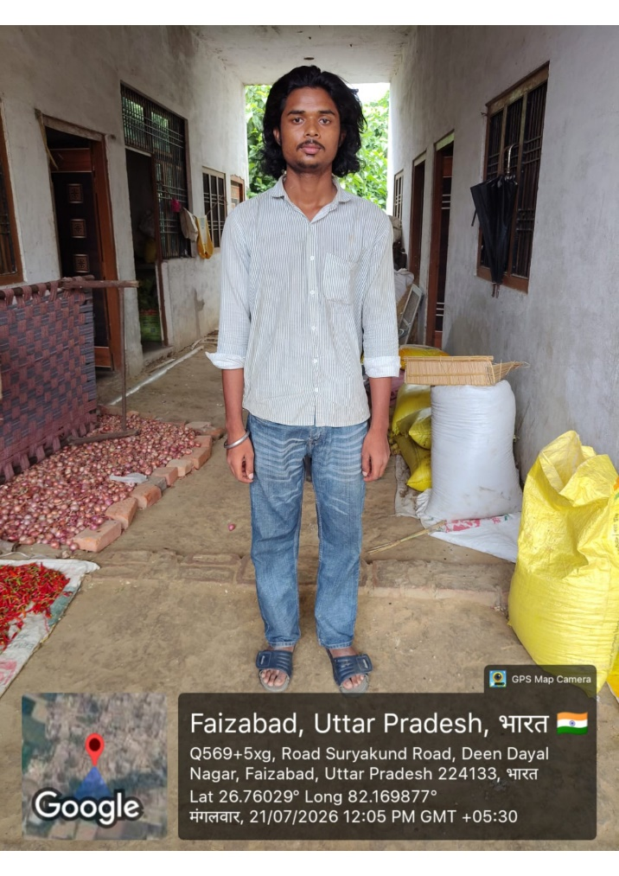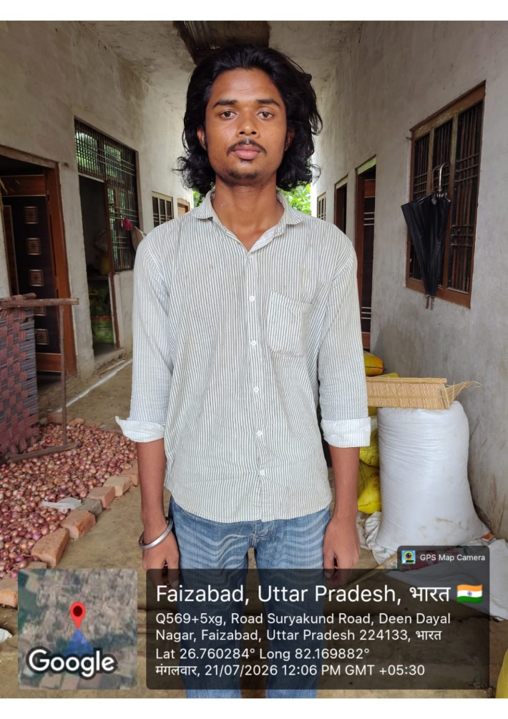
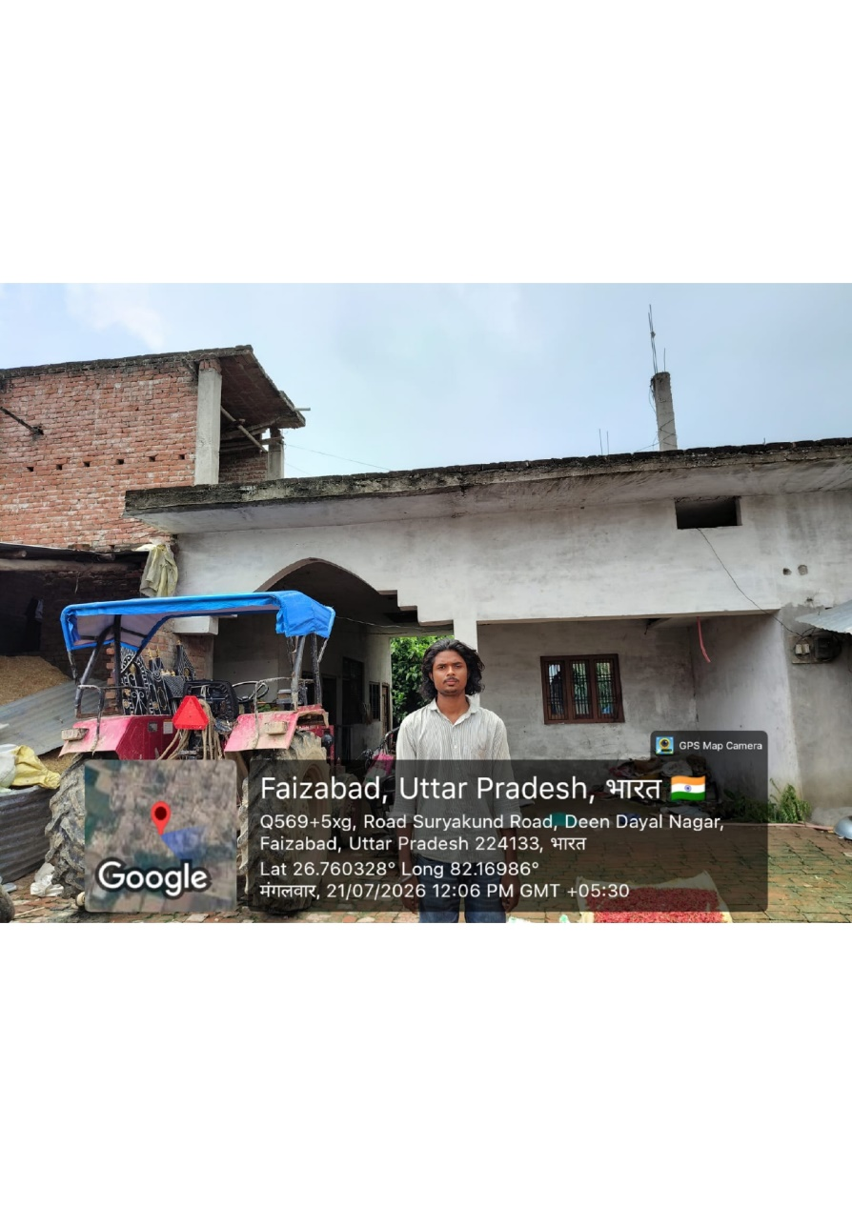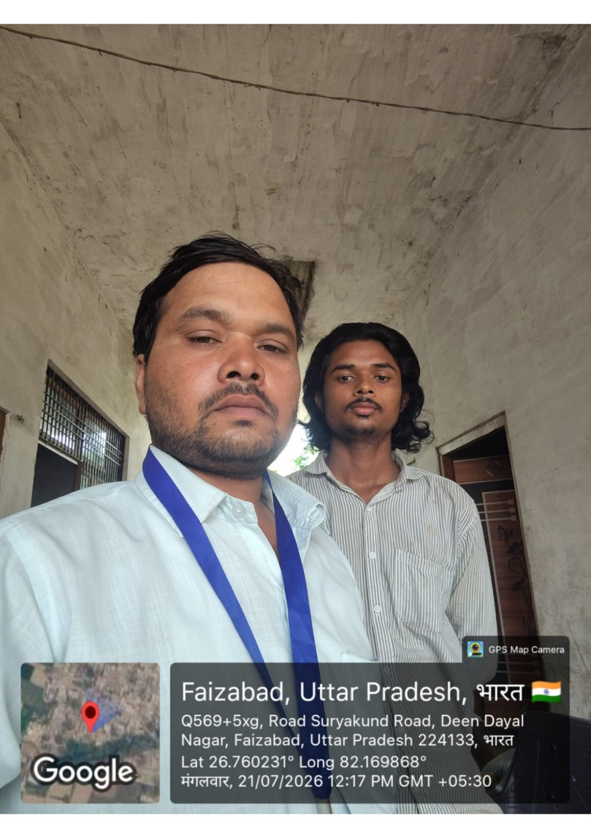
DECLARATION
I/We hereby declare that the foregoing statements and information have been given by me after full verifications and the same are true and complete in every manner to the best of my knowledge. Further, I have not provided any false information. I have verified that this report is filled completely in all respects and that all required documents are attached along with.
Date, Signed & stamped of your company | Authorized Signatory  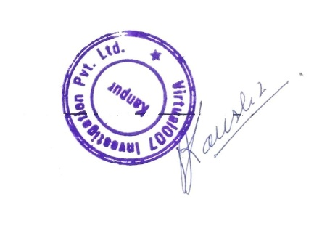  Date: 23-07-2026

