Bandhan Life Insurance Limited
Pre Issuance Verification Report
Report Type | {{ report_type }}
Application No | {{ application_number }}
INV Received Date | {{ inv_received_date }}
Name of Life Assured | {{ life_assured_name }}
Company Provided Address | {{ company_provided_address }}
Contact No / Alternate No | {{ contact_number }}
LA Met in person | {{ la_met_in_person }}
Existence of Address | {{ existence_of_address }}
Date of Birth | {{ la_dob }}
Occupation | {{ occupation }}
Name of Employer | {{ employer_name }}
Standard of Living | {{ standard_of_living }}
Negative Habits | {{ negative_habits }}
Call History | {{ call_history }}
Audio/Video Confirmation | {{ audio_video_confirmation }}
Existing policy details | {{ existing_policy_details }}
Overall Findings | {{ overall_remarks }}
Summary of Findings | {{ summary_of_findings }}
Investigation Final Remark | {{ final_remark }}
Verification agency & Owner name | {{ verification_agency }}
Field officer details | {{ field_officer_details }}
Photograph with Geo tagging with Latitude and Longitude –
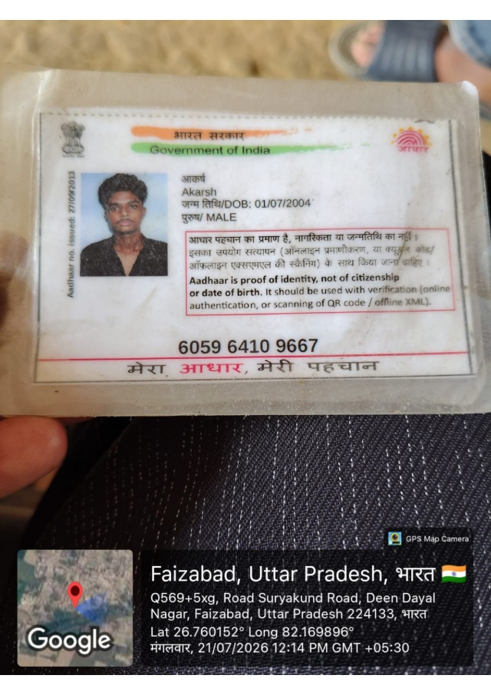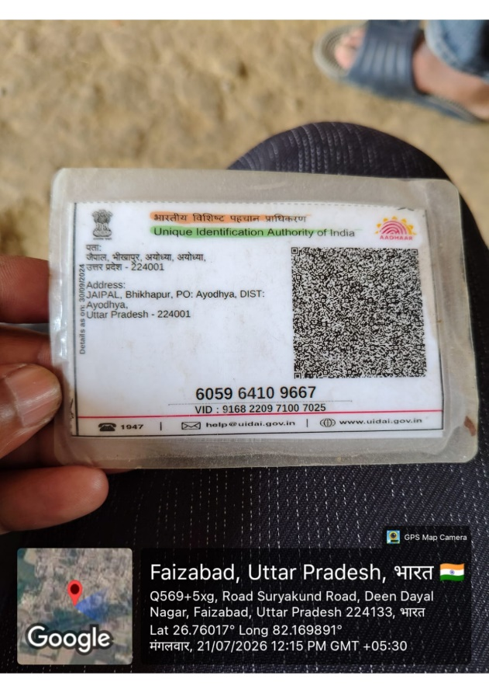
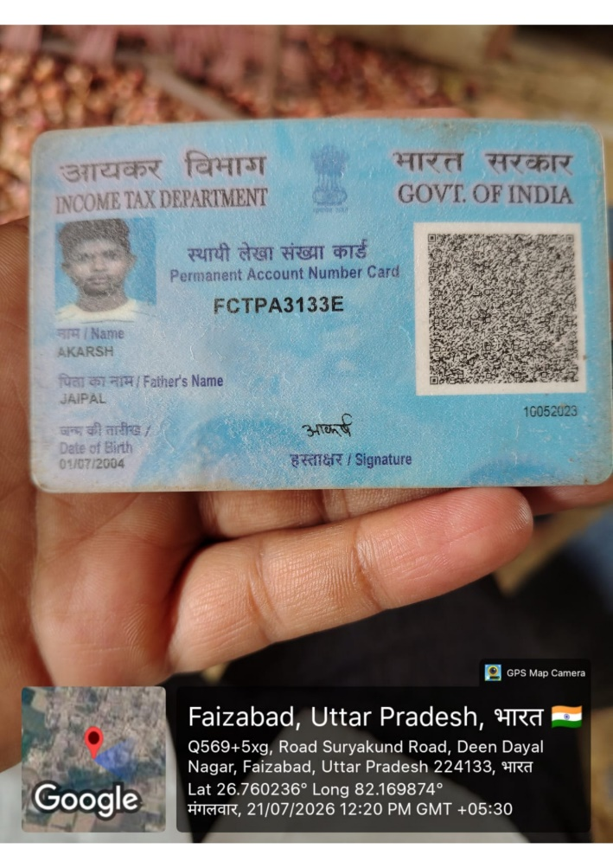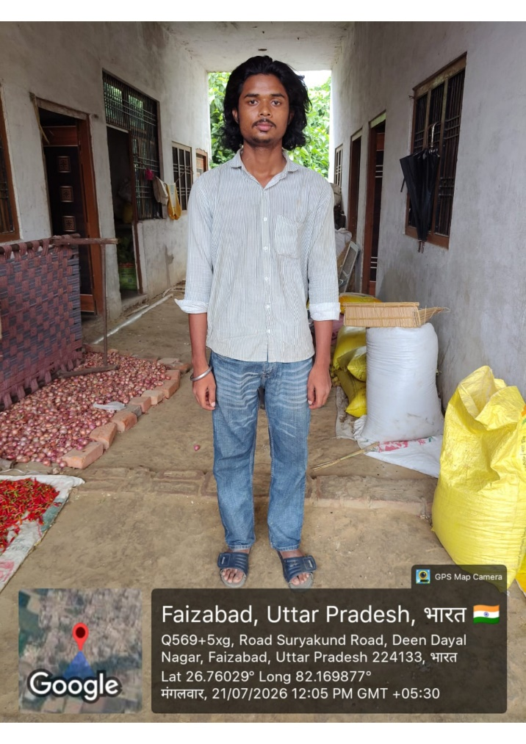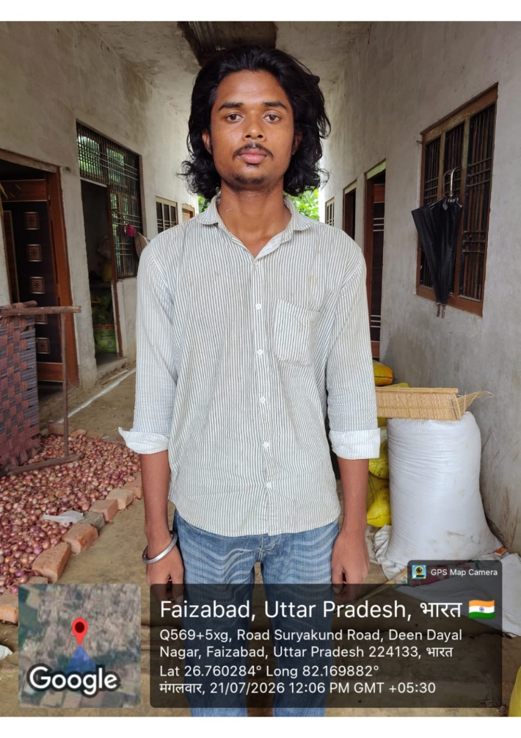
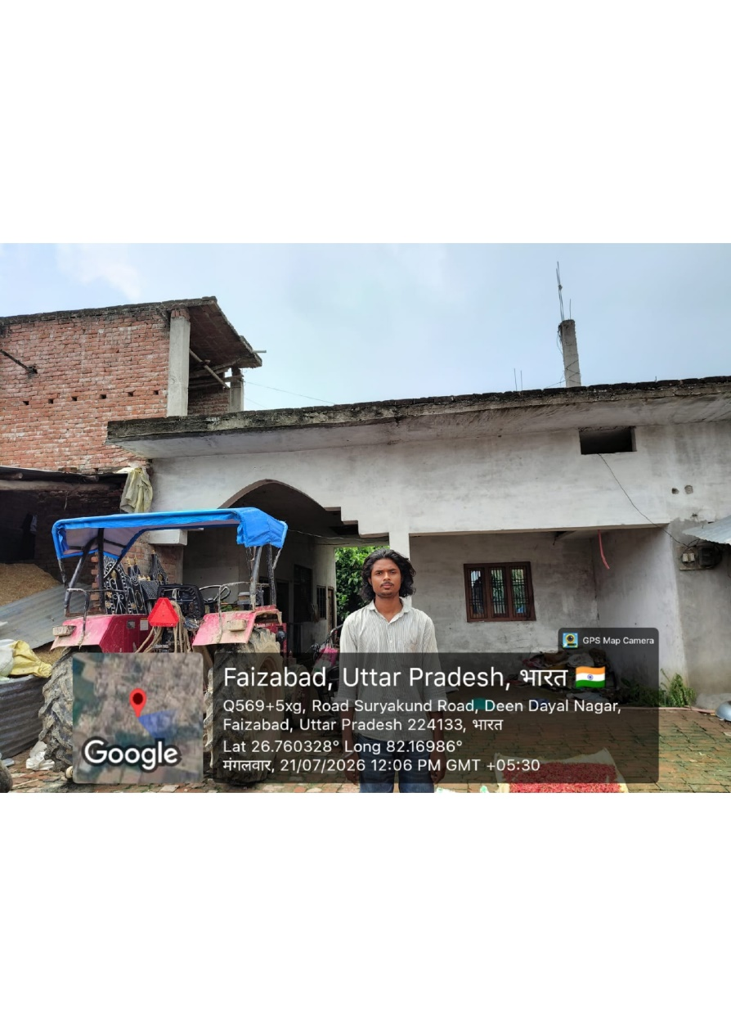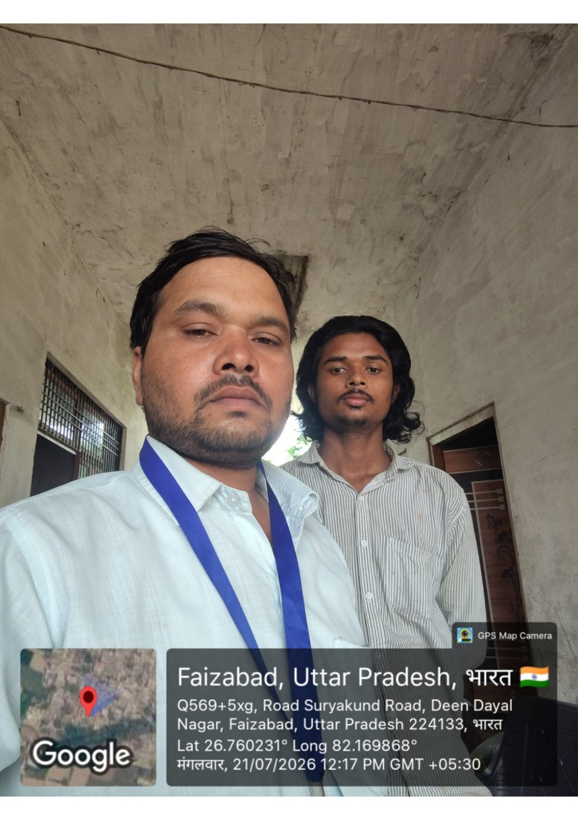
DECLARATION
I/We hereby declare that the foregoing statements and information have been given by me after full verifications and the same are true and complete in every manner to the best of my knowledge. Further, I have not provided any false information. I have verified that this report is filled completely in all respects and that all required documents are attached along with.
Date, Signed & stamped of your company

