Investigation Report (Death/Critical illness/Hospital Rider Claim)

Report status: (Interim / Final):  FINAL |  |  |  |  |  |  | {{ report_status }}
Claim details (For Investigator's reference)
Policy No. |  |  |  | {{ policy_number }}
Type of Claim |  |  |  | {{ type_of_claim }}
Name of LA |  |  |  | {{ life_assured_name }}
Date of Birth/Age of L.A. |  |  |  | {{ la_dob_age }}
Occupation of L.A. |  |  |  | {{ la_occupation }}
Income of L.A. |  |  |  | {{ la_income }}
State / City of LA |  |  |  | {{ la_city_state }}
Risk comm. date |  |  |  | {{ rcd }}
Date of Death |  |  |  | {{ date_of_death }}
Cause of Death |  |  |  | {{ cause_of_death }}
Place of Death |  |  |  | {{ place_of_death }}
Type of negative evidence collected |  |  |  | {{ negative_evidence_type }}
Any RTI Applied |  |  |  | {{ rti_applied }}
Case details:

Suspicious Points if any: NA

Online/Social media checks, any news posted about death/illness.

During investigation, we tried to search social media profile of Insured, but found no records.
Life Assured’s Profile
LA Profile
Name |  |  | {{ profile_name }}
DOB |  |  | {{ profile_dob }}
Age |  |  | {{ profile_age }}
DOD |  |  | {{ profile_dod }}
Marital Status |  |  | {{ profile_marital_status }}
Occupation |  |  | {{ profile_occupation }}
Annual Income |  |  | {{ profile_annual_income }}
Qualification |  |  | {{ profile_qualification }}
Address |  |  | {{ profile_address }}
Claimant/Beneficiary Relationship |  |  | {{ beneficiary_relationship }}
Family details & history
Name | Age | Relationship with LA |  |  |  |  |  | Occupation & Income |  |  | Other Insurance
{{ profile_name }} | {{ profile_age }} | {{ advisor_relationship }} |  |  |  |  |  | {{ panchayat_findings }} |  |  | {{ other_policies }}
Others
NA | {{ actionable_2 }}
Collect Ration Card / Voter ID or all possible age proofs of all family members
List of enclosures:
1. Anti-Bribery Declaration from Claimant,
2. Death Certificate
3. Statements & KYC’s
4. Pre RCD Medical Evidence

Verification status of documents collected during investigations (i.e. Pan card, ITR etc.)

We checked the validation of given KYC and death certificate online and they found to be genuine.
Nominee Details: Mention the nominee details and statement
Verification findings at LA's residence, with Name, relationship and contact details. Please also mention circumstances of death

The Life Assured’s (LA’s) wife, {{ claimant_name }} (Mobile: 7770967775), stated that the LA was 50 years old at the time of his death. She informed that on the evening of the same day, as usual, he returned from work, but his condition suddenly worsened—he experienced severe chest pain and anxiety. She immediately took him to Pramila Hospital, where he passed away during treatment. The Post-Mortem Report (PMR) revealed that the LA had ingested poisonous Celphous.
She further stated that the LA was engaged in the steel business and confirmed that he had no prior health issues. She added that his body was cremated at the local cremation ground in the presence of family members and relatives. She has also provided a written statement to the investigator, which is enclosed with this report for reference.
LA residence check:
Standard of Living (APL/BPL/High income group) |  |  |  |  |  |  |  |  | {{ standard_of_living }}
KYC & contact number |  |  |  |  |  |  |  |  | {{ kyc_and_contact }}
Past & present medical records, Consultation notes |  |  |  |  |  |  |  |  | {{ medical_records }}
Annual income confirmation |  |  |  |  |  |  |  |  | {{ income_confirmation }}
Purpose for insurance |  |  |  |  |  |  |  |  | {{ purpose_for_insurance }}
Other insurance details |  |  |  |  |  |  |  |  | Company Name  Star Health  {{ other_insurance_details }}
Health Insurance policy/claim details |  |  |  |  |  |  |  |  | Company Name  NA {{ actionable_2 }}
Claim details under Govt Sponsored scheme (Aayushman/Aarogayashree etc.)
Photographs of life assured with family/friends when he/she alive.(Death Claim Cases)
Photo 1

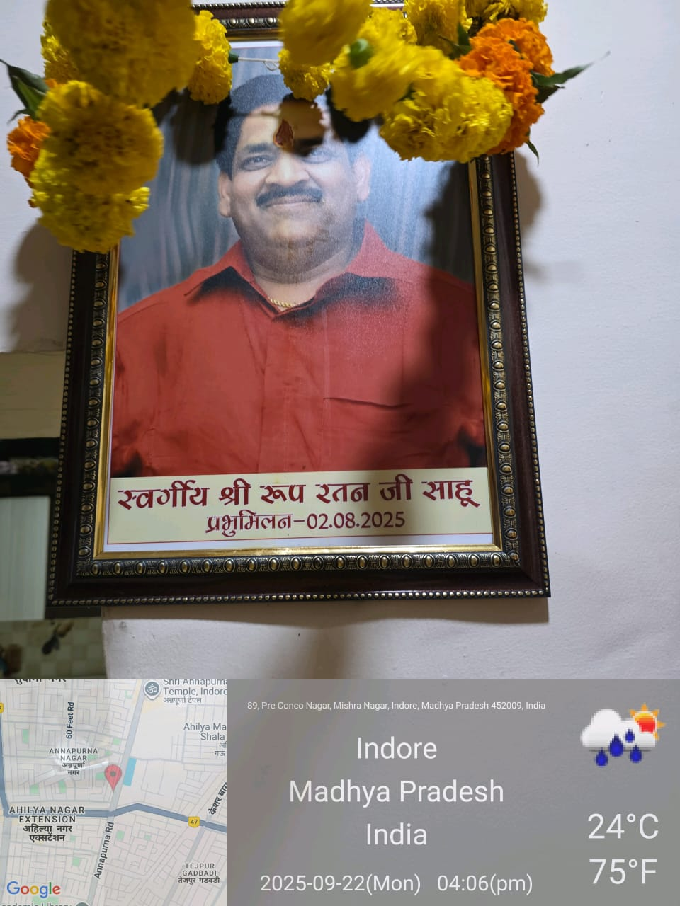

Photographs of life assured house inside/outside.

Photo 1
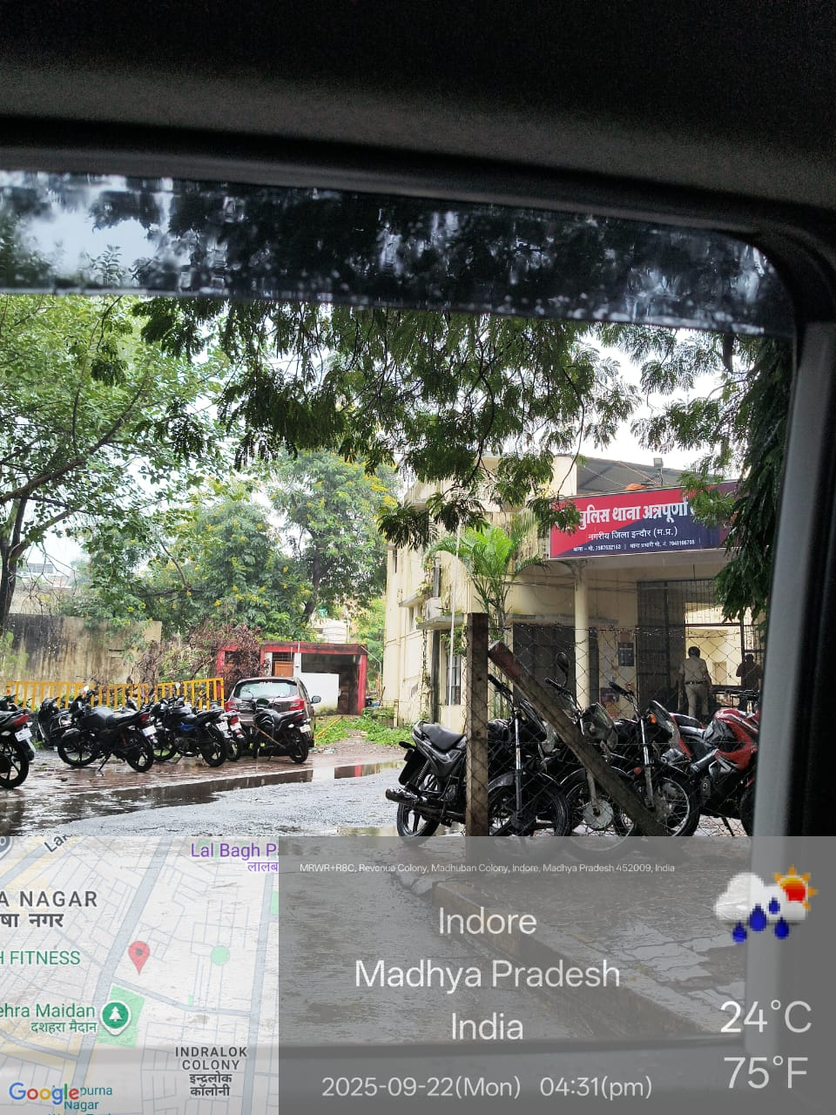

Neighborhood check - to be checked with 5-6 people
Basic details to be checked are: LA’s Age, habits, occupation, illness & hospitalization detail & get the written statement (mandatory) along with name & contact no. - format attached with the referral mail
Name: Kishan
Place (residence / work place): Residence
Contact number: {{ claimant_contact }}

Name: Mr. Kanwar Pal
Place (residence / work place): Residence
Contact number: Not disclosed

Name: Mr. Santosh Kumar
Place (residence / work place): Residence
Contact number: Not Shared

Name: Mr. Dharmendra Singh
Place (residence / work place): Residence
Contact number: Not Shared

Name: Mr. Vinod Kumar
Place (residence / work place): Residence
Contact number: Not Shared

Name: Mr. Sohail
Place (residence / work place): Residence
Contact number: Not Shared

Name: Mr. Brajesh Kumar
Place (residence / work place): Residence
Contact number: Not Shared

Name: Mr. Sonu
Place (residence / work place): Residence
Contact number: Not Shared

Name: Mr. Hariom
Place (residence / work place): Residence
Contact number: Not Shared

Name: Mr. Gajendra Yadav
Place (residence / work place): Residence
Contact number: Not Shared

Name: Mr. Shashikant Kumar
Place (residence / work place): Residence
Contact number: Not Shared

Summary of the details shared by the above listed individuals:

- In this case, the Investigator Officer (IO) visited the given address: S/O Rameshwar Sahu, Gaytr Petrol Pump, 89 Mishra Nagar Annpurna, {{ place_of_death }}
- * The IO began the inspection by enquiring with a few nearby residents and shopkeepers.
- * The nearby residents and shopkeepers informed that the Life Assured (LA) had been a patient of diabetes and hypertension for a long time. In his last stage, multiple organs were affected, and he was suffering from cardiac and related ailments. He had been undergoing treatment at a hospital in Indore, and on {{ date_of_death }}, the LA passed away at the hospital.
- * To gather further information, the IO discreetly questioned other nearby residents and long-term locals using the LA’s name. They stated that the LA had been suffering from cardiac ailments for a long time. Initially, he sought treatment on an OPD basis at Unique Hospital. On {{ date_of_death }}, the LA reportedly committed suicide by consuming poison due to his illness.
- * The residents also confirmed that the LA’s body was cremated at a nearby cremation ground in Indore, and they were present at the funeral ceremony.
Check with Doctors in the vicinity / place of treatment / other medical practitioners / path labs etc
Family doctor: Period known to Life Assured, Habits, illness & duration, contact no.
(Family doctor certificate to be collected)
Template to be link here

NA
Last treating doctor: LA's condition at admission, diagnosis & treatment given, contact no
(treating doctor certificate to be collected)
Template to be link here

NA
Hospitals as mentioned in the claim documents and get the necessary documents with filled Medical Hospital Attendant Certificate
NA

Check all the chemists / medical shops near residence, work place, treating doctors place, hospitals etc., & procure necessary documents
MEDICAL STORES / CHEMISTS CHECK
Name of the Medical/Chemist shop visited
1 Mishra Medical Store
2 Vishwanath Medical Store
3 Puri Medical Store
4 Puri Pharmacy
Documents Collected | NA | NA | NA
{{ documents_collected }} | {{ actionable_2 }} | {{ actionable_2 }} | {{ actionable_2 }}
Findings- Investigator visited on all the above chemists and tried to Procure information from the chemists but investigator found no record of LA in above chemists.

Hospital/ Pathology/ Lab Checks
Sr. No
1 | Unique Hospital
2 | Govt. Allopathic Hospital
3 | Arihant Hospital
4 | Samudayik Swasthya Kendra (Community health Center).
5 | District Hospital

Occupation / Workplace check including (employer/Business premises)
In case of salaried
For Salaried
- Name of employer:
- Life Assured designation and income, general health/habit, behavioral
- Name & address of the contact person/manager:
- Name and contact details of office Manager, colleague, friend etc
- Duly filled employer certificate to be collected:
- Salary slip/Income Tax Return/Form 16:
- Leave records:
- Reason for availing sick leaves (if any):
- Collect medical documents submitted for sick leaves:

If Self Employed

OCCUPATION / INCOME (if LA was Self-Employed) -
Name of the Business | {{ business_name }}
Not disclosed
Findings: The Claimant stated that the Life Assured (LA) used to operate his own Steel business under the name of Maa Annapurna Steels,

Photos of office/shop/workplace (Inside/Outside): Transport business was found at the given location during the investigation.
However, income proof document has also been provided by nominee.

Contact at least 2-3 adjacent shop owners, colleagues / HR, office security staff & record their statement & contact no.
Name: Santosh Kumar s/o Vivek Singh
Contact number: Not disclosed
Name: Dharmendra Singh
Contact number: Not disclosed
Summary of the details shared by the above listed individuals: NA
Police verification wherever applicable - mandatory for accidental, suicide, poisoning, murder cases
Police - FIR & Postmortem, circumstances under which accident has occurred and Final Report (Original verified and attested by authority with sign, seal/stamp
Circumstances of incident and death in detail with date and time
Summary of FIR: Attached
Summary of PMR: LA had taken celphous.
Viscera report (if any): Awaited
Cremation and Burial
Collect copy of death register and relevant records (cremation/Burial slip)
Findings/Remarks: Attached
In case not available – letter from authority.

Document Verification:
Age proof verification incase forgery / tampering suspected during investigation:
Remarks:
Death certificate by issuing authority with sign and stamp:
Remarks: Online Verified (Genuine).
News Paper / Internet check :
Collect newspaper cutting in case of availability:
Remarks: NA
Validate the age proof validity through Internet:
Remarks: Not disclosed

In case of investigation location falls under Panchayat/Village following touch points to be verified:
Do a detail check for LA’age, occupation, income, Health and habit details, date of death, type of death:
- Panchayat Secretary
- Gram Pradhan
- Block Development officer (BDO)
- Circle Officer (CO)
- Aganwadi Seviaka/ANM
- Primary/Community Health Centre (PHC/CHC),
- Other: Police Patil/Mamledar/Village officer/Councilar
Advisor check: Advisor detail, contact no, Relationship with LA & sourcing details, feedback from Advisor on LA & claim intimated
No adverse found while vicinity check.
Agency Over all remarks and conclusion :
Overall remarks should be a summary / brief of the findings along with recommendation and not repetition of the entire details as mentioned in the reports.
Remarks:

Investigation Findings:

Concerned Police Stations Remarks:
- Then IO went to the concerned Police Station, where he discussed the whole scenario with present constable.
- According to LA's family, it was reported that LA committed suicide by consuming poison.
- All pertinent information, including the post-mortem report and other relevant documents, has been duly verified.

Summary of PMR: {{ life_assured_name }} committed suicide by consuming celphous powder poison.
Cause of Death:
The primary cause of death in this case is attributed to the {{ cause_of_death }}.

Final police report: Intimation under Section 194 BNSS ({{ cause_of_death }} Clause)

1. Enclosed herewith is a Clear copy of the initial information received.

- During investigation, investigator came to know that Life Assured (LA) had been a patient of diabetes and hypertension for a long time. In his last stage, multiple organs were affected, and he was suffering from cardiac and related ailments., Initially, he sought treatment on an OPD basis at Unique Hospital. On {{ date_of_death }}, the LA reportedly committed suicide by consuming poison due to his illness.
- During the residence visit Investigating officer asked for the medical history with medical paper of LA, but nominee refused to have any medical paper and told that LA committed suicide by consuming poison and the duration of illness was only one day, investigating officer pressurized her but she was not being ready to disclose any medical history nor have she shared any medical paper.
- During investigation, investigator came to know that LA’s financial condition and living standard was High Class.

Summary of information received from the Hospital Check | {{ hospital_summary }}

Major Suspicion if any :
Remarks: Based on the overall investigation, the case has been assessed as Negative.

List of documents collected-
Name of the doctor signing the medical records in the investigation report.
Geo tagging on evidences collected
Type of documents collected |  | {{ documents_collected }}
Anti-Bribery Declaration from Nominee
KYC’s, Death Certificate & Statements
Findings post completing pending checks as stated in the interim report
- Final report: {{ report_submission_date }}
- Interim report:
Pending check in order:
Findings on the re-actionables gievn, if any
Any actionable kept pending at risk end and any further actionable given by claims team should be updated here with all the details in Pointers

Transaction: 01
Actionable given (Date and time)
Update received (Date and time)

Transaction: 02
Actionable given(Date and time)
Update received (date and time)

Name of the investigating agency: {{ agency_name }}
Name of the investigator: {{ field_investigator_name }}
Contact details : {{ agency_contact }}

Key Guidance:
- Date and time of all visit and verification done
- All statement and translation to be collected in HDFC life format provided
- Investigation format to be executed and printed on Investigation agency letter head with number)
- All procured documents to be listed and shared with annexure name and number
- Name of field investigator and contact number should be mention in report
- Photograph is mandatory for all visit viz. La’s house, workplace, employer premises, police station, person interviewed/contacted
- All format to be shared in PDF format, each transaction of email with documents should not exceed “<” “or” = 2MB
- All documents to be attested by Agency seal/stamp
- All new business and claim service documents to be physically and originally verified from actual issuing authority only and not from Notary or any other third party
- All records need to verify online and image to be shared along with report
- Affidavit is mandatory to be executed on Rs. 200/- non judicial stamp paper for all cases wherein discrepancy/mismatch or mis-representation or non disclosure noted
- All communication to be marked to HDFC claims id (hinvestigation@hdfclife.com)

