DETAILED INVESTIGATION REPORT

Proposal No. | {{ proposal_number }}
Life Assured Name | {{ life_assured_name }}
Allocation date | {{ allocation_date }}
Verification Type | {{ verification_type }}
Address (Complete address) | {{ la_address }}
Mobile No. | {{ contact_number }}
Mention alternate number/email-ID if given | {{ alternate_contact }}
Verification date | {{ verification_date }}
OBSERVATIONS OF THE INVESTIGATORS

Report Overall Status | {{ report_overall_status }}
Verifier Name | {{ verifier_name }}
ID Card Seen – Yes (Name of ID proof along with complete number) | {{ id_card_seen }}
Address Proof Seen – Yes (Name of ID proof along with complete number) | {{ address_proof_seen }}
Name Of Person Met (Name & Mobile No.) | {{ person_met }}
Met Person Relation With LA | {{ met_person_relation }}
LA Date of Birth | {{ la_dob }}
LA Health Condition and lifestyle (any adversity – history of Tobacco/ Alcohol or Smoking / swimming / diving etc.)
In case LA not healthy –Name of disease/ duration/Place of treatment (hospital and Doctor name)
Any history of medical investigation, surgery or treatment in past or planned in near future (even if it was a minor or major)
Family Medical History | {{ family_medical_history }}
Treatment papers/Audio/Video captured –In case of any adverse finding | {{ treatment_papers }}
Policy Details Other Than Canara HSBC and total life coverage | {{ other_policies }}
Residence Locality and type | {{ residence_locality }}
Residence Ownership | {{ residence_ownership }}
No of Year at Current Residence
Financial Status of Life Assured (Please mention your observation basis life style etc.) | {{ financial_status }}
No. Of Family Members and their details | {{ family_members_details }}
LA’s Education Qualification | {{ education_qualification }}
Employment Category (Salaried /Self-employed etc.) | {{ employment_category }}
Organization Name (Employer Name) and nature of work (In case Salaried)
Self Employed (Firm Name, Business type and address) | {{ self_employed_details }}
Annual income | {{ annual_income }}
Nominee Name and relationship with LA | {{ nominee_details }}
Vicinity Check Details – met person Name / Mobile number and details confirmed | - {{ vicinity_persons_details }}
Discreet Check:- As per the discreet check, nearby people know LA and confirmed that he resides at the mentioned address with his family. They stated that he is married and there are five members in his family. They also informed that he is engaged in farming and also owns a Jewellery shop. Regarding his health, nearby people confirmed that he is fit and healthy. Overall, they shared positive feedback about the LA.
Residence Visit: - When the IO visited the mentioned address, he met with LA. LA shared that the mentioned address is his owned house and he has been living there earlier.

Health and Habits:- As per the LA, he is fit and healthy and he is not having any health issues.

Family Details:- Total- 05 (LA, LA’s wife and his 3 sons), Earning member-01 (LA), Dependent- 04 (LA’s wife and 3 daughters)

Investigation Findings:-
When the IO visited the mentioned address, he met the LA. IO introduced himself as a representative of HSBC Canara Life Insurance and, after showing his authority letter, collected the required information.
The LA informed that the mentioned address is his own house and that he has been residing there since birth. He is married, and there are five members in his family. LA is 10th passed and owns a jewellery shop. He also owns 1 bigha of agricultural land. His annual income from the business and agriculture is approximately Rs. 5 lac. LA stated that he is fit and healthy and has no health-related issues.
Regarding the policy, the LA informed that his son, Mr. Harshit Verma, is the nominee. He stated that he pays an annual premium of approximately Rs. 1,50,000 for the next 7 years. LA also provided his Aadhaar Card and PAN Card as KYC proof, which are attached to the report.

Note:- As per the IO’s findings and based on the overall findings, this case is positively closed.

- Photo of LA house with Geo tagging

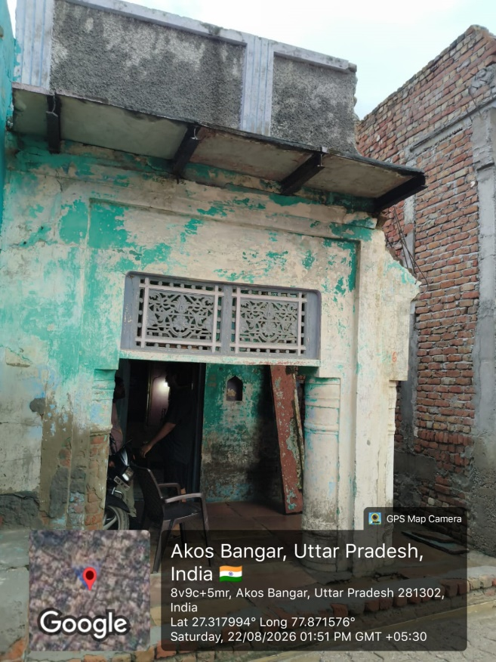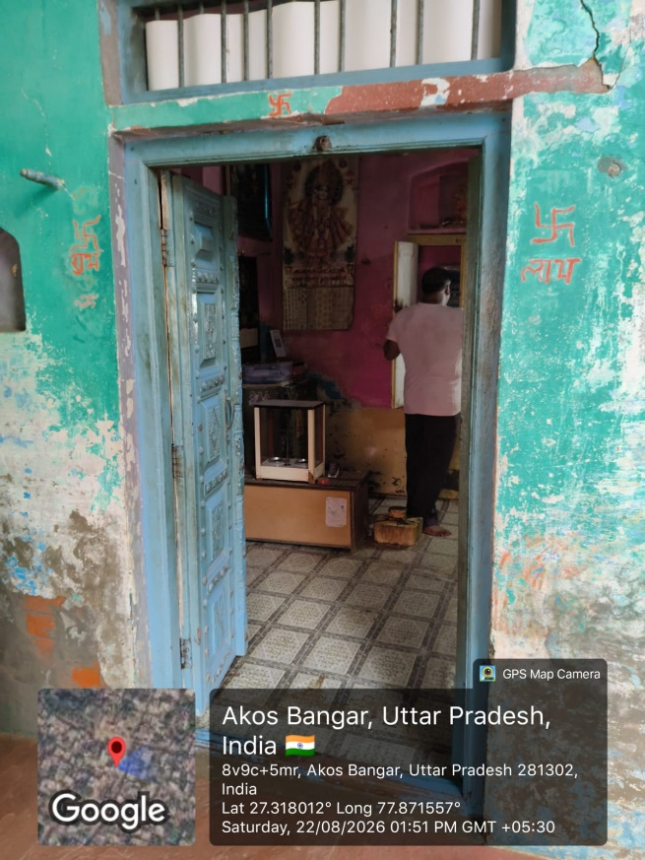

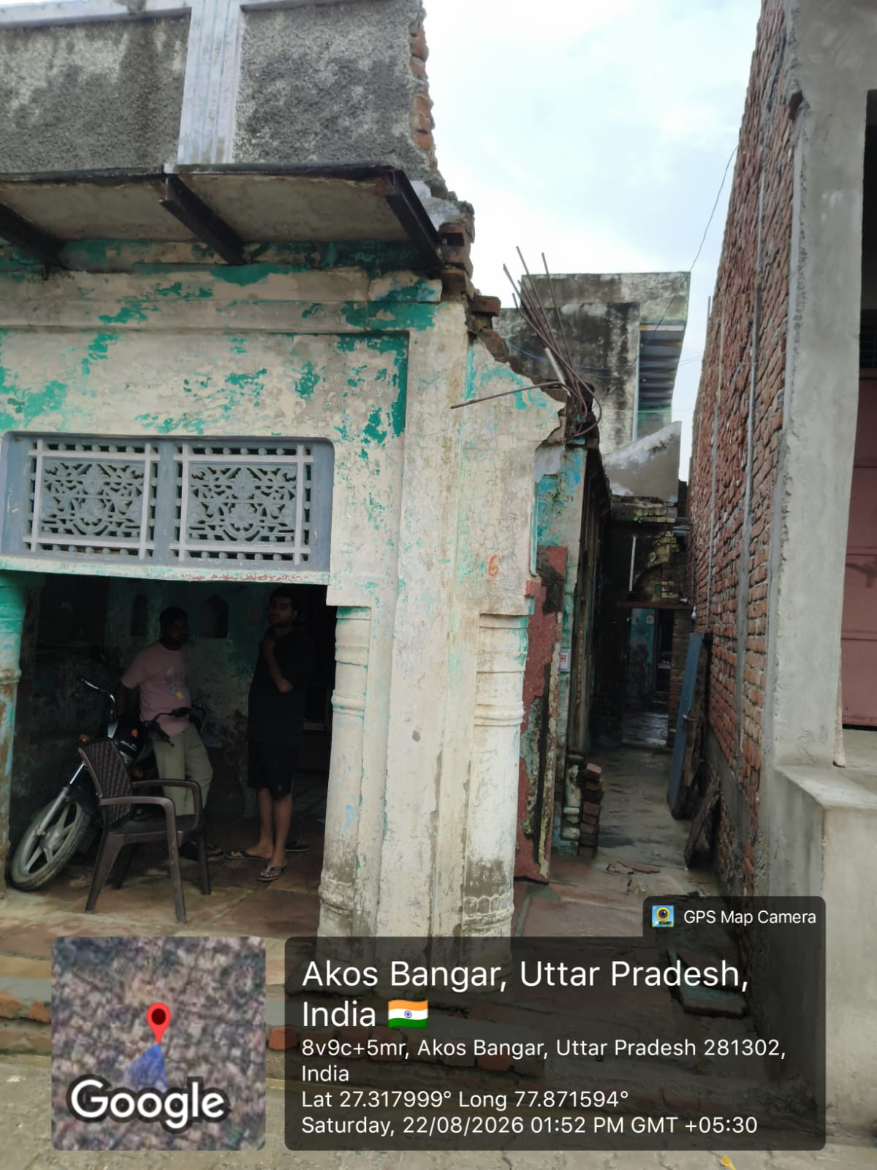
- Photo of LA or met person with Geo tagging

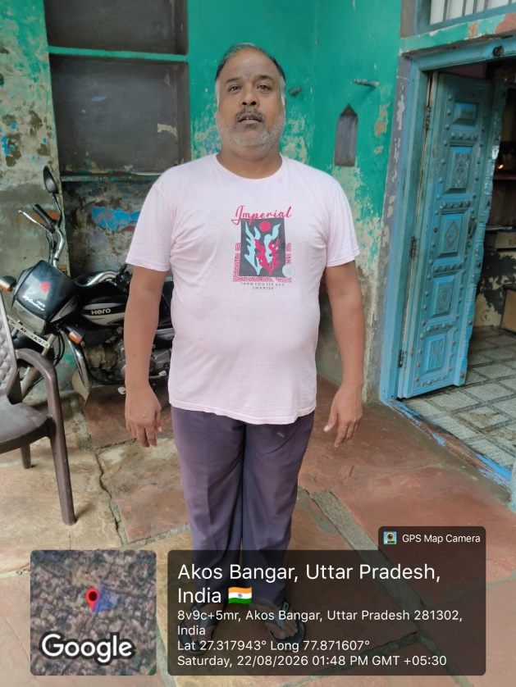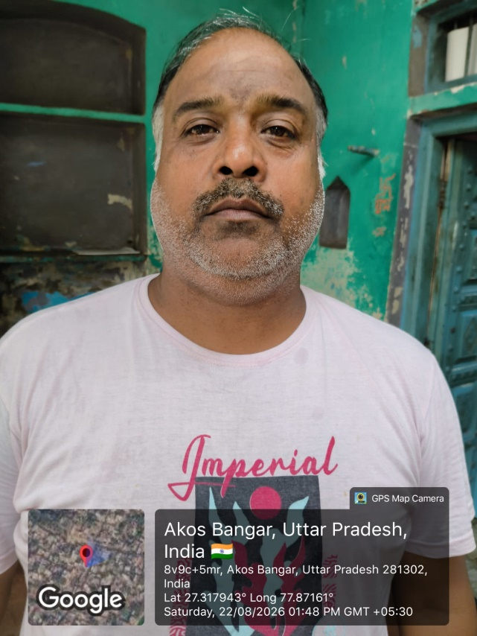

- Photo of LA’s KYC with Geo tagging

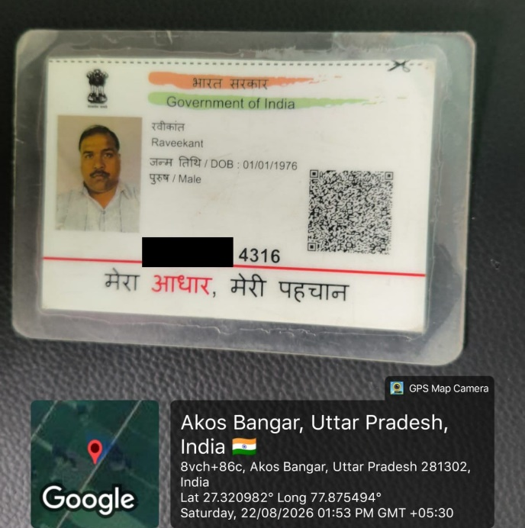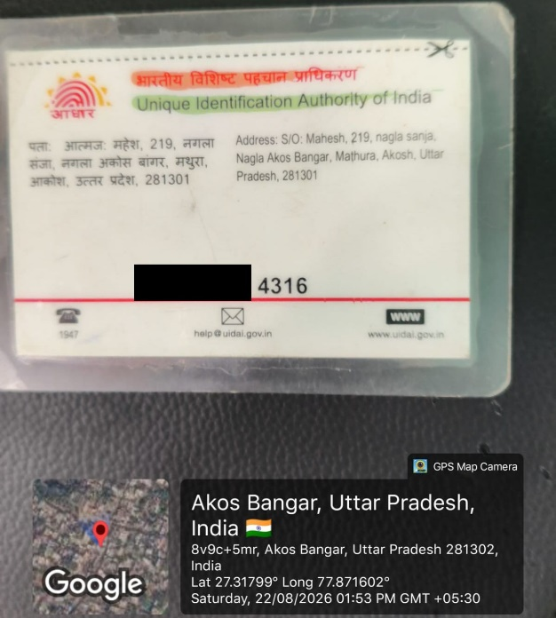

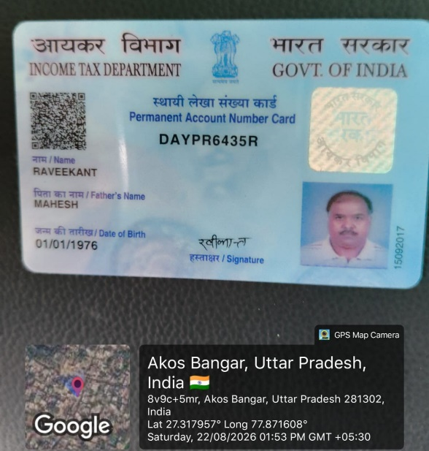

- Field Executive selfie with Geo tagging

