Customer profile verification form
Assignment date | Agency name | Contact number | Report submission date
{{ assignment_date }} | {{ assignment_date }}
Decision | {{ decision }}
Evidence details | {{ evidence_details }}
Remarks | {{ decision_remarks }}

Application no. | {{ application_number }}
Case details
Name of Proposer (PR) | {{ proposer_name }}
Name of Life Assured (LA) | {{ life_assured_name }}
Communication address | {{ communication_address }}
Permanent address | {{ permanent_address }}
Contact number | {{ agency_contact }}
Proposal verification
Locality of LA | {{ locality_of_la }}
Existence of LA established | {{ existence_established }}
Was LA met | {{ was_la_met }}
If LA not met, whom did you meet | {{ whom_did_you_meet }}
If family then relationship with LA
Life Assured details
Date of birth of LA | {{ la_dob }}
Identity proof of LA | {{ identity_proof }}
Address proof of LA | {{ address_proof }}
Education of LA | {{ education }}
Health details of LA | {{ health_details }}
Habits of LA | {{ habits }}
Quantity/ no. of years | {{ habits_quantity }}
Physical appearance of LA | {{ physical_appearance }}
If Handicapped, then | {{ handicapped }}
Existing insurance of LA | {{ existing_insurance }}
Live Photo of LA | {{ live_photo }}
Photo of residence of LA (complete house of LA should be visible) | {{ residence_photo }}
Proposer details
(LA details to be collected where LA and Proposer is same)
Occupation | {{ occupation }}
Name of Company | {{ company_name }}
Income | {{ income }}
Income proof | {{ income_proof }}
Number of members in family | {{ family_members_count }}
Number of earning members in family | {{ earning_members_count }}
Photo of office/shop | {{ office_shop_photo }}
Type of house | {{ house_type }}
Vicinity check
Personal details as per vicinity
Education of LA |  |  | {{ education }}
Health details of LA |  |  | {{ health_details }}
Habits of LA |  |  | {{ habits }}
Quantity/ no. of years |  |  | {{ habits_quantity }}
Physical appearance of LA |  |  | {{ physical_appearance }}
Since how many years is LA’s family staying at this address |  |  | {{ vicinity_years_at_address }}
Income details as per vicinity
Occupation |  |  | {{ occupation }}
Name of Company |  |  | {{ company_name }}
Income |  |  | {{ income }}
Family income |  |  | {{ vicinity_family_income }}
Number of members in family |  |  | {{ family_members_count }}
Number of earning members in family |  |  | {{ earning_members_count }}
Sr no
1. | Shivam
2. | Mithilesh
Remarks/ Details: The above mention told that LA lives on the given address with his family and looking wise he is fit and healthy.
Vicinity check conclusion: Positive
Sr no
1. | {{ hospitals }}
2. | Shir Medicare
Remarks/ Details: No Findings

Medical check conclusion: No negativity found from these places.
In case of DBRCD, Death Certificate / Cemetery Verification:
Name of authority | {{ authority_name }}
Designation and location | {{ authority_designation }}
Contact number | {{ agency_contact }}
Date of death in register | {{ death_register_date }}
Death certificate issue date | {{ dc_issue_date }}
Cause of death (if available) | {{ dbrcd_cause_of_death }}
Life Assured cremation/burial | {{ cremation_details }}
Death certificate verified | {{ dc_verified }}
Other insurance details
(Please collect husband’s insurance details if Life Assured is a housewife, parent’s insurance details if Life Assured is a student)

Name of Life Assured/ Proposer
Family History

Sr. No.
1. | Geeta Ahirwar
2. | Subham
3.
4.
5.
Overall Remarks/Conclusion
Discreet check
IO visited the mentioned address and met with nearby residents Mr. Naman and Mr. Kushal.
IO inquired about the mentioned address and the LA.
They informed that the mentioned address belongs to LA and that they know him.
Nearby people also stated that the LA is doing a job in Prayagraj.
Overall Remarks
IO visited at the mentioned address and met with LAs mother.
IO asked about LA she stated that LA is posted in Prayagraj.
IO make a call to LA on provided contact number and the call was picked by LA.
IO told that he is in investigating officer on behalf of ICICI Prudential life insurance and asked for policy verification.
LA shared the requested information over call.
LA shared that his educational qualification is graduation.
LA is married and he is doing a job in U.P.P PRAYAGRAJ as an accountant through which he earns an annual income of approximately 06 lakhs.
LAs family consists of 05 members with one active 01 earning members.
LA shared that his mother Mrs. Geeta Gupta is the nominee under the policy.
LA has shared his Pan card which is attached with this report.
LA shared that the he is not sure about policy premium and the term.
When asked about his health condition the LA stated that he does not have any health or medical issues and does not have any kind of addiction.
During the call the LA requested verification in Prayagraj but did not share the address He stated that the IO should call him after reaching Prayagraj and he would then share the address.
Prayagraj IO called the LA multiple times LA has scheduled multiple appointments but did not meet the IO.

Second Visit
After sometime, IO got a call of LA and he scheduled the appointment with LA.
IO visited at LAs Prayagraj address and met with LA.
IO told that he is in investigating officer on behalf of ICICI Prudential life insurance and asked for policy verification.
IO confirmed all the details with LA which was earlier shared by LA over call.
LA shared that the policy premium is approx. 35000 yearly.
LA has shared his Job ID card which is attached with this report.
When asked about his health condition the LA stated that he does not have any health or medical issues and does not have any kind of addiction.
All Photographs with Geo tagging
First Visit:
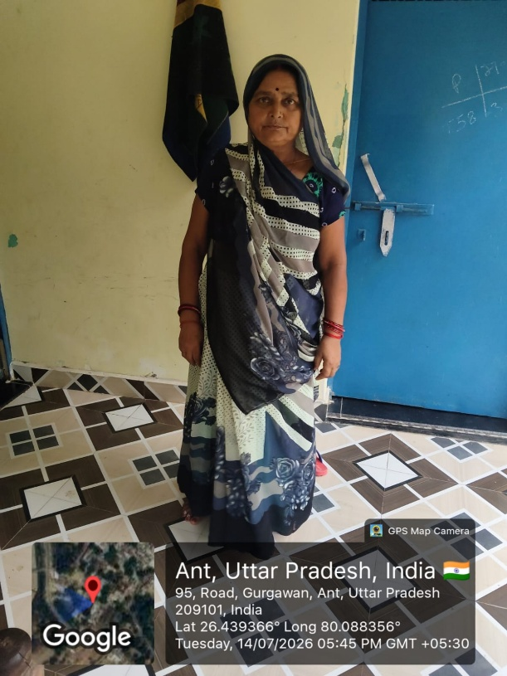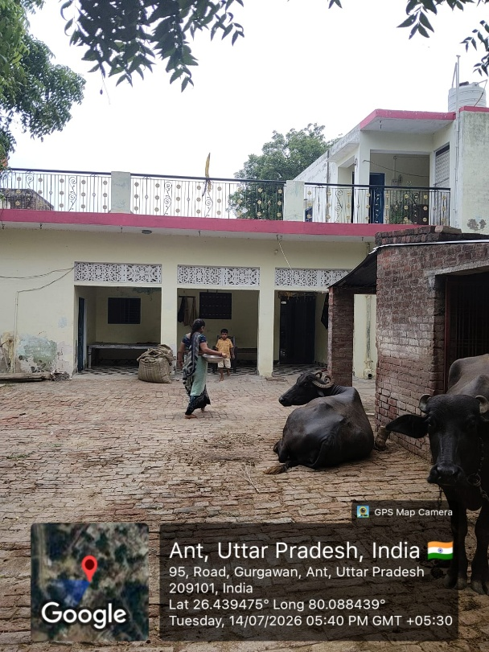
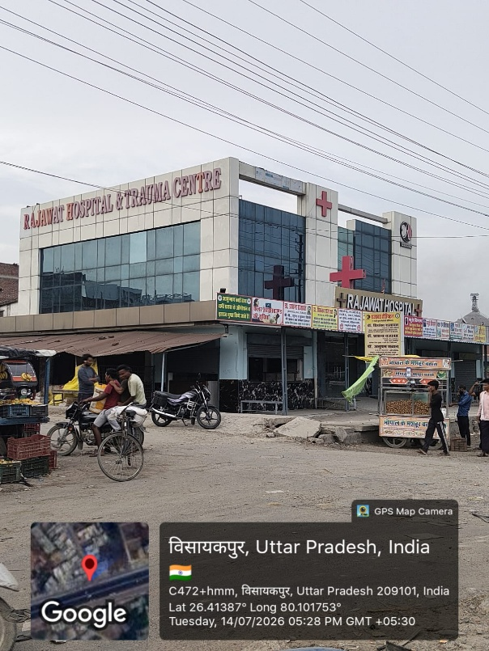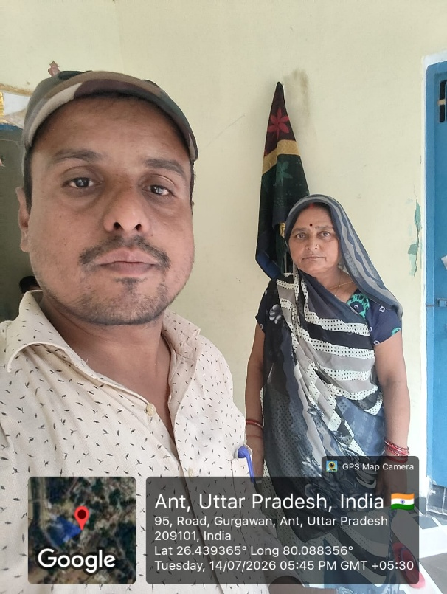
Second Visit:
