Details Investigation [Pre-Claims] Report

INVESTIGATOR DETAILS

Investigation Agency Name | Filed investigator name | Contact Number of field investigator | Investigation Assignment date | Report Submission date |  | Time Taken (TAT)
{{ agency_name }} |  | {{ fi_contact_number }} | {{ assignment_date }} | {{ report_submission_date }} |  | {{ tat_days }}
Decision (Positive / Negative) | {{ decision }}
Please specify - Meeting with LA done. |  |  |  |  | {{ decision_specify }}

PROPOSAL/POLICY DETAILS:
App No | {{ application_number }}
NA | {{ proposal_matrix }}

PROPOSAL VERIFICATION:
Personal Details of the Insured’s (Age, Income, Reason & Occupation – Nature of Duties)
Details – As per
Name | {{ business_name }}
Date of birth (Age)
Income | {{ business_findings }}
Occupation | {{ business_findings }}
Work Place Address
Health, Hospitalization details (past hospitalization details-if any)
Marital Status
Qualification/Education
Address
Nominee/Beneficiary
PEP – Political exposed person
Hazardous hobbies – if any
Please specify in detail if any considerable difference/discrepancy in above details with category (eg: age)

[In case of Life assured and Proper are different, please provide Proper name and other details, collect relationship proof also]

FAMILY HISTORY:
Sr. No.
1 | {{ life_assured_name }}
2 | Family member | {{ family_members }}
3 | Family member | {{ family_members }}
4 | Family member | {{ family_members }}
Please specify in detail if any considerable difference/discrepancy in above details

OTHER POLICY DETAILS & FAMILY INSURANCE DETAILS (Life/ Mediclaim/ Critical Illness):

Sr.
1 | Life - XXXXXXX
1 | Health – XXXXXXX
VICINITY CHECK:
(Discussion and conclusion made out of verification done with Relatives/neighborhood, nearby house)
Sr. No.
1 | Vinod Kumar
2 | Nitin
Findings/Observation/remarks:
- IO visited the nearby location of the mentioned address and met with local people.
- IO inquired about the mentioned address and the Life Assured (LA); however, local people were not aware of either.
- Local people stated that the mentioned address was incomplete, as no house number was provided.
- IO made his best efforts to locate the address, but the provided address could not be traced.

Workplace Check:
Sr. No.
1 | NA | {{ proposal_matrix }}
2 | NA | {{ proposal_matrix }}
(A) In case of Salaried:
- Name of employer: NA
- Life Assured designation and income, general health/habit, behavioral- NA
- Salary slip/Income Tax Return/Form 16: NA
- Sick Leave details, Reason for availing sick leaves, collect medical documents, duly filled employer certificate to be collected: NA

(B) In case of business/self-employed/Shop/Vendor: (Contact at least 2-3 adjacent shop owners, colleagues, friends record their statement in writing & contact no.) –
Photo of Shop/Business -

Findings/Observation/remarks (if any mismatch/discrepancy noted with regard to age, occupation, income, health, habit, …)
- During the investigation, IO came to know LA’s financial condition is Middle.
- During investigation, Investigator found that LA is fit & healthy.
News Paper / Internet check:
Name of documents/
Information. Eg: Voter id Card, ITR etc. )
By Visit/Verification- | {{ visit_verification }}
By Online Checks - | This needs to done by online Checks - Linked In / Business Registration Proof, Website checks. (Ration Card, Voter id Search for age difference suspected profile) | NA
{{ online_checks }} | {{ online_checks }} | {{ proposal_matrix }}

Investigation Agency Overall findings:
**Overall Remarks: **
First Visit:
- IO tried his best to locate the address, but provided address was not traceable.
- IO make a call to LA on provided number and the call was picked by LA.
- IO told that he is an investigating officer on behalf of Kotak Life insurance and asked for policy verification visit.
- On call, LA denied for any kind of verification.
- LA has not shared any details over the call and has not confirmed his address.
- LA was not cooperative during verification call LA was not cooperative during the verification call and did not provide the required information and documents.

Second Visit
- IO got a call from LA, he confirms the address and he schedule the visit for verification.
- IO visited at mentioned address and met with LA.
- IO introduced himself and asked for policy verification. Life assured has shared required verification details over call.

**Other information not covered in the report above: **
- During the investigation, LA shared that currently he is studying in class 10th.
- LA is unmarried.
- LA stated that his father manages his own hotel business but not sure about annual income.
- He stated that her family has 06 members, with 01 earning members.
- LA has shared his Aadhar card as a KYC proof which is attached with this proof.
- LA informed that he is not sure about policy premium, nominee and the term.
- When asked about his health condition, LA stated that he has no medical issues or has no any type of addiction.

DOCUMENTS PROCURED / COLLECTED:
Particulars
Age Proof
Occupation and Income Proof
Customer Live Photo, Workplace Photo
Medical Evidence – If any
Other Insurance policy - If any
Death Certificate (if applicable)
Family/Nominee KYC (Age/identity)
List are for reference only, change as per procured documents

First Visit
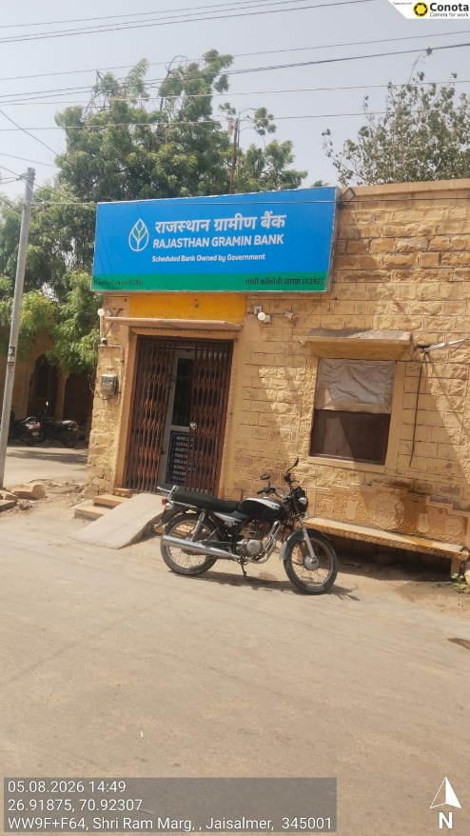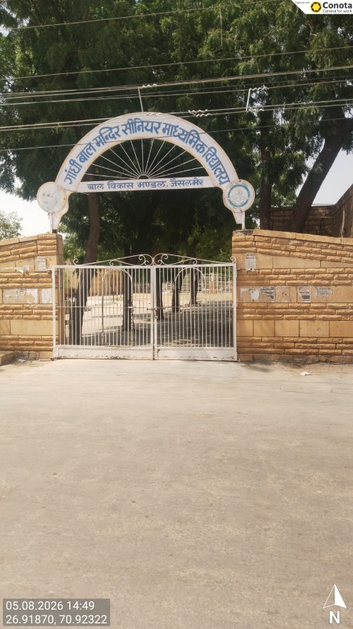
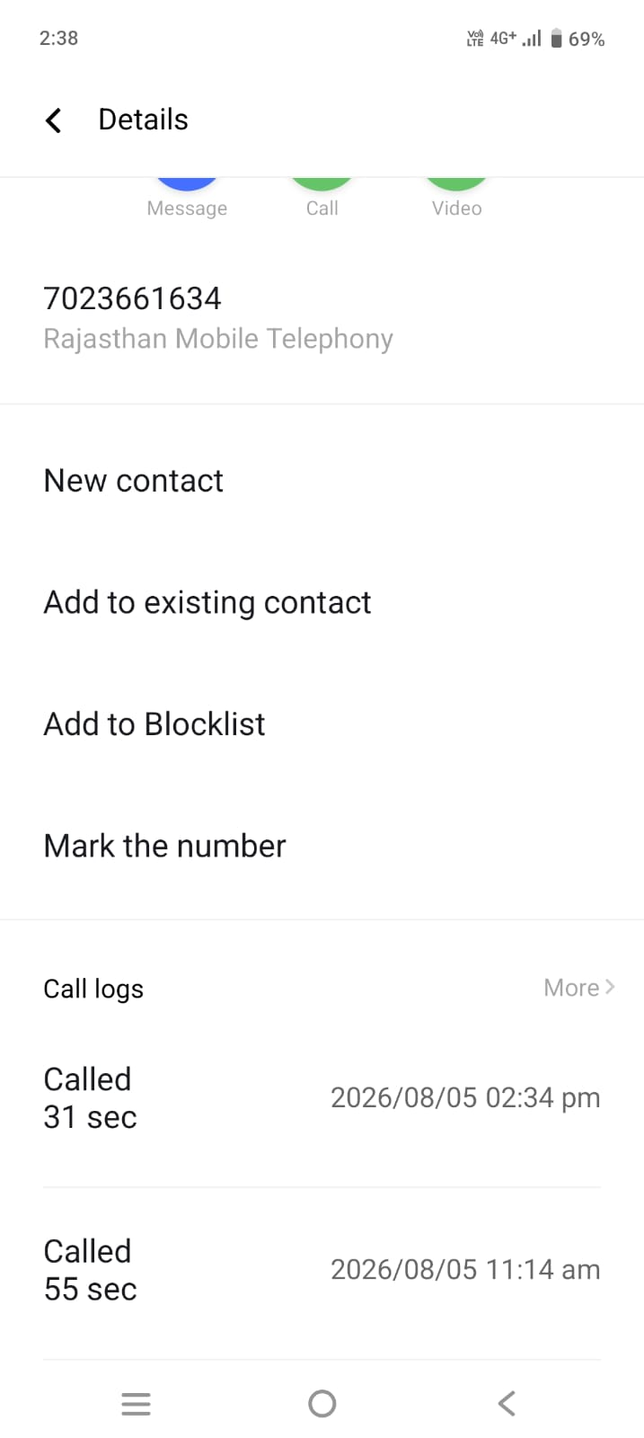

Second Visit

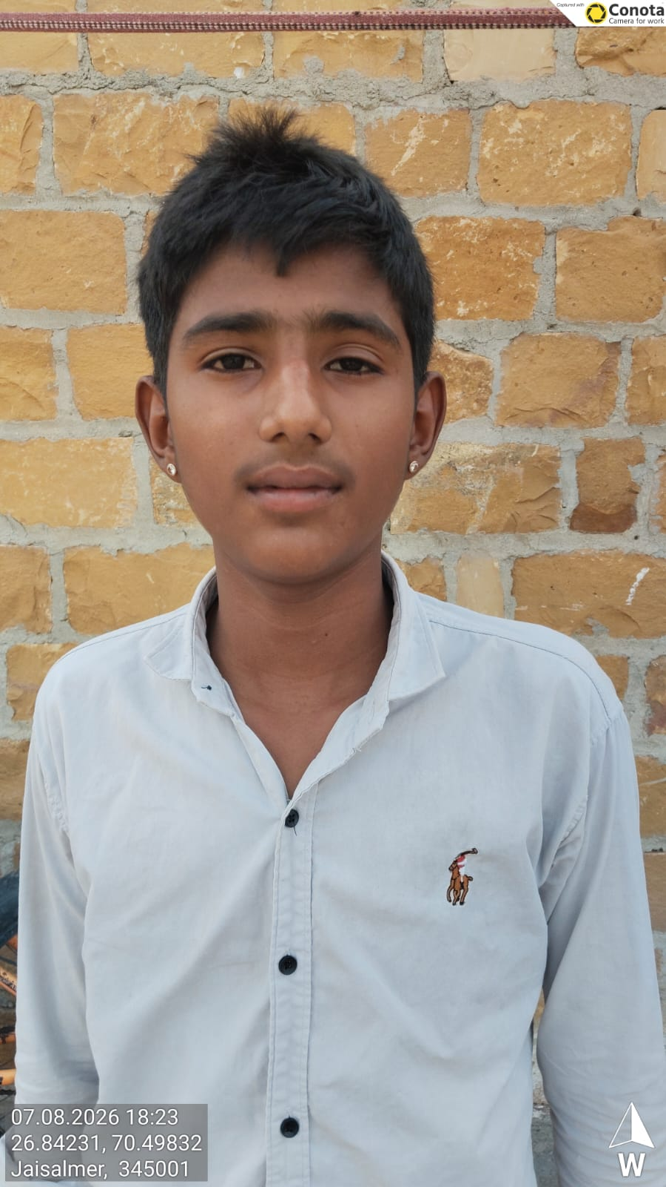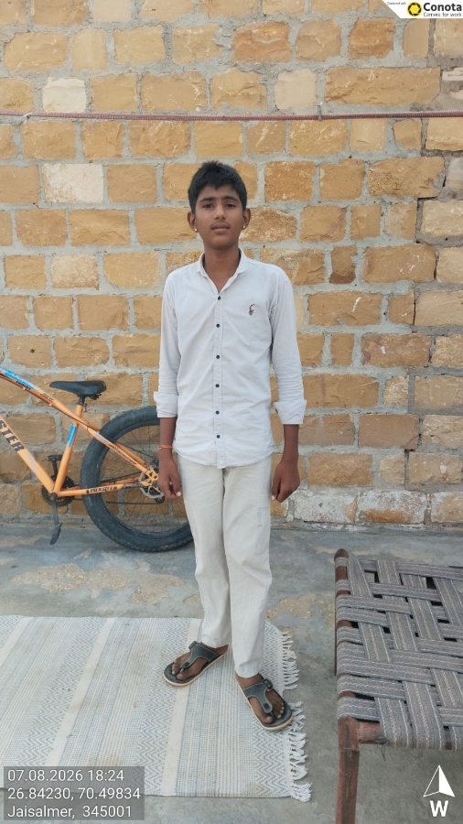
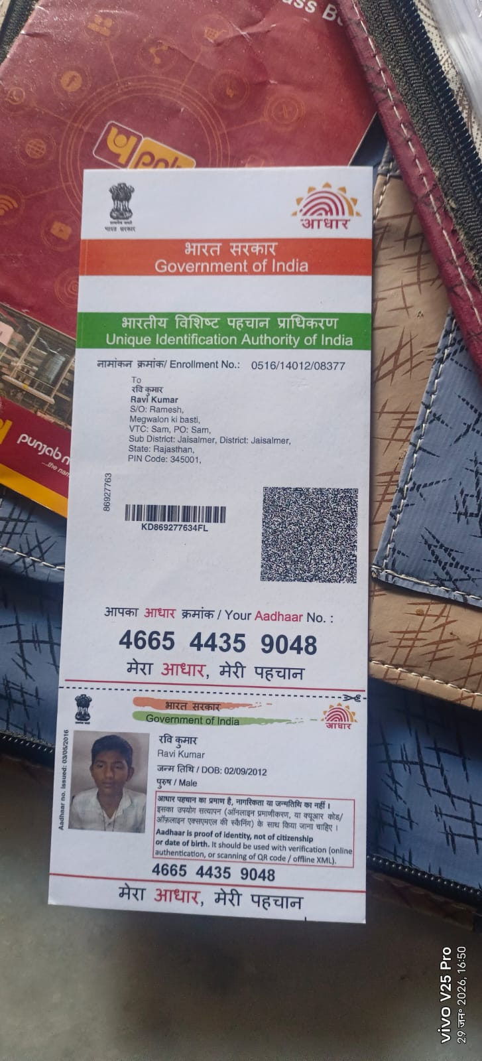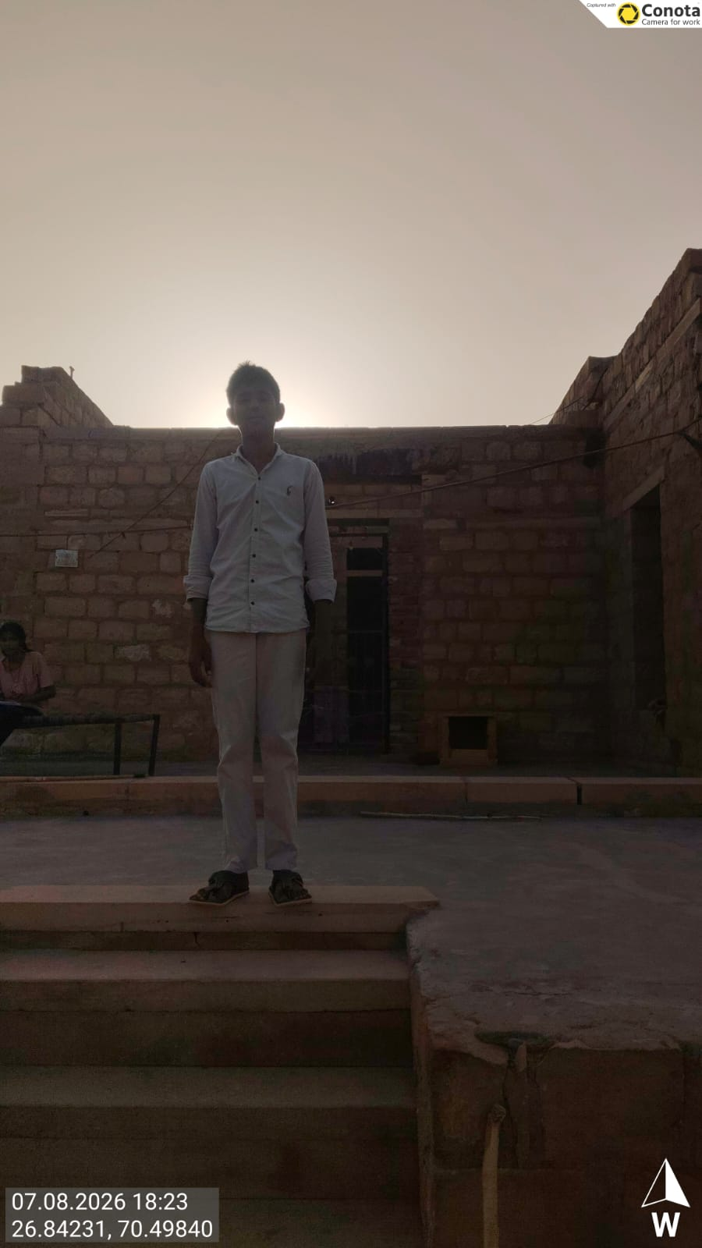
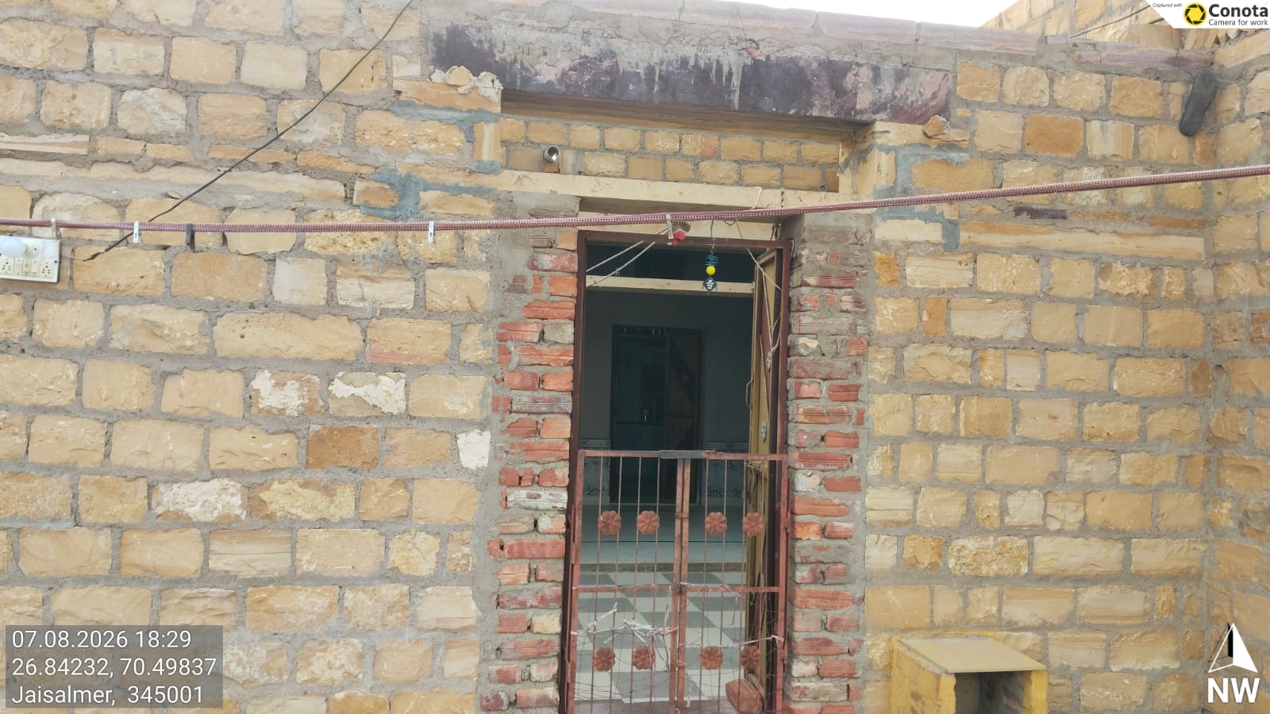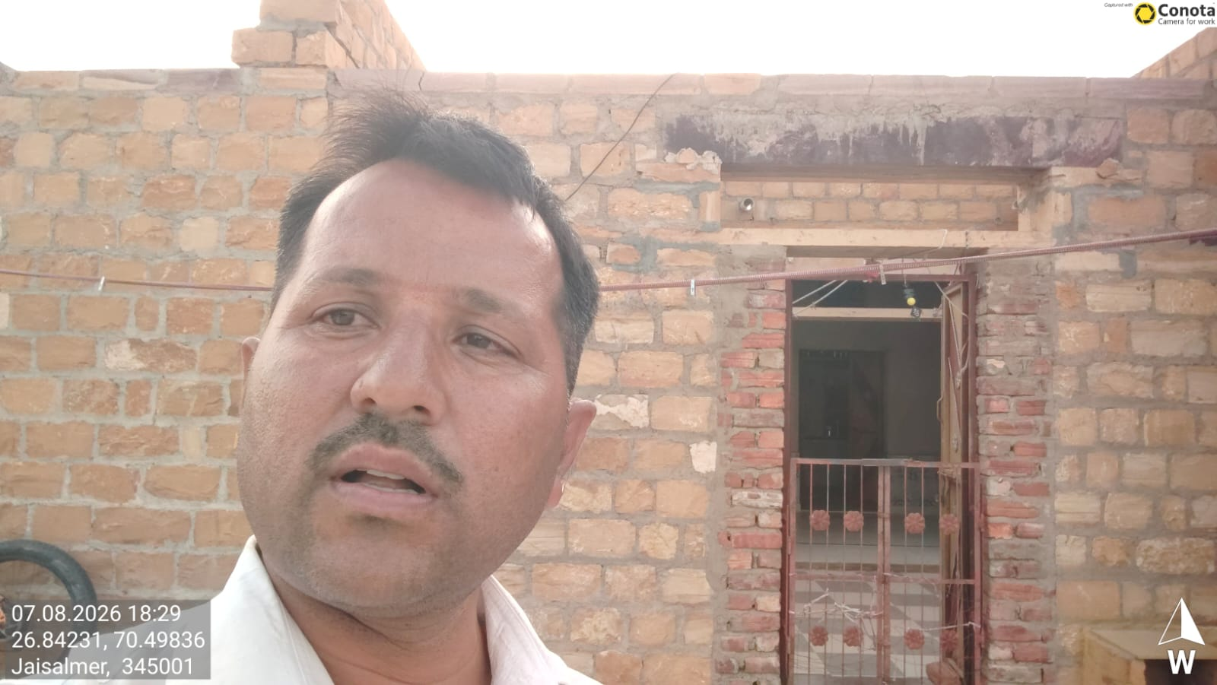

END

