Application No: - {{ application_number }}
Investigating Agency Details | {{ agency_details }}
OVERALL  STATUS | Meeting is done with LA | STATUS
{{ overall_status }} |  | {{ status }}
Scenario 1: Life Assured Met
Section 1
1.1 | {{ s2_disease_details }}
1.2 | {{ s1_physical_appearance }}
1.3 | {{ s2_physical_appearance }}
1.4 | {{ s2_vicinity_check }}
 | Special Remarks
Section 2
2.1 | {{ s2_disease_details }}
2.2 | {{ s1_physical_appearance }}
2.3 | {{ s2_physical_appearance }}
2.4 | {{ s2_vicinity_check }}
2.5 | {{ s3_photographs }}
Section 3
3.1 | {{ s2_disease_details }}
3.2 | {{ s1_physical_appearance }}
3.3 | {{ s2_physical_appearance }}
3.4 | {{ s2_vicinity_check }}
3.5 | {{ s3_photographs }}
3.6 | {{ s3_place_of_death }}
REMARKS | {{ s1_special_remarks }}
Scenario 2. Life Assured not met at first attempt (house locked etc.)
1 | Do One more attempt
2 | Do Follow other check, Viz. Family/relative, neighborhood/Vicinity check as listed | {{ vicinity_remarks }}
3 | If fail on second attempt proceed submit the report with findings basis Point No. 2
Scenario 3. Life Assured existence refused to meet/ identity not established/address or whereabouts not traced
Do Verification with Neighborhood/Vicinity and workplace - collect as much as information on ground about Life Assured existence, age, occupation/income, health, habit, physical appearance etc., collect information from neighbors etc.
Vicinity Check: -

- IO visited the mentioned address for verification purposes.
- During the field visit, IO met nearby residents and local persons of the area.
- The nearby persons confirmed the existence of the LA and verified the provided address.
- The mentioned address was confirmed as the LA’s self-owned house.
- They also stated that LA is married and having 04 members in her family.
- Thay stated that LA is housewife.
- No negative information was received from the vicinity regarding the LA.
- Vicinity verification was successfully conducted and found satisfactory.

Overall Remark: -

- IO visited the mentioned address on behalf of PNB MetLife for verification purposes.
- IO met the LA, Mrs. {{ life_assured_name }}, and introduced himself. After explaining the purpose of verification, the LA cooperated and provided the required information.
- The LA confirmed her personal details as Father: Mr. Radha Charan Agnihotri and Mother: Mrs. Snehlata Agnihotri.
- The LA confirmed that her nominee is Mr. Rakesh Kumar Agnihotri, who is her husband.
- The LA stated that there are 04 family members in the family, including self, husband, and two sons.
- The LA confirmed that her marital status is married.
- The LA informed that her educational qualification is BA.
- The LA stated that she is engaged in housewife work and coaching classes.
- The LA informed that her annual income is approximately ₹2,00,000.
- The LA confirmed that the policy premium is ₹2,100 per month and the policy term is 5 years.
- The LA provided her Aadhaar Card and PAN Card as KYC documents.
- KYC documents were checked and found satisfactory.
- The LA confirmed that she is health-wise fit and has no illness, medical issue, or health-related problem.
- The LA confirmed that she has no bad habits.
- The information provided by the LA was found to be consistent during verification.
- Meeting with the LA was successfully conducted.
- Case found to be Positive.
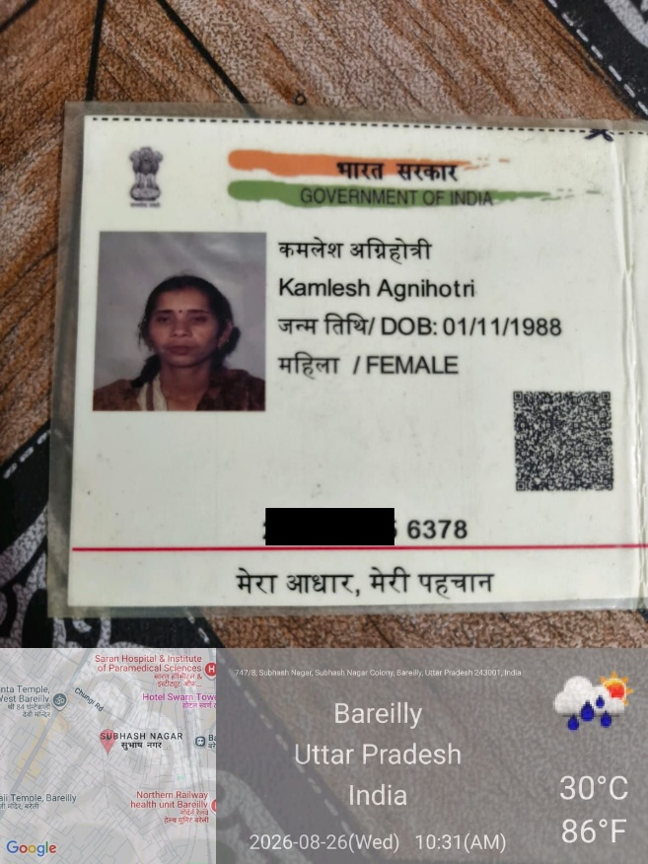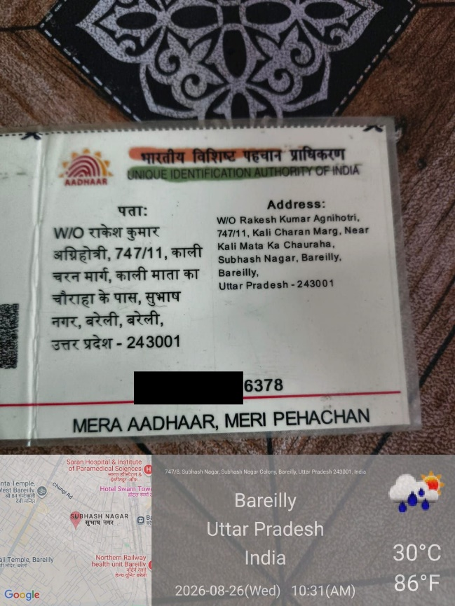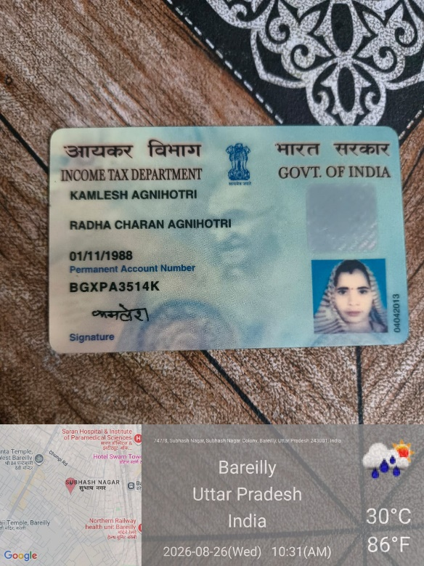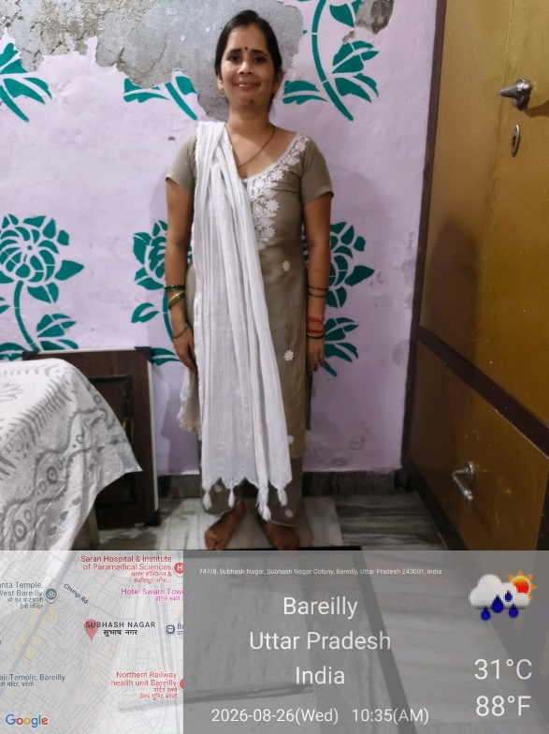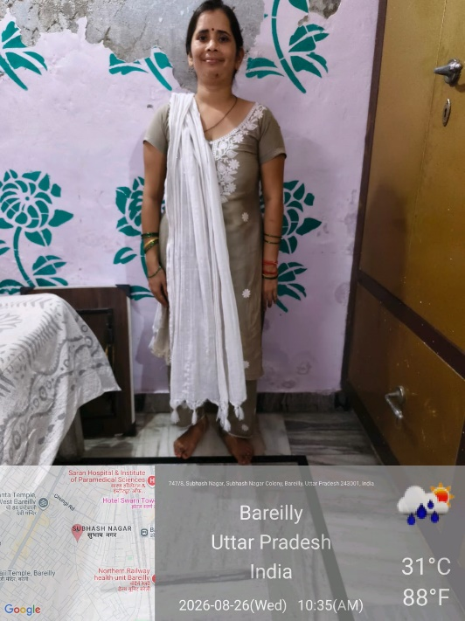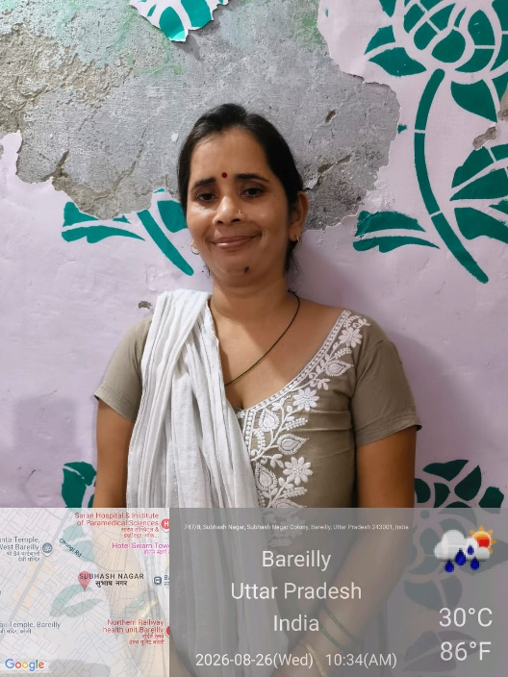
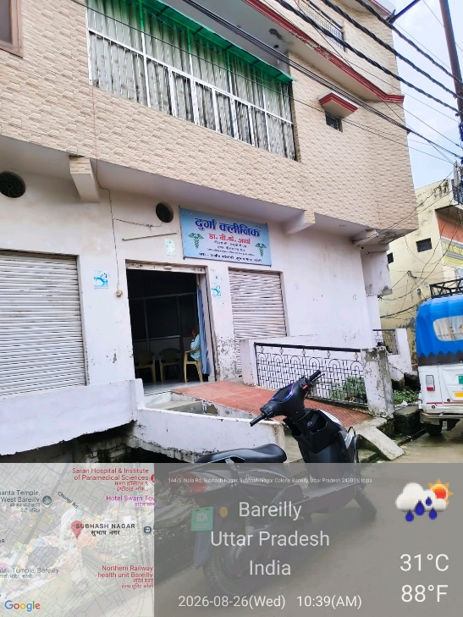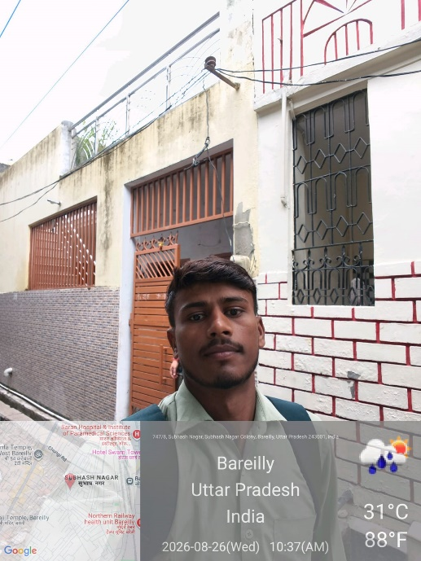


Seal of Investigation agency

