INVESTIGATION REPORT
INVETIGATION AGENCY NAME:
INVESTIGATORS NAME:
LA’s Name: | {{ life_assured_name }}
Contact number: | {{ contact_number }}
La is Present on visit (yes/No): | {{ la_present_on_visit }}
Occupation As per Proposal: | {{ occupation_proposal }}
Qualification as Per Proposal; | {{ qualification_proposal }}
Income As per Proposal: INR. | {{ income_proposal }}
Exact Nature of Duty | {{ nature_of_duty }}
Nominee Name: | {{ nominee_name }}
Education as per proposal form | {{ education_proposal }}
Address As per Proposal: | {{ address_proposal }}

BACKGROUND of LA (exposed to Political/Criminal Connections)
No criminal background or political connections were found during the investigation.

family details
Sr. No
1 | Anita Devi

NeIghbor Verification
Sr. No | Name | Address | Contact no. | Remark
 | {{ documents_verified }} | {{ photo_4 }} | {{ fi_name_contact }} | {{ overall_remarks }}
2 | Brijendra
3 | Surendra Yadav
4 | Shiv Prakash
5 | Suneel Pandey | Tamar Ranchi Jharkhand 835225 | NA | During the vicinity enquiry, local residents confirmed that the insured was a Labour

Income details of family & Sources (confirmed from Whom)
As per the nominee’s statement, the Life Assured (LA) was a Labour; however, no significant evidence regarding his occupation or work activity was found during the investigation.

Health history of LA (confirmed from Whom)
During the discreet inquiry, the Investigating Officer (IO) gathered information that the Life Assured was reportedly suffering from cancer. To verify the same and obtain supporting medical evidence, the IO conducted further inquiries. During the investigation, it was found that the LA had reportedly undergone treatment for cancer at Bhagwan Mahavir Medica Superspeciality Hospital. The IO therefore attempted to verify the LA’s previous treatment and obtain the relevant medical records from the hospital.

Asset’s of LA (Land/House/Vehicle/Shop/Other)- (confirmed from Whom)
Life Assured (LA) was working as an animal husbandry work; however, no significant evidence regarding his occupation or work activity was found during the investigation

Local Authority Verification - (Police/Panchayat)
Thereafter, the IO visited the local Gram Panchayat and ASHA/Anganwadi Centre to verify the death of the Life Assured (LA). The concerned officials verbally confirmed the LA’s death but refused to provide any written statement or supporting documents. They provided information verbally in support of the nominee.

VERIFICATION of documents
[Name of documents with name of the authority form whom document verified]
During the investigation, the IO verified the Government-subsidized ration card, KYC documents, and MNREGA records. But no records found in the name of insured.
We checked the validation of given KYCs and Death certificate and found to be Genuine.
DC Verified Link: https://dc.crsorgi.gov.in/crs/verifyCertificate?id=TjSviHeuw1ZfCgZ6a+FrjA==

observation and finding of investigator
Vicinity Check:
- In this case, the Investigator visited the given address: Tamar Ranchi Jharkhand 835225.
- The Investigator interacted with nearby residents and a few elderly members of the village.
- IO started his inspection by enquiring few distant Neighbors and shopkeepers.
- Nearby people told that LA was suffering from Cancer since last 1 ½ Years, for which he initially sought treatment from locally in Amroha, but later he was undergoing treatment at Bikaner Rajasthan.
- For finding some clue IO probed adjacent nearby people, Old members & Shopkeeper’s and discreetly inquired by the name of insured, but they said that LA was suffering from Cancer and during his last stage Cancer cells had spread from Lung to Esophagus and his body was generalized weak, subsequently, on 23.11.2024 he died at his home.
- However, despite questioning distant residents, Old members and local shopkeepers in the vicinity, IO came to know that LA was suffering from Cancer for the past 1 ½ Yrs., for which he initially sought treatment from somewhere Hospital locally in Amroha, but later he was undergoing treatment in Bikaner.
- They told that LA’s dead body was cremated at the nearby cremation ground in Amroha.

Additional Remarks:
- Eventually, IO visited at the given address of LA, There Investigator met with LA’s Wife. LA’s wife stated that on 18.11.2024, LA started suffering from chest pain. Concerned about his condition, they took him to Muzaffarnagar District Hospital, where he received treatment and underwent several tests. On 19.11.2024, LA was brought back to his permanent residence. On 23.11.2024, he passed away suddenly at home, and the family did not get the opportunity to take him to the hospital. On the same day, his cremation was conducted at the local cremation ground in his village in the presence of family members and relatives.

Conclusion:
- However, despite questioning distant residents, Old members and local shopkeepers in the vicinity, IO came to know that on dated 23.11.2024, LA’s death was taken on his current address and previously LA was a Patient of Cancer since last 1 ½ Yrs., for which he sought treatment from Amroha, but later he was undergoing treatment at Acharya Tulsi, Bikaner Hospital.
- After completing verification criteria from LA’s house, investigator visit at the nearby local Community Health Centre, there investigator met with Centre Staff, However, no entry was found by the name of insured and given ID proof.
- During the residence visit Investigating officer asked for the medical history with medical paper of LA and nominee refused to have any medical paper and told that LA died at his home and the duration of illness was only one day and prior to death her husband was good in health. Investigating officer pressurized her but she was not being ready to disclose any medical history nor have she shared any medical paper.
During investigation, investigator noticed that LA’s financial condition and the standard of living was Below Poverty Line.
According to Claimant, LA worked as a Farmer.
However, no income proof document has been provided by the nominee.
- We checked the validation of given Death Certificate and KYC’s online and they found to be genuine.

Final Conclusion: -

However, despite questioning distant residents, Old members and local shopkeepers in the vicinity, IO came to know that LA was suffering from Cancer since last 1 ½ Years, Additionally, some of the nearby people told that insured used to work as a Farmer. They commented that insured was a patient of CA Lung since 1 ½ Years; thus, consequently he sought treatment from Acharya Tulsi Hospital, later he was undergoing treatment at Bikaner Hospital. subsequently On dated 06.10.2024 LA’s death was taken place on his current address.
Bikaner Cancer Hospitals emerged as a potential lead.
During a discreet investigation, However, therefore through our concerned person, we applied for search of medical records at Acharya Tulsi Regional Cancer Treatment & Research center and finally, anyhow with our sources we have procured Pre Policy medical evidences include patient summary and reports from the Hospital to establish the treatment of LA at Bikaner Hospital, In received medical documents, investigator found that the LA was diagnosed as a case of FNAC Lung MASS Non-Small Cell Carcinoma, and he was undergoing treatment since June-July, 2024, We have obtained medical records related to this case; however, the Risk commencement Date (RCD) has not been confirmed in this group case.
LA’s Father name, Registration no., Age & Address is clearly mentioned in the medical documents for ID establishment.
So, overall investigation, case found to be Negative.

CONCLUSION & Reason (Positive /negative)
Final Conclusion: -
Based on the overall findings, including discreet inquiries and video evidence, it has been confirmed that the insured had been suffering from throat cancer for more than one and a half years. The case appears to be nexus-plotted and is therefore found to be negative during the investigation..

Hence, company may look in the case and take necessary decision.

Snap taken at Location (with GPS Tagging)
- LA’s Signature Sample (*Mandatory)

- LA’s Snap

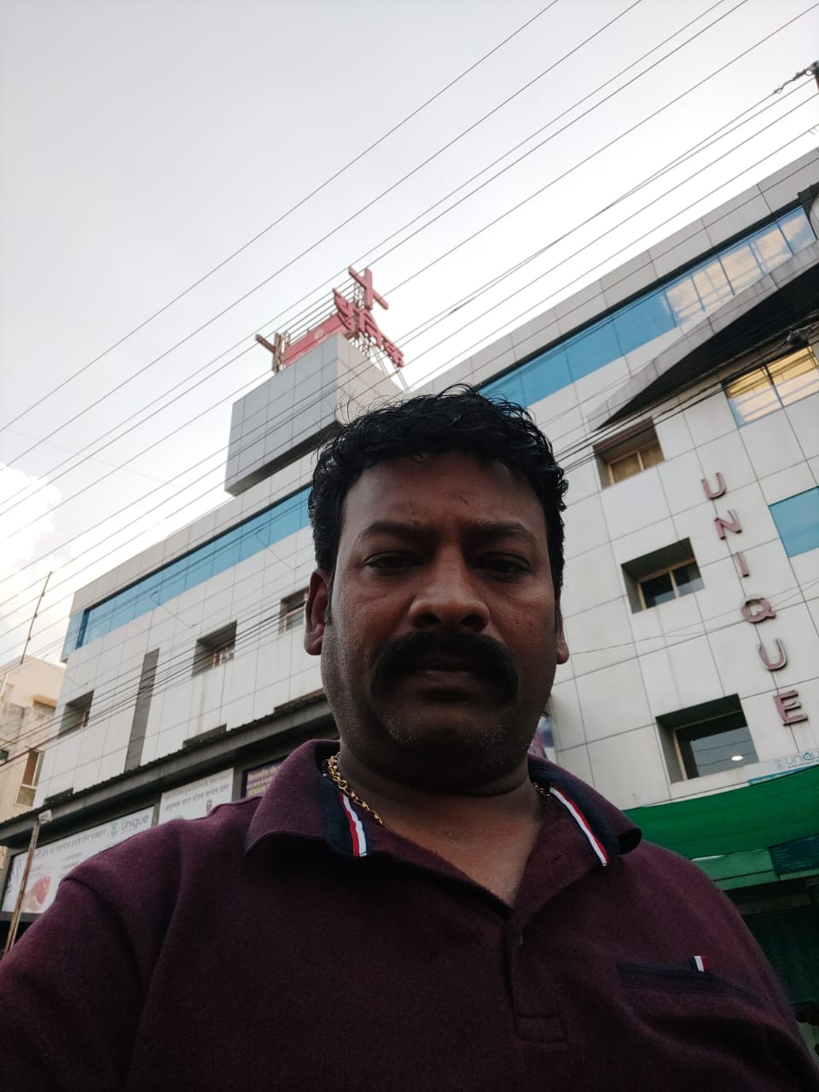

- LA’s ID and Address Proof Snap

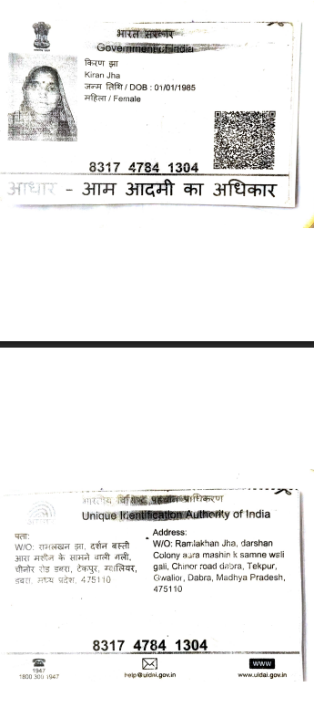

- LA’s House Snap
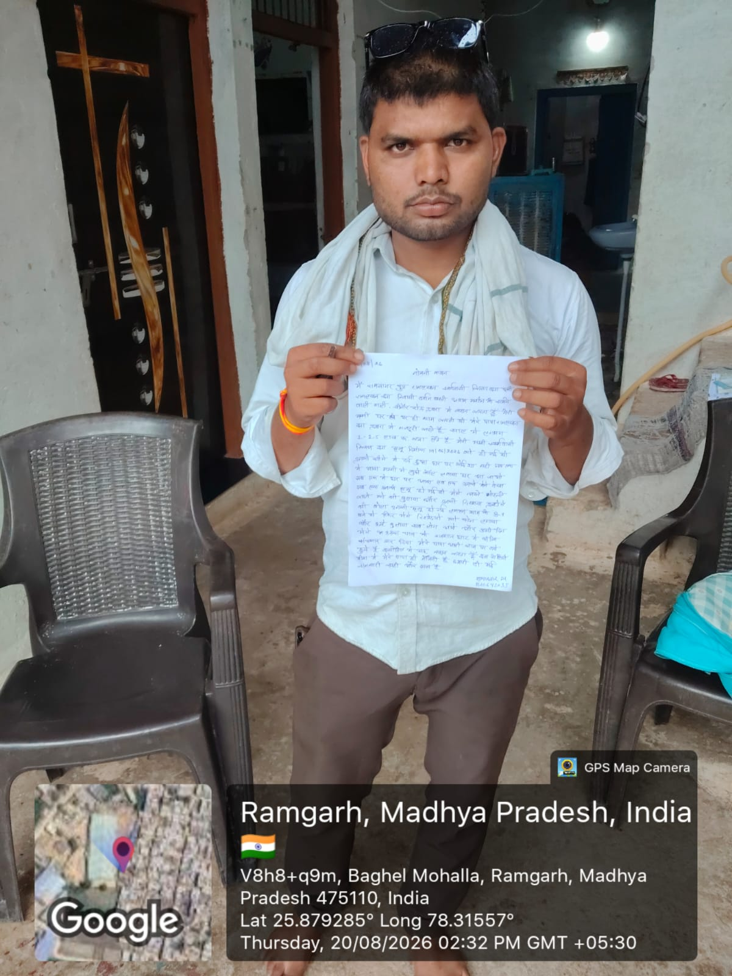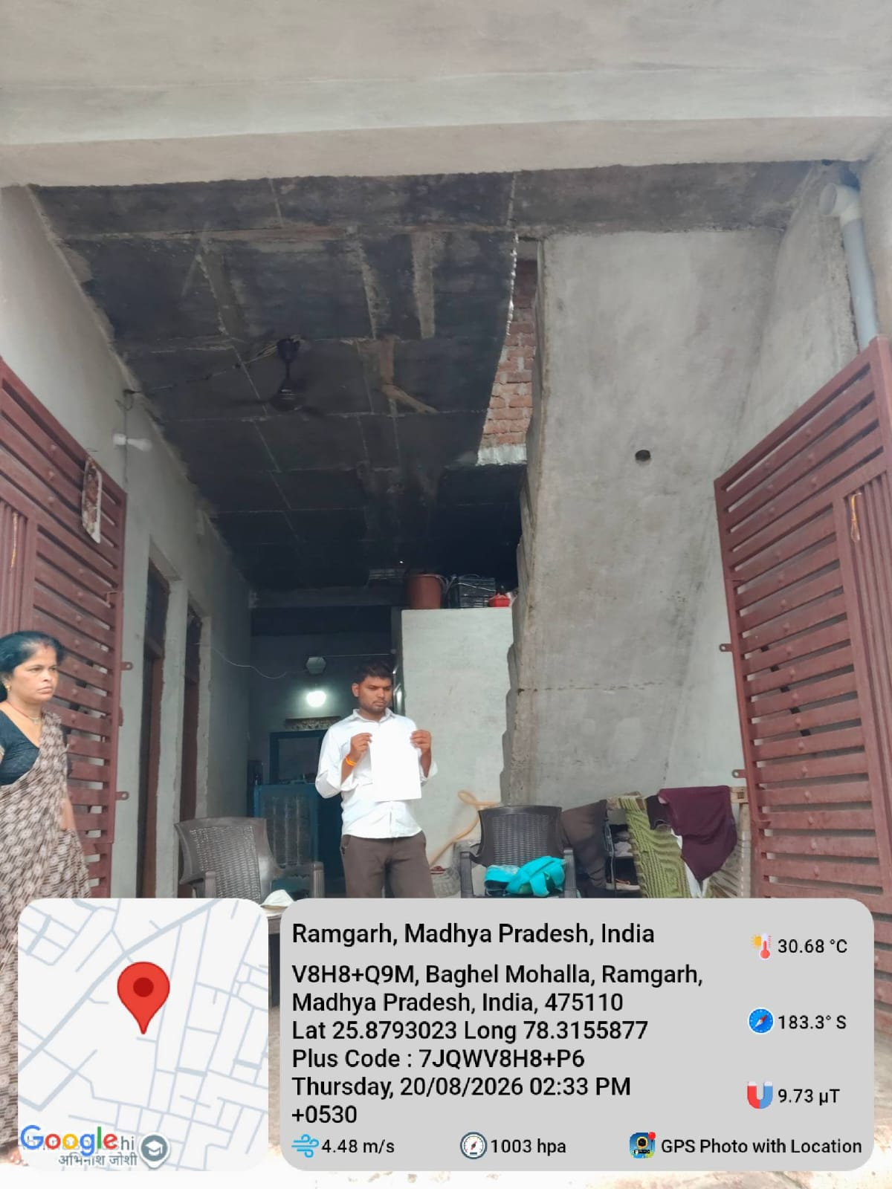
- Declaration:

I hereby declare that all above given details are verified and found to be true to best of my knowledge.

Field Investigators Name / Contact No.: {{ field_investigator_name }}
Investigation Report Drafted By: {{ report_prepared_by }}
Investigators Visit Date: {{ date_of_visit }}
Investigators’ Signature: {{ field_investigator_name }}

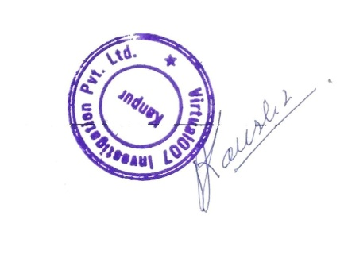

Agency’s Stamp:

Agency Stamp :

