OPERATING SYSTEM UPGRADE REPORT
Ubuntu 22.04 → 24.04
CKP Kubernetes Cluster (pra-ckp): Management Summary & Technical Runbook
Document type | Management summary and step-by-step technical runbook with evidence
Cluster | pra-ckp (3 control-plane nodes + 1 worker node)
Platform versions | CKP 1.34.3 | Calico 3.30.5 | containerd 1.7.28
Change executed | 22 May 2026
Overall status | COMPLETED SUCCESSFULLY

1. Executive Summary
The operating system on every node of the pra-ckp Kubernetes cluster was upgraded in place from Ubuntu 22.04.5 LTS to Ubuntu 24.04.4 LTS. The work was done as a rolling upgrade, one node at a time, control-plane nodes first and the worker last. The CKP (Kubernetes) version, Calico networking and containerd runtime were deliberately left unchanged, so the change was limited to the operating-system layer.

At a glance
Objective | Move all cluster nodes from Ubuntu 22.04 LTS to Ubuntu 24.04 LTS
Method | Rolling in-place upgrade: drain → patch → reboot → release-upgrade → verify → uncordon
Nodes upgraded | 4 of 4 (pra-ckp-1, pra-ckp-2, pra-ckp-3 control-plane; pra-ckp-4 worker)
Kernel | 5.15.0-136-generic → 6.8.0-117-generic
Platform versions | CKP v1.34.3, Calico 3.30.5, containerd v1.7.28: no change
Safeguards | etcd snapshot before change; node drain/uncordon; kubeadm, kubectl and kubelet held from upgrade
Result | All nodes Ready on Ubuntu 24.04.4 LTS; all system pods Running
Extra validation | Added and removed control-plane and worker nodes on Ubuntu 24.04 using the automation playbooks; all succeeded

Key outcomes
- Every node is now on the same OS family and kernel line, so the cluster can be supported and patched on Ubuntu 24.04.
- The control plane was never taken down as a whole: only one control-plane node was out of service at any time, so etcd kept its quorum.
- A full etcd snapshot was taken before any change, giving a recovery point.
- The add/remove node automation works on Ubuntu 24.04, which confirms that a problem node can be replaced rather than repaired.

Observations and recommendations
# | Observation | Recommendation
1 | Nodes added by automation (pra-ckp-5, pra-ckp-6) came up on Ubuntu 24.04.2 / kernel 6.8.0-57, while upgraded nodes are on 24.04.4 / kernel 6.8.0-117. | Run apt update / apt upgrade on the new nodes (one at a time) to align patch levels.
2 | Pod restart counters on node-level system components increased (e.g. 2 restarts). | Expected: each node was rebooted twice (pre-patch reboot and release-upgrade reboot). No action needed.
3 | kubeadm, kubectl and kubelet are on apt hold. | Keep the hold. Release it only during a planned Kubernetes version upgrade.
4 | containerd is deployed from a tar package, not apt. | It is unaffected by OS upgrades. Re-check its version after every OS change.

2. Scope and Environment

Version comparison (before vs after)
Component | Before upgrade | After upgrade | Comment
OS version | Ubuntu 22.04.5 LTS | Ubuntu 24.04.4 LTS | Upgraded
Kernel | 5.15.0-136-generic | 6.8.0-117-generic | Upgraded
Calico | 3.30.5 | 3.30.5 | No change
kubectl | v1.34.3 | v1.34.3 | No change (apt hold)
kubeadm | v1.34.3 | v1.34.3 | No change (apt hold)
kubelet | v1.34.3 | v1.34.3 | No change (apt hold)
containerd | v1.7.28 | v1.7.28 | No change (deployed from tar)

Node inventory
Node | Role | Internal IP | Phase
pra-ckp-1 | Control-plane | 172.16.108.231 | Upgraded first
pra-ckp-2 | Control-plane | 172.16.108.154 | Upgraded second
pra-ckp-3 | Control-plane | 172.16.108.223 | Upgraded third
pra-ckp-4 | Worker | 172.16.108.188 | Upgraded last
pra-ckp-5 | Worker (new) | 172.16.108.220 | Added after upgrade (validation)
pra-ckp-6 | Control-plane (new) | 172.16.108.243 | Added after upgrade (validation)

In scope / out of scope
- In scope: Ubuntu OS and kernel upgrade on all four nodes; etcd backup; post-upgrade validation; node add/remove validation.
- Out of scope: Kubernetes version upgrade, Calico upgrade, containerd upgrade, application changes.

3. Upgrade Approach
The upgrade followed a conservative, repeatable sequence. The same steps were applied to every node, and a node was only returned to service after it was verified.
Step | Phase | What happens
1 | Baseline and pre-checks | Record OS, kernel, component versions, held packages, node and pod status.
2 | etcd backup | Take an etcd snapshot from a control-plane node before any change.
3 | Control-plane nodes (1 → 2 → 3) | For each node: drain, patch, reboot, release-upgrade, verify, uncordon. Next node starts only when the previous one is Ready.
4 | Worker node (4) | Same procedure, after all control-plane nodes are complete.
5 | Cluster validation | Confirm all nodes Ready on Ubuntu 24.04 and all pods Running.
6 | Node lifecycle validation | Add a new worker and a new control-plane node on Ubuntu 24.04, retire one old master and the old worker.

4. Risks and Mitigations
Risk | Mitigation applied | Outcome
Loss of etcd quorum | Control-plane nodes upgraded strictly one at a time | Quorum preserved
Cluster data loss | etcd snapshot taken before the change | Backup available
Unplanned Kubernetes version change | kubeadm, kubectl, kubelet on apt hold | Versions unchanged
Workload disruption during reboot | Node drained before work, uncordoned after verification | Pods rescheduled and Running
Container runtime break | containerd deployed from tar; version re-checked after upgrade | v1.7.28 unchanged
Failed node after upgrade | Add/remove node automation validated on Ubuntu 24.04 | Replacement path proven

5. Execution Summary
Node | Role | OS before | OS after | Kernel after
pra-ckp-1 | Control-plane | Ubuntu 22.04.5 | Ubuntu 24.04.4 | 6.8.0-117-generic
pra-ckp-2 | Control-plane | Ubuntu 22.04.5 | Ubuntu 24.04.4 | 6.8.0-117-generic
pra-ckp-3 | Control-plane | Ubuntu 22.04.5 | Ubuntu 24.04.4 | 6.8.0-117-generic
pra-ckp-4 | Worker | Ubuntu 22.04.5 | Ubuntu 24.04.4 | 6.8.0-117-generic

6. Technical Runbook
This section is the detailed, repeatable procedure with evidence from the actual run. Commands are run as root on the node named in each step.

Phase 0: Pre-upgrade baseline
Capture the current state so that every result can be compared after the upgrade.
cat /etc/os-release
uname -r
kubectl get nodes -o wide
kubectl get pods -A
kubelet --version
kubeadm version
containerd --version
apt-mark showhold

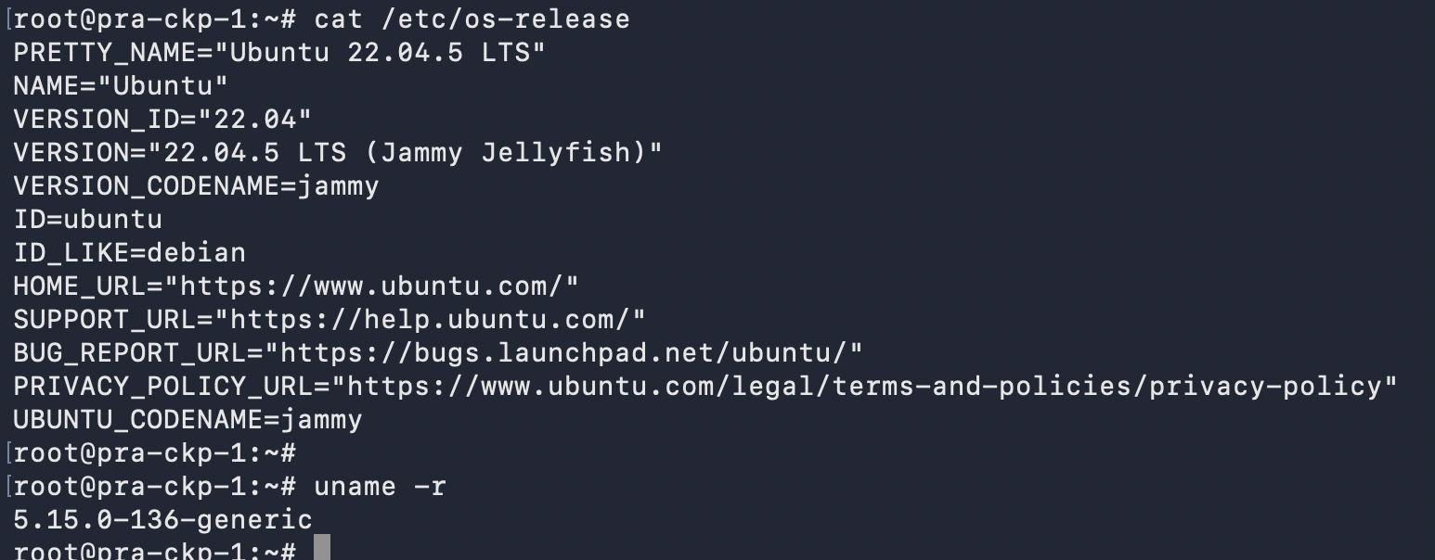
Figure 1: OS and kernel before upgrade (Ubuntu 22.04.5, kernel 5.15.0-136-generic)
Figure 2: Node status before upgrade (all nodes Ready, Ubuntu 22.04.5)
Figure 3: containerd version v1.7.28
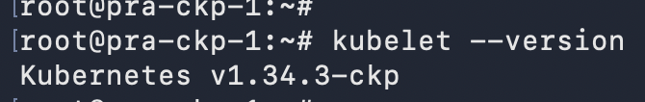
Figure 4: kubelet version v1.34.3-ckp
Figure 5: kubeadm version v1.34.3-ckp
Kubernetes packages are on hold so the OS upgrade cannot change them. Confirm on every control-plane node:
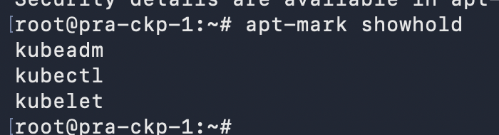
Figure 6: apt-mark showhold on pra-ckp-1 (kubeadm, kubectl, kubelet)
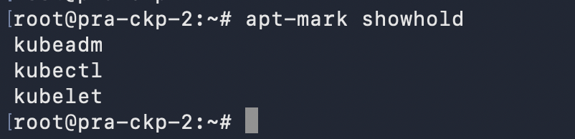
Figure 7: apt-mark showhold on pra-ckp-2 (kubeadm, kubectl, kubelet)
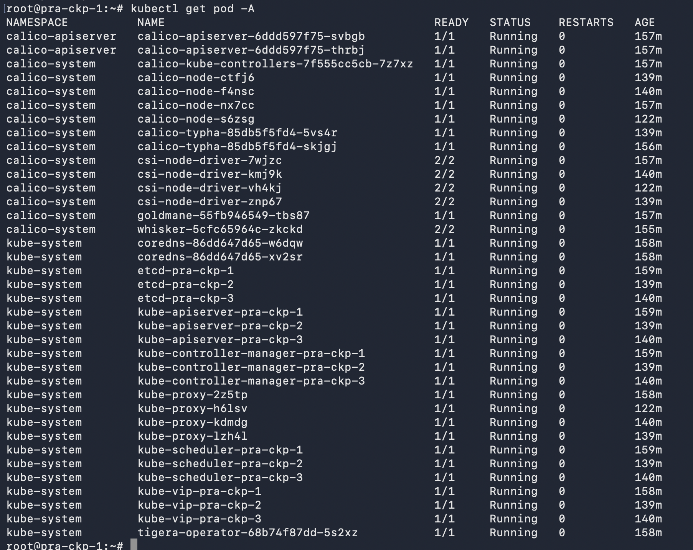
Figure 8: All pods Running before upgrade

Phase 1: etcd backup
Take the snapshot on the first control-plane node before making any change.
# Download etcd tools
wget https://github.com/etcd-io/etcd/releases/download/v3.6.11/etcd-v3.6.11-linux-amd64.tar.gz
tar xzf etcd-v3.6.11-linux-amd64.tar.gz
cd etcd-v3.6.11-linux-amd64

# Save snapshot
ETCDCTL_API=3 ./etcdctl --endpoints=https://127.0.0.1:2379 \
--cacert=/etc/kubernetes/pki/etcd/ca.crt \
--cert=/etc/kubernetes/pki/etcd/server.crt \
--key=/etc/kubernetes/pki/etcd/server.key \
snapshot save /root/etcd-backup-22may2026.db

# Recommended: verify the snapshot file
./etcdutl snapshot status /root/etcd-backup-22may2026.db -w table

Recommendation
Copy the snapshot file off the node (to a backup server or storage) before starting the upgrade. A backup stored only on the node being upgraded is not a safe recovery point.

Phase 2: Standard procedure for each node
Apply these steps to one node at a time, in the order pra-ckp-1, pra-ckp-2, pra-ckp-3 (control-plane), then pra-ckp-4 (worker). Do not start the next node until the current one shows Ready. Replace <node-name> with the node being upgraded.

Step 1: Drain the node
kubectl drain <node-name> --ignore-daemonsets --delete-emptydir-data

Step 2: Patch the current OS
apt update
apt upgrade -y
apt dist-upgrade -y

Step 3: Reboot and wait for the node to return
reboot

Step 4: Run the release upgrade (22.04 → 24.04)
do-release-upgrade

Tips for this step
Run do-release-upgrade inside tmux or screen so a dropped SSH session does not interrupt it. When asked "Remove obsolete packages?" answer y. At the end, answer y to "Restart required" so the node reboots into the new kernel.

Step 5: Verify the node
cat /etc/os-release # expect Ubuntu 24.04.x LTS (noble)
uname -r # expect 6.8.0-117-generic
containerd --version # expect v1.7.28
kubelet --version # expect v1.34.3-ckp
apt-mark showhold # expect kubeadm, kubectl, kubelet
kubectl get nodes -o wide # expect node Ready

Step 6: Return the node to service
kubectl uncordon <node-name>

Phase 3: Control-plane node 1 (pra-ckp-1)
kubectl drain pra-ckp-1 --ignore-daemonsets --delete-emptydir-data
apt update && apt upgrade -y && apt dist-upgrade -y
reboot
do-release-upgrade
kubectl uncordon pra-ckp-1

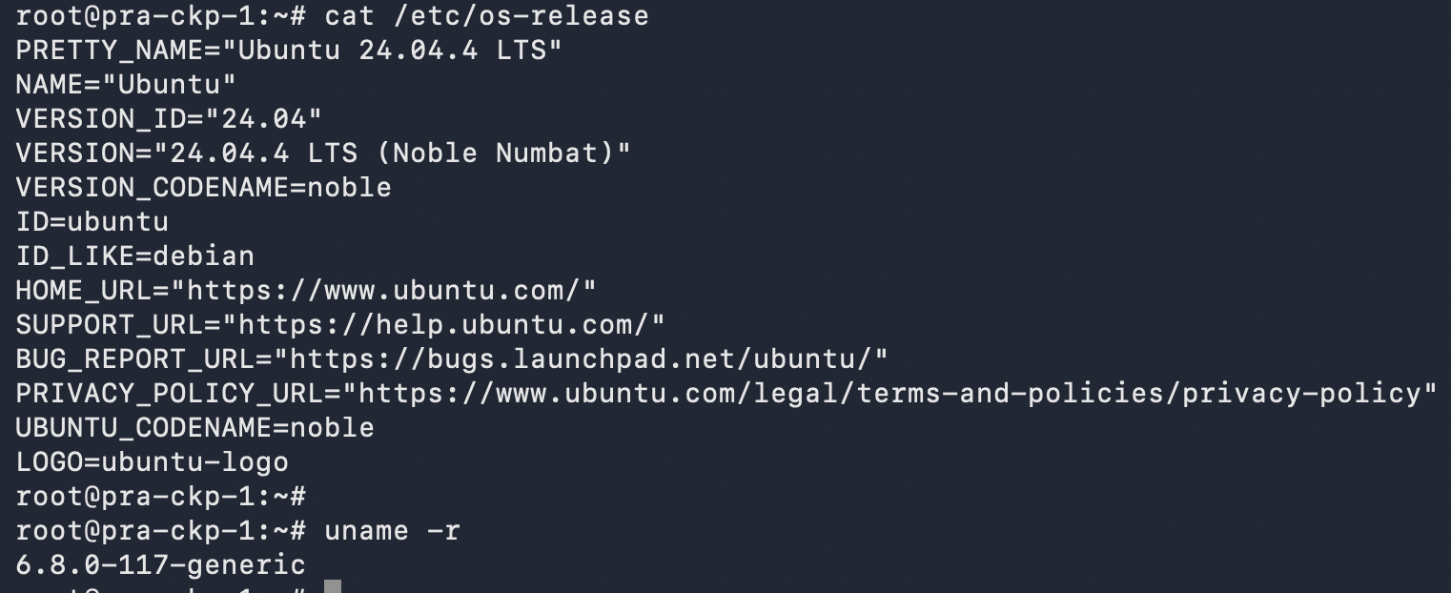
Figure 9: pra-ckp-1 after upgrade (Ubuntu 24.04.4, kernel 6.8.0-117-generic)
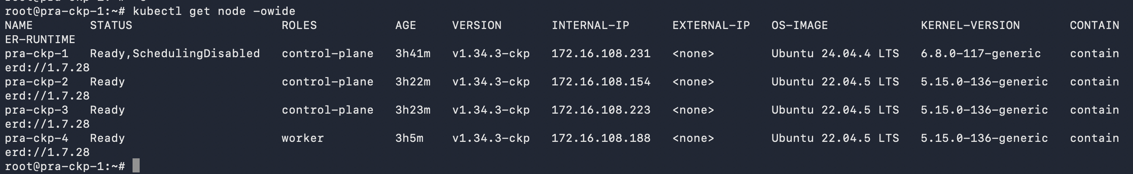
Figure 10: Node status after upgrade; pra-ckp-1 Ready, scheduling disabled until uncordoned
Figure 11: After uncordon, pra-ckp-1 is Ready on Ubuntu 24.04.4; other nodes still on 22.04

Phase 4: Control-plane node 2 (pra-ckp-2)
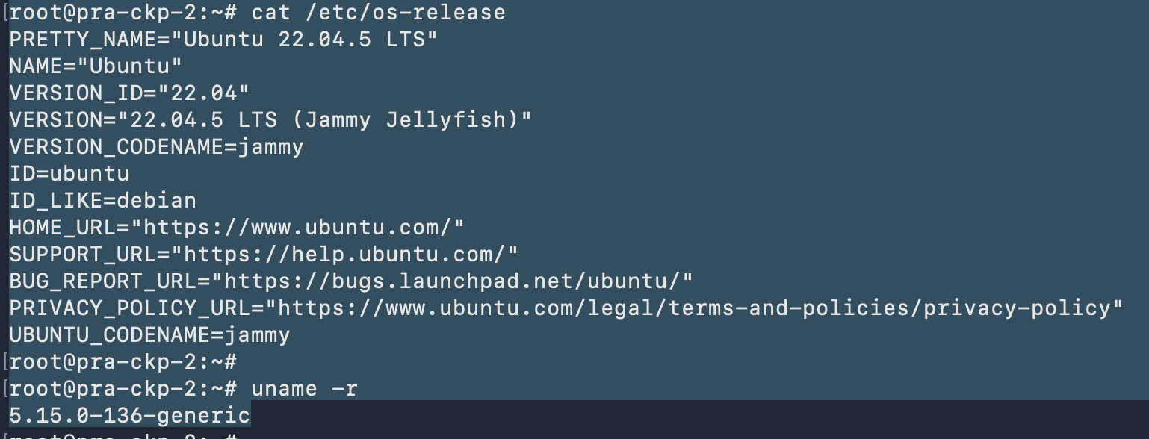
Figure 12: pra-ckp-2 before upgrade (Ubuntu 22.04.5, kernel 5.15.0-136-generic)
kubectl drain pra-ckp-2 --ignore-daemonsets --delete-emptydir-data
apt update && apt upgrade -y && apt dist-upgrade -y
reboot
do-release-upgrade
kubectl uncordon pra-ckp-2

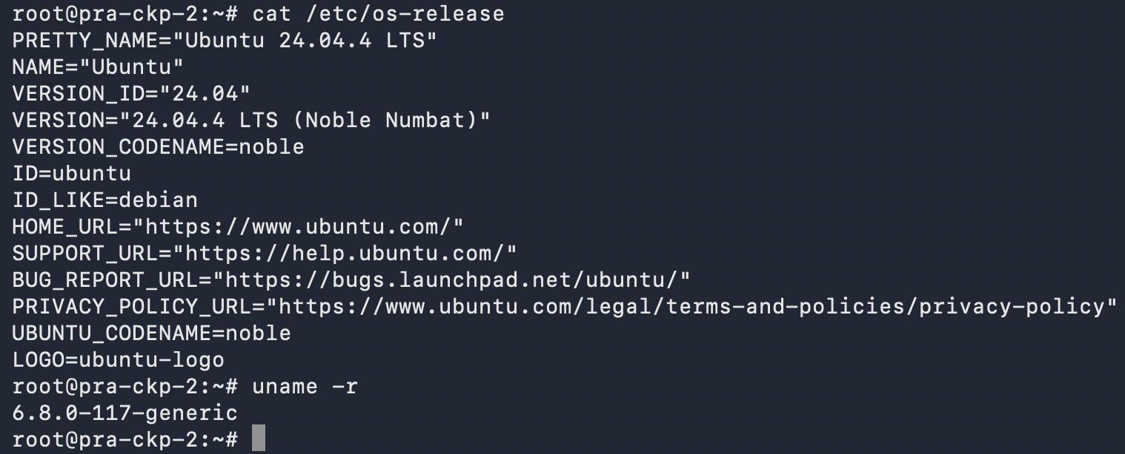
Figure 13: pra-ckp-2 after upgrade (Ubuntu 24.04.4, kernel 6.8.0-117-generic)
Figure 14: containerd unchanged at v1.7.28 on pra-ckp-2
Figure 15: pra-ckp-1 and pra-ckp-2 on Ubuntu 24.04.4; pra-ckp-3 and pra-ckp-4 still on 22.04

Phase 5: Control-plane node 3 (pra-ckp-3)
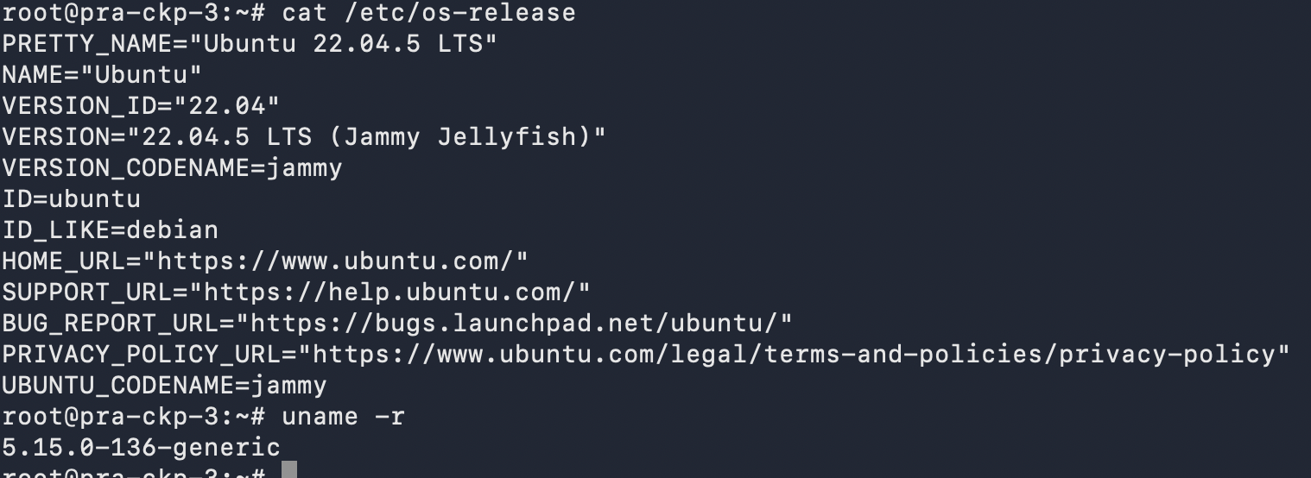
Figure 16: pra-ckp-3 before upgrade (Ubuntu 22.04.5, kernel 5.15.0-136-generic)
kubectl drain pra-ckp-3 --ignore-daemonsets --delete-emptydir-data
apt update && apt upgrade -y && apt dist-upgrade -y
reboot
do-release-upgrade
kubectl uncordon pra-ckp-3

Figure 17: All three control-plane nodes on Ubuntu 24.04.4; worker still on 22.04

Phase 6: Worker node (pra-ckp-4)
The worker is upgraded last, after all control-plane nodes are healthy.
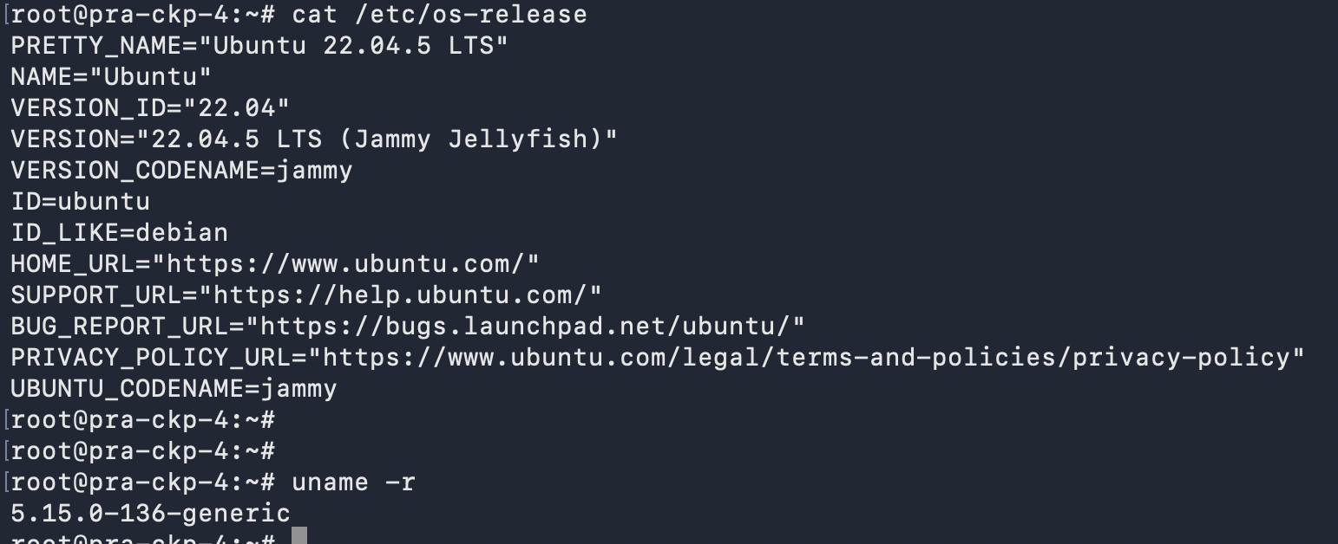
Figure 18: pra-ckp-4 before upgrade (Ubuntu 22.04.5, kernel 5.15.0-136-generic)
kubectl drain pra-ckp-4 --ignore-daemonsets --delete-emptydir-data
apt update && apt upgrade -y && apt dist-upgrade -y
reboot
do-release-upgrade
kubectl uncordon pra-ckp-4

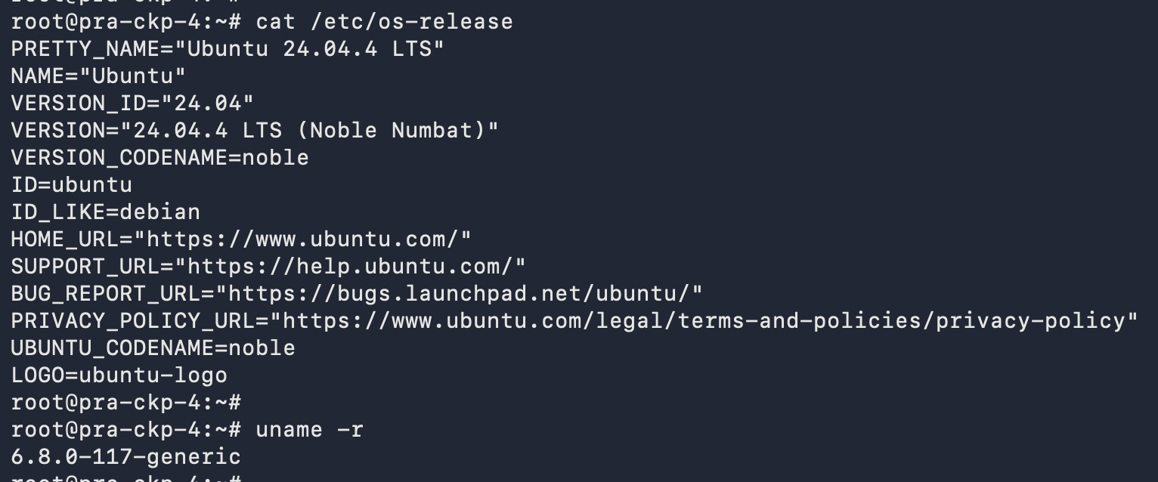
Figure 19: pra-ckp-4 after upgrade (Ubuntu 24.04.4, kernel 6.8.0-117-generic)

Phase 7: Post-upgrade validation
kubectl get nodes -o wide
kubectl get pods -A -o wide

Figure 20: All four nodes Ready on Ubuntu 24.04.4 LTS, kernel 6.8.0-117-generic
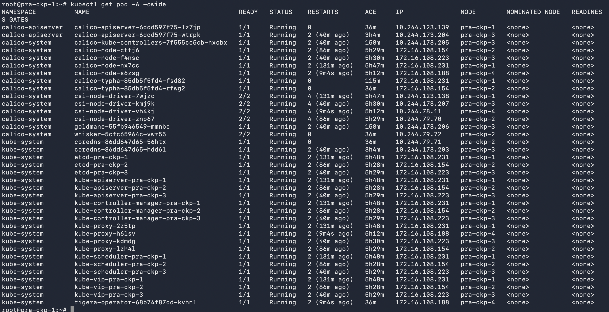
Figure 21: All system pods Running after upgrade (restart counts reflect node reboots)
Validation check | Result
All nodes Ready | Passed
OS is Ubuntu 24.04.4 LTS on all nodes | Passed
Kernel is 6.8.0-117-generic on all nodes | Passed
Kubernetes version unchanged (v1.34.3) | Passed
containerd unchanged (v1.7.28) | Passed
All system pods Running | Passed

Phase 8: Node lifecycle validation on Ubuntu 24.04
To prove that nodes can be added to and removed from the cluster on the new OS, the automation playbooks were run in the sequence below. Run them from the Ansible host; the target node is defined in the inventory and playbook variables.
# 1. Add a new worker (Ubuntu 24.04)
ansible-playbook -i inventory.ini playbooks/Add-worker-node.yaml -v

# 2. Remove one old control-plane node (pra-ckp-3)
ansible-playbook -i inventory.ini playbooks/Delete-node.yaml -v

# 3. Add a new control-plane node (Ubuntu 24.04)
ansible-playbook -i inventory.ini playbooks/Add-master-node.yaml -v

# 4. Remove the old worker (pra-ckp-4)
ansible-playbook -i inventory.ini playbooks/Delete-node.yaml -v

# Verify after each step
kubectl get nodes -o wide

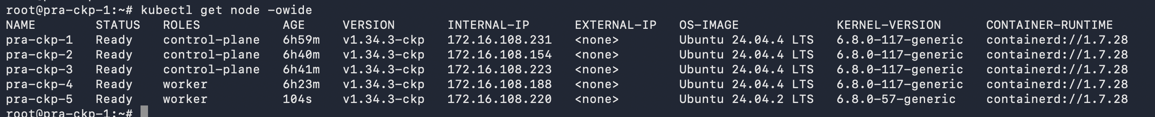
Figure 22: New worker pra-ckp-5 (Ubuntu 24.04.2) joined the cluster
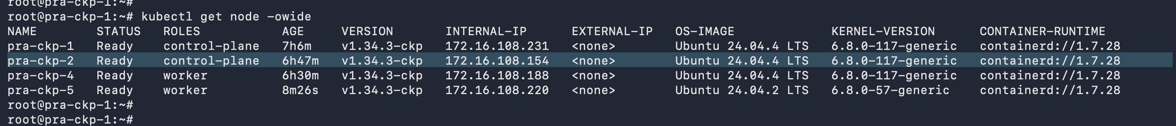
Figure 23: Control-plane node pra-ckp-3 removed
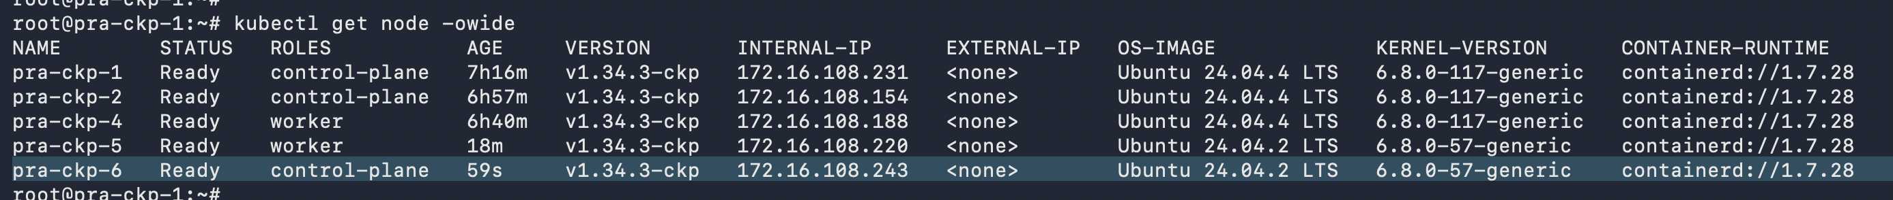
Figure 24: New control-plane node pra-ckp-6 (Ubuntu 24.04.2) joined the cluster
Figure 25: Old worker pra-ckp-4 removed; final cluster state
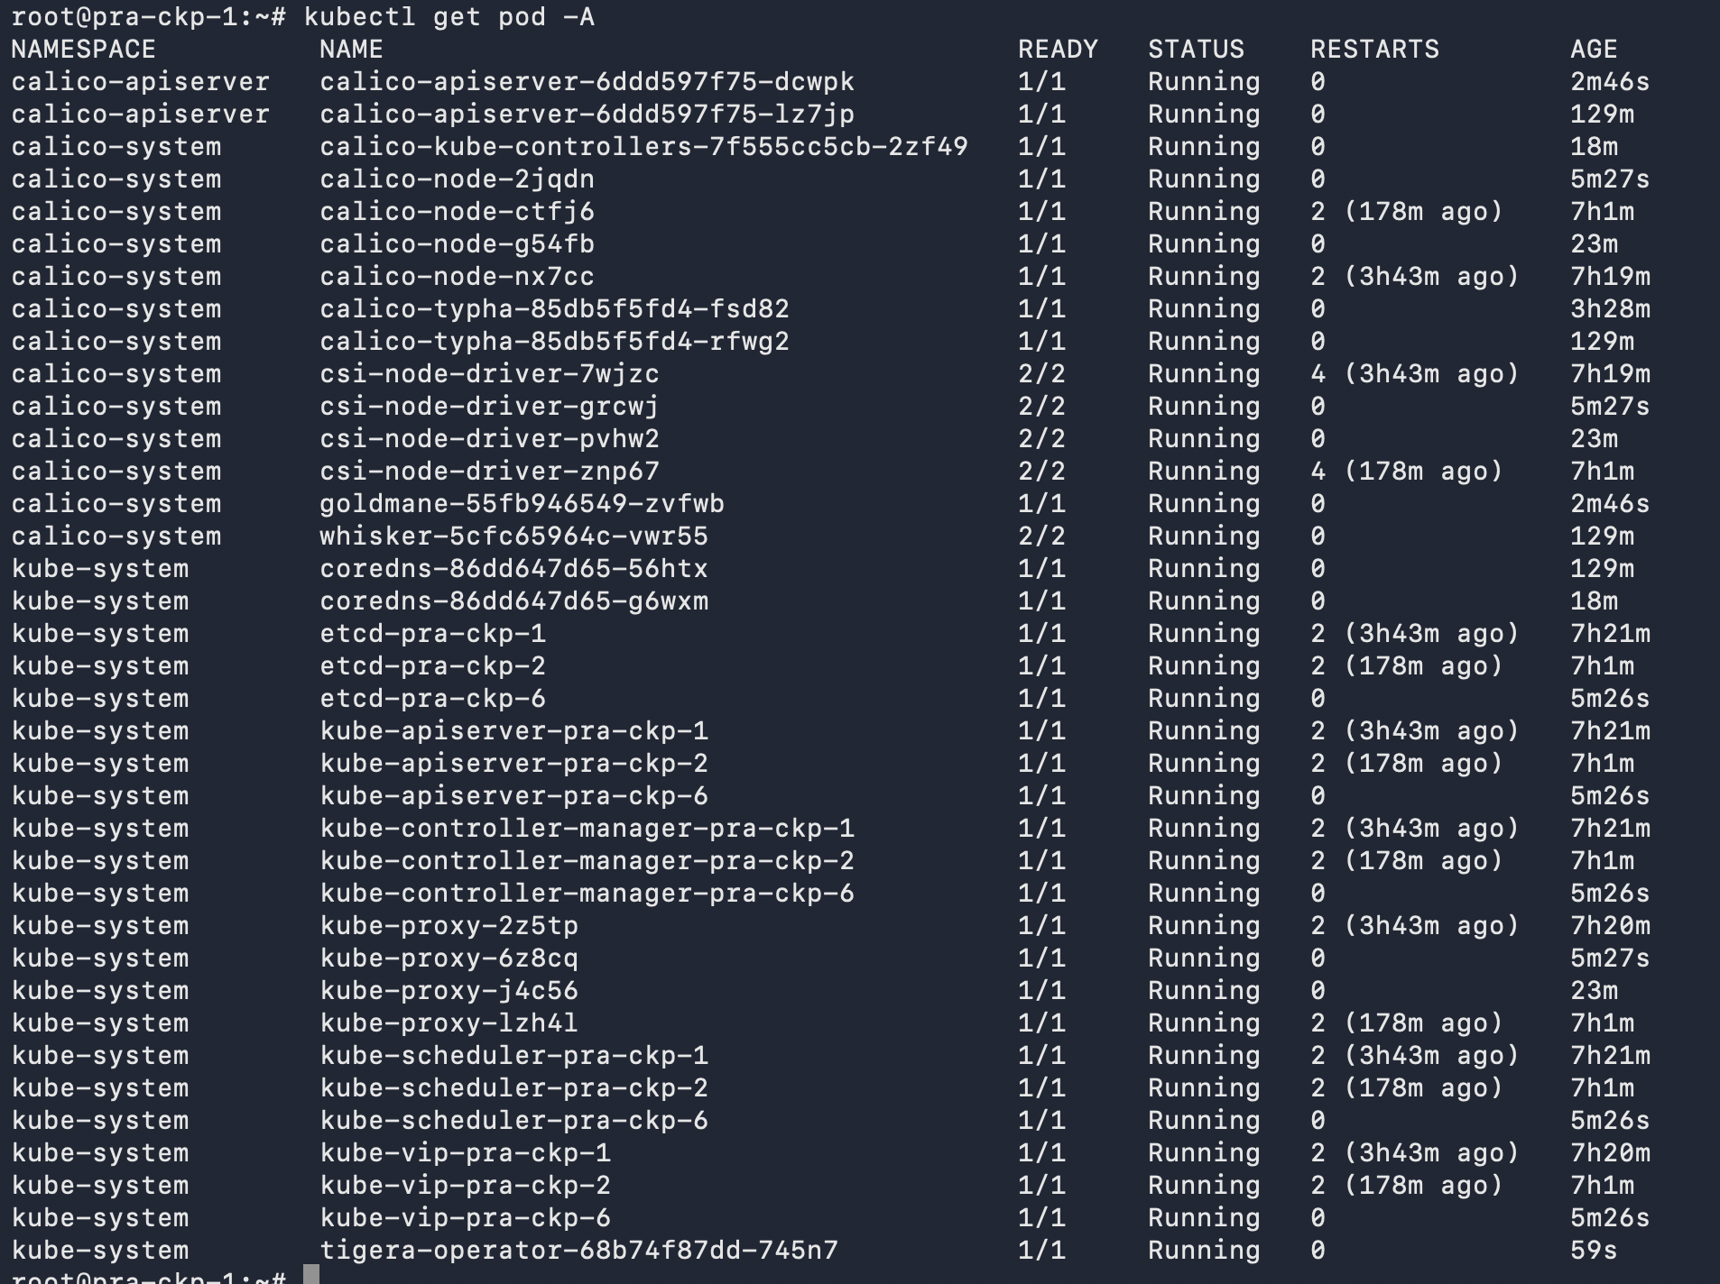
Figure 26: Final pod status; etcd, API server, controller-manager, scheduler and kube-vip Running on pra-ckp-1, -2 and -6

Final cluster composition
Node | Role | OS | Kernel | Status
pra-ckp-1 | Control-plane | Ubuntu 24.04.4 LTS | 6.8.0-117-generic | Ready
pra-ckp-2 | Control-plane | Ubuntu 24.04.4 LTS | 6.8.0-117-generic | Ready
pra-ckp-6 | Control-plane | Ubuntu 24.04.2 LTS | 6.8.0-57-generic | Ready
pra-ckp-5 | Worker | Ubuntu 24.04.2 LTS | 6.8.0-57-generic | Ready

7. Recovery Options
If a node does not return healthy after the release upgrade, the recommended options in order of preference are:
- Keep the node cordoned (do not uncordon) while investigating, so no workloads are placed on it. The other nodes continue to serve the cluster.
- Replace the node. Remove the failed node with Delete-node.yaml and add a fresh Ubuntu 24.04 node with Add-master-node.yaml or Add-worker-node.yaml. This path was validated in Phase 8.
- Restore from the etcd snapshot (/root/etcd-backup-22may2026.db) only for a cluster-wide data-loss scenario, following the official etcd restore procedure.

8. Conclusion
The pra-ckp cluster was successfully upgraded from Ubuntu 22.04 to Ubuntu 24.04 with no change to the Kubernetes, Calico or containerd versions. All nodes are Ready, all system pods are Running, and node add/remove operations were proven on the new OS. The procedure in Section 6 can be reused as the standard runbook for the same upgrade on other clusters, with the etcd backup and one-node-at-a-time rule kept unchanged.

Sign-off
Role | Name | Signature | Date
Prepared by
Reviewed by
Approved by (Client)

