How to create and start instance using “https://cloud.theworklabscloud.com/project/”

1. Enter the IP address of Bheemiah Cloud dashboardhttps://cloud.theworklabscloud.com/auth/login/or https://10.121.220.50/dashboard, below page will appear.
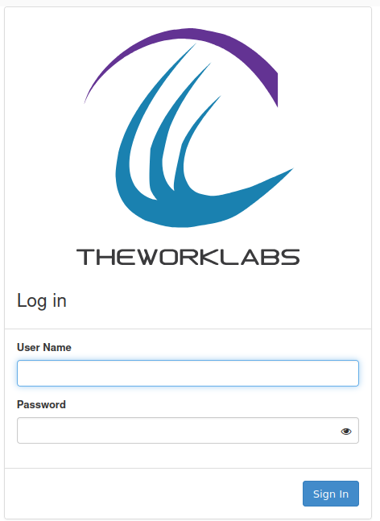

2. Login using username and password provided.
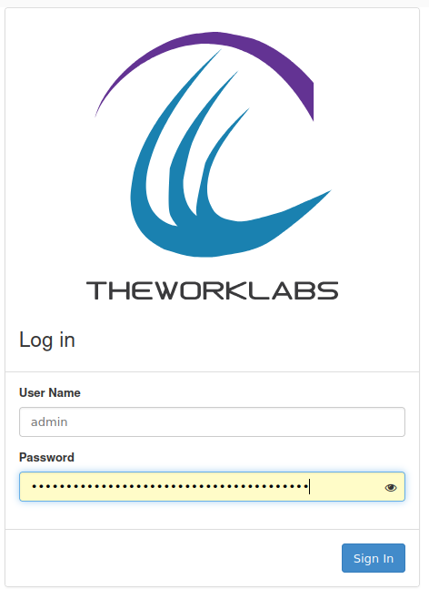

3. Enter the username & password and click on the connect button. You will get:-
Note: This is the overview of your quota for the account.
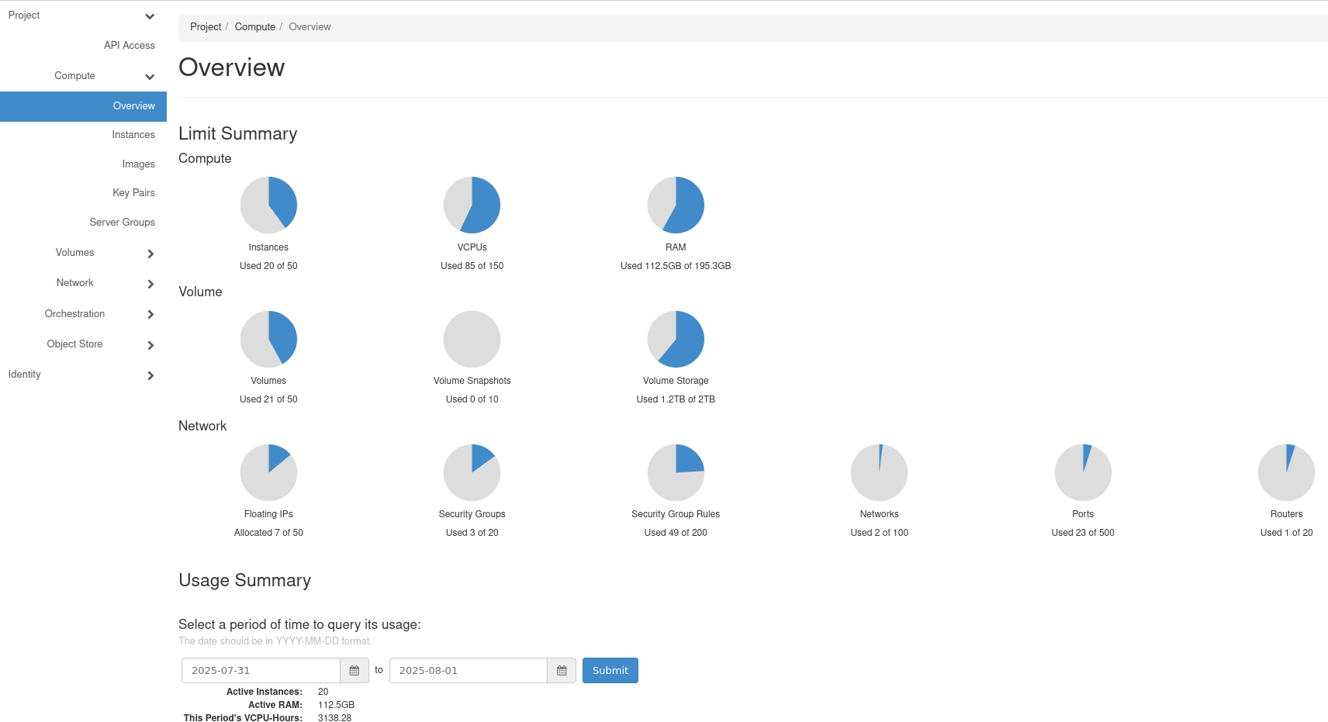
4. First of all, you need to create networks(Private & Public) for all VMs which you will use to access So Click on Network, under Project it will expand:
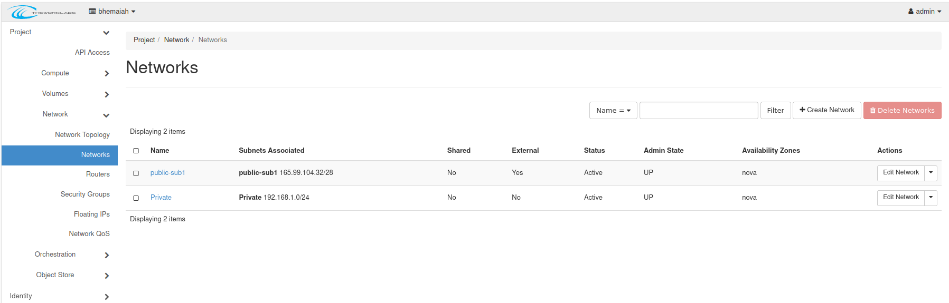

5. Click on Networks, sub menu of Network in project section, then click on Create Network.
6. In this slide you have to give Private network name and click next and also subnet name & IP subnet then click next and then give dns (8.8.8.8) and then click create network.

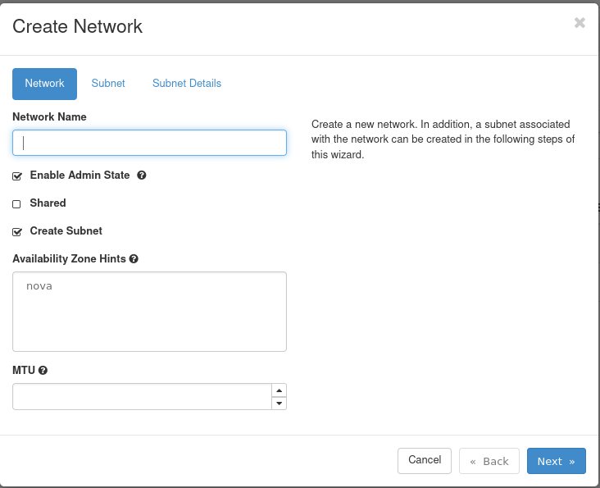

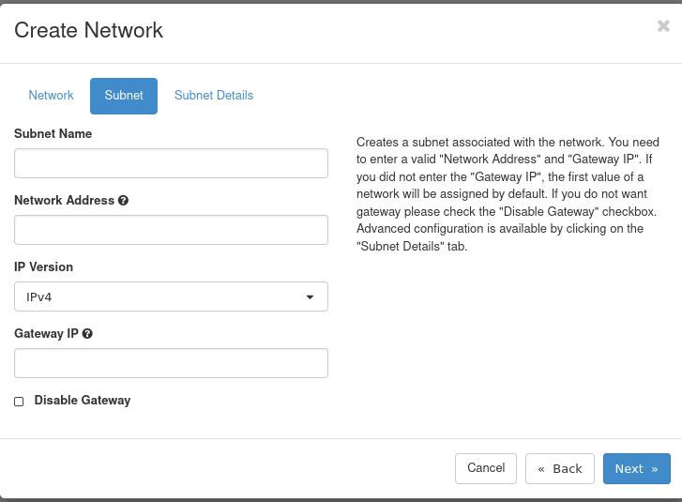

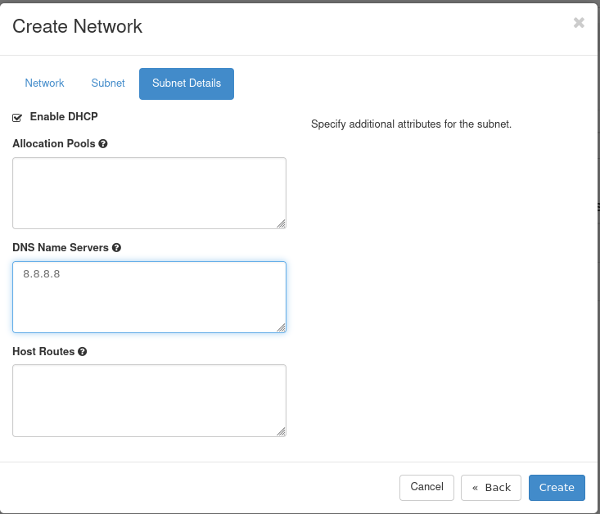
Click on check box Enable DHCP, it will provide automatically IP Address to all newly created VM.

7. Now private network created so we need public network go to –> Admin section –> network –> networks –> click on create network.
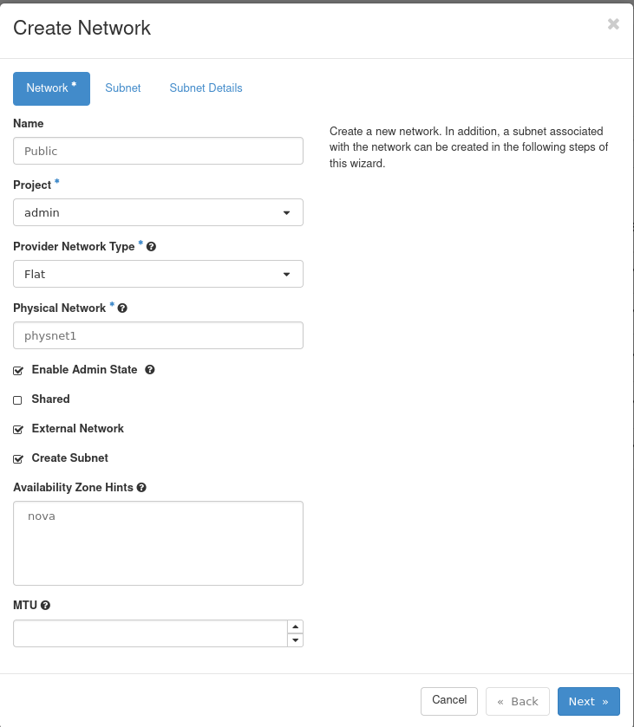
You have to add public network name then select project from drop down after that select provider network type then add physical network after adding this data check the box External Network and then click to next.

8. In this slide you have add subnet name , subnet-address then click next to create subnet for public network.

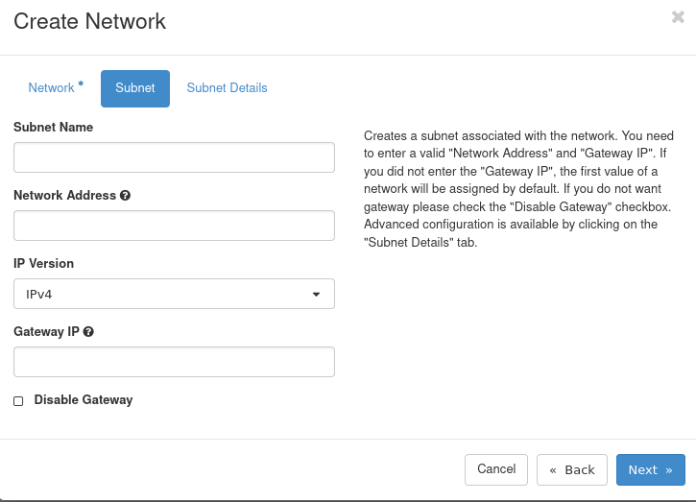

9. In this slide you have to add dns and click next to create public network.
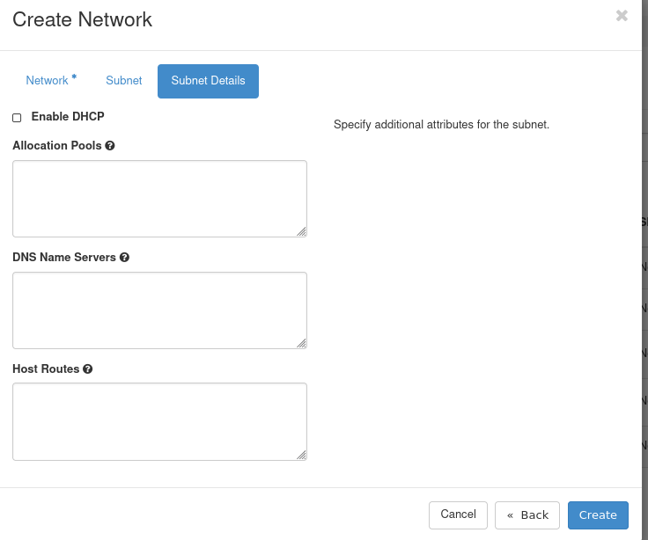

10. now our both networks created so next we have to create ROUTER so in Admin section – network – router (click on router).
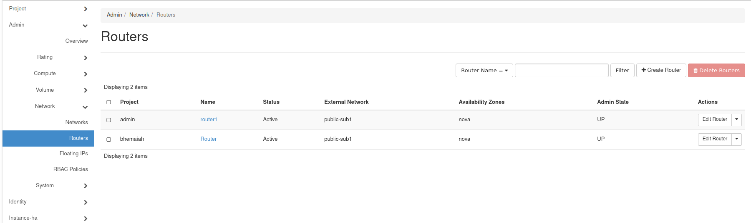

11. For router creation click on create router. Then you a slide like given below here you have to give Router-name , then select project from dropdown and also select external-network from drop down(public network), then click on create.
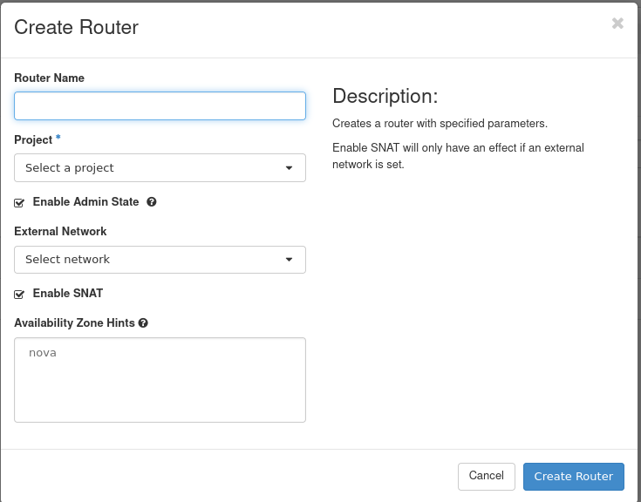

12. now go to project section and click on network – security_groups.here you will see default SG , click on manage rule.
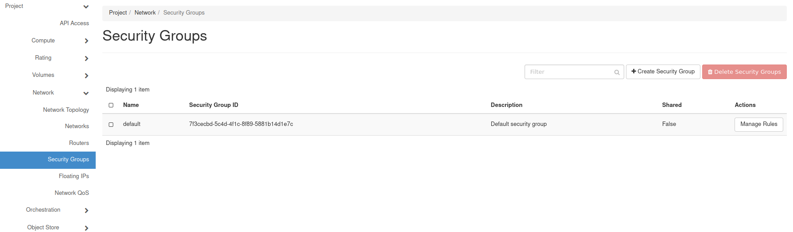
13. after click on manage rule you will a slide like give below then click on ADD RULE , then you will be able to add different -2 tcp,udp,custom rules in SG.
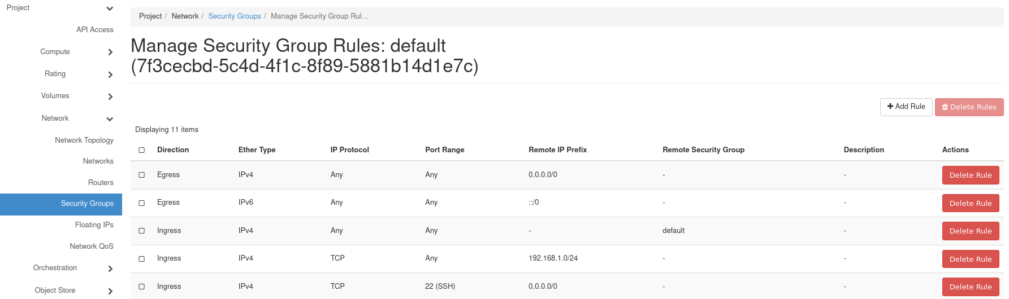

14. when you click on ADD RULE you will see slide like give below in this slide you select rule – direction of rule(ingress or egress) – in OPEN PORT section you can select (port, range port, all port) mostly (Port) – then click on add .
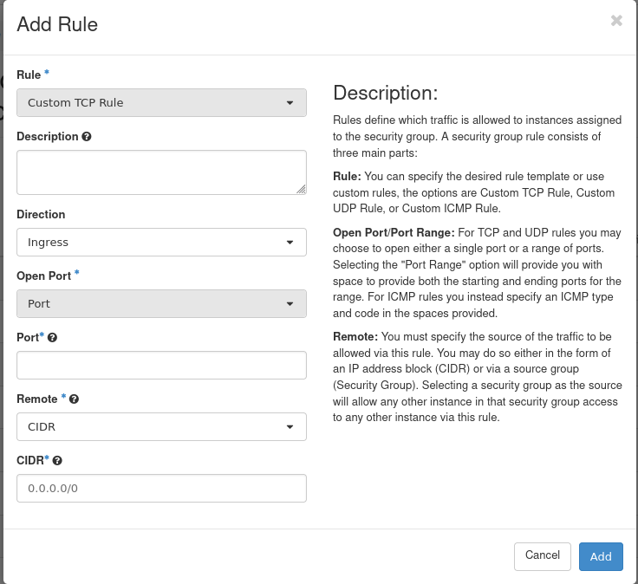
15. now come to the instance creation part here in project section – click on compute – instance , then you see slide like given below.
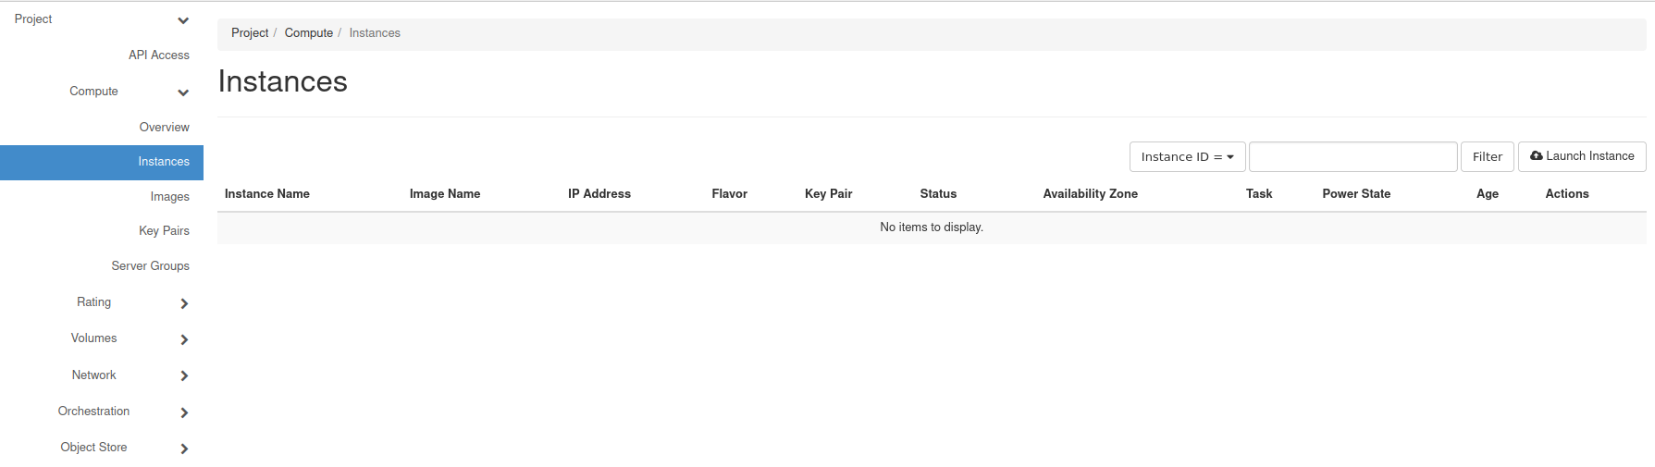
16. After getting this slide click on launch instance you will get slide like give below , in this slide you have to add instace-name and you can also give the description about VM and one more thing you can also extend the vm quantity from COUNT option.
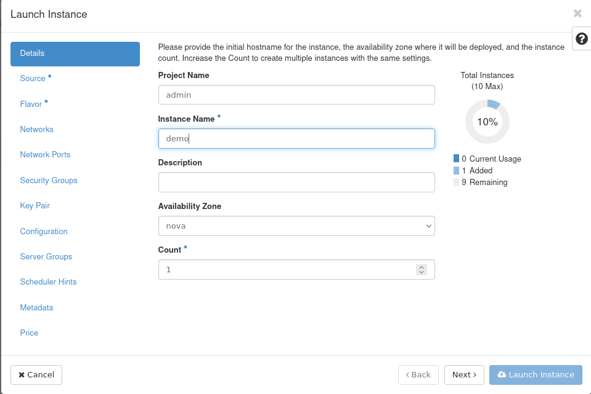
17. In this slide you have select boot source(image,volume,snapshot..) and give the volume size after that if you choose boot_source(image) so for this you have to select image ,for selection click on UP ARROW ONLY, Then click next.
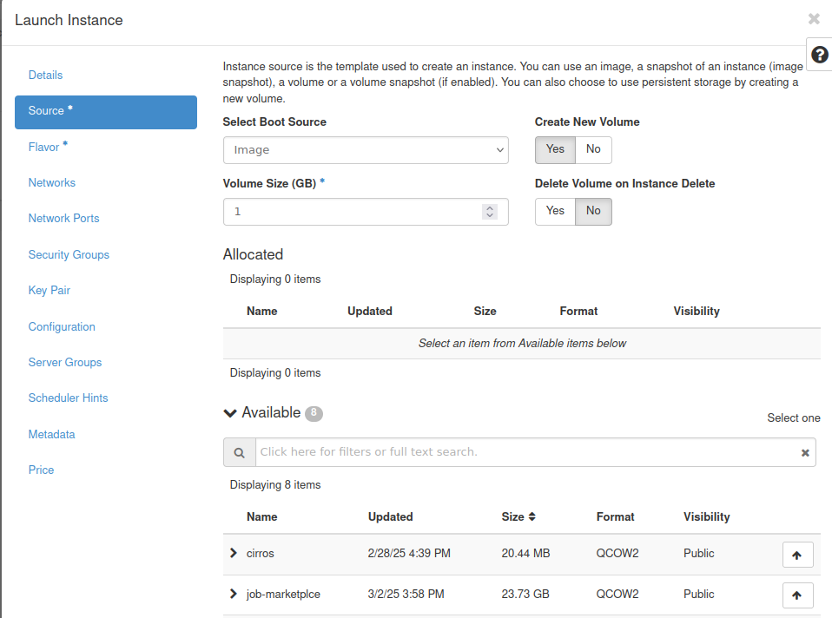
18. In this slide you have to select FLAVOR , you can choose any as per resource available in defined project.
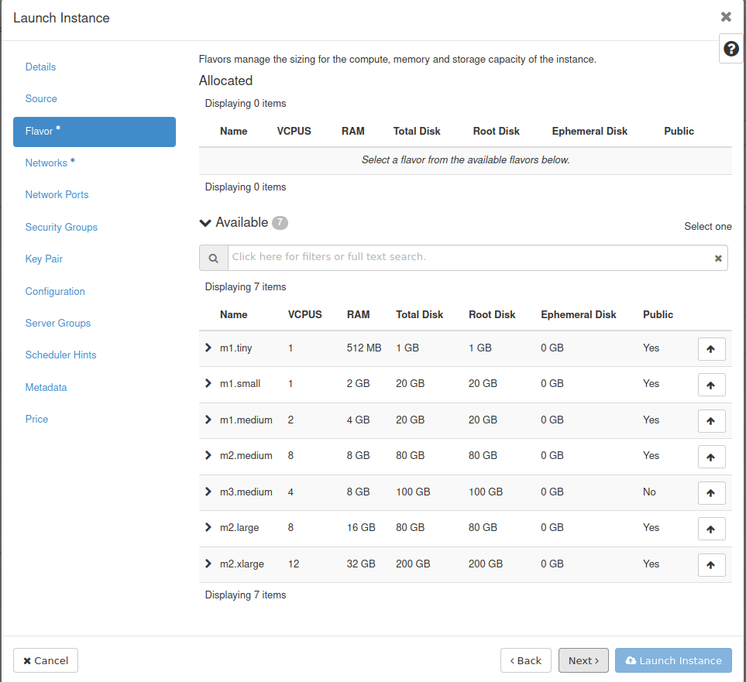
19. In this slide you have select network for vm hosting , you can select both networks (private & public) or can be one also(private) and then click next.
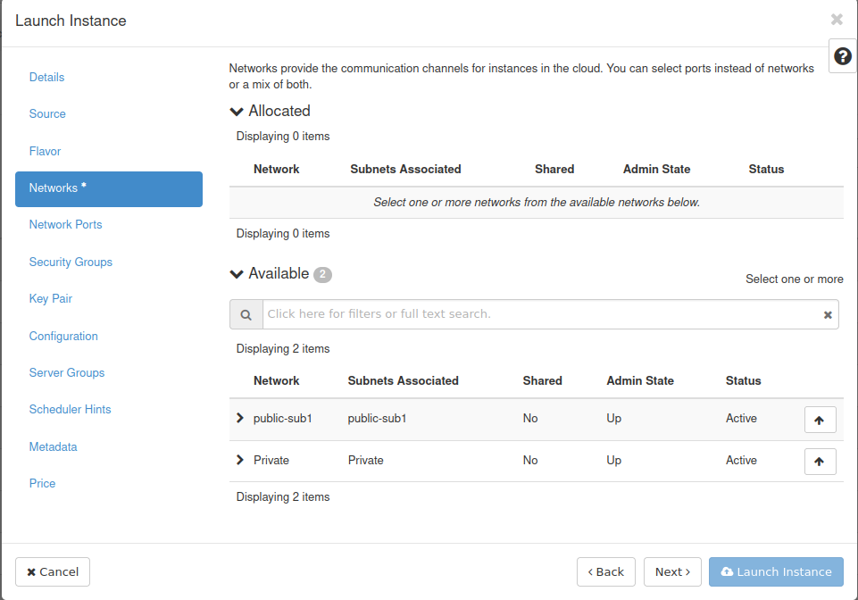
20. In this slide you have add security group by clicking UP ARROW, then click next.
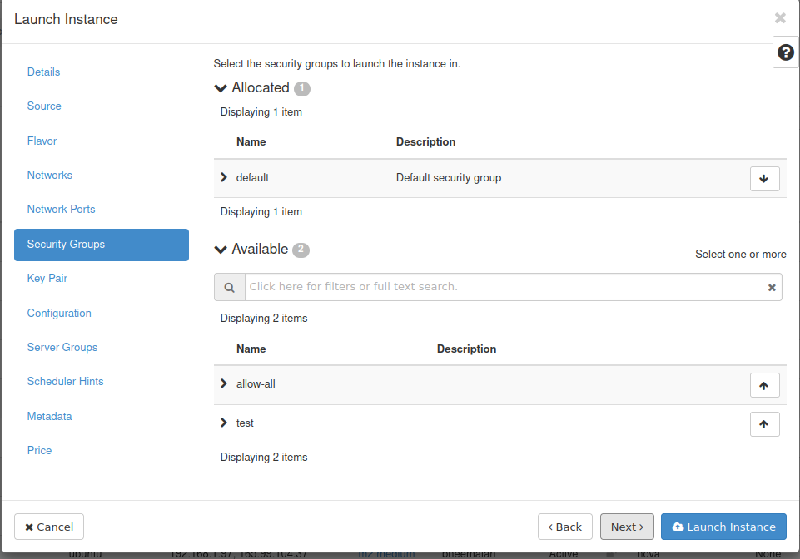
21. In this slide you have to add key_pair for when you try take ssh then this key will help you to access the vm. After selection of key click next.
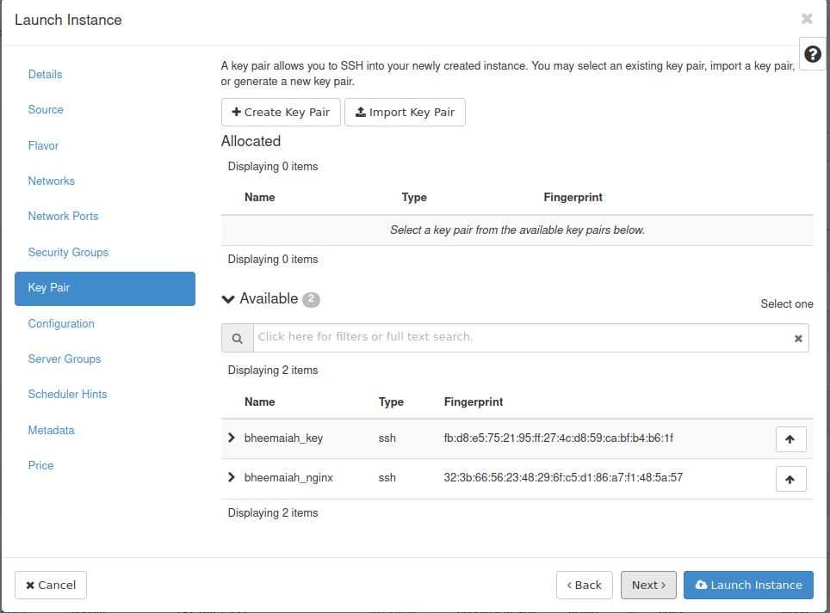

22. in this slide you can give your customized scripts like you want to give password for vm or install something etc , after that click on launch instance.
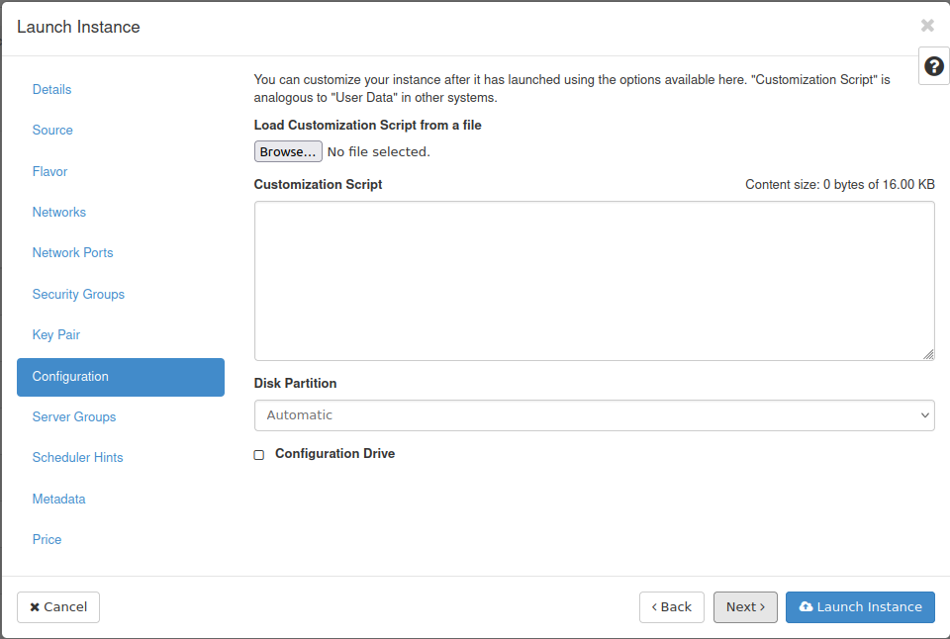

rfefr

ff

