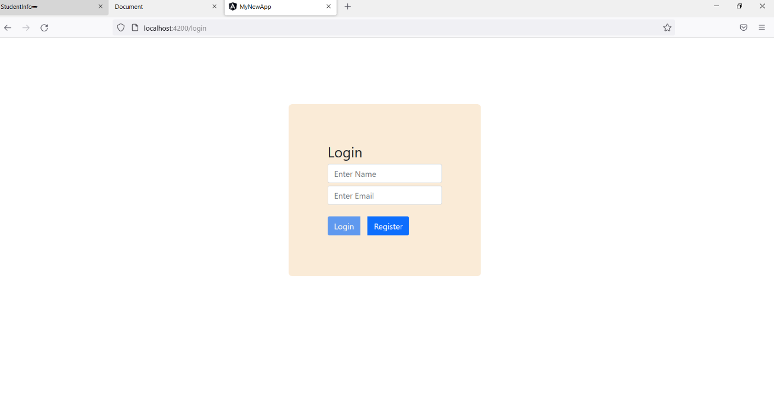

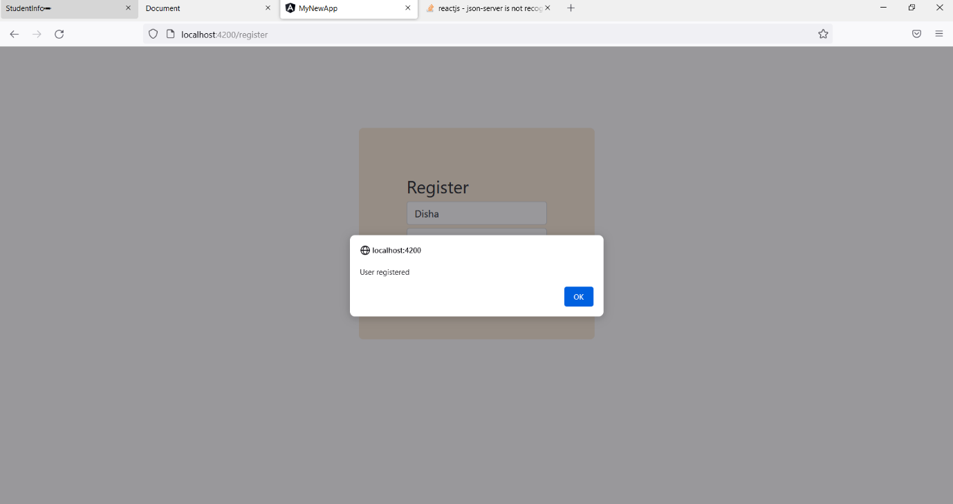

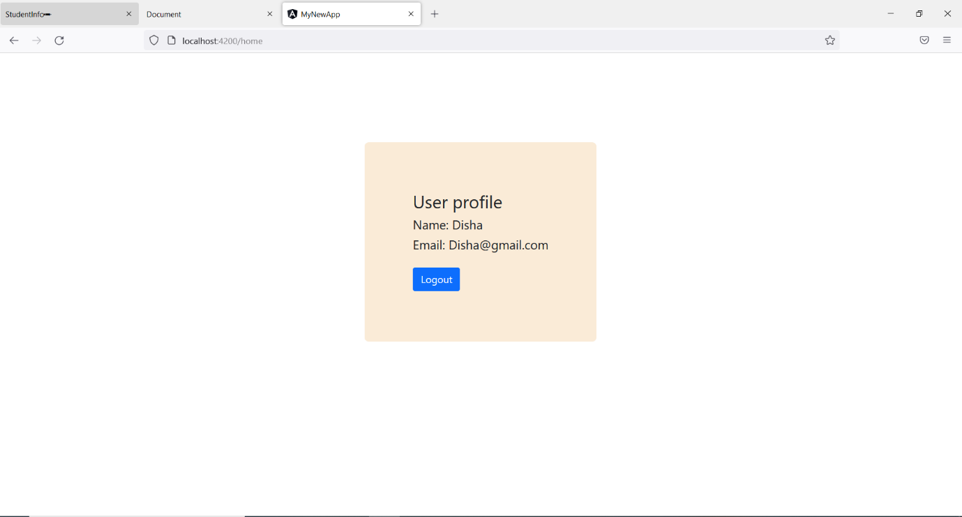

**index.html**

<!doctype html>

<html lang="en">

<head>

  <meta charset="utf-8">

  <title>MyNewApp</title>

  <base href="/">

  <meta name="viewport" content="width=device-width, initial-scale=1">

  <link href="https://cdn.jsdelivr.net/npm/bootstrap@5.1.3/dist/css/bootstrap.min.css" rel="stylesheet" integrity="sha384-1BmE4kWBq78iYhFldvKuhfTAU6auU8tT94WrHftjDbrCEXSU1oBoqyl2QvZ6jIW3" crossorigin="anonymous">

  <script src="https://cdn.jsdelivr.net/npm/bootstrap@5.1.3/dist/js/bootstrap.bundle.min.js" integrity="sha384-ka7Sk0Gln4gmtz2MlQnikT1wXgYsOg+OMhuP+IlRH9sENBO0LRn5q+8nbTov4+1p" crossorigin="anonymous"></script>

  <link rel="icon" type="image/x-icon" href="favicon.ico">

</head>

<body>

  <app-root></app-root>

</body>

</html>

**style.css**

.wrapper {

  /* display: flex;

  justify-content: center;

  align-items: center; */

  position: fixed;

  top: 20%;

  left: 40%;

  transform: translate(-50%, -50%);

  margin: 10%;

  padding: 5%;

  background-color: antiquewhite;

  font-size: 39px;

  width: max-content;

  border-radius: 2%;

}

button {

  padding: 2%;

  background-color: skyblue;

  border: none;

  margin-right: 10%;

}

.block {

  width: 50%;

  height: 100%;

}

input {

  display: inline;

  border: none;

  margin-bottom: 5%;

  padding: 1%;

  width: 200% !important;

  border-radius: 5%;

}

**Dashboard.component.html**

<div class="container wrapper">

    <div class="">

      <h3>User profile</h3>

        <h5>Name: {{userList[0]}}</h5>

        <h5>Email: {{userList[1]}}</h5>

        <button class="btn btn-primary" (click)="logout()">Logout</button>

    </div>

  </div>

**Dashboard.component.ts**

import { Component, OnInit } from '@angular/core';

import { Router } from '@angular/router';

import { CommonService } from 'src/app/common.service';

@Component({

  selector: 'app-dashboard',

  templateUrl: './dashboard.component.html',

  styleUrls: ['./dashboard.component.css']

})

export class DashboardComponent implements OnInit {

  userList: any = []

  constructor(private commServ:CommonService, private router: Router) { }

  ngOnInit(): void {

    this.userList = [localStorage.getItem("name"), localStorage.getItem("email")] ;

    console.log(this.userList);

  }

  logout(){

    localStorage.clear() ;

    this.router.navigate(['login']) ;

  }

}