TaskOrbit: A Workflow-Aware Collaborative Project Management System with Deadline Conflict Detection
Rahul Diwate  Dept. of Computer Engineering  Vishwakarma Institute Of Technology  Pune, India  diwate.rahul05@gmail.com | Gaurav Suryawanshi  Dept. of Computer Engineering  Vishwakarma Institute Of Technology  Pune, India  gauravsuryawanshi860@gmail.com | Aditi Sorte  Dept. of Computer Engineering  Vishwakarma Institute Of Technology  Pune, India  sorteaditi115@vit.edu
Satyam Srivastava
Dept. of Computer Engineering
Vishwakarma Institute Of Technology
Pune, India
satyam.srivastava24@vit.edu

Abstract— Typically, tools for collaborative project management consider workflow rules and access control as configuration options. While this does allow for workflow violations, e.g. applying decisions to out-of-date deliverables, and assigning conflicting tasks to the same resource, we present TaskOrbit: a web-based project management tool, ensuring workflow integrity at the server level. TaskOrbit is based on: (1) a finite-state lifecycle of a task, where every transition is connected with a role (client, manager, assignee, or reviewer), and where the ID of the last submission must always be provided during a review. All unauthorized requests are rejected with HTTP 403, and all invalid requests with HTTP 409; (2) a conflict detection method that allows identifying scheduling conflicts and ‘resource’ conflicts for the ‘assignee’ role using linear scanning of the task; and (3) a persistence layer implementing the storage of the development process. In this paper we will describe the system architecture, prove the correctness of the detection mechanism, highlight workflow guarantees derived from transition set definition and report shall report about our testing.
Index Terms—workflow enforcement, finite-state machine, role-based access control, interval scheduling, conflict detection, project management systems

I. INTRODUCTION
Software projects involve many parties whose roles differ. Clients order services and determine how to check the results. Project managers shape the clients’ requirements into tasks, estimates, and deadlines. Employees execute the tasks and present the results to reviewers such as technical leads and quality engineers. Providing reliable coordination of parties requires a program to decide who can do what and in what order.
Last but not least, there are four main recurrent problems that occur when lack of enforcement is the issue: (i) Unauthorized state modifications, i.e. acting beyond authority, e.g. approving incomplete deliverables and bypassing necessary reviews. (ii) Misleading reviews, i.e. when an employee submits the updated version to the reviewer who examines the previous one, and the verdict applies to the wrong version. (iii) Scheduling conflicts, which means that two or more tasks assigned to one employee coincide in time, and this is discovered only when the schedule is fixed. (iv) Information leakages, which means that technical discussions, internal messages about bugs, or scheduling information become available to those who should not have it.
Among the dominant players in work management software such as Jira, Asana, and Trello, a configurable workflow model is widely promoted. As a result, the user can employ a limited number of project management features since the full functionality of these platforms is dependent on the degree of implementation of the software's model. Role-based access control (RBAC) provides the means for users to assign roles but does not guarantee that the listed actions are done in a designated sequence. Für TaskOrbit, a more conservative approach is taken; therefore, software supports only one set of rules for any of the requests users make.
The outlined paper is organized as follows:
1. It provides a description of the process of finite-state utilization of roles that forces the API to process requests from the users so that the role-one submitting the request has to point the submission identifier (Sections III-C and III-D).
2. It offers the description of the proposed inclusive interval-overlap conflict detector for submitting requests based on the prior knowledge of the project (Section III-E).
3. It presents the architecture that has been created for this purpose alongside the report on the progress (Sections IV and

II. RELATED WORK

A. Access Control
RBAC is considered as an elitist system for allowing users in a multi-user system. Sandhu et al. [2] introduced the range of RBAC that consists of four models: the first one (RBAC0) refers to the base model, RBAC1 is about the role hierarchy, RBAC2 is about the constraints such as separation of duties, while RBAC3 combines both RBAC0 and RBAC1. ANSI/INCITS 359-2004 standard [3] introduces the ideas of roles, responsibilities, and authorities in accordance with the concept put forth by NIST [1]. Kern et al. [4] elaborate upon life-cycle management of roles in securing enterprises. The first element of TaskOrbit is linked to the sum of all four roles and the concept of fixed role in the system based on middleware requireRole(). It should be noted that transition and ownership rules explained in section III go beyond the aforementioned theory and deals with authorization constraints similar to constraints used in workflow systems [5].

B. Workflow Management
Van der Aalst et al. [6] documented such workflow control flow patterns as sequential, parallel split, synchronization, and state based choice, whereas Georgakopoulos et al. [7] analyzed workflow management from process modeling up to automation infrastructure. Reichert and Weber [8] investigate the conflict between the fixed process structure and flexibility in process-aware information systems, including deviations and modifications in their operations. TaskOrbit is situated at the extreme of the spectrum, referring to a rigid sequential workflow with one loop (revision) and no deviations.

C. Scheduling and Conflict Detection
Classical scheduling theory deals with the assignment of tasks to constrained resources; various scholars including Baker [9], Leung [10], and Pinedo [11] give presentations on deterministic and interval scheduling, feasibility and complexity of computational task scheduling. Thus, unlike the usual objective optimization techniques like makespan and tardiness, TaskOrbit provides a more specific feasibility solution whereby it checks whether the selected candidate task overlaps with any other concurrent task performed by the same assignee and gives the answer well before any change is made.

D. Collaboration Models
The phases of team processes involve transition, action and interpersonal, according to the positions of Marks et al. [12]; Fuks et al. [13] claim that collaboration consists of communication, coordination and cooperation in their 3C model. The model used in TaskOrbit is the same: the process of coordination is through workflow state; the process of communication is through comments to tasks, feedback and notifications, and the process of cooperation is described as the submission of version-oriented files.

E. State Machines for Authorization
Harel's Statecharts [14] offer a framework in which a system that reacts can have its components arranged in a hierarchy and run in parallel with each other. Basin and other researchers [15] demonstrate how authorization policies can be implemented based on models that rely on UML or Statecharts (Model-Driven Security). The TaskOrbit approach is based on a state machine with a hierarchical structure and a requirement for a user to possess specific authorizations before a move from state s to state s' can occur.

F. Web Application Security
Halfond ection attacks and methods of defense, which include parameterized queries and automated vulnerability scanners in web services, and Vieira et al. [17] present methods for the assessment of their performance. OWASP notes broken authorization as one of the most critical web application threats [18]. The TaskOrbit implementation promotes the usage of parameterized queries that are included in the Supabase SDK, and effective fields-requests validation, file upload processing with path cleaning, and PostgreSQL Row-Level Security (RLS) policies.

G. Positioning
The reviewed literature analyzes the aforementioned concepts separately; however, TaskOrbit’s contribution consists in their application within the single server-side realization, namely: (a) task transitions with roles applied, (b) decisions on review that correspond to the specific version of submission, and (c) potential conflicts that can appear before actual scheduling.

III. SYSTEM DESIGN

A. Architecture
The design of TaskOrbit comprises several components — frontend, backend, and data persistence. The frontend uses React and TypeScript, while the backend implements Express.js on Node.js, an asynchronous event-driven JavaScript runtime. The application’s data persistence system integrates an in-memory development database, as well as PostgreSQL hosted on Supabase. All communications between the frontend and the backend are conducted via HTTP REST APIs. The four layers, which are illustrated in Fig. 1, can be summarized as follows:
• Presentation layer: provides role-based dashboards and task filling forms, project view, submission interface, review queue, notifications, and activity views. The application’s state is managed by Redux Toolkit, while React Router is used for navigation;
• API and Authorization layer: Express routes process requests for controllers; authentication middleware checks identity, while role guards restrict access to different functions;
• Business Logic layer: enables controllers and services related to projects, tasks, scheduling conflicts, deadlines, file processing, cooperation, activity log, and exports of reports;
• Persistence layer: stores information using Firestore-compatible in-memory development storage. The storage supports asynchronous write-through synchronization with Supabase PostgreSQL, if configured. The files are stored on a local disk and may also be copied into Supabase Storage.

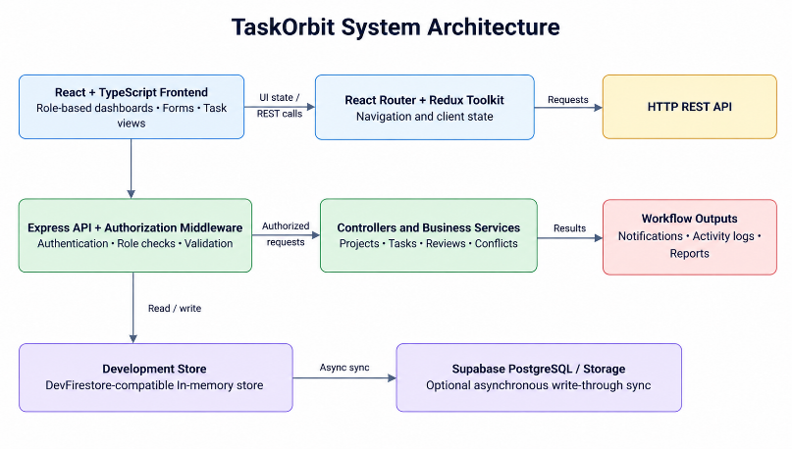
Fig. 1. System architecture of TaskOrbit.

B. Roles and Authentication
The client launches the projects, the coordinator manages the assignments, the assignee does the task, and the reviewer assesses the output. The requireRole() middleware verifies whether the user’s role is allowed for the given endpoint, while the responsibilities of the resource owner are checked in the handler. Invalid credentials return 401 status code, whereas lack of authorization gives out 403 error. As for the development mode, it utilizes sample IDs and a development token, while the intended production process involves working with Firebase authentication tokens.

C. Task Workflow
A task records its project information, the person who has been assigned to the task, the person who checks the work that has been done, the date of starting the task, the date by which the task must be finished, the priority assigned to the task, its current status, and records the relevant references of possible conflict situations. The back-end accepts only the six state transition possibilities listed in table I and rejects any other state update with an error code of HTTP 409.
TABLE I
Task state transitions enforced by the backend
Transition | Trigger | Actor
todo → in_progress | Work starts | Assignee
in_progress → submitted | Deliverable submitted | Assignee
submitted → in_review | Review begins | Reviewer
in_review → approved | Review accepted | Reviewer
in_review → revision | Revision requested | Reviewer
revision → in_progress | Rework starts | Assignee

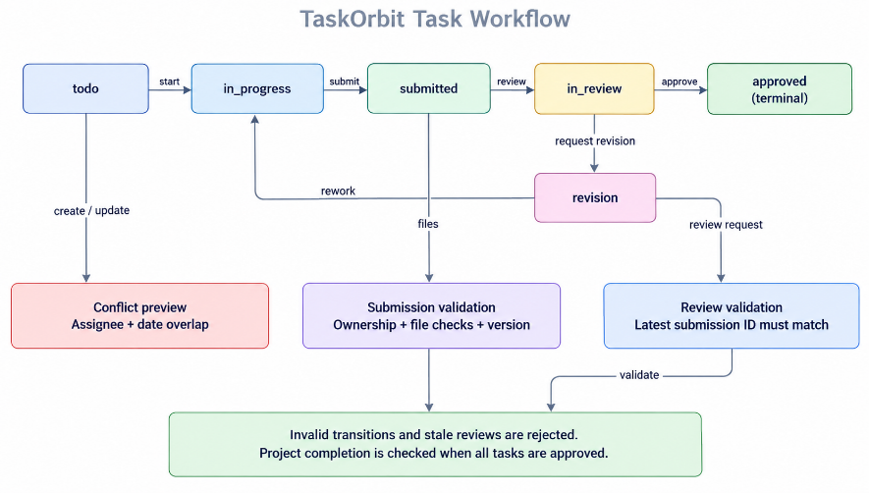
Fig. 2. Task lifecycle and validation points in TaskOrbit.

D. Submission Versioning and Stale-Review Rejection
Every record of submission has a version number, and the task keeps a record of the identification of its latest submission. The module of submission verifies the list of files, restricts the number of files, confirms the paths as well as the availability of the files, and denies the duplicate submissions. Any request for a review must refer to the identification of the last submission, regardless of whether it is a request for approval or revision. The backend system returns HTTP code 409 in case there is a submission submitted after the submission in question.
E. Deadline Conflict Detection.
Let each task have an assignee a, status q, start date s, and deadline d, where s ≤ d. A candidate task c is said to be in conflict with an already existing task ti if they have the same assignee, neither of them has been approved, and if their date intervals overlap:
C(c, ti) = (ac = ai) ∧ (qc ≠ approved) ∧
(qi ≠ approved) ∧ (sc ≤ di) ∧ (si ≤ dc) (1)
If the value is true, this means that a conflict has been found. Algorithm 1 analyzes all the tasks in the task pool foregoing the candidate task itself, tasks of other assignees, and the tasks that have already
Correctness. The database check constraints for the time range assure that s ≤ d for any task. For two legitimate time periods, the overlap condition defined in equation (1) is satisfied if and only if the two periods overlap on at least one common day. Since time ranges are inclusive, if the task ends on the day the other one starts, it is counted as a conflict, and this is valid in its own right.
Complexity. In the case of a pool of n tasks being scanned, one call of the model requires O(n) time and O(k) auxiliary space due to the k conflicts being returned (it may take O(n) in the worst case scenario). On the other hand, evaluating each task separately requires O(n2) time. The model only works at days of the calendar, not accounting for working hours or task length or scheduling tasks for a partial amount of the day.
Preview before commit. The detector works with the creation of tasks and their modifications. Whenever there is a conflict, the API gives the identifiers of the conflicting elements without saving them, thus allowing the client to show them. The operations may be proceeded only if the caller decides to repeat it with confirmation of the override. If the override is confirmed, the references to the conflict are saved to the current task as well as to each of the conflicting tasks, thus making the relationship visible in both directions and sending the notifications to the affected parties.

F. Data Model and Persistence
users, projects, tasks, submissions, reviews, requirements, feedback, notifications, activity logs, project documents, and user settings. There are foreign keys that relate users, projects, tasks, and submissions and checks which limit roles, statuses, priorities, and date ranges. The JSONB columns contain project and task details,in memory operations execute applied changes to the in-memory storage and then asynchronously synchronize with Supabase PostgreSQL, keeping the application running locally or enabling it to access permanent storage. But the update in memory and write into database does not happen in one atomic transaction: during synchronization errors recording happens, while the request is likely to succeed which may create inconsistency between the two layers.

G. Security Controls
The backend has a combination of bearer-token authentication and endpoint control based on the user role, verification of who owns a resource, approval of date and field parameters, cleansing of file paths, and a configurable list of approved CORS origin sites. x-powered-by header is disabled and generic error codes without the stack trace are returned. The audit records are audience specific while the responses from the workspace are role-dependent, which prevents revealing sensitive information regarding discussions regarding a particular tech issue, bug report, or schedule. The Supabase service role credentials are used only by the backend. The authentication bypass while developing is based on environmental settings and origin restrictions and should be disabled in the production environment.

H. End-to-End Workflow
When a project is started by a client, the manager creates tasks specifying the beginning of implementation and a deadline for each of them, while making the assessment of possible conflicts with regard to the workload of each assigned worker. Once the assigned worker has done the task and submitted a deliverable, the real-time records are checked and marked as valid. The reviewer evaluates the version of the deliverable, giving it thumbs up or suggesting a revision, which puts the task back to the state of 'in progress'. The project is considered finished when all the tasks have been approved by the reviewer.

IV. VERIFICATION AND CURRENT EVIDENCE
This section separates what follows from the design by argument, what is covered by documented tests, and what remains unmeasured.

A. Workflow Validation and Role-Based Enforcement

TaskOrbit uses a defined workflow to control how tasks progress from creation to completion. Each transition represents a permitted change in task status and is subject to role-based authorization checks. For example, an assignee submits a completed task, a reviewer evaluates the submission, and the task is either approved or returned for revision.
The workflow defines four important properties:
- P1. Controlled approval: A task can enter the approved state only from in_review, ensuring that approval follows the review stage.
- P2. Final-state protection: The approved state has no outgoing transition in the defined workflow, preventing further status changes through the guarded transition mechanism.
- P3. Mandatory resubmission: When a task is returned for revision, it moves to in_progress and must be submitted again before another review.
- P4. Submission-version integrity: A review request is accepted only when its submission identifier matches the task's latest submission. Requests referencing an older submission are rejected with HTTP 409.
These properties follow from the defined transition rules and submission-version validation described in Section III-D. Their enforcement depends on status changes passing through the corresponding guarded handlers. The documented integration tests cover workflow operations, including submission, review, revision, approval, and conflict handling, but do not establish correctness under every possible execution or concurrency condition.

B. Test Suite
The suite uses Jest, Supertest, and a mock database. Table II lists its composition. The figures are counts of documented test cases, not pass rates. The Firebase emulator workflow requires emulator services and could not be run in the documented environment.
TABLE II
Test suite composition (documented cases)
Suite | Cases | Scope
Conflict service | 6 | Non-overlapping, partial overlap, containment, same-day overlap, different assignees, approved-task exclusion
Supabase configuration | 4 | Configuration detection and endpoint behavior
Task workflow | 5 | Creation through approval, ownership rejection, conflict preview, forced creation, rescheduling
Development authentication | 9 | Bypass activation, production blocking, secret verification, origin restrictions, authentication gates, registration
Role access | 5 | Role-based endpoint enforcement
Total | 29

C. Evaluation Status and Planned Protocol
Table III records the status of each evaluation area.
TABLE III
Evaluation status of TaskOrbit
Evaluation area | Current status
Task workflow | Implemented; integration scenarios documented
Authorization | Role and authentication checks implemented; test outcomes to be reported
Conflict detection | Algorithm, correctness argument, and boundary scenarios documented
Persistence | In-memory store and optional Supabase synchronization implemented
API performance | Latency and throughput not yet measured
Scaling | Task-pool benchmark pending
Concurrent consistency | Atomicity and concurrent-write behavior untested
Frontend validation | Automated frontend and browser tests outstanding

The evaluation plan encompasses four aspects. (1) Detector effectiveness: evaluate the output of the detector against a brute-force day-by-day oracle on randomly produced valid intervals and check precision and recall because by Lemma 1 these two indicators must equal 1, thus any deviations signalize of an implementation error. (2) Latency and scalability: estimate API response time with pool sizes N ∈ {10, 50, 100, 500, 1000} across multiple runs along with median and 95th percentile latency. (3) Concurrency: send requests for the same task at the same time to check proper stale-review reject function which implies parallel requests for one assignee to check conflict resolution and then compare states in memory and PostgreSQL for discrepancies. (4) Access control: verify RLS policies execution and information visibility for each role using a separate account for each.

V. DISCUSSION AND LIMITATIONS
TaskOrbit solves the issues of coordination discussed in Section I at the boundary of a server instead of requiring configuration for each deployment: transitions are tied to roles, reviews to versions of submissions, and conflicts in scheduling can be observed prior to commitment. The properties discussed in Section IV-A can be derived from this design through reasoning. The following limitations restrict what this paper is able to assert.
• No evidence of performance. Latency, throughput, or scaling have yet to be recorded; the O(n) limit is theoretical.
• Persistence consistency. As the database write and in-memory update operations are not atomic, it is impossible to verify concurrency through failure and restart.
• Authentication. The fact that the authentication system in production has not been approved should be considered, and the escape route in development mode should be kept off.
• The visibility of the information. Neither RLS nor audience scope is verified independently. Inline validation does not necessarily imply that restricted fields are inaccessible.
• Scheduling model. The resolution is that only DAYS are considered without duration, time, or limits.
• Frontend and usability. Having no automated frontend functionality, neither browser tests nor users feedback, the comparison with existing platforms remains qualitative.
We consider ourselves unable to ensure anything, including the response times, usability and reliability of the system.

VI. CONCLUSION
TaskOrbit comprises a finite-state task workflow linked to a role, reviews that are finalized by a specific version of submission, and a conflict detector with a k-preview principle in a server-side solution. The correctness of the overlap predicate for inclusive intervals was proven, four guarantees are provided concerning the functioning of the models, and a test suite comprising 29 cases is prepared. However, the empirical evidence showing TaskOrbit's performance, access control and concurrency properties is absent so far. Future works will include an implementation of the evaluation protocol from Section IV-C, addition of concurrency and recovery from disasters mechanisms, validation of the authentication and database policies in operation, and also incorporation of time and capacity related scheduling aspects.

REFERENCES
[1] D. F. Ferraiolo, R. Sandhu, S. Gavrila, D. R. Kuhn, and R. Chandramouli, “Proposed NIST standard for role-based access control,” ACM Trans. Inf. Syst. Secur., vol. 4, no. 3, pp. 224–274, 2001, doi: 10.1145/501978.501980.
[2] R. S. Sandhu, E. J. Coyne, H. L. Feinstein, and C. E. Youman, “Role-based access control models,” Computer, vol. 29, no. 2, pp. 38–47, 1996, doi: 10.1109/2.485845.
[3] American National Standards Institute, “Information Technology—Role Based Access Control,” ANSI INCITS 359-2004, 2004.
[4] A. Kern, M. Kuhlmann, A. Schaad, and J. Moffett, “Observations on the role life-cycle in the context of enterprise security management,” in Proc. ACM Symp. Access Control Models and Technologies, 2002, pp. 43–51.
[5] E. Bertino, E. Ferrari, and V. Atluri, “The specification and enforcement of authorization constraints in workflow management systems,” ACM Trans. Inf. Syst. Secur., vol. 2, no. 1, pp. 65–104, 1999.
[6] W. M. P. van der Aalst, A. H. M. ter Hofstede, B. Kiepuszewski, and A. P. Barros, “Workflow patterns,” Distrib. Parallel Databases, vol. 14, no. 1, pp. 5–51, 2003, doi: 10.1023/A:1022883727209.
[7] D. Georgakopoulos, M. Hornick, and A. Sheth, “An overview of workflow management: From process modeling to workflow automation infrastructure,” Distrib. Parallel Databases, vol. 3, no. 2, pp. 119–153, 1995.
[8] M. Reichert and B. Weber, Enabling Flexibility in Process-Aware Information Systems: Challenges, Methods, Technologies. Berlin, Germany: Springer, 2012.
[9] K. R. Baker, Introduction to Sequencing and Scheduling. New York, NY, USA: Wiley, 1974.
[10] J. Y.-T. Leung, Ed., Handbook of Scheduling: Algorithms, Models, and Performance Analysis. Boca Raton, FL, USA: Chapman & Hall/CRC, 2004.
[11] M. L. Pinedo, Scheduling: Theory, Algorithms, and Systems, 5th ed. Cham, Switzerland: Springer, 2016.
[12] M. A. Marks, J. E. Mathieu, and S. J. Zaccaro, “A temporally based framework and taxonomy of team processes,” Acad. Manage. Rev., vol. 26, no. 3, pp. 356–376, 2001.
[13] H. Fuks, A. Raposo, M. A. Gerosa, M. Pimentel, and C. J. P. de Lucena, “The 3C collaboration model,” in Encyclopedia of E-Collaboration. Hershey, PA, USA: IGI Global, 2008.
[14] D. Harel, “Statecharts: A visual formalism for complex systems,” Sci. Comput. Program., vol. 8, no. 3, pp. 231–274, 1987, doi: 10.1016/0167-6423(87)90035-9.
[15] D. Basin, J. Doser, and T. Lodderstedt, “Model driven security: From UML models to access control infrastructures,” ACM Trans. Softw. Eng. Methodol., vol. 15, no. 1, pp. 39–91, 2006, doi: 10.1145/1125808.1125810.
[16] W. G. J. Halfond, J. Viegas, and A. Orso, “A classification of SQL-injection attacks and countermeasures,” in Proc. IEEE Int. Symp. Secure Softw. Eng., 2006.
[17] M. Vieira, N. Antunes, and H. Madeira, “Using web security scanners to detect vulnerabilities in web services,” in Proc. IEEE/IFIP Int. Conf. Dependable Syst. Netw., 2009.
[18] OWASP Foundation, “OWASP Top Ten web application security risks.” [Online]. Available: https://owasp.org/www-project-top-ten/. Accessed: Oct. 18, 2026.
[19] Meta Platforms, “React documentation.” [Online]. Available: https://react.dev/. Accessed: Oct. 18, 2026.
[20] OpenJS Foundation, “Express.js documentation.” [Online]. Available: https://expressjs.com/. Accessed: Oct. 18, 2026.
[21] PostgreSQL Global Development Group, “PostgreSQL documentation.” [Online]. Available: https://www.postgresql.org/docs/. Accessed: Oct. 18, 2026.
[22] Supabase, “Supabase documentation.” [Online]. Available: https://supabase.com/docs. Accessed: Oct. 18, 2026.

