Internal of Nodes:

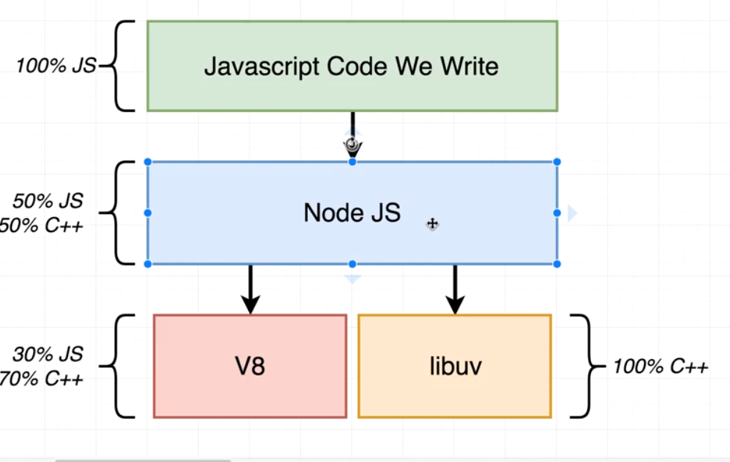

1. The v8 project is an open source js engine created by google. The purpose of this project is to able to execute js code outside of the browser and that’s
2. The libUV is open source c++ project that gives access to the OS, underlying file system. It gives access to networking and it also handles some aspects of concurrency as well.
3. Whats the use of nodejs then?
4. Bzox v8 is 70% c++ code and libuv is 100%c++ code. But we as a JS developer don’t want to write c++ code. We want to write js code. Sothats the purpose of Nodejs. Node gives us the nice interface to use to relate our JS side of our app to the actual c++ that’s running on our computer to actually interpret and execute.
5. 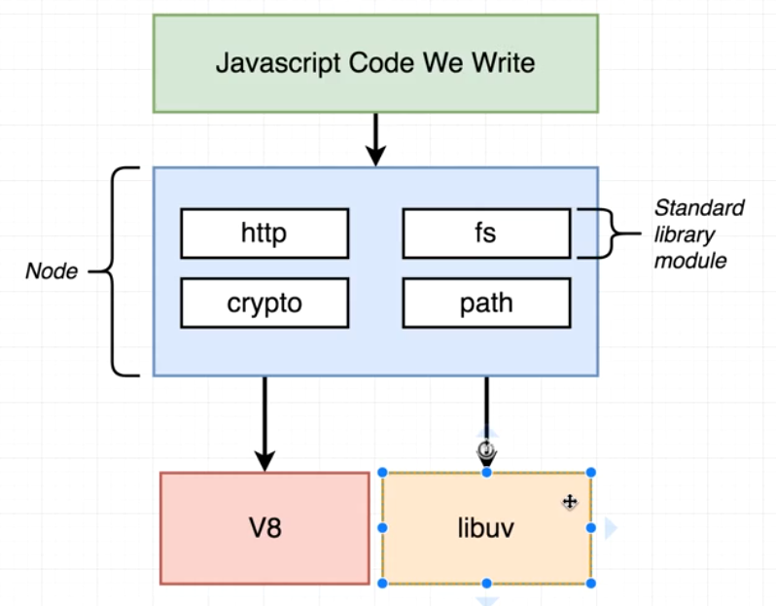
6. Nodejs provide us with series of wrappers and a very unified inconsistent API for us to use inside our projects.
7. The v8 project is used to translate the nodejs values that you and I place inside of our different programs like a Boolean, or a function or an object and translate it into their c++ equivalent.
8. So when we write js code we require node modules or node libraries they are depending upon some JS definition which eventually kind of maps up to actual c++ implementation. And on c++ side theres a lot of interoperability b/w v8 project as well as UV project.
9. 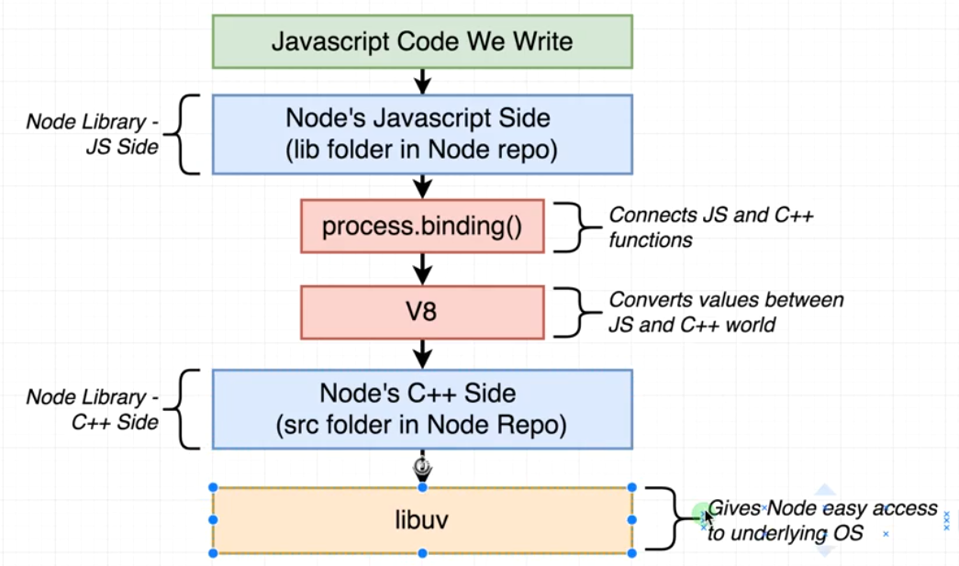

Threads:

1. Threads are unit of instruction that are waiting to be executed by the CPU deciding which order to execute these threads in is referred to as scheduling.
2. Scheduling is controlled by the OS. 2 ways of improving the rate at which we process
   1. To add more CPU cores to our machine
   2. To allow our OS schedular to detect big pauses in processing time due to expensive input and output operations.

Event-Loop:

1. A node program is run inside a thread. Different nodejs program required diffreretn number of threads. Inside thread there is 1 event-loop. EL is as being a control structure that decides what our one thread should be doing at any given point of time. Every program has only 1 EL.