**Configuration and Setup of application**

**PREREQUISITES:** The password for root user of MySQL MUST be set to ‘1020’ if any for the application to work.

1. Open MySQL Workbench and open a root connection.
2. Open ‘Server’ menu and tap on ‘Data Import’ option. 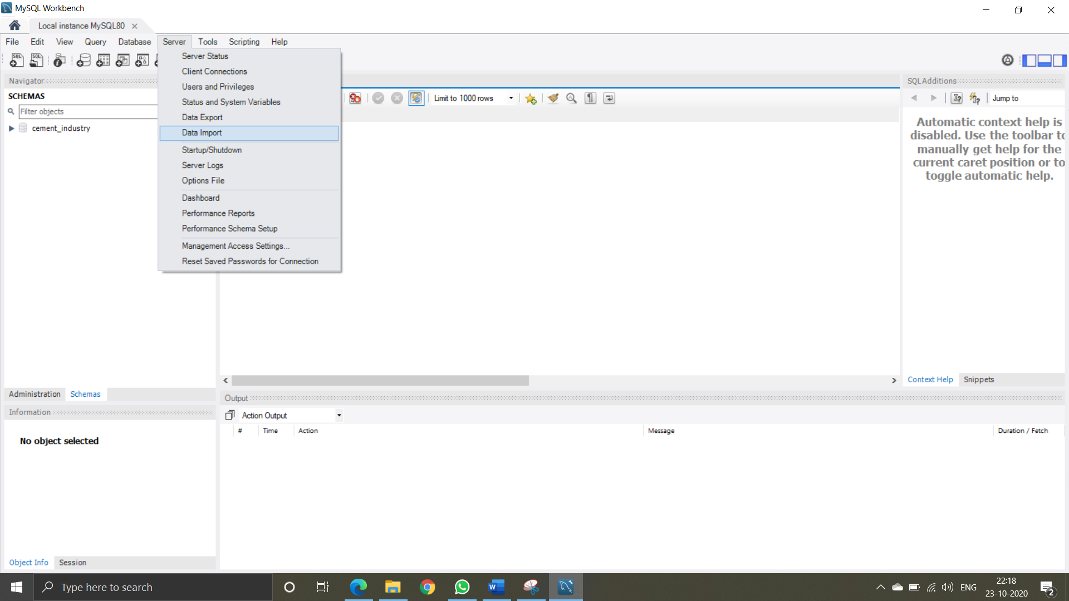
3. Check the ‘Import from Self-Contained File’ option and navigate select the ‘cement industry database schema import.sql’ file in the installer folder and make sure one of dump structue or dump data and structure option is selected.

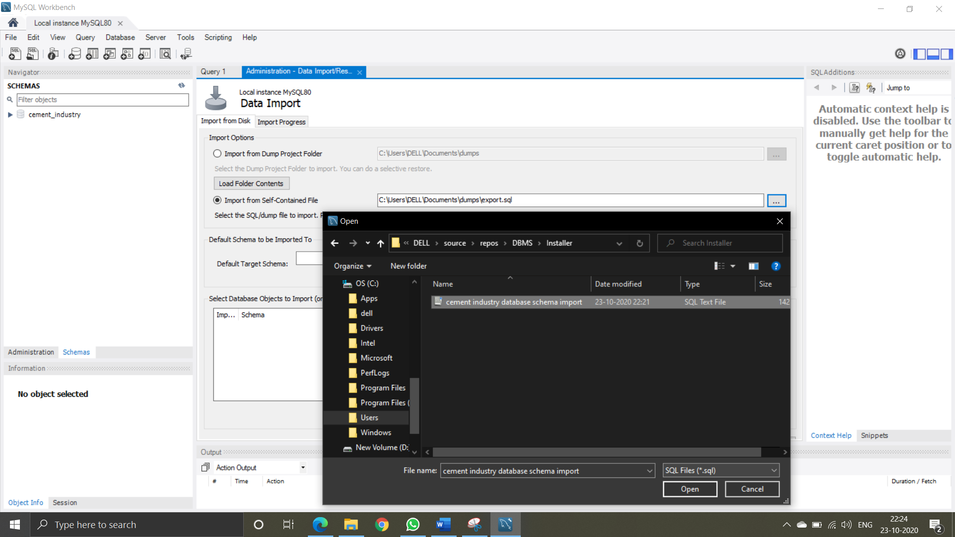

1. Click on ‘Start Import’ to import the database onto the system.
2. Now, to install the frontend application go to ‘Setup’ folder and open the Setup file. 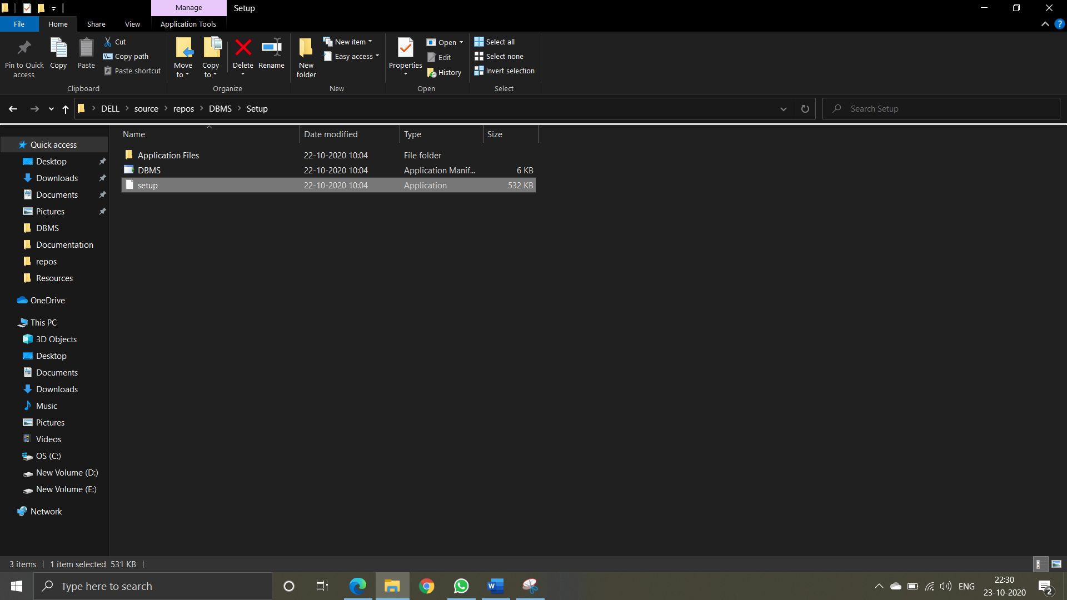
3. Continue installation as the wizard leads.
4. Your application is now installed and working given the prerequisites are met.