library(plotly)

Econdata <- read.csv("C:\\Users\\DELL\\Desktop\\Data Vis\\Lab\\DA\\DA2\\EconomistData.csv")

Econdata

View(Econdata)

**• Create stacked bar chart for Rank(group based on Region).**

p = plot_ly(data=Econdata,

x=~Region,

y=~HDI,

type = "bar"

)

p

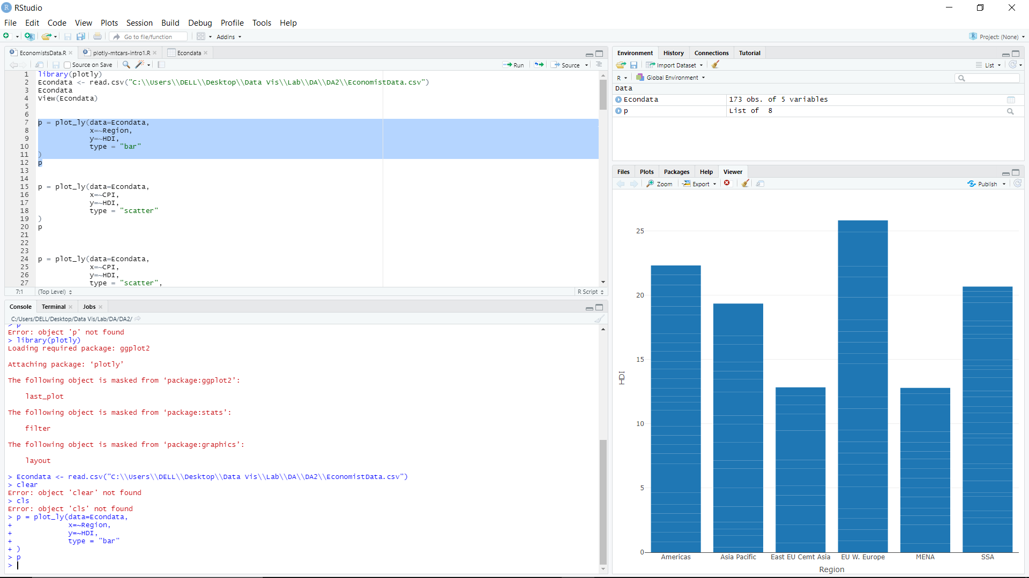

**• Create a scatter plot with CPI on the x axis and HDI on the y axis.**

p = plot_ly(data=Econdata,

x=~CPI,

y=~HDI,

type = "scatter"

)

P

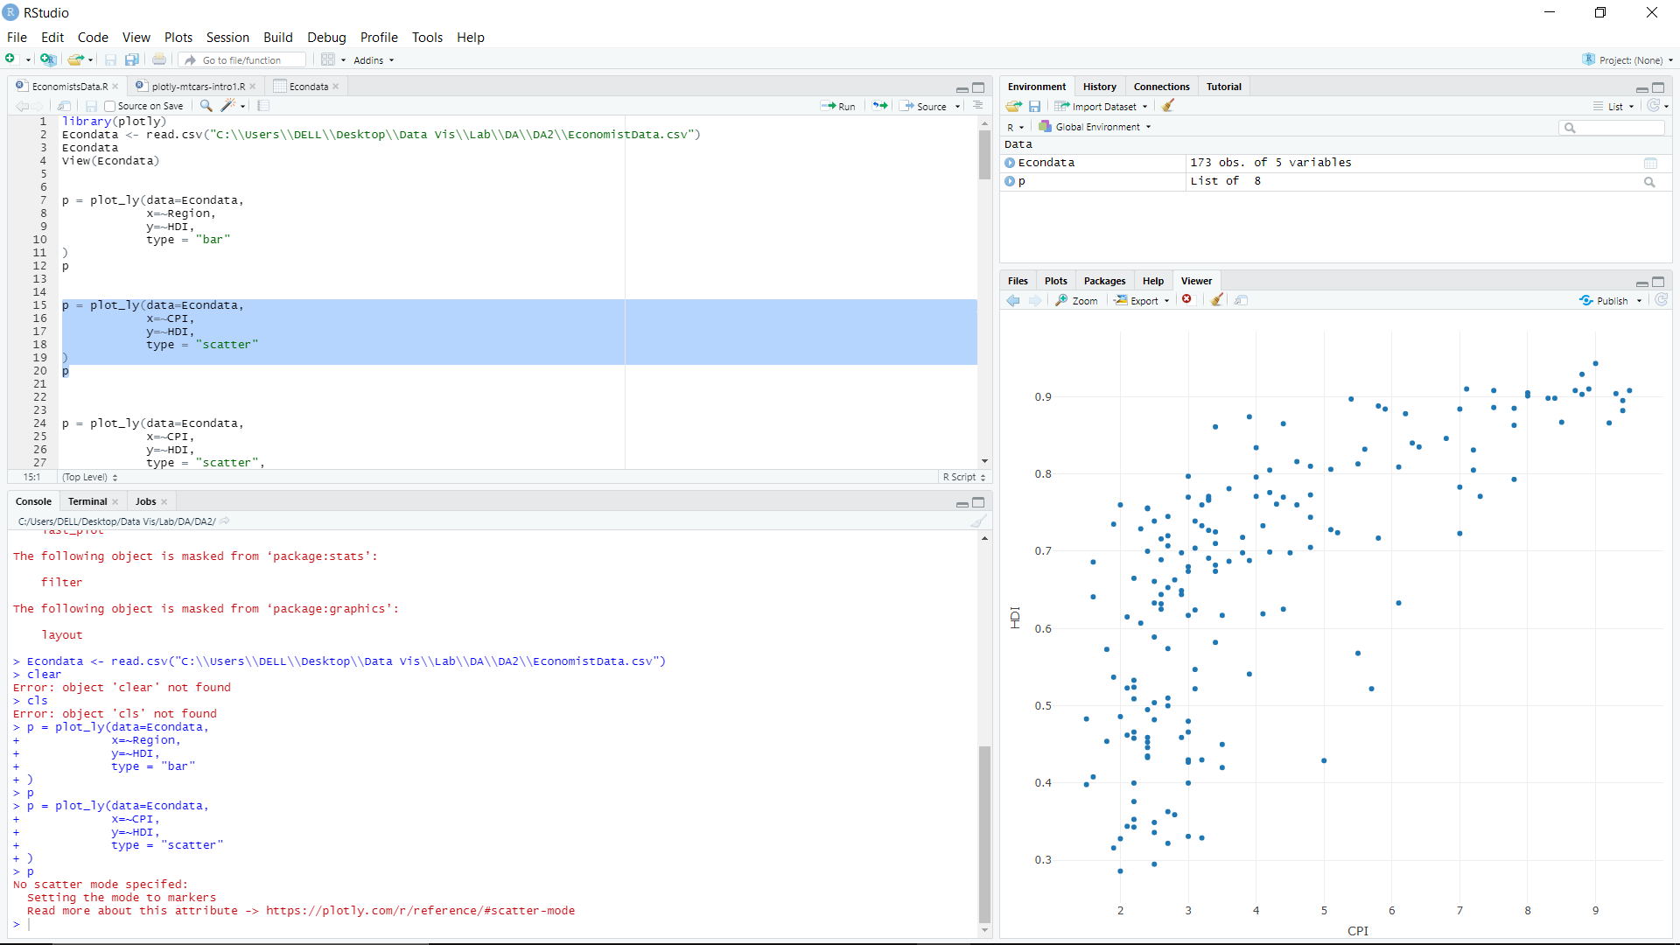

**• Colour the points green.**

p = plot_ly(data=Econdata,

x=~CPI,

y=~HDI,

type = "scatter",

mode="markers",

color=I("green")

)

P

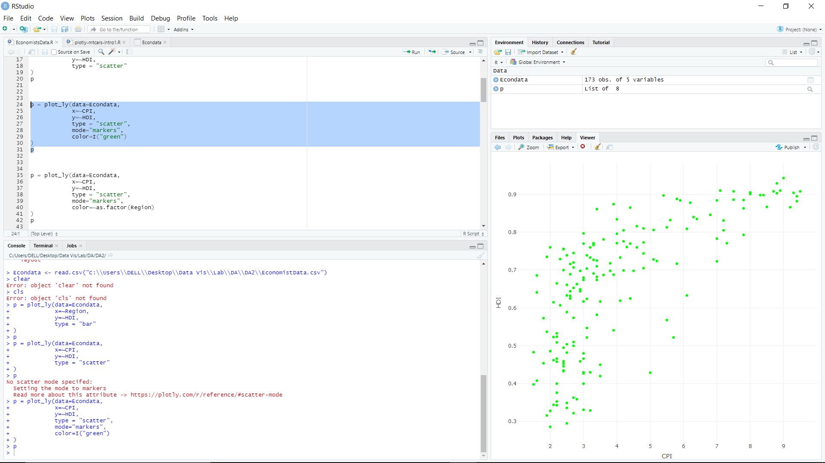

**• Map the color of the points to Region.**

p = plot_ly(data=Econdata,

x=~CPI,

y=~HDI,

type = "scatter",

mode="markers",

color=~as.factor(Region)

)

P

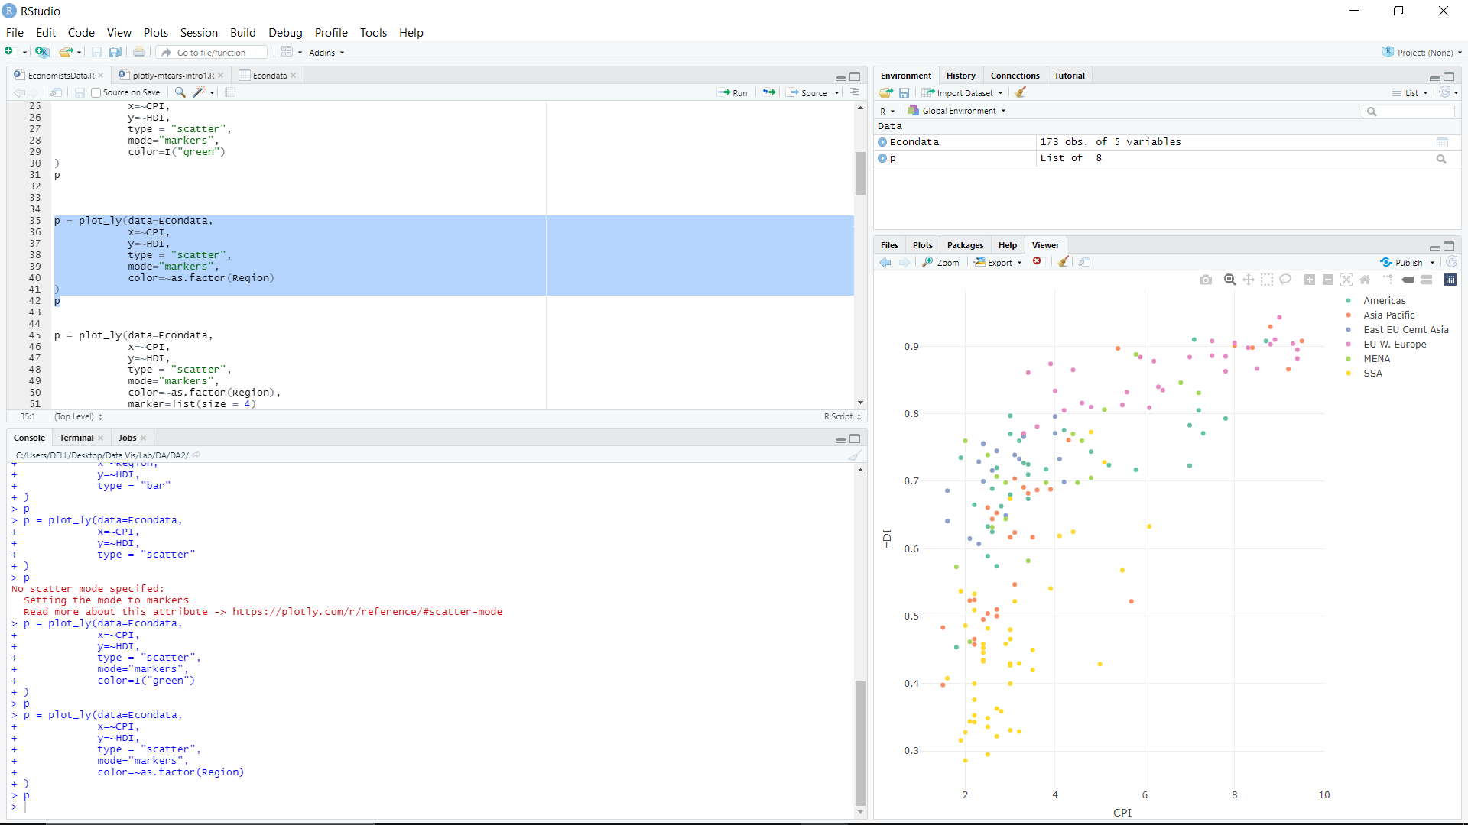

**• Make the points bigger by setting size to 4**

p = plot_ly(data=Econdata,

x=~CPI,

y=~HDI,

type = "scatter",

mode="markers",

color=~as.factor(Region),

marker=list(size = 4)

)

P

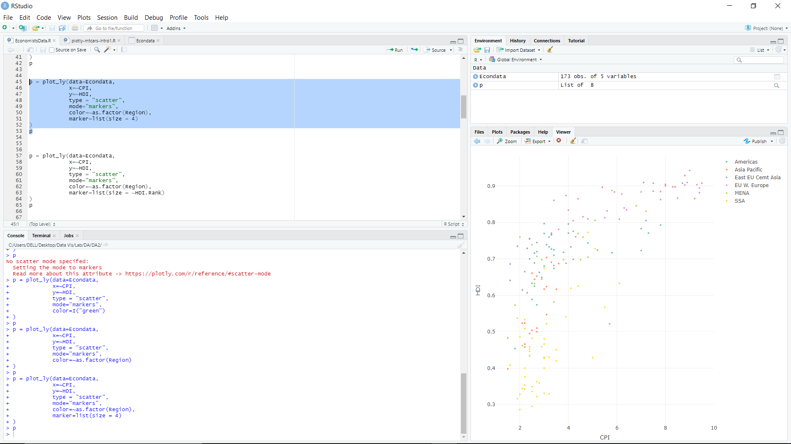

**• Map the size of the points to HDI.Rank**

p = plot_ly(data=Econdata,

x=~CPI,

y=~HDI,

type = "scatter",

mode="markers",

color=~as.factor(Region),

marker=list(size = ~HDI.Rank/10)

)

P

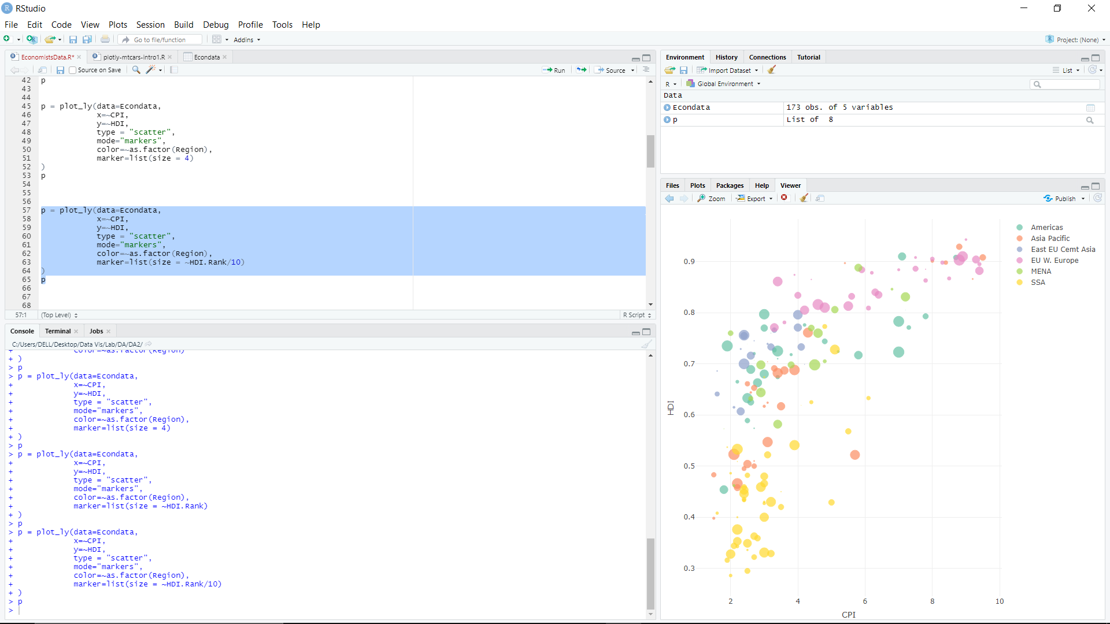

**• Mapping Data to Symbols**

p = plot_ly(data=Econdata,

x=~CPI,

y=~HDI,

type = "scatter",

mode="markers",

color=~as.factor(Region),

text = ~paste("HDI Rank: ", HDI.Rank),

symbol=~Region,

symbols=c('diamond','x','triangle-up-dot','square','circle-dot','star'),

marker=list(size = 7)

)

P

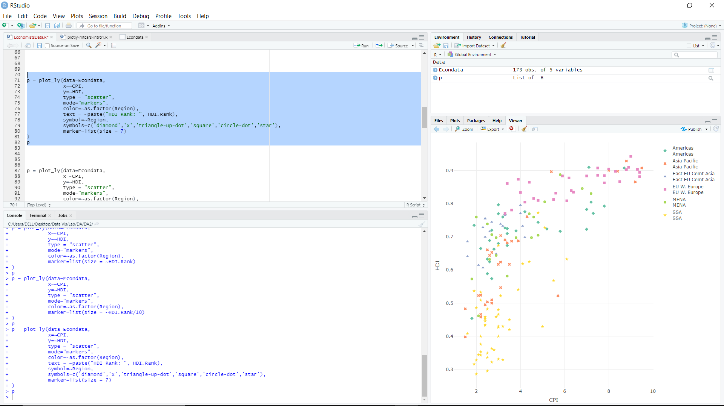

**• HDI.Rank-Data Labels on Hover**

p = plot_ly(data=Econdata,

x=~CPI,

y=~HDI,

type = "scatter",

mode="markers",

color=~as.factor(Region),

text = ~paste("HDI Rank: ", HDI.Rank),

symbol=~Region,

symbols=c('diamond','x','triangle-up-dot','square','circle-dot','star'),

marker=list(size = 7)

)

P

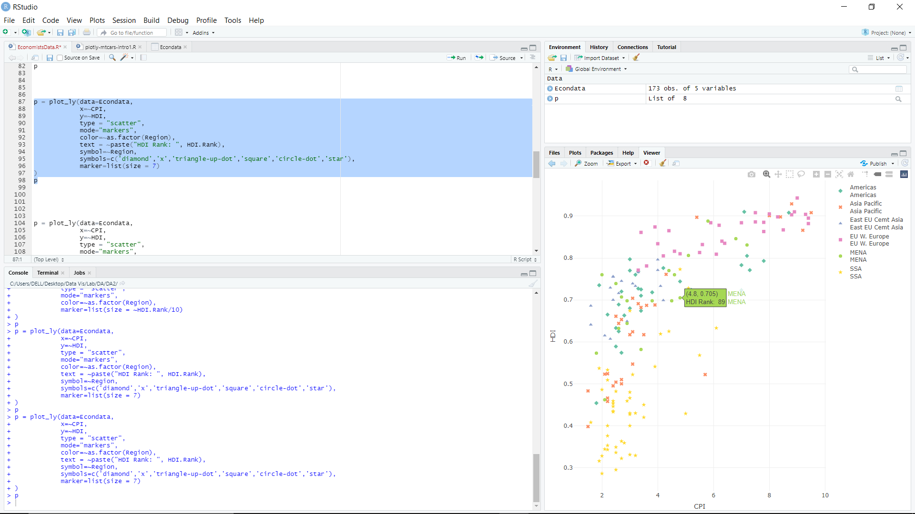

**• a. Add an appropriate title to the plot using the layout function and title argument.**

**b. Add an appropriate x-axis label using the xaxis argument. xaxis takes a list of attribute values.**

**c. Add an appropriate y-axis label.**

p = plot_ly(data=Econdata,

x=~CPI,

y=~HDI,

type = "scatter",

mode="markers",

color=~as.factor(Region),

text = ~paste("HDI Rank: ", HDI.Rank),

symbol=~Region,

symbols=c('diamond','x','triangle-up-dot','square','circle-dot','star'),

marker=list(size = 7)

)%>%

layout(title="Economists data",

xaxis=list(title="CPI"),

yaxis=list(title="HDI"))

p

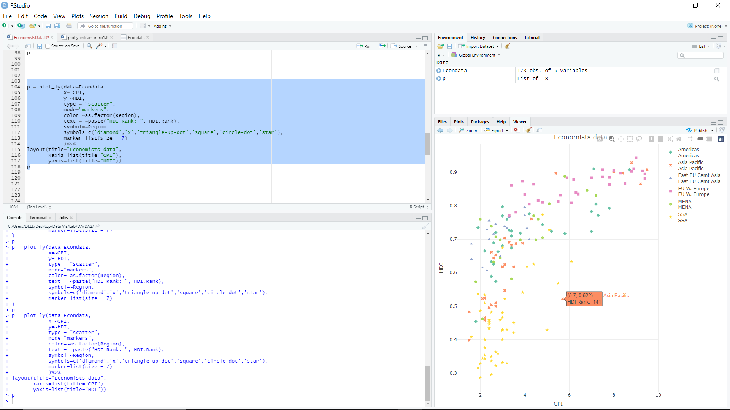

**• display annotations for country which top and lowest HDI.Rank**

p = plot_ly(data=Econdata,

x=~CPI,

y=~HDI,

type = "scatter",

mode="markers",

color=~as.factor(Region),

text = ~paste("HDI Rank: ", HDI.Rank, "Country: ", Country),

symbol=~Region,

symbols=c('diamond','x','triangle-up-dot','square','circle-dot','star'),

marker=list(size = 7)

)%>%

layout(title="Economists data",

xaxis=list(title="CPI"),

yaxis=list(title="HDI"))%>%

add_annotations(

x=Econdata$CPI[which.max(Econdata$HDI.Rank)],

y=Econdata$HDI[which.max(Econdata$HDI.Rank)],

text="Lowest Ranking",

showarrow=T)%>%

add_annotations(

x=Econdata$CPI[which.min(Econdata$HDI.Rank)],

y=Econdata$HDI[which.min(Econdata$HDI.Rank)],

text="Highest Ranking",

showarrow=T)

p

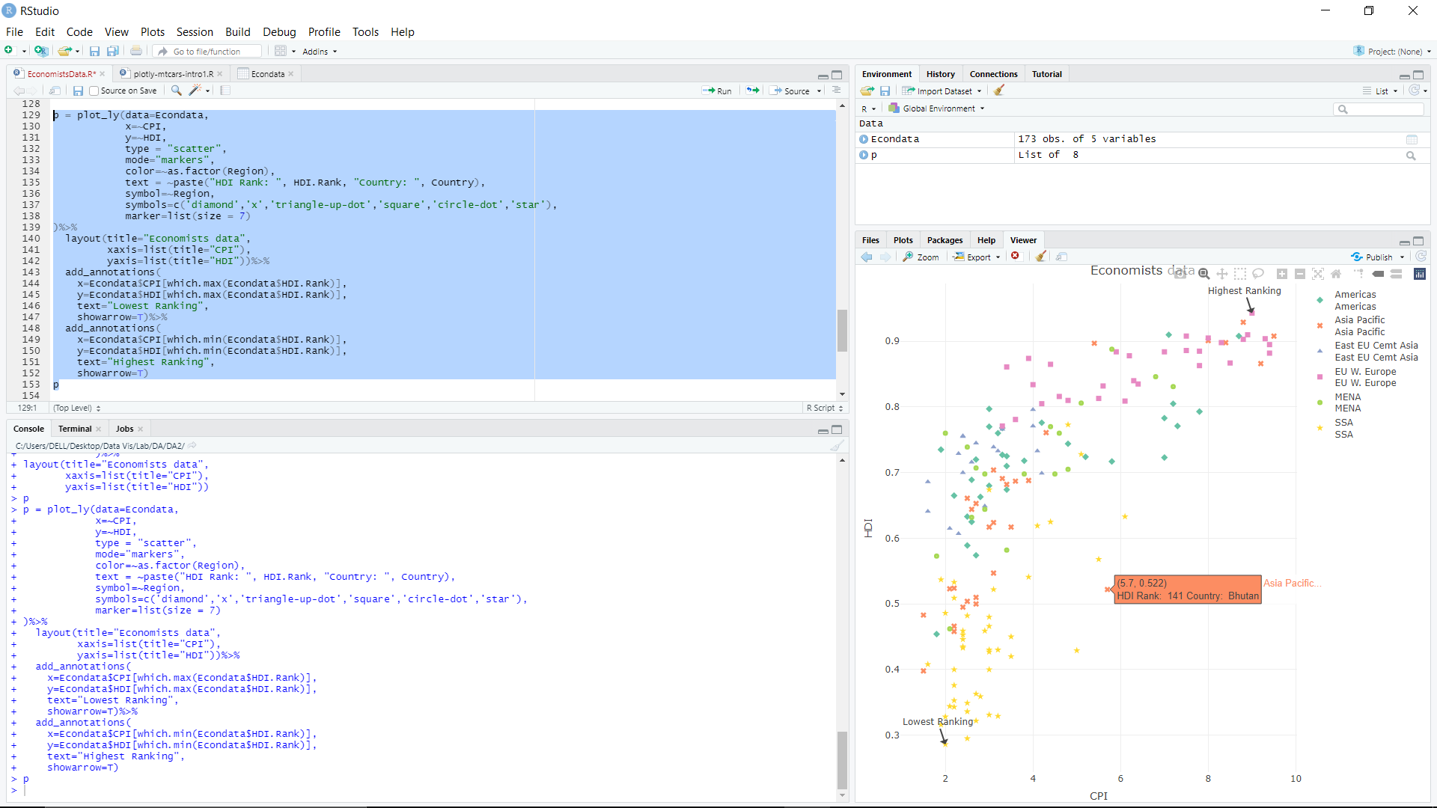

**• display annotations for our country (data label with HDI.Rank)**

p = plot_ly(data=Econdata,

x=~CPI,

y=~HDI,

type = "scatter",

mode="markers",

color=~as.factor(Region),

text = ~paste("HDI Rank: ", HDI.Rank, "Country: ", Country),

symbol=~Region,

symbols=c('diamond','x','triangle-up-dot','square','circle-dot','star'),

marker=list(size = 7)

)%>%

layout(title="Economists data",

xaxis=list(title="CPI"),

yaxis=list(title="HDI"))%>%

add_annotations(

x=Econdata$CPI[Econdata$Country=="India"],

y=Econdata$HDI[Econdata$Country=="India"],

text="India",

showarrow=T)

p

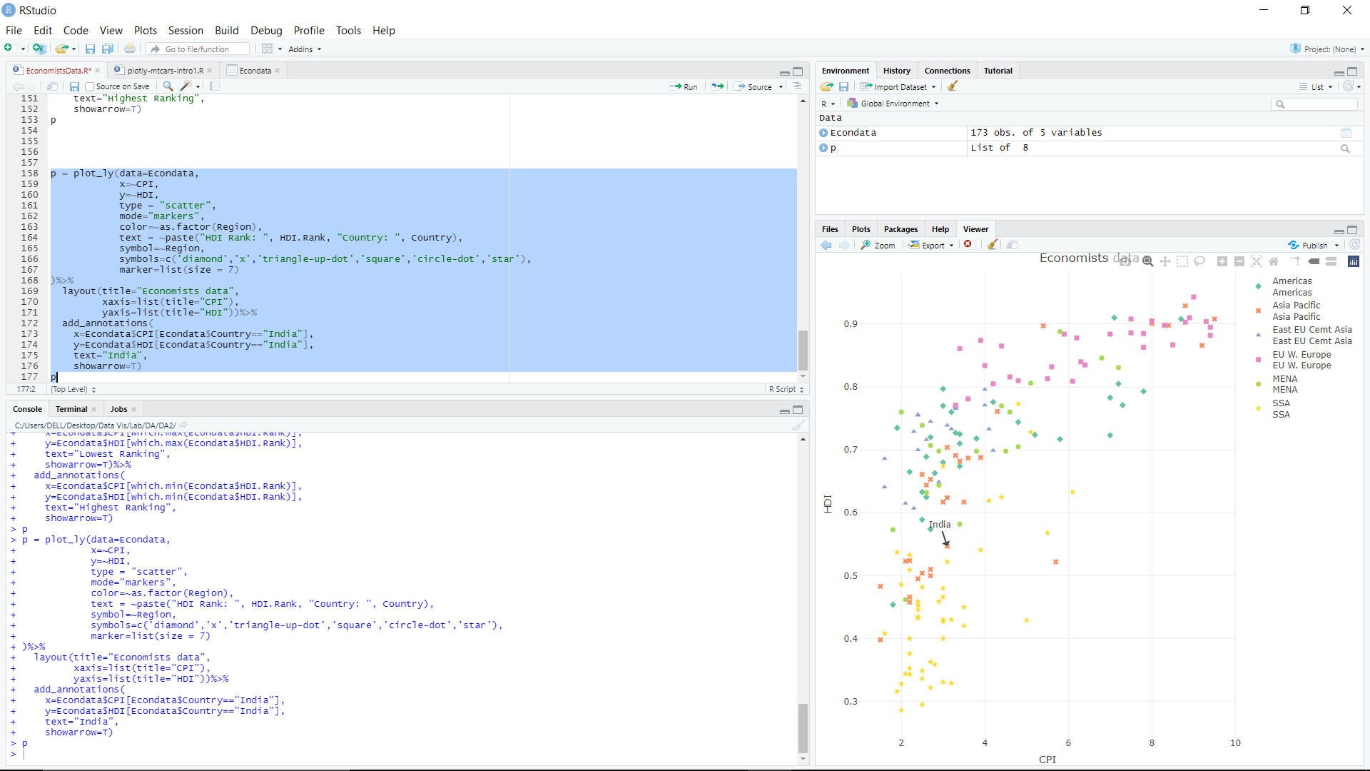

**• Save plot**

jpeg("rplot.jpg")

p =plot_ly(data=Econdata,

x=~CPI,

y=~HDI,

type = "scatter",

mode="markers",

color=~as.factor(Region),

text = ~paste("HDI Rank: ", HDI.Rank, "Country: ", Country),

symbol=~Region,

symbols=c('diamond','x','triangle-up-dot','square','circle-dot','star'),

marker=list(size = 7)

)%>%

layout(title="Economists data",

xaxis=list(title="CPI"),

yaxis=list(title="HDI"))%>%

add_annotations(

x=Econdata$CPI[Econdata$Country=="India"],

y=Econdata$HDI[Econdata$Country=="India"],

text="India",

showarrow=T)

p

dev.off()

