**Registration Number- 19BCE2119**

**Name- Gaurav Kumar Singh**

**Course- Data Visualization (L13+L14)**

**Digital Assignment 3**

• Importing libraries and dataset

library(ggplot2)

library(dplyr)

library(plotly)

library(hrbrthemes)

library(rlang)

library(tidyr)

library(gridExtra)

books <- read.csv("C:\\Users\\DELL\\Desktop\\Data Vis\\Lab\\DA\\DA3\\books.csv")

View(books)

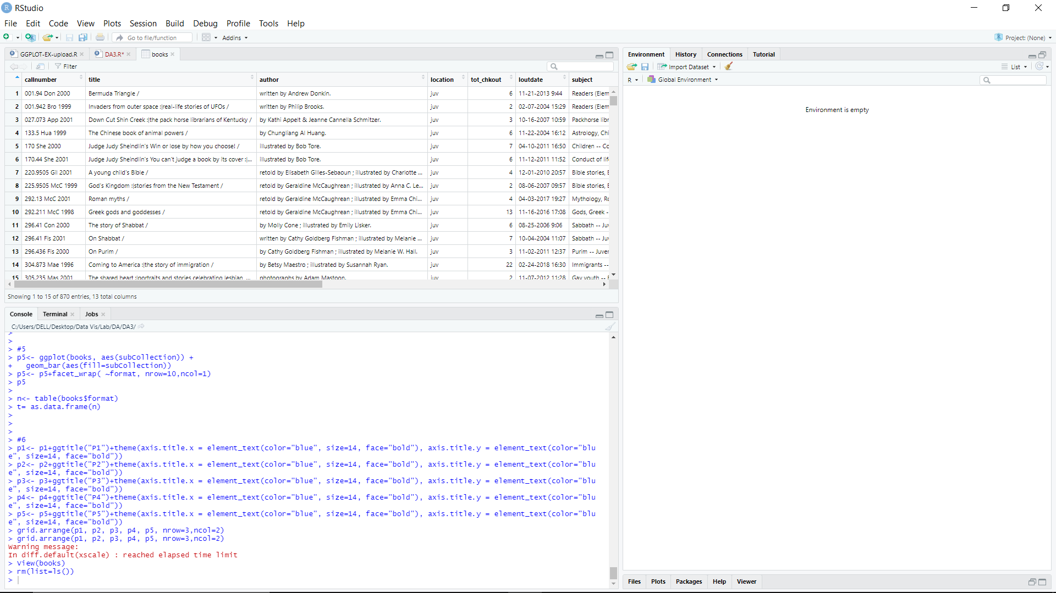

• Remove NA values

#Method1

books<-na.omit(books, na.action = "omit", cols="call_class")

#Method2

books<-subset(books,!is.na(call_class))

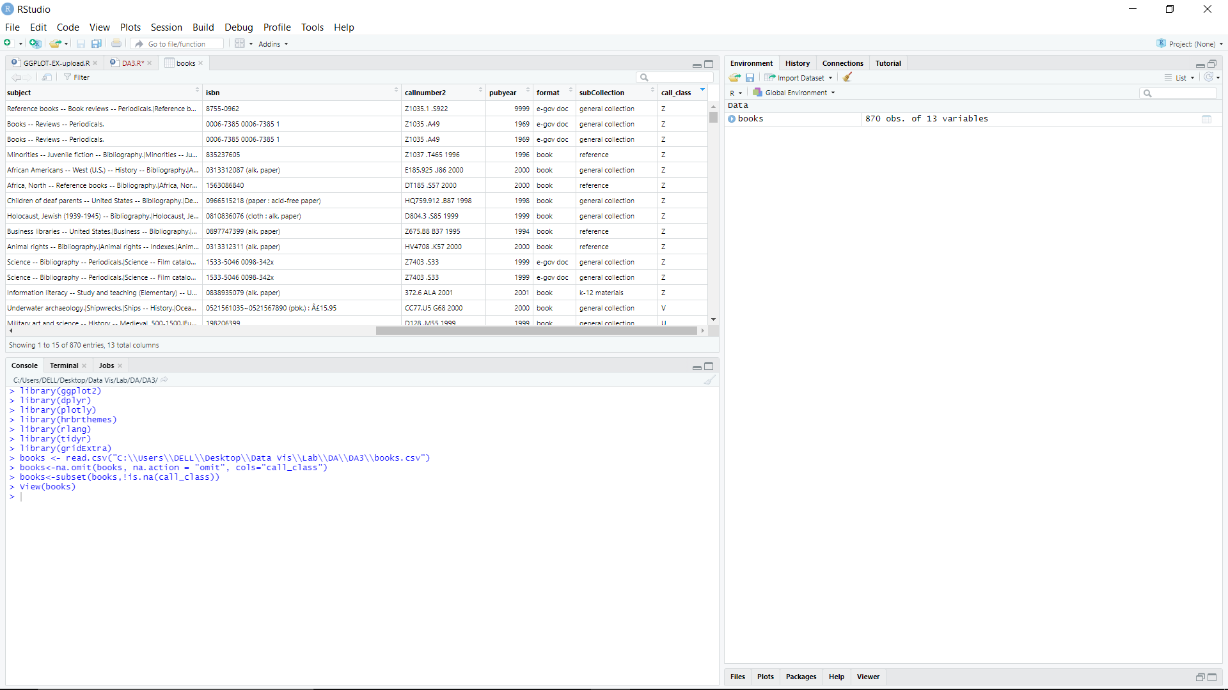

• Visualize frequency distribution of checkouts in the book dataset

p1<- ggplot(books, aes(tot_chkout)) + geom_bar()

p1

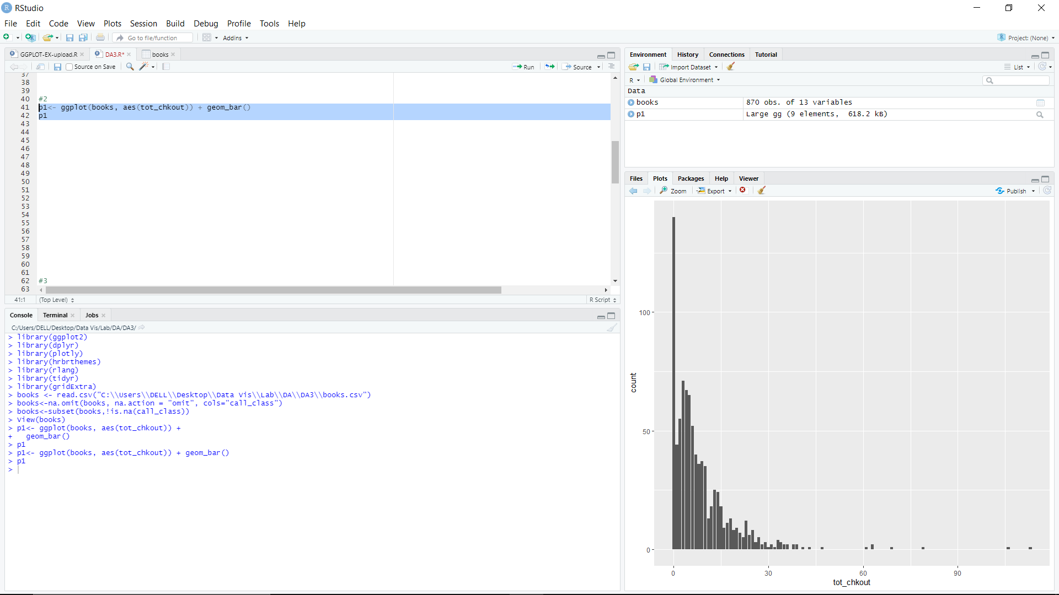

• Visualize boxplot plot high usage books by call number class[Hint: derive new variable high usage books which have more than 10 checkouts] and color by subCollection- any three category

subcol=c("juvenile", "special collections", "reserves")

newset<- subset(books, tot_chkout>10 & subCollection %in% subcol )

p2<- ggplot(newset, aes(x=call_class,y=tot_chkout, color=subCollection)) + geom_boxplot()

p2

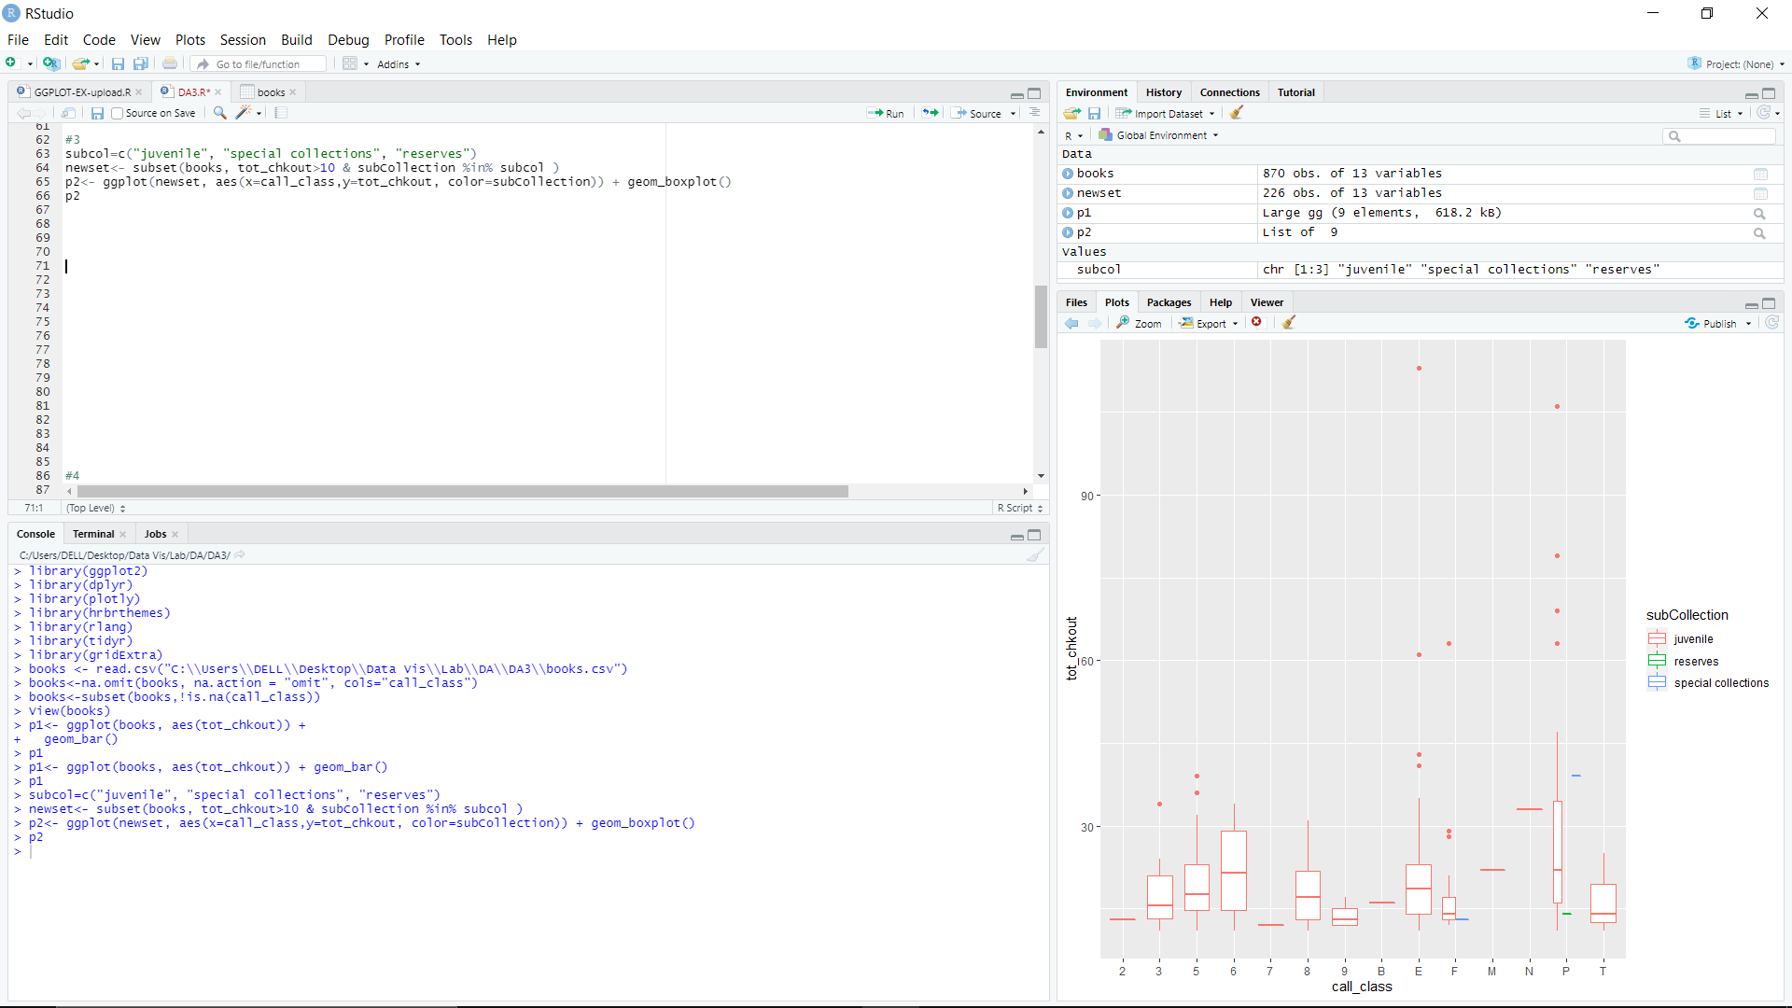

• Visualize stacked bar and group chart high usage books by call number class[Hint: derive new variable high usage books which have more than 10 checkouts] and color by subCollection- any four category

subcol=c("juvenile", "special collections", "reserves","general collection")

newset<- subset(books, tot_chkout>10 & subCollection %in% subcol)

p3<- ggplot(newset, aes(x=call_class,y=tot_chkout)) +

geom_bar(aes(fill=subCollection),position="dodge",stat="identity")

p3

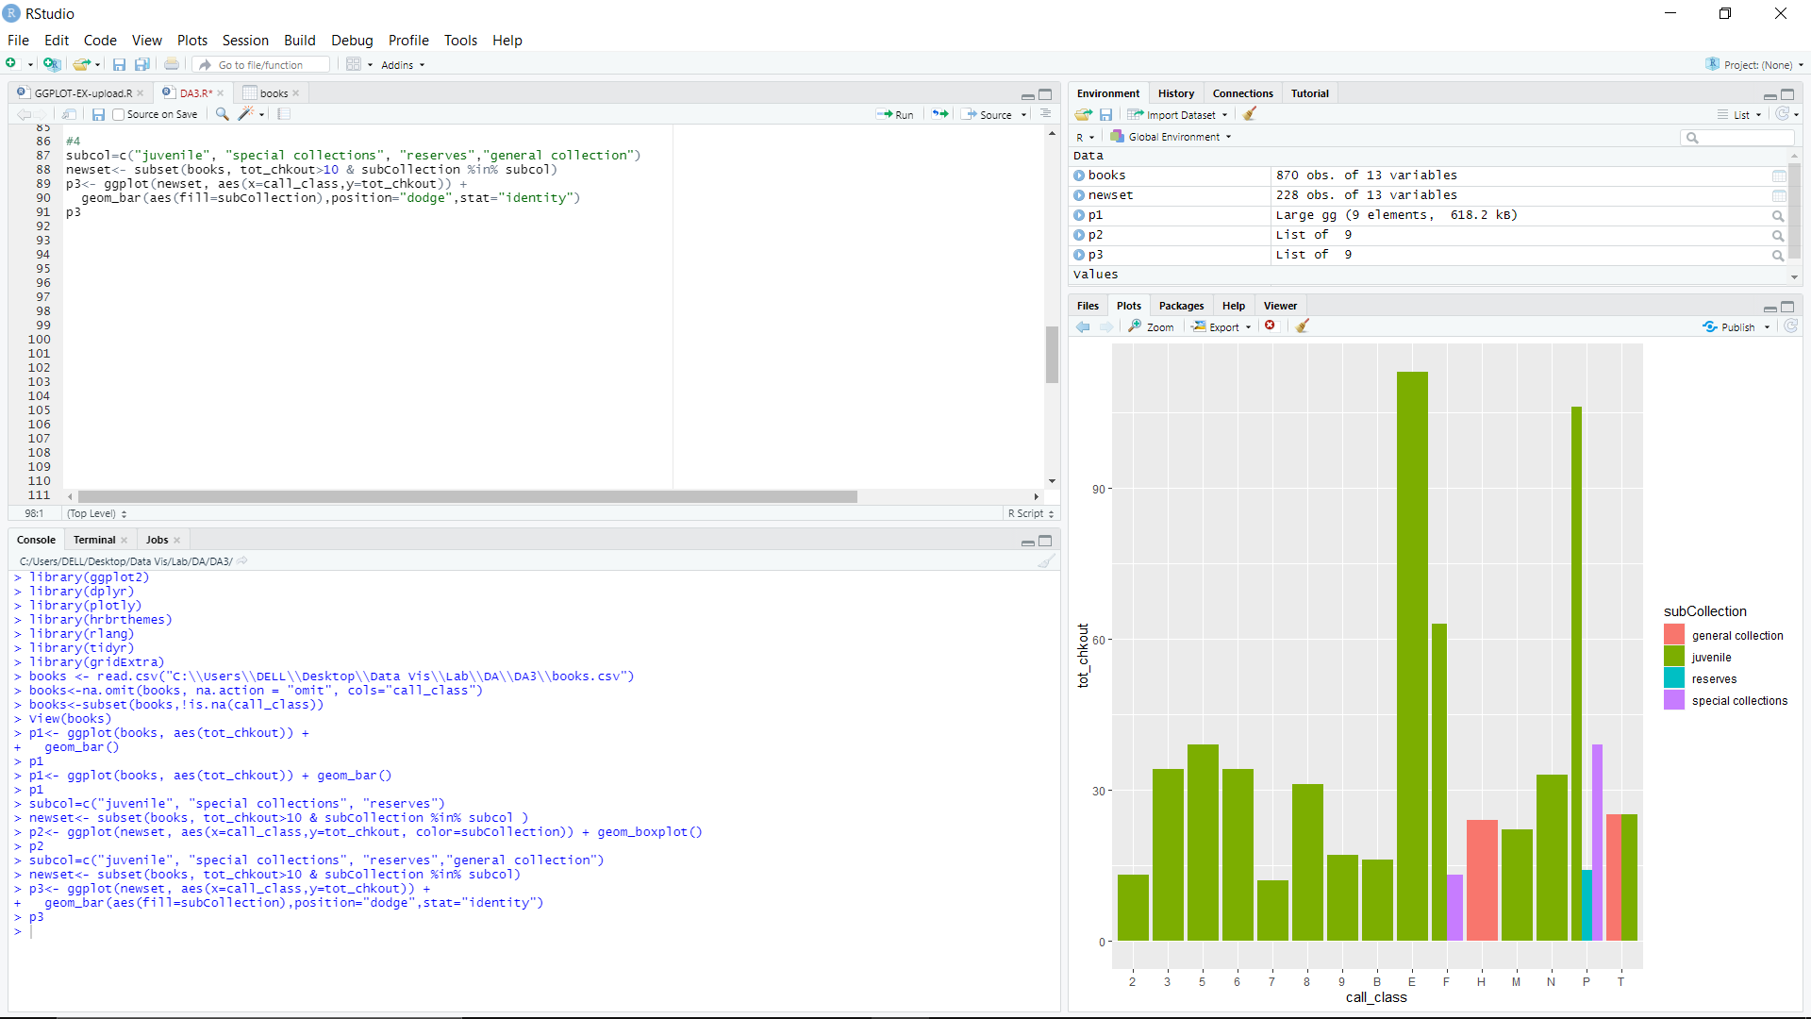

subcol=c("juvenile", "special collections", "reserves","general collection")

newset<- subset(books, tot_chkout>10 & subCollection %in% subcol)

p4<- ggplot(newset, aes(x=call_class,y=tot_chkout)) +

geom_bar(aes(fill=subCollection),position="stack",stat="identity")

p4

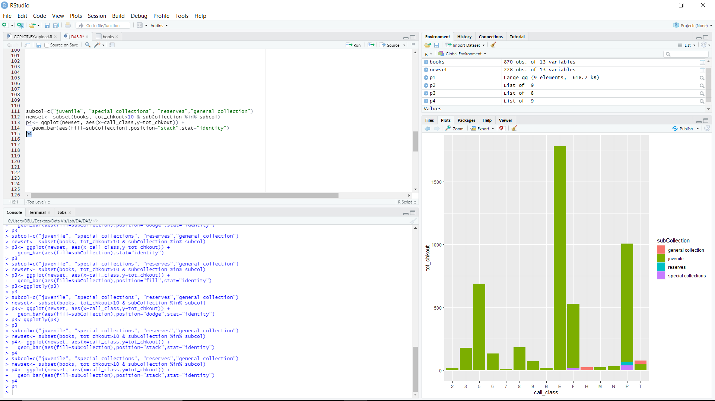

• Create a bar plot that depicts the number of items in each sub-collection, faceted by format. Arrange sub plots horizontally.

p5<- ggplot(books, aes(subCollection)) +

geom_bar(aes(fill=subCollection))

p5<- p5+facet_wrap( ~format, nrow=1,ncol=3)

p5

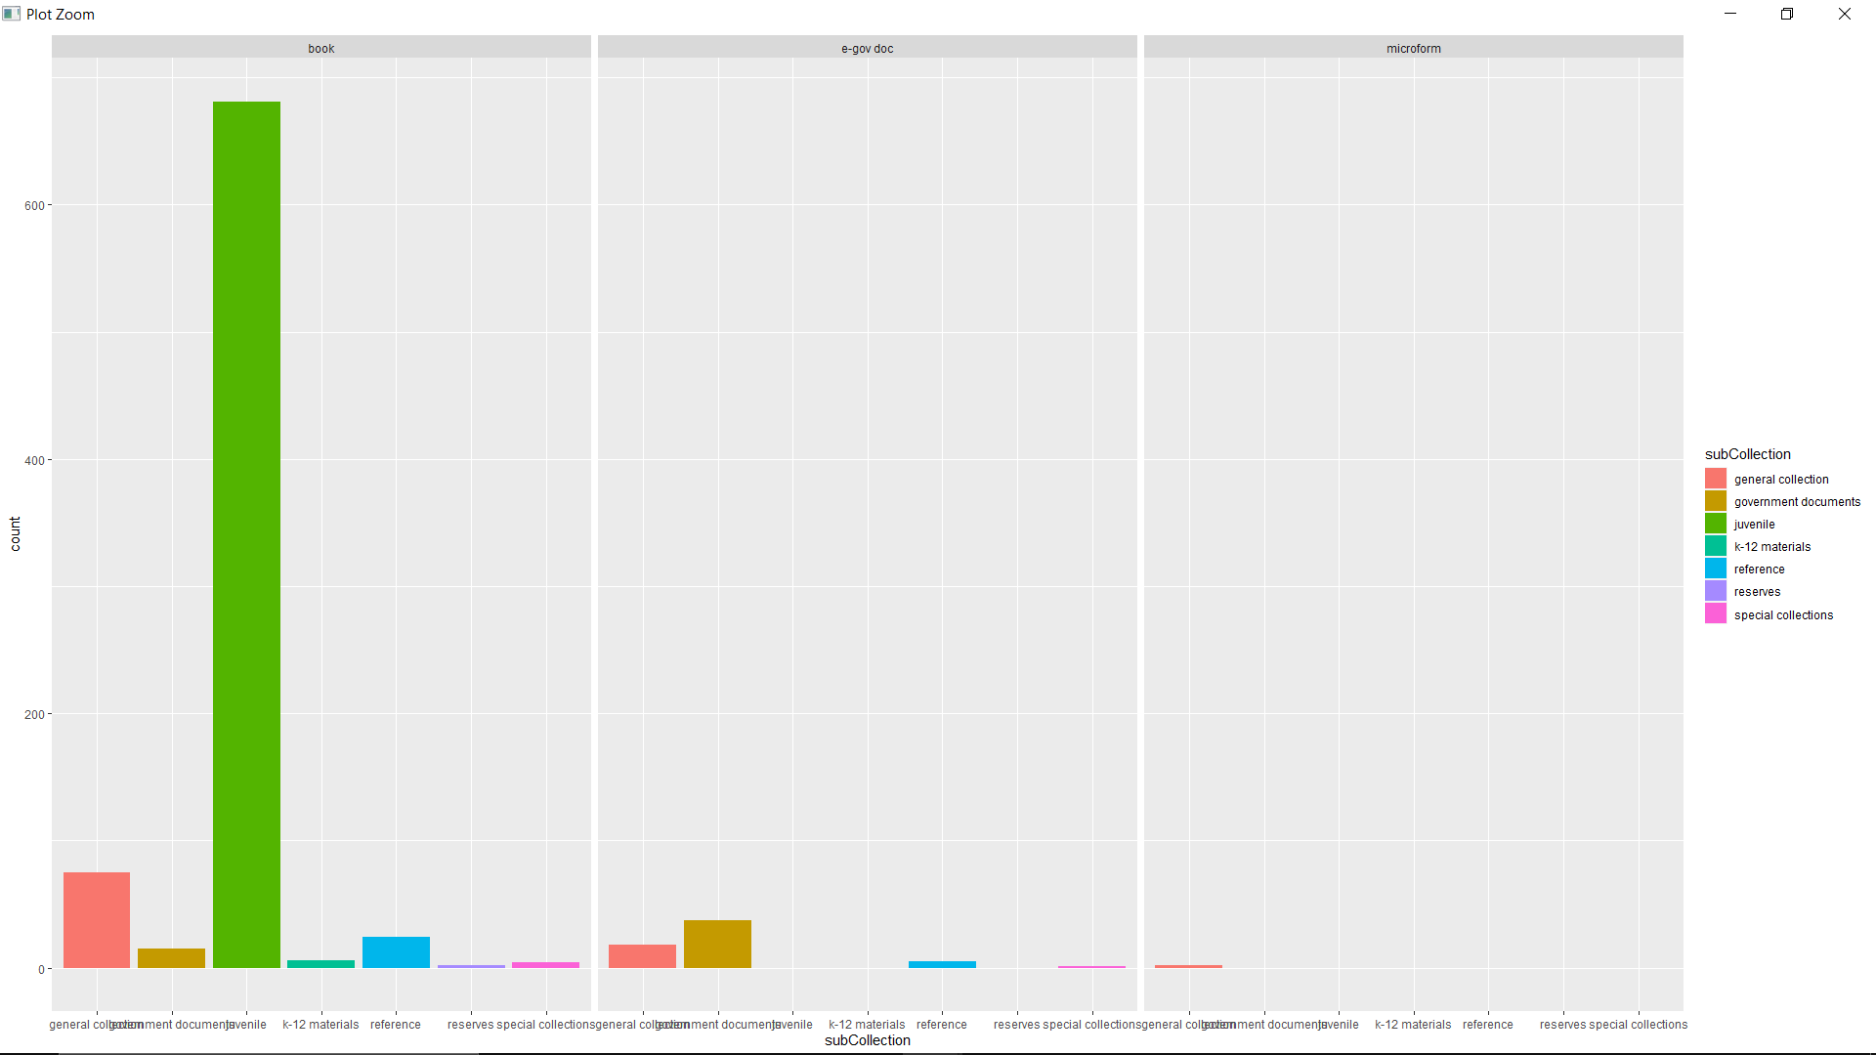

• Apply various themes in the above plots

p1<- p1+ggtitle("P1")+theme(axis.title.x = element_text(color="blue", size=14, face="bold"), axis.title.y = element_text(color="blue", size=14, face="bold"))

p2<- p2+ggtitle("P2")+theme(axis.title.x = element_text(color="blue", size=14, face="bold"), axis.title.y = element_text(color="blue", size=14, face="bold"))

p3<- p3+ggtitle("P3")+theme(axis.title.x = element_text(color="blue", size=14, face="bold"), axis.title.y = element_text(color="blue", size=14, face="bold"))

p4<- p4+ggtitle("P4")+theme(axis.title.x = element_text(color="blue", size=14, face="bold"), axis.title.y = element_text(color="blue", size=14, face="bold"))

p5<- p5+ggtitle("P5")+theme(axis.title.x = element_text(color="blue", size=14, face="bold"), axis.title.y = element_text(color="blue", size=14, face="bold"))

grid.arrange(p1, p2, p3, p4, p5, nrow=3,ncol=2)

