**Registration Number: 19BCE2119**

**Name: Gaurav Kumar Singh**

**Course: Network and Communication CSE1004**

**Digital Assignment 5**

**TCP**

**CODE-> SERVER**

#include <stdio.h>

#include <sys/types.h>

#include <sys/socket.h>

#include <netinet/in.h>

void error(char *msg){

perror(msg);

exit(1);

}

int main(int argc, char *argv[]){

int sockfd, newsockfd, portno, clilen;

char buffer[256];

struct sockaddr_in serv_addr, cli_addr;

int n;

if (argc < 2){

fprintf(stderr,"ERROR, no port provided\n");

exit(1);

}

sockfd = socket(AF_INET, SOCK_STREAM, 0);

if (sockfd < 0){

error("ERROR opening socket");

}

bzero((char *) &serv_addr, sizeof(serv_addr));

portno = atoi(argv[1]);

serv_addr.sin_family = AF_INET;

serv_addr.sin_addr.s_addr = INADDR_ANY;

serv_addr.sin_port = htons(portno);

if (bind(sockfd, (struct sockaddr *) &serv_addr,sizeof(serv_addr)) < 0){

error("ERROR on binding");

}

listen(sockfd,5);

clilen = sizeof(cli_addr);

newsockfd = accept(sockfd,(struct sockaddr *) &cli_addr, &clilen);

if (newsockfd < 0){

error("ERROR on accept");

}

bzero(buffer,256);

n = read(newsockfd,buffer,255);

if (n < 0){

error("ERROR reading from socket");

}

printf("Here is the message: %s\n",buffer);

n = write(newsockfd,"I got your message",18);

if (n < 0){

error("ERROR writing to socket");

}

return 0;

}

**CODE-> CLIENT**

#include <stdio.h>

#include <sys/types.h>

#include <sys/socket.h>

#include <netinet/in.h>

#include <netdb.h>

#include <string.h>

void error(char *msg){

perror(msg);

exit(0);

}

int main(int argc, char *argv[]){

int sockfd, portno, n;

struct sockaddr_in serv_addr;

struct hostent *server;

char buffer[256];

if (argc < 3){

fprintf(stderr,"usage %s hostname port\n", argv[0]);

exit(0);

}

portno = atoi(argv[2]);

sockfd = socket(AF_INET, SOCK_STREAM, 0);

if (sockfd<0){

error("Error opening socket");

}

server = gethostbyname(argv[1]);

if (server == NULL) {

fprintf(stderr, "ERROR no such host\n");

exit(0);

}

bzero((char*) &serv_addr, sizeof(serv_addr));

serv_addr.sin_family=AF_INET;

bcopy((char*)server->h_addr,(char*)&serv_addr.sin_addr.s_addr,server->h_length);

serv_addr.sin_port=htons(portno);

if (connect(sockfd, &serv_addr, sizeof(serv_addr))<0){

error("ERROR connecting");

}

printf("Enter the message: ");

bzero(buffer,256);

fgets(buffer,255,stdin);

n=write(sockfd,buffer,strlen(buffer));

if (n<0){

error("ERROR writing to socket");

}

printf("%s\n",buffer);

return 0;

}

**SCREENSHOTS**

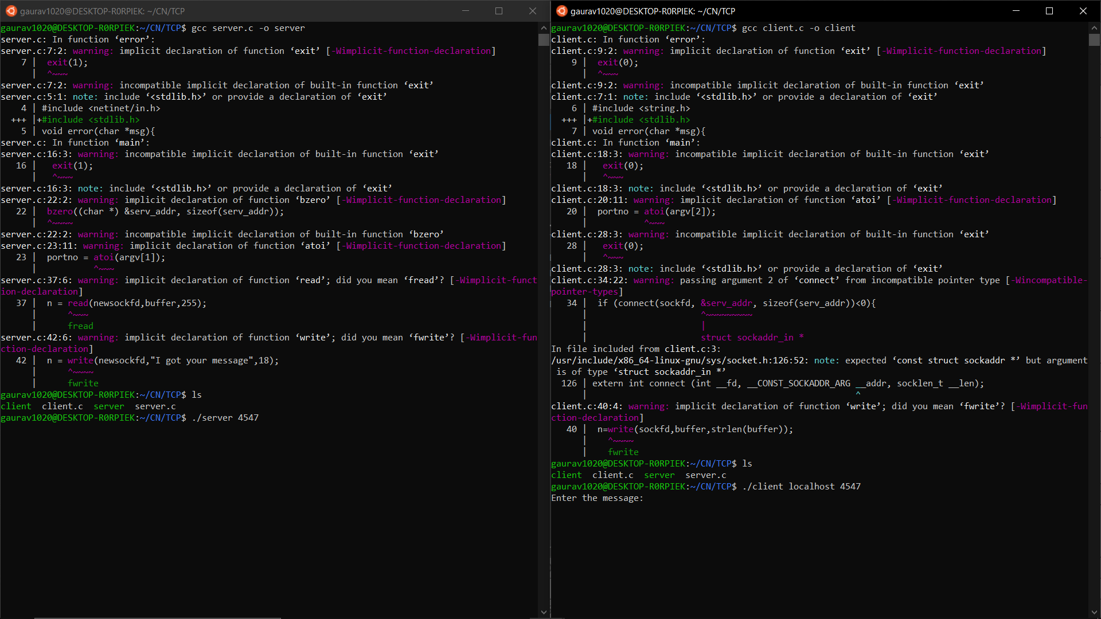

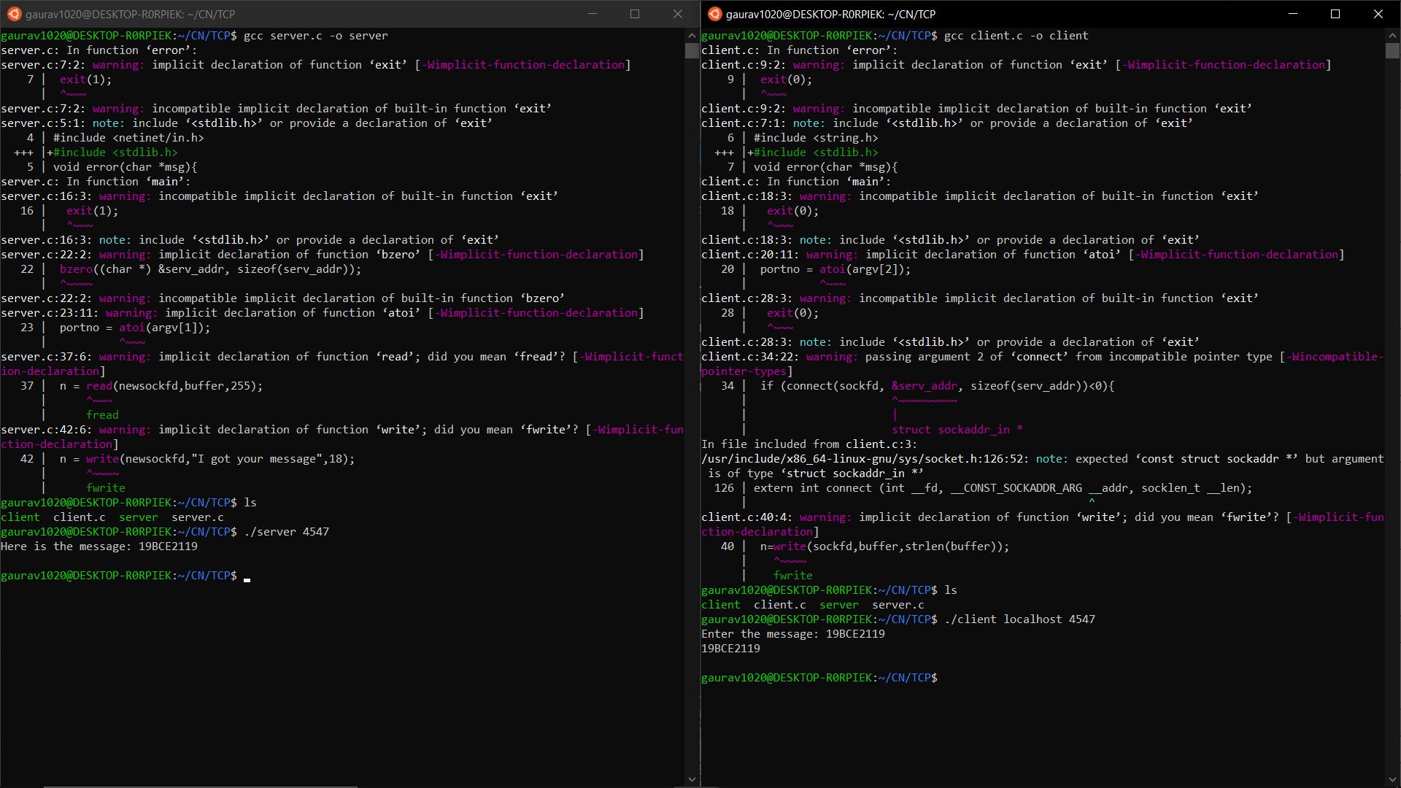

**UDP**

**CODE-> SERVER**

#include <stdio.h>

#include <sys/types.h>

#include <sys/socket.h>

#include <netinet/in.h>

#include <netdb.h>

#include <string.h>

#include <stdlib.h>

void error(char *msg){

perror(msg);

exit(0);

}

int main(int argc, char *argv[]){

int sock, length, fromlen, n;

struct sockaddr_in server;

struct sockaddr_in from;

char buf[1024];

if (argc < 2){

fprintf(stderr, "ERROR, no port provided\n");

exit(0);

}

sock=socket(AF_INET, SOCK_DGRAM, 0);

if (sock < 0){

error("Opening socket");

}

length = sizeof(server);

bzero(&server,length);

server.sin_family=AF_INET;

server.sin_addr.s_addr=INADDR_ANY;

server.sin_port=htons(atoi(argv[1]));

if (bind(sock,(struct sockaddr *)&server,length)<0){

error("binding");

}

fromlen = sizeof(struct sockaddr_in);

while (1){

n = recvfrom(sock,buf,1024,0,(struct sockaddr *)&from,&fromlen);

if (n < 0)

{

error("recvfrom");

}

write(1,"Received a datagram: ",21);

write(1,buf,n);

n = sendto(sock,"Got your message\n",17,0,(struct sockaddr *)&from,fromlen);

if (n < 0){

error("sendto");

}

}

return 0;

}

**CODE-> CLIENT**

#include <stdio.h>

#include <sys/types.h>

#include <sys/socket.h>

#include <netinet/in.h>

#include <netdb.h>

#include <string.h>

#include <stdlib.h>

void error(char *msg){

perror(msg);

exit(0);

}

int main(int argc, char *argv[]){

int sock, length, n;

struct sockaddr_in server, from;

struct hostent *hp;

char buffer[256];

if (argc != 3){

printf("Usage: server port\n");

exit(1);

}

sock= socket(AF_INET, SOCK_DGRAM, 0);

if (sock<0){

error("ERROR socket");

}

server.sin_family=AF_INET;

hp=gethostbyname(argv[1]);

if(hp==0){

error("Unknown host");

}

bcopy((char*)hp->h_addr, (char*)&server.sin_addr,hp->h_length);

server.sin_port = htons(atoi(argv[2]));

length=sizeof(struct sockaddr_in);

printf("Please enter the message: ");

bzero(buffer,256);

fgets(buffer,255,stdin);

n=sendto(sock,buffer,strlen(buffer),0,&server,length);

if (n < 0){

error("ERROR Sendto");

}

n = recvfrom(sock,buffer,256,0,&from, &length);

if (n < 0){

error("ERROR recvfrom");

}

write(1,"Got an ack: ",12);

write(1,buffer,n);

return 0;

}

**SCREENSHOTS**

