**Name: Gaurav Kumar Singh**

**Registration number: 19BCE2119**

**Course: Network and Communication**

**Final Assessment Test**

**Question no. 9**

**a)**

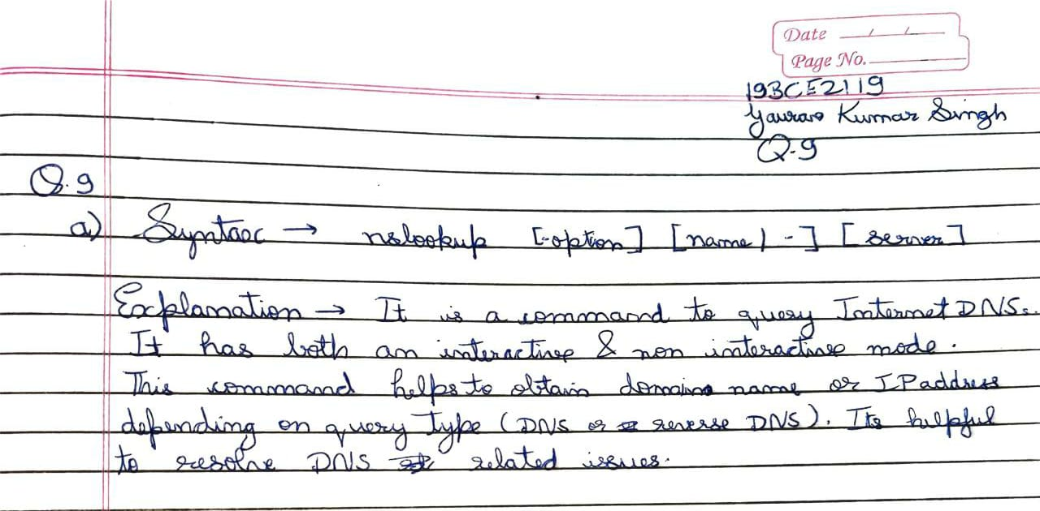

**OUTPUT**

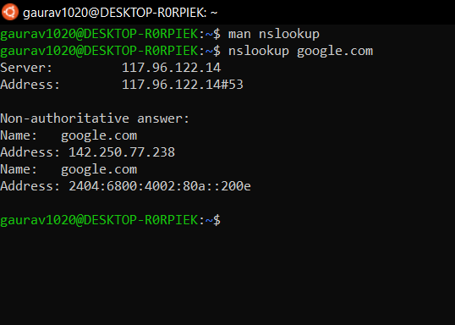

**b)**

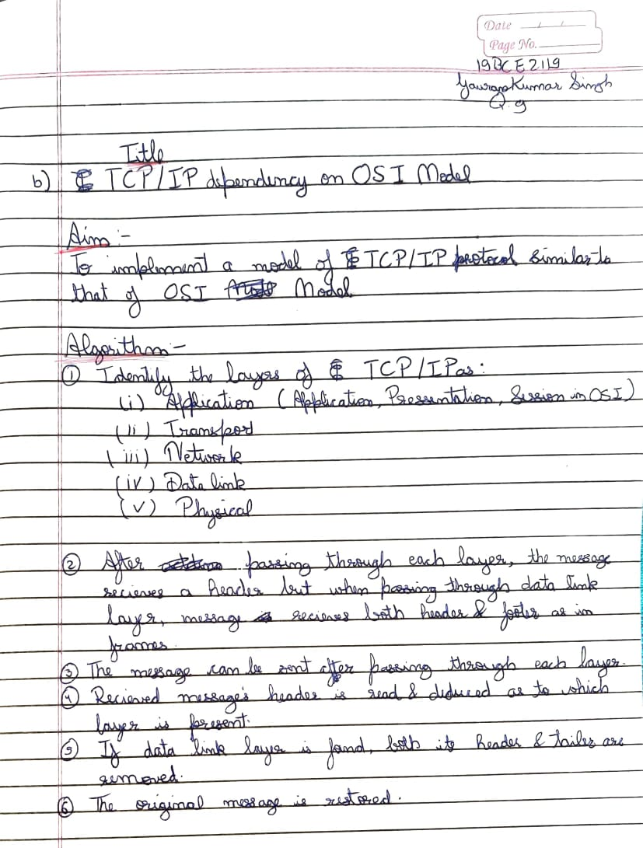

**OUTPUT**

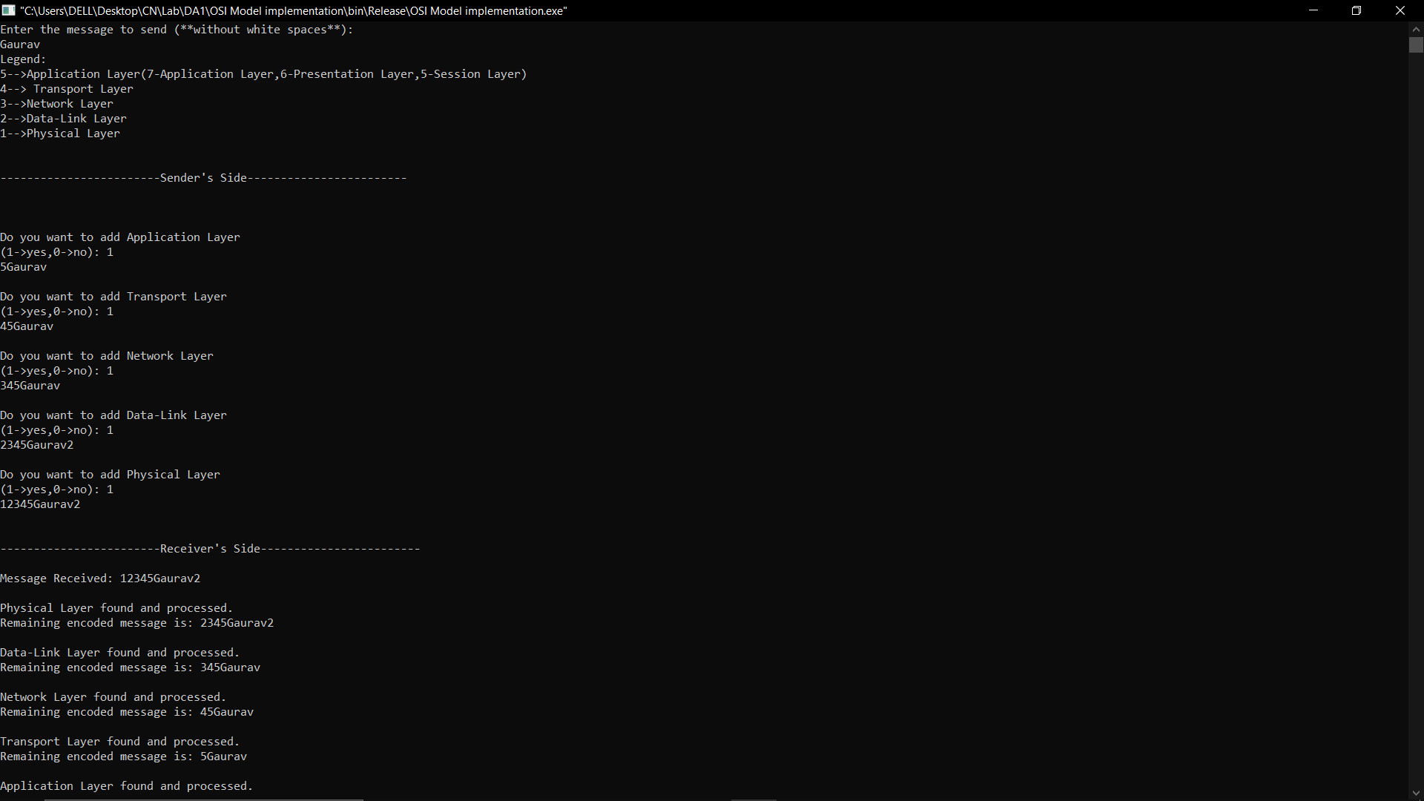

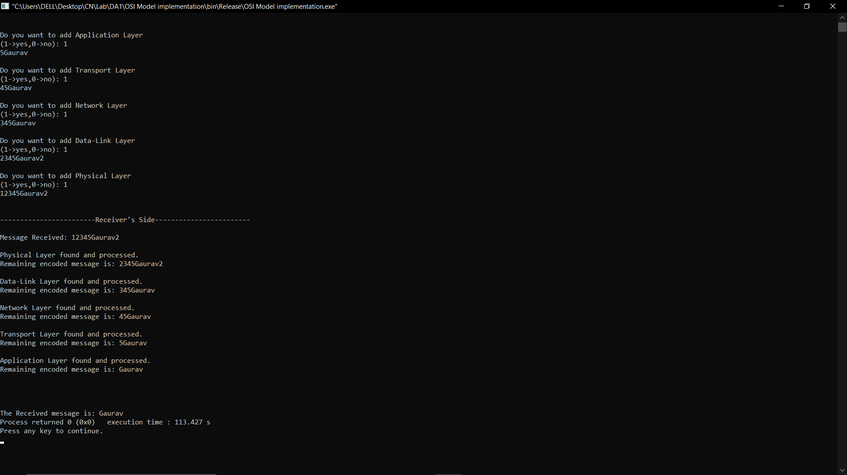

**c) Using the concept of classful addressing to manage file/folder system in central storage HUB to store data.**

