**Registration Number: 19BCE2119**

**Name: Gaurav Kumar Singh**

**Final Assessment Test**

**Course: Operating Systems**

**QUESTION SET 1**

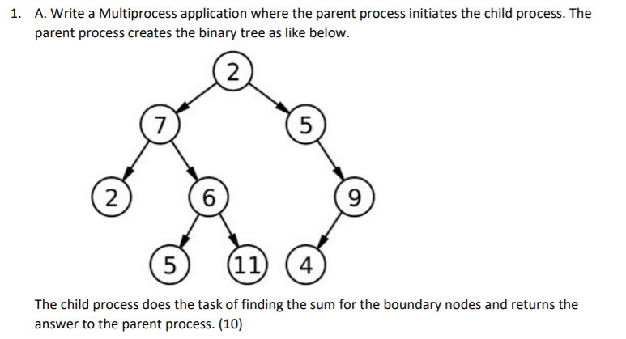

CODE:

#include <stdio.h>

#include <sys/types.h>

#include <unistd.h>

int main(){

int pipefds1[2];

int pipefds2[2];

int returnstatus1,returnstatus2;

returnstatus1=pipe(pipefds1);

returnstatus2=pipe(pipefds2);

int *writeval=0;

int *readval1,*readval2;

pid_t l1,r1;

l1=fork();

if(l1==0){

*writeval=5;

write(pipefds1[1],writeval,sizeof(int));

pid_t l2, r2;

l2=fork();

if(l2==0){

}

else{

r2=fork();

pid_t l3,r3;

l3=fork();

if(l3==0){

*writeval=5;

write(pipefds1[1],writeval,sizeof(int));

}

else{

r3=fork();

if(r3==0){

*writeval=11;

write(pipefds2[1],writeval,sizeof(int));

}}

read(pipefds1[0],readval1,sizeof(int));

read(pipefds2[0],readval2,sizeof(int));

printf("Sum of child with value 6 is: %d\n",*readval1+*readval2);

}

}

else{

*writeval=11;

write(pipefds2[1],writeval,sizeof(int));

r1=fork();

if(r1==0){

pid_t r2x;

if(r2x==0){

pid_t l3x;

l3x=fork();

if(l3x==0){

}

}

}

read(pipefds1[0],readval1,sizeof(int));

read(pipefds2[0],readval2,sizeof(int));

printf("Sum of child with value 2 is: %d\n",*readval1+*readval2);

}

return 0;

}

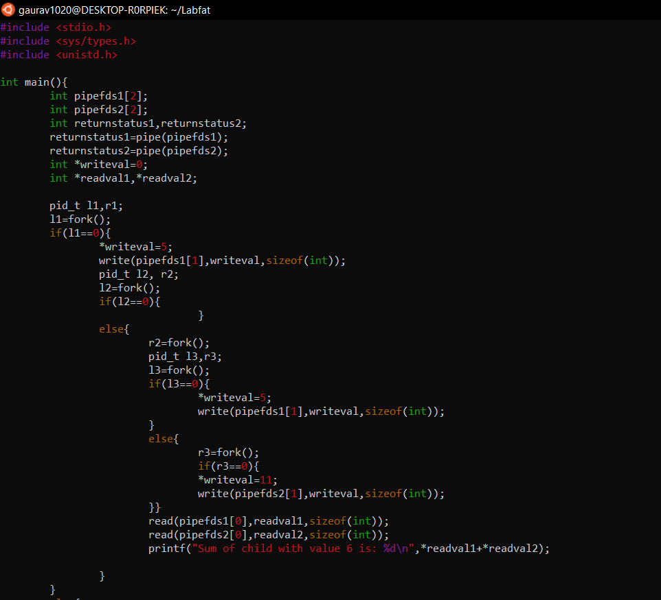

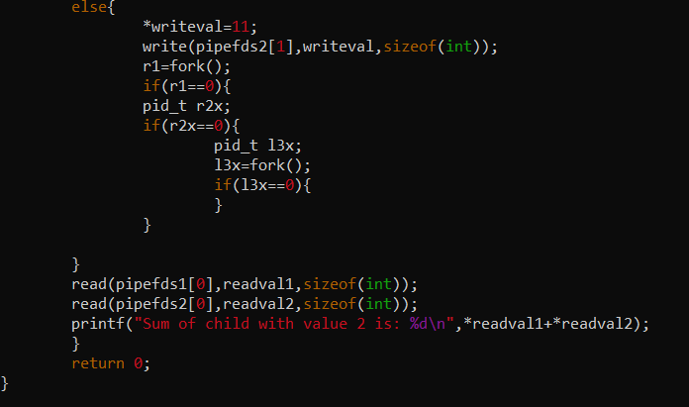

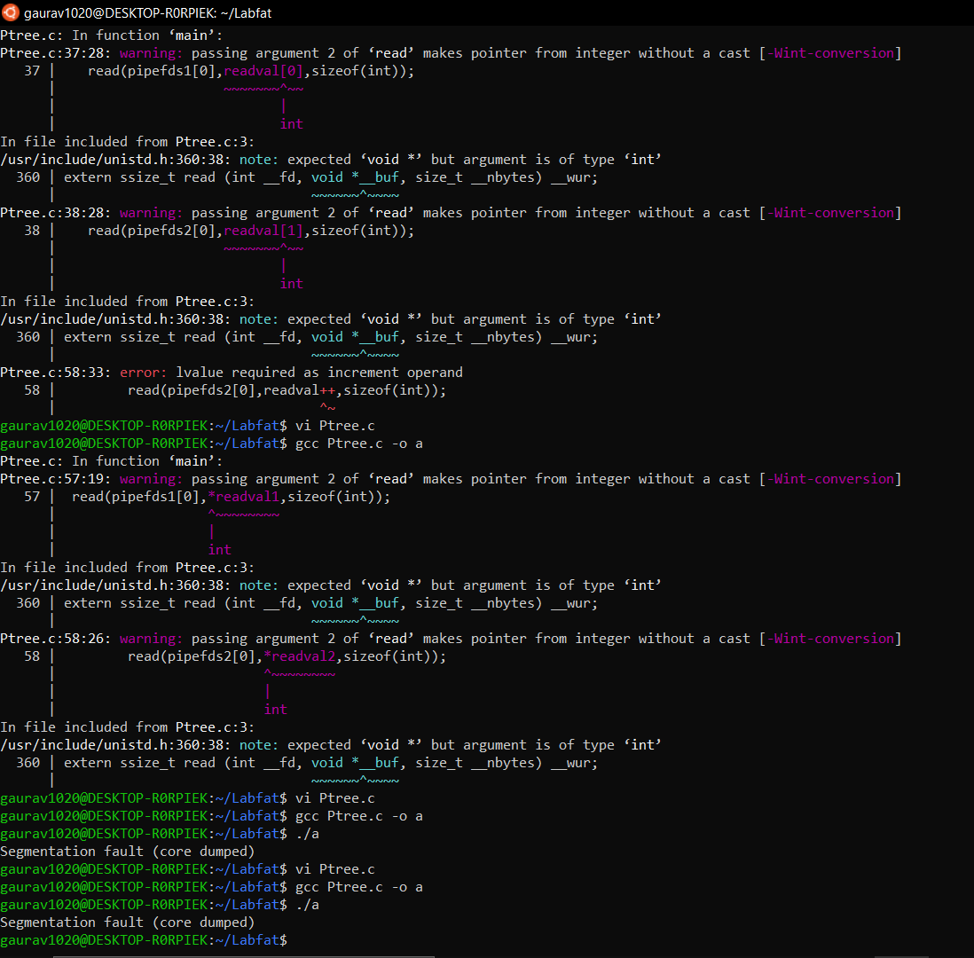

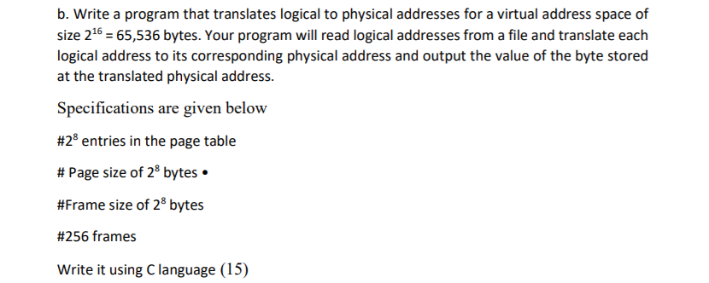

CODE

#include<stdio.h>

#include <stdlib.h>

int TLB[16][2];

int TLBsize = 0;

int pageTable[256];

int memoryFull = 0;

int memory[256][256];

void pageFault(int pageNum) {

FILE * ptr = fopen("BACKING_STORE.bin", "rb");

if (ptr == NULL) {

printf("Couldn't open the file! \n");

return;

}

if (fseek(ptr, 256 * pageNum, SEEK_SET) != 0) {

printf("Page not found!\n");

return;

}

unsigned char buffer[256];

fread(buffer, sizeof(buffer), 1, ptr); // read 10 bytes to our buffer

for (int i = 0; i < 256; i++) {

memory[memoryFull][i] = buffer[i];

}

pageTable[pageNum] = memoryFull;

memoryFull++;

fclose(ptr);

}

int main(int argc, char * argv[]) {

if (argc == 1)

printf("No File name is passed in Command Line.\n");

if (argc >= 2) {

char * fileName = argv[1];

FILE * fp = fopen(fileName, "r");

if (fp == NULL) {

printf("Couldn't open the file! \n");

return -1;

}

int logicalAddress;

int pageFaultStat = 0, TLBstat = 0;

int totalAccess = 0;

for (int i = 0; i < 256; i++) {

pageTable[i] = -1;

}

while (fscanf(fp, "%d", & logicalAddress) != EOF) {

totalAccess++;

int pageNumMask = 0, offsetMask = 0;

for (int i = 0; i < 8; i++) {

offsetMask |= 1 << i;

pageNumMask |= 1 << (i + 8);

}

int pageNum = pageNumMask & logicalAddress;

pageNum = pageNum >> 8;

int offset = offsetMask & logicalAddress;

int TLBhit = 0;

for (int i = 0; i < TLBsize; i++) {

if (TLB[i][0] == pageNum) {

TLBhit = 1;

int valueOfAdd = memory[TLB[i][1]][offset];

int physicalAddress = TLB[i][1] * 256 + offset;

printf("Virtual Address : %d and Physical Address : %d with Value : %d\n", logicalAddress, physicalAddress, valueOfAdd);

TLBstat++;

break;

}

}

if (TLBhit == 0) {

if (pageTable[pageNum] == -1) {

pageFault(pageNum);

pageFaultStat++;

}

int valueOfAdd = memory[pageTable[pageNum]][offset];

int physicalAddress = pageTable[pageNum] * 256 + offset;

printf("Virtual Address : %d and Physical Address : %d with Value : %d \n", logicalAddress, physicalAddress, valueOfAdd);

if (TLBsize != 16) {

TLB[TLBsize][0] = pageNum;

TLB[TLBsize][1] = pageTable[pageNum];

TLBsize++;

} else {

for (int i = 0; i < 15; i++) {

TLB[i][0] = TLB[i + 1][0];

TLB[i][1] = TLB[i + 1][1];

}

TLB[15][0] = pageNum;

TLB[15][1] = pageTable[pageNum];

}

}

}

printf("\n\nPage-fault rate is : %.2f %%\n", (1.0 * pageFaultStat) / (1.0 * totalAccess) * 100.0);

printf("TLB-hit rate is : %.2f %%\n", (1.0 * TLBstat) / (1.0 * totalAccess) * 100.0);

fclose(fp);

}

return 0;

}

