**Name: Gaurav Kumar Singh**

**Registration Number: 19BCE2119**

**CASE STUDY OF BITCOIN**

**History**

During the writing of this case study, the market value of one bitcoin is equal to 42,86,939.61 INR. This particular case study won’t be exploring the technical aspects of bitcoin blockchain and protocol in details but rather focus more on the use of bitcoin as a cryptocurrency technology. The value of cryptocurrencies in general are based on their supply and demand. To understand what made bitcoin such a success, we must look at its past upon how it was created and presented. Designed and majorly developed by Satoshi Nakamoto, the bitcoin blockchain came to existence in 2009. He himself mined the first block of bitcoins with a reward of 50 bitcoins which is also known as the genesis block. Not long after it’s launch, despite a lot of seeming vulnerabilities of the system, only one was significant which was used to over produce 180 billion bitcoins; however, those coins were later removes from blockchain and the patch was hard forked into the blockchain. Bitcoin introduced proof of work mechanism, a variation of which is still used in many cryptocurrencies even now. During its launch many other cryptocurrency evangelists also supported it, such as Finney, Wei Dai (Creator of b-money), and Nick Szabo (creator of bit gold). Nakamoto however abandoned is involvement to the bitcoin, only after mining 1 million bitcoins to himself. After that Gavin Andresen took over as lead developer of the Bitcoin Foundation.

**Growth**

Even though bitcoin was launched in 2009 itself, the first transaction involving physical goods was made on 22nd May 2010 by transacting 10,000 BTC in exchange for two pizzas to be delivered by Papa John’s. It is the same year when a major vulnerability was found on the bitcoin network which enabled which enabled the users to bypass bitcoins economic restrictions and create indefinite number of bitcoins. This vulnerability was later removed and all the ghost blocks were also removed from the block chain by hard forking the patch. This is considered the only major security flaw found and exploited in the history of bitcoin.

In 2011 however, foundation such as EFF and WikiLeaks started accepting bitcoins for donations and payments. EFF however discontinued accepting bitcoin in the same year only to start accepting it again in 2013.

In 2012, bitcoin grew in popularity thanks to it being mentioned in various television shows such as ‘The Good Wife’ third episode named `Bitcoin for Dummies`, CNBC’s Mad Money etc. Although the public consensus on cryptocurrency such as bitcoin as a mode of payment was still mixed at the time. Many considered it as the future of currency, while other backlashed mentioning it as scam. These backlashes however were toned down a lot in the subsequent years when more and more people came to know about how bitcoin protocol works and that gave them reassurance over its security aspect which generally is the main concern regarding cryptocurrencies.

2013 was the year of many ups and downs for bitcoin. On one hand bitcoin-based payment processor Coinbase reported record-breaking sale of bitcoins worth over 1 million USD in a single month at 22 USD per BTC. The popularity of BTC was at an all time high. However, during the same year the con of bitcoin being decentralised was also as many bitcoins’ transaction related firms such as Mt. Gox were shut down due in accusation of supposed frauds and not being registered as a money transmitter in FinCEN in the US. Having known, the pros and cons of the bitcoin protocol by this time, the popularity of bitcoin as a cryptocurrency only grew in the subsequent years. Since the value of bitcoins is based on its demand and supply, and since there is a fixed number of bitcoins in the bitcoin protocol and the demand increased for the subsequent years consistently, the market value of bitcoin as cryptocurrency also increased significantly. Starting from value less 0.01 USD in may 2010 per BTC, now its value is at an all-time high resting at 66,974.77 USD as of October 2021.

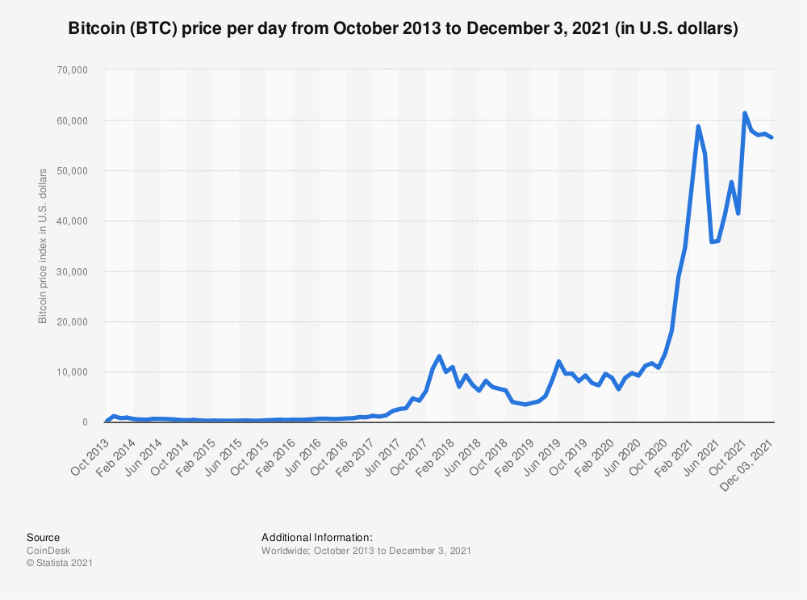

**Advantages of Bitcoin Protocol**

* Compared to most modern banks, the transaction fees of a bitcoin transaction are not only lower but also fairly consistent.
* Bitcoin transactions are anonymous which make it perfect for people worried about their privacy. A user can have multiple public and private keys to make transaction to keep their anonymity.
* Decentralization ensures that bitcoin transactions can not be interfered by governments and financial institutions and that no individual have control over the blockchain.
* Since the number of bitcoins that can be generated is capped at 21 million, it does not experience inflation.
* Bitcoin is secure and the transactions made on its ledger cannot be altered after the append and the blockchain itself is tamper-proof.
* Bitcoin is open-source meaning anyone can contribute to its development or have access to its code and make improvements via GitHub.
* Bitcoin is looked upon as an investment by many people. It is different from all other asset classes such as gold, currencies and real estates.
* International transactions are very easy to make using bitcoin as compared to fiat currencies since its value is consistent across regions. No conversion discrepancies are experienced and everyone knows the value of bitcoin at any said moment and can make the transactions as such.
* Being cryptocurrency, it is digital cash implying it does not really require to have any physical existence and thus can be accessed from anywhere.
* Microtransactions are made very convenient in modern bitcoin protocol making it very easy to make subscription-based transactions.
* Multisig feature along with escrow transactions made it a reliable mode of payment.

**Disadvantages of Bitcoin Protocol**

* Since it is decentralized it is accompanied by the cons that come along with a currency which is not regulated by government, one of which is that there is no security over your bitcoins even though transactions themselves are security. This means there is no guarantee of minimum valuation.
* Bitcoin and cryptocurrencies in general are very volatile because no one knows what they are worth and there is no governing party which can assure you its worth. Since bitcoin number limit is capped it 21 million, it is also a scarce unit which adds a lot to its volatile nature.
* Bitcoin transactions are irreversible, anonymous and unregulated so nothing can be done after a transaction has been made which makes it suitable for scammers to ask for as a mode of payment made to them.
* Loss of private key due to any accident means that those bitcoins are now completely gone and can never be recovered.
* Although more and more organization are accepting bitcoins every day, its domain is still quite limited especially due to backlash of national governments as it disrupts their national economy.

**Conclusion**

Bitcoin is a risky investment. It's not for the faint-hearted. However, the potential gains are huge if it does take off. The bitcoin market is open 24 hours a day and offers an unprecedented opportunity to trade with both bullish and bearish markets. Many people invest in bitcoin as they believe it is a safer option than other investments such as stocks and shares which can be risky, as seen with the 2008 crash of Lehman Brothers and various other companies that have gone bust or been saved by governments in recent years. The Bitcoin has the potential to change how we handle our finances, but there are a few risks to be aware of.

In conclusion, Bitcoin can make a lot of people happy with its advantages and opportunities. However, with the risks involved, it is not for everyone and everyone is advised to do their own research over the topic before using cryptocurrencies such as bitcoin as an investment or as a mode of payment.