**INTRODUCTION TO CISCO PACKET TRACER**

Cisco Packet tracer is a cross platform visual simulation tool developed by Cisco Systems which allow us to create and test various network topologies and simulate modern computer networking architecture. Since, it is created by Cisco, it primarily supports Cisco networking modules like Cisco routers and switches using simulated command line interface. It makes use of drag and drop user interface making it user friendly and easy to understand. Basic networking and communication knowledge is required to configure the elements of the network created following the IP and networking standards and helps to learn fundamental CCNA concepts. The tool if free of charge for educational use. It can be run on Linux, Microsoft Windows and macOS, similarly, android and iOS apps are also available. Packet Tracer allows students to design complex and large networks, which is often not feasible with physical hardware, due to costs. Unlike software such as GNS3, it is a simulator, not an emulator which means it mimics behaviour and configuration of a real device whereas emulators duplicates all the hardware and software features of real device which can mean software like GNS3 might require user to create and emulate multiple Virtual machines on the system to establish connection which tend to be very strenuous on low end systems.

1. **Configuring LAN network**
   1. **Introduction**

LAN (Local Area Network) is a computer network which interconnects computers within a small area (100-1000 meters coverage). It has low cost of setup and the data transfer bandwidth is generally very high due to the fact that it has low reach which enables it to make use of higher frequency waves for data transmission which can carry more data per unit time but tend to get blocked easily. LANs are usually owned by individual or an organisation. LAN has higher speeds of data as compared to MANs and WANs (100-1000 Mbps). Ethernet (wired) and Wi-Fi (wireless) are one of the most common technologies used in LAN.

The function of Local Area Networks is to link computers together and provide shared access to printers, files, and other services. Local area network architecture is categorized as either peer-to-peer or client-server. On a client-server local area network, multiple client-devices are connected to a central server, in which application access, device access, file storage, and network traffic are managed.

Applications running on the Local Area Network server provide services such as database access, document sharing, email, and printing. Devices on a peer-to-peer local area network share data directly to a switch or router without the use of a central server.

Components used:

**PC**

It is a component which is used to simulate the functionality of independent computer including terminal with networking commands. Its IP configuration, default Gateway etc can be configured manually and can be connected to other PCs using wires, routers, switches, Hubs etc.

**Switches**

A network switch is networking hardware that connects that connects on a computer network by using packet switching to receive and forward data to the destination device. Unlike hubs, after discovering the path to the destination it does not flood any other route other than the route decided by the mac address lookup table whereas hubs broadcast the packets to every device on the network and leaves it to the devices to detect if the packet belongs to them. It is a multiport network bridge that uses MAC addresses to forward data. Its sole purpose is to forward the packets as it is to another system connected to the switch. It operates on Data Link Layer of the OSI model.

**Wires**

Wires are used to connect to components with each other. We have used ethernet to connect the pcs to the switch in star topology. Ethernet is mainly as a standard communication protocol used to create LANs because the cost of setting up wires is fair trade-off to its speeds at shorter distances. This facilitates network communication between two or more different types of network cables such as from copper to fiber-optic and vice versa.

* 1. **Screenshots with timestamps**

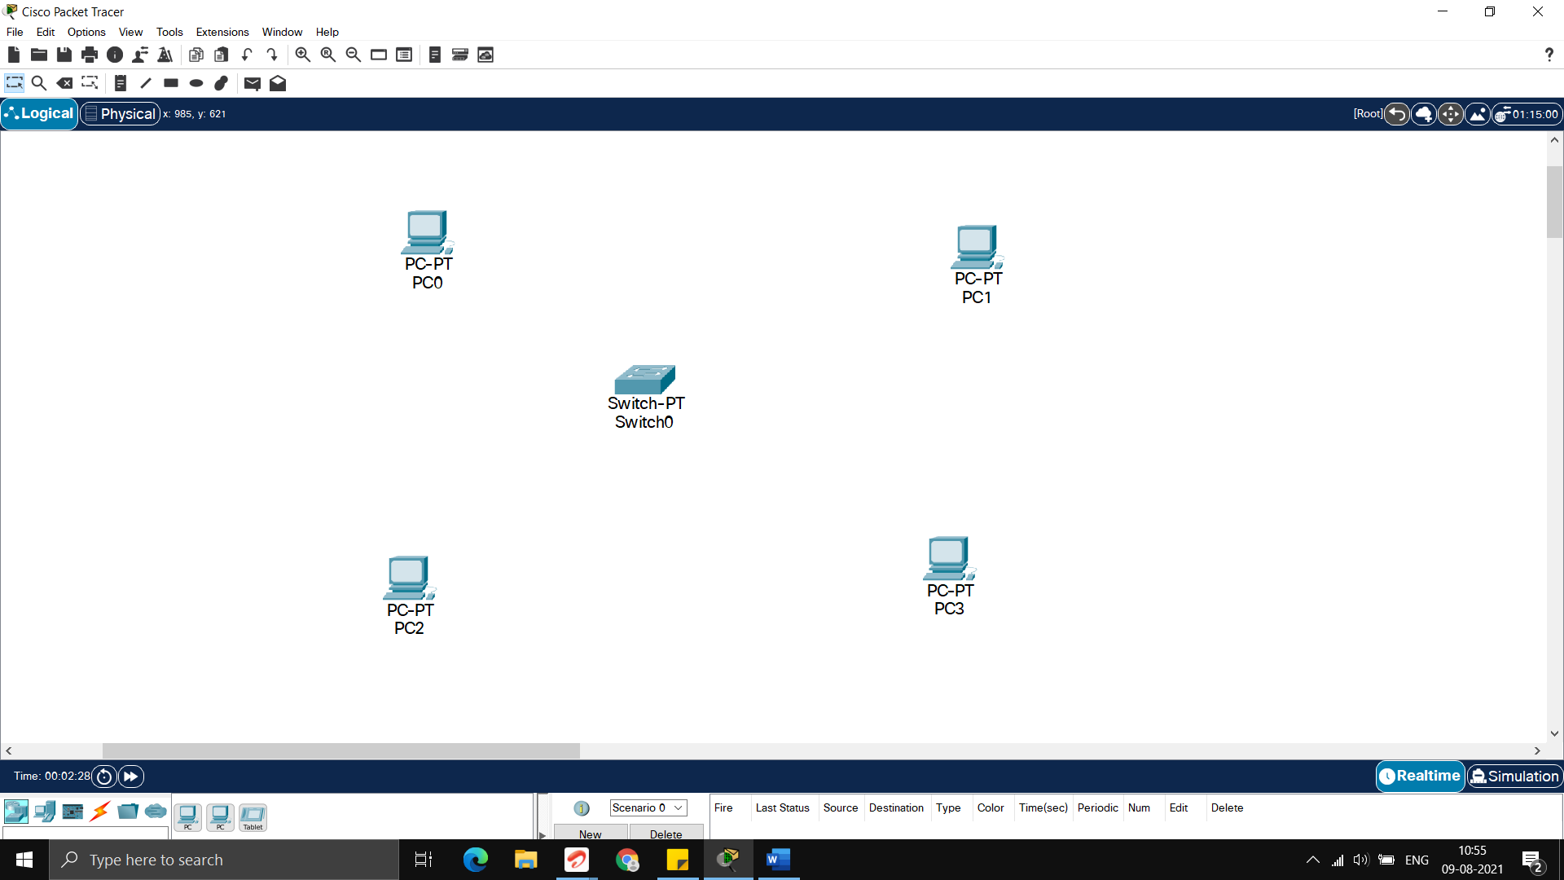

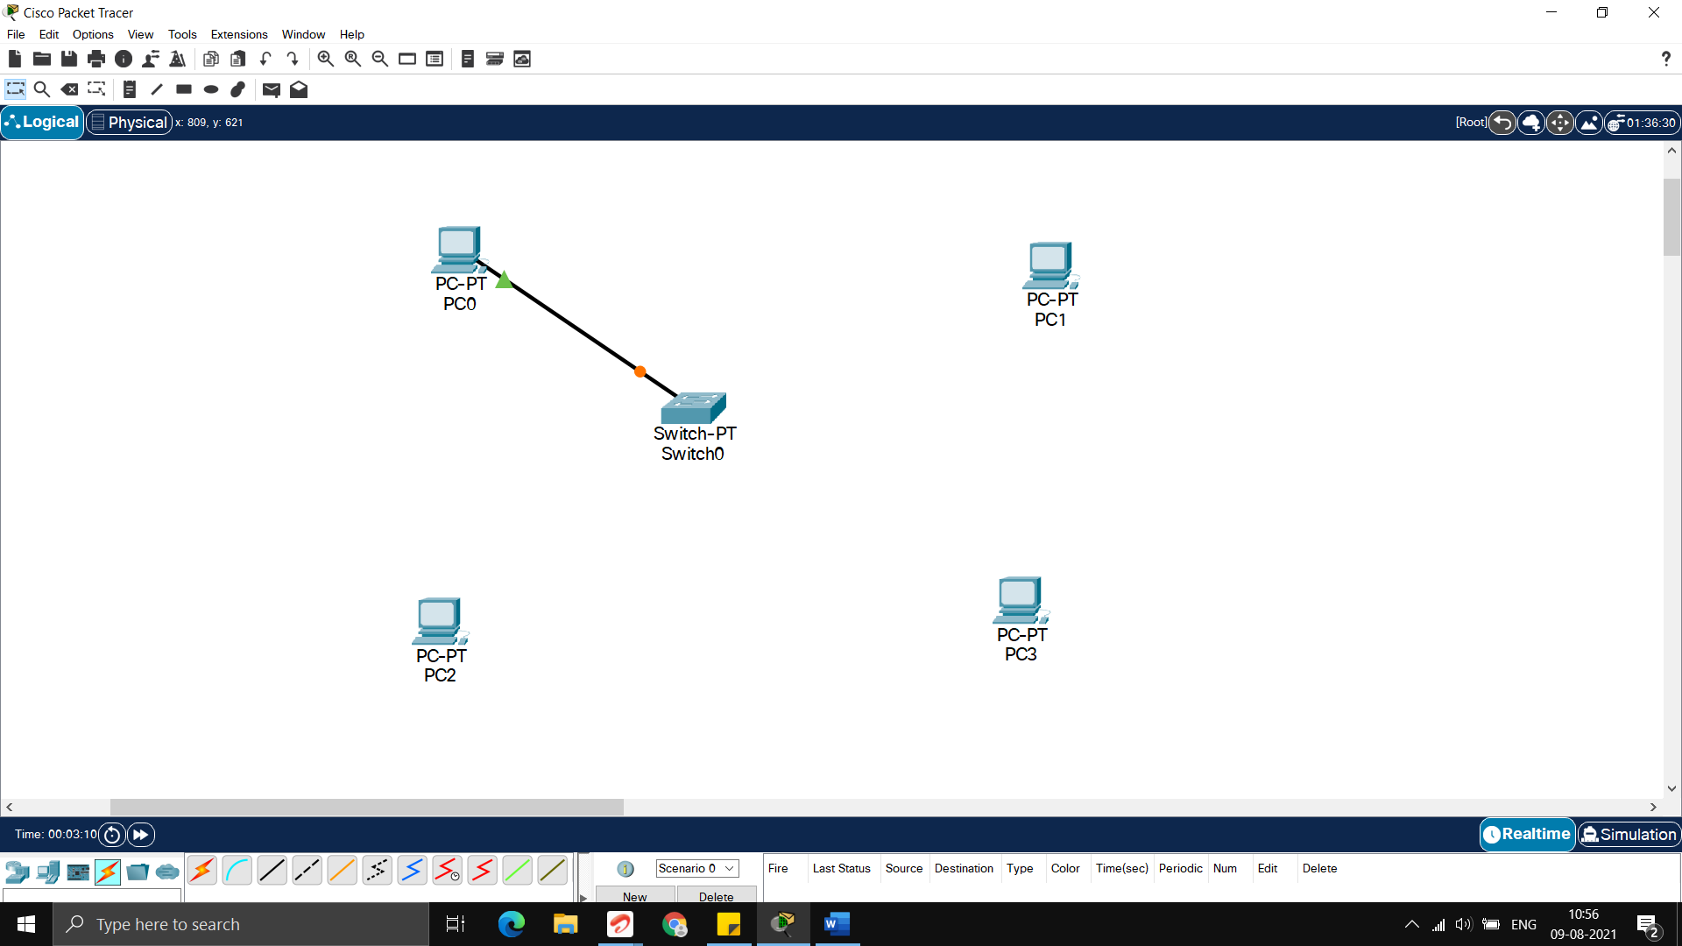

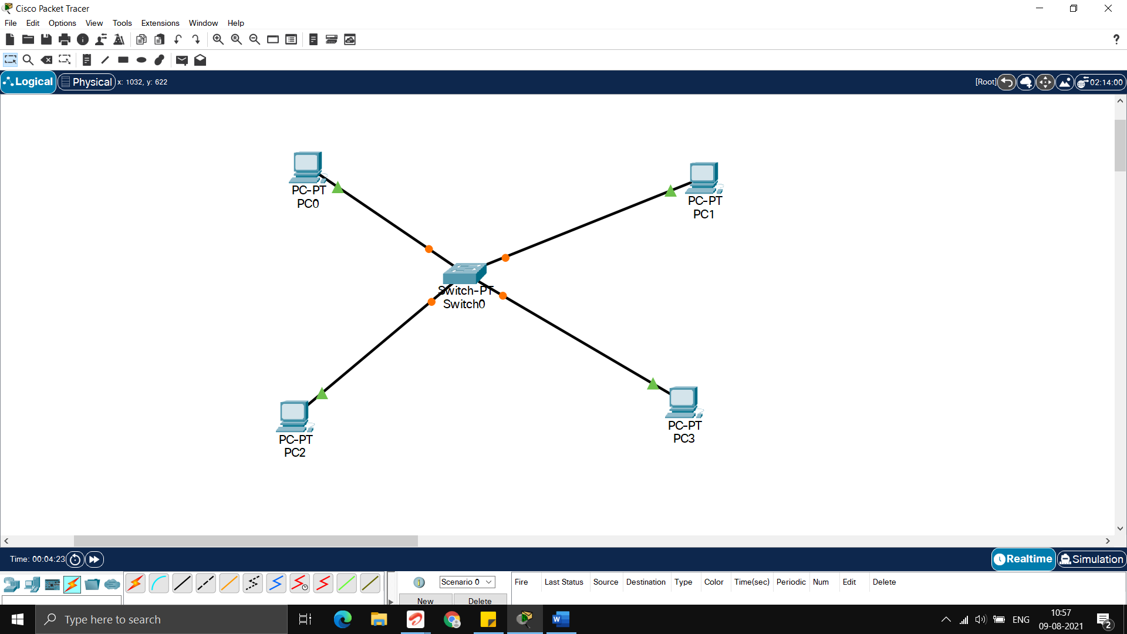

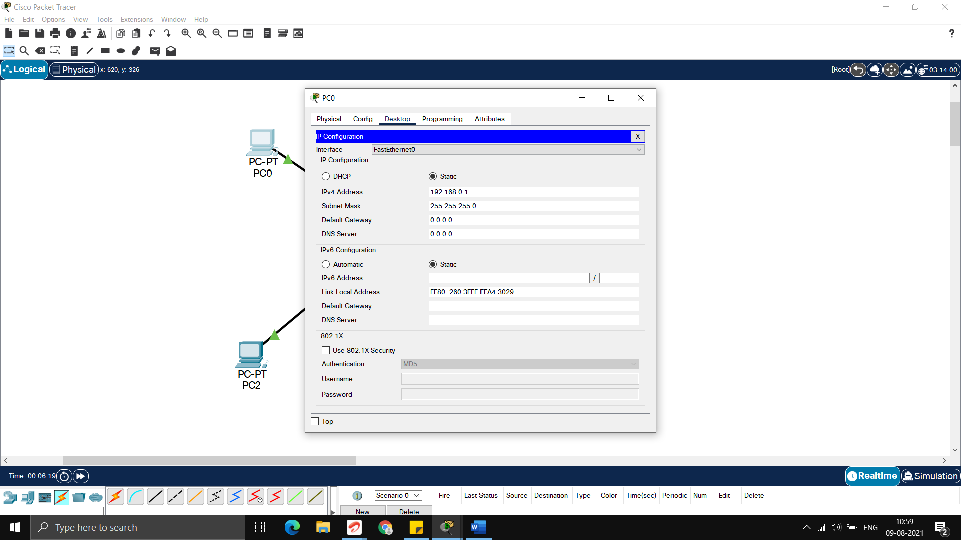

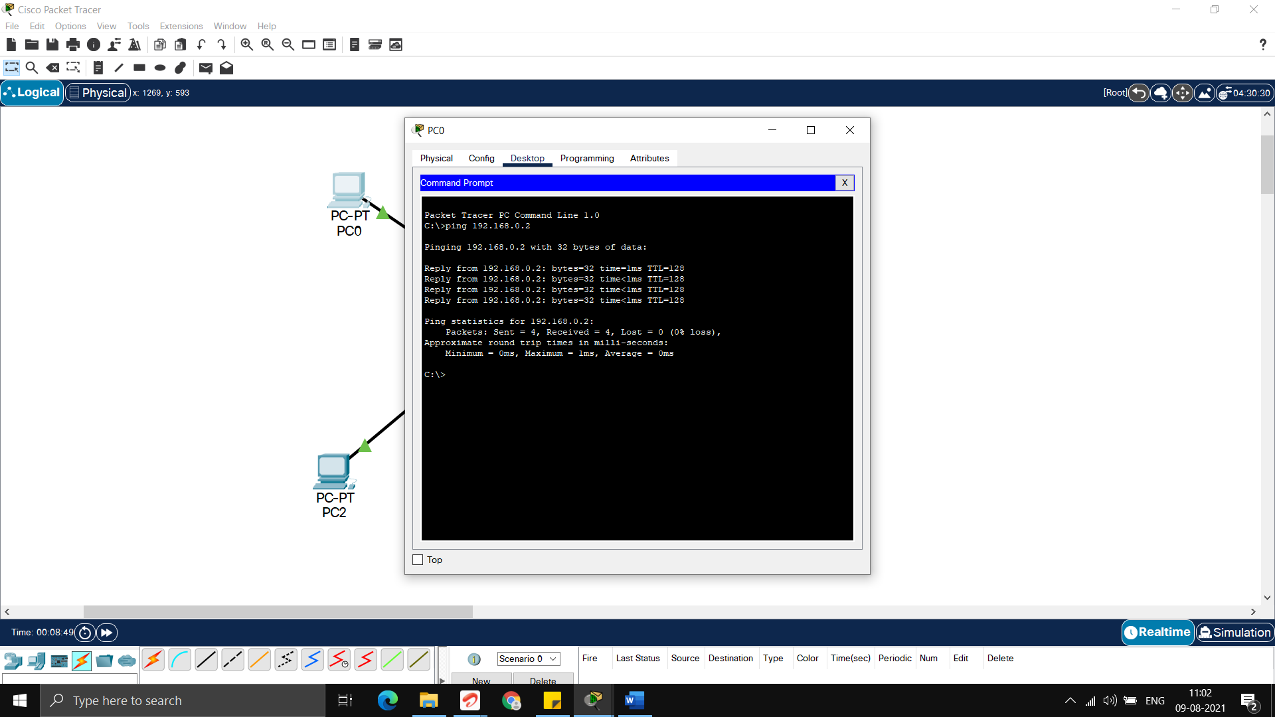

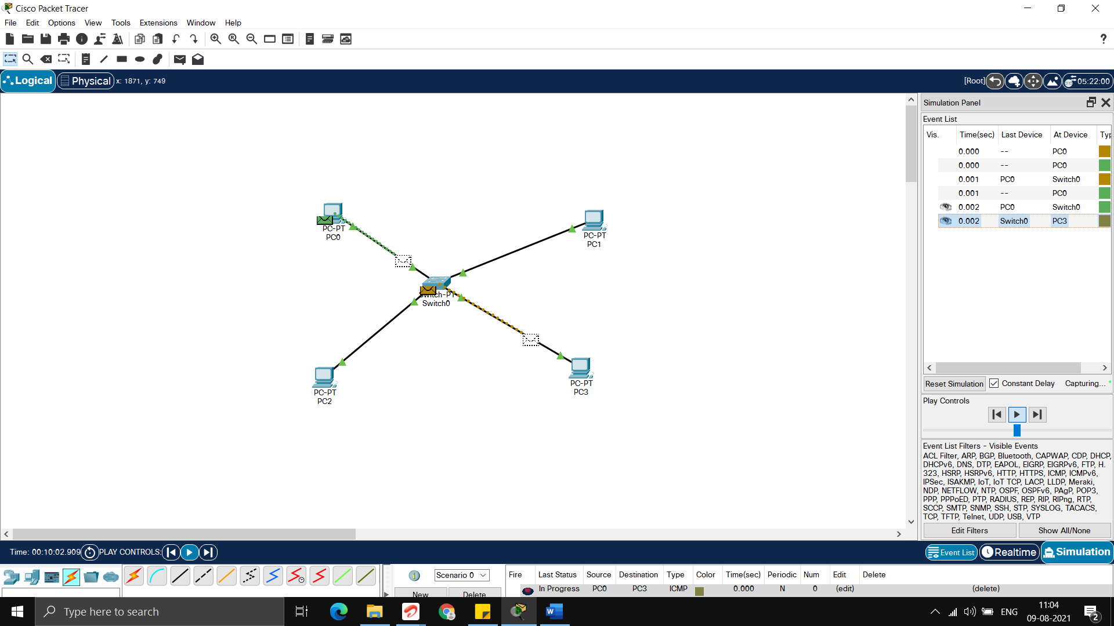

1. **Configuring multi layered n/w using router**
   1. **Introduction**

**Switches**

A network switch is networking hardware that connects that connects on a computer network by using packet switching to receive and forward data to the destination device. Unlike hubs, after discovering the path to the destination it does not flood any other route other than the route decided by the mac address lookup table whereas hubs broadcast the packets to every device on the network and leaves it to the devices to detect if the packet belongs to them. It is a multiport network bridge that uses MAC addresses to forward data. Its sole purpose is to forward the packets as it is to another system connected to the switch. It operates on Data Link Layer of the OSI model.

**Routers**

Routers are computer networking devices that serve two primary functions:

(1) create and maintain a local area network.

(2) manage the data entering and leaving the network as well as data moving inside of the network.

It also helps you to handle multiple networks and routes network traffic between them. In your home network, your router has one connection to the Internet and one connection to your private local network. Moreover, many routers also contain built-in switches that allow you to connect multiple wired devices. It operates on the Network Layer of the OSI model. Unlike Switches it also offers many other services other than just routing like NAT (Network Address Translation), Network Flow, QoS (Quality of Service) and maintains a routing table. It can also help to connect 2 or more independent networks for data transfer.

While a network switch can connect multiple devices and networks to expand the LAN, a router will allow you to share a single IP address among multiple network devices. In simpler terms, the Ethernet switch creates networks and the router allows for connections between networks.

* 1. **Screenshots with timestamps**

