**Name: Gaurav Kumar Singh**

**Registration Number: 19BCE2119**

**Course: Software Engineering**

**Lab FAT**

1. **Social Network for PET Owners**  
   This would connect pet owners with other pet owners. It would allow them to chat and exchange advice. Businesses could promote their services through curated and paid advertising and promotion.  
     
   1. Identify 5 functional and non-functional requirements for the above scenario.  
   2. Tabulate 5 test cases for the above scenario.

**SOLUTION:**

1. FUNCTIONAL REQUIREMENTS

* Sign-in, Sign-up and Sign-out features for proper user authentication
* Advert Management system to control the adverts on the application. Advert filter for more user targeted ads, so the ads are relevant to the user’s specific interests.
* Messaging protocol to enable the users to chat with each other.
* User profile management for updating personal information and view other user’s profile.
* Clustering of users with similar interests and suggest them to each other

NON-FUNCTIONAL REQUIREMENTS

* Session and cookie management system for easy sign-in and sign-out and continuity in using application between sessions.
* Minimalistic Design without complicated UI for easy access of functional features.
* The application, especially the messaging system should be able to handle large number of requests.
* The latency of the messaging system should be minimized and messaging system should support multiple languages.
* Unsuccessful login attempts by the user must be audited as suspicious and ‘forgot password’ feature to help users recover their accounts in case they do really forget their password.

1. TEST CASES

|  |  |  |  |  |  |  |
| --- | --- | --- | --- | --- | --- | --- |
| **Test Case ID** | **Test Scenario** | **Test Case** | **Test Steps** | **Test Data** | **Expected Result** | **Output Received** |
| 1 | Verify Login | Valid Username  Valid Password | Enter username.  Enter password.  Login | Valid Username  Valid Password | Successful Login | Redirected to user profile page |
| 2 | Verify Login | Invalid Username  Valid Password | Enter username.  Enter password.  Login | Invalid Username  Valid Password | Unsuccessful Login “Invalid username and password” | Redirected back to login page |
| 3 | Verify Login | Valid Username  Invalid Password | Enter username.  Enter password.  Login | Valid Username  Invalid Password | Unsuccessful Login “Invalid username and password” | Redirected back to login page |
| 4 | Verify Login | Invalid Username  Invalid Password | Enter username.  Enter password.  Login | Invalid Username  Invalid Password | Unsuccessful Login “Invalid username and password” | Redirected back to login page |
| 5 | Message functionality | Any message | Enter any text | Message delivered | Message delivered | Message delivered |

1. Design the use case diagram for the **Social Network for PET Owners using an online tool**  
    **Social Network for PET Owners  
   This would connect pet owners with other pet owners. It would allow them to chat and exchange advice. Businesses could promote their services through curated and paid advertising and promotion.**

**SOLUTION:**

Visual paradigm generated link lagged the system that’s why I am sharing the .vpd file itself with instructions

**Link to the diagram**: <https://drive.google.com/file/d/1B_J4g3KJOyLgESeQugk2cEVh4Heljvnx/view?usp=sharing>

Steps: 1) Download the LabFAT2.vpd file

2) Head over to Visual paradigm online and import the downloaded .vpd file to view the diagram.

Tool Used: [Visual Paradigm Online](https://online.visual-paradigm.com/)

**Screenshot:**

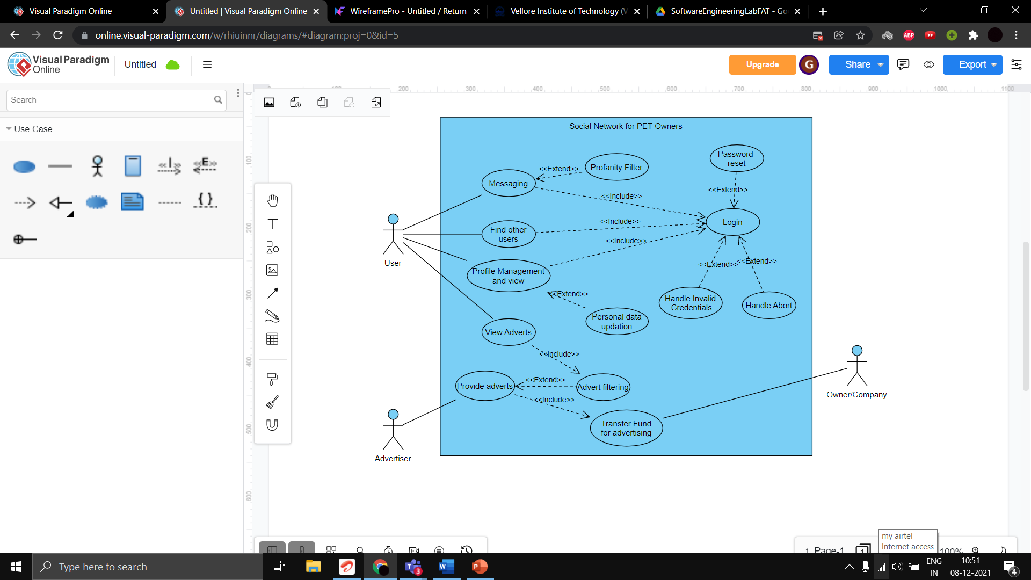

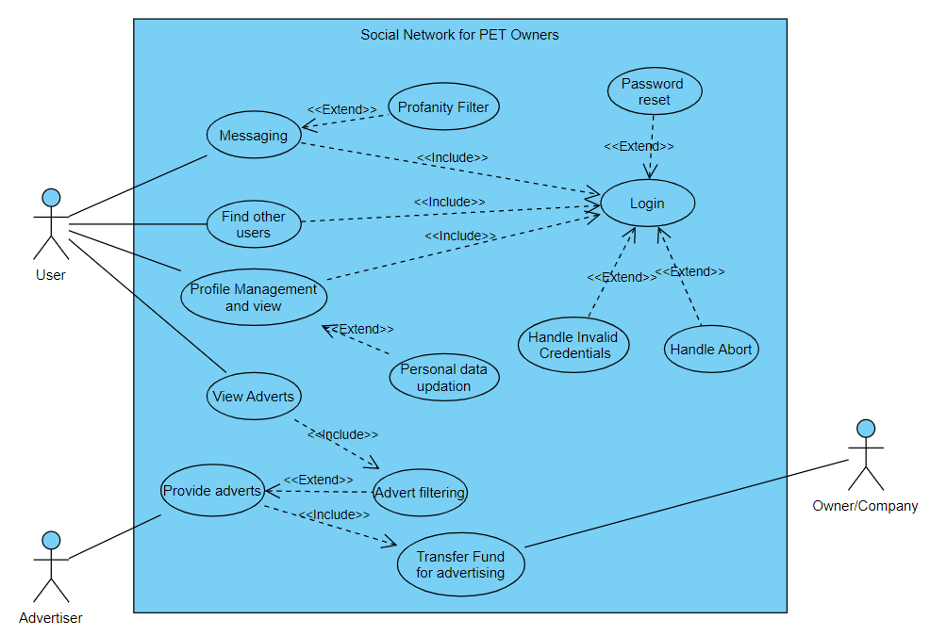

1. Design the user interface design for **Social Network for PET Owners using an online tool**  
    **Social Network for PET Owners  
   This would connect pet owners with other pet owners. It would allow them to chat and exchange advice. Businesses could promote their services through curated and paid advertising and promotion.**

**SOLUTION:**

**SCREENSHOTS**

**Sign-In** 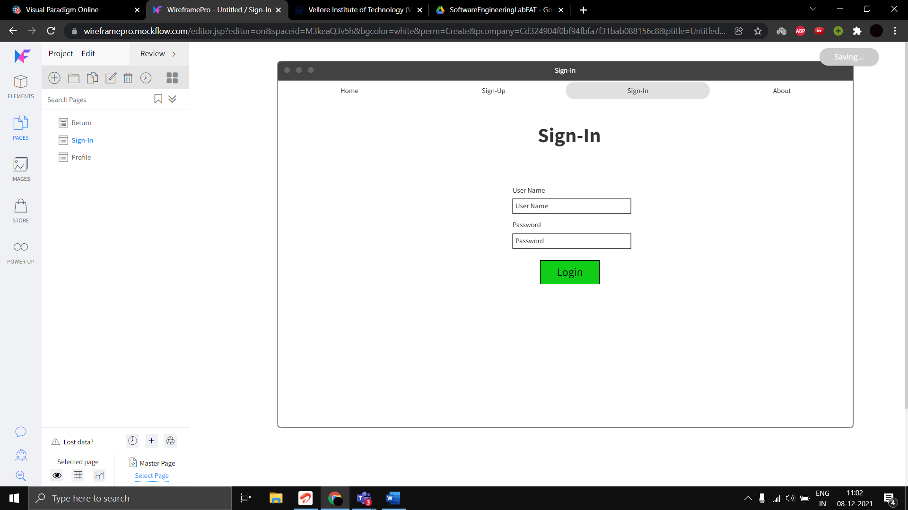

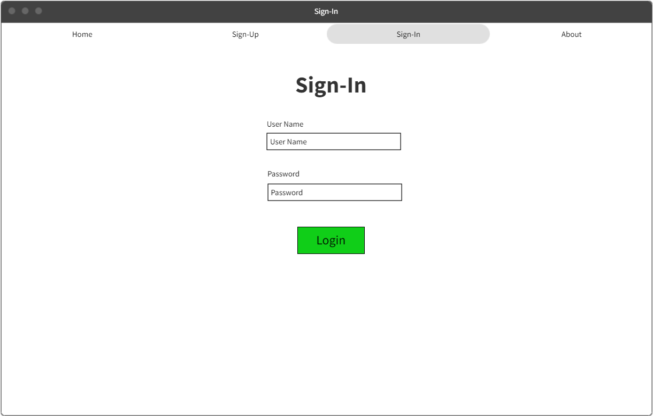

**Sign-Up**

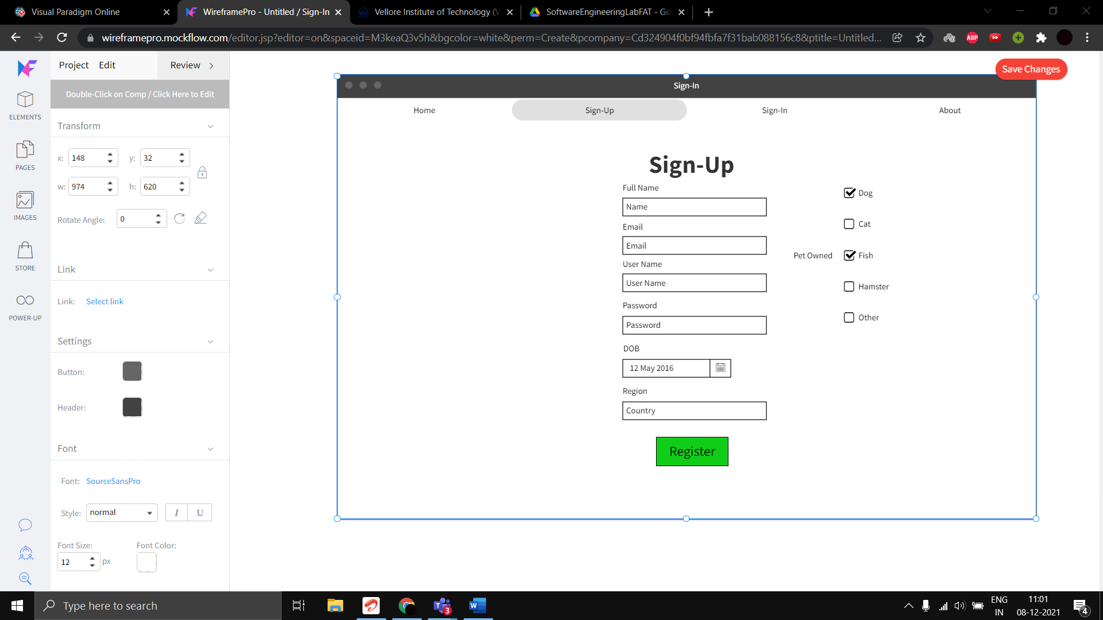

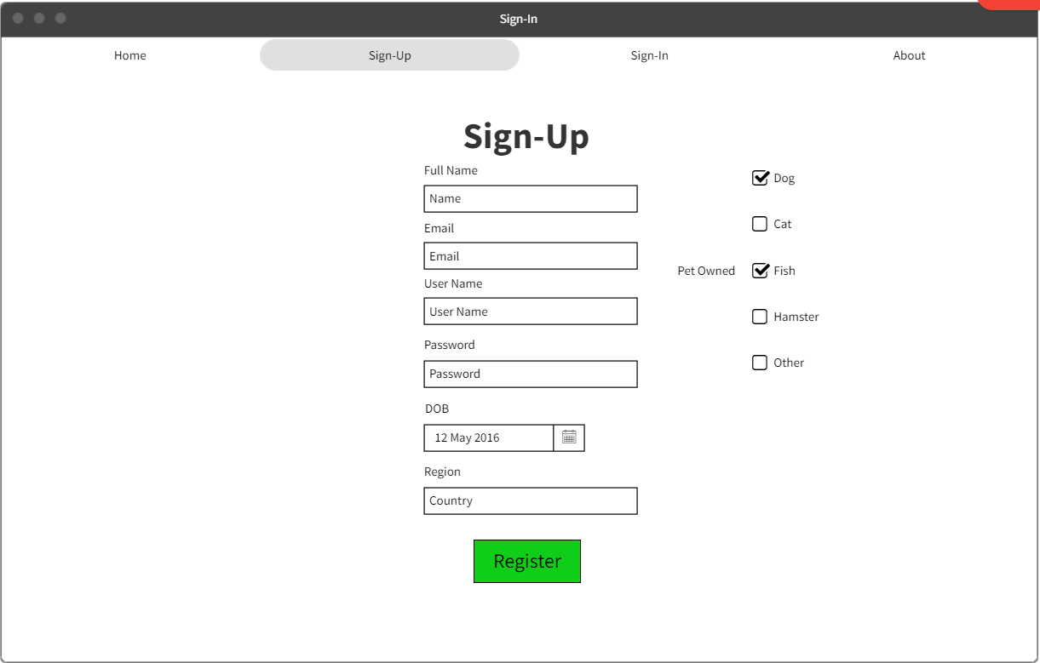

**Profile Page**

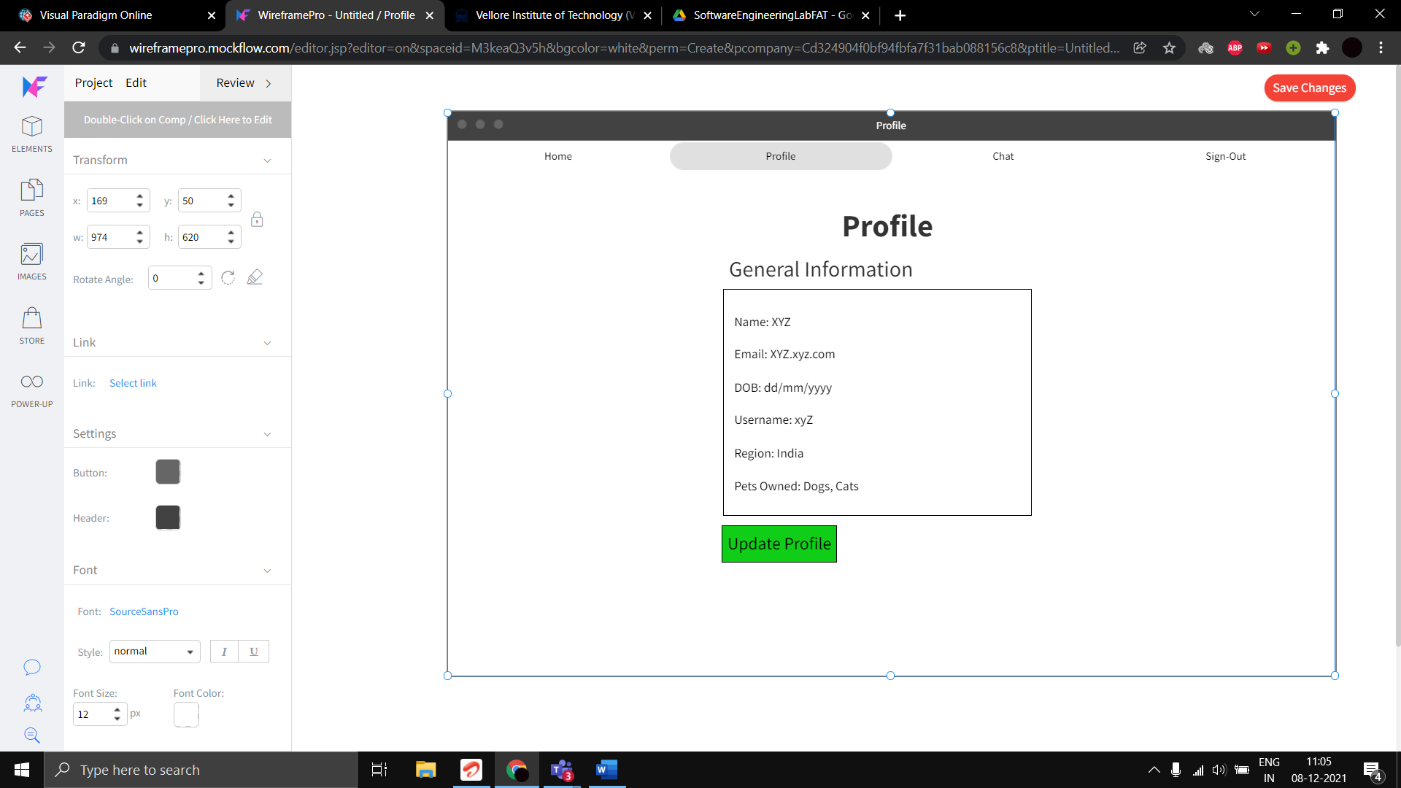

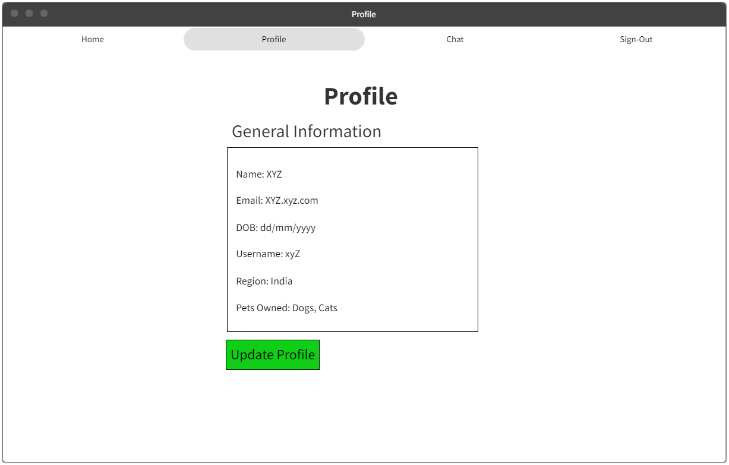

**Update Profile**

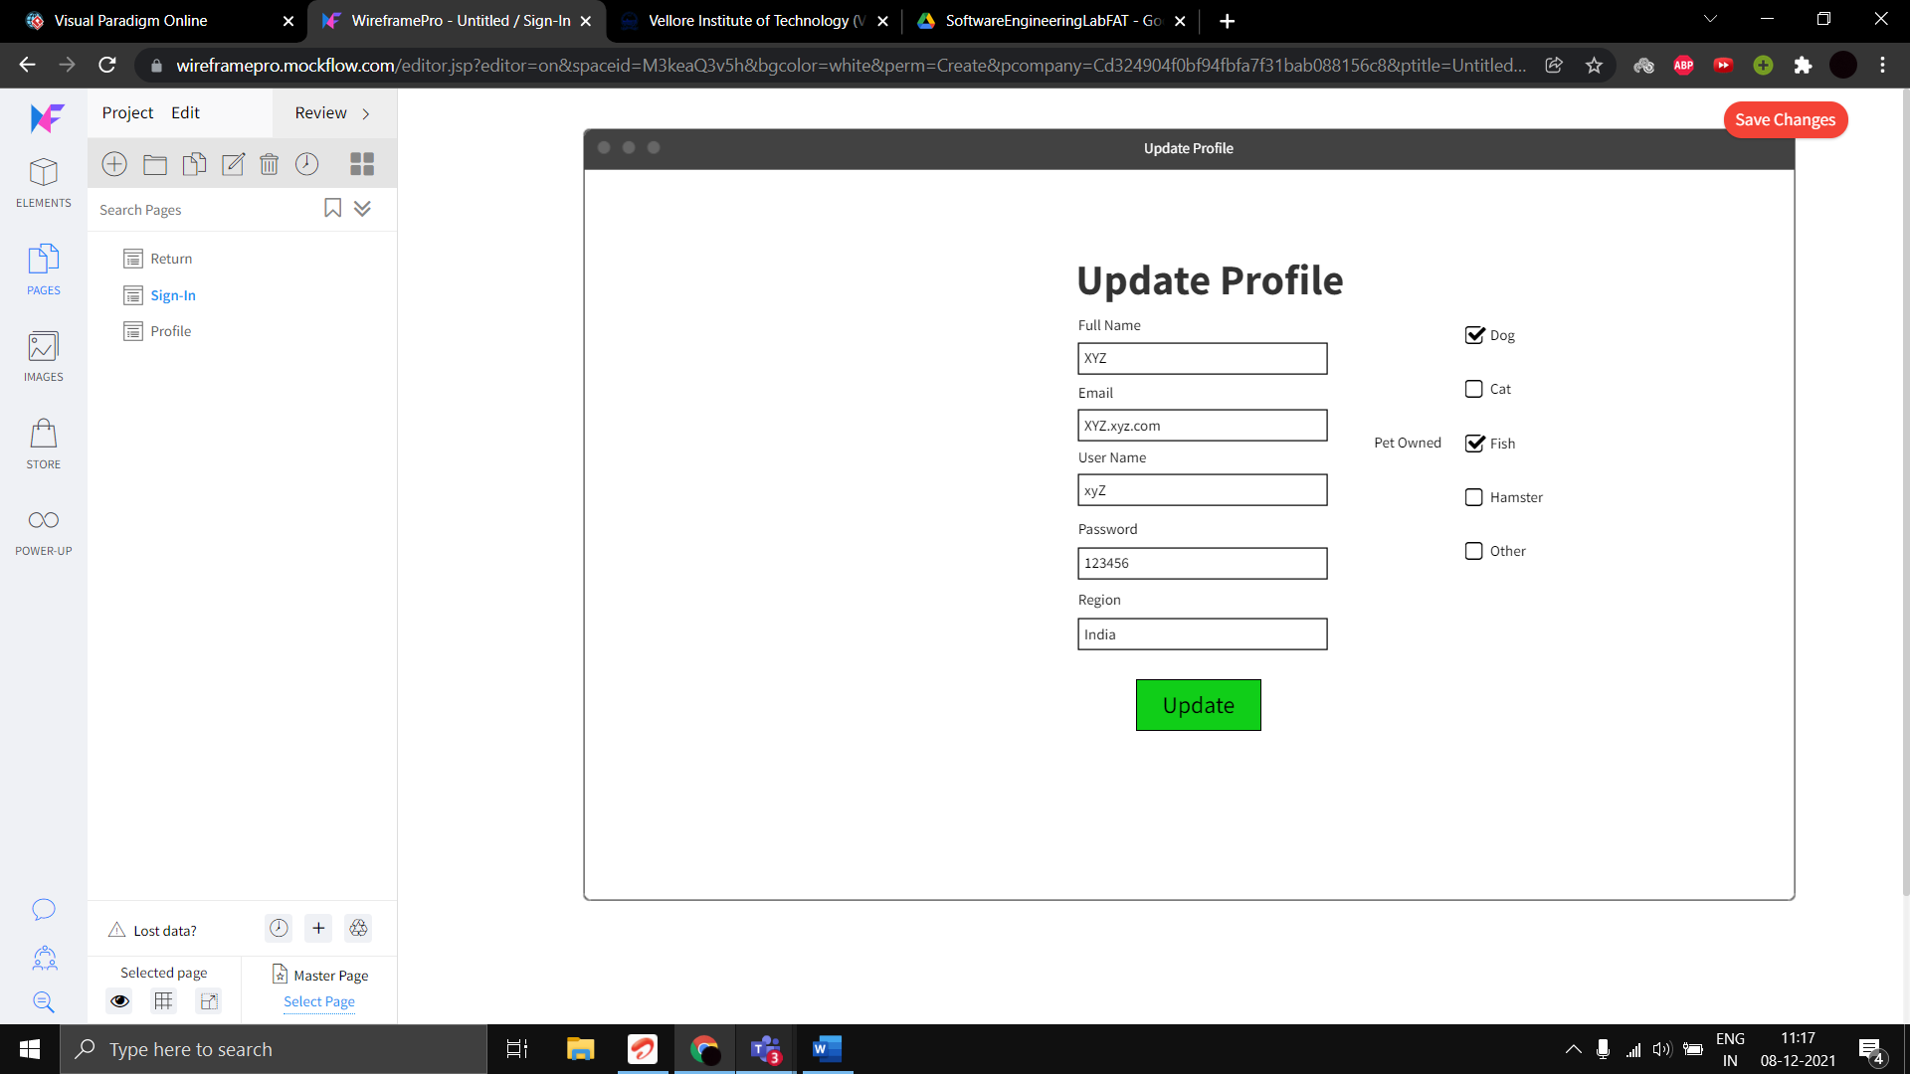

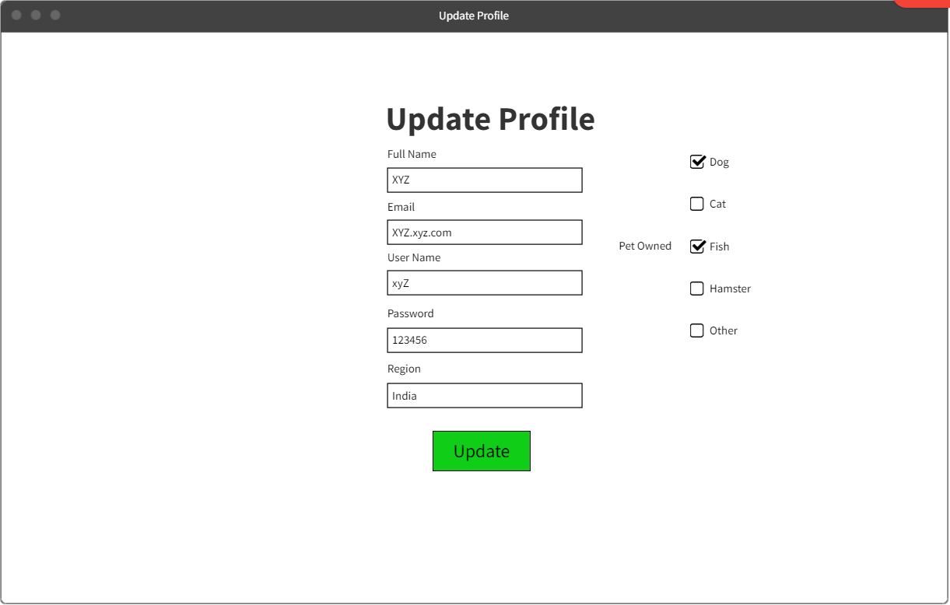

**Messaging Application**

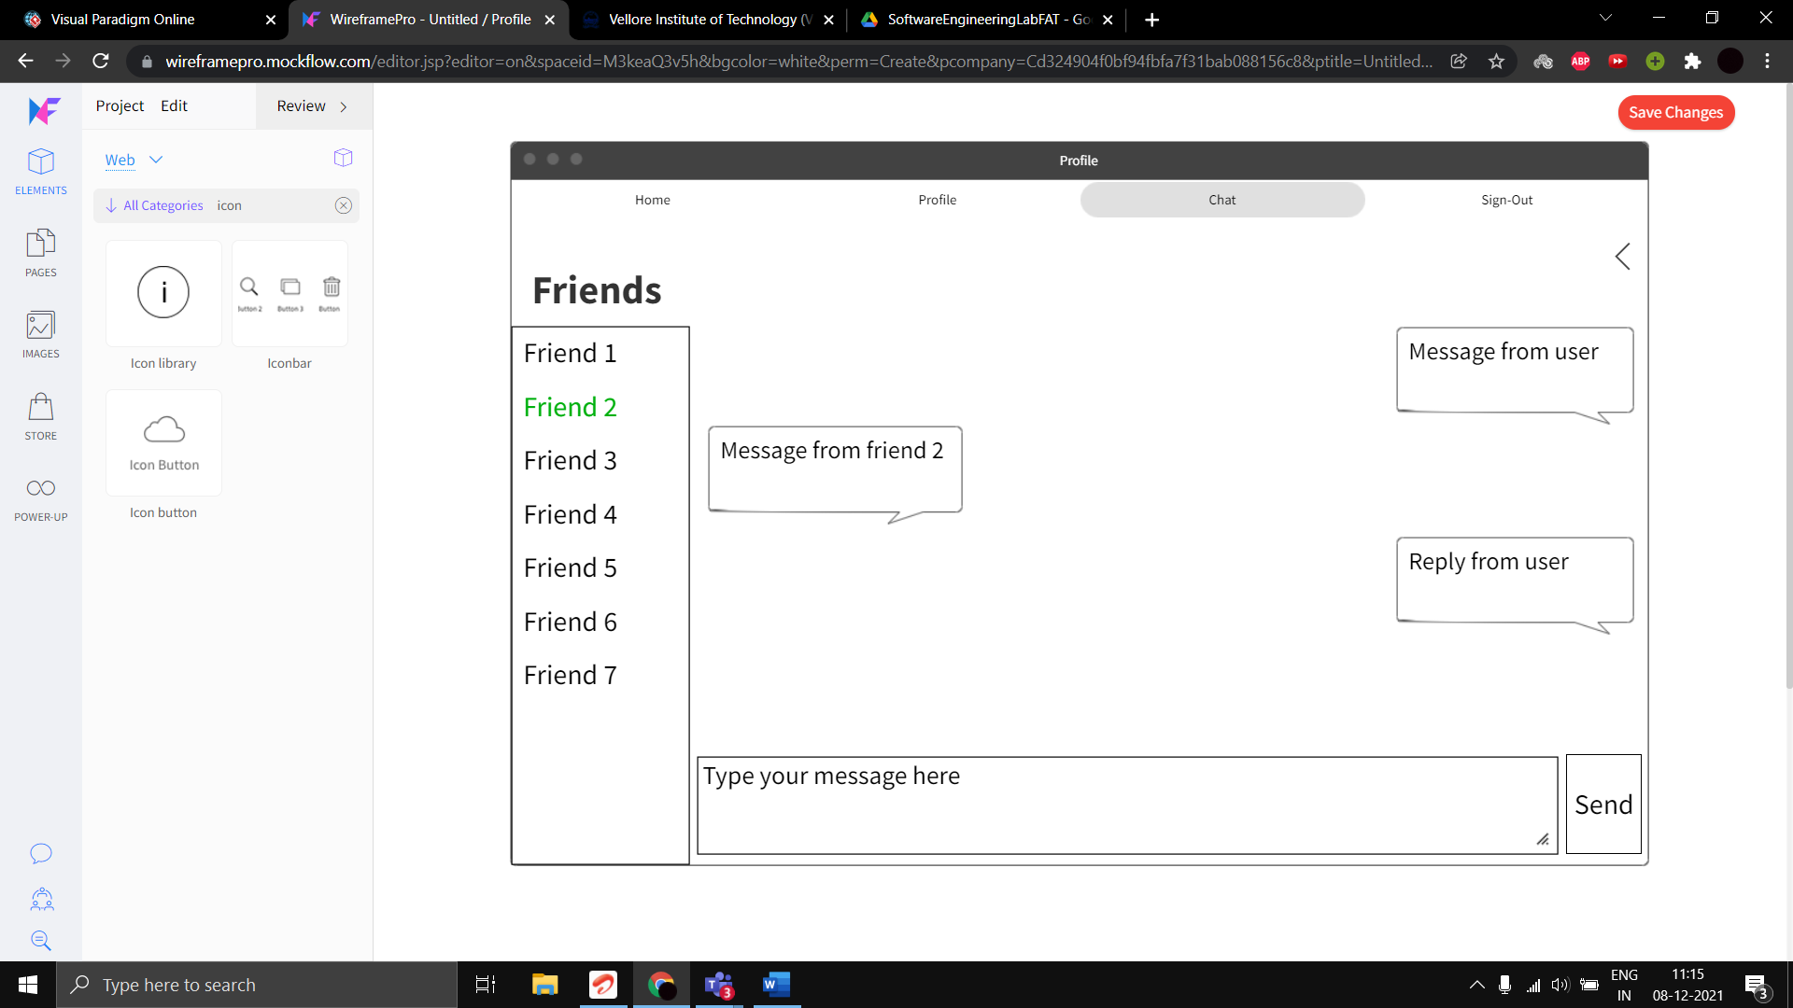

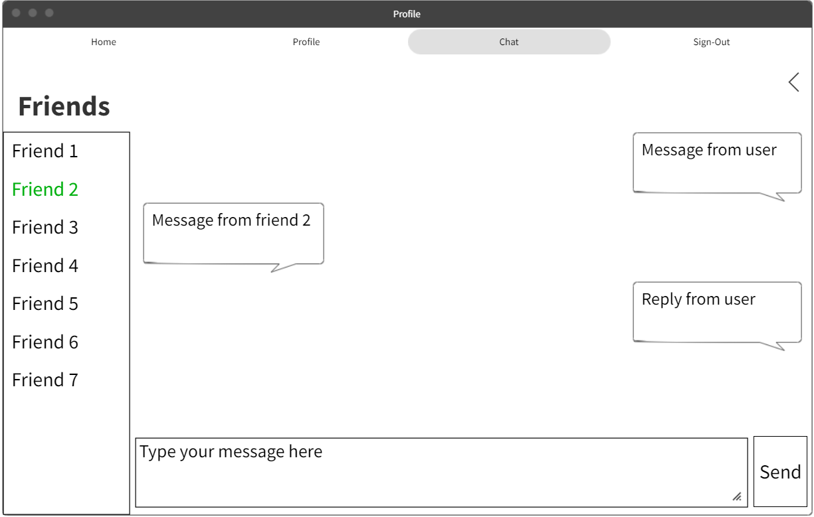

**Tool Used:** [**Wireframepro mockflow**](https://wireframepro.mockflow.com/)