- Daily net revenue by zone and by store (delivered orders only, after discount).
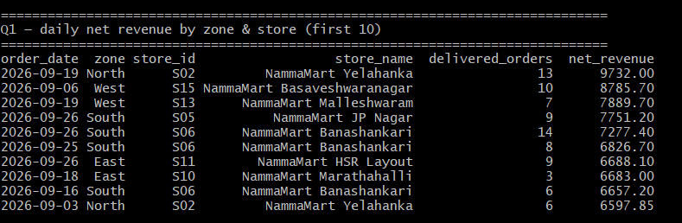
- Revenue and gross margin by product category (margin = revenue − quantity × cost_price).
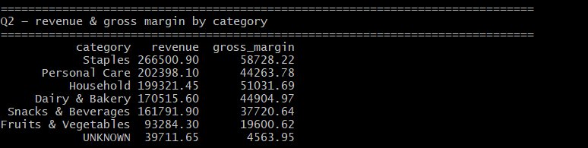
- Average delivery time per store, and the % of delivered orders within 15 minutes.
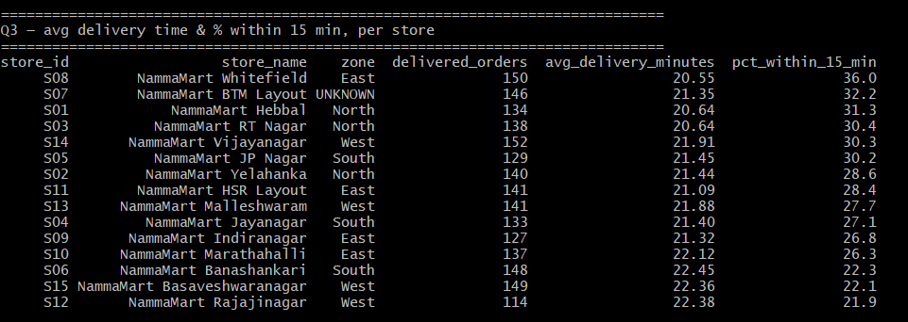
- Revenue by payment mode, and the total amount that doesn't reconcile with the payment
gateway.
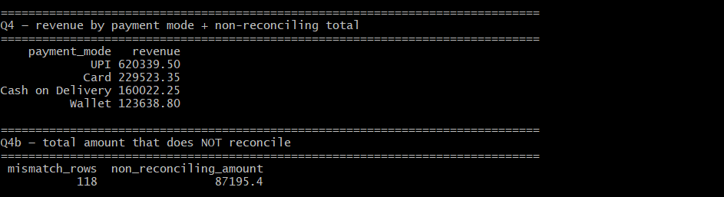
- Top 10 customers by spend, with loyalty tier (no raw email or phone shown).
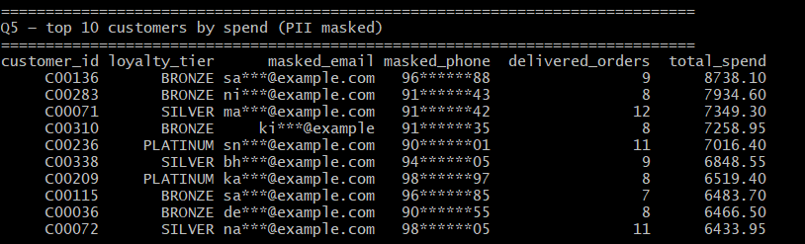
- Number of rows rejected today, by file and by reason.
