Web Application Security Audit Report
of
Department of FCSCA.
Website: http://52.66.174.155/
Submitted By
Secnic Consultancy

Report Release Date | 06.09.2025
Type of Audit | Application Security Aduit
Type of Audit Report | Level 1 Report
Period | Sep 19, 2025 to Sep 22, 2025

© 2025 Department of FCSCA.
All rights reserved. All information contained in this document is confidential and proprietary to Department of FCSCA. No part of this document may be photocopied, electronically transferred, modified, or reproduced in any manner without the prior written consent of Department of FCSCA.
All brands or product names are trademarks or registered trademarks of their respective companies or organisations.

Document Control

Document Preparations
Document Title | Application Security Audit Report
Document ID | SCS/WAC/202503
Document Version | 1.0
Prepared By
Reviewed By
Approved By
Released By
Released Date | 19 Sep 2025

Document Change History

Version | Date | Remarks
1.0 | Sep 19, 2025 | Level 1 report

Document Distribution List

Name | Organization | Designation | Email Id
Atul Suri | Manager (Quality & Audit) | Department of FCSCA

Table of Contents

1. EXECUTIVE SUMMARY 3
1.1 Introduction 3
1.2 Scope 3
1.3 Summary of Findings 4
1.4 Overall Assessment 4
1.5 Key Vulnerabilities Discovered 5
2. OVERALL SUMMARY OF FINDINGS 6
3. BENCHMARKING WITH OWASP 6
4. KEY FINDINGS AND ACTION ITEMS 8
5. General Guidelines 16

EXECUTIVE SUMMARY

Introduction
This report presents the results of the penetration testing for the Department of FCSCA. Website (http://52.66.174.155/) The objective of the test was to find out vulnerabilities that can be seen and compromised by malicious users from the Internet. The application was found to be vulnerable to security risks including Security Misconfiguration, & Denial of Service issues etc... The following sections provide details of the scope of the penetration test, the IPs on which detailed penetration testing was conducted, and the detailed findings from the penetration testing exercise.

Our opinion provided in this report is valid for the period during which the penetration testing was carried out and is based on the information and the website contents provided for audit. Projection of any conclusions based on our findings for future periods and application versions is subject to the risk that the validity of such conclusions may be altered because of changes made to the network or application or system or the failure to make the changes to the network, application, system when required.

Disclaimers and Restrictions
- Organization’s management is responsible for its assertions. Our responsibility is to express an opinion on management’s assertion based on our audit.
- The audit was conducted in accordance with the Information Systems Auditing Standards issued by the Standards Board of Information Systems Audit and Control Association. Further, the objective of the audit was to obtain reasonable assurance that the assertion is not materially misstated. Our audit included
  - Obtaining an understanding of the objectives;
  - selectively testing these objectives;
  - testing and evaluating; and
  - performing such other procedures as we considered necessary under the circumstances. We believe that our audit provides a reasonable basis for our opinion.
- Because of inherent limitations in controls, errors or fraud may occur and may not be detected. Furthermore, the projection of any conclusions, based on our findings, to future periods are subject to the risk that changes made to the system or controls, changes in processing requirements, changes required because of the passage of time, or degree of compliance with the policies or procedures may alter the validity of such conclusions.
- This report is strictly to be used for the intend purpose of compiling the controls being followed for the purposes of analysis and improvement.
- It is firmly recommended to test out all our technical recommendations to the system internals such as services or registry in a test environment and the impact on the reliability and integrity of the system be evaluated before rolling out the changes to the production environment.
- This report does not include any representation on the financial, marketing, human resources or any other health of the Organization or on the future viability of the Organization or minimizing or exposure of all risks associated with computerized environment, due to its inherent limitations.

Details of the Auditing Team
Sr. No. | Name | Designation | Email Id | Professional Qualifications/ Certifications | Whether the resource has been shortlisted in the snapshot information published on Cert-In’s website (Yes/No)
1 |  |  |  | CISA, ISO 27001 LA | Yes
2 |  |  |  | ISO LA | Yes
3 |  |  |  | CEH | Yes

Audit Activities and Timelines

Audit Phases | Timelines
Receipt of URL/Application Auditee for Audit | Sep 19, 2025
Execution of Assignment
Report Preparation
Report Submission to Auditee | Sep 22, 2025

Audit Methodology and Criteria / Standard referred for audit
During the course of this review, we assessed the activities as stated above for compliance with OWASP & other known vulnerabilities and best practices, as applicable. We conducted the assignment using automated tools and conducting manual testing, as applicable.

Tools/Software Used

Sr. No. | Name of Tool/Software Used | Version of the tool/Software used | Open Source/Licensed
1. | Burp Suite Professional | 2024.5 | Licensed
2. | Invicti Standard | 25.5.1 | Licensed
3. | Kali Tools |  | Open Source
4. | Manual scripts

Scope
The following table details an overview on the scope of the penetration test.

Details
Application Name | Gallantry award
Testing IP/URL | http://52.66.174.155/
Mode of Test | Grey Box Testing

Summary of Findings
Penetration testing on the Website (http://52.66.174.155/ ) was performed for a period of 4 days. As a result of the penetration test following risks were identified:
No of Findings | Critical | High | Medium | Low
12 | 0 | 1 | 7 | 4

The table below gives an overall result of the findings from the penetration testing exercise. The “Key Findings and Action Items” section gives the details of the vulnerabilities and provides the recommendations to mitigate them.

Overall Assessment
We have identified 12 vulnerabilities during the penetration testing of the (http://52.66.174.155/). The team concluded the risks based on the results of the various tests carried out during the penetration testing process. The following table lists down the key vulnerabilities discovered.

Key Vulnerabilities Discovered
Sr. No. | VULNERABILITY | RISK LEVEL | REMARKS &  ACTION ITEMS
1. | No SSL Certificate Implemented | High | The application is currently running without an SSL/TLS certificate. As a result, communication between the client and server occurs over unencrypted HTTP.
2. | Absence of Anti CSRF Token | Medium | The application does not implement anti-CSRF tokens in forms or state-changing requests.
3. | CSP: Failure to Define Directive with No Fallback | Medium | The application implements a Content Security Policy (CSP) header but fails to define certain directives, and no fallback is provided.
4. | Content Security Policy (CSP) – Use of Wildcard Directive | Medium | Wildcards are overly permissive and allow resources to be loaded from any origin. This defeats the purpose of CSP by enabling attackers to inject malicious content from untrusted sources.
5. | CSP: script-src unsafe-inline | Medium | The application defines a Content Security Policy (CSP) header but includes the directive script-src 'unsafe-inline'.
6. | CSP: style-src unsafe-inline | Medium | The application’s Content Security Policy (CSP) header includes the directive style-src 'unsafe-inline', which allows inline CSS styles to be executed. While CSP is meant to mitigate Cross-Site Scripting (XSS) and data injection attacks, using 'unsafe-inline'
7. | Content Security Policy (CSP) Header Not Set | Medium | A CSP header is a powerful browser security control that helps mitigate common client-side attacks such as Cross-Site Scripting (XSS), data injection, clickjacking, and content injection by restricting the sources from which the browser can load scripts, styles, images, and other resources.
8. | Vulnerable JS Library | Medium | Use of vulnerable libraries may allow attackers to execute arbitrary code, exfiltrate sensitive data, bypass access controls, or manipulate application behavior.
9. | Cookie No HttpOnly Flag | Low | Certain cookies set by the application do not include the HttpOnly attribute. The HttpOnly flag instructs browsers to prevent access to the cookie via client-side scripts (e.g., document.cookie).
10. | Cookie without SameSite Attribute | Low | The application sets cookies without the SameSite attribute. The SameSite cookie attribute is designed to control whether cookies are sent with cross-site requests.
11. | Cross-Domain JavaScript Source File Inclusion | Low | The application includes a JavaScript file from an external domain without proper validation or origin checks. If the external domain is attacker-controlled, an attacker can inject and execute malicious JavaScript on the application. This can occur via static script tags or dynamic script loading from user-supplied inputs.
12. | Server Leaks Version Information via "Server" HTTP Response Header Field | Low | The web server exposes its software type and version in the HTTP response headers, specifically the Server header.

OVERALL SUMMARY OF FINDINGS
Below Chart gives the overall summary of number of Vulnerabilities discovered with the Risk rating. Total of 12 vulnerabilities High-1 medium-7 Low-4 Informational-0 level Vulnerabilities were reported.

BENCHMARKING WITH OWASP
The below chart depicts the number of discovered vulnerabilities mapped to OWASP Testing Category.

OWASP has rated the Top Ten Vulnerabilities found in web applications worldwide. OWASP Top Ten Vulnerabilities details can be found at below link.

https://owasp.org/Top10/

The table shows the application vulnerability mapped with respect to the OWASP Top 10 - 2021 list.

Sl. No | Vulnerabilities | Status
1 | Injection Flaws | Unprotected
2 | Broken Authentication | Unprotected
3 | Sensitive Data Exposure | Unprotected
4 | XML External Entities (XXE) | PROTECTED
5 | Broken Access Control | protected
6 | Security Misconfiguration | Unprotected
7 | Cross-Site Scripting (XSS) | Unprotected
8 | Insecure Deserialization | protected
9 | Using Components with Known Vulnerabilities | Unprotected
10 | Insufficient Logging & Monitoring | protected

Tools | Used
- Burp Suite | 9
- Kali Linux | 1
Browser | 3
OWASP ZAP | 0

KEY FINDINGS AND ACTION ITEMS

- SSL/TLS Certificate Not Implemented
Brief Description | Risk Rating | Impact on Application | Probability of Attack
The application is currently running without an SSL/TLS certificate. As a result, communication between the client and server occurs over unencrypted HTTP. This exposes sensitive data such as login credentials, session cookies, and other transmitted information to interception (Man-in-the-Middle attacks) | High | High | High
Impact:

Unencrypted data transfer makes it possible for attackers to eavesdrop on traffic.
Session hijacking and credential theft can occur.
Fails compliance requirements such as OWASP ASVS, PCI DSS, and GDPR, which mandate secure communication.
Reduces user trust in the application due to the absence of HTTPS padlock indicator in the browser.

Affected items
http://52.66.174.155/
Proof of Concept:
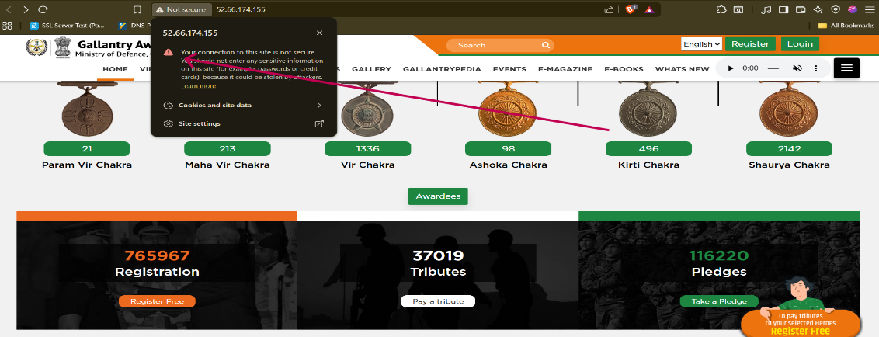
Recommendation:
Configure the web server to use HTTPS with a valid SSL/TLS certificate issued by a trusted Certificate Authority (CA).
Redirect all HTTP traffic to HTTPS.
Regularly renew and monitor certificate validity.
Tool Used:- Browser
- Absence of Anti CSRF Token
Brief Description | Risk Rating | Impact on Application | Probability of Attack
The application does not implement anti-CSRF tokens in forms or state-changing requests. Without CSRF protection, an attacker can trick authenticated users into performing unintended actions (such as changing account details, performing transactions, or updating sensitive data) by sending maliciously crafted requests. | Medium | Medium | High
Impact:
An attacker can exploit the lack of CSRF protection to perform unauthorized state-changing actions on behalf of an authenticated user.
If a victim is logged in and visits a malicious site, attacker-controlled HTML/JS can automatically submit forged requests to the vulnerable application.
Affected items
http://52.66.174.155/pledge
Proof of Concept:
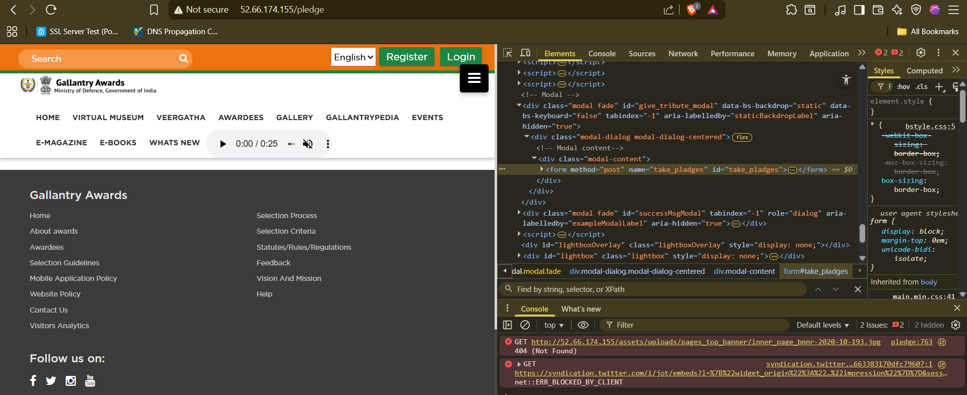

Recommendation:
Implement CSRF protection using unique, unpredictable tokens:
- Generate a random CSRF token per session/request.
- Embed token in every sensitive form and AJAX request.
- Validate token on server-side for each request.
Tool Used:- Browser

- (CSP) – Failure to Define Directive with No Fallback
Brief Description | Risk Rating | Impact on Application | Probability of Attack
The application does not implement a Content Security Policy (CSP) header in HTTP responses.  CSP helps mitigate attacks such as Cross-Site Scripting (XSS), clickjacking, and data injection by restricting the sources from which scripts, styles, and other resources can be loaded.  Without CSP, the browser will execute any script included in the page, increasing the risk of exploitation if an attacker injects malicious content. | Medium | High | Medium
Impact:
Increased risk of XSS (Cross-Site Scripting) attacks.
Malicious scripts may be injected and executed in the user’s browser.
Sensitive data such as cookies, tokens, and session details can be stolen.
Potential to compromise user accounts and damage application trust
Affected items:
http://52.66.174.155/awardee/1045
Proof of Concept:
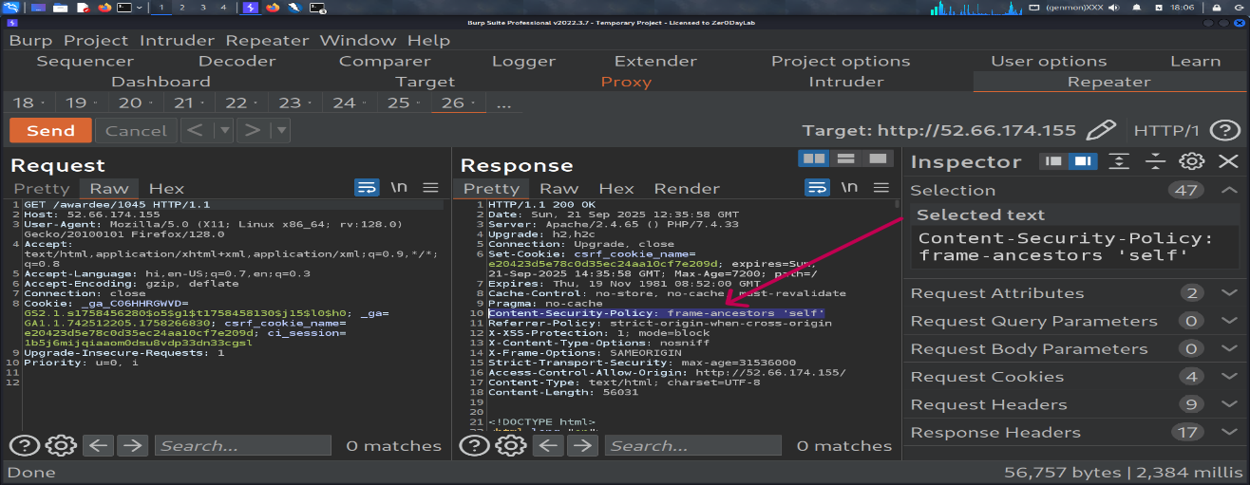

Recommendation:
Define explicit CSP directives for sensitive resources:
- script-src 'self' https://trusted.cdn.com
- object-src 'none'
- frame-ancestors 'none' (or trusted domains only)
Avoid relying solely on default-src.
Add a report-uri or report-to directive for monitoring violations.
Use strict CSP with nonce/hash-based whitelisting for inline scripts.
Test policy with tools like Google CSP Evaluator before deployment.

Tool Used:- Burpsuite
- (CSP) – Use of Wildcard Directive
Brief Description | Risk Rating | Impact on Application | Probability of Attack
The application defines a Content Security Policy (CSP) header but uses wildcard (*) directives such as script-src * or img-src *. Wildcards are overly permissive and allow resources to be loaded from any origin. This defeats the purpose of CSP by enabling attackers to inject malicious content from untrusted sources. | Medium | High | Medium
Impact:
Increases likelihood of Cross-Site Scripting (XSS) and data injection attacks.
Attackers can host malicious scripts on any domain and have them executed in the victim’s
browser.
Users’ sensitive data (cookies, tokens, personal info) may be exfiltrated.
Reduces effectiveness of CSP as a security control.

Affected items
http://52.66.174.155/awardee/1039

Proof of Concept:
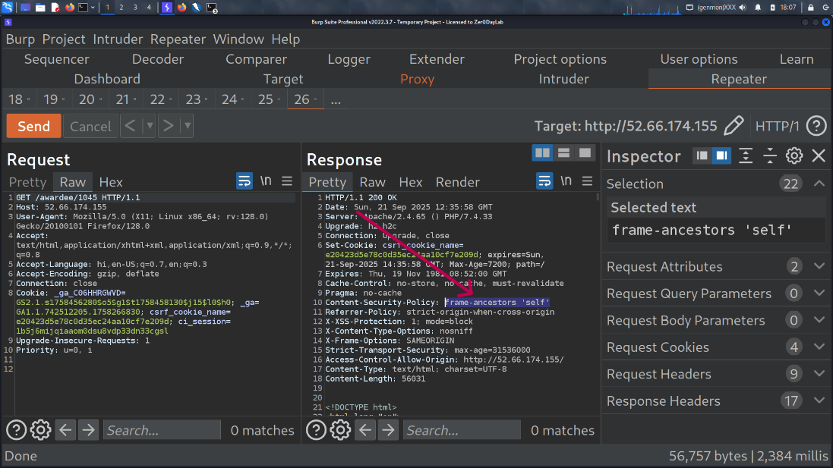

Recommendation:
Avoid wildcard usage (*) in CSP directives.
Restrict sources to specific trusted domains. Example:
Content-Security-Policy: script-src 'self' https://trusted.cdn.com; object-src 'none'; frame- ancestors 'none';
Use nonces (nonce-...) or hash-based whitelisting for inline scripts.
Test policies with Google CSP Evaluator and browser developer tools.
Implement CSP reporting with report-uri or report-to for visibility into policy violations.

Tool Used:- Burpsuite

- (CSP) – Use of script-src 'unsafe-inline'
Brief Description | Risk Rating | Impact on Application | Probability of Attack
The application defines a Content Security Policy (CSP) header but includes the directive script-src 'unsafe-inline'. This directive allows the execution of inline JavaScript (such as <script> blocks and inline event handlers). Allowing inline scripts negates the security benefits of CSP, as attackers can inject and execute malicious code through XSS or content injection vulnerabilities. | Medium | Low | Medium

Impact: Inline JavaScript can be executed without restriction.
Increases the risk of Cross-Site Scripting (XSS) exploitation.
Attackers may steal sensitive data (cookies, tokens, personal information) or perform
unauthorized actions on behalf of the user.
Reduces the overall effectiveness of CSP as a mitigation control.

Affected items
http://52.66.174.155/awardee/1045
Proof of Concept:

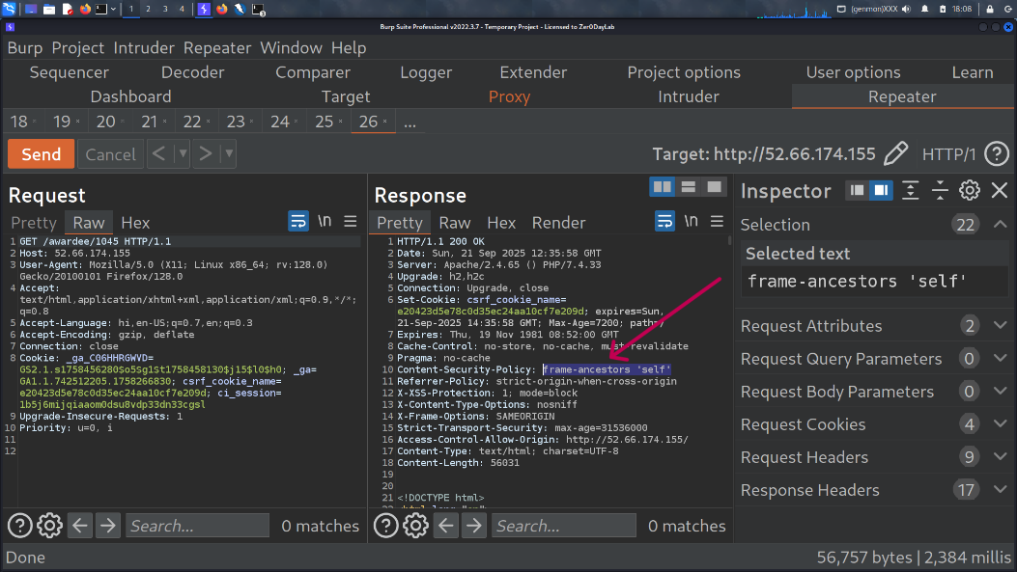

Recommendation:
Remove 'unsafe-inline' from the script-src directive.
Replace inline scripts with external JavaScript files hosted on trusted domains.
Use nonces (nonce-...) or hash-based whitelisting (sha256-...) for legitimate inline
scripts. Example:
Content-Security-Policy: script-src 'self' https://trusted.cdn.com 'nonce-abc123'; object-src
'none'; frame-ancestors 'none';
Implement a strong CSP with fallback directives (default-src 'none') for defense-in-depth.
Test updated CSP using Google CSP Evaluator and browser dev tools.

Tool Used:- Burp suite

- (CSP) – Use of style-src 'unsafe-inline'
Brief Description | Risk Rating | Impact on Application | Probability of Attack
The application’s Content Security Policy (CSP) header includes the directive style-src 'unsafe-inline', which allows inline CSS styles to be executed. While CSP is meant to mitigate Cross-Site Scripting (XSS) and data injection attacks, using 'unsafe-inline' for styles weakens the policy. It allows attackers to inject malicious inline CSS that could manipulate the look and feel of the application, and in some cases, be combined with other vulnerabilities (e.g., XSS or clickjacking) to escalate attacks. | Medium | Medium | Medium
Impact:
- Attackers can inject malicious inline CSS to:
- Hide important security warnings or UI elements.
- Trick users into clicking disguised links (phishing within app).
- Overlay fake input fields for credential theft.
- Reduces the overall protection CSP offers against injection attacks.
- In some advanced attacks, CSS injection can lead to sensitive data exfiltration (e.g., detecting password length through style-based side channels).
Affected items:
http://52.66.174.155/awardee/1045
Proof of Concept:
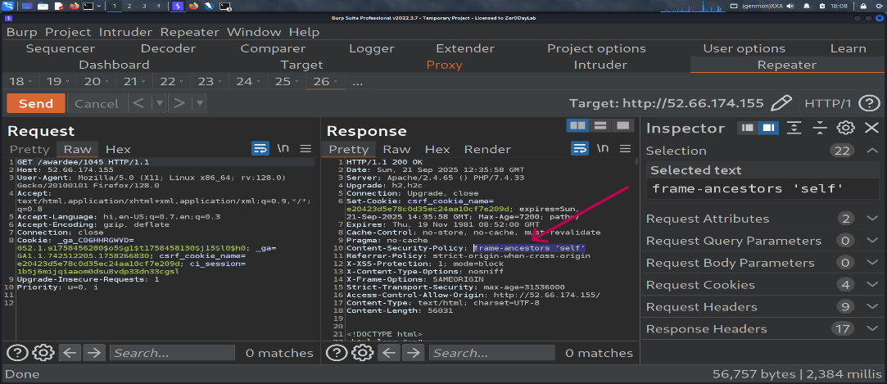

Recommendation:
- Remove 'unsafe-inline' from the style-src directive.
- Use external CSS files hosted on trusted domains instead of inline <style> blocks.
- If inline styles are absolutely required, use hashes (sha256-...) or nonces (nonce-...) to allow only trusted inline styles.

Tool Used:- Burpsuite

- Content Security Policy (CSP) Header Not Set
Brief Description | Risk Rating | Impact on Application | Probability of Attack
The application does not return a Content-Security-Policy (CSP) header in its HTTP responses. A CSP header is a powerful browser security control that helps mitigate common client-side attacks such as Cross-Site Scripting (XSS), data injection, clickjacking, and content injection by restricting the sources from which the browser can load scripts, styles, images, and other resources. | Medium | Medium | Medium
Impact: Increased risk of XSS attacks (attackers can inject arbitrary JavaScript).
- Potential for malicious iframe embedding leading to clickjacking.
- No restriction on loading untrusted external scripts, styles, or content.
- User session hijacking, credential theft, and data leakage become easier.
Affected items
http://52.66.174.155/
Proof of Concept:
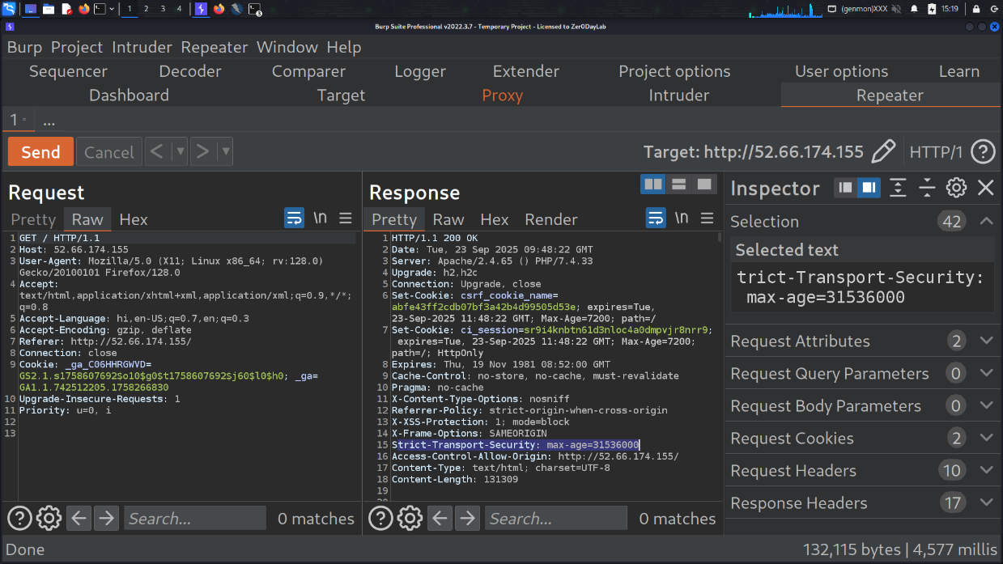

Recommendation:
Remove or disable the X-Powered-By header from server responses.
Configure the web server/framework to suppress version disclosure.

Tool used: Burp Suite

- Vulnerable JavaScript Library
Brief Description | Risk Rating | Impact on Application | Probability of Attack
The application depends on one or more JavaScript libraries that are known to contain security vulnerabilities (e.g., XSS, remote code execution, prototype pollution, deserialization, command injection). Use of vulnerable libraries may allow attackers to execute arbitrary code, exfiltrate sensitive data, bypass access controls, or manipulate application behavior. | Medium | Medium | Medium
Impact: Remote Code Execution (RCE) or Server Side Code Execution (if server package vulnerable)
- Cross-Site Scripting (XSS) in client context (if DOM-facing library)
- Data exposure (cookies, tokens, PII) via exploited library
- Privilege escalation or account takeover if attacker abuses library behavior
- Supply-chain attacks — attacker can inject malicious code that runs in many applications
Affected items
http://52.66.174.155/assets/veergatha/js/isotope.min.js
Proof of Concept:
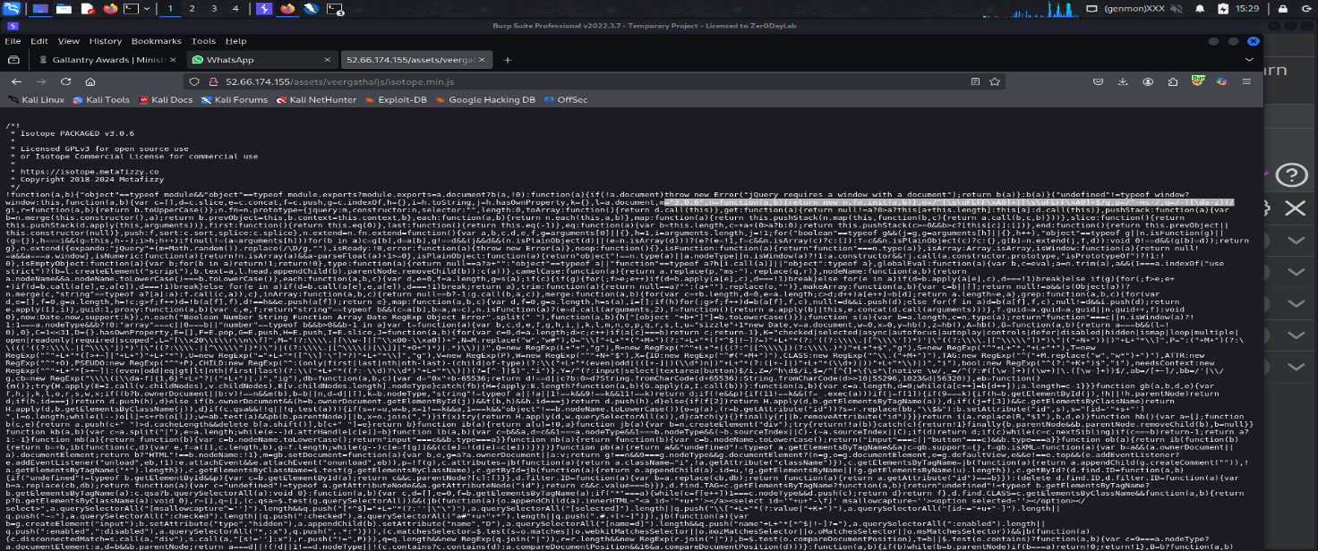

Recommendation: Upgrade the vulnerable library to a non-vulnerable version per the advisory.
If no patch available, replace the library with a safe alternative or remove usage.
For transitive dependencies, update parent package or use npm-force-resolutions / Yarn resolutions temporarily until fixed upstream.

Tool used: Burp Suite

- Cookie Missing HttpOnly Flag
Brief Description | Risk Rating | Impact on Application | Probability of Attack
Certain cookies set by the application do not include the HttpOnly attribute. The HttpOnly flag instructs browsers to prevent access to the cookie via client-side scripts (e.g., document.cookie). Without HttpOnly, sensitive cookies (session identifiers, auth tokens) may be exposed to Cross-Site Scripting (XSS) attacks or other client-side injection vectors, enabling theft and session hijacking. | Low | Low | Medium

Impact: Theft of session cookies via XSS leading to account takeover.
Exposure of authentication or CSRF tokens to malicious scripts.
Increased attack surface when combined with other client-side vulnerabilities (e.g.,
reflected/stored XSS).
Non-compliance with secure-coding best practices and certain regulatory standards.
Affected items
http://52.66.174.155/awardee/1049
Proof of Concept:

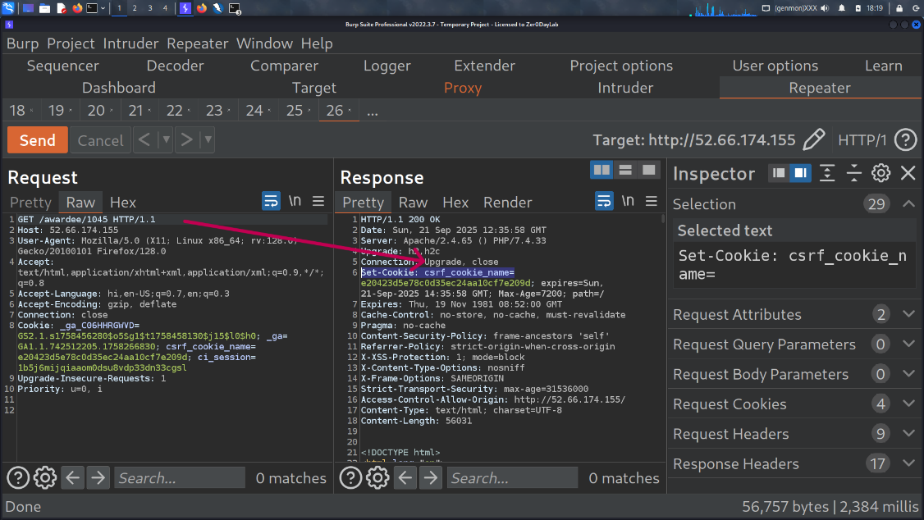

Recommendation:
Set HttpOnly for all cookies that are not intended to be accessed by client-side scripts, especially session/authentication cookies:
Tool used: Burp Suite

- Cookie Without SameSite Attribute
Brief Description | Risk Rating | Impact on Application | Probability of Attack
The application sets cookies without the SameSite attribute. The SameSite cookie attribute is designed to control whether cookies are sent with cross-site requests. If it is missing, the browser defaults vary (older browsers treat it as None, newer may default to Lax), which increases the risk of Cross-Site Request Forgery (CSRF) and unintended cookie leakage across sites. | Low | Low | Medium

Impact: Cookies may be included in cross-site requests without restriction.
Increases risk of CSRF attacks, allowing attackers to perform unauthorized actions on behalf of an authenticated user.
May allow third-party sites to track users across applications (privacy concern).
When combined with absence of CSRF tokens, risk escalates to High.

Affected items:-
http://52.66.174.155/awardee/1045
Proof of Concept:
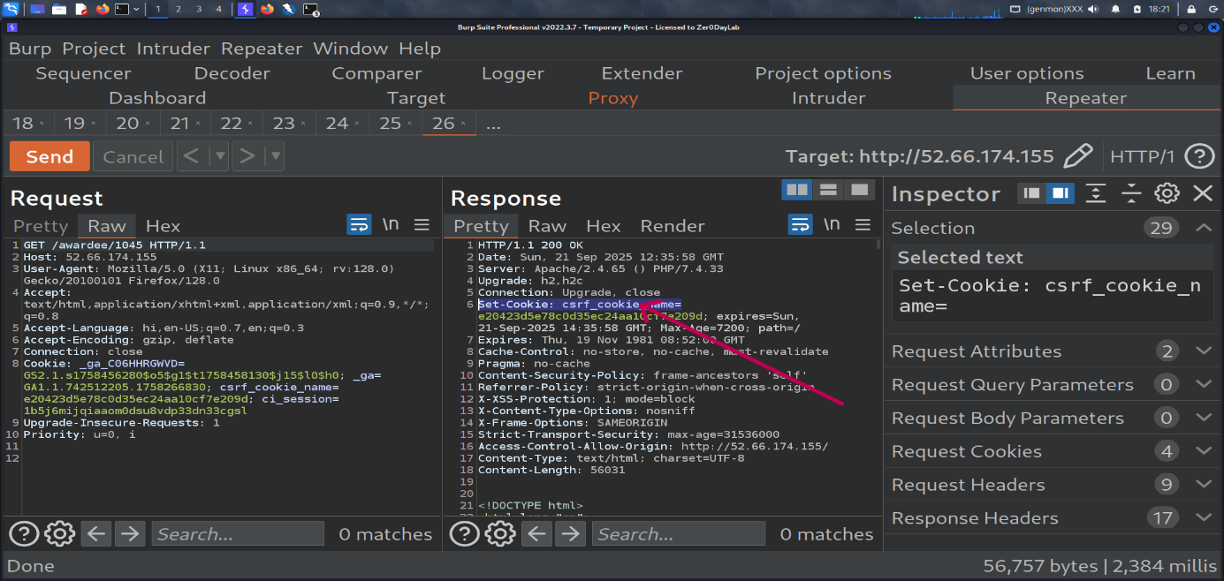

Recommendation: Always set the SameSite attribute explicitly on all sensitive cookies.
- SameSite=Strict → Strongest, prevents all cross-site inclusion (best for auth/session cookies if app supports).
- SameSite=Lax → Safer default, allows top-level navigation but blocks most cross-site requests.
- SameSite=None; Secure → Only when third-party usage is required (must also include Secure).
Tool used: Burpsuite

- Cross-Domain JavaScript Source File Inclusion
Brief Description | Risk Rating | Impact on Application | Probability of Attack
The application includes JavaScript files from external or third-party domains. If these external sources are not fully trusted or get compromised, an attacker can inject malicious JavaScript into the application. Since JavaScript executes with the same privileges as the application’s own code, this can lead to severe security risks. | Low | Low | Low
Impact: Malicious JavaScript could execute in users’ browsers.
Possible attacks include:
- Session hijacking (stealing cookies or authentication tokens).
- Defacement or redirecting users to phishing/malware sites.
- Data theft (stealing form inputs or sensitive information).
- Complete takeover of client-side functionality.
Affected items:-
http://52.66.174.155/awardee/1045
Proof of Concept:

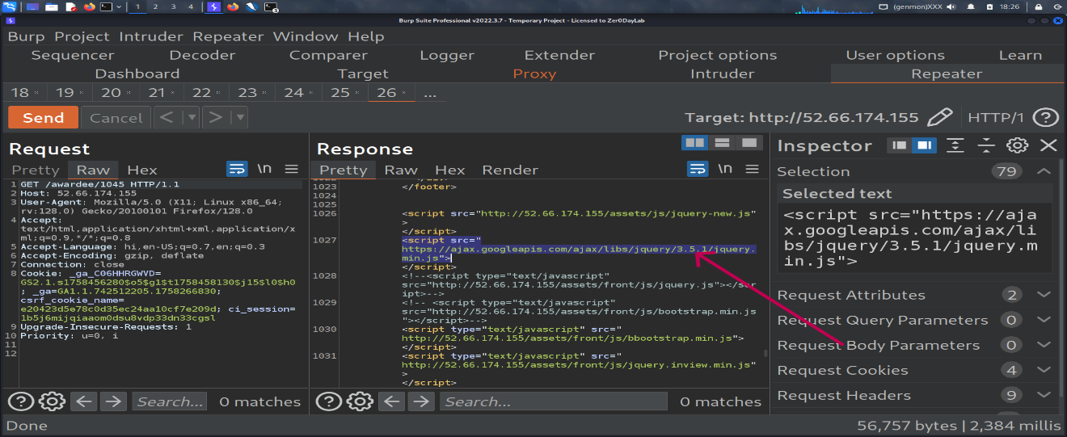

Recommendation:
Avoid including JavaScript from untrusted or third-party domains.
If external scripts are necessary:
- Use Subresource Integrity (SRI) to ensure integrity of loaded scripts.
- Host critical scripts locally on the application server.
- Implement a strict Content Security Policy (CSP) to control script sources.
- Regularly review and validate third-party libraries.
.
Tool used: Burpsuite

- Server Leaks Version Information via "Server" HTTP Response Header
Brief Description | Risk Rating | Impact on Application | Probability of Attack
The web server discloses its software type and version in the HTTP Server response header. For example:  Server: Apache/2.4.41 (Ubuntu)  Such information provides attackers with useful insights about the underlying technology stack. By knowing the exact version, attackers can search for publicly available exploits or known vulnerabilities targeting that specific version. | Low | Medium | Medium
Impact: Helps attackers in fingerprinting the server.
- Increases the risk of targeted attacks if the disclosed version has known vulnerabilities.
- Makes it easier for attackers to perform automated exploitation.
- Reduces the security posture by leaking unnecessary internal details.

Affected items:-
http://52.66.174.155/
Proof of Concept:
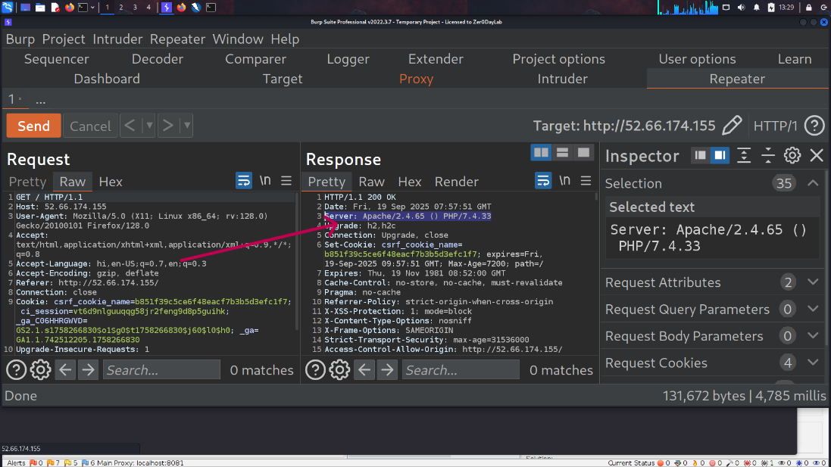

Recommendation:
Avoid including JavaScript from untrusted or third-party domains.
If external scripts are necessary:
- Use Subresource Integrity (SRI) to ensure integrity of loaded scripts.
- Host critical scripts locally on the application server.
- Implement a strict Content Security Policy (CSP) to control script sources.
- Regularly review and validate third-party libraries.
.
Tool used: Burpsuite

General Guidelines

Validate Input and Output
The input that the server receives from the user can lead to malicious code entering the server. Similarly, the output shown to the user can transmit malicious code to the client system. All user input and output should be checked to ensure it is both appropriate and expected. Input validation should be done on the client-side as well as on the server-side.
There are three main models to consider about when designing a data validation strategy.
Accept Only Known Valid Data
A character set may be defined for each field where input from the user is accepted. E.g. “A-Z, a-z, @,., 0-9, _” is a character set for a field that accepts user email.
Reject Known Bad Data
A character set of bad data may be defined for the site that has to be rejected. E.g. “CREATE, DROP, OR”
Sanitize Known Bad Data
A character set of bad data is defined and any input field that has such a character is modified. E.g. “If there is a single quote (‘) in the data, it is replaced with two single quotes.”
All methods must check:
- Data Type
- Syntax
- Length
It is recommended to use the strategy of “Accept only known data”. Further all the allowed input/output data must be sanitized on the server side by replacing scripts tags, sent as part of user input/output, with appropriate representations.
For example
- “<” by &lt;
- “>” by &gt;
- “(“ by &#40

This would avoid scripts from being executed on the client side.
Client-side input must also be checked for URL encoded data. URL encoding sometimes referred to as percent encoding, is the accepted method of representing characters within a URI that may need special syntax handling to be correctly interpreted. This is achieved by encoding the character to be interpreted with a sequence of three characters. This triplet sequence consists of the percentage character “%” followed by the two hexadecimal digits representing the octet code of the original character. For example, the US-ASCII character set represents a space with octet code 32, or hexadecimal 20. Thus, its URL-encoded representation is %20.
Other common characters that can be used for malicious purposes and their URL encoded representations are: -
# | Character | URL encoded
 | ‘ | %27
 | “ | %22
 | ; | %3b
 | < | %3c
 | = | %3d
 | > | %3e
 | ) | %29
 | ( | %28
 | space | %20

All input validation checks should be completed after the data has been decoded and validated as acceptable content (e.g. maximum and minimum lengths, correct data type, does not contain any encoded data, textual data only contains the characters a-z and A-Z etc.)
A one-time check on the database is to be made for invalid malicious data. This would enable removal of input that has not been validated in earlier sessions. As otherwise the invalid data may cause script execution on the user’s browser.

Session Management / Strong session tracking
Session Tokens on Logout
In shared computing environments, session tokens take on a new risk. If the session tokens are not invalidated after logout, they can be reused to gain access to the application. It is imperative for the application to remove the cookies from both the server and the client side after the user has logged out. The user session maintained on the server side must also be invalidated immediately after logout.
Session Time-out
All the user Session tokens must be timed-out after a certain interval of user inactivity. The Session tokens that do not expire on the HTTP server can allow an attacker unlimited time to guess or brute force a valid authenticated session token. If a user's cookie file is captured or brute-forced, then an attacker can use these static-session tokens to gain access to that user's web accounts. Additionally, session tokens can be potentially logged and cached in proxy servers that, if broken into by an attacker, may contain similar sorts of information in logs that can be exploited if the particular session has not been expired on the HTTP server.
Session Token Transmission
If a session token is captured in transit through network interception, a web application account is then trivially prone to a replay or hijacking attack. Typical web encryption technologies include Secure Sockets Layer (SSLv2/v3) and Transport Layer Security (TLS v1) protocols in order to safeguard the state mechanism token.
Some more key points to remember:
Session ID’s that are used should have the following properties:
- Randomness.
  - Session Ids must be randomly generated.
  - Session Ids must be unpredictable.
  - Make use of non-linear algorithms to generate session ID’s
- Session ID Size
  - The size of a session ID should be large enough to ensure that it is not vulnerable to a brute force attack.
  - The character set used should be complex. i.e. Make use of special characters.
  - A length of 50 random characters is advised.
Salted Hashing
What is salted hashing?
The process starts with 2 elements of data:
1.) A clear text string (this could represent a password for instance).
2.) The salt, a random seed of data. This is the value used to augment a hash in order to ensure that 2 hashes of identical data yield different output.
In pseudo code we generate a salted hash as follows:
1.) Get the source string and salt as separate binary objects
2.) Concatenate the 2 binary values
3.) SHA hash the concatenation into Salted Password Hash
4.) Base64 Encode (concat (Salted Password Hash, Salt))
Credentials should be encrypted using salted hashes, so that even if the hashes are sniffed the possibility of replay attack does not exist.
References: http://www.owasp.org/images/3/33/Salted_Hashes_Demystified.doc
Cache Control Directives
Pages that contain sensitive information should not be stored in the local cache of the browser. To enforce this, HTTP directives need to be specified in the response. These HTTP directives need to be used to prevent enlisting of links on the browser history. The following HTTP directives can be sent by the server along with the response to the client. This would direct the browser to send a new request to the server each time it is generated.
Expires: <a previous date>, for e.g. Expires: Thu, 10 Jan 2020 19:20:00 GMT

Cache-Control: private
- Cache-Control: no-cache
- Cache-Control: no-store
- Cache-Control: must-revalidate
- Pragma: no-cache

The directive “Cache-Control: must-revalidate” directs the browser to fetch the pages from the server rather than picking it up from the local “Temporary Internet Folders”. It also directs the browser to remove the file from the temporary folders.

