Web Application Security Audit Report
of
Department of FCSCA.
Website: https://training.gifmis.cga.gov.in/Home.aspx
Submitted By
Secnic Consultancy

Report Release Date | 06.09.2025
Type of Audit | Application Security Aduit
Type of Audit Report | Level 1 Report
Period | Sep 06, 2025 to Sep 10, 2025

© 2025 Department of FCSCA.
All rights reserved. All information contained in this document is confidential and proprietary to Department of FCSCA. No part of this document may be photocopied, electronically transferred, modified, or reproduced in any manner without the prior written consent of Department of FCSCA.
All brands or product names are trademarks or registered trademarks of their respective companies or organisations.

Document Control

Document Preparations
Document Title | Application Security Audit Report
Document ID | SCS/WAC/202503
Document Version | 1.0
Prepared By
Reviewed By
Approved By
Released By
Released Date | 06 Sep 2025

Document Change History

Version | Date | Remarks
1.0 | Sep 06, 2025 | Level 1 report

Document Distribution List

Name | Organization | Designation | Email Id
Atul Suri | Manager (Quality & Audit) | Department of FCSCA

Table of Contents

1. EXECUTIVE SUMMARY 3
1.1 Introduction 3
1.2 Scope 3
1.3 Summary of Findings 4
1.4 Overall Assessment 4
1.5 Key Vulnerabilities Discovered 5
2. OVERALL SUMMARY OF FINDINGS 6
3. BENCHMARKING WITH OWASP 6
4. KEY FINDINGS AND ACTION ITEMS 8
5. General Guidelines 16

EXECUTIVE SUMMARY

Introduction
This report presents the results of the penetration testing for the Department of FCSCA. Website (https://training.gifmis.cga.gov.in/Home.aspx) The objective of the test was to find out vulnerabilities that can be seen and compromised by malicious users from the Internet. The application was found to be vulnerable to security risks including Security Misconfiguration, & Denial of Service issues etc... The following sections provide details of the scope of the penetration test, the IPs on which detailed penetration testing was conducted, and the detailed findings from the penetration testing exercise.

Our opinion provided in this report is valid for the period during which the penetration testing was carried out and is based on the information and the website contents provided for audit. Projection of any conclusions based on our findings for future periods and application versions is subject to the risk that the validity of such conclusions may be altered because of changes made to the network or application or system or the failure to make the changes to the network, application, system when required.

Disclaimers and Restrictions
- Organization’s management is responsible for its assertions. Our responsibility is to express an opinion on management’s assertion based on our audit.
- The audit was conducted in accordance with the Information Systems Auditing Standards issued by the Standards Board of Information Systems Audit and Control Association. Further, the objective of the audit was to obtain reasonable assurance that the assertion is not materially misstated. Our audit included
  - Obtaining an understanding of the objectives;
  - selectively testing these objectives;
  - testing and evaluating; and
  - performing such other procedures as we considered necessary under the circumstances. We believe that our audit provides a reasonable basis for our opinion.
- Because of inherent limitations in controls, errors or fraud may occur and may not be detected. Furthermore, the projection of any conclusions, based on our findings, to future periods are subject to the risk that changes made to the system or controls, changes in processing requirements, changes required because of the passage of time, or degree of compliance with the policies or procedures may alter the validity of such conclusions.
- This report is strictly to be used for the intend purpose of compiling the controls being followed for the purposes of analysis and improvement.
- It is firmly recommended to test out all our technical recommendations to the system internals such as services or registry in a test environment and the impact on the reliability and integrity of the system be evaluated before rolling out the changes to the production environment.
- This report does not include any representation on the financial, marketing, human resources or any other health of the Organization or on the future viability of the Organization or minimizing or exposure of all risks associated with computerized environment, due to its inherent limitations.

Details of the Auditing Team
Sr. No. | Name | Designation | Email Id | Professional Qualifications/ Certifications | Whether the resource has been shortlisted in the snapshot information published on Cert-In’s website (Yes/No)
1 |  |  |  | CISA, ISO 27001 LA | Yes
2 |  |  |  | ISO LA | Yes
3 |  |  |  | CEH | Yes

Audit Activities and Timelines

Audit Phases | Timelines
Receipt of URL/Application Auditee for Audit | Sep 06, 2025
Execution of Assignment
Report Preparation
Report Submission to Auditee | Sep 10, 2025

Audit Methodology and Criteria / Standard referred for audit
During the course of this review, we assessed the activities as stated above for compliance with OWASP & other known vulnerabilities and best practices, as applicable. We conducted the assignment using automated tools and conducting manual testing, as applicable.

Tools/Software Used

Sr. No. | Name of Tool/Software Used | Version of the tool/Software used | Open Source/Licensed
1. | Burp Suite Professional | 2024.5 | Licensed
2. | Invicti Standard | 25.5.1 | Licensed
3. | Kali Tools |  | Open Source
4. | Manual scripts

Scope
The following table details an overview on the scope of the penetration test.

Details
Application Name | Training gifmis
Testing IP/URL | https://training.gifmis.cga.gov.in/Home.aspx
Mode of Test | Grey Box Testing

Summary of Findings
Penetration testing on the Website (https://training.gifmis.cga.gov.in/Home.aspx ) was performed for a period of 4 days. As a result of the penetration test following risks were identified:
No of Findings | Critical | High | Medium | Low
11 | 0 | 1 | 3 | 6

The table below gives an overall result of the findings from the penetration testing exercise. The “Key Findings and Action Items” section gives the details of the vulnerabilities and provides the recommendations to mitigate them.

Overall Assessment
We have identified 11 vulnerabilities during the penetration testing of the (https://training.gifmis.cga.gov.in/Home.aspx). The team concluded the risks based on the results of the various tests carried out during the penetration testing process. The following table lists down the key vulnerabilities discovered.

Key Vulnerabilities Discovered
Sr. No. | VULNERABILITY | RISK LEVEL | REMARKS &  ACTION ITEMS
1. | Cryptography Failure | High | During testing, it was observed that user credentials (username and password) are transmitted in clear text within the HTTP request body.
2. | Absence of Anti CSRF Token | Medium | No Anti-CSRF tokens were found in a HTML submission form.  A cross-site request forgery is an attack that involves forcing a victim to send an HTTP request to a target destination without their knowledge or intent in order to perform an action as the victim
3. | Content Security Policy (CSP) Header Not Set | Medium | Content Security Policy (CSP) is an added layer of security that helps to detect and mitigate certain types of attacks, including Cross Site Scripting (XSS) and data injection attacks.
4. | Missing Anti-clickjacking Header | Medium | Modern Web browsers support the Content-Security-Policy and X-Frame-Options HTTP headers. Ensure one of them is set on all web pages returned by your site/app.
5. | Cookie with SameSite Attribute None | Low | A cookie has been set with its SameSite attribute set to "none", which means that the cookie can be sent as a result of a 'cross-site' request. The SameSite attribute is an effective counter measure to cross-site request forgery, cross-site script inclusion, and timing attacks.
6. | Cookie without SameSite Attribute | Low | A cookie has been set without the SameSite attribute, which means that the cookie can be sent as a result of a 'cross-site' request. The SameSite attribute is an effective counter measure to cross-site request forgery, cross-site script inclusion, and timing attacks.
7. | Server Leaks Information via "X-Powered-By" HTTP Response Header Field(s) | Low | The web/application server is leaking information via one or more "X-Powered-By" HTTP response headers. Access to such information may facilitate attackers identifying other frameworks/components your web application is reliant upon and the vulnerabilities such components may be subject to.
8. | Server Leaks Version Information via "Server" HTTP Response Header Field | Low | The web/application server is leaking version information via the "Server" HTTP response header. Access to such information may facilitate attackers identifying other vulnerabilities your web/application server is subject to.
9. | Strict-Transport-Security Header Not Set | Low | HTTP Strict Transport Security (HSTS) is a web security policy mechanism whereby a web server declares that complying user agents (such as a web browser) are to interact with it using only secure HTTPS connections (i.e. HTTP layered over TLS/SSL). HSTS is an IETF standards track protocol and is specified in RFC 6797.
10. | X-Content-Type-Options Header Missing | Low | The Anti-MIME-Sniffing header X-Content-Type-Options was not set to 'nosniff'. This allows older versions of Internet Explorer and Chrome to perform MIME-sniffing on the response body, potentially causing the response body to be interpreted and displayed as a content type other than the declared content type. Current (early 2014) and legacy versions of Firefox will use the declared content type (if one is set), rather than performing MIME-sniffing.
11. | Information Disclosure - Suspicious Comments | Informational | The response appears to contain suspicious comments which may help an attacker.

OVERALL SUMMARY OF FINDINGS
Below Chart gives the overall summary of number of Vulnerabilities discovered with the Risk rating. Total of 30 vulnerabilities High-1 medium-3 Low-6 Informational-1 level Vulnerabilities were reported.

BENCHMARKING WITH OWASP
The below chart depicts the number of discovered vulnerabilities mapped to OWASP Testing Category.

OWASP has rated the Top Ten Vulnerabilities found in web applications worldwide. OWASP Top Ten Vulnerabilities details can be found at below link.

https://owasp.org/Top10/

The table shows the application vulnerability mapped with respect to the OWASP Top 10 - 2021 list.

Sl. No | Vulnerabilities | Status
1 | Injection Flaws | Unprotected
2 | Broken Authentication | Unprotected
3 | Sensitive Data Exposure | Unprotected
4 | XML External Entities (XXE) | PROTECTED
5 | Broken Access Control | protected
6 | Security Misconfiguration | Unprotected
7 | Cross-Site Scripting (XSS) | Unprotected
8 | Insecure Deserialization | protected
9 | Using Components with Known Vulnerabilities | Unprotected
10 | Insufficient Logging & Monitoring | protected

Tools | Used
- Burp Suite | 9
- Kali Linux | 0
Browser | 2
OWASP ZAP | 0

KEY FINDINGS AND ACTION ITEMS

- Cryptographic Failure – Cleartext Transmission of Credentials
Brief Description | Risk Rating | Impact on Application | Probability of Attack
During testing, it was observed that user credentials (username and password) are transmitted in clear text within the HTTP request body. An attacker intercepting network traffic (e.g., via a Man-in-the-Middle attack) could easily capture sensitive login information. This indicates a cryptographic failure due to lack of proper encryption mechanisms. | High | High | High
Impact:

An attacker on the same network (public Wi-Fi, corporate LAN, ISP) can capture login credentials.
Compromise of user accounts, privilege escalation, or complete account takeover.
May lead to regulatory non-compliance (OWASP A02:2021 – Cryptographic Failures, GDPR, PCI-DSS).
Affected items
https://training.gifmis.cga.gov.in/Login
Proof of Concept:
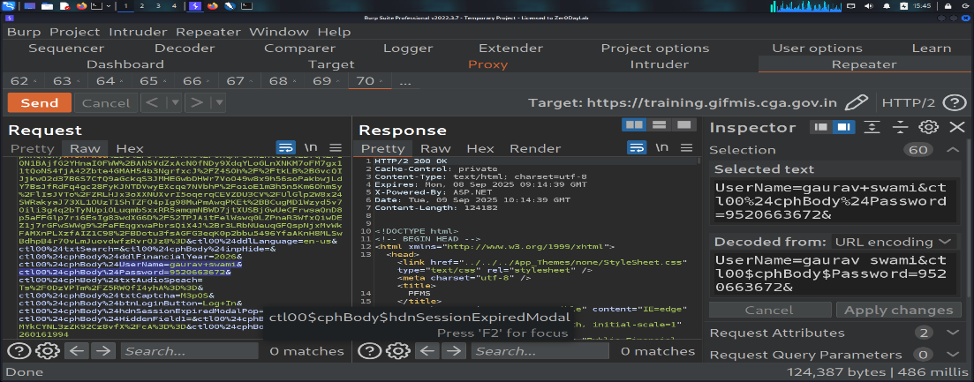
Recommendation:
Enforce HTTPS/TLS 1.2+ for all authentication and sensitive endpoints.
Ensure that credentials are never sent over HTTP in cleartext.
Implement secure password handling:
- Hash passwords using strong algorithms (e.g., bcrypt, Argon2) on server side
- Do not rely on client-side obfuscation or encoding
Use HSTS (Strict-Transport-Security header) to enforce secure connections.
Tool Used:- Burpsuite
- Absence of Anti CSRF Token
Brief Description | Risk Rating | Impact on Application | Probability of Attack
During testing, it was observed that the application does not implement an Anti-CSRF (Cross-Site Request Forgery) token in sensitive state-changing requests (e.g., login, logout, profile update, password change, transactions).  CSRF tokens are required to ensure that requests are legitimately initiated by the user and not forged by a malicious site.  Absence of such tokens makes the application vulnerable to CSRF attacks, where an attacker tricks a logged-in user into performing unintended actions. | Medium | Medium | High
Impact:
An attacker can exploit the lack of CSRF protection to perform unauthorized state-changing actions on behalf of an authenticated user.
If a victim is logged in and visits a malicious site, attacker-controlled HTML/JS can automatically submit forged requests to the vulnerable application.
Affected items
https://training.gifmis.cga.gov.in/SitePages/Users/LoginDetails/Login.aspx
Proof of Concept:
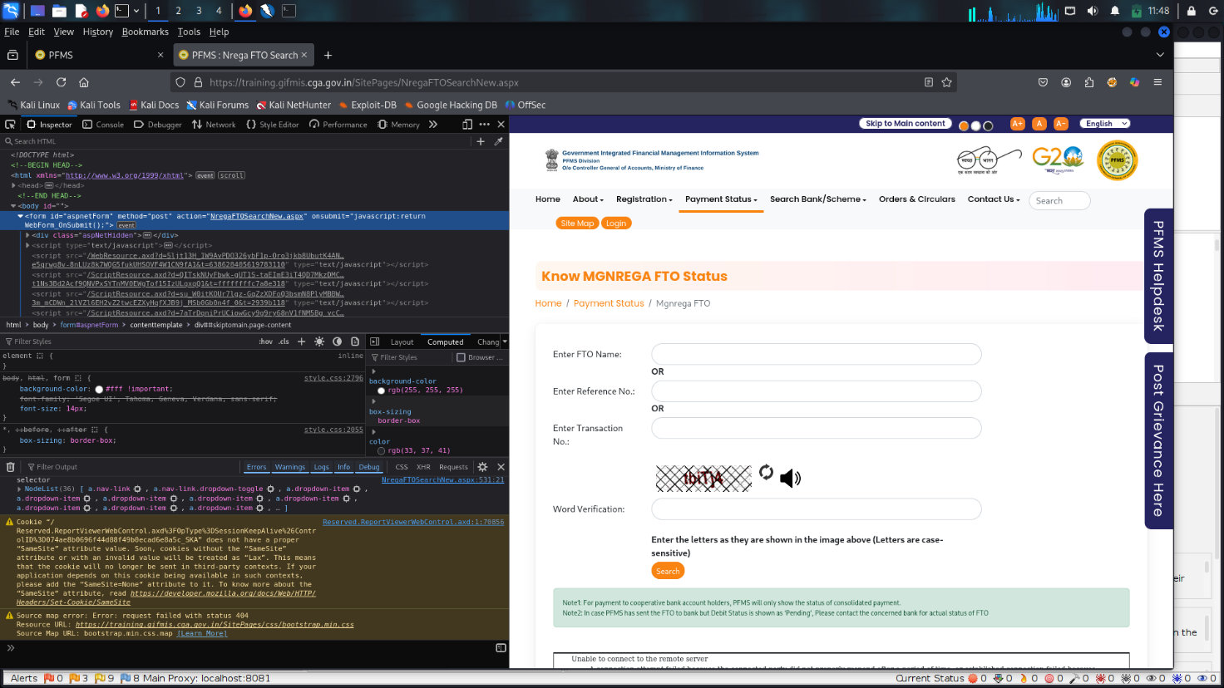
Recommendation:
Implement CSRF protection using unique, unpredictable tokens:
- Generate a random CSRF token per session/request.
- Embed token in every sensitive form and AJAX request.
- Validate token on server-side for each request.
Tool Used:- Browser

- Content Security Policy (CSP) Header Not Set
Brief Description | Risk Rating | Impact on Application | Probability of Attack
The application does not implement a Content Security Policy (CSP) header in HTTP responses.  CSP helps mitigate attacks such as Cross-Site Scripting (XSS), clickjacking, and data injection by restricting the sources from which scripts, styles, and other resources can be loaded.  Without CSP, the browser will execute any script included in the page, increasing the risk of exploitation if an attacker injects malicious content. | Medium | High | Medium
Impact:
Increased exposure to XSS and HTML injection attacks.
Malicious scripts can be executed in the context of the victim’s browser.
Possible theft of sensitive data (session cookies, tokens, PII).
Browser-based attacks like clickjacking and data exfiltration may succeed more easily.
Affected items:
https://training.gifmis.cga.gov.in/Home.aspx
Proof of Concept:
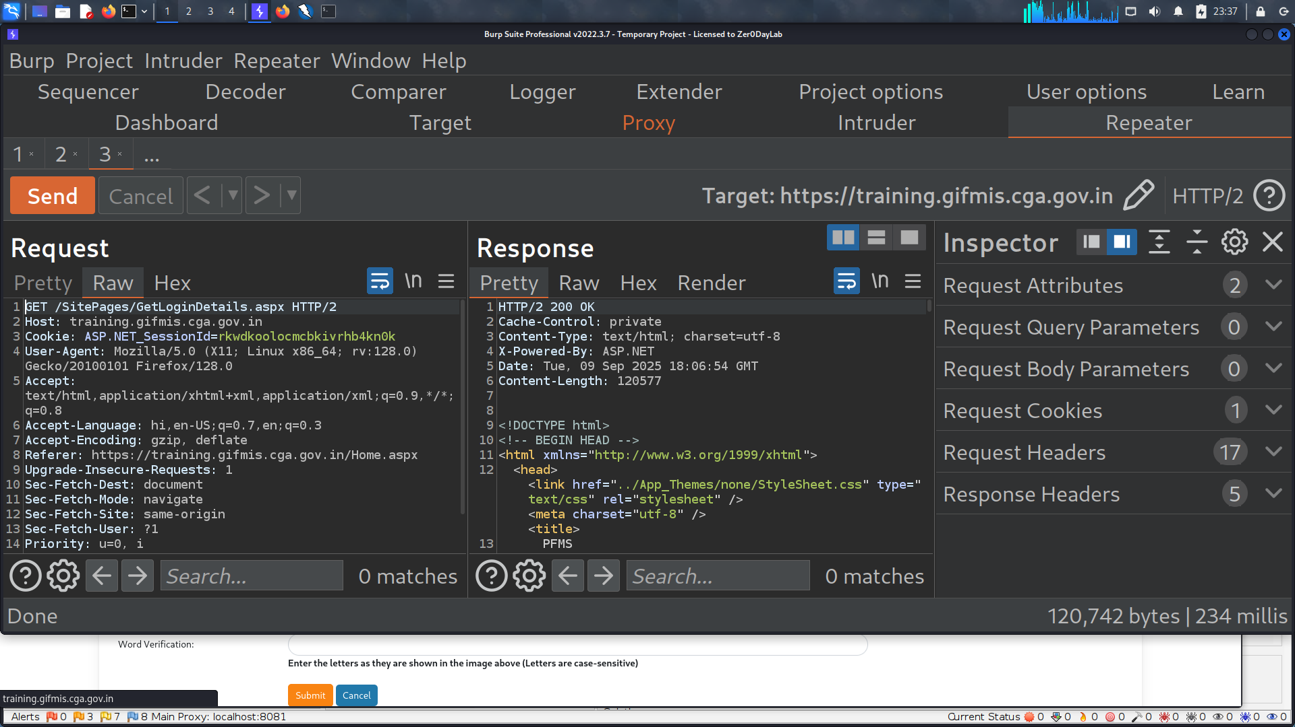

Recommendation:
Implement a strict Content Security Policy in HTTP responses. Example:
Content-Security-Policy: default-src 'self'; script-src 'self' https://apis.google.com; object-src 'none'; frame-ancestors 'none'; base-uri 'self';
Tailor the policy to the application needs by whitelisting only trusted sources.
Use reporting (Content-Security-Policy-Report-Only) during deployment to detect violations before enforcing.

Tool Used:- Burpsuite
- Missing Anti-clickjacking Header
Brief Description | Risk Rating | Impact on Application | Probability of Attack
The application’s HTTP response does not include any anti-clickjacking protection header (X-Frame-Options or Content-Security-Policy: frame-ancestors).  These headers instruct the browser whether the site is allowed to be embedded in a frame/iframe.  In their absence, the application is vulnerable to clickjacking attacks, where an attacker tricks a victim into unknowingly performing actions by overlaying the application in a hidden iframe. | Medium | High | Medium
Impact:
Attackers can embed the application in a malicious site using a hidden iframe.
Victims may be tricked into clicking hidden buttons/links (e.g., fund transfers, account settings).
May lead to unauthorized actions, loss of integrity, and reputational damage.

Affected items
https://training.gifmis.cga.gov.in/Home.aspx

Proof of Concept:
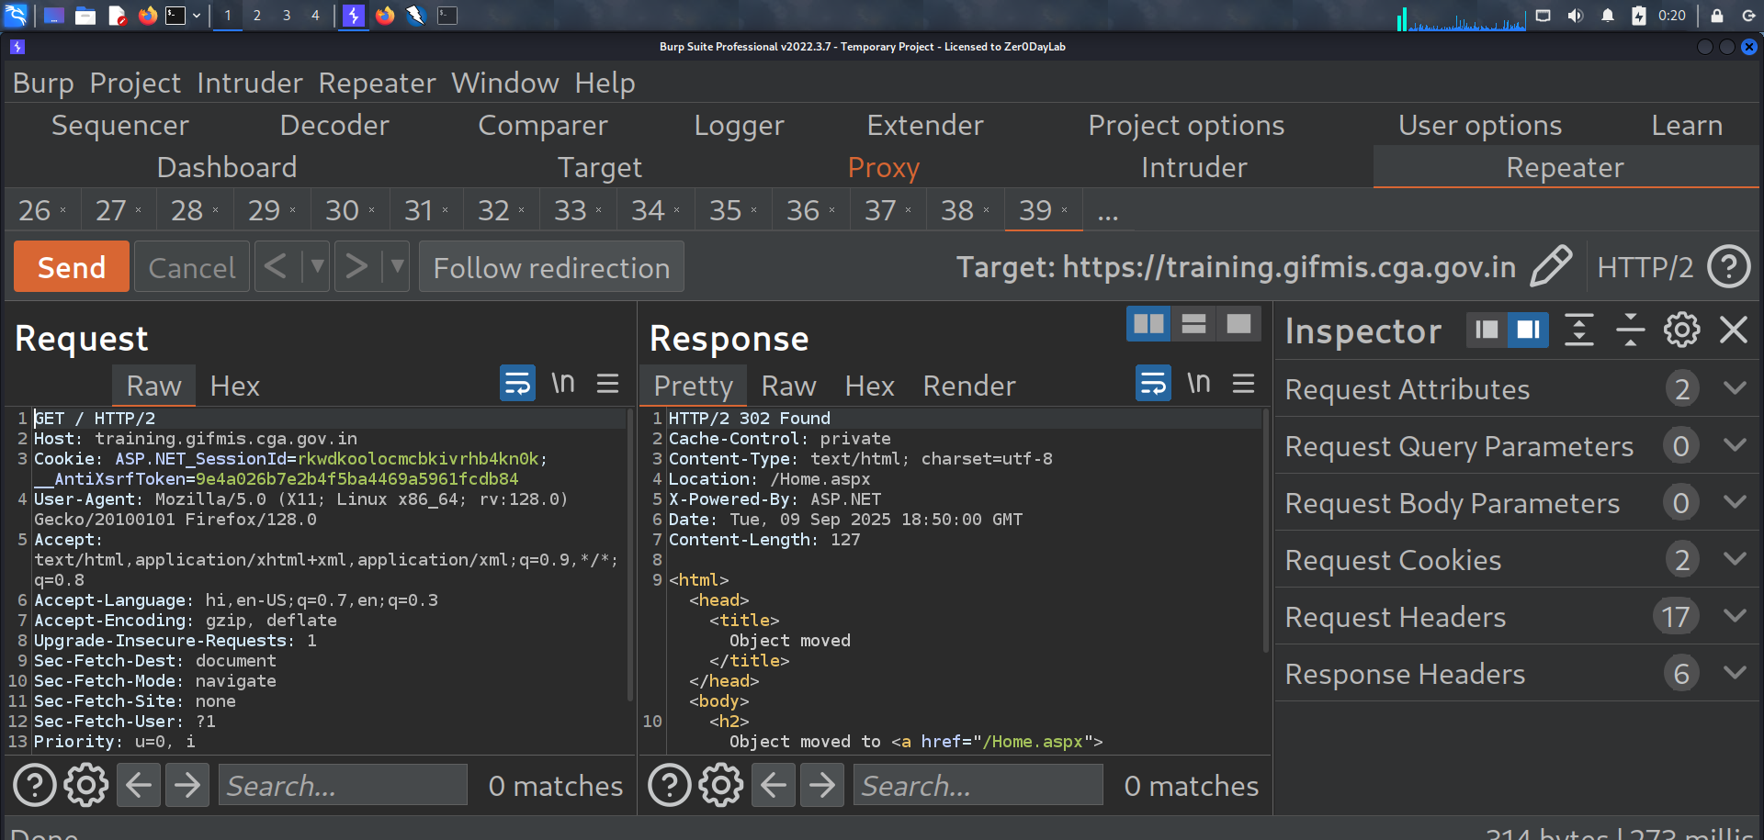

Recommendation:
Implement anti-clickjacking headers in server responses:
- Prefer modern CSP directive:
- Content-Security-Policy: frame-ancestors 'none';
- Or use legacy header for wider browser support:
- X-Frame-Options: DENY
or
X-Frame-Options: SAMEORIGIN

Tool Used:- Burpsuite

- Cookie with SameSite Attribute None
Brief Description | Risk Rating | Impact on Application | Probability of Attack
During testing, it was observed that the application sets cookies with the SameSite=None attribute (or without any SameSite attribute, which defaults to None).  The SameSite attribute controls whether cookies should be sent along with cross-site requests.  If SameSite=None is used without Secure flag, it increases the risk of Cross-Site Request Forgery (CSRF) and cross-site information leakage. | Low | Low | Medium
Impact: Cookies can be sent in cross-site requests, making the application more vulnerable to:
- CSRF attacks (attacker forces victim’s browser to send authenticated requests).
- Cross-site tracking (third-party sites can use the cookie).
If the cookie also lacks Secure flag, it may be transmitted over unencrypted HTTP, exposing it to theft via network sniffing.
Affected items
https://training.gifmis.cga.gov.in/Home.aspx
Proof of Concept:
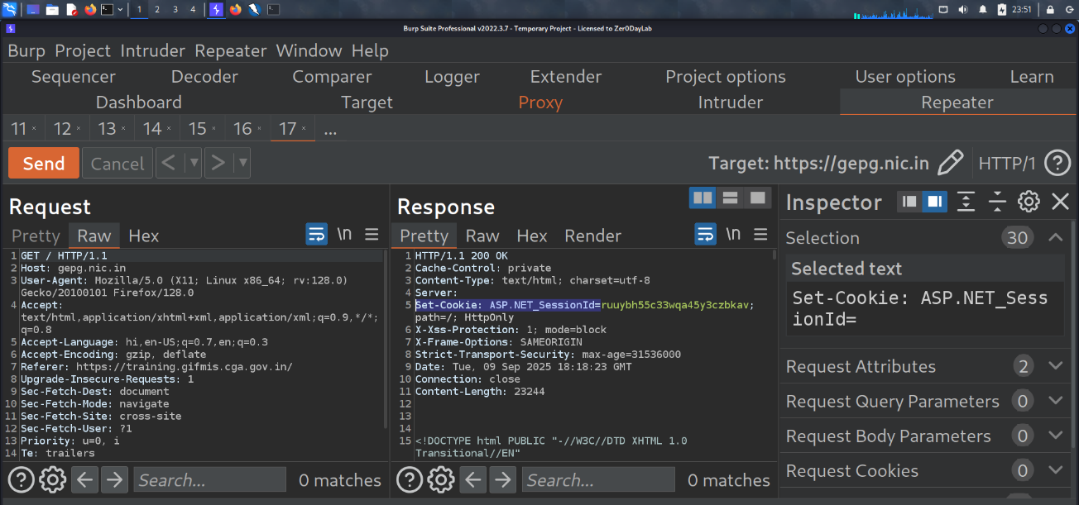

Recommendation:
Set SameSite=Strict or SameSite=Lax for all sensitive cookies (especially authentication/session cookies).
If SameSite=None is required for cross-domain usage, always set it with Secure flag:
Set-Cookie: sessionid=abc123; Path=/; Secure; Http Only ; Same Site=None
Avoid SameSite=None unless there is a legitimate business requirement

Tool Used:- Burp suite

- Cookie without SameSite Attribute
Brief Description | Risk Rating | Impact on Application | Probability of Attack
The application sets cookies without the SameSite attribute.  When SameSite is not specified, browsers treat it as SameSite=None (legacy behavior), which means the cookie will be sent along with cross-site requests.  This makes the application more susceptible to Cross-Site Request Forgery (CSRF) and cross-site tracking attacks. | Low | Medium | Medium
Impact:
Cookies may be included in cross-site requests without restriction.
Increases risk of CSRF attacks, where attackers can force authenticated users to perform unintended actions.
Cookies may also be exposed to cross-site tracking.
If combined with missing Secure flag, the cookie could also be leaked over unencrypted HTTP.
Affected items:
https://training.gifmis.cga.gov.in/Home.aspxindex
Proof of Concept:
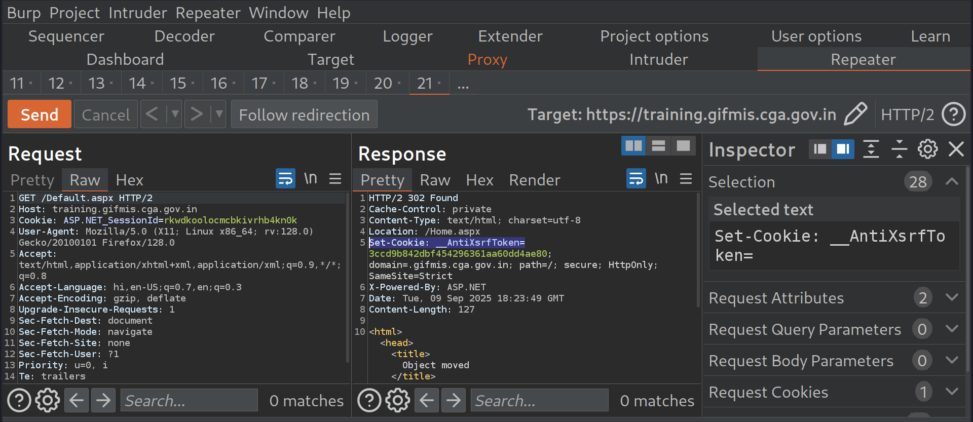

Recommendation:
Always set the SameSite attribute for all cookies, especially session/authentication cookies.
- For most cases:
- Set-Cookie: sessionid=xyz123; Path=/; Secure; HttpOnly; SameSite=Strict
- If cross-site functionality is required:
Set-Cookie: sessionid=xyz123; Path=/; Secure; HttpOnly; SameSite=None

Tool Used:- Burpsuite

- Server Leaks Information via "X-Powered-By" HTTP Response Header Field(s)
Brief Description | Risk Rating | Impact on Application | Probability of Attack
The application discloses server technology details through the X-Powered-By HTTP response header.  This provides attackers with unnecessary information about the backend framework or version. | Low | Low | Medium
Impact: Attackers can use disclosed version information to identify known vulnerabilities.
This increases the likelihood of targeted attacks and exploitation.
Affected items
https://training.gifmis.cga.gov.in/Home.aspxIndex
Proof of Concept:

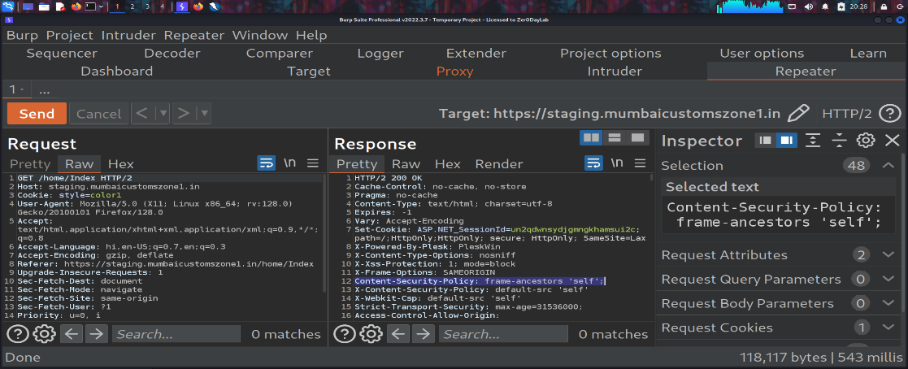

Recommendation:
Remove or disable the X-Powered-By header from server responses.
Configure the web server/framework to suppress version disclosure.

Tool used: Burp Suite

- Server Leaks Version Information via "Server" HTTP Response Header Field
Brief Description | Risk Rating | Impact on Application | Probability of Attack
The application discloses web server details (e.g., software and version) in the Server HTTP header.  This information can help attackers fingerprint the technology stack. | Low | Low | Medium
Impact: Attackers may map the server version to known vulnerabilities and exploits.
This increases the risk of targeted attacks against the server.
Affected items
https://training.gifmis.cga.gov.in/Home.aspxIndex
Proof of Concept:

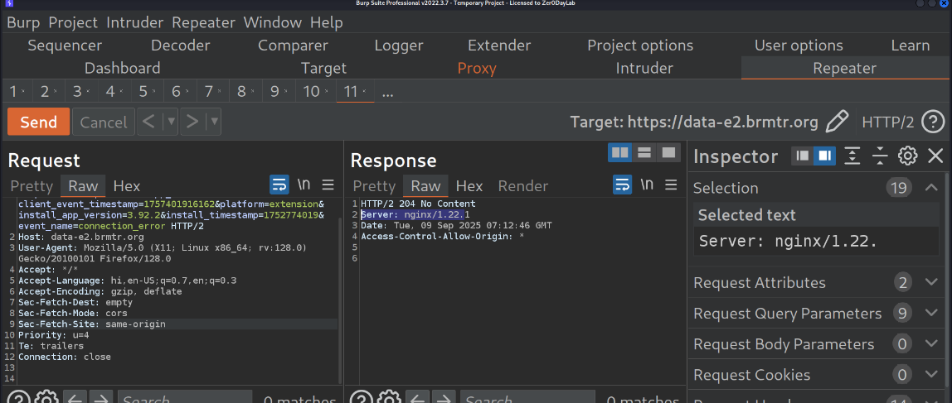

Recommendation: Suppress or remove the Server header from HTTP responses.
Avoid exposing version details to minimize the attack surface.

Tool used: Burp Suite

- Strict-Transport-Security Header Not Set
Brief Description | Risk Rating | Impact on Application | Probability of Attack
The application does not implement the Strict-Transport-Security (HSTS) header.  HSTS forces browsers to connect only via HTTPS, protecting against protocol downgrade and SSL stripping attacks. | Low | Low | Medium
Impact: Without HSTS, attackers can intercept traffic over HTTP and perform man-in-the-middle attacks.
Sensitive data like credentials may be exposed over insecure connections
Affected items
https://training.gifmis.cga.gov.in/Home.aspxIndex
Proof of Concept:

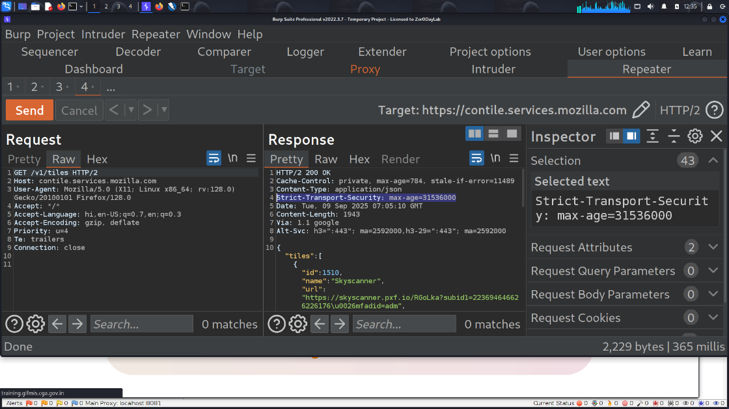

Recommendation:
Enable the HSTS header in server responses, for example:-Transport-Security: max-age=31536000; includeSubDomains; preload.
Tool used: Burp Suite
- X-Content-Type-Options Header Missing
Brief Description | Risk Rating | Impact on Application | Probability of Attack
The X-Content-Type-Options HTTP header is a security measure that tells the browser not to MIME-sniff the content type.  When this header is missing, browsers may ignore the declared Content-Type and try to guess the file type.  This can allow attackers to trick the browser into interpreting a harmless file (e.g., .txt or .json) as an executable script, enabling Cross-Site Scripting (XSS) or malicious content execution. | Low | Low | Low

Impact: Attackers can upload or inject files with misleading extensions (e.g., .jpg or .txt) that the browser might execute as HTML/JavaScript.
This could lead to stored or reflected XSS if a malicious file is interpreted as a script.
Increases risk of drive-by downloads or script execution in victim’s browser.
Overall, it lowers the browser’s protection level and widens the attack surface.
Affected items:-
https://training.gifmis.cga.gov.in/SitePages/Users/LoginDetails/Login.aspx
Proof of Concept:
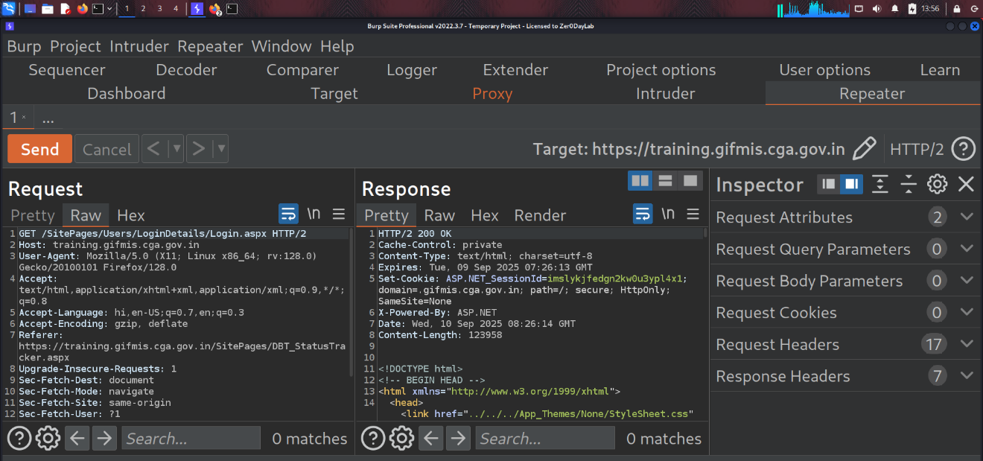

Recommendation: Configure the server to include: X-Content-Type-Options: nosniff in all HTTP responses.
Configure the server to include the following header in all HTTP responses: X-Content-Type-Options: nosniff
Ensure correct Content-Type is set for each response (e.g., text/html for HTML, application/json for APIs).

Tool used: Burpsuite
- Information Disclosure - Suspicious Comments
Brief Description | Risk Rating | Impact on Application | Probability of Attack
During testing, it was observed that the application source code and HTML responses contain comments that reveal sensitive or unnecessary information. While comments are not rendered to end users, they can be easily viewed through View Source or BurpSuite/Developer Tools. | Informational | Low | Low
Impact: Attackers may discover hidden or unlinked endpoints. Disclosure of internal system details. Even seemingly harmless comments can help attackers perform reconnaissance and craft targeted attacks.
Affected items:-
https://training.gifmis.cga.gov.in/SitePages/Users/LoginDetails/Login.aspx
Proof of Concept:

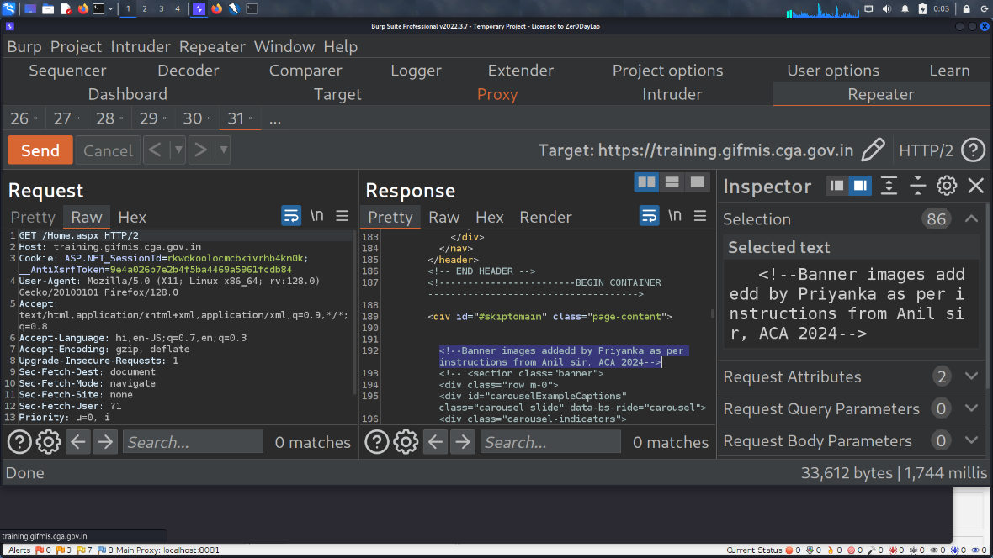

Recommendation:
Remove all unnecessary developer/debug comments from production code.
Perform a source code review to ensure no sensitive information is disclosed via comments.
Tool used: Burpsuite

General Guidelines
Validate Input and Output
The input that the server receives from the user can lead to malicious code entering the server. Similarly, the output shown to the user can transmit malicious code to the client system. All user input and output should be checked to ensure it is both appropriate and expected. Input validation should be done on the client-side as well as on the server-side.
There are three main models to consider about when designing a data validation strategy.
Accept Only Known Valid Data
A character set may be defined for each field where input from the user is accepted. E.g. “A-Z, a-z, @,., 0-9, _” is a character set for a field that accepts user email.
Reject Known Bad Data
A character set of bad data may be defined for the site that has to be rejected. E.g. “CREATE, DROP, OR”
Sanitize Known Bad Data
A character set of bad data is defined and any input field that has such a character is modified. E.g. “If there is a single quote (‘) in the data, it is replaced with two single quotes.”
All methods must check:
- Data Type
- Syntax
- Length
It is recommended to use the strategy of “Accept only known data”. Further all the allowed input/output data must be sanitized on the server side by replacing scripts tags, sent as part of user input/output, with appropriate representations.
For example
- “<” by &lt;
- “>” by &gt;
- “(“ by &#40

This would avoid scripts from being executed on the client side.
Client-side input must also be checked for URL encoded data. URL encoding sometimes referred to as percent encoding, is the accepted method of representing characters within a URI that may need special syntax handling to be correctly interpreted. This is achieved by encoding the character to be interpreted with a sequence of three characters. This triplet sequence consists of the percentage character “%” followed by the two hexadecimal digits representing the octet code of the original character. For example, the US-ASCII character set represents a space with octet code 32, or hexadecimal 20. Thus, its URL-encoded representation is %20.
Other common characters that can be used for malicious purposes and their URL encoded representations are: -
# | Character | URL encoded
 | ‘ | %27
 | “ | %22
 | ; | %3b
 | < | %3c
 | = | %3d
 | > | %3e
 | ) | %29
 | ( | %28
 | space | %20

All input validation checks should be completed after the data has been decoded and validated as acceptable content (e.g. maximum and minimum lengths, correct data type, does not contain any encoded data, textual data only contains the characters a-z and A-Z etc.)
A one-time check on the database is to be made for invalid malicious data. This would enable removal of input that has not been validated in earlier sessions. As otherwise the invalid data may cause script execution on the user’s browser.

Session Management / Strong session tracking
Session Tokens on Logout
In shared computing environments, session tokens take on a new risk. If the session tokens are not invalidated after logout, they can be reused to gain access to the application. It is imperative for the application to remove the cookies from both the server and the client side after the user has logged out. The user session maintained on the server side must also be invalidated immediately after logout.
Session Time-out
All the user Session tokens must be timed-out after a certain interval of user inactivity. The Session tokens that do not expire on the HTTP server can allow an attacker unlimited time to guess or brute force a valid authenticated session token. If a user's cookie file is captured or brute-forced, then an attacker can use these static-session tokens to gain access to that user's web accounts. Additionally, session tokens can be potentially logged and cached in proxy servers that, if broken into by an attacker, may contain similar sorts of information in logs that can be exploited if the particular session has not been expired on the HTTP server.
Session Token Transmission
If a session token is captured in transit through network interception, a web application account is then trivially prone to a replay or hijacking attack. Typical web encryption technologies include Secure Sockets Layer (SSLv2/v3) and Transport Layer Security (TLS v1) protocols in order to safeguard the state mechanism token.
Some more key points to remember:
Session ID’s that are used should have the following properties:
- Randomness.
  - Session Ids must be randomly generated.
  - Session Ids must be unpredictable.
  - Make use of non-linear algorithms to generate session ID’s
- Session ID Size
  - The size of a session ID should be large enough to ensure that it is not vulnerable to a brute force attack.
  - The character set used should be complex. i.e. Make use of special characters.
  - A length of 50 random characters is advised.
Salted Hashing
What is salted hashing?
The process starts with 2 elements of data:
1.) A clear text string (this could represent a password for instance).
2.) The salt, a random seed of data. This is the value used to augment a hash in order to ensure that 2 hashes of identical data yield different output.
In pseudo code we generate a salted hash as follows:
1.) Get the source string and salt as separate binary objects
2.) Concatenate the 2 binary values
3.) SHA hash the concatenation into Salted Password Hash
4.) Base64 Encode (concat (Salted Password Hash, Salt))
Credentials should be encrypted using salted hashes, so that even if the hashes are sniffed the possibility of replay attack does not exist.
References: http://www.owasp.org/images/3/33/Salted_Hashes_Demystified.doc
Cache Control Directives
Pages that contain sensitive information should not be stored in the local cache of the browser. To enforce this, HTTP directives need to be specified in the response. These HTTP directives need to be used to prevent enlisting of links on the browser history. The following HTTP directives can be sent by the server along with the response to the client. This would direct the browser to send a new request to the server each time it is generated.
Expires: <a previous date>, for e.g. Expires: Thu, 10 Jan 2020 19:20:00 GMT

Cache-Control: private
- Cache-Control: no-cache
- Cache-Control: no-store
- Cache-Control: must-revalidate
- Pragma: no-cache

The directive “Cache-Control: must-revalidate” directs the browser to fetch the pages from the server rather than picking it up from the local “Temporary Internet Folders”. It also directs the browser to remove the file from the temporary folders.

