Web Application Security Audit Report
of
Department of FCSCA.
Website: http://164.100.150.68/gstapi

Submitted By
Secnic Consultancy

Report Release Date | 21.07.2025
Type of Audit | Application Security Aduit
Type of Audit Report | Level 1 Report
Period | Aug 11, 2025 to Aug 14, 2025

© 2025 Department of FCSCA.
All rights reserved. All information contained in this document is confidential and proprietary to Department of FCSCA. No part of this document may be photocopied, electronically transferred, modified, or reproduced in any manner without the prior written consent of Department of FCSCA.
All brands or product names are trademarks or registered trademarks of their respective companies or organisations.

Document Control

Document Preparations
Document Title | Application Security Audit Report
Document ID | SCS/WAC/202503
Document Version | 1.0
Prepared By
Reviewed By
Approved By
Released By
Released Date | 11 Aug 2025

Document Change History

Version | Date | Remarks
1.0 | Aug 11, 2025 | Level 1 report

Document Distribution List

Name | Organization | Designation | Email Id
Atul Suri | Manager (Quality & Audit) | Department of FCSCA

Table of Contents

1. EXECUTIVE SUMMARY 3
1.1 Introduction 3
1.2 Scope 3
1.3 Summary of Findings 4
1.4 Overall Assessment 4
1.5 Key Vulnerabilities Discovered 5
2. OVERALL SUMMARY OF FINDINGS 6
3. BENCHMARKING WITH OWASP 6
4. KEY FINDINGS AND ACTION ITEMS 8
5. General Guidelines 16

EXECUTIVE SUMMARY

Introduction
This report presents the results of the penetration testing for the Department of FCSCA. Website (http://164.100.150.68/gstapi) The objective of the test was to find out vulnerabilities that can be seen and compromised by malicious users from the Internet. The application was found to be vulnerable to security risks including Security Misconfiguration, & Denial of Service issues etc... The following sections provide details of the scope of the penetration test, the IPs on which detailed penetration testing was conducted, and the detailed findings from the penetration testing exercise.

Our opinion provided in this report is valid for the period during which the penetration testing was carried out and is based on the information and the website contents provided for audit. Projection of any conclusions based on our findings for future periods and application versions is subject to the risk that the validity of such conclusions may be altered because of changes made to the network or application or system or the failure to make the changes to the network, application, system when required.

Disclaimers and Restrictions
- Organization’s management is responsible for its assertions. Our responsibility is to express an opinion on management’s assertion based on our audit.
- The audit was conducted in accordance with the Information Systems Auditing Standards issued by the Standards Board of Information Systems Audit and Control Association. Further, the objective of the audit was to obtain reasonable assurance that the assertion is not materially misstated. Our audit included
  - Obtaining an understanding of the objectives;
  - selectively testing these objectives;
  - testing and evaluating; and
  - performing such other procedures as we considered necessary under the circumstances. We believe that our audit provides a reasonable basis for our opinion.
- Because of inherent limitations in controls, errors or fraud may occur and may not be detected. Furthermore, the projection of any conclusions, based on our findings, to future periods are subject to the risk that changes made to the system or controls, changes in processing requirements, changes required because of the passage of time, or degree of compliance with the policies or procedures may alter the validity of such conclusions.
- This report is strictly to be used for the intend purpose of compiling the controls being followed for the purposes of analysis and improvement.
- It is firmly recommended to test out all our technical recommendations to the system internals such as services or registry in a test environment and the impact on the reliability and integrity of the system be evaluated before rolling out the changes to the production environment.
- This report does not include any representation on the financial, marketing, human resources or any other health of the Organization or on the future viability of the Organization or minimizing or exposure of all risks associated with computerized environment, due to its inherent limitations.

Details of the Auditing Team
Sr. No. | Name | Designation | Email Id | Professional Qualifications/ Certifications | Whether the resource has been shortlisted in the snapshot information published on Cert-In’s website (Yes/No)
1 |  |  |  | CISA, ISO 27001 LA | Yes
2 |  |  |  | ISO LA | Yes
3 |  |  |  | CEH | Yes

Audit Activities and Timelines

Audit Phases | Timelines
Receipt of URL/Application Auditee for Audit | Aug 11, 2025
Execution of Assignment
Report Preparation
Report Submission to Auditee | Aug 14, 2025

Audit Methodology and Criteria / Standard referred for audit
During the course of this review, we assessed the activities as stated above for compliance with OWASP & other known vulnerabilities and best practices, as applicable. We conducted the assignment using automated tools and conducting manual testing, as applicable.

Tools/Software Used

Sr. No. | Name of Tool/Software Used | Version of the tool/Software used | Open Source/Licensed
1. | Burp Suite Professional | 2024.5 | Licensed
2. | Invicti Standard | 25.5.1 | Licensed
3. | Kali Tools |  | Open Source
4. | Manual scripts

Scope
The following table details an overview on the scope of the penetration test.

Details
Application Name | IAOS
Testing IP/URL | http://164.100.150.68/gstapi
Mode of Test | Grey Box Testing

Summary of Findings
Penetration testing on the Website (https://164.100.150.68//) was performed for a period of 3 days. As a result of the penetration test following risks were identified:
No of Findings | Critical | High | Medium | Low | Informational
19 | 0 | 4 | 7 | 6 | 3

The table below gives an overall result of the findings from the penetration testing exercise. The “Key Findings and Action Items” section gives the details of the vulnerabilities and provides the recommendations to mitigate them.

Overall Assessment
We have identified 19 vulnerabilities during the penetration testing of the (http://164.100.150.68/gstapi). The team concluded the risks based on the results of the various tests carried out during the penetration testing process. The following table lists down the key vulnerabilities discovered.

Key Vulnerabilities Discovered
Sr. No. | VULNERABILITY | RISK LEVEL | REMARKS &  ACTION ITEMS
1. | No Encryption (TLS handshake failure ) | High | Enable HTTPS with a valid TLS certificate
2. | Missing Secure flag | High | Enable Secure flag while set cookie in Server side.
3. | Missing X-Frame-Options Header | High | Add: X-Frame-Options: Deny  Or  X-Frame-Options: SAMEORIGIN
4. | Server Version Disclosure | Medium | Remove or obfuscate server version details from HTTP headers.
5. | Multiple HTTP Ports exposed | High/Medium/Low | Hide Version headers.  Disable Unnecessary services  Redirect HTTP to Https  If 4723 port not in use close this..
6. | Absence of Anti-CSRF Tokens | Medium | Use a vetted library or framework that does not allow this weakness to occur or provides construsts that make this weakness easier to avoid
7. | Content security policy Header not set | Medium | Ensure that your web server load balancer , etc is configured to set the Content-security-Policy header.
8. | Emails Found in the viewstate | Medium | Verify the provided information is’nt confidential
9. | Potential IP Address Found in the viewstate | Medium | Remove any sensitive or internal information (such as IP addresses) from ViewState. Enable ViewState encryption (ViewStateEncryptionMode="Always") and ensure ViewState MAC is enabled to prevent tampering. Sensitive values should be stored server-side rather than in client-visible ViewState.
10. | Vulnerable JS library | Medium | Upgraded the latest version of the affected library
11 | Application Error disclosure | Low | Review the source code of the page and implement the custom error page
12. | Cross Domain javaScript Source File inclusion | Low | Ensure Java script file loaded only trusted sources, and the sources can’t be controlled by end users of the application
13. | Information disclosure – Debug Error Messages | Low | Disable debugging messages before pushing the production
14. | Strict – Transport-Security Header Not Set | Low | Ensure that your web server , application server , load balancer , etc, is configured to enforce Strict -Transport-Security
15. | Timestamp Disclosure | Low | Manual confirm that Timestamp data is not sensitive and that the data cannot be aggregatted to disclouse the exploitable patterns.
16. | X-Aspnet version response Header | Low | Configure the server so it wil not return those headers
17. | Authentication request identified | Informational | Do not pass sensitive information in URIs
18. | Information disclosure suspicious comment | Informational | Remove all comments that return information that may help an attacker and fix any underlying problems they refer to
19. | User Controllable HTML Element Attribute (Potential XSS) | Informational | Validate all input and sanitize output it before writing to any HTML attributes.

OVERALL SUMMARY OF FINDINGS
Below Chart gives the overall summary of number of Vulnerabilities discovered with the Risk rating. Total of 19 vulnerabilities 4 High 7 medium, 6 Low 3 Informational level Vulnerabilities were reported.

BENCHMARKING WITH OWASP
The below chart depicts the number of discovered vulnerabilities mapped to OWASP Testing Category.

OWASP has rated the Top Ten Vulnerabilities found in web applications worldwide. OWASP Top Ten Vulnerabilities details can be found at below link.

https://owasp.org/Top10/

The table shows the application vulnerability mapped with respect to the OWASP Top 10 - 2021 list.

Sl. No | Vulnerabilities | Status
1 | Injection Flaws | Unprotected
2 | Broken Authentication | Unprotected
3 | Sensitive Data Exposure | Unprotected
4 | XML External Entities (XXE) | PROTECTED
5 | Broken Access Control | Unprotected
6 | Security Misconfiguration | Unprotected
7 | Cross-Site Scripting (XSS) | Unprotected
8 | Insecure Deserialization | Unprotected
9 | Using Components with Known Vulnerabilities | Unprotected
10 | Insufficient Logging & Monitoring | Unprotected

Tools | Used
- Burp Suite | 1
- Kali Linux | 5
Browser | 1
OWASP ZAP | 12

KEY FINDINGS AND ACTION ITEMS

- No Encryption (TLS handshake failure )
Brief Description | Risk Rating | Impact on Application | Probability of Attack
This Exposes sensitive data such as login credentials, payment details, and session tokens to interception. | High | High | High
Impact:

- Complete loss of confidentiality and integrity of transmitted data
- Credentials and sensitive data can be intercepted by MITM attacker.
Could lead to full accound compromise, fraud, and legal non-compliance.
Affected items
http://164.100.150.68/
Proof of Concept:
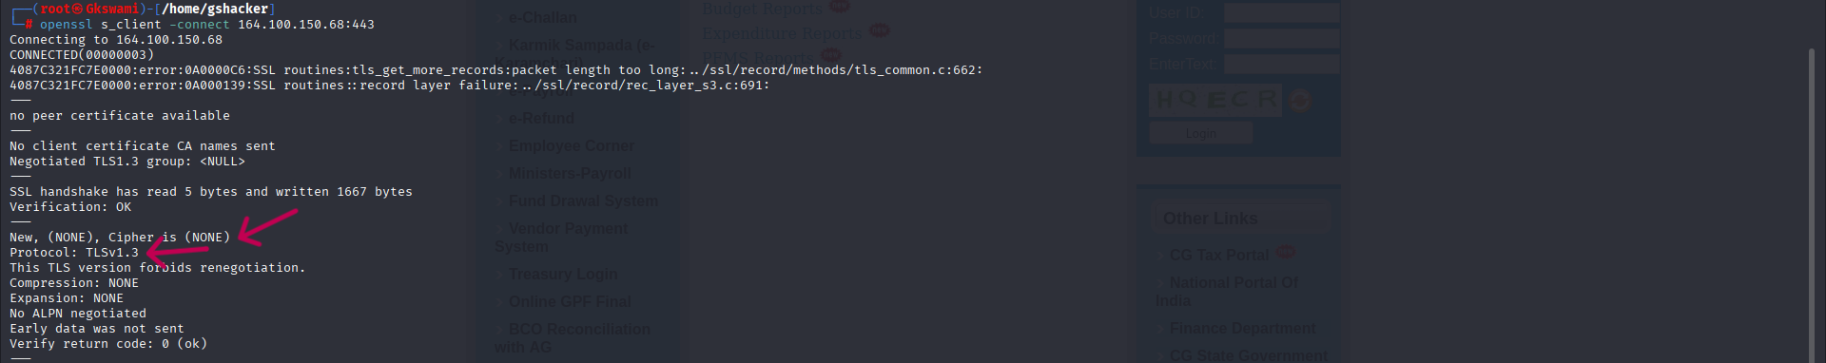
Recommendation:
Configure Strong cipher suites only (AES256,CHACHA20)
Disable non-encrypted HTTP or SSLv2/SSLv3 protocols.
Tool Used:- Openssl

- Missing Secure flag on Session Cookie
Brief Description | Risk Rating | Impact on Application | Probability of Attack
It was observed that the ASP .NET_sessionID cookie has the HttpOnly attribute set to true but the Sucure attribute set to False. | High | Medium | High
Impact:
If a session cookie without the secure flag is sent over an unencrypted HTTP connection, an attacker can intercept it using MITM techniques, potentially hijacking the user’s session
Affected items
http://164.100.150.68/
Proof of Concept:

Recommendation:
Enable Secure Flag for Cookies in Web.config (ASP.NET):
Enforce HTTPS site -wide no page should be accessible over HTTP
Use HSTS to ensure browsers only use HTTPS:

Tool Used:- Python
- Missing X-Frame-Options Header
Brief Description | Risk Rating | Impact on Application | Probability of Attack
The HTTP response for the web application does not include the X-Frame-Options header.  This header is used to control whether a browser should be allowed to render a page in a <frame> or <iframe>.  Without it, the application is vulnerable to Clickjacking attacks, where a malicious site can embed the application in a hidden frame and trick users into clicking on concealed UI elements. | High | medium | medium
Impact:
Attackers can trick users into performing unintended actions on the web application (e.g., clicking a hidden “delete” button).
Sensitive operations can be executed without the user’s knowledge.
May lead to account compromise, data loss, or unauthorized actions.
Affected items
http://164.100.150.68/gstapi/login
Proof of Concept:
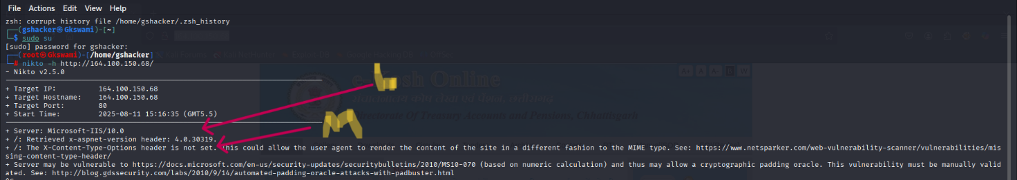
Recommendation:
Add the X-Frame-Options header to all HTTP responses.
Possible secure values:
- DENY → Completely prevent the page from being displayed in a frame.
- SAMEORIGIN → Allow framing only from the same origin.
- ALLOW-FROM uri → Allow framing from a specific trusted origin (not supported in all browsers).
Tool Used:- Nikto

- Server Version Disclosure
Brief Description | Risk Rating | Impact on Application | Probability of Attack
The HTTP response headers disclose detailed server information, such as web server type and version (e.g., Server: Apache/2.4.49 (Ubuntu) or X-Powered-By: PHP/7.4.3).  Exposing such details can help attackers identify specific server software and version, making it easier to find and exploit known vulnerabilities for that version. | Medium | High | High
Impact:
Attackers can:
- Identify the exact server version.
- Search for public exploits targeting that version.
- Use this information in reconnaissance to plan targeted attacks.
Increases the success rate of attacks like RCE (Remote Code Execution), SQL Injection, or DoS if the disclosed version has known vulnerabilities.
Affected items
http://164.100.150.68/

Proof of Concept:
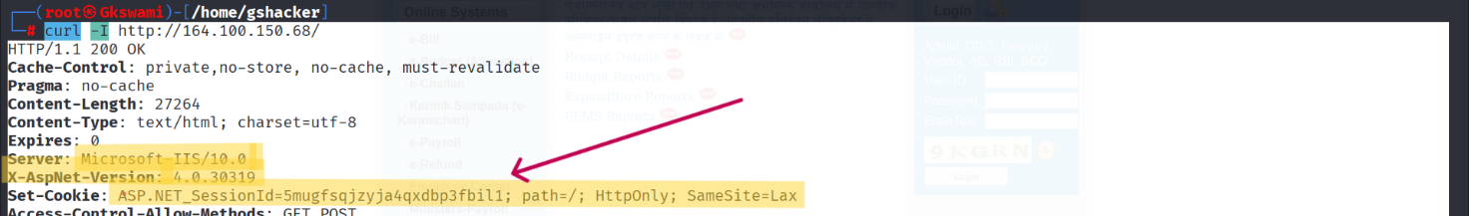

Recommendations:
Disable server version disclosure in HTTP response headers.

Tool Used:- CURL

Multiple HTTP Ports exposed
Brief Description | Risk Rating | Impact on Application | Probability of Attack
The server is listening on multiple HTTP ports (80, 443) in addition to the primary application port.  These additional open ports may host administrative panels, test applications, default installations, or outdated services that are not intended for public access.  Exposing multiple HTTP services increases the attack surface of the application. | Medium | High | Medium
Impact: Discover and exploit vulnerabilities in applications running on secondary ports. Access unprotected admin consoles or development interfaces. Leverage outdated or misconfigured services for exploitation. Increases risk of unauthorized access, sensitive data leakage, or compromise of the main application.
Affected items
http://164.100.150.68/

Proof of Concept:
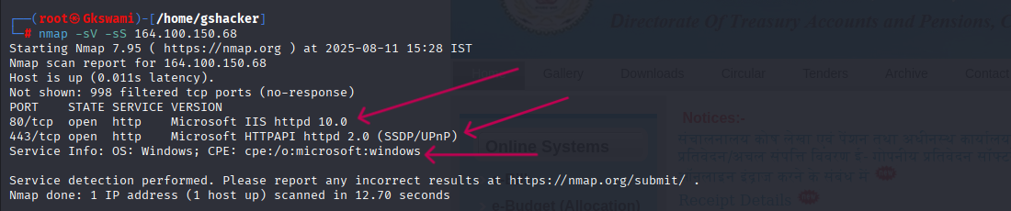
Recommendations:
Close all unnecessary HTTP ports and allow only required services to be accessible from the internet.

Tool Used: - Nmap

Absence of Anti-CSRF Tokens
Brief Description | Risk Rating | Impact on Application | Probability of Attack
The application does not implement Anti-CSRF (Cross-Site Request Forgery) tokens in sensitive state-changing requests (such as account updates, password changes, or financial transactions).  Without this protection, an attacker can trick an authenticated user into unknowingly submitting malicious requests, leveraging their active session. | Medium | Medium | High
Impact:
- Attackers can perform unauthorized actions on behalf of authenticated users, leading to account takeover, data loss, or fraudulent transactions..
Affected items
http://164.100.150.68/gstapi/.hg

Proof of Concept:
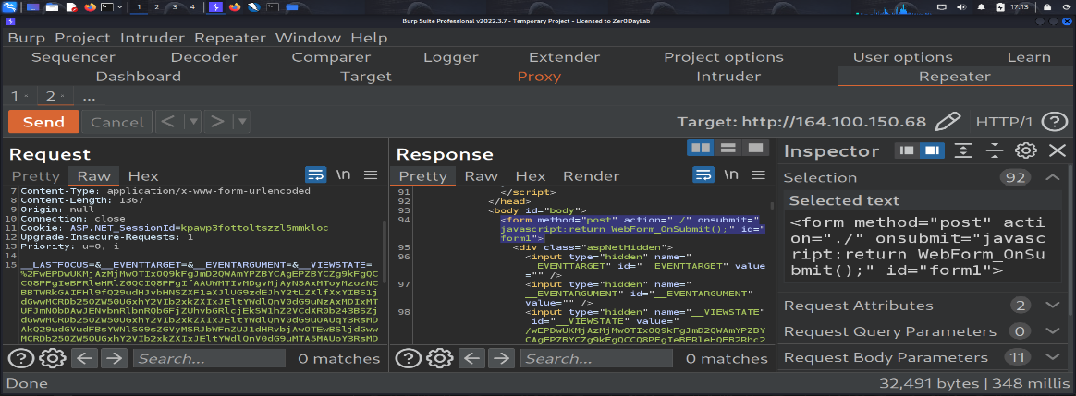
Recommendations:
Implement unique, session-bound CSRF tokens for all state-changing requests and validate them server-side.

Tool Used:- Burp Suite

Content security policy Header not set
Brief Description | Risk Rating | Impact on Application | Probability of Attack
The application does not return a Content-Security-Policy (CSP) HTTP response header. CSP is a security standard that helps prevent a wide range of attacks such as Cross-Site Scripting (XSS), clickjacking, and code injection by restricting the sources from which content can be loaded. | Medium | Low | High
Impact:
Increases the risk of XSS attacks, data theft, and session hijacking.
Allows loading of malicious scripts, styles, or other resources from untrusted sources.
Makes it easier for attackers to exploit vulnerabilities through client-side injection.
Affected items

http://164.100.150.68/gstapi/

Proof of Concept:
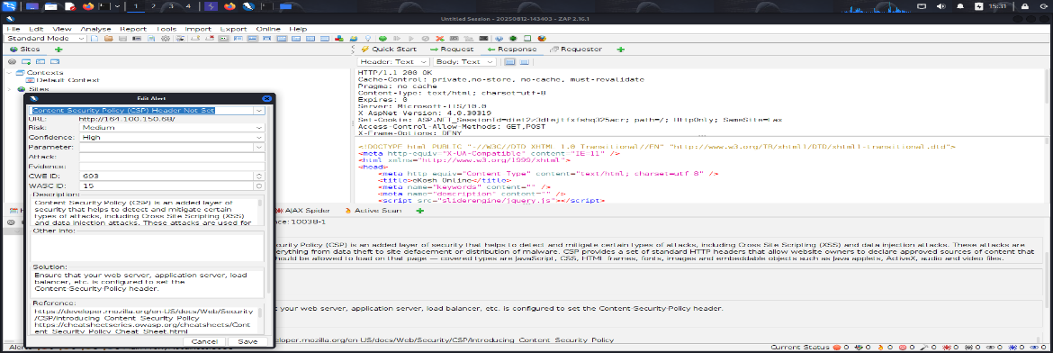
Recommendations:
implement a strict CSP header in the HTTP response, for example:
Content-Security-Policy: default-src 'self'; script-src 'self'; style-src 'self';
Review and adjust the policy to match application needs while minimizing external sources.
Regularly test CSP implementation to ensure it does not break legitimate site functionality.

Tool Used:- Owasp Zap

Emails Found in the view state
Brief Description | Risk Rating | Impact on Application | Probability of Attack
During testing, email addresses were discovered embedded in the ASP.NET View State. View State is used to store page and control state information between requests, but embedding sensitive data such as email addresses can lead to information disclosure if intercepted or decoded | Medium | Medium | Medium

Impact:
Leakage of sensitive or personal information (email addresses).
Exposure of internal or user contact details that can be exploited for spam, phishing, or social engineering attacks.
Increases the application’s attack surface by giving attackers valid identifiers.
Affected items
http://164.100.150.68/gstapi/

Proof of Concept:
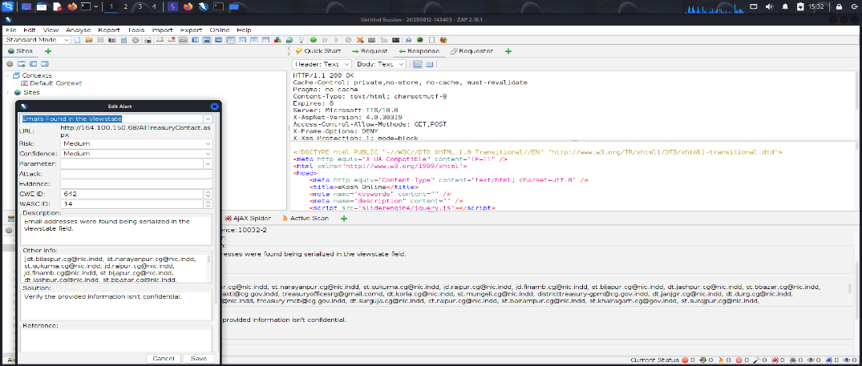
Recommendations:
Avoid storing sensitive data in the ViewState or enable ViewState encryption and use secure server-side storage.

Tool Used:- OWASP ZAP

Potential IP Address Found in the viewstate
Brief Description | Risk Rating | Impact on Application | Probability of Attack
Potential IP addresses were found embedded in the ASP.NET ViewState, which may lead to information disclosure if intercepted or decoded.. | Medium | Medium | Medium

Impact:
Exposure of internal or external IP addresses can assist attackers in mapping the network and targeting specific systems.
Affected items: http://164.100.150.68/gstapi/assets%5Cjs%5Cjquery.min.js

Proof of Concept:

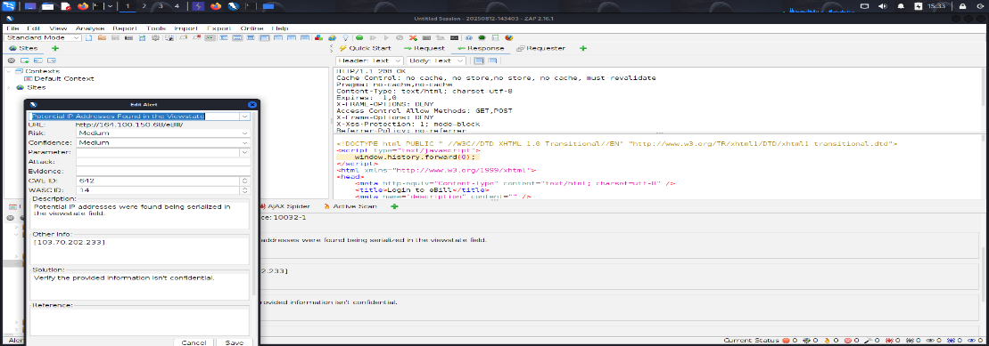
Recommendations:
Avoid storing IP addresses in the ViewState or enable ViewState encryption and use secure server-side storage.

Tool Used:- OWASP ZAP

Vulnerable JS library
Brief Description | Risk Rating | Impact on Application | Probability of Attack
The application is using an outdated or vulnerable JavaScript library version that contains known security flaws. | Medium | Low | High

Impact:
Attackers can exploit vulnerabilities in the library to perform XSS, data theft, or other client-side attacks.

Affected items:

http://164.100.150.68/gstapi/

Proof of Concept:

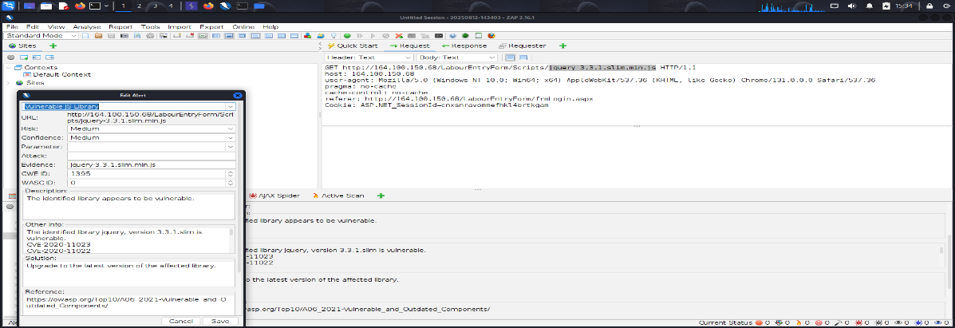

Recommendations:
Update the JavaScript library to the latest stable and secure version, and regularly review third-party dependencies for security updates.

Tool Used:- OWASP ZAP

Application Error disclosure
Brief Description | Risk Rating | Impact on Application | Probability of Attack
The application displays detailed error messages that reveal sensitive information such as file paths, server details, or stack traces. | Low | Low | Low
Impact:
Exposure of internal technical details can help attackers identify vulnerabilities and plan
targeted attacks.

Affected items
http://164.100.150.68/ePayroll/SelfDDO/frmLogin.aspx

Proof of Concept:

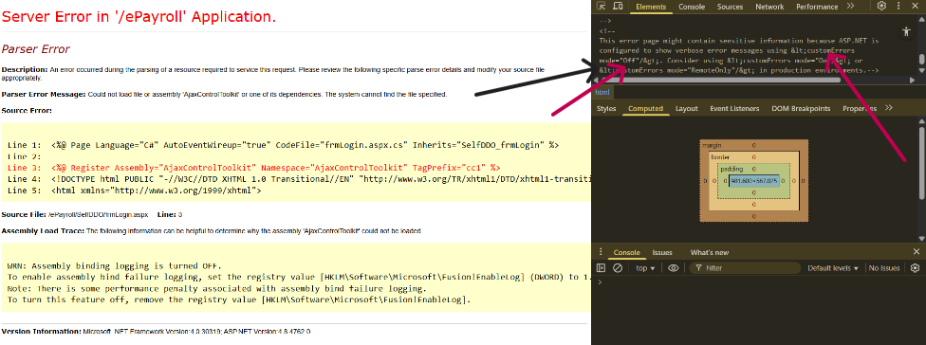
Recommendations:
Configure the application to show generic error messages to users and log detailed errors on the server side only. Create a Custom error page

Tool Used:- Browser

Cross Domain javaScript Source File inclusion
Brief Description | Risk Rating | Impact on Application | Probability of Attack
The application includes JavaScript files from external domains, which could be tampered with to execute malicious code in the user's browser. | Low | Low | Low
Impact:
An attacker controlling the external source could perform XSS, steal sensitive data, or
compromise user sessions.

Affected items
http://164.100.150.68/ExpenditureReportsHome.aspx

Proof of Concept:
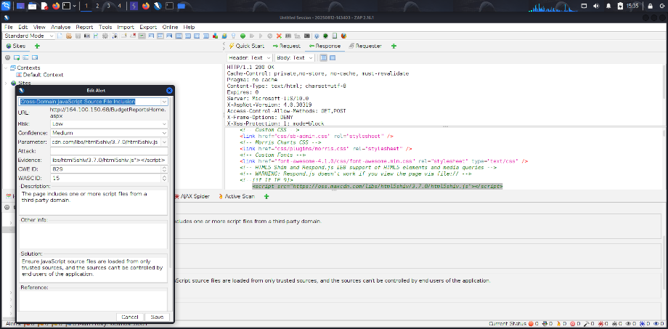

Recommendations:
Host JavaScript files locally or use only trusted sources with Subresource Integrity (SRI) and a strict Content Security Policy (CSP).
Tool Used:- OWASP ZAP

Information disclosure – Debug Error Messages
Brief Description | Risk Rating | Impact on Application | Probability of Attack
The application displays debug error messages that reveal sensitive information such as server configuration, file paths, or database queries. | Low | Low | Low
Impact:
Disclosure of internal technical details can assist attackers in identifying vulnerabilities and
crafting targeted attacks.

Affected items
http://164.100.150.68/ePayroll/SelfDDO/frmLogin.aspx

Proof of Concept:
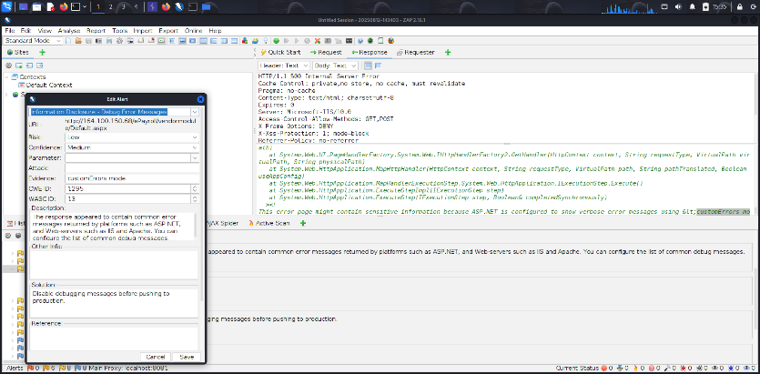

Recommendations:
Disable debug mode in the production environment and configure the application to show only generic error messages to end users.
Tool Used:- OWASP ZAP

Strict – Transport-Security Header Not Set
Brief Description | Risk Rating | Impact on Application | Probability of Attack
The application does not return the Strict-Transport-Security (HSTS) header, which enforces secure HTTPS connections. | Low | Low | Low
Impact:
Without HSTS, users may be vulnerable to SSL stripping and man-in-the-middle (MITM)
attacks.

Affected items
https://tracking-protection.cdn.mozilla.net/google-trackwhite-digest256/128.0/1754651396

Proof of Concept:
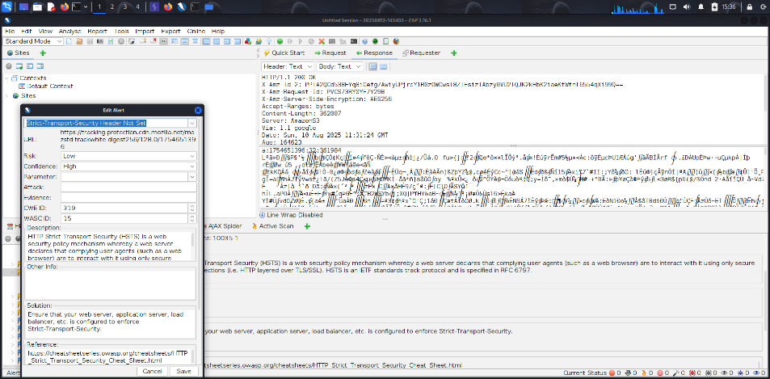

Recommendations:
Configure the server to include the Strict-Transport-Security header with an appropriate max-age value and preload option.
Tool Used:- OWASP ZAP

Timestamp Disclosure
Brief Description | Risk Rating | Impact on Application | Probability of Attack
The application reveals timestamp information in responses or page content, which can disclose system or application update details. | Low | Low | Low
Impact:
Attackers can use timestamp data to infer system uptime, software version age, or patch
timelines, aiding in targeted attacks.

Affected items
https://tracking-protection.cdn.mozilla.net/google-trackwhite-digest256/128.0/1754651396

Proof of Concept:
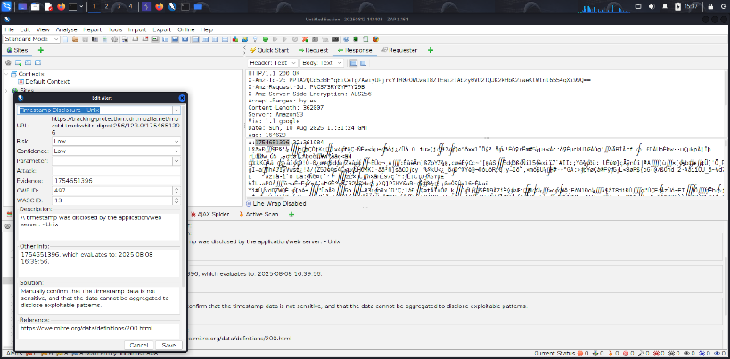

Recommendations:
Remove or obfuscate timestamp information from client-facing content unless required for functionality.

Tool Used:- OWASP ZAP

X-Aspnet version response Header
Brief Description | Risk Rating | Impact on Application | Probability of Attack
The application discloses the ASP.NET version in the X-AspNet-Version HTTP response header. | Low | Low | Low
Impact:
Revealing the framework version can help attackers identify specific vulnerabilities and target
known exploits.

Affected items
http://164.100.150.68

Proof of Concept:
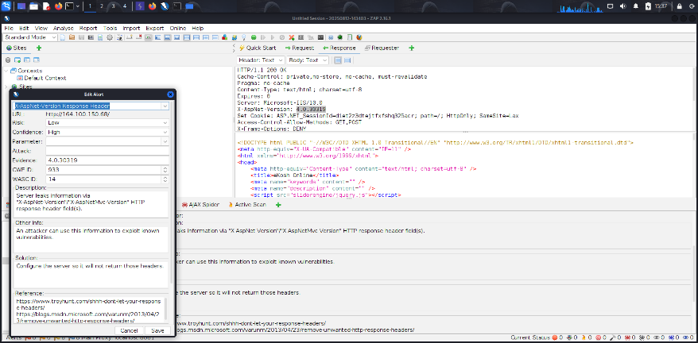

Recommendations:
Configure the server to remove or suppress the X-AspNet-Version header from HTTP responses.
Tool Used:- OWASP ZAP

Authentication request identified
Brief Description | Risk Rating | Impact on Application | Probability of Attack
The application exposes authentication request patterns or parameters that can reveal login endpoints and authentication mechanisms. | Informational | Low | Low
Impact:
Attackers can target identified authentication points for brute force, credential stuffing, or
enumeration attacks.

Affected items
http://164.100.150.68/ImageGallery.aspx

Proof of Concept:

Recommendations:

Obfuscate authentication request details where possible and implement strong security controls such as rate limiting and multi-factor authentication.

Tool Used:- OWASP ZAP

Information disclosure suspicious comment

Brief Description | Risk Rating | Impact on Application | Probability of Attack
The application’s source code or HTML comments contain suspicious or sensitive information such as credentials, file paths, or internal notes. | Informational | Low | Low
Impact:
Attackers can use the disclosed information to identify vulnerabilities, access sensitive data,
or compromise the application.

Affected items
http://164.100.150.68

Proof of Concept:

Recommendations:
Remove sensitive or unnecessary comments from the code before deploying to production.

Tool Used:- OWASP ZAP

  - User Controllable HTML Element Attribute
Brief Description | Risk Rating | Impact on Application | Probability of Attack
The application contains HTML element attributes that can be modified by user input, potentially allowing the injection of malicious content. | Informational | Low | Low
Impact:
Attackers may exploit this to perform Cross-Site Scripting (XSS) or manipulate the
application's behavior in the user's browser.

Affected items
http://164.100.150.68/HomePage.aspx

Proof of Concept:

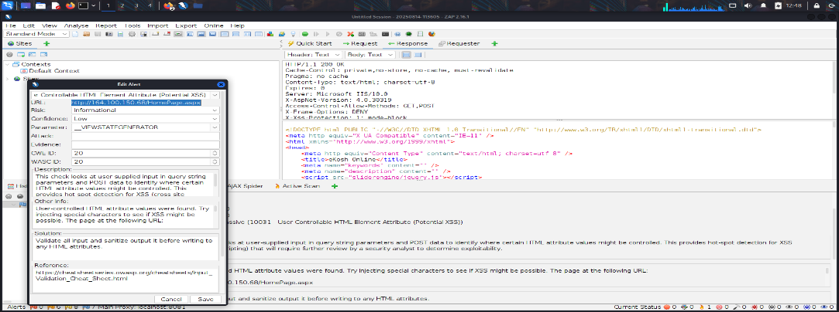
Recommendations:
Validate all input and sanitize output it before writing to any HTML attributes.

Tool Used: - OWASP ZAP

General Guidelines
Validate Input and Output
The input that the server receives from the user can lead to malicious code entering the server. Similarly, the output shown to the user can transmit malicious code to the client system. All user input and output should be checked to ensure it is both appropriate and expected. Input validation should be done on the client-side as well as on the server-side.
There are three main models to consider about when designing a data validation strategy.
Accept Only Known Valid Data
A character set may be defined for each field where input from the user is accepted. E.g. “A-Z, a-z, @,., 0-9, _” is a character set for a field that accepts user email.
Reject Known Bad Data
A character set of bad data may be defined for the site that has to be rejected. E.g. “CREATE, DROP, OR”
Sanitize Known Bad Data
A character set of bad data is defined and any input field that has such a character is modified. E.g. “If there is a single quote (‘) in the data, it is replaced with two single quotes.”
All methods must check:
- Data Type
- Syntax
- Length
It is recommended to use the strategy of “Accept only known data”. Further all the allowed input/output data must be sanitized on the server side by replacing scripts tags, sent as part of user input/output, with appropriate representations.
For example
- “<” by &lt;
- “>” by &gt;
- “(“ by &#40

This would avoid scripts from being executed on the client side.
Client-side input must also be checked for URL encoded data. URL encoding sometimes referred to as percent encoding, is the accepted method of representing characters within a URI that may need special syntax handling to be correctly interpreted. This is achieved by encoding the character to be interpreted with a sequence of three characters. This triplet sequence consists of the percentage character “%” followed by the two hexadecimal digits representing the octet code of the original character. For example, the US-ASCII character set represents a space with octet code 32, or hexadecimal 20. Thus, its URL-encoded representation is %20.
Other common characters that can be used for malicious purposes and their URL encoded representations are: -
# | Character | URL encoded
 | ‘ | %27
 | “ | %22
 | ; | %3b
 | < | %3c
 | = | %3d
 | > | %3e
 | ) | %29
 | ( | %28
 | space | %20

All input validation checks should be completed after the data has been decoded and validated as acceptable content (e.g. maximum and minimum lengths, correct data type, does not contain any encoded data, textual data only contains the characters a-z and A-Z etc.)
A one-time check on the database is to be made for invalid malicious data. This would enable removal of input that has not been validated in earlier sessions. As otherwise the invalid data may cause script execution on the user’s browser.

Session Management / Strong session tracking
Session Tokens on Logout
In shared computing environments, session tokens take on a new risk. If the session tokens are not invalidated after logout, they can be reused to gain access to the application. It is imperative for the application to remove the cookies from both the server and the client side after the user has logged out. The user session maintained on the server side must also be invalidated immediately after logout.
Session Time-out
All the user Session tokens must be timed-out after a certain interval of user inactivity. The Session tokens that do not expire on the HTTP server can allow an attacker unlimited time to guess or brute force a valid authenticated session token. If a user's cookie file is captured or brute-forced, then an attacker can use these static-session tokens to gain access to that user's web accounts. Additionally, session tokens can be potentially logged and cached in proxy servers that, if broken into by an attacker, may contain similar sorts of information in logs that can be exploited if the particular session has not been expired on the HTTP server.
Session Token Transmission
If a session token is captured in transit through network interception, a web application account is then trivially prone to a replay or hijacking attack. Typical web encryption technologies include Secure Sockets Layer (SSLv2/v3) and Transport Layer Security (TLS v1) protocols in order to safeguard the state mechanism token.
Some more key points to remember:
Session ID’s that are used should have the following properties:
- Randomness.
  - Session Ids must be randomly generated.
  - Session Ids must be unpredictable.
  - Make use of non-linear algorithms to generate session ID’s
- Session ID Size
  - The size of a session ID should be large enough to ensure that it is not vulnerable to a brute force attack.
  - The character set used should be complex. i.e. Make use of special characters.
  - A length of 50 random characters is advised.
Salted Hashing
What is salted hashing?
The process starts with 2 elements of data:
1.) A clear text string (this could represent a password for instance).
2.) The salt, a random seed of data. This is the value used to augment a hash in order to ensure that 2 hashes of identical data yield different output.
In pseudo code we generate a salted hash as follows:
1.) Get the source string and salt as separate binary objects
2.) Concatenate the 2 binary values
3.) SHA hash the concatenation into Salted Password Hash
4.) Base64 Encode (concat (Salted Password Hash, Salt))
Credentials should be encrypted using salted hashes, so that even if the hashes are sniffed the possibility of replay attack does not exist.
References: http://www.owasp.org/images/3/33/Salted_Hashes_Demystified.doc
Cache Control Directives
Pages that contain sensitive information should not be stored in the local cache of the browser. To enforce this, HTTP directives need to be specified in the response. These HTTP directives need to be used to prevent enlisting of links on the browser history. The following HTTP directives can be sent by the server along with the response to the client. This would direct the browser to send a new request to the server each time it is generated.
Expires: <a previous date>, for e.g. Expires: Thu, 10 Jan 2020 19:20:00 GMT

Cache-Control: private
- Cache-Control: no-cache
- Cache-Control: no-store
- Cache-Control: must-revalidate
- Pragma: no-cache

The directive “Cache-Control: must-revalidate” directs the browser to fetch the pages from the server rather than picking it up from the local “Temporary Internet Folders”. It also directs the browser to remove the file from the temporary folders.

