Web Application Security Audit Report
of
Department of FCSCA.
Website: https://staging.mumbaicustomszone1.in/Home/
Submitted By
Secnic Consultancy

Report Release Date | 21.08.2025
Type of Audit | Application Security Aduit
Type of Audit Report | Level 1 Report
Period | Sep 01, 2025 to Sep 03, 2025

© 2025 Department of FCSCA.
All rights reserved. All information contained in this document is confidential and proprietary to Department of FCSCA. No part of this document may be photocopied, electronically transferred, modified, or reproduced in any manner without the prior written consent of Department of FCSCA.
All brands or product names are trademarks or registered trademarks of their respective companies or organisations.

Document Control

Document Preparations
Document Title | Application Security Audit Report
Document ID | SCS/WAC/202503
Document Version | 1.0
Prepared By
Reviewed By
Approved By
Released By
Released Date | 01 Sep 2025

Document Change History

Version | Date | Remarks
1.0 | Sep 01, 2025 | Level 1 report

Document Distribution List

Name | Organization | Designation | Email Id
Atul Suri | Manager (Quality & Audit) | Department of FCSCA

Table of Contents

1. EXECUTIVE SUMMARY 3
1.1 Introduction 3
1.2 Scope 3
1.3 Summary of Findings 4
1.4 Overall Assessment 4
1.5 Key Vulnerabilities Discovered 5
2. OVERALL SUMMARY OF FINDINGS 6
3. BENCHMARKING WITH OWASP 6
4. KEY FINDINGS AND ACTION ITEMS 8
5. General Guidelines 16

EXECUTIVE SUMMARY

Introduction
This report presents the results of the penetration testing for the Department of FCSCA. Website (https://staging.mumbaicustomszone1.in/Home/) The objective of the test was to find out vulnerabilities that can be seen and compromised by malicious users from the Internet. The application was found to be vulnerable to security risks including Security Misconfiguration, & Denial of Service issues etc... The following sections provide details of the scope of the penetration test, the IPs on which detailed penetration testing was conducted, and the detailed findings from the penetration testing exercise.

Our opinion provided in this report is valid for the period during which the penetration testing was carried out and is based on the information and the website contents provided for audit. Projection of any conclusions based on our findings for future periods and application versions is subject to the risk that the validity of such conclusions may be altered because of changes made to the network or application or system or the failure to make the changes to the network, application, system when required.

Disclaimers and Restrictions
- Organization’s management is responsible for its assertions. Our responsibility is to express an opinion on management’s assertion based on our audit.
- The audit was conducted in accordance with the Information Systems Auditing Standards issued by the Standards Board of Information Systems Audit and Control Association. Further, the objective of the audit was to obtain reasonable assurance that the assertion is not materially misstated. Our audit included
  - Obtaining an understanding of the objectives;
  - selectively testing these objectives;
  - testing and evaluating; and
  - performing such other procedures as we considered necessary under the circumstances. We believe that our audit provides a reasonable basis for our opinion.
- Because of inherent limitations in controls, errors or fraud may occur and may not be detected. Furthermore, the projection of any conclusions, based on our findings, to future periods are subject to the risk that changes made to the system or controls, changes in processing requirements, changes required because of the passage of time, or degree of compliance with the policies or procedures may alter the validity of such conclusions.
- This report is strictly to be used for the intend purpose of compiling the controls being followed for the purposes of analysis and improvement.
- It is firmly recommended to test out all our technical recommendations to the system internals such as services or registry in a test environment and the impact on the reliability and integrity of the system be evaluated before rolling out the changes to the production environment.
- This report does not include any representation on the financial, marketing, human resources or any other health of the Organization or on the future viability of the Organization or minimizing or exposure of all risks associated with computerized environment, due to its inherent limitations.

Details of the Auditing Team
Sr. No. | Name | Designation | Email Id | Professional Qualifications/ Certifications | Whether the resource has been shortlisted in the snapshot information published on Cert-In’s website (Yes/No)
1 |  |  |  | CISA, ISO 27001 LA | Yes
2 |  |  |  | ISO LA | Yes
3 |  |  |  | CEH | Yes

Audit Activities and Timelines

Audit Phases | Timelines
Receipt of URL/Application Auditee for Audit | Sep 01, 2025
Execution of Assignment
Report Preparation
Report Submission to Auditee | Sep 03, 2025

Audit Methodology and Criteria / Standard referred for audit
During the course of this review, we assessed the activities as stated above for compliance with OWASP & other known vulnerabilities and best practices, as applicable. We conducted the assignment using automated tools and conducting manual testing, as applicable.

Tools/Software Used

Sr. No. | Name of Tool/Software Used | Version of the tool/Software used | Open Source/Licensed
1. | Burp Suite Professional | 2024.5 | Licensed
2. | Invicti Standard | 25.5.1 | Licensed
3. | Kali Tools |  | Open Source
4. | Manual scripts

Scope
The following table details an overview on the scope of the penetration test.

Details
Application Name | Mumbai customs zone
Testing IP/URL | https://staging.mumbaicustomszone1.in/Home/
Mode of Test | Grey Box Testing

Summary of Findings
Penetration testing on the Website (https://staging.mumbaicustomszone1.in/Home/ ) was performed for a period of 4 days. As a result of the penetration test following risks were identified:
No of Findings | Critical | High | Medium | Low
15 | 0 | 2 | 8 | 5

The table below gives an overall result of the findings from the penetration testing exercise. The “Key Findings and Action Items” section gives the details of the vulnerabilities and provides the recommendations to mitigate them.

Overall Assessment
We have identified 15 vulnerabilities during the penetration testing of the (https://staging.mumbaicustomszone1.in/Home/). The team concluded the risks based on the results of the various tests carried out during the penetration testing process. The following table lists down the key vulnerabilities discovered.

Key Vulnerabilities Discovered
Sr. No. | VULNERABILITY | RISK LEVEL | REMARKS &  ACTION ITEMS
1. | MailEnable IMAP/POP3 Vulnerabilities | High | The target uses MailEnable services for IMAP/POP3. Historical versions of MailEnable contain multiple buffer overflow and remote code execution vulnerabilities. Without patching, the server is at high risk of exploitation.
2. | Vulnerable JS Library | High | The application uses an outdated version of the jQuery library that contains publicly disclosed security vulnerabilities (such as Cross-Site Scripting (XSS) and Denial of Service issues). Attackers can exploit these flaws via client-side scripts to inject malicious payloads or manipulate application behavior.
3 | Weak SSL/TLS Configuration on IMAPS/POP3S (993/995) | Medium | The server supports outdated SSL/TLS versions (TLS 1.0/1.1) and weak ciphers such as 3DES, which are considered insecure. These protocols are vulnerable to known cryptographic attacks such as SWEET32. Modern security standards recommend disabling weak ciphers and only allowing strong TLS versions.
4. | FTP Service Exposed (21/tcp) | Medium | The FTP service is open and accessible from the internet. Although anonymous login is not permitted, the service is unencrypted by design and is prone to brute-force authentication attempts. FTP does not provide secure file transfer.
5. | MSRPC Service Exposed (135/tcp) | Medium | Microsoft RPC services are exposed to the internet. RPC is known to be vulnerable to several critical flaws (e.g., MS17-010 EternalBlue).
6 | Absence of Anti-CSRF Tokens | Medium | The application’s submission form does not implement an Anti-CSRF (Cross-Site Request Forgery) token. Without this protection, an attacker can trick authenticated users into unknowingly submitting malicious requests (such as updating account details or performing sensitive actions) on their behalf.
7 | CSP: Failure to Define Directive with No Fallback | Medium | The Content Security Policy fails to define one of the directives that has no fallback. Missing/excluding them is the same as allowing anything
8 | Content Security Policy (CSP) – Wildcard Directive | Medium | The application’s Content Security Policy (CSP) is configured with wildcard (*) directives, which allow resources such as scripts, styles, or images to be loaded from any origin. This undermines the main purpose of CSP by not restricting potentially unsafe sources.
9 | Content Security Policy (CSP) – script-src allows unsafe-inline | Medium | The Content Security Policy (CSP) for this application includes the unsafe-inline keyword within the script-src directive.
10 | Vulnerable JS Library (Bootstrap) | Medium | The application uses an outdated version of the Bootstrap library. Older versions of Bootstrap are known to contain security flaws such as Cross-Site Scripting (XSS), DOM-based injection, and improper input sanitization. Using vulnerable libraries exposes the application to risks even if the main application code is secure.
11 | Cookie without Same Site Attribute | Low | The application sets cookies without the SameSite attribute. This attribute helps restrict how cookies are sent with cross-site requests, reducing the risk of Cross-Site Request Forgery (CSRF) and unauthorized cross-origin information leakage.
12 | Server Leaks Version Information via "Server" HTTP Response Header Field | Low | The web server discloses detailed version information in the Server HTTP response header. For example, headers may reveal the exact software type and version (e.g., Microsoft-IIS/10.0 or Apache/2.4.41).
13 | Strict-Transport-Security Header Not Set | Low | The publicly accessible robots.txt file references the sitemap.xml The application does not implement the Strict-Transport-Security (HSTS) header in its HTTP responses. HSTS enforces secure communication over HTTPS by instructing browsers to only interact with the site using encrypted connections.
14 | Generic Error Handling for Invalid URLs (302/404 Responses) | Low | Attackers may attempt extensive directory enumeration to locate hidden admin panels, debug files, or sensitive resources. Although not directly exploitable, this increases reconnaissance opportunities for attackers.
15 | X-AspNet-Version Disclosure | Low | The application’s HTTP response headers expose the X-AspNet-Version header. This reveals the exact ASP.NET framework version being used. Disclosing framework versions provides attackers with valuable information to identify known vulnerabilities associated with that specific version.

OVERALL SUMMARY OF FINDINGS
Below Chart gives the overall summary of number of Vulnerabilities discovered with the Risk rating. Total of 30 vulnerabilities High-0 medium-0 Low-0 Informational level Vulnerabilities were reported.

BENCHMARKING WITH OWASP
The below chart depicts the number of discovered vulnerabilities mapped to OWASP Testing Category.

OWASP has rated the Top Ten Vulnerabilities found in web applications worldwide. OWASP Top Ten Vulnerabilities details can be found at below link.

https://owasp.org/Top10/

The table shows the application vulnerability mapped with respect to the OWASP Top 10 - 2021 list.

Sl. No | Vulnerabilities | Status
1 | Injection Flaws | protected
2 | Broken Authentication | Unprotected
3 | Sensitive Data Exposure | protected
4 | XML External Entities (XXE) | PROTECTED
5 | Broken Access Control | protected
6 | Security Misconfiguration | Unprotected
7 | Cross-Site Scripting (XSS) | protected
8 | Insecure Deserialization | protected
9 | Using Components with Known Vulnerabilities | Unprotected
10 | Insufficient Logging & Monitoring | protected

Tools | Used
- Burp Suite | 8
- Kali Linux | 3
Browser | 4
OWASP ZAP | 1

KEY FINDINGS AND ACTION ITEMS

- MailEnable IMAP/POP3 Vulnerabilities
Brief Description | Risk Rating | Impact on Application | Probability of Attack
The target uses MailEnable services for IMAP/POP3. Historical versions of MailEnable contain multiple buffer overflow and remote code execution vulnerabilities. Without patching, the server is at high risk of exploitation. | High | Medium | High
Impact:

An attacker could exploit these vulnerabilities to crash the mail service, execute arbitrary code, or gain remote access to the underlying system. Successful exploitation could lead to full compromise of the email infrastructure.
Affected items
https://staging.mumbaicustomszone1.in/Home/
Proof of Concept:
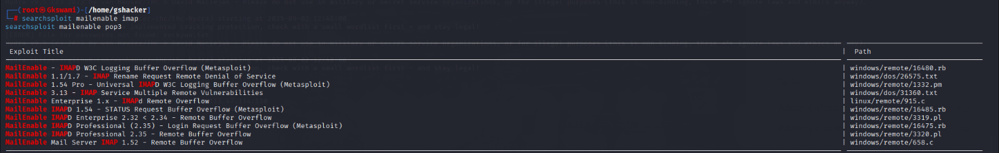
Recommendation:
Immediately verify the installed MailEnable version and apply the latest patches from the vendor. Consider upgrading to the most recent supported release. Limit IMAP/POP3 exposure to trusted networks and monitor logs for brute-force attempts.
Tool Used:- Searchsploit

- Vulnerable JS Library
Brief Description | Risk Rating | Impact on Application | Probability of Attack
The application uses an outdated version of the jQuery library that contains publicly disclosed security vulnerabilities (such as Cross-Site Scripting (XSS) and Denial of Service issues). Attackers can exploit these flaws via client-side scripts to inject malicious payloads or manipulate application behavior. | High | Medium | High
Impact:
Exploitation could allow attackers to execute arbitrary JavaScript in users’ browsers, leading to session hijacking, credential theft, or malicious redirections. It also increases the attack surface since known vulnerabilities in old libraries are actively targeted by automated scanners and bots.
Affected items
https://staging.mumbaicustomszone1.in/js/jquery.validate.min.js
Proof of Concept:
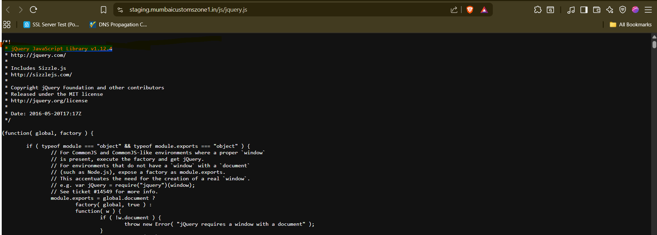
Recommendation:
Upgrade jQuery to the latest stable and secure version recommended by the vendor. Perform regression testing to ensure compatibility with application code. Regularly audit and update all third-party JavaScript libraries to minimize exposure.
Tool Used:- Browser

- Weak SSL/TLS Configuration on IMAPS/POP3S (993/995)
Brief Description | Risk Rating | Impact on Application | Probability of Attack
The server supports outdated SSL/TLS versions (TLS 1.0/1.1) and weak ciphers such as 3DES, which are considered insecure. These protocols are vulnerable to known cryptographic attacks such as SWEET32. Modern security standards recommend disabling weak ciphers and only allowing strong TLS versions. | Medium | High | Medium
Impact:
An attacker in a man-in-the-middle (MITM) position could potentially decrypt sensitive communication or downgrade the encryption level. This also violates industry compliance requirements such as PCI-DSS and CERT-In advisories. Sensitive email credentials and content may be exposed.
Affected items:
https://staging.mumbaicustomszone1.in/Home/
Proof of Concept:
Steps:- Nmap –script ssl-enum-ciphers -p 993,995, 148.113.47.114
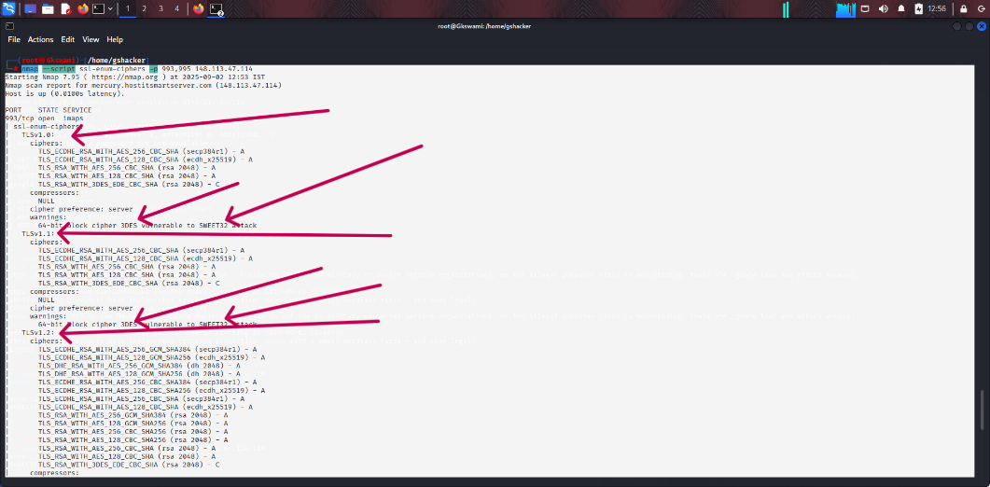

Recommendation:
Disable TLS 1.0/1.1 and weak ciphers such as 3DES. Enforce TLS 1.2+ or TLS 1.3 with strong cipher suites (AES-GCM, ChaCha20). Regularly scan SSL configuration to ensure compliance with current security best practices.
Tool Used:- Nmap
- FTP Service Exposed (21/tcp)
Brief Description | Risk Rating | Impact on Application | Probability of Attack
The FTP service is open and accessible from the internet. Although anonymous login is not permitted, the service is unencrypted by design and is prone to brute-force authentication attempts. FTP does not provide secure file transfer. | Medium | High | Medium/High
Impact:
An attacker may attempt brute-force attacks to gain valid credentials. Since FTP transmits data in clear text, usernames and passwords can be captured through network sniffing. Compromised credentials would allow unauthorized access to sensitive files.

Affected items
https://staging.mumbaicustomszone1.in/Home/
Proof of Concept:
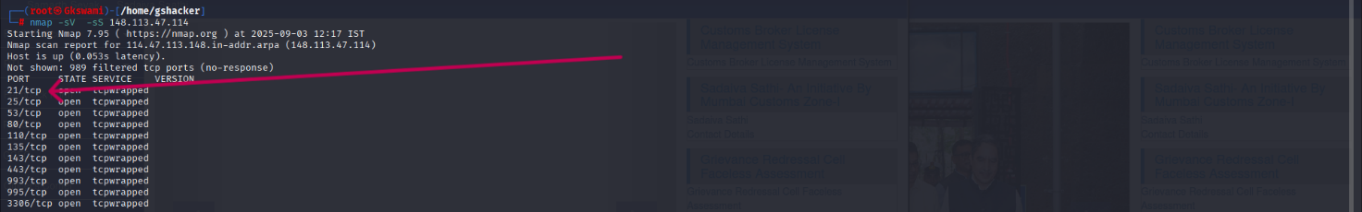

Recommendation:
Disable FTP if not required. If file transfer is needed, replace FTP with secure alternatives such as SFTP or FTPS. Additionally, implement account lockout policies, strong passwords, and restrict access to trusted IP addresses.

Tool Used:- Nmap

- MSRPC Service Exposed (135/tcp)
Brief Description | Risk Rating | Impact on Application | Probability of Attack
Microsoft RPC services are exposed to the internet. RPC is known to be vulnerable to several critical flaws (e.g., MS17-010 EternalBlue). Unauthenticated attackers may enumerate services, users, and groups using RPC tools. | Medium | Low | Medium/High
Impact: If the server is unpatched, attackers could exploit known vulnerabilities to achieve remote code execution (RCE) or privilege escalation. This has historically led to ransomware outbreaks such as WannaCry.
Affected items
https://staging.mumbaicustomszone1.in/Home/
Proof of Concept:
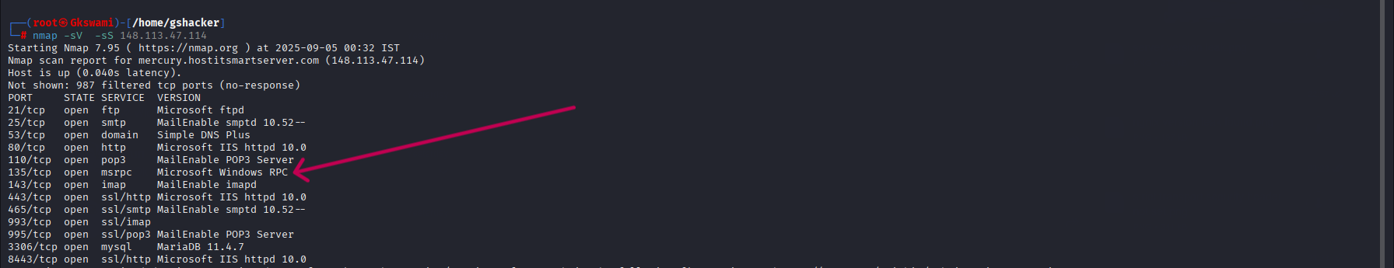

Recommendation:
Restrict MSRPC services to internal/trusted networks only. Ensure the system is fully patched with Microsoft security updates (including MS17-010). Consider disabling unnecessary RPC services if not required.
Tool Used:- Burp suite

- Absence of Anti-CSRF Tokens
Brief Description | Risk Rating | Impact on Application | Probability of Attack
The application’s submission form does not implement an Anti-CSRF (Cross-Site Request Forgery) token. Without this protection, an attacker can trick authenticated users into unknowingly submitting malicious requests (such as updating account details or performing sensitive actions) on their behalf. | Medium | Medium | High
Impact:
Exploitation may lead to unauthorized state-changing actions, such as modifying user data, changing passwords, or performing transactions. This compromises the integrity of the application and may result in account compromise or data manipulation.
Affected items:
https://staging.mumbaicustomszone1.in/home/index
Proof of Concept:
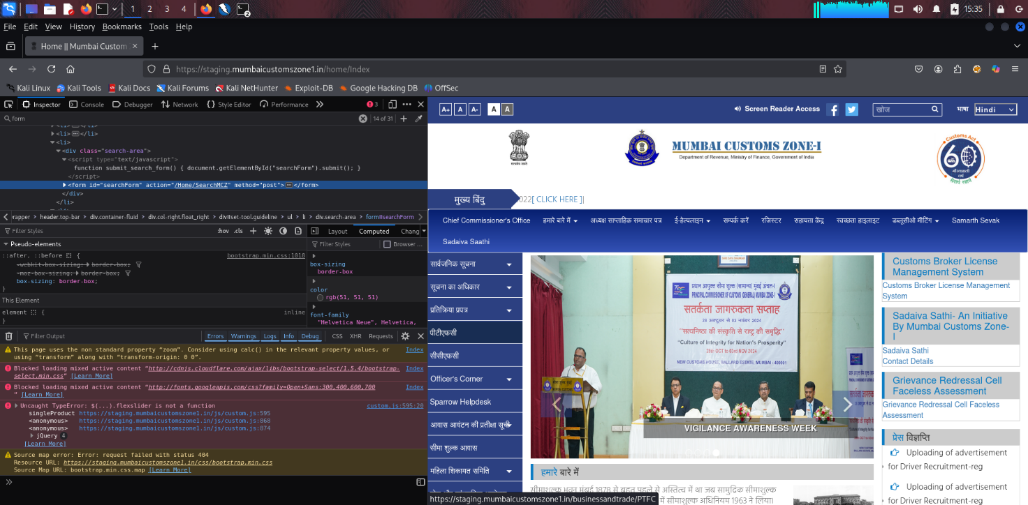

Recommendation:
Implement CSRF protection by including unique, unpredictable CSRF tokens in all form submissions and validating them on the server side. Additionally, enforce secure cookies with SameSite and HttpOnly attributes to reduce the CSRF attack surface.

Tool Used:- Browser

- CSP: Failure to Define Directive with No Fallback
Brief Description | Risk Rating | Impact on Application | Probability of Attack
The Content Security Policy fails to define one of the directives that has no fallback. Missing/excluding them is the same as allowing anything. | Medium | Low | Medium/High
Impact: If the server is unpatched, attackers could exploit known vulnerabilities to achieve remote code execution (RCE) or privilege escalation. This has historically led to ransomware outbreaks such as WannaCry.
Affected items
https://staging.mumbaicustomszone1.in/Home/Index
Proof of Concept:

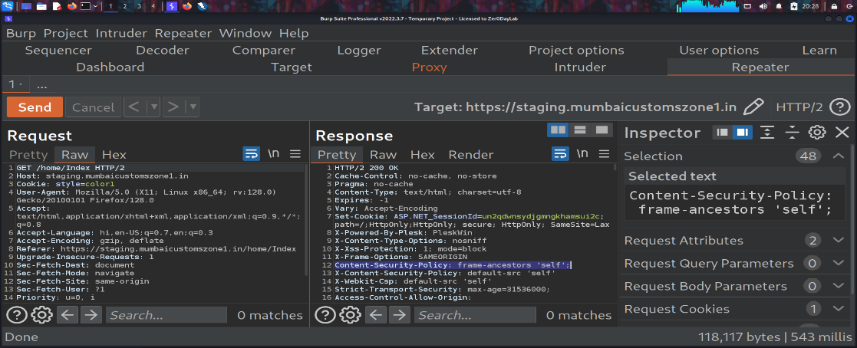

Recommendation:
Define all necessary CSP directives explicitly, including default-src, script-src, style-src, img-src, and frame-ancestors. Ensure that fallback sources are restricted to trusted domains only, and avoid using unsafe options like unsafe-inline or unsafe-eval. Regularly review and harden the CSP policy for maximum protection.
Tool used: Burp Suite

- Content Security Policy (CSP) – Wildcard Directive
Brief Description | Risk Rating | Impact on Application | Probability of Attack
The application’s Content Security Policy (CSP) is configured with wildcard (*) directives, which allow resources such as scripts, styles, or images to be loaded from any origin. This undermines the main purpose of CSP by not restricting potentially unsafe sources. | Medium | Low | Medium/High
Impact: An attacker can exploit this misconfiguration to load malicious scripts or content from untrusted domains. This can lead to Cross-Site Scripting (XSS), data theft, clickjacking, or complete compromise of user sessions and sensitive information.
Affected items
https://staging.mumbaicustomszone1.in/Home/Index
Proof of Concept:

Recommendation:
Remove the use of wildcards (*) from CSP directives. Instead, explicitly specify trusted sources (e.g., your own domain or required CDNs). For inline scripts, use nonces or hashes. Ensure a strict default-src policy is enforced to minimize exposure.

Tool used: Burp Suite
- Content Security Policy (CSP) – script-src allows unsafe-inline
Brief Description | Risk Rating | Impact on Application | Probability of Attack
The Content Security Policy (CSP) for this application includes the unsafe-inline keyword within the script-src directive. This setting allows inline JavaScript (such as <script> tags, onclick attributes, or inline event handlers) to execute in the browser. While convenient for developers, it defeats a core security benefit of CSP. | Medium | Low | Medium/High
Impact: Attackers can exploit this weakness by injecting malicious inline scripts, leading to Cross-Site Scripting (XSS) attacks, session hijacking, credential theft, or malicious redirections. This effectively reduces CSP’s ability to mitigate script-based attacks.
Affected items
https://staging.mumbaicustomszone1.in/Home/Index
Proof of Concept:

Recommendation:
Remove the use of unsafe-inline from the CSP script-src directive. Instead, use nonces (nonce or hashes (sha256-...) to allow only trusted inline scripts. Ensure all scripts are loaded from trusted, explicitly whitelisted sources.
Tool used: Burp Suite

- Vulnerable JS Library (Bootstrap)
Brief Description | Risk Rating | Impact on Application | Probability of Attack
The application uses an outdated version of the Bootstrap library. Older versions of Bootstrap are known to contain security flaws such as Cross-Site Scripting (XSS), DOM-based injection, and improper input sanitization. Using vulnerable libraries exposes the application to risks even if the main application code is secure. | Medium | Low | Medium/High
Impact: Attackers can exploit known vulnerabilities in the outdated Bootstrap library to inject malicious scripts, bypass client-side validations, or perform UI-based attacks. This could lead to session hijacking, redirection to malicious sites, or compromise of sensitive data.
Affected items
https://staging.mumbaicustomszone1.in/Areas/Eawas/js/bootstrap.min.js
Proof of Concept:

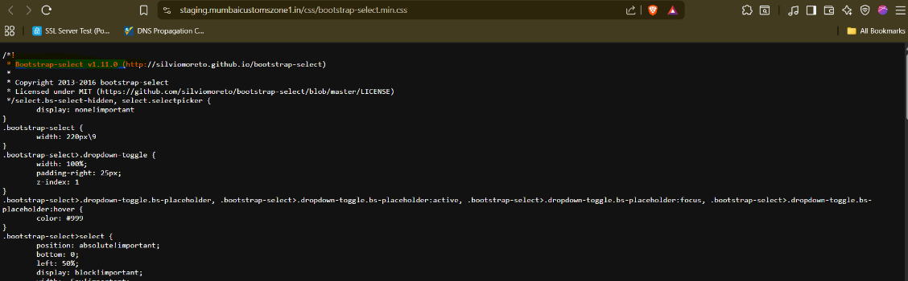

Recommendation:
Upgrade Bootstrap to the latest stable version (preferably 5.x or newer, depending on application compatibility). Regularly audit third-party JavaScript libraries using tools like npm audit, Retire.js, or OWASP Dependency-Check to ensure no outdated or vulnerable libraries remain in use.
Tool used: Browser

- Cookie without SameSite Attribute
Brief Description | Risk Rating | Impact on Application | Probability of Attack
The application sets cookies without the SameSite attribute. This attribute helps restrict how cookies are sent with cross-site requests, reducing the risk of Cross-Site Request Forgery (CSRF) and unauthorized cross-origin information leakage. Without SameSite, browsers may include cookies in all cross-site requests. | Low | Low | Medium/High
Impact: Attackers can trick users into performing unintended actions on the application by embedding malicious requests in third-party sites. This could lead to CSRF attacks, session hijacking, or unauthorized account actions if authentication cookies are exposed.
Affected items
https://staging.mumbaicustomszone1.in/Areas/Eawas/js/bootstrap.min.js
Proof of Concept:

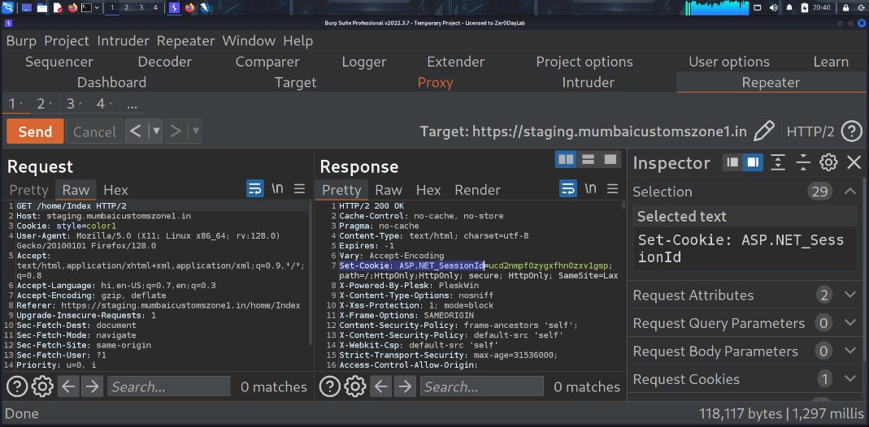

Recommendation:
Set the Same Site attribute for all cookies, preferably as SameSite=Strict or SameSite=Lax depending on functionality requirements. Also ensure cookies are marked as Secure and Http Only to strengthen session protection.
Tool used: Burpsuite

- Server Leaks Version Information via "Server" HTTP Response Header Field
Brief Description | Risk Rating | Impact on Application | Probability of Attack
The web server discloses detailed version information in the Server HTTP response header. For example, headers may reveal the exact software type and version (e.g., Microsoft-IIS/10.0 or Apache/2.4.41). This information can be leveraged by attackers to identify the underlying technology stack and target known vulnerabilities specific to that version. | Low | Low | Medium/High
Impact: Information disclosure aids attackers during reconnaissance by narrowing down attack vectors. Once the server version is identified, attackers can search for public exploits, misconfigurations, or weaknesses related to that specific version, increasing the likelihood of a successful attack.
Affected items
https://staging.mumbaicustomszone1.in/Aboutus/www.brightidea.in
Proof of Concept:

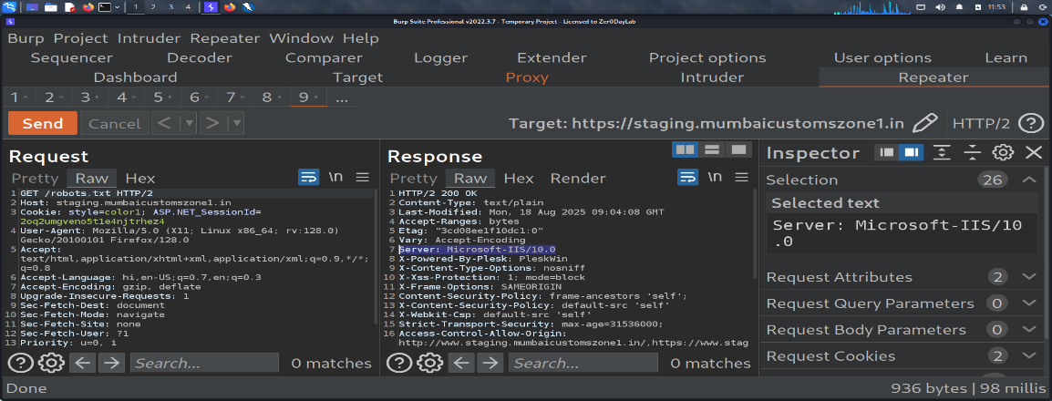
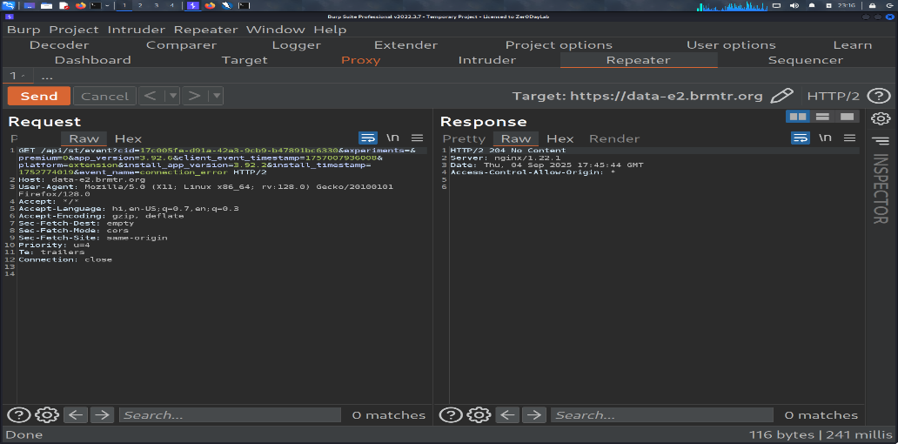

Recommendation:
Configure the web server to suppress or obfuscate version information in HTTP headers. For IIS, disable detailed version information in the Server header using registry or configuration changes. For Apache, set Server Tokens Prod and Server Signature Off. Regularly patch and update the server software regardless of header disclosure.
Tool used: Burpsuite

- Strict-Transport-Security Header Not Set
Brief Description | Risk Rating | Impact on Application | Probability of Attack
The publicly accessible robots.txt file references the sitemap.xml The application does not implement the Strict-Transport-Security (HSTS) header in its HTTP responses. HSTS enforces secure communication over HTTPS by instructing browsers to only interact with the site using encrypted connections. Without HSTS, users may still access the site over insecure HTTP if they manually type or are redirected to an HTTP URL. | Low | Medium | Medium
Impact:
Attackers can exploit the absence of HSTS to perform SSL stripping attacks, forcing users to communicate over unencrypted HTTP. This may lead to session hijacking, credential theft, or exposure of sensitive data during transmission.
Affected items
https://staging.mumbaicustomszone1.in/home/www.brightidea.in/

Proof of Concept:

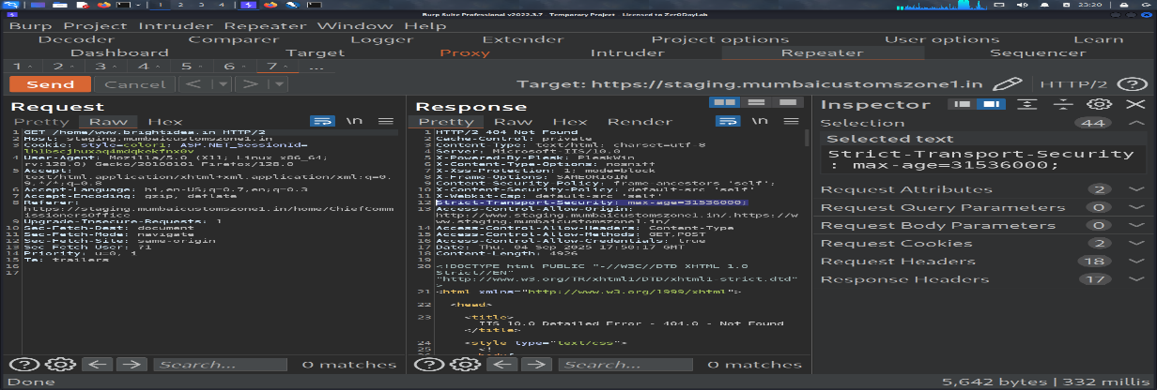

Recommendations:
Ensure that your web server, application server, load balancer, etc. is configured to enforce Strict-Transport-Security : max-age=31536000; includeSubDomains; preload

Tool Used:- Burpsuite

Generic Error Handling for Invalid URLs (302/404 Responses)
Brief Description | Risk Rating | Impact on Application | Probability of Attack
The application returns the same response codes (302/404) for multiple non-existing URLs. This uniform error handling may confuse scanners, but it can still allow attackers to brute-force hidden files and directories. | Low | Medium | High
Impact: Attackers may attempt extensive directory enumeration to locate hidden admin panels, debug files, or sensitive resources. Although not directly exploitable, this increases reconnaissance opportunities for attackers.
Affected items
https://staging.mumbaicustomszone1.in/Jt.

Proof of Concept:
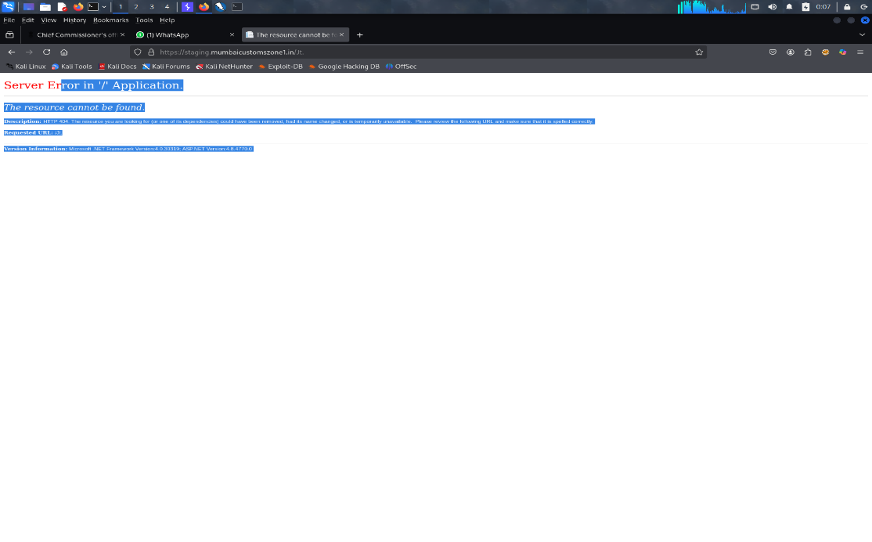
Recommendations:
Implement proper error handling with generic messages. Configure custom error pages that do not disclose detailed file paths or server-side information. Restrict access to sensitive directories using authentication and authorization.

Tool Used: - Burpsuite

X-AspNet-Version Disclosure
Brief Description | Risk Rating | Impact on Application | Probability of Attack
The application’s HTTP response headers expose the X-AspNet-Version header. This reveals the exact ASP.NET framework version being used. Disclosing framework versions provides attackers with valuable information to identify known vulnerabilities associated with that specific version. | Low | Medium | High
Impact : - Attackers can use the disclosed version information to tailor their attacks by exploiting known vulnerabilities in that ASP.NET release. This increases the risk of targeted exploitation such as buffer overflows, remote code execution, or privilege escalation depending on the patch level.
Affected items
https://staging.mumbaicustomszone1.in/Home/JNCH

Proof of Concept:

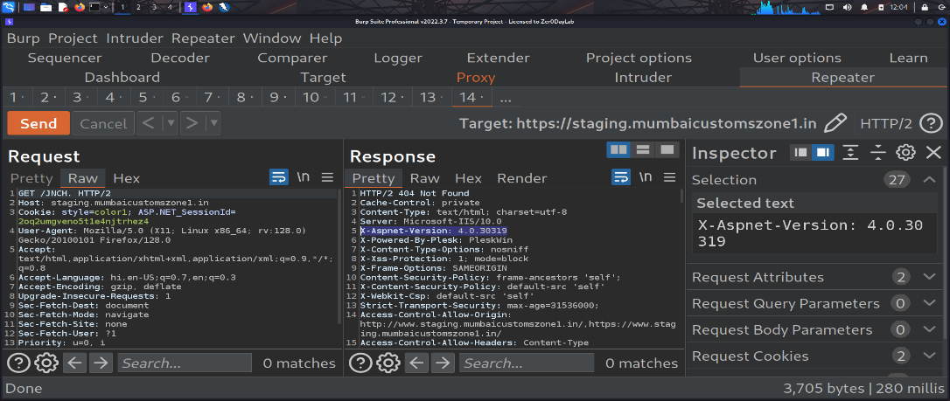

Recommendations:
Disable or remove the X-AspNet-Version header in IIS/ASP.NET configuration. This can be done by editing the web.config file and setting <httpRuntime enableVersionHeader="false" />. Keeping the framework and server components fully patched will also mitigate risks from disclosed version information.

Tool Used: - Burpsuite

General Guidelines
Validate Input and Output
The input that the server receives from the user can lead to malicious code entering the server. Similarly, the output shown to the user can transmit malicious code to the client system. All user input and output should be checked to ensure it is both appropriate and expected. Input validation should be done on the client-side as well as on the server-side.
There are three main models to consider about when designing a data validation strategy.
Accept Only Known Valid Data
A character set may be defined for each field where input from the user is accepted. E.g. “A-Z, a-z, @,., 0-9, _” is a character set for a field that accepts user email.
Reject Known Bad Data
A character set of bad data may be defined for the site that has to be rejected. E.g. “CREATE, DROP, OR”
Sanitize Known Bad Data
A character set of bad data is defined and any input field that has such a character is modified. E.g. “If there is a single quote (‘) in the data, it is replaced with two single quotes.”
All methods must check:
- Data Type
- Syntax
- Length
It is recommended to use the strategy of “Accept only known data”. Further all the allowed input/output data must be sanitized on the server side by replacing scripts tags, sent as part of user input/output, with appropriate representations.
For example
- “<” by &lt;
- “>” by &gt;
- “(“ by &#40

This would avoid scripts from being executed on the client side.
Client-side input must also be checked for URL encoded data. URL encoding sometimes referred to as percent encoding, is the accepted method of representing characters within a URI that may need special syntax handling to be correctly interpreted. This is achieved by encoding the character to be interpreted with a sequence of three characters. This triplet sequence consists of the percentage character “%” followed by the two hexadecimal digits representing the octet code of the original character. For example, the US-ASCII character set represents a space with octet code 32, or hexadecimal 20. Thus, its URL-encoded representation is %20.
Other common characters that can be used for malicious purposes and their URL encoded representations are: -
# | Character | URL encoded
 | ‘ | %27
 | “ | %22
 | ; | %3b
 | < | %3c
 | = | %3d
 | > | %3e
 | ) | %29
 | ( | %28
 | space | %20

All input validation checks should be completed after the data has been decoded and validated as acceptable content (e.g. maximum and minimum lengths, correct data type, does not contain any encoded data, textual data only contains the characters a-z and A-Z etc.)
A one-time check on the database is to be made for invalid malicious data. This would enable removal of input that has not been validated in earlier sessions. As otherwise the invalid data may cause script execution on the user’s browser.

Session Management / Strong session tracking
Session Tokens on Logout
In shared computing environments, session tokens take on a new risk. If the session tokens are not invalidated after logout, they can be reused to gain access to the application. It is imperative for the application to remove the cookies from both the server and the client side after the user has logged out. The user session maintained on the server side must also be invalidated immediately after logout.
Session Time-out
All the user Session tokens must be timed-out after a certain interval of user inactivity. The Session tokens that do not expire on the HTTP server can allow an attacker unlimited time to guess or brute force a valid authenticated session token. If a user's cookie file is captured or brute-forced, then an attacker can use these static-session tokens to gain access to that user's web accounts. Additionally, session tokens can be potentially logged and cached in proxy servers that, if broken into by an attacker, may contain similar sorts of information in logs that can be exploited if the particular session has not been expired on the HTTP server.
Session Token Transmission
If a session token is captured in transit through network interception, a web application account is then trivially prone to a replay or hijacking attack. Typical web encryption technologies include Secure Sockets Layer (SSLv2/v3) and Transport Layer Security (TLS v1) protocols in order to safeguard the state mechanism token.
Some more key points to remember:
Session ID’s that are used should have the following properties:
- Randomness.
  - Session Ids must be randomly generated.
  - Session Ids must be unpredictable.
  - Make use of non-linear algorithms to generate session ID’s
- Session ID Size
  - The size of a session ID should be large enough to ensure that it is not vulnerable to a brute force attack.
  - The character set used should be complex. i.e. Make use of special characters.
  - A length of 50 random characters is advised.
Salted Hashing
What is salted hashing?
The process starts with 2 elements of data:
1.) A clear text string (this could represent a password for instance).
2.) The salt, a random seed of data. This is the value used to augment a hash in order to ensure that 2 hashes of identical data yield different output.
In pseudo code we generate a salted hash as follows:
1.) Get the source string and salt as separate binary objects
2.) Concatenate the 2 binary values
3.) SHA hash the concatenation into Salted Password Hash
4.) Base64 Encode (concat (Salted Password Hash, Salt))
Credentials should be encrypted using salted hashes, so that even if the hashes are sniffed the possibility of replay attack does not exist.
References: http://www.owasp.org/images/3/33/Salted_Hashes_Demystified.doc
Cache Control Directives
Pages that contain sensitive information should not be stored in the local cache of the browser. To enforce this, HTTP directives need to be specified in the response. These HTTP directives need to be used to prevent enlisting of links on the browser history. The following HTTP directives can be sent by the server along with the response to the client. This would direct the browser to send a new request to the server each time it is generated.
Expires: <a previous date>, for e.g. Expires: Thu, 10 Jan 2020 19:20:00 GMT

Cache-Control: private
- Cache-Control: no-cache
- Cache-Control: no-store
- Cache-Control: must-revalidate
- Pragma: no-cache

The directive “Cache-Control: must-revalidate” directs the browser to fetch the pages from the server rather than picking it up from the local “Temporary Internet Folders”. It also directs the browser to remove the file from the temporary folders.

