DEEP LEARNING
NOTES
A Field Guide to Neural Networks, from First Principles to Practice
ANN · RNN · NLP

Compiled and structured from personal study notes,
expanded with worked examples, comparisons, and reference diagrams.

A Note on How to Read This
This is a living reference, not a one-time read. Each part builds on the one before it: Part 1 sets up the vocabulary (AI, ML, DL), Part 2 builds a working artificial neural network from a single neuron up through training, and Parts 3 and 4 will extend the same foundations to sequences (RNN) and language (NLP) as that material is added.
Every equation in this document is real, typeset mathematics, not an approximation. Every diagram was built specifically to match the surrounding explanation. Where it helps, a box like the one below calls out something worth pausing on.
Example callout: Boxes like this one flag a subtlety, a common point of confusion, or a connection back to something covered earlier. They are worth the extra ten seconds.
The Table of Contents on the next page is fully linked: click any entry (in Word or a PDF viewer) to jump straight to that section.
Table of Contents
Part 1: Introduction to Deep Learning
AI vs ML vs DL vs Data Science
Why Deep Learning Is Becoming Popular
Prerequisites for This Course
Part 2: Artificial Neural Networks (ANN)
The Perceptron: A Single Layer Neural Network
Weights and Bias
Activation Functions: A First Look
Forward Propagation
Loss Function: A First Look
Backward Propagation and Optimizers
The Weight Update Formula
Chain Rule of Differentiation
The Vanishing Gradient Problem
Activation Functions in Depth
Sigmoid: A Closer Look at Its Derivative
Tanh
ReLU (Rectified Linear Unit)
Leaky ReLU and PReLU
ELU (Exponential Linear Unit)
Swish
Softmax
Choosing an Activation Function
Loss Functions in Depth
Loss vs. Cost: One Example vs. a Batch
Regression Losses
Classification Losses
Matching Loss Functions to Tasks
Multi-Layer Neural Network
Worked Numeric Example
Summary: The ANN Training Loop
Part 3: Recurrent Neural Networks (RNN)
RNN
Part 4: Natural Language Processing (NLP)
NLP
Glossary of Terms

Part 1: Introduction to Deep Learning

AI vs ML vs DL vs Data Science
Artificial Intelligence (AI) is the broadest category. It refers to an application that can perform a task on its own, without a human explicitly telling it what to do at every step. Instead, the application learns from user behavior and makes its own decisions.
- Netflix: automatic movie and show recommendations
- Self-driving cars: autopilot systems
- Amazon: automatic product recommendations
- Chatbots: conversational assistants such as Sofia
Machine Learning (ML) is a subset of AI. It provides statistical tools and algorithms to analyze data, visualize data, and perform tasks such as prediction (supervised learning), forecasting, and clustering (unsupervised learning).
Deep Learning (DL) is a subset of ML. Formal research on multi-layered neural networks dates back to 1958, but DL only became mainstream in the last decade. Two forces drove that shift: the explosion of available data, and major advances in GPU hardware that make training large networks practical. The core aim of DL is to mimic how the human brain processes information.
Data Science (DS) does not sit neatly inside this nesting. A data scientist's work can touch AI, ML, or DL depending on the task: they might build a predictive model, train a deep network, or simply clean and analyze data. Regardless of the specific tool used, the broader goal is usually to ship a working AI application.
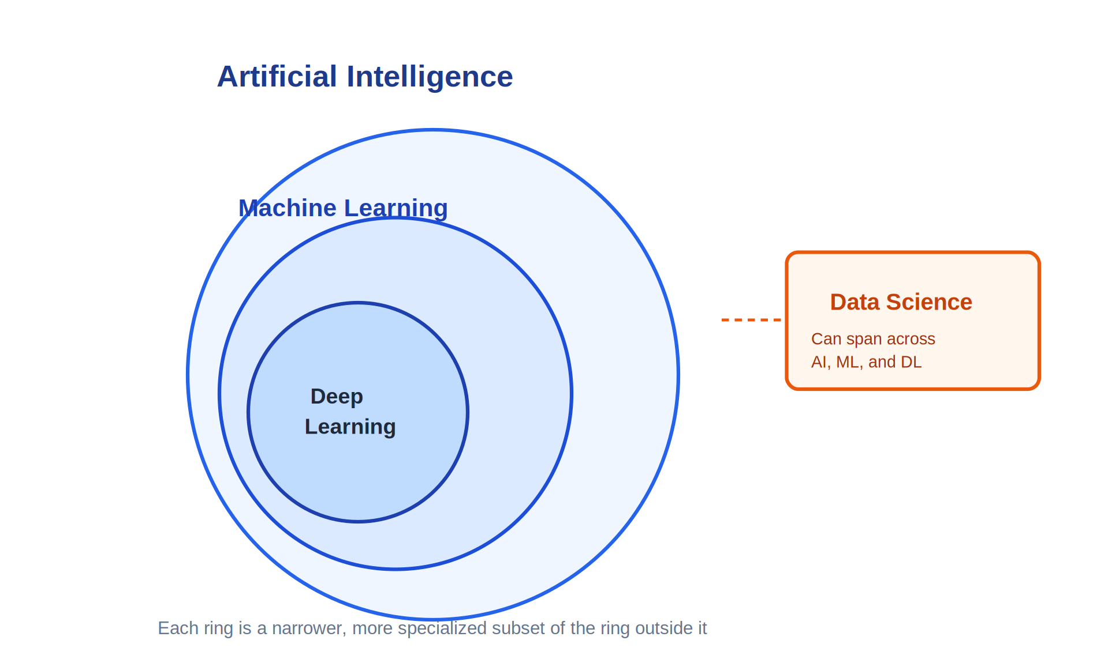
Figure 1.1: How AI, ML, DL, and Data Science relate to each other

Why Deep Learning Is Becoming Popular
Three factors, arriving in sequence over roughly two decades, explain why deep learning moved from a niche research topic to an industry standard.
Period | What happened | Effect
2005 onward | Web 2.0 platforms emerge: Orkut, Facebook, Instagram, WhatsApp, LinkedIn, Twitter | Users start generating data at an exponential rate
2008 | Data volumes outgrow what traditional tools can handle | Big Data emerges as a discipline focused on efficient storage and retrieval
2013 to 2014 | Companies find themselves sitting on huge stores of collected data | AI becomes a business priority: companies want to use that data to improve products, not just store it
Ongoing | GPU hardware keeps advancing (NVIDIA and others), while cost per GPU keeps falling | Large multi-layer networks with millions of parameters become practical and affordable to train

Example: A model that reduces air conditioner electricity bills by learning a household's usage pattern (a real Panasonic use case) shows the full loop in practice: raw sensor data leads to a trained model, which leads to a better product experience, which leads to new subscription revenue.

Prerequisites for This Course
- Python programming
- At least one machine learning algorithm; linear regression is enough to start
- Basic statistics

Part 2: Artificial Neural Networks (ANN)

The Perceptron: A Single Layer Neural Network
The perceptron is the simplest possible neural network. It has three parts: an input layer, one hidden layer (a single neuron, in the basic case), and an output layer. Every neuron in one layer connects to every neuron in the next layer, the same way biological neurons pass signals to one another.
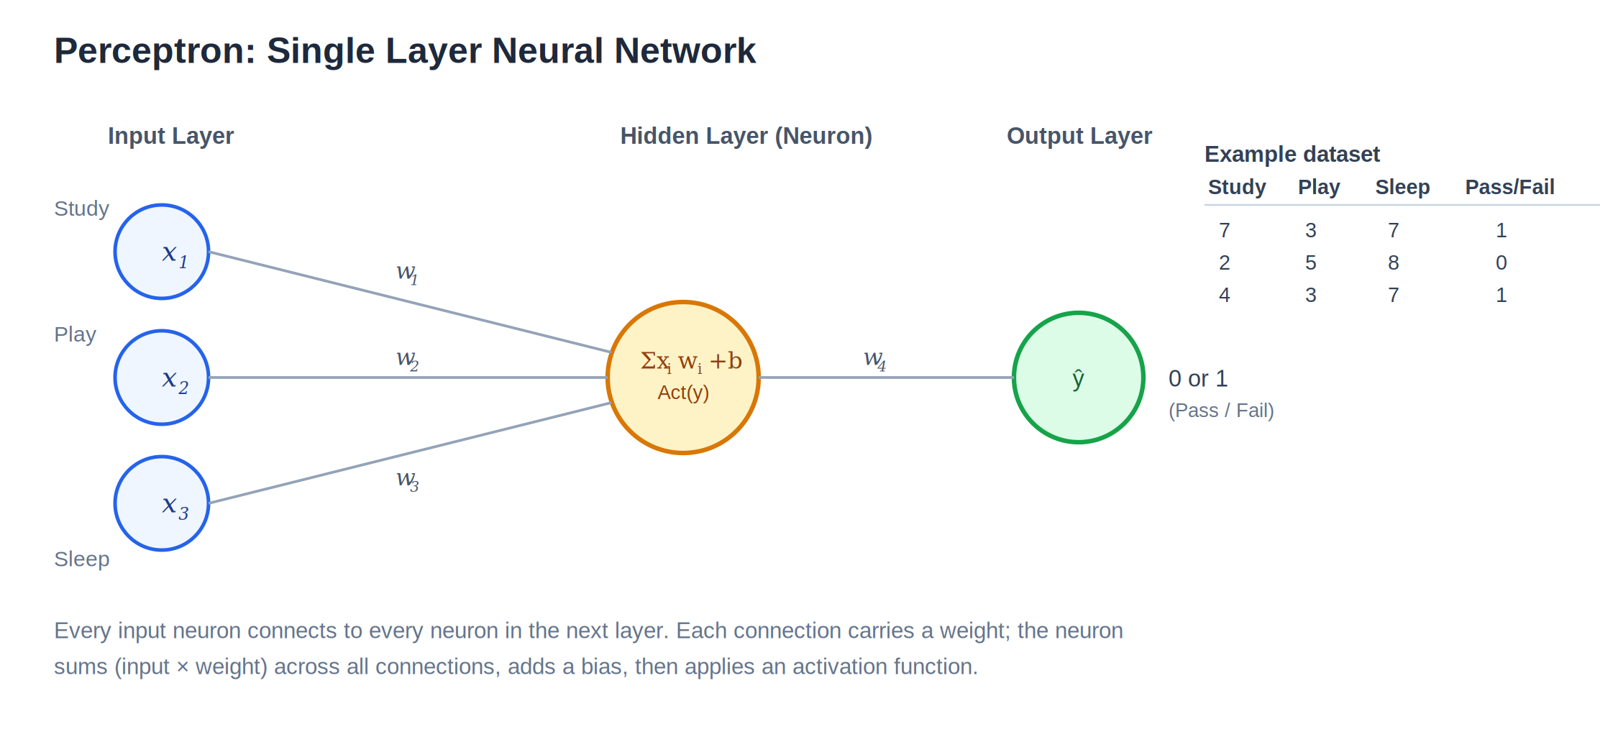
Figure 2.1: Perceptron structure, using a study and play and sleep example that predicts pass or fail
Worked example: predict Pass (1) or Fail (0) from three features: hours spent studying (x1), hours spent playing (x2), and hours spent sleeping (x3). This is a binary classification problem. During training, each row of the dataset is fed through the network one at a time.

Weights and Bias
Inside a neuron, two operations happen in sequence.
- Step 1, weighted sum: multiply each input by its corresponding weight, sum the results, then add a bias term.
- Step 2, activation: pass that sum through an activation function to produce the neuron's output.
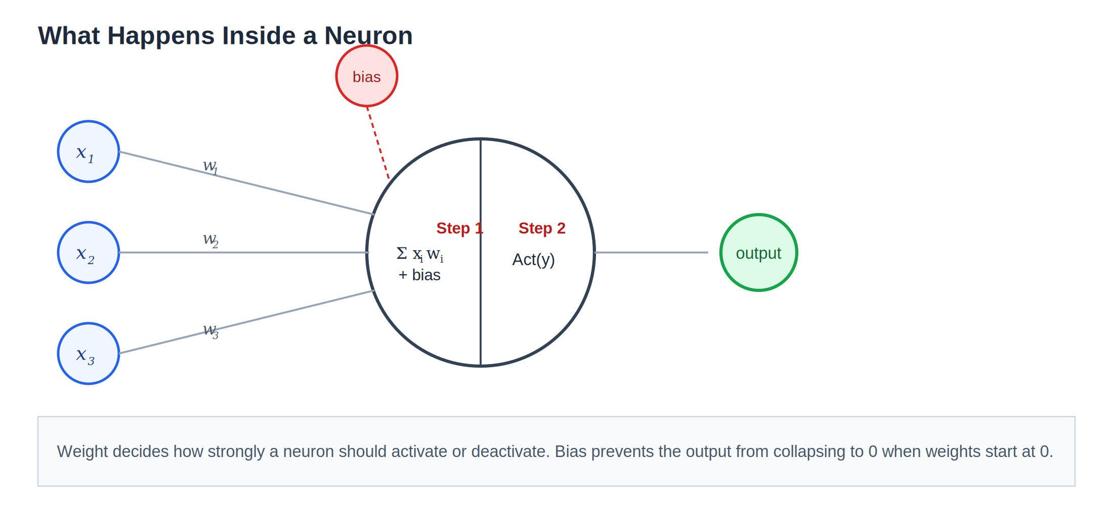
Figure 2.2: Weighted sum plus bias, followed by activation, inside a single neuron
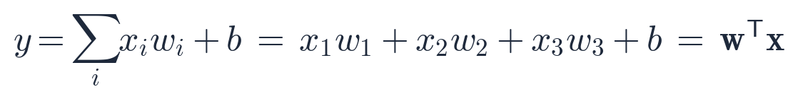
This has the same mathematical shape as linear regression:
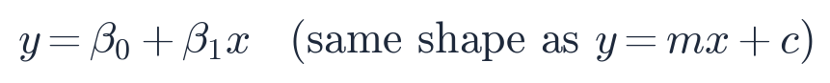
The weight controls how strongly a neuron responds to a given input, similar to how strongly a nerve fires when it senses something like heat.
Why bias matters: If every weight is initialized to 0, then every weighted input (x times w) is also 0, no matter what x is. The bias term is added specifically so the neuron's output is not forced to 0 at the very start, which lets training actually begin.

Activation Functions: A First Look
An activation function decides whether, and how strongly, a neuron should fire. It also introduces non-linearity, which is what allows a network to model more than a straight line. For binary classification tasks, a common choice is the sigmoid function.
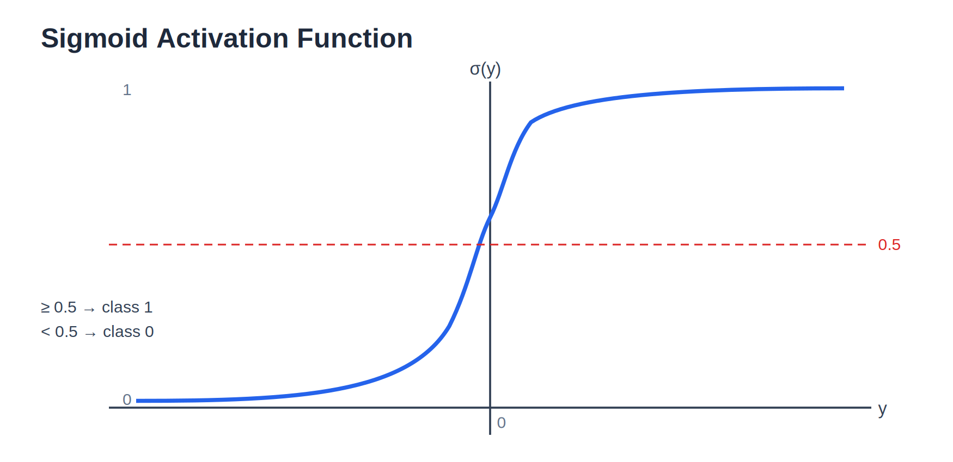
Figure 2.3: Sigmoid squashes any real-valued input into the range zero to one
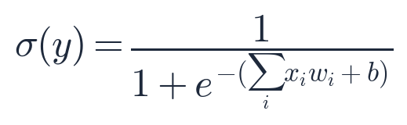
- Output of 0.5 or higher is treated as predicted class 1
- Output below 0.5 is treated as predicted class 0
Sigmoid is not the only option, and it is not even usually the best one. Part 2 comes back to this with a full comparison of activation functions once the machinery of backward propagation is in place to explain why the choice matters so much.

Forward Propagation
Forward propagation is the complete left to right pass through the network: take the input, multiply by weights, add bias, apply the activation function, then repeat that same process layer by layer until the output layer produces a prediction, written as y-hat.

Loss Function: A First Look
The loss function measures how far the predicted value (y-hat) is from the true value (y). The entire point of training is to make that difference as small as possible.
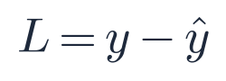
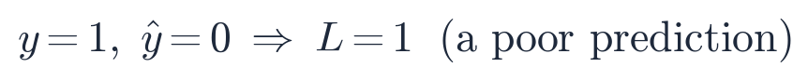
Different tasks use different loss functions, and Part 2 dedicates a full section to them later on. For now, the concept is what matters: loss is a single number that says how wrong the current prediction is.

Backward Propagation and Optimizers
When the loss is high, backward propagation sends that error signal back through the network so the weights can be corrected. The component that actually decides how much to change each weight is called an optimizer.
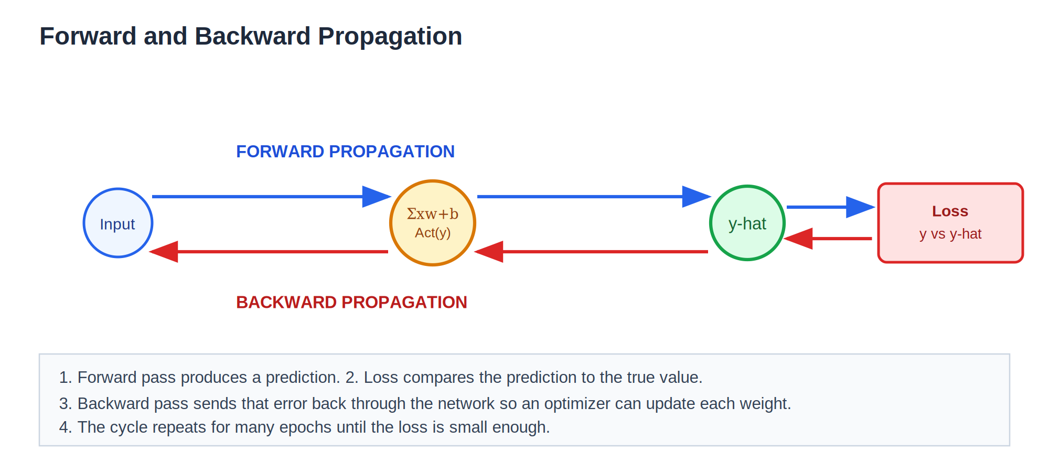
Figure 2.4: One full training cycle, from forward pass to loss to backward pass to updated weights
Gradient Descent is a classic example of an optimizer. It is the same idea used to fit a simple linear regression line: nudge each weight, step by step, in the direction that reduces the loss, until the network settles near the point of lowest loss, known as the global minimum.
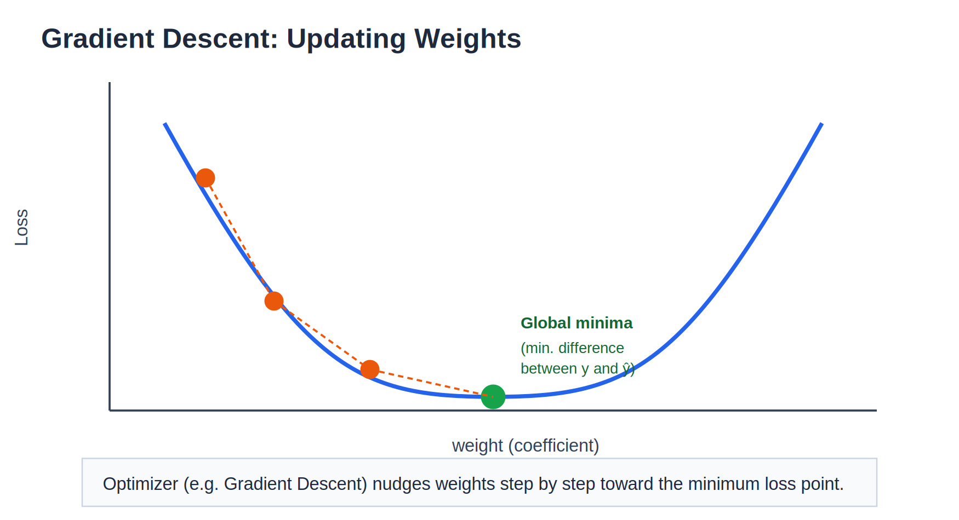
Figure 2.5: Gradient descent walking down the loss curve toward the global minimum
One training cycle is one forward pass followed by one backward pass. Repeating that cycle many times, called epochs, sometimes just a handful and sometimes thousands, is how a neural network is trained. It is conceptually similar to how a baby gradually learns to recognize an object through repeated exposure and correction.

The Weight Update Formula
Gradient descent updates every weight using one rule:

The partial derivative term is the slope of the loss curve at the weight's current position. Its sign decides which direction the weight moves.
Either way, the update always pushes the weight toward the direction that reduces loss. The learning rate controls the size of that step: too large and the weight can overshoot the minimum; too small and training crawls.

Chain Rule of Differentiation
A weight near the start of the network is not directly connected to the loss. It only affects the loss indirectly, through every neuron that sits between it and the output. To measure that indirect effect, backward propagation uses the chain rule: multiply the local derivative at each step along the path.
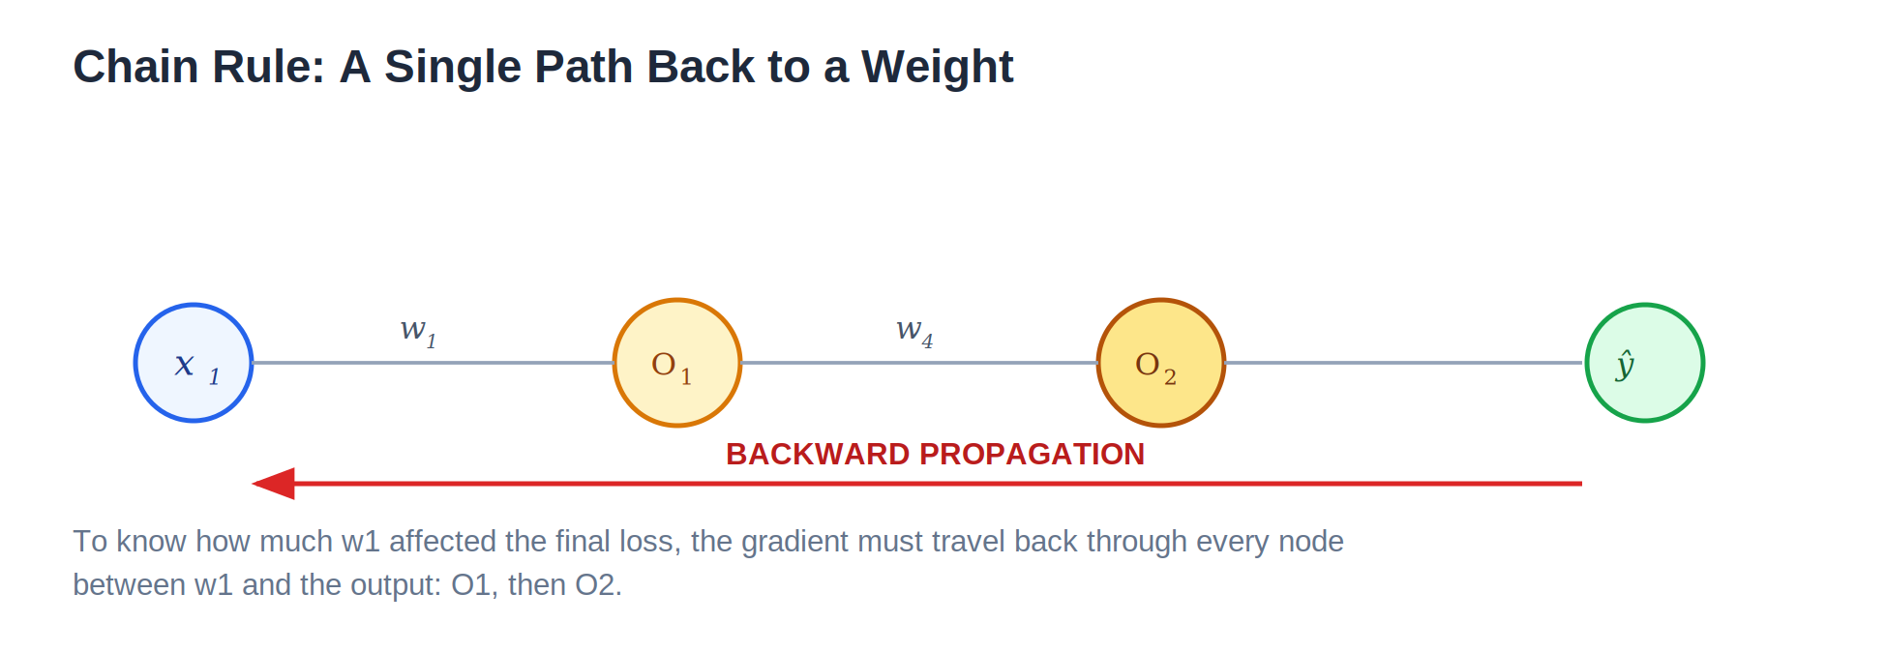
Figure 2.6: A single path from a weight back to the output
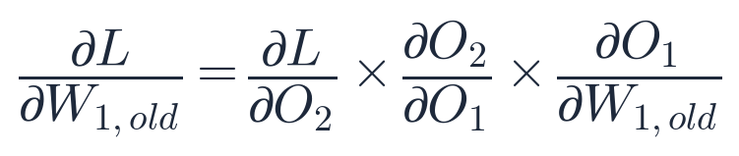
Networks rarely stay this simple. As soon as a neuron's output feeds into more than one neuron in the next layer, a single weight can reach the loss through more than one route.
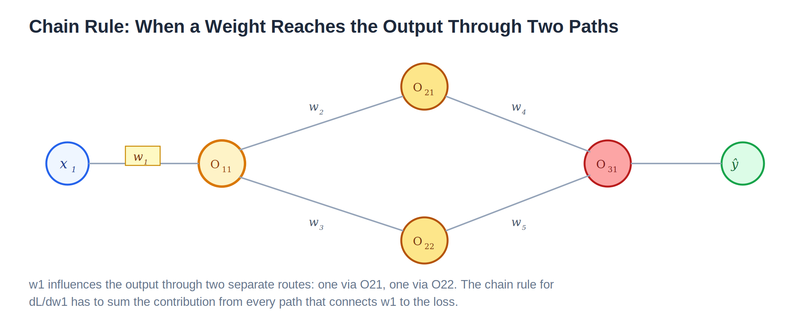
Figure 2.7: A weight that reaches the loss through two separate paths
When that happens, the chain rule sums the contribution from every path:
Why this matters: This is the same rule from calculus used to differentiate a function of a function. A deep network is just a very long, very branched composition of functions, so the chain rule is applied over and over, once per layer, all the way back to the first weight.

The Vanishing Gradient Problem
Consider a deep network trained with mean squared error, one of the most common loss functions:
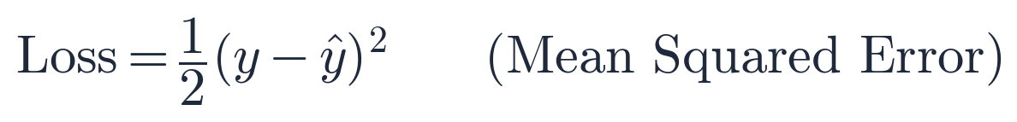
Sigmoid has a subtle problem that only shows up once the network gets deep. Its derivative is never larger than 0.25:
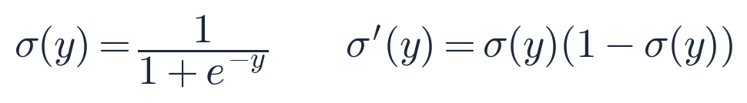
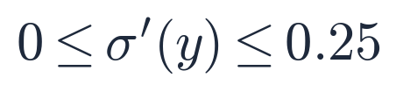
Because backward propagation multiplies one derivative per layer (the chain rule again), a deep stack of sigmoid neurons multiplies several numbers that are all smaller than 0.25.
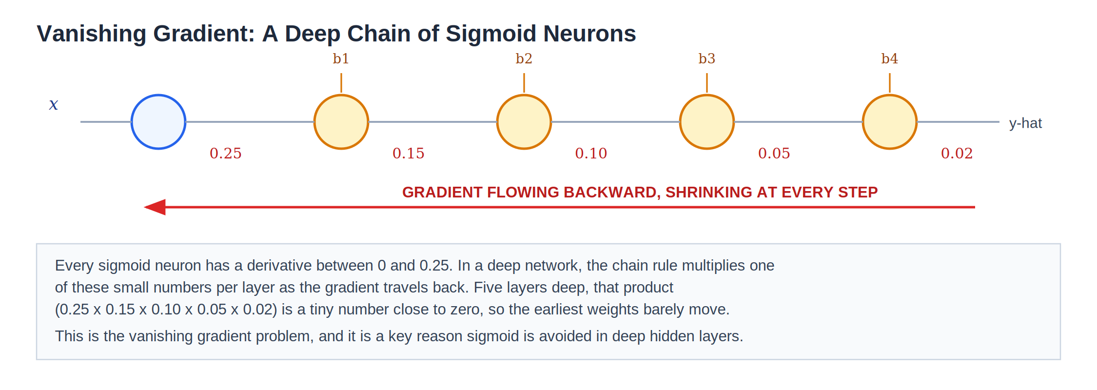
Figure 2.8: A five-layer chain of sigmoid neurons; the gradient shrinks at every step going backward
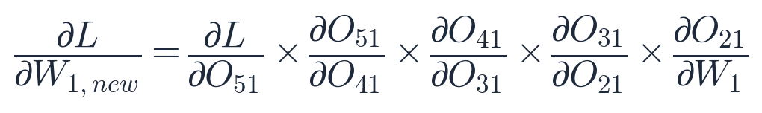
With almost no gradient reaching them, the earliest layers barely learn at all, even though later layers keep training normally. This is the vanishing gradient problem. It is one of the main reasons sigmoid (and tanh, which has the same shape) is avoided in the hidden layers of deep networks, and why ReLU-family activation functions became the default.

Activation Functions in Depth
Four properties decide whether an activation function works well in practice: how expensive it is to compute, whether its gradient stays healthy across many layers, whether its output is centered around zero, and how it behaves for large positive or negative inputs. The table below compares the most common options, followed by each one in detail.
Function | Output range | Strength | Weakness
Sigmoid | 0 to 1 | Smooth; clean probability-like output | Vanishing gradient; not zero-centered; slow (uses exponentials)
Tanh | -1 to 1 | Zero-centered, unlike sigmoid | Still vanishes for large inputs; still uses exponentials
ReLU | 0 to infinity | Very fast; no vanishing gradient for positive inputs | Dead neurons: negative inputs get a zero gradient permanently
Leaky ReLU / PReLU | -infinity to infinity | Fixes dead neurons with a small negative slope | The slope is a fixed guess (Leaky) or an extra learned parameter (PReLU)
ELU | -alpha to infinity | Smooth negative side; closer to zero-centered output | More expensive to compute than ReLU
Swish | ≈ -0.28 to infinity | Smooth everywhere; competitive with ReLU on deep nets | More expensive to compute (uses sigmoid internally)
Softmax | 0 to 1, all outputs sum to 1 | Turns raw scores into class probabilities | Used only at the output layer for multi-class problems

Sigmoid: A Closer Look at Its Derivative
Sigmoid's derivative has a convenient closed form, and it peaks at exactly 0.25 when the input is 0, tapering to nearly 0 as the input moves toward either extreme. That peak of 0.25 is the largest gradient value sigmoid can ever pass backward, which is the root cause of the vanishing gradient problem above.

Figure 2.9: Sigmoid, repeated for reference

Tanh
Tanh has the same S-shape as sigmoid but is rescaled to output between -1 and 1 instead of 0 and 1, which keeps its output centered around zero. That helps the next layer train slightly better, but tanh still saturates (flattens) for large inputs, so it suffers from the same vanishing gradient problem.
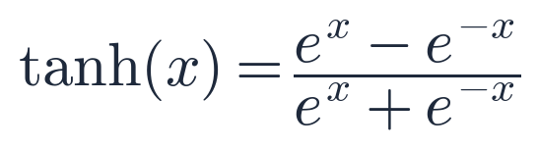
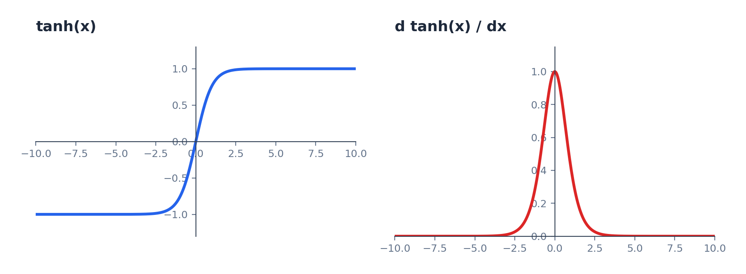
Figure 2.10: Tanh and its derivative

ReLU (Rectified Linear Unit)
ReLU is the simplest and most widely used activation function in modern hidden layers. It passes positive inputs through unchanged and zeroes out everything negative.
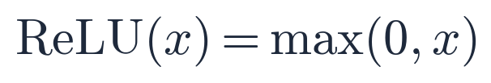
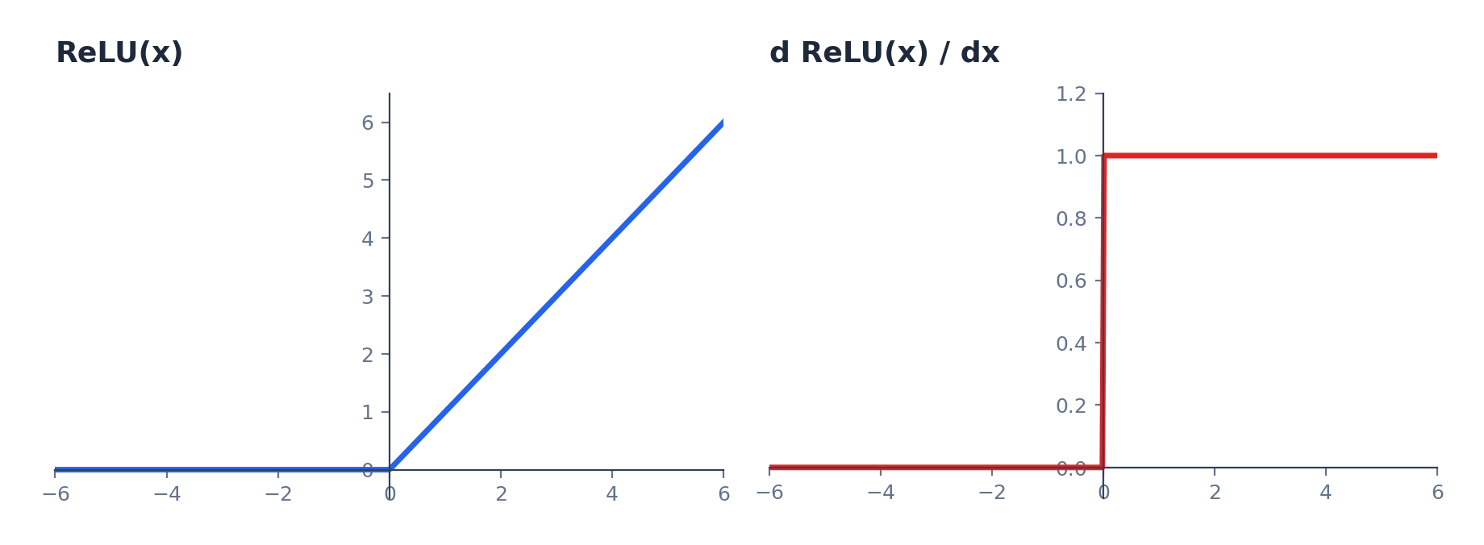
Figure 2.11: ReLU and its derivative
- No vanishing gradient for positive inputs. The derivative is exactly 1, not a fraction, so it does not shrink as it passes backward through many layers.
- Much cheaper to compute than sigmoid or tanh: no exponentials, just a comparison against zero.
- The tradeoff is the dying ReLU problem: once a neuron's input goes negative, its gradient becomes exactly 0. If that keeps happening, the neuron stops updating and effectively stops contributing to the network.

Leaky ReLU and PReLU
Leaky ReLU is a small fix for dying ReLU: instead of flattening negative inputs to exactly 0, it lets a small fraction through.
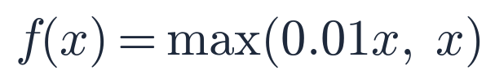
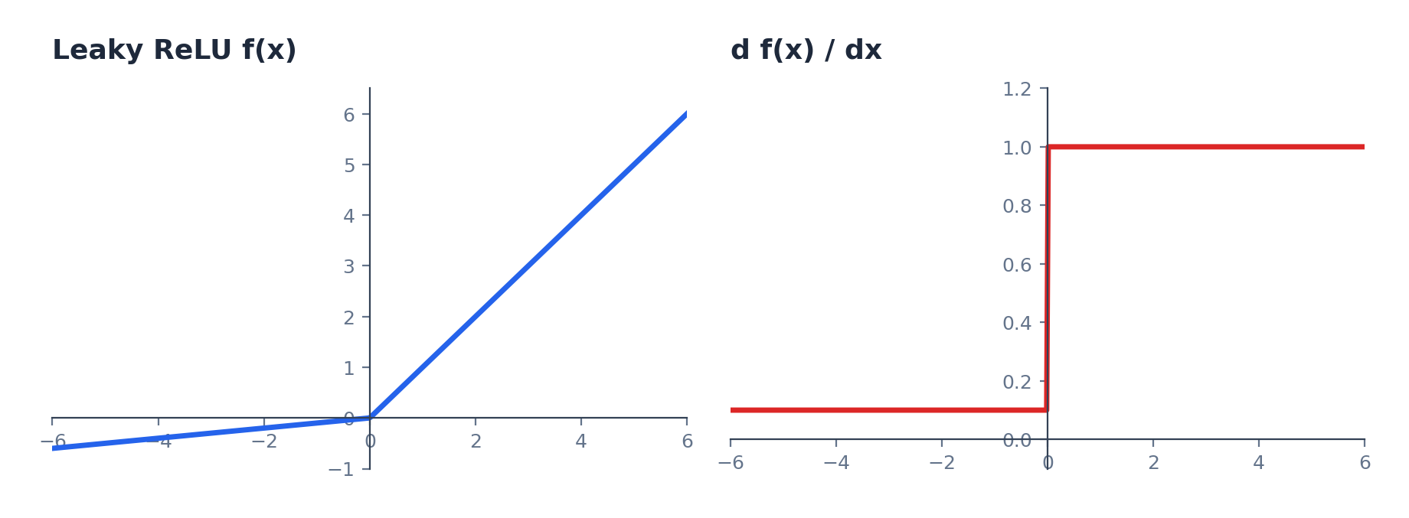
Figure 2.12: Leaky ReLU and its derivative
Because the negative side now has a tiny but nonzero slope, a neuron that receives a negative input still has some gradient flowing back through it, so it is not permanently stuck.
Parametric ReLU (PReLU) takes this one step further: instead of fixing that negative-side slope at 0.01, it treats the slope as a learnable parameter, updated by backward propagation like any weight.
When that learned slope happens to settle at 0, PReLU behaves exactly like ordinary ReLU; when it settles at a small fixed value, it behaves like Leaky ReLU. PReLU simply lets the network decide which behavior fits the data best.

ELU (Exponential Linear Unit)
ELU keeps ReLU's behavior for positive inputs but replaces the flat negative side with a smooth curve that approaches -alpha instead of stopping at 0.
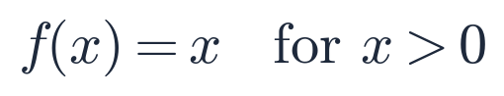
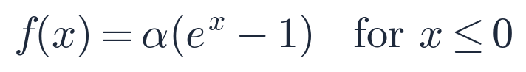
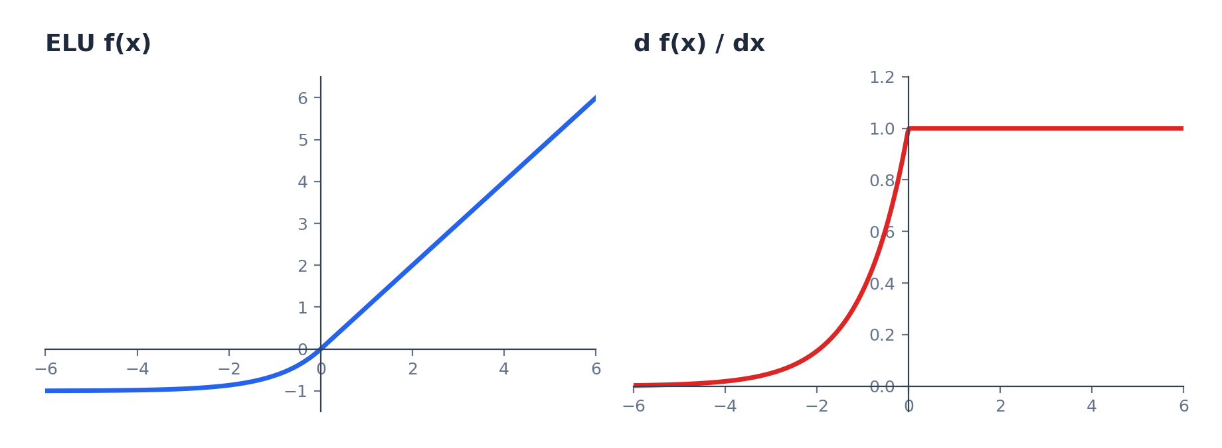
Figure 2.13: ELU and its derivative
The smooth negative curve avoids the dying neuron problem entirely and pulls the average output closer to zero, similar in spirit to tanh. The cost is that the exponential on the negative side is more expensive to compute than the flat or linear alternatives.

Swish
Swish is a newer activation function, designed by Google, built from the sigmoid function itself: multiply the input by its own sigmoid.
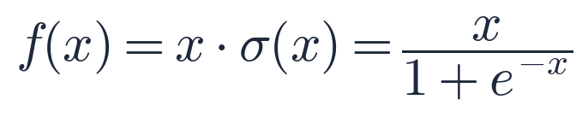
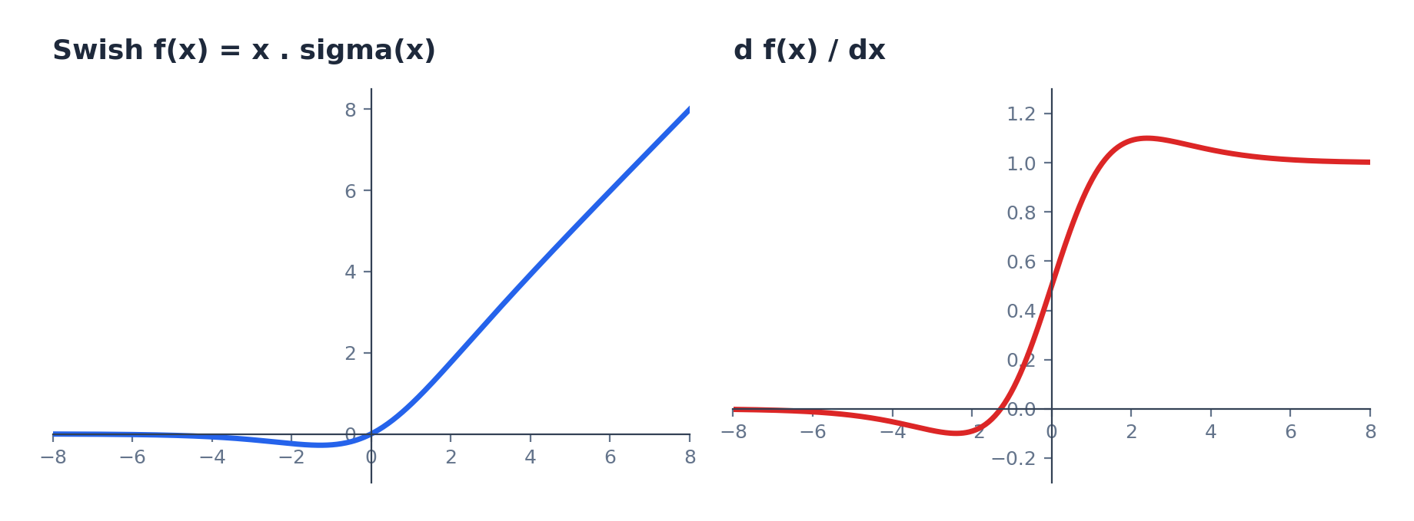
Figure 2.14: Swish and its derivative
This construction is called self-gating: sigmoid(x) acts as a gate between 0 and 1 that decides how much of x to let through, and Swish uses the input itself to control its own gate rather than needing a separate signal, the same idea used for gating in LSTMs. Unlike ReLU, Swish is smooth everywhere and dips slightly below zero just left of the origin instead of flattening out completely, which keeps a small gradient alive for mildly negative inputs. In practice it has performed competitively with, and sometimes better than, ReLU on deep networks, though at extra computational cost from the sigmoid term.

Softmax
Softmax is not used in hidden layers. It sits at the output layer of a multi-class classifier, converting a raw score for each class into a probability, with every probability between 0 and 1 and all of them summing to 1.
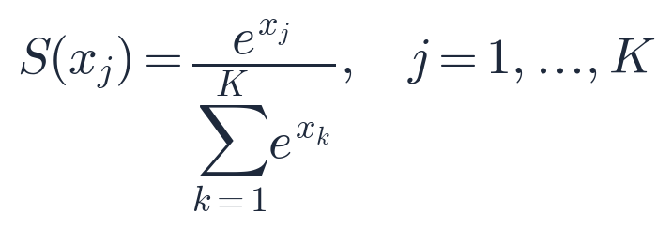
Worked example: a network scores four possible classes with raw values 2.0, 1.0, 0.1, and -1.0. Softmax exponentiates each score and divides by the total, turning those raw numbers into a clean probability distribution.
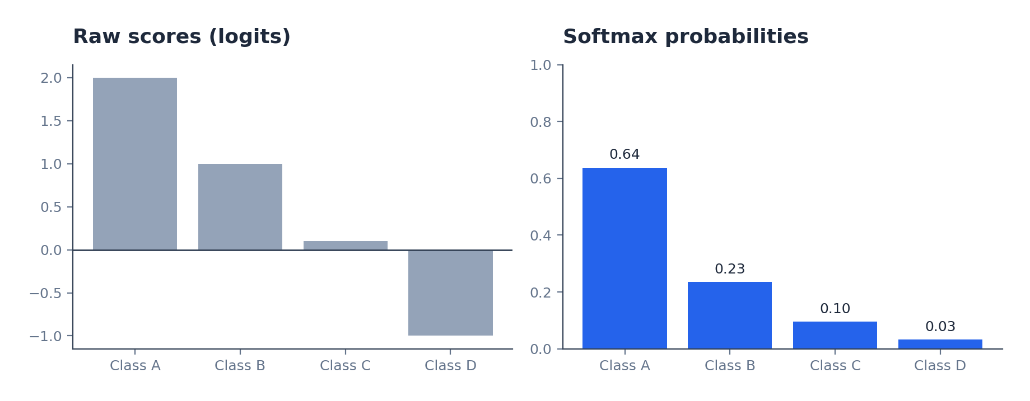
Figure 2.15: Raw scores compared with the probabilities softmax produces from them
Notice the highest raw score does not just win outright: it gets amplified into a large probability (0.64), but every class keeps some nonzero share. Compare this with sigmoid, used for binary classification: softmax is effectively sigmoid generalized to more than two classes.

Choosing an Activation Function
With seven options on the table, a few practical defaults cover almost every situation. The pattern holds regardless of the task: hidden layers default to ReLU, and only the output layer's activation changes to match what the task needs to produce.
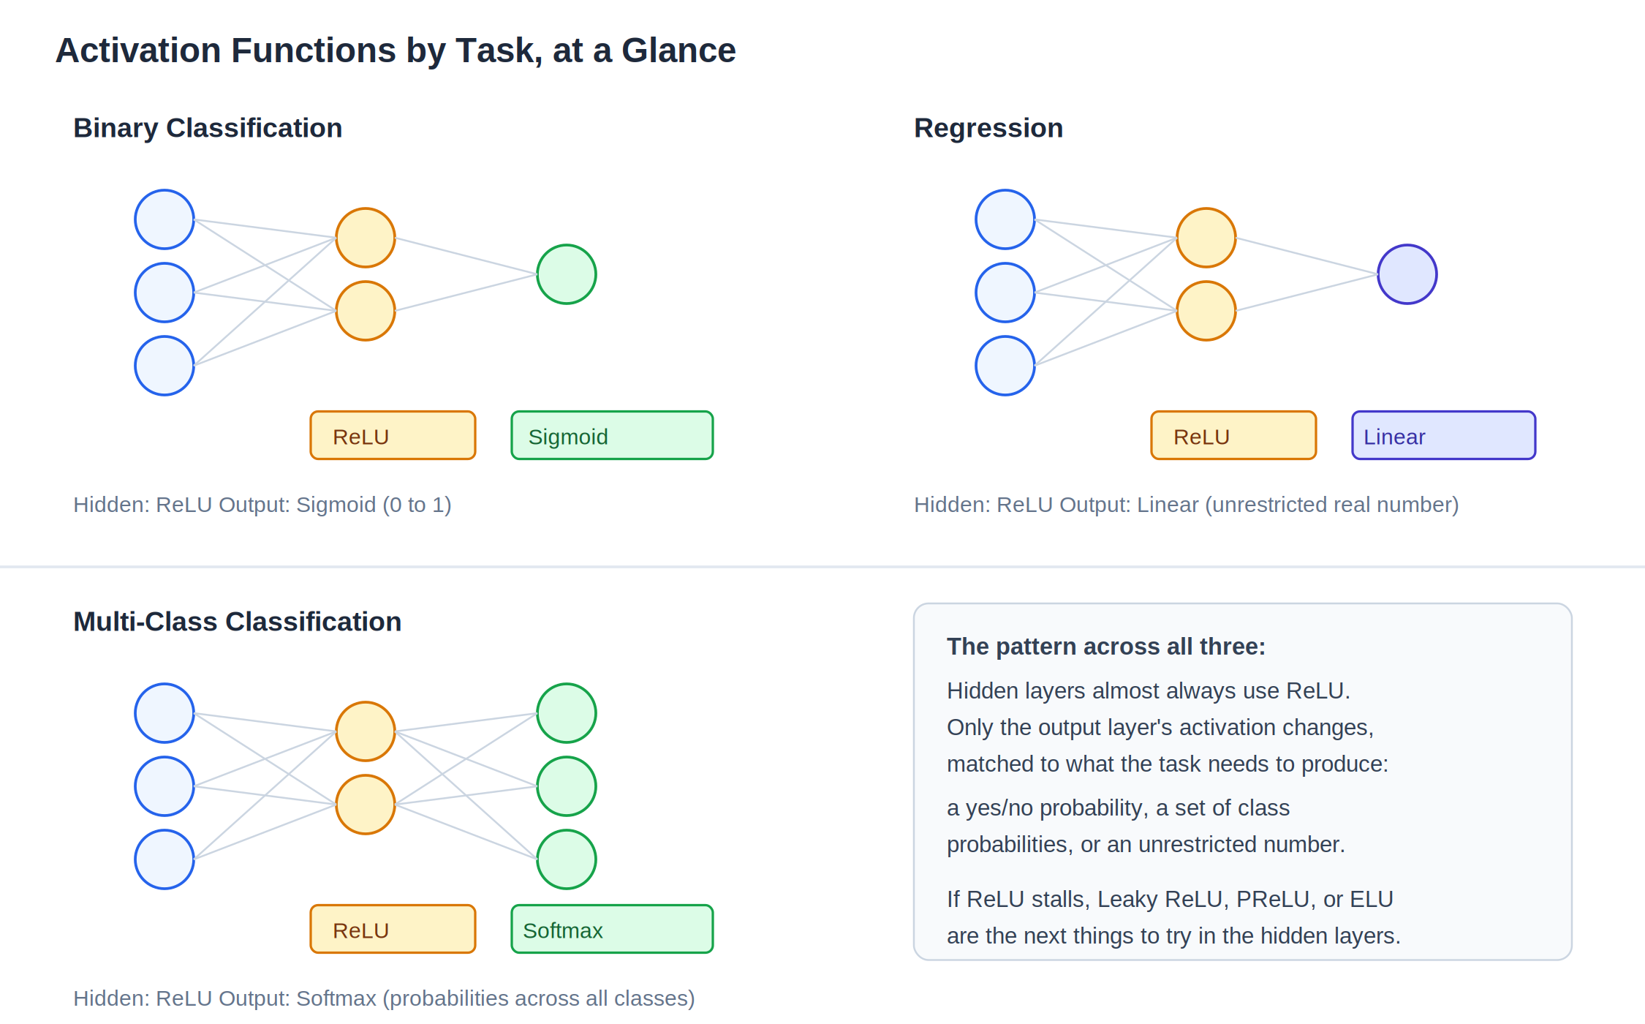
Figure 2.16: The same hidden-layer default, matched to three different output-layer needs
- Hidden layers, default choice: ReLU. It is cheap, avoids vanishing gradients for positive inputs, and works well in most architectures.
- Hidden layers, if dead neurons show up in practice: switch to Leaky ReLU, PReLU, or ELU, in roughly that order of complexity.
- Output layer, binary classification: sigmoid, since its 0-to-1 output maps directly onto a probability of the positive class.
- Output layer, multi-class classification: softmax, since it produces a full probability distribution across all classes.
- Output layer, regression: no activation function (a linear output), since the prediction needs to be an unrestricted real number.
- Sigmoid and tanh in hidden layers: generally avoided in deep networks because of the vanishing gradient problem, though tanh still appears in some recurrent architectures.
Rule of thumb: When in doubt, start with ReLU in the hidden layers and the task-appropriate function (sigmoid, softmax, or linear) at the output layer. Only reach for Leaky ReLU, PReLU, ELU, or Swish if ReLU is visibly underperforming.

Loss Functions in Depth
Every neural network is solving one of two kinds of problems, and the shape of the target variable gives it away immediately.
Problem type | What the output looks like | Example dataset
Regression | A continuous number, unbounded in principle | Years of experience, degree -> predicted salary
Classification | One of a fixed set of categories | Hours studied, hours played -> pass or fail

Loss functions are not interchangeable across these two problem types. A function built to compare two numbers (regression) has no natural way to compare two categories (classification), and vice versa. The rest of this section works through the standard choices for each.

Loss vs. Cost: One Example vs. a Batch
So far, loss has been described as if the network sees one training example at a time: pass one row through, get one prediction, compare it to one true value. That is accurate, but it is not how networks are usually trained in practice. Passing records through one at a time is slow and makes every weight update noisy, since a single unusual example can swing the gradient a lot.
Instead, most training passes a whole batch of examples through the network before updating anything. The per-example loss becomes a per-batch cost: the average loss across every example in that batch.
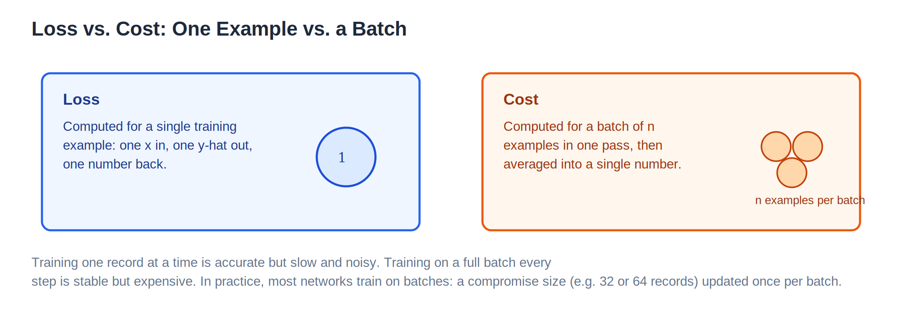
Figure 2.17: A single training example produces a loss; a batch of examples produces a cost
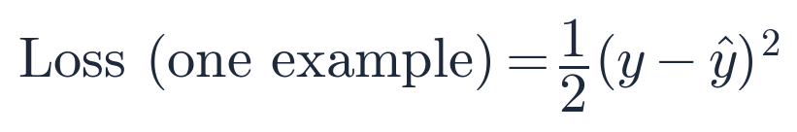
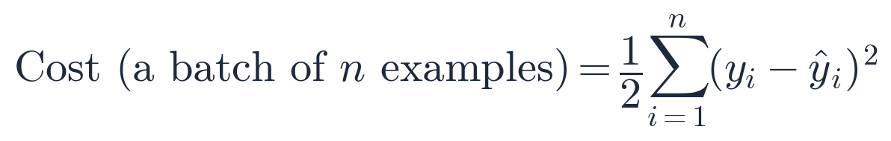
The two formulas look almost identical on purpose. Cost is just loss, averaged over every example in the current batch, before backward propagation runs. A batch size of 32 or 64 is a common practical compromise: large enough to smooth out noisy individual examples, small enough to keep each training step fast.

Regression Losses
Mean Squared Error (MSE) is the default choice for regression. For a single example it looks like this, which should look familiar from the Loss Function introduction earlier in this chapter:

The reason MSE pairs so naturally with gradient descent is visible in its shape. Expanding the square shows it is a quadratic equation, the same family as a parabola:
A quadratic loss produces exactly the bowl-shaped curve gradient descent needs: a single global minimum, with a slope that points the way there from anywhere on the curve. That is precisely the gradient descent picture from earlier in this chapter, just with the loss function now spelled out explicitly.
MSE's one real weakness: Because the error term is squared, a single large outlier contributes disproportionately to the loss. One badly mispredicted example can dominate training and drag every weight toward fixing that one point at the expense of the rest of the dataset.
Mean Absolute Error (MAE) fixes exactly that weakness by using the absolute difference instead of the squared difference:
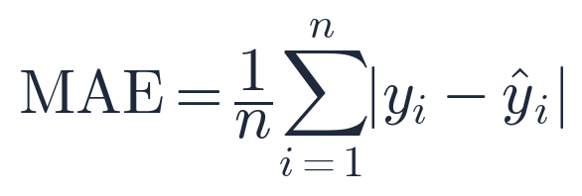
Because MAE grows linearly instead of quadratically, a single large outlier contributes proportionally to its size, not to its square, so it can no longer dominate the loss the way it can under MSE. The tradeoff is at the bottom of the curve: MAE has a sharp corner at zero error, where the slope is undefined, which can make the last stretch of convergence slightly less smooth than MSE's rounded bowl.
Huber Loss is a deliberate compromise between the two: quadratic (like MSE) for small errors, linear (like MAE) for large ones, switching over at a threshold called delta.
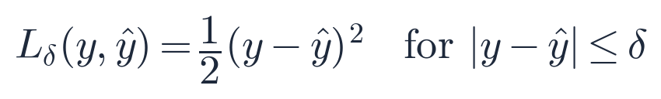
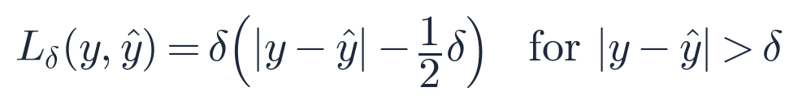
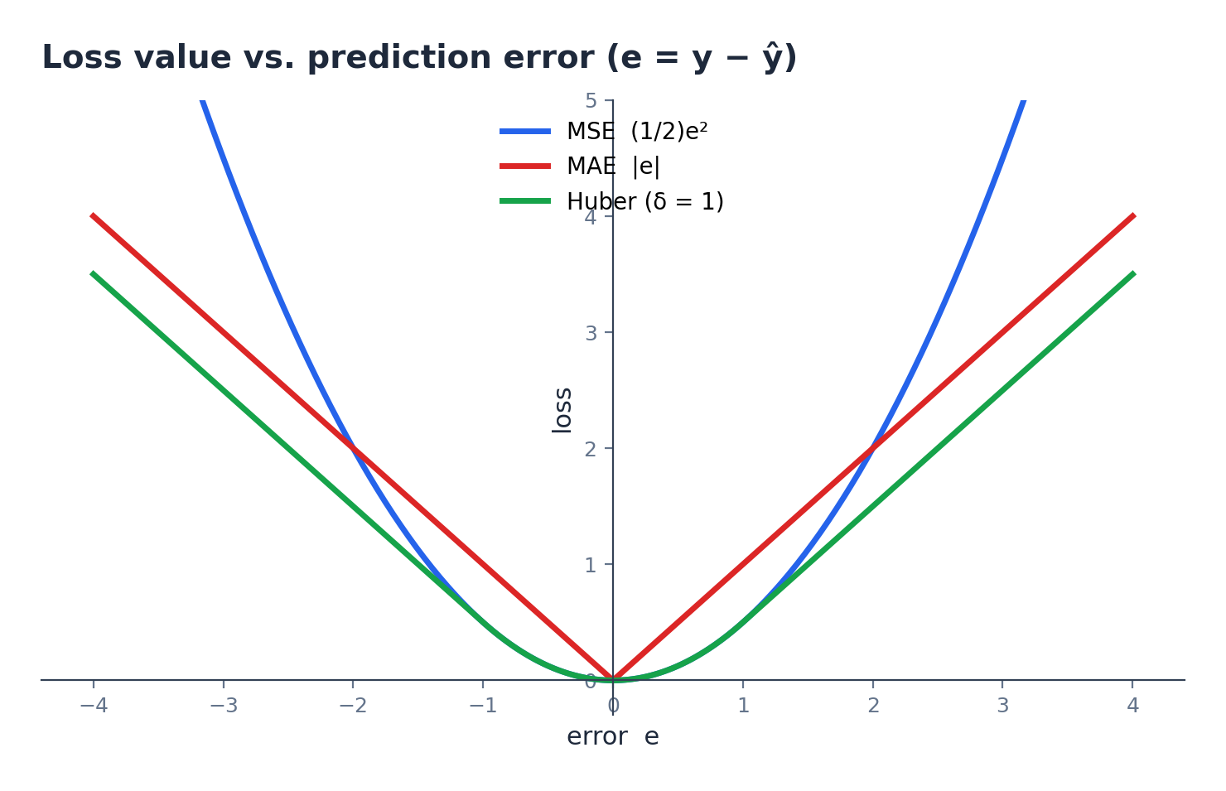
Figure 2.18: MSE, MAE, and Huber loss plotted against the same prediction error
The comparison makes the tradeoff visible directly: MSE curves upward fastest, punishing large errors heavily; MAE grows in a straight line, treating every unit of error equally; Huber tracks MSE closely near zero, then bends into a straight line for larger errors, capturing MSE's smooth convergence behavior near the minimum without MSE's outlier sensitivity far from it.
Loss | Best for | Watch out for
MSE | Clean data, few outliers, smooth convergence matters | Outliers dominate the loss
MAE | Data with outliers you do not want to overweight | Sharp corner at zero can slow fine convergence
Huber | A middle ground when you are not sure which applies | One extra parameter (delta) to choose

Classification Losses
Regression losses measure the distance between two numbers. Classification losses need to measure something different: how well a predicted probability matches a true category. The standard tool for that job is cross-entropy, which comes in two flavors depending on how many classes there are.
Binary Cross-Entropy (BCE) is used whenever the output is a single sigmoid probability, for a yes-or-no style prediction:
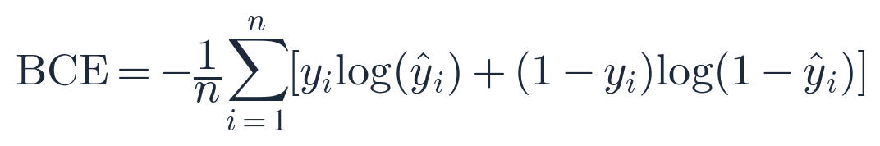
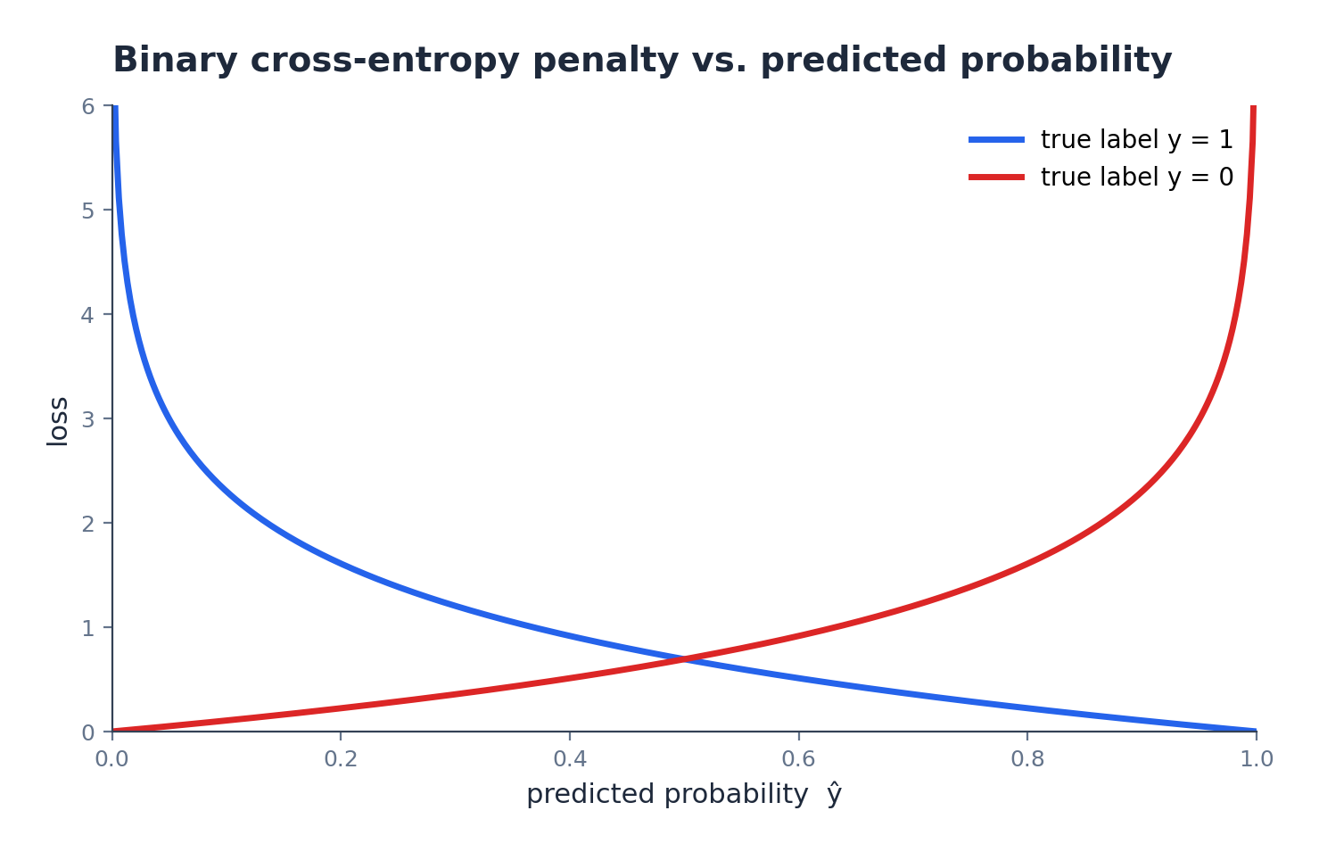
Figure 2.19: How heavily BCE penalizes a prediction, depending on the true label
The shape in Figure 2.19 is the entire point of using log instead of a simple difference. When the true label is 1 and the model predicts a probability close to 1, the loss is nearly 0, as expected. But as that predicted probability drifts toward 0, the loss does not grow gently. It shoots upward toward infinity. A confident, wrong prediction is punished far more severely than a hesitant, wrong one, which pushes the network to be well-calibrated rather than just technically correct.
Categorical Cross-Entropy (CCE) is the multi-class generalization, used together with a softmax output layer:
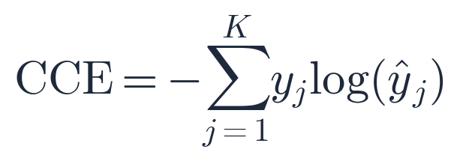
Because softmax output is a probability for every class and exactly one class is correct, this sum collapses to a single term in practice: the negative log of the probability the model assigned to the correct class. Maximizing that probability is the same as minimizing this loss.

Matching Loss Functions to Tasks
Task | Typical output activation | Typical loss function
Regression | Linear (no activation) | MSE, MAE, or Huber
Binary classification | Sigmoid | Binary Cross-Entropy
Multi-class classification | Softmax | Categorical Cross-Entropy

Callback: This table lines up exactly with the "Choosing an Activation Function" guide earlier in this chapter. The output activation and the loss function are chosen together, as a matched pair, not independently.

Multi-Layer Neural Network
A perceptron generalizes into a multi-layer neural network by stacking additional hidden layers, each containing any number of neurons. The exact same two-step process, weighted sum plus bias followed by activation, happens inside every neuron in every layer. What usually changes at scale is the choice of activation function and loss function, for example when the task becomes multi-class classification instead of binary classification.
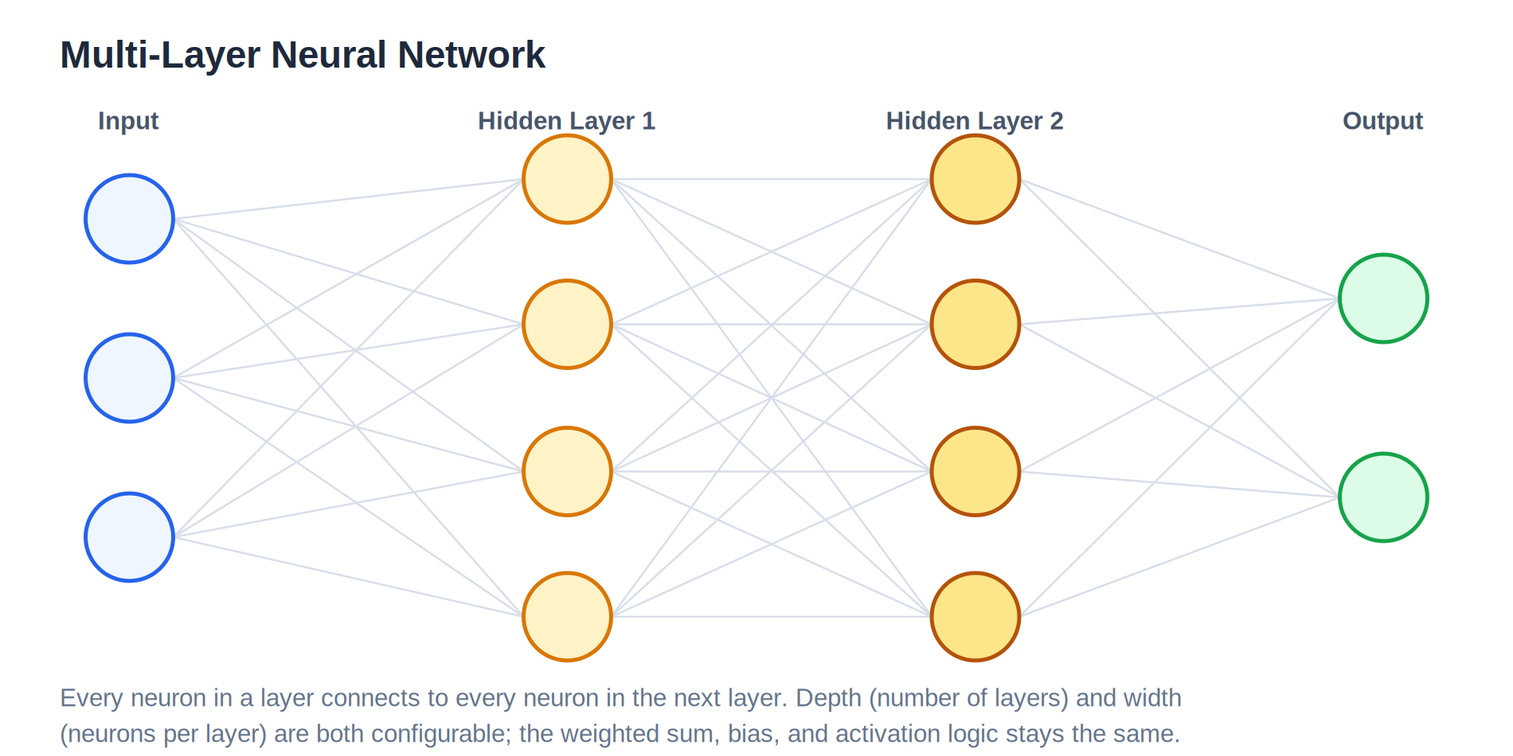
Figure 2.20: A network with two hidden layers; both depth and width are configurable

Worked Numeric Example
To make the process concrete, consider a single neuron with two inputs.
Weighted sum plus bias:
Passed through the sigmoid activation function:
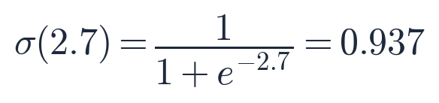
Since 0.937 is greater than or equal to 0.5, this neuron would output class 1. If the true label were 0, the loss function would register a large error, and backward propagation would adjust w1, w2, and the bias so that the next forward pass produces a value further from 1.

Summary: The ANN Training Loop
Step | Belongs to | What happens
1. Input layer | Forward propagation | Raw feature values enter the network
2. Weights | Forward propagation | Each input is scaled by a learned weight
3. Bias | Forward propagation | A constant offset is added to the weighted sum
4. Activation function | Forward propagation | Introduces non-linearity and decides neuron output
5. Loss / cost function | Backward propagation | Measures the error between y-hat and y
6. Optimizer | Backward propagation | Computes how each weight should change, for example gradient descent
7. Weight update | Backward propagation | Weights are adjusted; the cycle repeats next epoch

Part 3: Recurrent Neural Networks (RNN)

RNN
Notes for RNN will be added here as transcripts and screenshots come in.

Part 4: Natural Language Processing (NLP)

NLP
Notes for NLP will be added here as transcripts and screenshots come in.

Glossary of Terms
Term | Meaning
Neuron | A single processing unit that computes a weighted sum plus bias, then applies an activation function
Weight | A learned number that scales an input, controlling how much influence that input has
Bias | A learned constant added to the weighted sum, preventing the output from collapsing to zero
Activation function | A function such as sigmoid, ReLU, or tanh that introduces non-linearity and shapes the neuron's output
Forward propagation | The left to right pass through the network that produces a prediction
Loss function | A function that measures the difference between the predicted value and the true value for one example
Cost function | The average loss across a batch of examples, used to drive one weight-update step
Backward propagation | The process of sending the loss signal backward through the network to compute weight updates
Optimizer | An algorithm, such as gradient descent, that decides how much to adjust each weight
Epoch | One complete pass of the entire training dataset through forward and backward propagation
Global minimum | The point on the loss curve where the loss is at its lowest achievable value for the given weights
Learning rate | A small constant (e.g. 0.01) that scales how big a step the optimizer takes on each weight update
Chain rule | A calculus rule for differentiating a function of a function; used to compute how a weight buried deep in the network affects the final loss
Vanishing gradient | A failure mode in deep networks where the gradient shrinks toward zero as it passes backward through many layers, so early weights barely update
ReLU | Rectified Linear Unit; an activation function that outputs the input unchanged if positive, and 0 otherwise
Dying ReLU | A failure mode where a ReLU neuron receives only negative inputs, so its gradient is permanently 0 and it stops learning
Softmax | An output-layer activation function that converts raw class scores into probabilities that sum to 1, used for multi-class classification
PReLU | Parametric ReLU; like Leaky ReLU, but the negative-side slope is learned during training rather than fixed
Swish | A smooth activation function, f(x) = x times sigmoid(x), that self-gates its own input instead of hard-clipping at zero
Mean Squared Error (MSE) | A regression loss equal to half the squared difference between the true value and the prediction; sensitive to outliers
Mean Absolute Error (MAE) | A regression loss equal to the absolute difference between the true value and the prediction; more robust to outliers than MSE
Huber Loss | A regression loss that behaves like MSE for small errors and like MAE for large errors, controlled by a threshold delta
Binary Cross-Entropy (BCE) | A classification loss for two-class problems that heavily penalizes confident, wrong predictions
Categorical Cross-Entropy (CCE) | The multi-class generalization of BCE, paired with a softmax output layer
Batch size | The number of training examples processed together before one weight update

