Module 4 & 5 Documentation

4. Forecasting & Cancellation Trends
This module focuses on future occupancy trends, guest cancellation behavior, and refund/no-show patterns. The visuals help hotel management make proactive operational and pricing decisions.

4.1 Predicting Future Occupancy (Trend Lines)
Purpose
To estimate upcoming occupancy using historical booking data and visual trend lines.
What the Visual Shows
- Line chart of past occupancy levels
- Projected trend based on rolling averages / simple forecasting
- Seasonal patterns (weekends, holidays)
Key Insights Provided
- Expected occupancy for next 7 / 30 days
- Identification of low-demand periods for discounting
- Identification of high-demand periods for rate increases

4.2 Cancellation Rate & Lead-Time Distribution
Purpose
To understand how often guests cancel and how far in advance they cancel.
What the Visual Shows
- Monthly/weekly cancellation percentages
- Lead-time histogram (days between booking & cancellation)
- Channels or room types with the highest cancellations
Key Insights Provided
- Channels causing most revenue leakage
- Ideal cancellation policy windows
- Behaviour patterns of last-minute cancellers

4.3 No-Show & Refund Trend Visuals
Purpose
To analyse guests who booked but did not arrive, and bookings that were refunded.
What the Visual Shows
- Monthly no-show trend
- Refund rate and reasons
- Combined operational losses due to no-show/refund
Key Insights Provided
- Identify periods or channels with high no-shows
- Evaluate refund policy effectiveness
- Support decisions for enforcing deposits or prepayment

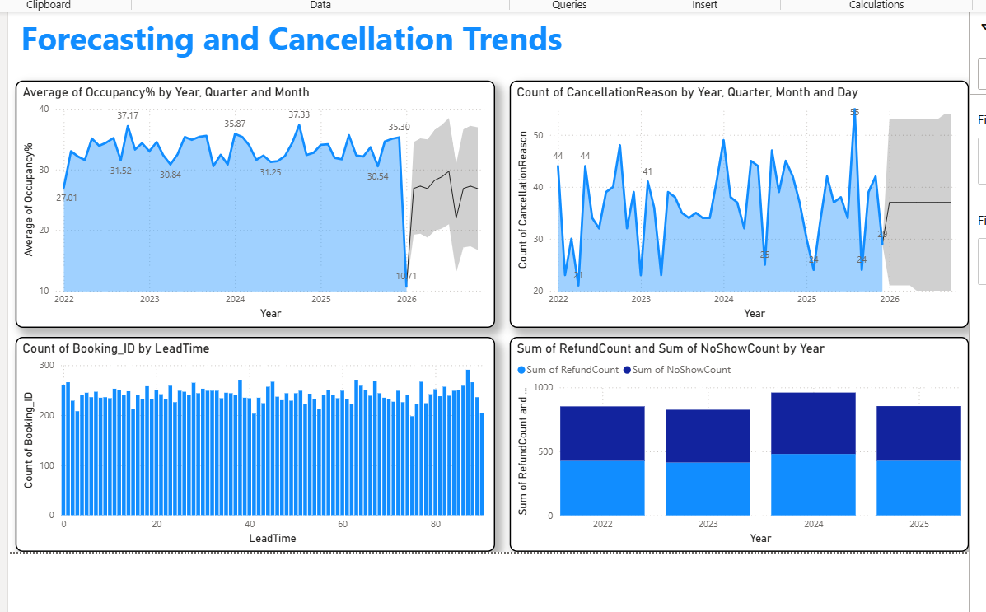

5. Revenue Strategy Dashboard
This module translates hotel performance data into pricing and upsell recommendations.

5.1 Upsell Potential (Spa, Dining, Services)
Purpose
To identify which guests or segments are most likely to buy ancillary services.
How the Data Is Generated
You created Ancillary_Transactions using Power Query (M-code) that:
- Assigns random ancillary service categories (Spa / Dining / Services)
- Adds transaction amount, quantity, and date during stay
- Generates customer-level upsell behaviour insights
What the Visual Shows
- Attach rate (percentage of bookings with ancillary purchase)
- Top-performing services (e.g., Spa > Dining >Service)
- High-value guest segments
Key Insights Provided
- Which services to promote more
- Which guests should receive upsell campaigns
- Timing of promotions (pre-arrival / during stay)

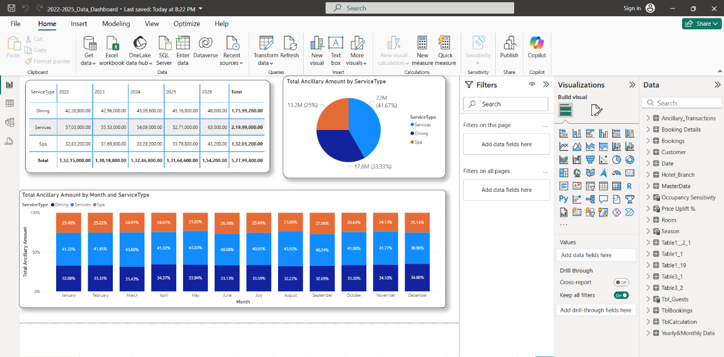

5.2 Pricing Tier Recommendations (Season & Room Type)
Purpose
To determine optimal pricing tiers based on seasonality and room type performance.
What the Visual Shows
- Peak, shoulder, and low seasons
- ADR, occupancy, and revenue patterns by room type
- Recommended rate ranges/tiered pricing structure
Key Insights Provided
- When to increase or decrease prices
- Which room types can be pushed to premium pricing
- Seasonal demand-based pricing strategy

5.3 Final Interactive Dashboard (For GMs & Revenue Managers)
Purpose
To give hotel leadership a single page to monitor performance and take decisions.
What the Dashboard Includes
- Top KPIs: Occupancy, ADR, RevPAR, Cancellations, No-shows
- Forecast View: Next 30-day occupancy curve
- Cancellation Patterns: Lead-time + high-risk channels
- Revenue Strategy: Upsell performance + pricing tiers
- Filters: Date, room type, channel, customer segment
Why It’s Useful
- Quick operational overview for GMs
- Actionable revenue insights for Revenue Managers
- Single source for daily decision-making

